Jessica Phillips (2102890)

My exhibition, assignment 1

BA Fine Art, Studio, Site and Context

ADAD4019 ways of perceiving.

Word count: 1,565
Task: introduction to show, explanation of what I will be looking at in terms of themes, artwork and site to context of my theme, history and theories to artists and artworks, why I wanted to include them in the show and why they are relevant to me to maps to bibliography.

My shows name is “desolate urge” and is at surface level a exhibition and review on loneliness and emotional separation of humans from one another. The show is about how humans are naturally tribe and herds species with symbiosis behaviours and passion for ultimate growth and success of the breed, however we are profoundly lonely and avoid each others attempts of communication and we are ignorant to bonds between strangers. The show displays works regarding solitude, weakness, seclusion and fragility, I decided to display the work in a train carriage for that is when I view the most separation and loneliness throughout my day; I see people on their way to work or to the shops where they keep their heads down, ears covered and mouths sealed, often distracted by crosswords, books or phones. The title of the show is “desolate” meaning barren, glum, dispirited while “urge” is regards to a natural human instinct to work together, live together and communicate. The theories I will be reviewing in this essay are loneliness in artists and artworks also how modern times are making us lonely. The artists I will be looking at are Jackson Pollack, Umberto Boccioni, Lucian Freud, Hyenk Martinec, and Edward Hopper.
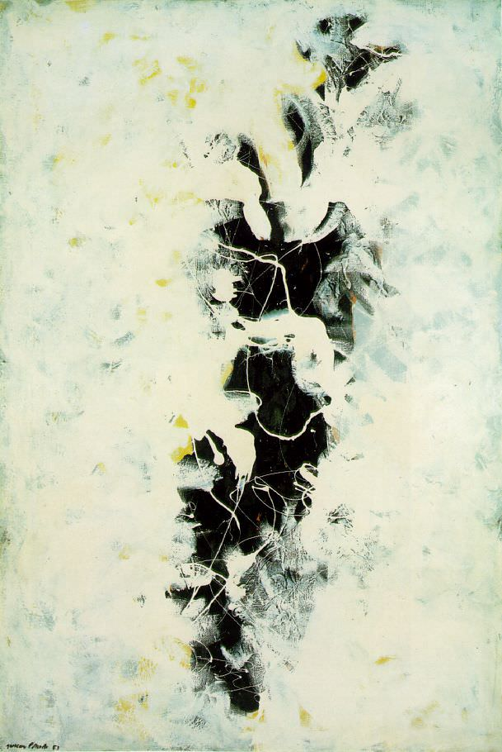
Firstly, let’s analyse the theme and understanding of loneliness. I want to discuss the origin and history of the word loneliness itself to begin with. The word was first seen in english around the 17th century, however before this time a word known as “oneliness” was used to describe how one was simply alone, by ones self, not necessarily feeling emotional solitude or separation. This term was mostly referred to a person who was to be alone with God, for the belief was that he was always present with you so you could never truly be alone. (Alberti bound, F, berfroise.com, 21st September 2018) Another correlation to religion from the word lonely is through John Milton’s 1667 poem “paradise lost” where he describes one of the first “lonely” characters in english literature. The poem displays Satan on his journey to the garden of Eden to entice Eve. He’s described as taking “lonely steps” out of hell and travelling the path that no other angel previously had. During these times the word loneliness and associated words such as lonely, isolation and lone were rarely used in writings. The concept of being lonely just wasn’t prominent or known. The naturalist John Ray created a glossary of infrequently used words within the english language in 1674, where he involves the word loneliness (Worsley A, the conversation.com, march 18th 2021) As we can see from the history of the word, it is a modern concept and is only relatable to our present times. Scientifically, loneliness is brain chemistry, a decrease of serotonin and an odd connection between the dorsal raphe nucleus (DRN). Gillian Matthews was one of the first neuroscientists of her time to unintentionally conduct an experiment on the relation between loneliness and brain chemistry. As part of her PhD she was surveilling mice and their brains under cocaine and saltwater solution. Throughout the experiment, Matthews could see DNR neutron connections within the mice continue to grow and become stronger. She soon determined that this was not due to the drugs but due to the fact the mice had been isolating 24 hours prior and were experiencing the effects of loneliness. (Trafton A, news.mit.edu, February 11th 2016) By discovering this she then proved that us as humans can also experience change in brain chemistry due to solitude. To be lonely is to grieve connection, to deeply feel isolation, to lack relationships. It is something that humans have always experienced, it’s a natural emotion for the species, however, it is becoming more prominent and noticeable as the date ages. Historian and author of “the history of loneliness” Jill Lenore (Lenore, J, thenewyorker.com, April’s 16th 2020) states “Before modern times, very few human beings lived alone. Slowly, beginning not much more than a century ago, that changed.” Her statement supports the idea of humans becoming more lonely and isolated as we progress through time. One of the first experts to see this pattern was Fay Bound Alberti, she is British cultural historian of gender, emotion and medicine, and Professor of Modern History and UKRI Future Leaders Fellow at the University of York. (Author unknown, wikipedia.org November 24th 2021) And she also believes that this is a Morden problem. Her research shows that it wasn’t until the 1800s that being lonely was recognised, during and before these times people always lived in close proximity and connected with strangers on a daily basis, so it isn’t surprising that in the 1940’s was when a very early study by Joseph Harold Sheldon was wrote and released named "The Social Medicine of Old Age. Report of an Enquiry in Wolverhampton" ( Sheldon, J.H, The social medicine of old age. Report of an enquiry in Wolverhampton. (1948) Journal of gerontology) that again shows us that the feeling of being lonely has come about in recent times, due to shifts in living conditions and social norms.

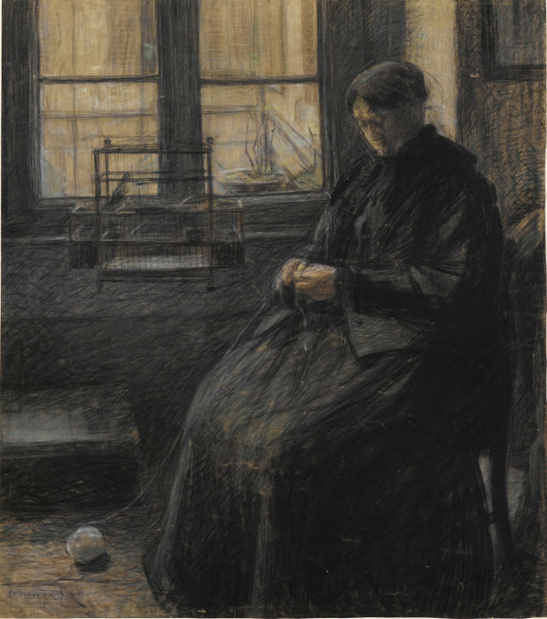
The first artwork I will discuss is Jackson Pollocks “the deep” 1953. I believe the title of the piece is relevant, “the deep” can be assassinated with the sinking feeling of loneliness, the deep, empty, unfulfilled emotional hole left within a person who is experiencing loneliness. I was drawn to this piece by the colours and shapes that are created across the canvas, the openings, the unveiling, the tearing nature of the work. The white enamel and oil paints across the canvas look like energy trying to connect across the black river between them, small connections are being made, links are forming in the shape of paint strokes but overall, there are gaps between the canyon, it is still lacking full connection. I believe this artwork is a great depiction of loneliness as a feeling and sensation within humans and works well with my theme.

The next artwork that will be displayed within my exhibition is Umberto Boccioni’s “la signora sacchi” 1907. This is a pastel piece on paper and depicts a lone woman sitting on a chair knitting. Boccioni was ultimately fascinated and curious about women, their behaviours, their auras, their roles within society in the early 1900. Within his work we can see many sketches and observations about women, most commonly, mothers. This piece is a view into “a mothers work” at the time. The woman is alone, mindlessly creating, without child and without husband near to keep her company. Being a mother is hard, exhausting, not always rewarding and sometimes lonely. Being busy and occupied to tend to children alone while the husband goes out to work can leave mothers feeling isolated and detached from other aspects of life. I decided to include this piece to show loneliness in a unique but prominent form.
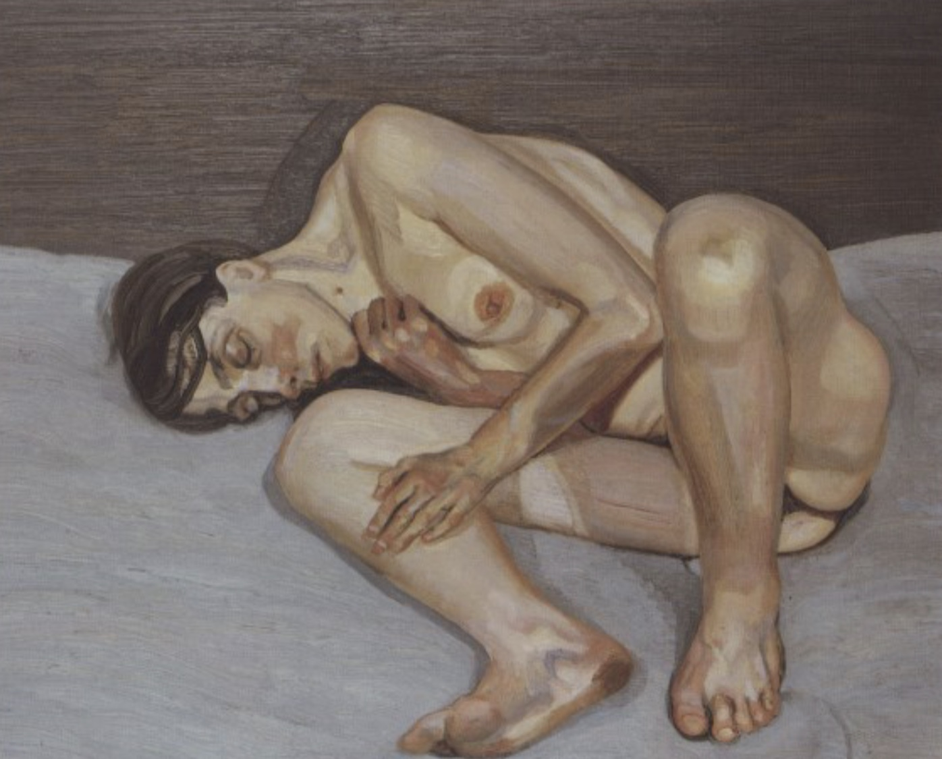
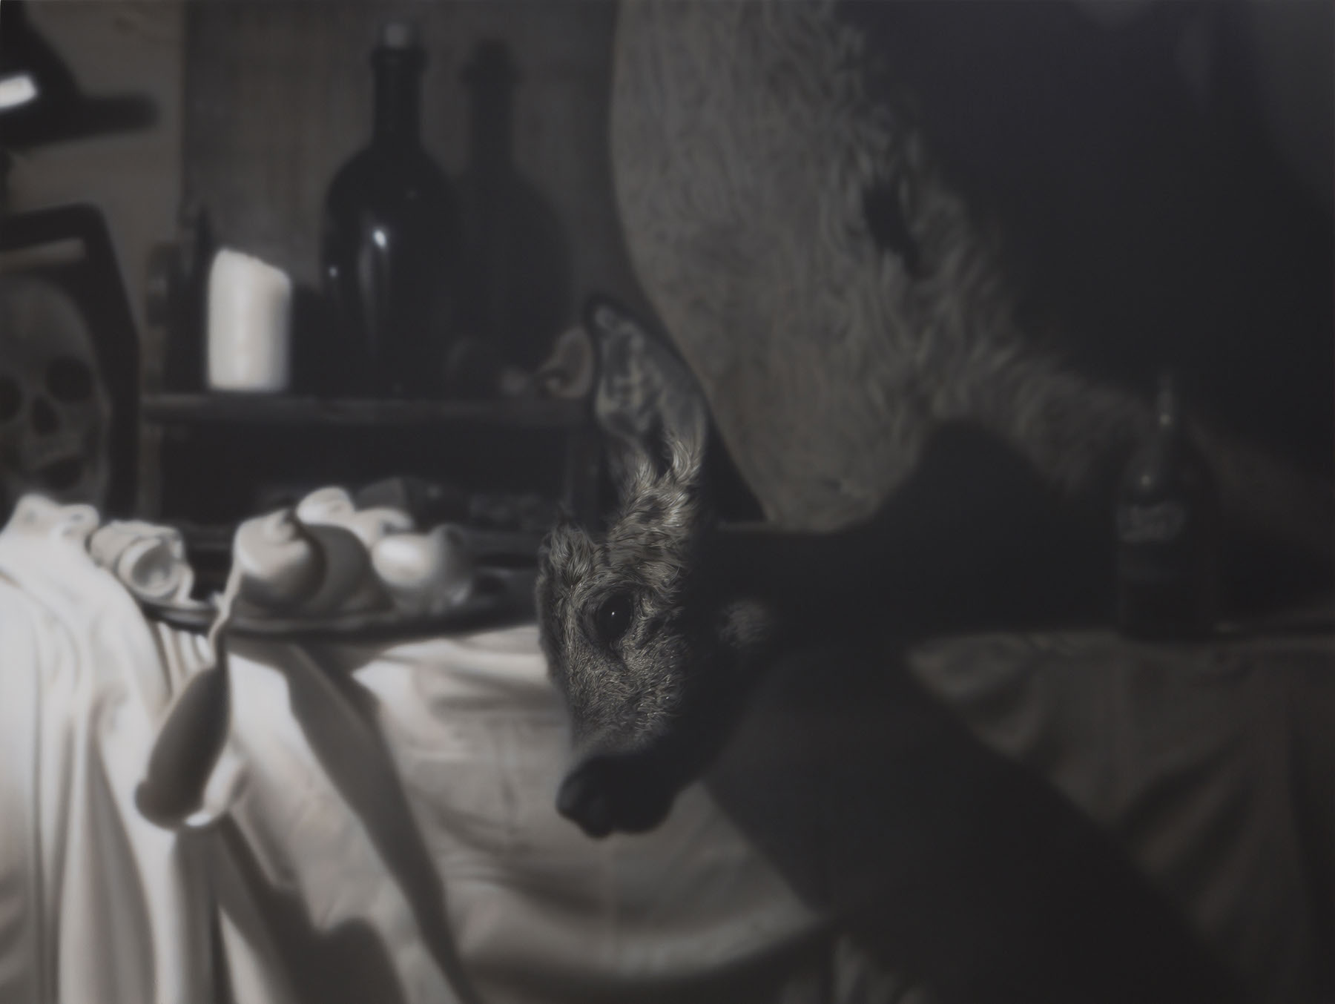
The next work I will be including in the show is Lucian Freud’s “small naked portrait” 1973-74. The piece is oil on canvas and I was initially drawn to the work by the looming dread that I first felt while looking at the piece. I felt like I was an entity, a higher being, looking down on this shivering, tired, disconnected woman and I felt a sense of recognition within her. I felt an urge to crawl through the frame and hold her, to tell her she wasn’t alone and not to give up just yet. Overall, I felt the most connection to this piece, the loneliness depicted within the work was the most recognisable to my own. It gave an aura of boredom with life, a weariness to continue to try and the isolation that follows as a consequence. The muted and earthy tones of paint the artist chose adds to this ambiance of a dampened and silenced life.

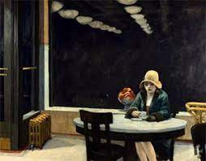
Second to last, I will be discussing Hynek Martinec’s “every minute you are closer to death” 2013. This is an oil on canvas work and depicts a dead deer on a table clothed with white, surrounded by bottles of various liquids and a skull image to the left of the canvas. The title and colours of the work are what reflect my theme, “every minute you are closer to death” initially strikes the viewer with feelings of crisis and suddenly a moment of unexpected truth. It creates notions of dispirit, demoralise and arises the question “why are we doing this?” We continue to work and live in the unhappy, lonely, dejected society which has negative effects on not only us as humans but also Mother Earth. The colours of the piece are monochrome and cadaverous, it lacks joy, comfort and amusement just as one feels suffering from loneliness.

Lastly, I will include Edward Hoppers “automat” 1927. Edward Hopper is renowned for his creations within the theme of loneliness. This piece depicts a lady sitting alone in an automat drinking a cup of coffee during the night. Although, the females mood is undetermined, I believe there is a desolate ambience surrounding her. The woman is well dressed and seen to have put effort into her appearance, with well maintained makeup and sophisticated clothes; she is on her way to work. Like I stated at the beginning of my essay, I see the most loneliness during commute times. The woman has only taken off one glove suggesting she is in a hurry and cannot stay to drink very long, this relates to current life; constantly being rushed or hurried along, too fast to stop, make connections and build friendships. This piece relates to my theme of loneliness for she is solitary, diverted and secluded.
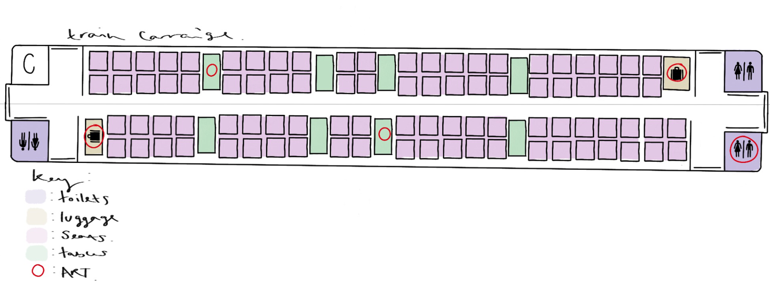
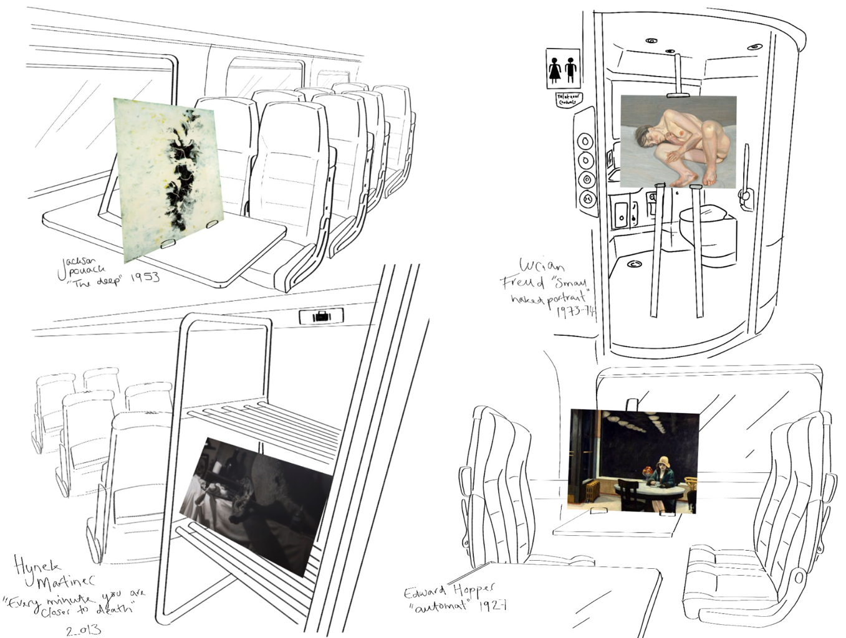
Maps:

Bibliography:
Books
- Smith, T (1997) In visible touch, Sydney, 1st edition, Power Publications.

- Lucie-Smith, E (1977) Art today, London, Phaidon Press Ltd.
Images
- Pollock, J (1953) The deep [enamel and oil on canvas] centre Georges Pompidou, Paris, France
- Boccioni, U (1907) la signora sacchi [pastel on paper] Civico Gabinettto dei Disegni, Castello Sforzesco, Milan

- Freud, L (1973-74) small naked portrait [oil on canvas] The Ashmolean Museum of Art and Archaeology, Oxfordshire

- Martinec, H (2013) every minute you are closer to death [oil on canvas] Parafin, London

- Hopper, E (1927) automat [oil on canvas] Des Moines art centre, Des Moines.

Journals
- Sheldon, J.H. (1948) The social medicine of old age. Report of an enquiry in Wolverhampton. Journal of gerontology, 3 (4) 306-308. Publisher unknown

Websites
- Jill Lenore (April 6, 2020) the history of loneliness, the New Yorker, 21st February 2022, https://www.newyorker.com/magazine/2020/04/06/the-history-of-loneliness

- Author unknown ( November 24th, 2021) Fay Bound Alberti, 21st February 2022, https://en.wikipedia.org/wiki/Fay_Bound_Alberti

- Harper, D. (Date unknown). Etymology of loneliness. Online Etymology Dictionary. Retrieved March 2, 2022, from https://www.etymonline.com/word/loneliness

- Worsley, A (March 18th 2018) a history of loneliness, 23rd February 2022, https://theconversation.com/a-history-of-loneliness-91542

- Fay bound Alberti (21st September 2018) One is the Loneliest Number: The History of a Western problem, 23rd February 2022, https://www.berfrois.com/2018/09/loneliness-has-a-history/

- Trafton A, (February 11th 2016) Pinpointing loneliness in the brain, 4th march 2022, https://news.mit.edu/2016/neurons-loneliness-brain-0211

