Watson Street, Derby.
07478 736912 • luiseduardochinchillacortez@gmail.com
LinkedIn: Luis Chinchilla - https://www.linkedin.com/in/luis-chinchilla-63139b345/?isSelfProfile=true

Personal statement

Results-driven Operations Shift Manager with 3+ years of experience overseeing fast-paced fulfilment, cold-chain assembly, and D2C distribution environments, including high-volume operations at HelloFresh. In-depth knowledge of site safety compliance (HACCP/BRCGS), lean production planning, and labour optimization. Skilled at leading cross-functional teams of 50+ associates and line supervisors, driving key performance metrics such as UPH, packing accuracy, and on-time dispatch while managing labour costs. Possesses a calm, decisive leadership attribute profile, excelling at root-cause problem solving and process optimization during peak operational windows. Seeking to leverage proven operational management and continuous improvement expertise to deliver high-quality fulfilment performance in a senior shift management role.
Key Skills

- Focuses on Long-term Throughput & Capacity Planning
- Proficiency in all areas of Microsoft Office, including Access, Excel, Word and PowerPoint
- Indirect Leader (coaches Shift Managers to lead)
- Owns, audits, and builds SOPs / Lean Initiatives
- Fully qualified first-aider
- Performs Root-Cause Analysis (RCA) to stop reoccurrences

Employment History

HelloFresh

December 2023 – Present
- Step-Up Shift Manager (May 2026 – Present)
  - Seamlessly transitioned into high-level operational leadership, directly managing full site logistics and production floor operations.
  - Command and coordinate large-scale shifts of up to 135 operatives and 6 Team Leaders, ensuring optimal resource allocation and workflow continuity.
  - Consistently maintain an outstanding 115% productivity rate, outperforming benchmarks and exceeding corporate KPIs through fast-paced problem-solving and decisive leadership.
  - Demonstrated a rapid learning curve and high adaptability, proving that performance and output consistently exceed stakeholder expectations despite being newer to the role compared to tenured managers.

- Production Team Leader (October 2024 – May 2026)
  - Promoted to lead, mentor, and drive production line efficiency and safety within a fast-moving environment.
  - Headed and supervised up to 95 operatives during peak days, successfully balancing high-volume output with strict quality control standards.
  - Maintained high team morale and operational discipline, conducting daily briefings, tracking individual performance, and implementing H&S (Health and Safety) compliance.

- Production Operative (March 2024 – October 2024)
  - Transitioned to a permanent direct contract with HelloFresh due to exceptional performance, reliability, and work ethic.
  - Executed high-volume picking, packing, and inventory tasks under strict food safety regulations while maintaining excellent line speed.

- Adecco Employment Agency
- Production Operative (Assigned to HelloFresh) (December 2023 – March 2024)
- Successfully adapted to a fast-paced food production environment, securing a direct permanent contract with the client within just 3 months.

Education

Education & Professional Certifications

- Level 4 Certificate in Leadership and Management Skills for the Workplace (In Progress)
  - University of Wales Trinity Saint David (UWTSD) | Expected Completion: 2026/2027
  - Key Areas: Operational management, team development, strategic decision-making, and workplace performance optimization.

Hobbies & Interests

- Football & Team Sports: Passionate football player with past experience competing at a semi-professional level in El Salvador. Currently continue to play in local recreational leagues on Monday or Thursday evenings, which helps maintain physical fitness, competitive drive, and strong teamwork skills.
- Family & Outdoor Activities: Dedicated to spending quality time with my family and my 18-month-old toddler. I thoroughly enjoy outdoor activities such as hiking through quiet nature trails, visiting countryside farms, and exploring rivers. These outings serve as a vital way to recharge, maintain a healthy work-life balance, and disconnect from the fast-paced routine of professional and academic life.

References

References are available upon request.

Luis Chinchilla Cortez
07478736312 | luiseduardochinchillacortez@gmail.com | Derby, UK
Date: 18th October 2026
Hiring Team
Tarmac Trading Limited / Hydro International
Springfield Park, Nottingham, NG10 1PX
RE: Application for the Position of Deputy Operations Manager (Ref: job108053306)
Dear Hiring Team,
I am writing to apply for the Deputy Operations Manager role at Tarmac Trading Limited (Hydro International), which was posted on TotalJobs two weeks ago. I have a strong background in managing large teams, driving production output, and running fast-paced workplace logistics. I am confident I can successfully support your Area Manager and help lead your engineering and service projects.

My career at HelloFresh shows how quickly I adapt and grow as a leader. I started on the shop floor through an agency, but my hard work and strict commitment to safety and quality standards earned me a permanent direct contract in just three months. Following this, I was promoted to Production Team Leader, where I was responsible for leading up to 95 workers during our busiest peak days.

Right now, I am working as a Step-Up Shift Manager. In this role, I manage the site logistics, look after 6 Team Leaders, and lead shifts of up to 135 people. Even though I am newer to senior management than other managers, my results prove my capability. My shifts regularly hit a 115% productivity rate. I achieve this by solving problems quickly on the floor, keeping morale high, and making sure the operation runs efficiently.

To support my practical experience, I am currently studying for a Level 4 Certificate in Leadership and Management Skills for the Workplace at the University of Wales Trinity Saint David (UWTSD). This course is helping me improve my skills in operational planning, strategic decisions, and team scheduling, which matches exactly what you need for this role.
Outside of work, my experience playing semi-professional football in El Salvador taught me a lot about discipline, teamwork, and staying calm under pressure. I bring this same energy and focus to my work every day to keep standards high and motivate my team.

Tarmac’s great workplace culture is exactly what I am looking for in my next career step. I have a full UK driving licence, and I am fully ready to travel for site visits and help the business wherever needed. Thank you for your time, and I hope to discuss during an interview how my leadership skills can support Hydro International.

Yours Sincerely,
Luis Cortez

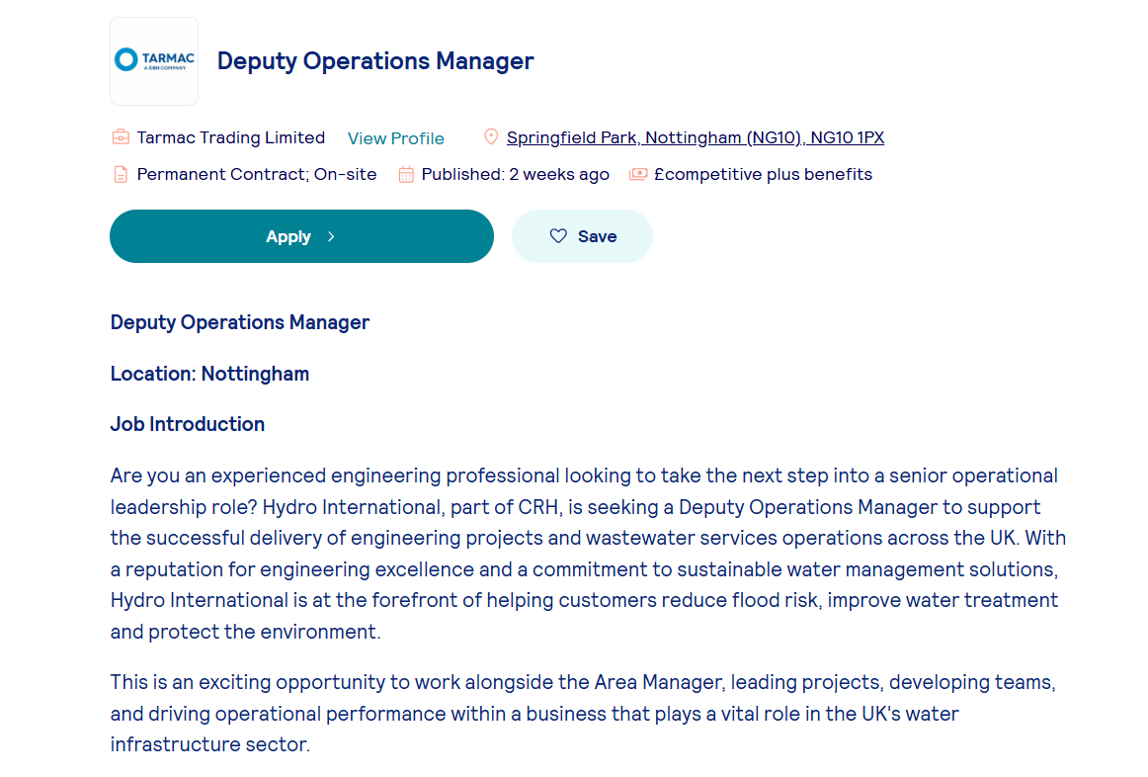

https://www.totaljobs.com/job/deputy-operations-manager/tarmac-trading-limited-job108053306?rltr=2_2_25_seorl_m_0_0_0_0_0_0

