Tower 4 Furnace Uplift
Wall colmonoy
Group Project assignment (M5X00400)
Gavin John (1809103)
2020

Contents Page
Table of Contents
Contents Page 1
Introduction 2
Forming a team 3
Belbin Roles 3
Tuckman’s model 3
Planning the project 5
Program Evaluation and Review Technique (PERT) 6
5S 6
Carrying out the project 7
Maslow 7
Herzberg 8
Motivators 8
Hygiene Factors 8
Conclusion 9
Works Cited 10
Appendix 12
Appendix A: Assigning Belbin Roles 12
Appendix B: General Arrangement Drawings 12
Appendix C: Project Justification 14
Appendix D: Timing Plan 15
Appendix E: Spend Control Document 16
Appendix F: Project Action Tracker 17

Introduction
Recently I completed a capital expenditure project called Tower 4 Furnace Uplift. This project had two main aims. The first being to comply with the new electromagnetic field at work regulations 2016. By complying with this regulation, the company will comply with the amount of exposure of electromagnetic fields being produced from the furnace. The second aim of this project was to increase the melting capacity for this atomising tower. Before the project began, the furnace's melt capacity was 325kg per melt. With the new furnace, this melt capacity increased to 450kg per melt which allows a greater throughput for production. Along with this uplift, it gives the process a great deal of standardisation which will be a major benefit if any problems arise with any tower as furnaces can be swapped to ensure product delivery is met. Throughout this project, it was key to use certain techniques to ensure deadlines were met and how the team was formed and managed. As the project manager, it was critical to ensure my team were still motivated to complete each task, even when the tough time hits.

Forming a team

Belbin Roles
The first step to this project was to form a team. It was vital to ensure each task was assigned to the correct person who could deal with the roles and responsibilities. To do this, I used Belbin’s roles. Within Belbin's roles, there are nine roles which can be defined into three subcategories. The first category is the action-oriented roles. Within this category, the roles for the shaper, implementer and completer finisher can be found. The next subcategory within Belbin's roles is the people-oriented roles. From here, coordinator, team worker and resource investigator roles can be located. The last subcategory that can be found within Belbin's roles is the thought orientated roles which contain plant, monitor evaluator and specialist [ (Tools, 2009) (Belbin, 2019) (Manage, 2020)]. The reason we use Belbin’s roles is to have a balanced team for the project.

To set a team-up, I called and chaired a meeting. This gave me and my team a chance to discuss each individual’s role within Belbin’s roles to ensure they were happy with what was expected from them. As a group, I asked them to list all nine roles from Belbin and write a score from one to nine, with one being the best, to each role where each individual felt they were best and worst suited. However, I soon learnt that this wasn’t the best theory. This was due to some people having the same strengths, which left other roles unfulfilled. The roles that have more than one person with the same strength become void and this is indicated with a red box (this is shown in appendix A.) Although this approached didn’t work for this project, this is a powerful method to ensure projects can run successfully and efficiently. I will look to include this theory in future projects.

Tuckman’s model
The Tuckman’s model, also known as “Forming – Storming – Norming – Performing” was developed in 1965 by Bruce Tuckman. This theory focuses on team strategy from the very start of a project up until project completion [ (Balls, 2019) (Tools, 2019)]. I soon realised this method was the best to assign roles and set targets to each individual as there was no limitations to each person’s role, like there is in Belbin’s roles.

From the initial meeting, the team was in the ‘forming’ stage. As I was the project manager, it was my responsibility to delegate the roles, responsibilities and expectations [ (Balls, 2019) (Tools, 2019)]. The initial tasks that needed to be completed were research into what furnace would suit the company business needs the best. The second task that needed to be completed were general arrangement drawings of the area. These needed to be well detailed and precise to allow us to make the necessary modifications (see appendix B for full drawings.) The third task to be completed was the company's procedure documents. These documents include a justification with a scope, timing plan and estimated spends, which I completed (which are shown in appendix C, D and E respectively.)
Within these meetings, I helped my team set deadlines by using a SMART technique. SMART stands for Specific Measurable Agreed Realistic Timebound (Tools, 2020). This technique is key to sticking to deadlines to ensure successful project completion and allowed us to manage our time wisely [ (Tools, 2020) (Education, 2016)]. Once these dates have been finalised, I can also feed this into the timing plan along with the action tracker (Shown in appendix F) so there are multiple forms of tracking what actions are being completed.

Planning the project
With the project progressing, we were now in the storming stage of Tuckman's model. This is the hardest stage of any project as deadlines are a lot closer. This is a stressful time, meaning conflicts tend to occur amongst the team [ (Balls, 2019) (Tools, 2019)]. With the new furnace, it gave us a 4% increase in melt volume. This meant there was a £110,000 yearly profit potential, resulting in 11 months’ pay back for the project.

Being the project leader, I needed to have the timing plan as accurate as possible. To do this, I used a process called Activity-On-Node (AON) which ties in with critical path method (CPM), where the critical path shows the dependency on some tasks [ (Andrew Slate, 2018) (Tutor2u, 2018)].

AON uses boxes, which denote the 'node'. These are used to denote scheduled activities from the start of the project to the end and are connected with arrows to show the timing and progression of each task. This relationship can be summarised as “Finish-to-Start” (KNOWLEDGE, 2004). Now the tasks have been arranged in a logical order with their corresponding relationships, the calculation process can begin. This calculation starts with a process called "Forward Pass". In this stage, the Early Start and Early Finish values are calculated for each task using the task durations. For the first activity, the Early Start has to begin with zero as there isn’t any other task before this. From here, the following formulas can be used; [ (Scott W. Kramer, 2006) (Sohel Akhter, 2019)]
- Early Start = Maximum Early Finish from the predecessor
- Early Finish = Early Start + duration of the task

This then ties into the second step, the "Backward Pass". Within this stage, the Late Start and Late Finish values are calculated. The equation for this stage follows a similar suit to the "Forward Pass" and are shown below; [ (Scott W. Kramer, 2006) (Gabriel, 2009)]
- Late Start = Late Finish – Duration of activity
- Late Finish = Minimum value of Late Start from the successor

The last calculation involved in AON is float. Two different types of float need to be considered, which are “Total Float” and “Free Float”. Total float is how long a task can be delayed without affecting the project completion date. However, free float is how long a task can be delayed without delaying the Early Start of its successor. Both of these have their calculations. [ (Scott W. Kramer, 2006) (Sohel Akhter, 2019)]
- Total float = Late Finish – Early Finish
- Free Float = Early Start of a predecessor – Early Finish of current activity

By calculating these values, I was able to finalise the Gantt chart with the critical path included. The Gantt chart with CPM can be seen in appendix D. The most critical actions have no room for float so these must be completed on time to ensure the project deadline is complete. Even though this process seems to be long winded, it is a very helpful tool to finalise deadlines to ensure the efficiency of the project.

Program Evaluation and Review Technique (PERT)
PERT is another technique used to determine the schedule of an activity, which determines the critical path method. Just like activity-on-node, it measures the time it takes to complete each activity which gives you an overall project completion date. This method also takes into account what dependencies each task may have. PERT using a unique formula;
Estimated Duration = (Ot+4Mt+Pt)/6 [ (Bahnmaier, 2001) (C, 2019)]
Where;
- Optimistic time (Ot) – Assuming no delays and everything goes ahead of schedule, this is the minimum time to complete an activity. (Bahnmaier, 2001)
- Most likely time (Mt) – This is the fairest timescale as the timeline is balanced, assuming the task sticks to the plan. (C, 2019)
- Pessimistic time (Pt) – The maximum time is allocated in this section. This considers the negative aspects of an activity. (Bahnmaier, 2001)
Within this project, I used PERT to sense check that the dates I agreed with my team were accurate to ensure we met the target completion date. AON and PERT methods are similar in that they work out how long a task should take. AON is a more accurate method, which is why I used it as the primary calculations and PERT for the checks.

5S
A major company policy is, as the employee, represent and respect the company. To ensure my team and I always surpassed the company's expectations, we ensured we followed the ‘5S’ attitude. The 5S stands for;
- Sort – This is the first step, and this involves creating and maintaining a clean working environment. By conducting an audit of the area, we placed red tags on items we found weren't necessary for our working area so we could get rid of these items. (Rob, 2018)
- Straighten – In this section, we ensured we had all the necessary working gear to hand, which included personal protection equipment (PPE) to allow us to access all areas of the factory, where special PPE was required. (Definition, 2019)
- Shine – Due to the nature of the business, our working area often became dirty. With help from our health & safety officer, we had a cleaner to clean our workspace at the end of each day. However, we added in additional steps to often clean our working area regularly to reduce the build-up of dirt. (Today, 2019)
- Standardise – For this step, we implemented a small procedure and templates to ensure the whole team worked to the same standard. (Rob, 2018)
- Sustain – This step was for me to follow very closely. I often checked on my team to ensure they were working to a high standard and that their work areas were clean and tidy. (Rob, 2018)
By following the 5S theory, it ensured my team and I were disciplined and working to a high standard that would be respected by the company.

Carrying out the project
With the timing plans constructed and the project approved by the company's senior management team, the project could get fully underway, meaning we were in the performing stage of Tuckman’s model. The regular daily meetings were a great help to ensure all was going to plan. However, as deadlines quickly approached, some members of the team became stressed and emotions flared within the team (Tools, 2019). To keep morale high, I used a combination of Maslow and Herzberg’s theories.

Maslow
Maslow’s Hierarchy of needs is spilt into five sections and is portrayed as a pyramid. However, each section of the pyramid has to be fulfilled before moving onto another section. The five sections of the pyramid are;
- Physiological needs – For this stage, I communicated what the overall project goal, the budget and resources available were. This ensured that the team understood that they have the financial backing and their ideas could be developed. This would give each member of the team the right motivation to get on with their task. (ThoughtCo, 2019)
- Safety – Within this section, my team needed to have all the correct equipment to do their tasks. This included the right computers with the relevant computer-aided design package installed to allow them to carry out the general arrangement drawings and to design any other modifications/fabrications. As well as tape measures and laser measurers to allow my team to get accurate measurements. A relevant Microsoft Office package to allow my team to communicate back to me and manufacturers via email. I also made sure that my team were in the work area together. This allowed them to challenge their teammates and me in ensuring the tasks were done on time. (Orfano, 2009)
- Belongingness – For this section within Maslow's theory, I had a one-to-one meeting every week with each member of my team. I did this to ensure they were happy with their progression of the project and to make sure their general and mental health was not being affected. To keep the socialism high within my team we scheduled our breaks together, so it allowed us to talk to one another about topics that didn't involve work. (Vaughan-Williams, 2019)
- Esteem – In this stage, whenever my team met a milestone, I made to sure they got the recognition they deserved. I would firstly congratulate the individual personally then again in the next team meeting. As well as this, I would meet with the senior management and board of directors monthly to give them feedback on the project. In this meeting, I made sure to give the recognition of my team on their successes. (Orfano, 2009)
- Self-Actualisation – This last section allows my team to develop their knowledge and understanding. When delegating the roles, I took into consideration what each member could do and challenged their skills to allow them to grow as engineers. (Vaughan-Williams, 2019)
These are in order from the bottom of the pyramid to the top.

Herzberg
Herzberg’s theory describes how a business could introduce certain factors to motivate their employees and the factors that would de-motivate employees. These were split into two groups, motivators and hygiene factors. (Tutor2u, 2019)

Motivators
Motivators tend to be more indulged with the job itself. These workers tend to push extra responsibility to show what they can produce which could lead to promotion because of the recognition shown [ (Tutor2u, 2019) (NIZHEBETSKIY, 2017)]. Whenever my team met a deadline, I wanted them to feel a sense of recognition from the task they had completed. I was able to give them this well-deserved recognition when reporting back to the senior management. With all this, it gave my team a feeling of pride to implement such an improvement for the company.

Hygiene Factors
The factors which surround the job are called Hygiene factors. It was important to let my team know that their job was secure during and after this project. It was also important for the company to give my team equal contracts and for my team to obey the company’s policy (Management, 2018). Within the company's policy, there is a strict rule on bullying and that it will not be tolerated. I ensured regularly that this never took place and encouraged my team to talk to me personally if they did have any issues (NIZHEBETSKIY, 2017).

By using both these theories, it allowed my team to stay motivated to their tasks while enjoying their work in stressful situations. As our company is American owned, my team and I would regularly communicate with our sister company in Los Lunas and our board of directors. We would regularly update our presentations to show the progress being made. These presentations would be combined and presented by each member of the team every month. We used Microsoft Teams to present our progress on the project. This is a new package from Microsoft which comes with Office 365. This technology works exceptionally well and allows interaction from all parties. These meetings don't only give updates across the board, but it allows other engineers to have their input, which is greatly beneficial as we can learn from other people's experience.

Conclusion
Throughout this project, I learnt that a good team makes a successful project. There are many different theory's that can be applied to forming a good team. However, I found using Tuckman's model was the best due to having more flexibility in roles compared to Belbin’s roles. I found that it is also vital to get a very precise timing plan and ensure your team understand what their roles and responsibilities are. With any projects, there will always be times where things are overlooked or misinterpreted. However, by using SMART targets, it was rare that anything within this project was overlooked. This is why, having a team, who have expertise in different sections can get a solution to a problem as soon as possible. Being the project manager, it is vital to ensure, that your team have a safe working environment and are happy with the work they are doing and this was done by using the 5S theory. It was also vital that I made the sign-off on any spends, because I was able to keep track of spends and make sure we were still within the budget. Finally, by having good morale within the group led to us having a successful project and this came by using a combination of Maslow's and Herzberg theories.

Works Cited
- Andrew Slate, 2018. Critical Path Method: A Project Management Essential. [Online]
Available at: https://www.wrike.com/blog/critical-path-is-easy-as-123/
[Accessed 19 March 2020].
- Bahnmaier, W. W., 2001. SCHEDULING GUIDE FOR PROGRAM MANAGERS, Washington: DEFENSE SYSTEMS MANAGEMENT COLLEGE PRESS FORT BELVOIR.
- Balls, B., 2019. Tuckman: Forming, Storming, Norming, Performing model. [Online]
Available at: https://www.businessballs.com/team-management/tuckman-forming-storming-norming-performing-model/
[Accessed 19 March 2020].
- Belbin, 2019. The Nine Belbin Team Roles. [Online]
Available at: https://www.belbin.com/about/belbin-team-roles/
[Accessed 18 March 2020].
- C, P., 2019. PERT Analysis. [Online]
Available at: https://theinvestorsbook.com/pert-analysis.html
[Accessed 21 March 2020].
- Definition, L. S. S., 2019. 5S. [Online]
Available at: http://www.leansixsigmadefinition.com/glossary/5s/
[Accessed 21 March 2020].
- Education, C., 2016. SMART Goal. [Online]
Available at: https://corporatefinanceinstitute.com/resources/knowledge/other/smart-goal/
[Accessed 20 March 2020].
- Gabriel, D. S. A., 2009. Management Science Applications in Project Management. Project Management LP Models in Scheduling, Integer Programming.
- INSTRUMENTS, S., 2016. The Control of Electromagnetic Fields at Work Regulations 2016. [Online]
Available at: http://www.legislation.gov.uk/uksi/2016/588/pdfs/uksi_20160588_en.pdf
[Accessed 17 March 2020].
- KNOWLEDGE, P. M., 2004. Activity-on-Node. [Online]
Available at: https://project-management-knowledge.com/definitions/a/activity-on-node/
[Accessed 19 March 2020].
- Manage, 1., 2020. Belbin Team Roles. [Online]
Available at: https://www.12manage.com/methods_belbin_team_roles.html
[Accessed 18 March 2020].
- Management, E. P., 2018. Herzberg’s Motivation Theory – Two Factor Theory. [Online]
Available at: https://expertprogrammanagement.com/2018/04/herzbergs-two-factor-theory/
[Accessed 22 March 2020].
- NIZHEBETSKIY, D., 2017. Herzberg’s Two-Factor Theory in Project Management. [Online]
Available at: https://pmbasics101.com/herzbergs-two-factor-theory/
[Accessed 22 March 2020].
- Orfano, F., 2009. Maslow’s Hierarchy of Needs and Project Management – How Do They Relate?. [Online]
Available at: https://www.brighthubpm.com/monitoring-projects/50474-maslows-hierarchy-for-project-management/
[Accessed 22 March 2020].
- Rob, 2018. We CANDO 5S to make our workplace more efficient. [Online]
Available at: https://sixsigmaninja.com/5s-cando/#straighten
[Accessed 21 March 2020].
- Scott W. Kramer, J. L. J., 2006. Understanding the basics of CPM calculations, Seattle: PMI.
- Sohel Akhter, 2019. The easiest way to calculate Critical Path, Total Float, Free Float, Early Start, Early Finish, Late Start, and Late Finish.. [Online]
Available at: https://netcomlearning.s3.amazonaws.com/webinars/slides/Webinar%20presentation%20PMP%20-%20Time%20Management.pdf
[Accessed 19 March 2020].
- ThoughtCo, 2019. Maslow's Hierarchy of Needs Explained. [Online]
Available at: https://www.thoughtco.com/maslows-hierarchy-of-needs-4582571
[Accessed 21 March 2020].
- Today, 5., 2019. [Online]
Available at: https://www.5stoday.com/what-is-5s/
[Accessed 22 March 2020].
- Tools, M., 2009. Belbin's Team Roles. [Online]
Available at: https://www.mindtools.com/pages/article/newLDR_83.htm
[Accessed 18 March 2020].
- Tools, M., 2019. Forming, Storming, Norming, and Performing. [Online]
Available at: https://www.mindtools.com/pages/article/newLDR_86.htm
[Accessed 19 March 2020].
- Tools, M., 2020. SMART Goals. [Online]
Available at: https://www.mindtools.com/pages/article/smart-goals.htm
[Accessed 20 March 2020].
- Tutor2u, 2018. Critical Path Analysis. [Online]
Available at: https://www.tutor2u.net/business/reference/critical-path-analysis
[Accessed 19 March 2020].
- Tutor2u, 2019. Motivation - Herzberg (Two Factor Theory). [Online]
Available at: https://www.tutor2u.net/business/reference/motivation-herzberg-two-factor-theory
[Accessed 22 March 2020].
- Vaughan-Williams, A., 2019. How a Leader can apply Maslow’s Hierarchy of Needs in Project Management. [Online]
Available at: https://medium.com/@Aden.VaughanWilliams/how-a-leader-can-apply-maslows-hierarchy-of-needs-in-project-management-ed0cf8290317
[Accessed 22 March 2020].

Appendix

Appendix A: Assigning Belbin Roles

Appendix B: General Arrangement Drawings
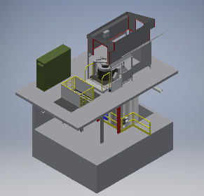
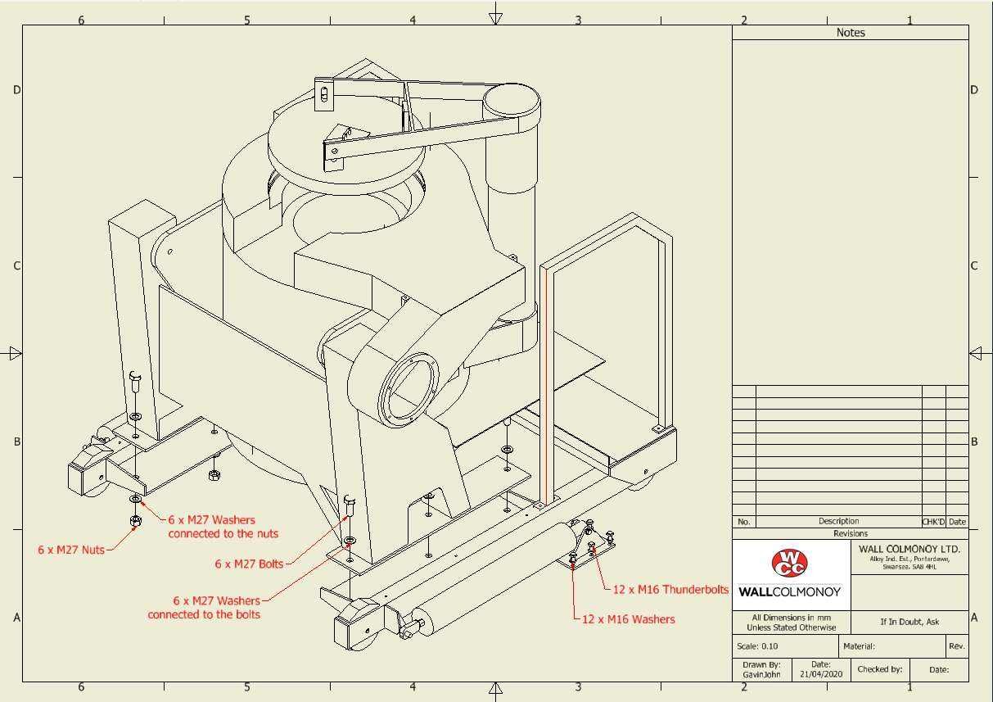

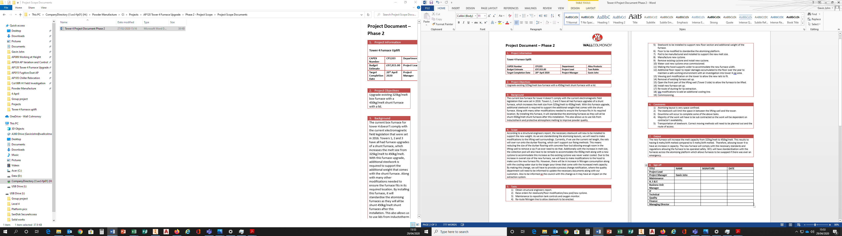
Appendix C: Project Justification

Appendix D: Timing Plan
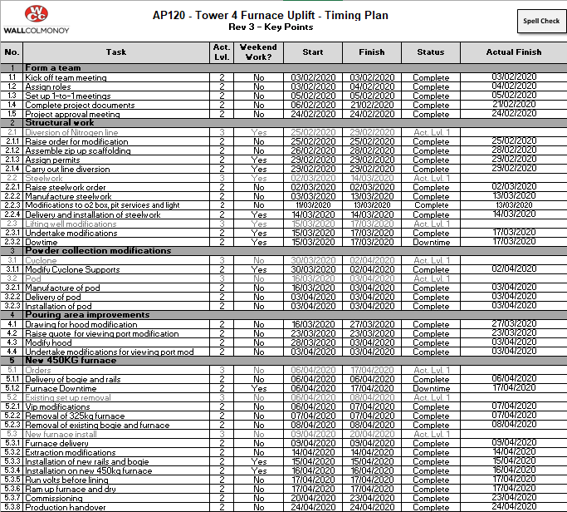
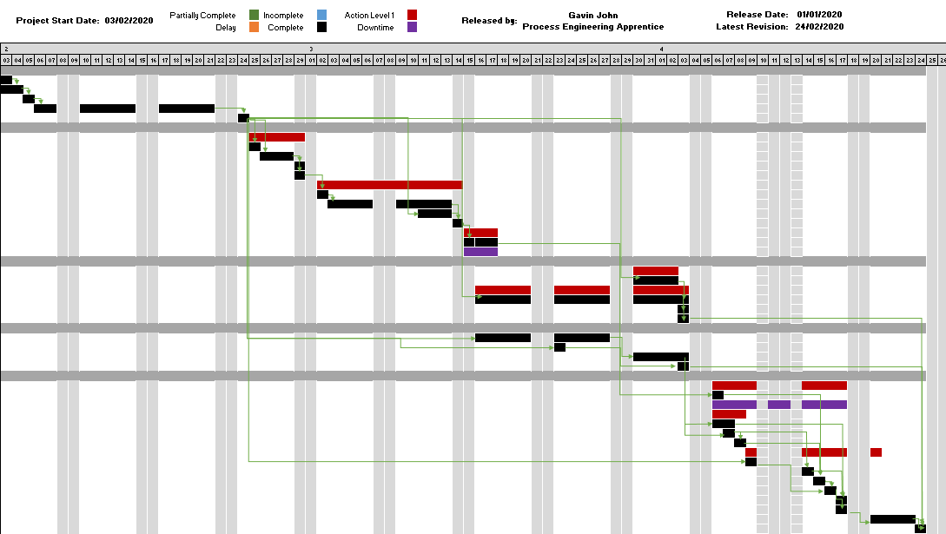

Appendix E: Spend Control Document

Appendix F: Project Action Tracker

