

Managing Enterprise in the 21st Century

Business Plan
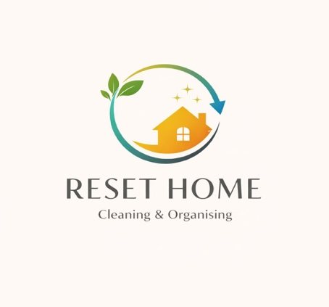
VALDICE CRISTINA ALBUQUERQUE SOUSA
2435221

Submission Date: 30 March 2026
Lecturer: Dr Charles Oham

Table of Contents
Executive Summary 4
Business Concept 5
Business Description 5
Product Description 5
Business Objectives (SMART Objectives) 5
Short-Term Objectives (less than a year) 5
Long-Term Objectives (More than a year) 5
Market Analysis and Marketing Plan 6
Market Analysis (Competitors, Customers, Target Groups) 6
PESTEL Analysis 6
SWOT Analysis 6
Marketing Mix (4Ps) 6
Management Team 7
Management Team and Their Background 7
Organisational Chart 7
Key Milestones 7
Financial Plan (One Year) 8
Sources of Finance 8
Cash Flow Forecast 8
Sales Forecast 8
Cost of Production Forecast 8
Break Even Analysis 8
Operations and Management Plan 9
Production of Good and Service 9
Technology Plan 9
Human Resource Plan 9
Expansion Plan 9
Reference List 10
Appendices: 11

Executive Summary

This business plan outlines a cleaning and home organising service aimed at residential clients. The business will provide regular and one-off services, focusing on high-quality cleaning and personalised organisation solutions.
The business operates as a mobile service, reducing overhead costs and allowing flexibility. Prices are based on an average hourly rate of £20, within the UK market range.
The financial forecast shows steady growth, with expected monthly income increasing from approximately £1,000 in the first month to over £3,000 as the client base expands.
The business will initially be managed by the owner, with additional staff support introduced from month 6 as demand increases.
The goal is to build a strong base of regular clients and gradually expand the business through quality service and customer satisfaction.

Business Concept

My business idea is to start a cleaning and home organising service. The purpose of this business is to help busy people keep their homes clean, comfortable, and organised. Many people work long hours and do not have enough time to clean or organise their homes properly.

This business will offer professional cleaning services together with home organising support. Cleaning focuses on hygiene and keeping the home environment healthy. Organising services focus on improving how items are arranged and stored in the home.

By combining cleaning and organising services, the business will help clients create homes that are cleaner, more organised, and easier to maintain.

Business Description
This Reset Home Co. will operate as a residential cleaning and home organising service. The business will be owned and managed by me Valdice Albuquerque. I have more than five years of experience working in the cleaning industry. During this time, I have worked in different environments, including residential homes and commercial buildings. This experience helped me develop strong cleaning skills, attention to detail, and knowledge of hygiene standards.
I have experience with regular cleaning, deep cleaning, and maintaining high standards of cleanliness in professional environments.
At the beginning of the business, I will work together with my sister-in-law Daiane Vilela, who will help with the daily cleaning services.
Daiane also has experience with domestic cleaning and maintaining organised homes. She understands household routines and how to keep living spaces clean and tidy.
Working together will allow the business to serve more clients while maintaining good service quality and reliability.

The target customers are:
• Busy professionals
• Families with children
• Elderly people who need support
The business will focus on:
• High hygiene standards
• A colour-coded cleaning system
• Attention to detail
• Professional and trustworthy service

As the client base grows, the company plans to hire additional employees while maintaining service quality and strong customer relationships

Product Description
The business will offer three main services:
1 Regular Cleaning
This service is for weekly or fortnightly clients. It includes:
• Dusting
• Hoovering
• Mopping
• Bathroom cleaning
• Kitchen cleaning
• Surface disinfecting
This service helps maintain a clean and organised home.

2 Deep Cleaning (One-Off Service)
Deep cleaning is a more detailed service. It is usually requested:
• Before moving in or out
• After renovation
• For first-time clients
• When a home needs extra care
It may include:
• Inside kitchen appliances
• Inside cupboards (if requested)
• Detailed bathroom cleaning
• Skirting boards
• Hard-to-reach areas

Deep cleaning takes more time and costs more than regular cleaning.

3 Home Organising Service
The Home Organising Service helps clients create more organised and functional living spaces. Many homes accumulate unnecessary items over time. This can create clutter and make daily life more difficult. The organising process usually starts by identifying items that are no longer needed. After that, the remaining items are sorted into categories.
This service includes:
• Wardrobe organisation
• Pantry organisation
• Decluttering
• Storage organisation

This service can be offered separately or together with cleaning.

Business Objectives (SMART Objectives)

Short-Term Objectives (less than a year)

1. To gain at least 15 regular clients within the first 12 months.
2. To offer competitive prices for services. Estimated prices may include:

* Regular cleaning: £18 – £22 per hour
* Deep cleaning: £120 – £180 depending on the size of the property
* Home organising service: £20 – £25 per hour

3. To promote the business through social media, local advertising, and word-of-mouth recommendations.
4. To receive positive customer feedback and reviews during the first year.
These objectives will help the business build a stable client base.

Long-Term Objectives (More than a year)

The long-term objectives focus on growing the business and increasing the number of clients.
1. To increase the number of regular clients to around 30 clients within three years.
2. To hire additional employees when the business reaches about 25 regular clients or becomes fully booked on a regular basis.
3. To offer service packages that combine cleaning and organising services for busy families.
4. The growth of the business will be supported by competitive prices based on the local market. In the UK, domestic cleaning services usually cost between £18 and £25 per hour. Reset Home Co. will offer prices within this range to stay competitive while maintaining good service quality.
5. The business will also grow through social media promotion, customer recommendations, and reliable service.

Market Analysis and Marketing Plan

Market Analysis (Competitors, Customers, Target Groups)

Describe your marketing approach
The market for cleaning and organising services can be divided into different groups.
Instructions:
- Market Segmentation
  - Demographic: My main customers are adults between 25–55 years old. They are working professionals or families with stable income.
  - Geographic: The business will operate in the local area in the UK, focusing on residential homes.
  - Psychographic: Customers who value a clean, organised and comfortable home. They prefer convenience and are willing to pay for services that save time.
- Targeting
  - Select your primary audience: Busy professionals and families who do not have time to clean or organise their homes.
  - This group is a good target because:
• They have less time
• They need regular services
• They can afford to pay for help

The business will focus on building long-term relationships with these customers.
- Positioning
  - Reset Home Co. will position itself as:
A reliable, professional, and friendly cleaning and organising service that helps customers feel comfortable and stress-free in their homes.
  - The business will stand out by:
• Offering both cleaning and organising services
• Using a colour-coded cleaning system
• Providing personalised service
• Building trust with clients
- Reaching Your Audience
  - Channels and Tactics: The business will use social media such as Instagram and Facebook to promote services and show before-and-after results. WhatsApp will be used to communicate with clients quickly and easily. Word of mouth will also be important to attract new customers through recommendations.
  - Promotion Strategy: The business will offer discounts for regular customers to build loyalty. It will also focus on providing high-quality service to encourage referrals. Posting results on social media will help attract new clients and build trust.

PESTEL Analysis- RESET HOME.CO
FACTOR | IMPACT ON THE BUSINESS
POLITICAL | Government rules can affect small businesses. Self-employed workers must pay taxes and national insurance. (GOV.UK, 2023).  Strategy: The business will ensure all taxes and legal requirements are followed correctly. It will stay updated with government regulations to avoid legal problems.
ECONOMIC | The economy affects how much people spend on services. In UK cleaning services usually cost between £15 and £25 per hour (Checkatrade,2023).  Strategy: The business will offer competitive prices and flexible services to attract customers, even during economic downturns.
SOCIAL | Many people in the UK have busy lifestyles and limited free time due to work and daily responsibilities (ONS, 2023).  Strategy: The business will promote its services as a time-saving solution and focus on busy professionals and families.
TECHNOLOGICAL | Technology helps promote the business. Social media platforms are widely used for communication and marketing (Statista, 2023).  Strategy: The business will use social media such as Instagram and Facebook to advertise services and communicate with customers.
ENVIROMENTAL | Many customers prefer eco-friendly cleaning products and services (Statista, 2023).  Strategy: The business will offer eco-friendly cleaning options to attract environmentally conscious customers.
LEGAL | Cleaning businesses must follow health and safety regulations when using cleaning products (HSE, 2023).  Strategy: The business will follow safety guidelines and use cleaning products correctly to protect workers and customers.

STRENGTHS | - The business owner has more than five years of experience in the cleaning industry, which helps maintain high cleaning standards and good service quality.  - The company offers both cleaning and home organising services, which creates additional value for customers.  - Personal service and attention to detail can help build strong relationships with customers.
WEAKNESSES | - The business is new and may take time to build a strong reputation and customer base.  - The business starts with a small team, which may limit the number of clients at the beginning.  - Limited financial resources may make marketing and expansion slower at the beginning.
OPPORTUNITIES | - Many people have busy lifestyles and prefer to hire cleaning services to save time.  - The demand for organised homes is increasing, which creates opportunities for home organising services.  - Social media marketing can help the business promote services and attract new clients at low cost.
THREATS | - There is strong competition from other cleaning companies and self-employed cleaners.  - Economic changes may reduce spending on cleaning services in some households.  - Customer expectations are high, and poor service could damage the company’s reputation.

SWOT Analysis

Marketing Mix (4Ps)
Reset Home Co.

-Product (Service)
The business offers cleaning and home organising services. This includes regular cleaning, deep cleaning, and organising spaces such as kitchens, wardrobes, and storage areas. The service uses a colour-coded cleaning system to ensure hygiene and safety.
-Price
The business will charge competitive prices based on the UK market, around £15 to £25 per hour (Checkatrade, 2023). Discounts will be offered for regular customers to encourage long-term relationships.
-Place
The services will be provided at customers’ homes in the local area in the UK. The business will focus on residential properties and offer flexible scheduling to meet customer needs.
-Promotion
The business will promote its services through social media platforms such as Instagram and Facebook, as well as word of mouth. It will also use before-and-after photos to attract customers and build trust. Discounts and special offers will be used to attract new clients and retain existing ones.

Management Team
The business is owned and managed by Valdice Cristina Albuquerque Sousa, who is responsible for overall operations, customer service, and business management.
The business will also include Daiane Vilela, who supports cleaning and home organising services and is responsible for training and supporting new staff.
In addition, Junior Vilela will support the business with marketing and promotion activities, including social media and customer engagement.
As the business grows, new cleaners and organising assistants will be hired to support operations and expand the services.

Management Team and Their Background
Valdice Cristina Albuquerque Sousa has over 5 years of experience in cleaning services, including residential and commercial cleaning. She has strong attention to detail and understands customer needs.
Daiane Vilela has experience in cleaning and organising and will support daily operations, ensuring high-quality service and helping train new staff.
Junior Vilela has completed courses in marketing and has previous experience in this area. He will support the business with marketing and promotion, including social media management and customer communication.

Organisational Chart

Cleaning and Organizing Business

Key Milestones
These milestones show how the business will grow over time and achieve its objectives.
-Month 1–3
Start the business and gain the first clients through social media and word of mouth.

-Month 3–6
Build a small client base and begin offering both cleaning and organising services.

- Month 6–12
Reach 10–15 regular clients and receive positive customer feedback.

- End of Year 1
Maintain a stable number of regular clients and recover initial costs.

- Year 2
Increase the number of clients and hire one additional cleaner when the business becomes fully booked.

Financial Plan (One Year)

Sources of Finance
The business will be funded through personal savings and existing assets. An initial investment of £300 from personal savings will be used to purchase essential equipment such as cleaning materials and uniforms. In addition, existing household resources valued at approximately £200 will support the business operations. No external loans are required at this stage.

Cash Flow Forecast

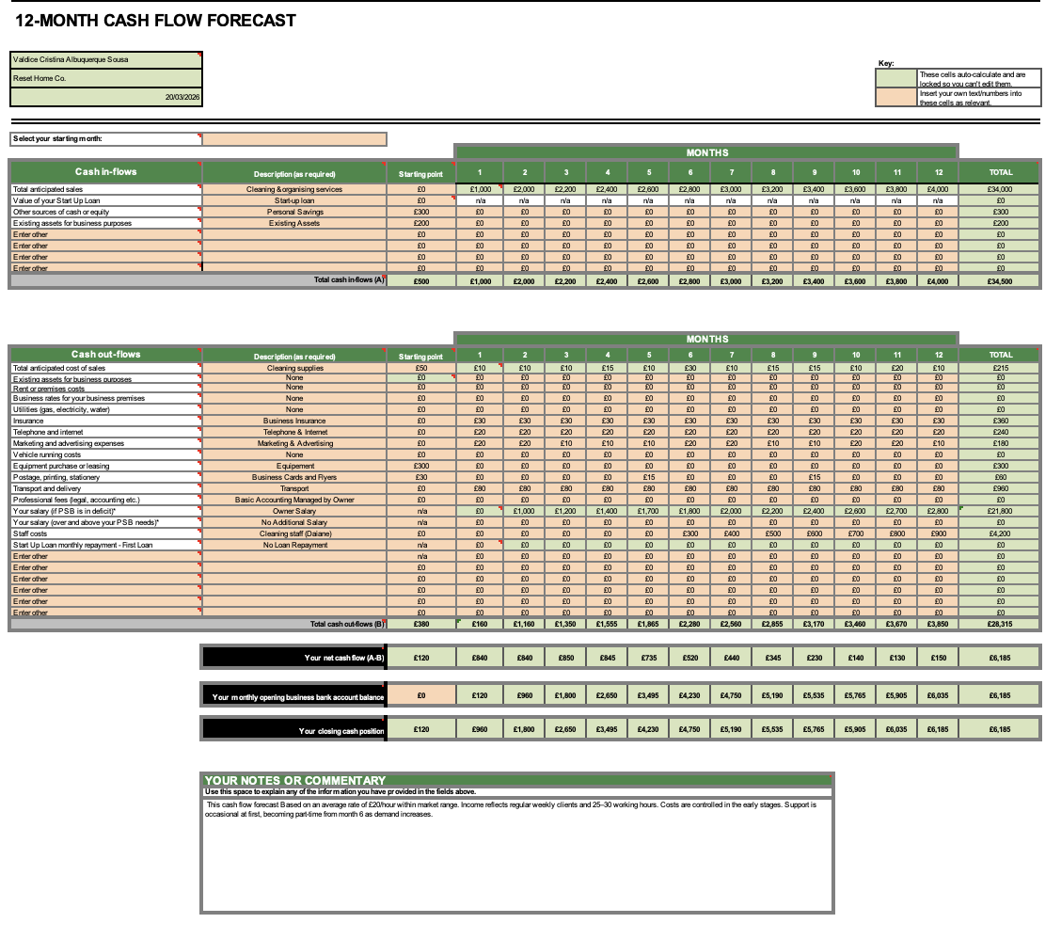

Sales Forecast
The sales forecast is based on an average hourly rate of £20, which is within the typical market range of £15 to £25 per hour. The business is expected to work approximately 25–30 hours per week, generating between £2,000 and £4,000 per month as the number of clients increases. This growth reflects the high demand for cleaning services and the development of a regular client base.

Cost of Production Forecast
The cost of production includes cleaning supplies, transport, communication, and basic operational expenses.
Costs are kept low in the early stages, as many clients provide their own cleaning products. Initial costs are higher in the first month due to equipment purchases.
Transport is a key ongoing expense, estimated at approximately £80 per month. Marketing and communication costs remain minimal, using low-cost strategies such as social media.
Staff costs are introduced from month 6 as the business grows and client demand increases.

Break Even Analysis
The break-even point is estimated at approximately 7–8 cleaning services per month. This is based on average monthly costs of around £500 and an average service price of £60–£70.
Once this level of activity is reached, the business will begin to generate profit. Due to the high demand for cleaning services, this level is expected to be achieved early in the business.

Operations and Management Plan

The business will provide cleaning and home organising services to residential clients. Cleaning focuses on hygiene, while organising improves space and functionality through decluttering and practical storage solutions.

Services are tailored to each client and can be regular (weekly or bi-weekly) or one-off. The process includes understanding client needs, planning, and delivering efficient and high-quality results.

The business will be managed by the owner, with support introduced as demand increases. From month 6, a part-time staff member will assist with service delivery.

Basic supplies will be available if needed, and a colour-coded system will be used to ensure hygiene. The business aims to grow by building long-term client relationships and maintaining high standards.

Production of Good and Service
The business will use simple and cost-effective technology to support daily operations. This includes the use of a smartphone for communication with clients, scheduling appointments, and managing bookings.
Social media platforms such as Instagram and Facebook will be used for marketing and customer engagement. Online messaging apps will be used to maintain direct communication with clients.

Technology Plan
The business will use simple and cost-effective technology to support daily operations. This includes the use of a smartphone for communication with clients, scheduling appointments, and managing bookings.
Social media platforms such as Instagram and Facebook will be used for marketing and customer engagement. Online messaging apps will be used to maintain direct communication with clients.

Human Resource Plan
The business will initially be managed by the owner, who will be responsible for delivering services, managing clients, and handling daily operations.
In the early stages, additional support will be provided on a flexible basis when required. From month 6, an additional staff member will be employed to support the growing number of clients.
Staff responsibilities will include cleaning services, organising tasks, and maintaining service quality

Expansion Plan
The business aims to expand gradually by increasing the number of regular clients and extending service areas.
As demand grows, additional staff will be recruited to maintain service quality and efficiency. Future growth may include offering specialised organising services and expanding into new locations.

Conclusion
In conclusion, this business plan demonstrates a viable and realistic cleaning and home organising service with strong potential for growth. The financial forecast shows increasing income as the client base expands, while costs remain controlled. With a focus on quality service and customer satisfaction, the business is well-positioned to succeed and grow over time.

Reference List

Checkatrade (2023)
Average cost of cleaning services in the UK. Available at: https://www.checkatrade.com (Accessed: 17 March 2026).

GOV.UK (2023)
Self-employment and tax responsibilities. Available at: https://www.gov.uk (Accessed: 17 March 2026).

Health and Safety Executive (HSE) (2023)
Working safely with cleaning products. Available at: https://www.hse.gov.uk (Accessed: 17 March 2026).

Office for National Statistics (ONS) (2023)
Time use in the UK. Available at: https://www.ons.gov.uk (Accessed: 17 March 2026).

Statista (2023)
Social media usage and consumer behaviour in the UK. Available at: https://www.statista.com (Accessed: 17 March 2026).

Appendices:

Appendix 1: Market Research
Appendix 2: PESTEL Analysis
Appendix 3: SWOT Analysis
Appendix 4: Cash Flow Forecast
Appendix 5: Services Overview

