Title Page
University of Wales Trinity Saint David.
School of Engineering
Title of the coursework: FEA and Numeric Analysis and Comparison of Connecting Rods from a Car and a Motorcycle.
Your Name: Loaghan Slade
Your Student Number: P151151
Date: 07/03/2020
Module Name and Code: Major Project, M6X00417
Lecturer’s name: Dr. Owen Williams

Abstract
This report seeks to compare the design characteristics and operating conditions of two connecting rods, one is taken from a Triumph Daytona 675r, the other is taken from a Ford Sigma 1.6L. To find critical information to compare between the two rods they are modelled in a computer aided design suite, the models then have a finite element analysis study carried out on them under motion loads calculated from real-world pressure data. In addition to a computational approach the rods are also analysed at key locations to provide more detailed analysis where required. The results of each study can then be compared to ascertain any design considerations made to optimise the rods for their particular usage and purpose.
Contents
Abstract II
1 Introduction. 1
2 Data Collection, Calculation, and Simulation. 2
2.1 Engine 1, Ford Sigma 1.6L 2
2.2 Engine 2, Triumph Daytona 675R 2
2.3 Connecting Rod Dimensions 3
2.4 Force and speed Calculations 4
2.4.1 Revolution Speed 4
2.4.2 Time Taken Per Degree Travelled 4
2.4.3 Average pressure 5
2.4.4 Gas Force 5
2.4.5 Inertia Force 5
2.4.6 Rod Masses 6
2.4.7 First Order Inertia Force 7
2.4.8 Second Order Inertia Force 7
2.4.9 Combined Inertia Force 7
2.4.10 Net Force 8
2.4.11 Connecting Rod Angle 8
2.4.12 Connecting Rod Force 8
2.5 Further Calculations and Simulation 9
2.5.1 Simulation 9
2.5.2 Clearance Volume 9
2.5.3 Piston Displacement 10
2.5.4 Simulated Volume 10
2.5.5 Polytropic Index 10
2.5.6 Simulated Pressure 11
2.5.7 Wiebe Function 11
2.5.8 Combustion Pressure 11
2.5.9 Further Calculations 12
2.5.10 Side and Friction Force 12
2.5.11 Radial and Radial Friction Force 12
2.5.12 Work Done and Work Loss Due to Friction 13
3 Finite Element Analysis* 13
3.1.1 What is FEA and How Does it Work? 14
3.1.2 Why Use FEA? 14
3.2 Methodology 15
3.2.1 Preparation 15
3.2.2 CAD Modelling 15
3.2.3 Material Allocation 18
3.2.4 Motion Simulation 19
3.2.5 FEA Process 20
3.3 FEA Results 21
4 Numerical Analysis 27
4.1 Connecting Rod Forces 27
4.1.1 Acceleration 27
4.1.2 Inertia Force 28
4.1.3 Second Moment of Area 31
4.1.4 Connecting Rod Forces 32
4.2 Gudgeon Pin Stress Calculations 32
4.2.1 Net Bending Moment 32
4.2.2 Bending Stress 33
4.2.3 Shear Force and Stress 34
4.2.4 Combined Stress 34
4.2.5 Allowable Range of Stresses and Fatigue Safety Factor 34
4.3 Triumph Gudgeon Pin 35
4.4 Ford Gudgeon Pin 38
4.5 Key Point Stress Calculations 41
4.5.1 Compressive Stress 42
4.5.2 Tensile Stress 43
4.5.3 Triumph Point A 43
4.5.4 Ford Point A 45
4.5.5 Triumph Point B 46
4.5.6 Ford Point B 48
4.5.7 Triumph Point C 49
4.5.8 Ford Point C 51
4.6 Buckling Loads 52
4.6.1 Triumph Buckling Load 53
4.6.2 Ford Buckling Load 54
5 Comparisons 55
5.1.1 FEA Comparison 55
5.1.2 Calculated Comparison 56
6 Conclusion 56
7 Recommended Further Work 57
8 Works Cited 58
8.1 Figures 63
8.2 Equations 64
8.3 Acknowledgements 67

Introduction.
The aim of this project is to compare connecting rods used in car and motorcycle engines in order to highlight any differences in design due to forces acting on the piston while the engine is running. The vehicles used are a Triumph Daytona 675R, and a Ford Sigma 1.6. In order to fully understand the forces and stresses acting on each connecting rod, Finite Element Analysis (FEA) as well as numerical analysis will be carried out. Real-world data will be used wherever possible to maintain the accuracy of the study. The primary point of interest is how inertia loads due to the higher engine speed of the motorcycle will affect the design of the connecting rod. The analysis for this project is carried out using data gathered from both vehicles at the highest RPM available, these are 6000RPM for the Ford, and 14400RPM for the Triumph.
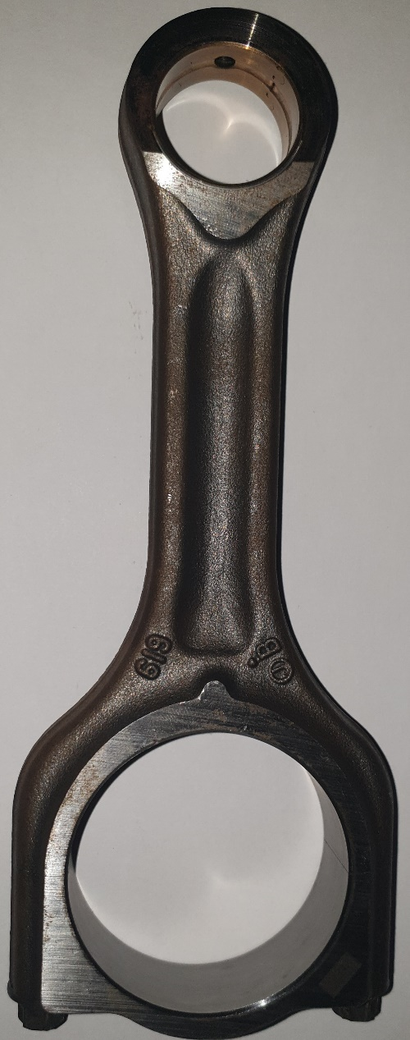 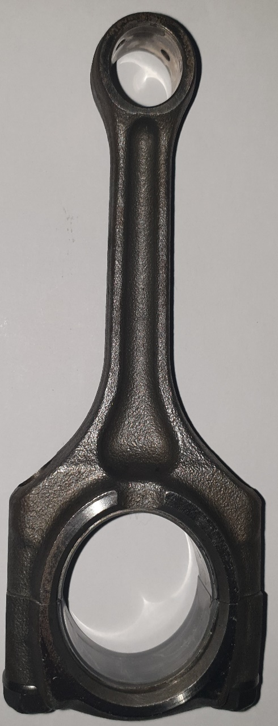 Figure 1 Ford Connecting Rod Figure 2 Triumph Connecting Rod

Data Collection, Calculation, and Simulation.
Before any analysis can be carried out the specifications of both connecting rods must be known, as well as the forces acting on them and other information needed for specific aspects of the analysis. The first step towards calculating forces and stresses is to create profiles for each engine containing all the required information with constant values.

Engine 1, Ford Sigma 1.6L
Ford
Ignition |  | Cylinder |  | Piston mass (Kg)
MFB% | CA_DEG | Bore (m) | 0.079 | conrod | 0.456
0 | -8 | Stroke (m) | 0.0814 | conrod cap | 0.117
2 | -6.066 | Con Rod (m) | 0.1865 | conrod bolts | 0.013
5 | -1.731 | Crank Rad (m) | 0.0278 | conrod assembly | 0.587
10 | 1.476 | Cross-section (m^2) | 0.00013626 | Gudgeon pin | 0.195
50 | 13.911 | Piston ring height (m) | 0.0012 | Piston | 0.421
90 | 28.811 | piston ring diameter (m) | 0.076 | piston ring | 0.022
100 | 40 | piston ring thickness (m) | 0.0015 | circlip | 0.001
B_DUR | 48 | Lambda | 0.9 | assembly | 0.629
friction |  | CR | 11.16 | total | 1.216
skirt | 0.1 | R/L | 0.149 | M rec | 0.825
O-ring | 0.1 | R^2/L^2 | 0.022 | M rot | 0.587
 |  | R+L | 0.214 | M rec (g) | 824.923
 |  |  |  | M rot (g) | 586.660
Figure 3 Ford Sigma 1.6L Engine Information (Motrolix, 2020)

Engine 2, Triumph Daytona 675R
Triumph
Ignition |  | Cylinder |  | Piston mass (Kg)
MFB% | CA_DEG | Bore (m) | 0.076 | conrod | 0.198
0 | -59 | Stroke (m) | 0.0523 | conrod cap | 0.108
2 | -13 | Con Rod (m) | 0.144 | conrod bolts | 0.018
5 | -8 | Crank Rad (m) | 0.025 | conrod assembly | 0.324
10 | -4 | Cross-section (m^2) | 0.00013626 | Gudgeon pin | 0.07
50 | 10 | Piston ring height (m) | 0.0012 | Piston | 0.286
90 | 22 | piston ring diameter (m) | 0.076 | piston ring | 0.015
100 | 37 | piston ring thickness (m) | 0.0015 | circlip | 0.001
B_DUR | 50 | Lambda | 0.9 | assembly | 0.365
friction |  | CR | 12.7 | total | 0.689
skirt | 0.1 | R/L | 0.174 | M rec | 0.473
O-ring | 0.1 | R^2/L^2 | 0.030 | M rot | 0.324
 |  | R+L | 0.169 | M rec (g) | 473.103
 |  |  |  | M rot (g) | 323.650
Figure 4 Triumph Daytona 675R Engine Information (Motorcycle Specs, 2020)

Connecting Rod Dimensions
The same measurements were taken from both connecting rods. These measurements were acquired using a set of digital Vernier Callipers with a stated accuracy to 0.01mm. Each individual part was also weighed using scales with a stated accuracy of 0.01g.
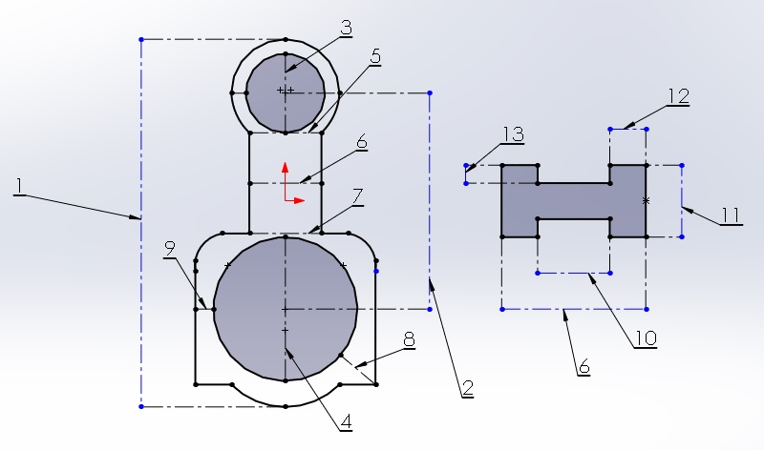
Figure 5 Connecting Rod Dimension Diagram
Triumph |  |  |  | Ford
Location | Value | Units |  | Location | Value | Units
1 | 143.61 | mm |  | 1 | 186.5 | mm
2 | 104.68 | mm |  | 2 | 136.9 | mm
3 | 15.83 | mm |  | 3 | 26.01 | mm
4 | 32.96 | mm |  | 4 | 50.25 | mm
5 | 14.28 | mm |  | 5 | 25.21 | mm
6 | 15.67 | mm |  | 6 | 26.61 | mm
7 | 58.12 | mm |  | 7 | 71.83 | mm
8 | 11.49 | mm |  | 8 | 13.09 | mm
9 | 12.95 | mm |  | 9 | 10.81 | mm
10 | 6.51 | mm |  | 10 | 9.95 | mm
11 | 9.56 | mm |  | 11 | 14.78 | mm
12 | 3.96 | mm |  | 12 | 7.24 | mm
13 | 3.63 | mm |  | 13 | 3.4 | mm
Figure 6 Triumph Connecting Rod Dimensions Figure 7 Ford Connecting Rod Dimensions

Triumph |  |  |  | Ford
Part | Value | Units |  | Part | Value | Units
Gudgeon Pin | 0.064 | KG |  | Gudgeon Pin | 0.186 | KG
Piston | 0.286 | KG |  | Piston | 0.421 | KG
Piston Rings | 0.015 | KG |  | Piston Rings | 0.022 | KG
Rod Top | 0.198 | KG |  | Rod Top | 0.456 | KG
Rod Bottom | 0.108 | KG |  | Rod Bottom | 0.117 | KG
Rod Bolts | 0.018 | KG |  | Rod Bolts | 0.013 | KG
Figure 8 Triumph Piston Mass Figure 9 Ford Piston Mass

Force and speed Calculations
Using pressure data collected during real-world testing of each vehicle the forces acting on the connecting rods can be calculated. The data sets used for each vehicle are from the peak RPM values for each vehicle; these are 6000 RPM for the Ford and 14400 RPM for the Triumph. The data used consists of two complete revolutions, from -360 degrees to +360 degrees.

Revolution Speed
The speed at which the engine is rotating is given in Revolutions Per Minute (RPM). For the revolution speed to be used it must first be converted to radians per second. This is done by multiplying the initial number by 2 pi and dividing the result by 60. This is because 1 revolution is described as 2 pi radians, and there are 60 seconds in a minute. (The Engineering Tool Box, 2020)
$${Rad}/s=\frac{2π×RPM}{60}$$
Equation 1 RPM to Radian per Second Conversion

Time Taken Per Degree Travelled
The time taken for the crankshaft to travel through one degree is found by first finding the time taken for 1 full revolution; this is done by dividing the current RPM by 60 to find revolutions per second, then dividing 1 by the result, this is then divided by 360 to find time taken per degree of crank travel.
$$Revolution per second= \frac{RPM}{60}$$
Equation 2 Revolutions Per Second
$$Time per revolution= \frac{1}{Revolutions per second}$$
Equation 3 Time Per Revolution
$$Time per degree of crank travel= \frac{Time per revolution}{360}$$
Equation 4 Time Taken Per Degree of Crank Travel

Average pressure
Pressure information is gathered for each individual cylinder. In order to have a single representative value for the pressure acting across all cylinders an average is taken, this gives one number to represent all cylinders.
$$Average pressure for Ford engine= \frac{P_{Cylinder 1}+P_{Cylinder 2}+P_{Cylinder 3}+P_{Cylinder 4}}{4}$$
Equation 5 Ford Average Cylinder Pressure
$$Average pressure for Triumph engine=\frac{P_{Cylinder 1}+P_{Cylinder 2}+P_{Cylinder 3}}{3}$$
Equation 6 Triumph Average Cylinder Pressure
The data gathered in testing gives results in BAR, this needs to be converted to $N/{m^{2}}$ , 1 BAR is equal to 10,000 $N/{m^{2}}$. To convert from readings given to SI (Systeme Internationale) units simply multiply the given value by 10,000. (Metric Conversions, 2020)
$$1 BAR=10000N/{m^{2}}$$
Equation 7 Bar to Newton per Square Metre Conversion

Gas Force
To be able to calculate the net force acting on the connecting rod it is essential to find the gas force acting on the piston. The gas force is simply the pressure acting on the cylinder multiplied by the area over which it is acting. (Parks, 2018)
$$Gas Force= P_{Average}×\frac{π×{Bore}^{2}}{4}$$
Equation 8 Gas Force Equation

Inertia Force
The inertia force acting on the engine consists of two separate forces; these are first and second order inertia forces. The separate inertia forces generated by the engine are created by the rotating and reciprocating masses created by the piston as the engine fires and rotates. The first order inertia force is synchronised with the crankshaft of the engine, and as such, there is 1 peak per revolution. Second order inertia forces act at twice the frequency of the first order forces. (Cartecc, 2020). These forces acting on the engine are responsible for the need for balance shafts to reduce or eliminate the resultant vibration caused by these forces.

Figure 10 First and Second Order Inertia Forces

Rod Masses
The mass of the rod acting on the engine is separated into two parts, the rotating mass, and the reciprocating mass. This is due to not all of a piston rotating; the piston head does not rotate it instead reciprocates within the cylinder bore, much like the “big end” of the rod which rotates around the crank shaft. These masses are calculated from measured masses found for each individual component that makes up the full piston assembly. (EPI Inc, 2014)
$$M_{rec}=piston mass+gudgeon pin mass+\frac{1}{3}rod mass$$
Equation 9 Piston Reciprocating Mass
$$M_{rot}=\frac{2}{3}×rod mass$$
Equation 10 Piston Rotating Mass

First Order Inertia Force
The first order inertia force is synchronised with the crank shaft. Due to this the force peaks at Top Dead Centre (TDC) and the lowest value is found at Bottom Dead Centre (BDC), therefore the inertia force is directly related to the crank angle denoted as θ. (Zhifeng Xie, 2018)
$${First order Inertia Forces=M}_{Piston}×R×ω^{2}\cos{θ}$$
Equation 11 First Order Inertia Force

Second Order Inertia Force
The second order inertia force acts in the same way as the first order inertia force, however it has a lower magnitude but twice the frequency. The peak forces act at -360 degrees (TDC) , -180 degrees (BDC), 0 degrees (TDC), +180 degrees (BDC), and +360 degrees (TDC) for this study. (Feng Yu, 2019).
$$Second Order Inertia Force=\frac{R}{L}×M_{Piston}×R×ω^{2}×\cos{2 (θ) }$$
Equation 12 Second Order Inertia Force

Combined Inertia Force
Once first and second order inertia forces have been calculated they must be combined to find the total inertia force acting on the piston. The forces are combined by multiplying the sum of the first and second order forces by the total mass of the piston. (Dung Viet Nguyen, 2018)
$$Combined Inertia Force=\left(First order force+Second order force\right)×Piston mass$$
Equation 13 Combined Inertia Force
Figure 11 Combined Inertia Forces

Net Force
Because the gas force acts counter to the inertia force it is necessary to establish the net force acting on the piston. This can be calculated by subtracting the combined inertia force from the gas force. (A.L. Guzzomi D. H., 2007)
$$Net Force=Gas force-Combined Inertia Force$$
Equation 14 Net Force

Connecting Rod Angle
The connecting rod angle is the angle at which the connecting rod is attached to the Gudgeon pin. This changes as the piston reciprocates as a result of the rotation of the crank shaft. The angle is found by taking the inverse sin of the stroke, which is found by dividing the radius of the crankshaft by the length of the connecting rod, then multiplying this value by crank angle. (University C. , 2020)
$$Connecting Rod Angle= \sin^{-1}{\frac{R}{L}×\sin{Crank Angle}}$$
Equation 15 Connecting Rod Angle

Connecting Rod Force
As the inertia force and gas forces act in a vertical direction, the force is wholly translated into the connecting rod, it acts at the connecting rod angle. The connecting rod force is found by dividing the net force by the cosine of the rod angle. (Hailemariam Nigus, 2015)
$$Connecting Rod Force= \frac{Gas Force-Inertia Force}{\cos{Rod Angle}}$$
Equation 16 Connecting Rod Force
The connecting rod force is used to calculate the nominal forces and stresses acting on the connecting rod. The maximum and minimum values for each of these is used in further calculations.
Ford
Maximum net compressive force | 13662.09
Maximum net tensile force | 32947.71
Figure 12 Ford Maximum Compressive and Tensile Forces
Triumph
Maximum net compressive force | 15800.96
Maximum net tensile force | 33371.03
Figure 13 Triumph Maximum Compressive and Tensile Forces

Further Calculations and Simulation
While no further calculations are required to provide the basis for analysis, they can be completed to give other useful information that can be used in other methods of analysis. Using the same equations it is possible to create a simulator from the polytropic index and information that is readily available from any number of online sources or from workshop manuals.

Simulation
As all the previous calculations have been based on pressure data gathered from real-world testing once a method of simulating pressure accurately has been found the further calculations do not change.

Clearance Volume
The clearance volume of the cylinder is constant and represents the minimum volume of a cylinder. This can be found from a variety of sources or calculated from the compression ratio and the swept or total volume of the cylinder; this is found using the formula for volume of a cylinder, where bore represents the diameter and stroke represents the height. (Richard Gentle, 2001)
$$Swept Volume= \frac{π}{4}×{Bore}^{2}×Stroke$$
Equation 17 Swept Cylinder Volume
Once the swept volume and compression ratio are known it is possible to calculate the clearance volume.
$$Compression ratio= \frac{Clearance volume+Swept Volume}{Clearance volume}$$
Equation 18 Compression Ratio
$$Clearance volume=\frac{Swept Volume}{Compression ratio-1}$$
Equation 19 Clearance Volume

Piston Displacement
The piston displacement represents the distance the piston has travelled at any point. This will also give the height of the cylinder at every crank angle. This can be calculated using information that can be found easily. (P.L.DHAR, 2017)
$$Displacement=crank radius×\left(1-\cos{crank angle}\right)+conrod length×\left(1-\sqrt{1-\frac{{crank radius}^{2}}{{conrod length}^{2}}\sin^{2}crank angle}\right)$$
Equation 20 Piston Displacement

Simulated Volume
The volume of the cylinder can be calculated if all of the variables for volume of a cylinder are known. As the bore represents the diameter of the cylinder and the piston displacement represents the height, all variables are known. Because the clearance volume of the cylinder is constant the change in volume is an increase from this baseline. (G.F. Hundy, 2016)
$$simulated vloume=clearance volume+\left(\frac{π×{bore}^{2}}{4}×displacement\right)$$
Equation 21 Simulated Cylinder Volume

Polytropic Index
The polytropic index is needed to calculate cylinder pressure, often denoted as “n” it provides insight into the polytropic process occurring within the cylinder. A process can be considered polytropic if it obeys the ideal gas law (PV=nRT), where Pressure times volume to the power of the polytropic index is constant. As the pressure is needed to calculate this value use of a set of values calculated from real-world data and imported into the simulator must be used. (Horedt, 2004)
$$n=\frac{log⁡(\frac{P_{1}}{P_{2}})}{log⁡(\frac{V_{2}}{V_{1}})}$$
Equation 22 Polytropic Index

Simulated Pressure
Initial pressure is considered atmospheric (1 BAR) and does not consider the increase in pressure due to combustion. As the change in pressure in an internal combustion engine is considered a polytropic process It is directly related to the initial pressure and change in volume. (Boyce, 2012)
$$P_{2}=P_{1}×(\frac{V_{1}}{V_{2}})^{N}$$
Equation 23 Pressure Simulation
While the pressure calculated does not take into account the further increase in pressure due to combustion, it can be used to provide an estimate of the forces acting through the piston.

Wiebe Function
The Wiebe function Is a method of predicting fuel mass fraction burned in internal combustion pressure. This is used to help calculate the increase in pressure due to combustion. This considers the burn duration, ignition delay, as well as two factors of the Wiebe function. The two additional factors of the Wiebe function are named Wiebe A, which is commonly represented by 5, and Wiebe M represented by 2. (Ghojel, 2010)
$$Wiebe function=1-EXP(\frac{- Wiebe A×(Crank Angle-Ingition Start)}{Burn duration})^{(Wiebe M-1)}$$
Equation 24 Wiebe Function
Before the start of combustion, the Wiebe function is considered to be 0 only changing during combustion to a maximum value of 1 after the combustion cycle has been completed.

Combustion Pressure
Using the factors calculated from the combustion process it is possible to account for them in the cylinder pressure, this will give the combustion pressure in the cylinder. However one final factor is needed, the thermal efficiency of the engine denoted by “γ” (Gamma). Gamma can be found in workshop manuals or from online sources. (Caton, 2018)
$$Combustion pressure=Simulated pressure+(Wiebe function×\frac{γ-1}{Simulated volume})$$
Equation 25 Combustion Pressure
Combustion pressure once calculated can be substituted into the simulator replacing data gathered from testing.

Further Calculations
As previously stated, it is possible to calculate further information that may be useful to provide additional insight into forces acting in the engine or the performance of the engine as a whole.

Side and Friction Force
The side force acting in the piston is sometimes referred to as “piston slap” caused by the rotation of the crankshaft inducing horizontal forces. Due to the force not acting vertically, a percentage is exerted horizontally, this force is a result of the tangent of the crank angle and the vertical force. (S.H. Cho, 2001). As there is direct contact between the piston and the cylinder wall there is a resultant friction force, the friction force is calculated from the coefficient of friction (μ) between the cylinder and the piston. The friction coefficient can be found from the materials used in the engine construction, a common value for this is 0.1 and has no units. (Pranav Nagar, 2011)
$$Side force=Net force×\tan{Crank angle}$$
Equation 26 Side Force
$$Side friction force= μ×Side force$$
Equation 27 Side Friction Force

Radial and Radial Friction Force
The radial force can be described as the contact force between the piston rings and the cylinder wall. As the pressure in the cylinder increases so too will the contact force between the piston rings and the cylinder wall. This is due to the increase in pressure between the piston and the rings forcing them to spread into the walls. The force is calculated as a result of the cylinder pressure and the area of the piston rings. The contact between the piston rings and cylinder wall will also have a resultant friction force found using the same equation as side friction force however substituting the side force with the radial force. (Chao Cheng, 2015)
$$Radial force=Cylinder pressure×(\left(π×Crank Diameter\right))×(Piston ring height))$$
Equation 28 Radial Force
$$Radial Friction force=μ×Radial force$$
Equation 29 Radial Friction Force

Work Done and Work Loss Due to Friction
Work is defined as the result of the force applied to an object and the distance that object is moved due to the force applied to it. To calculate the work done by a single engine cylinder the force acting on the piston is represented by the net force, and the distance is represented by the displacement. The same calculations are used to calculate the work lost through friction however the net force is replaced by the side friction force. (University P. , 2020). The power loss is calculated by subtracting the work lost through friction from the total work done by the piston.
$$Total work done=net force×displacement$$
Equation 30 Total Work done
$$Friction force=side friction force+radial friction force$$
Equation 31 Total Friction Force
$$Work lost through friction= friction force×displacement$$
Equation 32 Work Lost Through Friction
$$Net work done by the cylinder=Total work done- friction force$$
Equation 33 Net Work Done by the Cylinder

Finite Element Analysis*
The first comparison between the two connecting rods was completed using Finite Element Analysis (FEA). This will give an overview of how the forces acting through the connecting rod will affect it, and the results give insight into how to optimise the connecting rods to better fulfil their purpose.

What is FEA and How Does it Work?
Finite element analysis or FEA is a way to solve complicated engineering problems by making use of computers to simulate how the part they are analysing will react when certain boundary conditions and loads are applied to it. Analysis is carried out by dividing a model made in a computer aided design studio, in this case Solidworks, into a finite number of smaller elements. These elements have a relationship to the force and displacement that has been determined through calculation. This pre-defined relationship is then used to estimate the physical properties of the model such as stiffness and load distribution. In order to complete these calculations the forces acting on each element are put into matrix form and solved to determine the properties of the model as a whole. There are several different types of FEA the most common of these, and the one used in this study, is a linear elastic analysis. A linear elastic analysis makes the assumption that the model will behave elastically, and the forces are proportional to the stresses in a linear fashion. The study also assumes that the strains are small or negligible and the deformation will have no impact on the behaviour of the model. This method was selected as it provides a reasonable approximation of how the rod will behave. Other non-linear methods can be done though they require far more initial information, time, and computing power to run. These may be used when the linear solutions do not give an accurate representation of reality due to changes in the behaviour of the material or geometry of the part. (Femto, 2020)

Why Use FEA?
FEA is typically used to aid in the design process of new parts or products, it can also be used to help engineers analyse parts or products for use in projects or to isolate failure points. FEA is used to reduce the time and money it takes to physically test an item; it can even be used to fully eliminate physical testing if the simulation is deemed accurate enough. The implementation of FEA gives insight into the way the part will react under the boundary conditions set during testing. If these calculations were to be done by hand for the entire model it is unlikely that this form of testing would be carried out as the amount of uncertainty introduced through human error would likely render the results useless. This is due to the way the finite element method works; for each increase in element density the size of the matrix produced increases exponentially, as do the number of calculations needed and the time required to complete these calculations. (Baguley, 1994)

Methodology
The methodology used to complete a finite element analysis of both connecting rods is to first correctly and accurately measure both rods; the measurements are then used to accurately model the parts in a Computer Aided Design (CAD) suite. The forces that act on the rods or motion loads are then imported into the CAD design in a motion simulation which can finally extract any stresses, strains, and deformations that may occur during the simulated scenario. The motion loads are exported into the part being tested, the finite element method can then be implemented to show how these stresses, strains, and deformations will in theory affect the part.

Preparation
In order to produce an accurate CAD model, the dimensions must first be found; these can be found from a clear picture of the part using the scale function in Solidworks. The scale function uses a known dimension such as the length of the connecting rod to base all further dimensions on while tracing the outline and contours of the connecting rod. While using the scale tool can produce accurate models where high-quality pictures are available, it can still be problematic if the pictures are not directly facing the connecting rod as pictures at an angle can introduce variances in the dimensions used when tracing the contours of the part. To mitigate any errors introduced by variance in the scale drawing, where possible it is better to physically measure the part. In the interests of accurate analysis, both the Ford and Triumph connecting rods were acquired and measured with digital Vernier Callipers with a stated accuracy of 0.01mm. The measurements gathered are shown in Figure 1 Connecting Rod Dimension Diagram, as well as Table 3 Triumph Connecting Rod Dimensions and, Table 4 Ford Connecting Rod Dimensions.

CAD Modelling
Using the measurements gathered to create an accurate model of the connecting rods as these are the only part being analysed for the purposes of this report, other parts required to construct a functional cylinder assembly must also be created though less emphasis is put on creating fully accurate models of these parts, though key dimensions such as bore diameter, piston stroke, and crankshaft diameter remain the same as the standard operating conditions of their respective engines. The parts required to create a functional assembly are the connecting rod, piston cap, Gudgeon pin, cylinder guide, and crankshaft. In order to link any parts that contact each other their dimensions are connected using the equations tool in Solidworks.
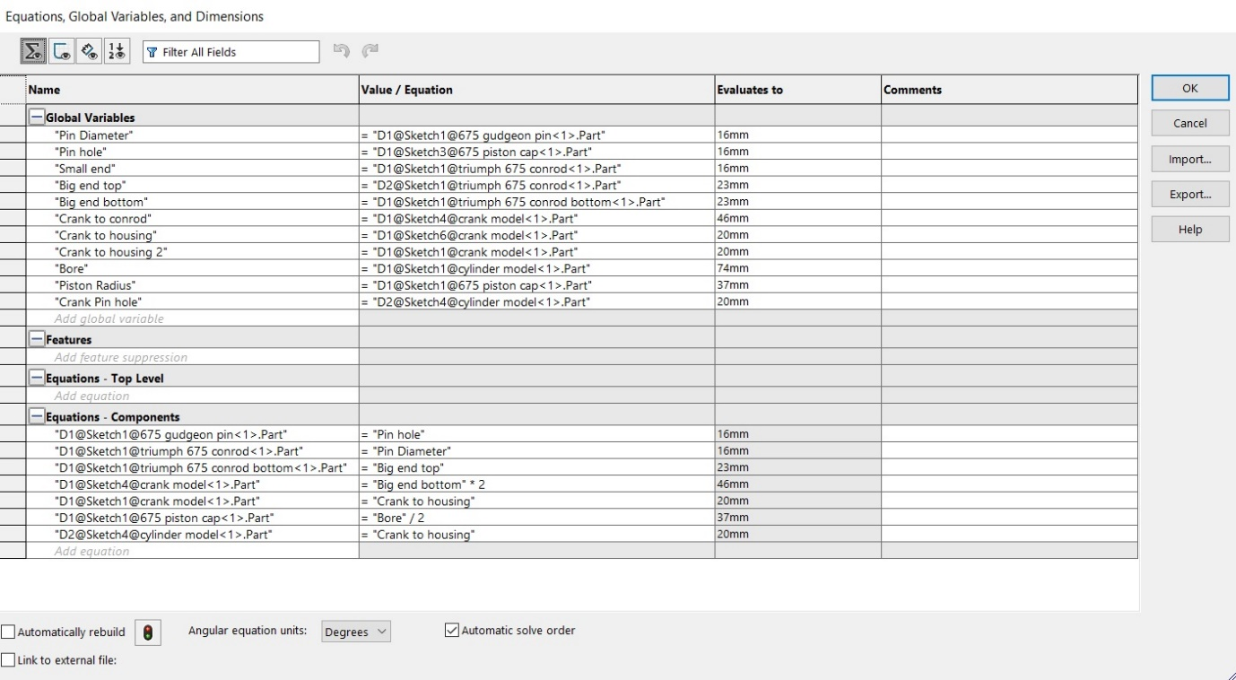
Figure 14 Solidworks Equations
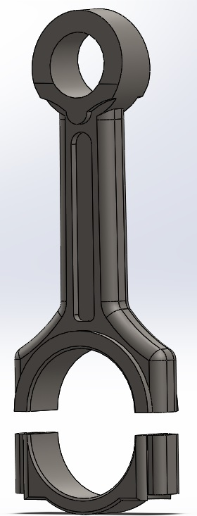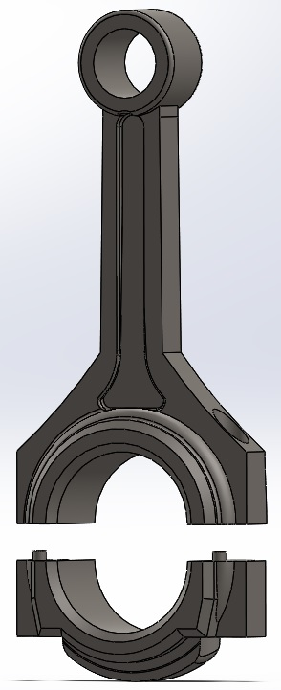
Figure 15 Ford Con-rod Model Figure 16 Triumph Con-rod Model
After all the components have been modelled maintaining accuracy in key points they must be assembled. Extra care is taken to remove any redundancies present in the assembly; redundancies are found by running an initial motion study which will display the number of redundant mates. The way in which each mate is redundant can be found by selecting to display the degrees of freedom for all mates. Reduction in redundancies is done by creating “rigid groups” which links two or more individual parts as if they were one solid piece, removal of entirely redundant mates, and changing the type of mate used at specific locations. Finally, the remaining mates can be replaced with bushings, which is found under simulation settings in the motion analysis tab of Solidworks.
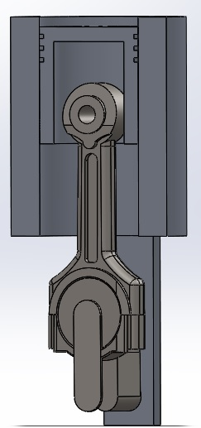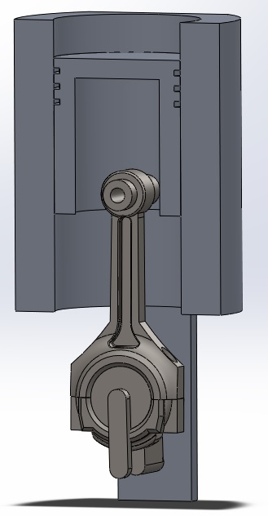
Figure 17 Ford Cylinder Assembly Figure 18 Triumph Cylinder Assembly

Material Allocation
When a working assembly has been made, their materials should be allocated. It is important that the correct materials are used as even different variants of the same material can have wildly different properties and characteristics. (Kazuo Nakayama, 1988)
The material allocated to the Triumph connecting rod is AISI 4340 annealed steel and has an ultimate tensile strength (UTS) of $1400 N/{{mm}^{2}}$, This steel is alloyed with nickel, chromium, and molybdenum, commonly referred to as chrome-moly steel. Chrome-moly steel is widely used in high pressure and temperature environments due to its resistance to corrosion, as well as its ability to maintain a high tensile strength at higher temperatures. The same material is used for the crankshaft and Gudgeon pin. (AZO Materials, 2020), (All Metals & Forge Group, 2020), (Ape Race Parts, 2020). The cylinder model and piston cap were assigned the material 201.0-T6 insulated Mould casting (ss) Aluminium, an alloy of aluminium designed specifically for casting. Due to the temper applied to this material it maintains integrity in high stress environments and is resistant to corrosion. (Mitsuhiro Okayasu, 2015), (Matweb, 2020).
The Ford connecting rod is allocated the material AISI 4130 annealed at 870 Celsius. The rod was manufactured using powdered metal forging, which uses a powdered form of the alloy steel and, using heat and pressure, forces each grain together to form the desired shape. AISI 4130 is also a chrome-molybdenum alloy used for the same corrosion and heat resistance which has an UTS value of $1000 N/{{mm}^{2}}$, The crankshaft and Gudgeon pin are also made from this material and technique, (Ford Racing, 2020), (AZO Materials, 2020). although the Gudgeon pin has undergone a process known as super-finishing. This process creates a super smooth surface on the Gudgeon pin to eliminate as many stress concentrations caused by uneven surfaces as possible and reduce friction between the pin and the connecting rod. (The National Programme on Technology Enhanced Learning (MPTEL) India, 2020). The same material as is used in the Triumph cylinder and piston cap is used for the Ford parts.

Motion Simulation
When all the pieces of the model have been made and assembled with as few redundant mates as possible, work on creating an accurate motion simulation and analysis can begin. As the data that will be used consists of 2 full rotations of the crankshaft, the simulation should only run for the same length of time. In order to find the duration of the simulation, the data tables assembled in Excel contain a column showing the change in time per degree of crank travel, the final entry for this is the total amount of time taken for the two full rotations. Using this value, the simulation for the Ford will take 0.02 seconds and the Triumph will take 0.01 seconds. The duration of each simulation should be set to match as closely as possible the duration of the data available. As the engines are turning at their highest respective RPMs the crankshaft of the model must also rotate at the correct speed; to achieve this a motor is applied to the crankshaft and set to 14400 RPM for the Triumph model and 6000 RPM for the Ford model. When the rotation speed and duration of the simulation have been set correctly the recording speed of the simulation should be set. This is because by default Solidworks will record the animation of the simulation at 60 frames per second; at this speed, the entire animation would consist of one – two frames. In the simulation used for this study the framerate is set to 10,000. Once the initial parameters of engine speed, framerate, and simulation duration have been set, a test run of the simulation is completed to ensure there are no bugs or interference present. If the simulation runs without any issues the next step is to apply motion loads to the connecting rod. Solidworks requires the motion loads to be set into two columns separated by a comma; this can be done in Excel by copying the column containing time taken per degree of crank travel, and the column containing rod forces to a separate area with an empty column between them. This empty column is then filled with commas. In order to import this information into Solidworks it must be converted to a “.txt” file for the program to read it; to do this the three columns created from time taken per degree of crank travel, commas, and rod force are pasted into a word processor and saved in the required file format creating a force profile that can then be imported into the model. The force profile is added by adding a force acting through the “small end” of the connecting rod where the Gudgeon pin connects the piston cap to the rest of the model. The model is then ready to run the final motion simulation.

FEA Process
The first step in completing the FEA study on the connecting rods is to extract the motion loads at their peak values. To find the peak forces acting on the rod the highest value is found in the Excel spreadsheet; the time at the point before and after is taken to give a range of time for the study to collect data from. The part being tested is selected in Solidworks and the motion loads are extracted by using a range of frames captured and analysed during motion. The start frame is found by selecting the frame with the closest timestamp to the time given by the data point before the peak force value, the same process is done for the end frame. This range is used to ensure the study captures the forces acting on the connecting rods when it is at its peak. The forces acting on the rod are then extracted into a separate file in the rod’s model which is where the FEA study is be carried out.
Before the study is carried out the mesh parameters and solver type for each FEA study must be set; to avoid any inaccuracies caused by elements being too far apart the finest mesh available will provide the best results. However, it would also require more computing power than was available due to unforeseen circumstances in the testing phase. To mitigate this a coarse mesh was used forcing the elements too far apart to generate an accurate FEA model, leading to greater displacements than would occur in a real-world scenario. There are a number of FEA solver types available in Solidworks, each is used for different scenarios and has different computing power requirements; the automatic solver will apply the optimal parameters to the study if there are no issues with the complexity of the model. Where this issue arises the solver must be selected manually, or the model must be simplified. This was the case when attempting to run a study on the Triumph connecting rod model. A direct sparse solver is also available; this solver has the greatest computing requirements. The solver requires 1 GB of RAM for every 200,000 degrees of freedom statically. At each element node there is 3 degrees of freedom present, the solver then runs for each frame of the study causing the number of elements to increase rapidly. This solver is used on computers with large amounts of RAM and multiple CPUs, it is also used on specific types of analysis. It is used when there is no penetrating contact between parts and when the material parts which have been assigned have significantly different properties. The next solver available is named FFEPlus; this solver is ideal to efficiently solve large problems. This is achieved by the program re-arranging the matrix created for the study to solve in a more efficient way. The third option is the large problem sparse solver which utilises the same matrix re-arranging technique as FFEPlus, however it places more emphasis on CPU usage and is used in systems with limited memory. The final option is the Intel direct sparse solver which utilises the CPU and memory in the most efficient way, however it requires more memory than the large problem sparse solver. (Dassault Systemes, 2020). Due to the large displacements occurring in the part the FEA solver in Solidworks is set to use the large problem sparse solver; this solver requires less computing power to produce results by utilising CPU cores more efficiently. The same process is repeated for both connecting rods

FEA Results
Once all the boundary conditions, mesh density, material properties, have been set and the correct solver has been selected, it is possible to run the FEA study. The total combined solving time for both models run consecutively was 6 hours and 43 minutes. They were run at the highest degree of accuracy possible with the computing power available at the time.
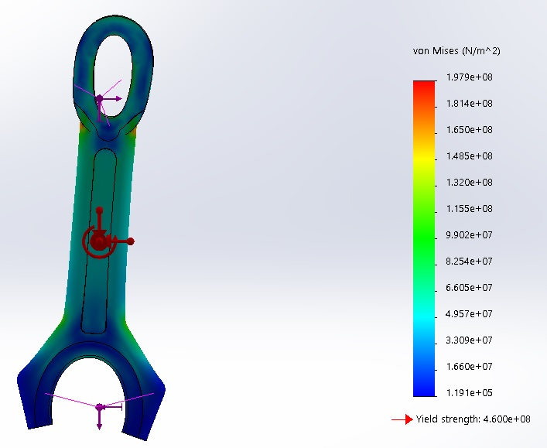
Figure 19 Ford Connecting Rod FEA Von Mises Stress
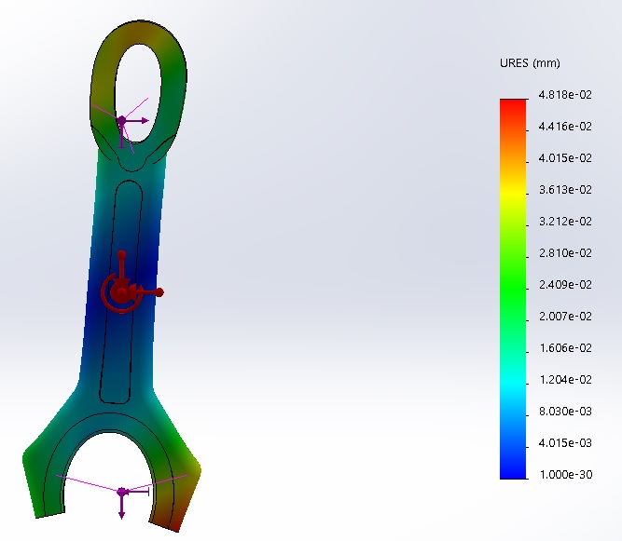
Figure 20 Ford Connecting Rod FEA Displacement
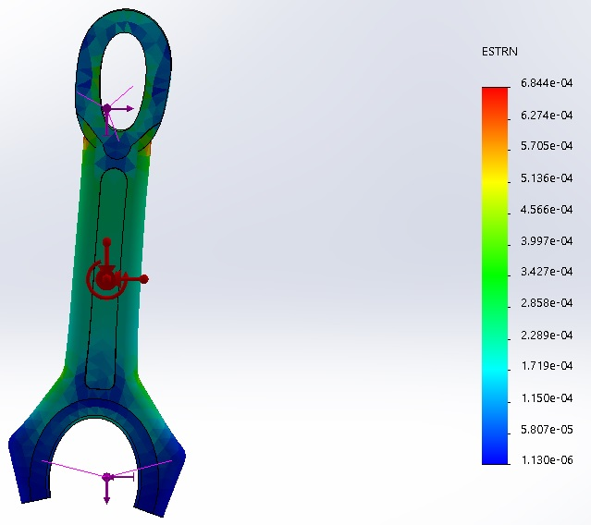
Figure 21 Ford Connecting Rod FEA Strain
As the model for the Ford connecting rod was significantly less complex than the model made for the Triumph, results gained from this were gathered to a higher degree of accuracy, though the displacements present specifically the deformation of both the “big” and “small” ends which would be unlikely to happen in an actual engine at maximum RPM as it represents a failure of the part.
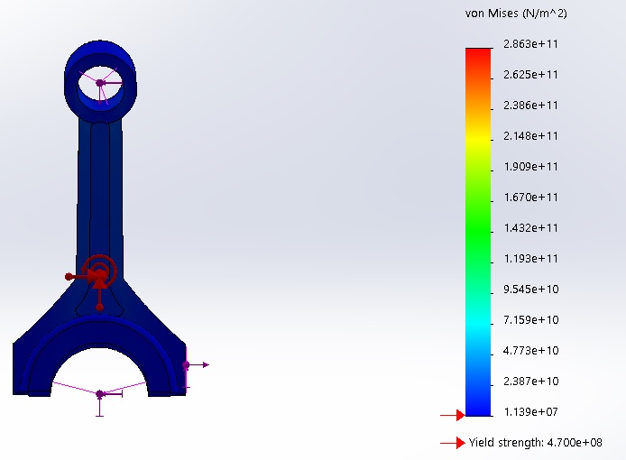
Figure 22 Triumph Connecting Rod FEA Von Mises Stress
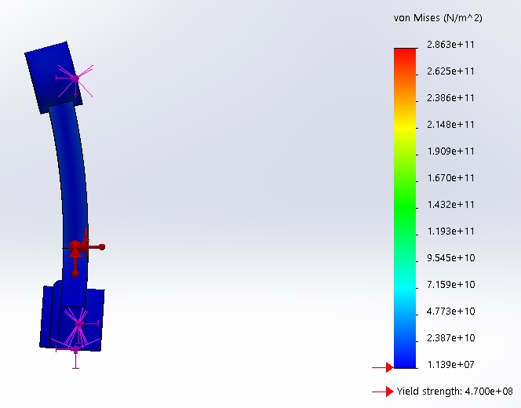
Figure 23 Triumph Connecting Rod FEA Von Mises Stress Plan View
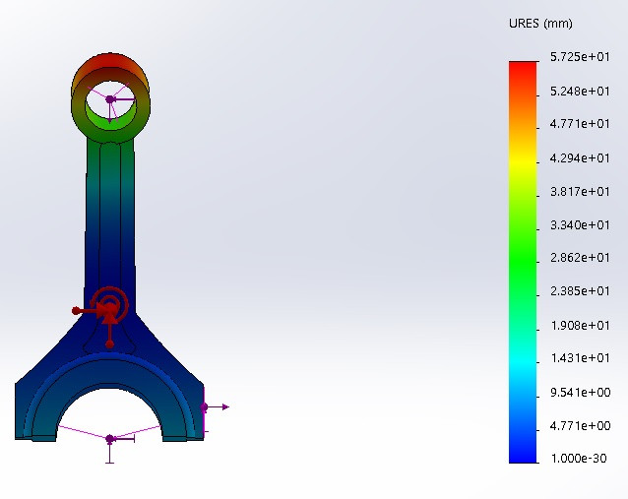
Figure 24 Triumph Connecting Rod FEA Displacement
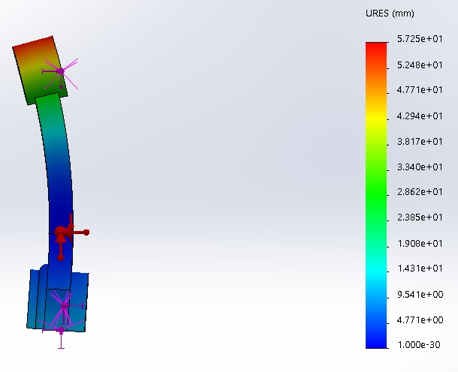
Figure 25 Triumph Connecting Rod FEA Displacement Plan View
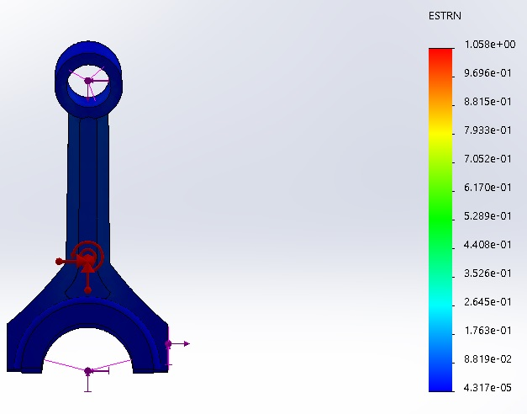
Figure 26 Triumph Connecting Rod FEA Strain
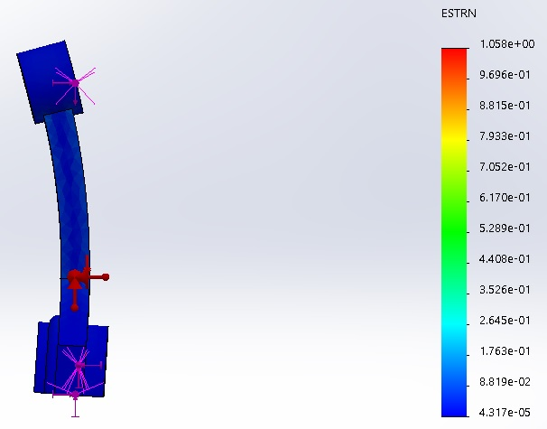
Figure 27 Triumph Connecting Rod FEA Strain Plan View
Due to the increased complexity of the design of the Triumph connecting rod even after simplification, the mesh used was set at the maximum coarseness as this was the only way the study would run to completion. The results show that this model would also fail under the loads present in the engine; due to both connecting rod models showing failures results used and discussed from them are representative and not to be considered as the actual values.

Numerical Analysis
While FEA testing provides a good overview of the entire part, it is hard to extract information from specific key areas; for this, the most effective method of extracting information is to complete specific calculations by hand. These calculations provide the specific stresses acting at the key points and can also provide insight into other likely failure points such as the Gudgeon pin and the connecting rod bolts.
The desired result of each set of calculations is to produce a Goodman diagram from the maximum stresses, minimum stresses, mean stresses, and range of stresses to find the fatigue safety factor for each point or component.

Connecting Rod Forces
The forces acting on each connecting rod were calculated as part of creating the simulation in section 2.5. These forces give the base from which manual calculations can be completed. However other information is required; this information can be calculated from the characteristics of each rod that are already known.

Acceleration
Acceleration is present between each angle of crank travel due to the oscillating motion of the piston. The acceleration must be found for both the maximum net tensile and compressive forces acting on the rod to find the inertia loads acting counter to them. The acceleration is a function of the crank radius, connecting rod length “L”, engine speed “ω” in radians per second, and connecting rod angle “θ” found from the corresponding peak rod forces, acceleration is denoted as “α”. (X-Engineer, 2020).
$$α=Rω^{2}\cos{θ}+\frac{R}{L}Rω^{2}\cos{2θ}$$
Equation 34 Piston Acceleration
$$α_{Triumph Compressive}=\left(0.025\right)\left(1507.9645^{2}\right)\cos\left(0.68\right)+\frac{0.0125}{0.144}(0.025)(1507.9645^{2})\cos{2(0.68)}$$
Equation 35 Triumph Compressive Piston Acceleration Evaluated
$$α_{Triumph Compressive}=66570.24895{Rad}/{S^{2}}$$
$$α_{Triumph Tension}=\left(0.025\right)\left(1507.9645^{2}\right)\cos\left(3.18\right)+\frac{0.0125}{0.144}(0.025)(1507.9645^{2})\cos{2(3.18)}$$
Equation 36 Triumph Tensile Piston Acceleration Evaluated
$$α_{Triumph Tension}=66711.74416{Rad}/{S^{2}}$$
$$α_{Ford Compressive}=\left(0.0278\right)\left(628.319^{2}\right)\cos\left(2.791\right)+\frac{0.0278}{0.1865}(0.0278)(628.319^{2})cos{2\left(2.791\right)}$$
Equation 37 Ford Compressive Piston Acceleration Evaluated
$$α_{Ford Compressive}=12590.19442{Rad}/{S^{2}}$$
$$α_{Ford Tension}=\left(0.0278\right)\left(628.319^{2}\right)\cos\left(0.299\right)+\frac{0.0278}{0.1865}(0.0278)(628.319^{2})\cos{2(0.299)}$$
Equation 38 Ford Tensile Piston Acceleration Evaluated
$$α_{Ford Tension}=12610.73214{Rad}/{S^{2}}$$

Inertia Force
Inertia forces are a product of the acceleration of the piston and the mass of the Gudgeon pin. The pin inertia force acts counter to the rod force, this is due to inertia acting to resist a change in the direction of motion which occurs in an oscillating piston. The mass of the Gudgeon pin can be found by weighing where it is possible to obtain the physical part. If this is not possible the mass can be estimated by multiplying the calculated volume of the pin by the density of steel. The volume of the pin can be found from technical information or OEM parts catalogues for the respective engine or using the scale tool on Solidworks to find diameters and length. (A.L. Guzzomi D. H., 2008)
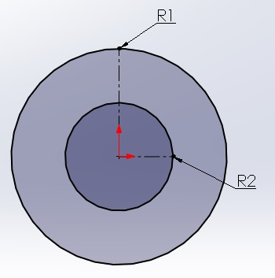
Figure 28 Gudgeon Pin Radii
$$M_{Pin}=Length×π(r_{1}^{2}-r_{2}^{2})×ρ_{Steel}$$
Equation 39 Gudgeon Pin Mass
The density “ρ” of steel is 7850 ${KG}/{m^{3}}$ (ToolBox, 2020).
In order to accurately calculate the mass of the Gudgeon pin the length is assumed to be the same as the cylinder bore, the equation will give the total mass of the pin.
$$M_{Pin Total Triumph}=0.076×π((7.95×{10}^{-3})^{2}-(5.085×{10}^{-3})^{2})×7850$$
Equation 40 Gudgeon Pin Mass Evaluated, Triumph Total
$$M_{Pin Total Triumph}=0.069995 Kg$$

$$M_{Pin Total Ford}=0.079×π((13×{10}^{-3})^{2}-(6.32×{10}^{-3})^{2})×7850$$
Equation 41 Gudgeon Pin Mass Evaluated, Triumph Total
$$M_{Pin Total Ford}=0.2414 Kg$$
The total mass of the pin can be used to help in the calculation of reciprocating mass, however the pin mass needed is the mass of the pin jutting out from the connecting rod.
$$L_{Pin Jutting Out}=\frac{L_{Pin Total}-Rod Thickness}{2}$$
Equation 42 Length of the Pin Section Jutting Out
$$L_{Pin Jutting Out Triumph}=\frac{0.076-0.01611}{2}$$
Equation 43 Length of the Pin Section Jutting Out Evaluated Triumph
$$L_{Pin Jutting Out Triumph}=0.02905 m$$
$$L_{Pin Jutting Out Ford}=\frac{0.079-0.0209}{2}$$
Equation 44 Length of the Pin Section Jutting Out Evaluated Ford
$$L_{Pin Jutting Out Ford}=0.02905 m$$
The length of the pin jutting out is then substituted into the equation for pin mass to find the mass of the pin jutting out.
$$M_{Pin Jutting Out Triumph}=0.029945×π((7.95×{10}^{-3})^{2}-(5.085×{10}^{-3})^{2})×7850$$
Equation 45 Mass of the Pin Jutting Out Evaluated Triumph
$$M_{Pin Jutting Out Triumph}=0.027579 Kg$$
$$M_{Pin Jutting Out Ford}=0.02905×π((13×{10}^{-3})^{2}-(6.32×{10}^{-3})^{2})×7850$$
Equation 46 Mass of the Pin Jutting Out Evaluated Ford
$$M_{pin Jutting Out Ford}=0.09246 Kg$$
As the mass and acceleration have been calculated it is possible to find the inertia force following Newton’s second law of motion, force is equal to mass times acceleration. ((NASA), 2020).
$${Fi}_{Pin}= α×M_{Pin Jutting Out}$$
Equation 47 Pin Inertia Force

$${Fi}_{Pin Triumph (comp)}=66570.24895×0.027579$$
Equation 48 Pin Inertia Force Triumph (Compressive)
$${Fi}_{Pin Triumph (Comp)}=1835.9409 N$$
$${Fi}_{Pin Triumph (Tens)}=66711.74416×0.027579$$
Equation 49 Pin Inertia Force Triumph (Tensile)
$${Fi}_{Pin Triumph (Tens)}=1839.8432 N$$
$${Fi}_{Pin Ford (Comp)}=12590.19442×0.09246$$
Equation 50 Pin Inertia Force Ford (Compressive)
$${Fi}_{Pin Ford (Comp)}=1164.0894 N$$
$${Fi}_{Pin Ford (Tens)}=12610.73214×0.09246$$
Equation 51 Pin Inertia Force Ford (Tensile)
$${Fi}_{Pin Ford (Tens)}=1165.9883 N$$

Second Moment of Area
The second moment of area or moment of inertia shows the resistance of a cross-sectional area to deformation caused by loads acting on the part. Second moment of area is denoted by “I”. Different shapes have different methods of calculating the second moment of area; the formula used is for a hollow tube and is a function of the major and minor diameters. Units for second moment of area are “mm⁴”. (MDME: Manufacturing, 2020)
$$I=\frac{π}{64}(D_{1}^{4}-D_{2}^{4})$$
Equation 52 Second Moment of Area for a Hollow Cylinder
$$I_{Triumph}=\frac{π}{64}({15.9}^{4}-{10.17}^{4})$$
Equation 53 Second Moment of Area Evaluated Triumph
$$I_{Triumph}=2612.2028 {mm}^{4}$$
$$I_{Ford}=\frac{π}{64}({26}^{4}-{12.64}^{4})$$
Equation 54 Second Moment of Area Evaluated Ford
$$I_{Ford}=21178.7364 {mm}^{4}$$
In addition to the second moment of area the distance from the neutral axis is also needed; the neutral axis is a plane through a shape that remains the same as the rest of the part deforms under load. In a hollow cylinder it is the centre line, the distance to the centre line is the major radius, denoted as “Y”. (Naveed Anwar, 2017)
$$Y=\frac{D_{1}}{2}$$
Equation 55 Distance to the Neutral Axis
$$Y_{Triumph}=\frac{15.9}{2}$$
Equation 56 Distance to Neutral Axis Evaluated Triumph
$$Y_{Triumph}=7.95 mm$$
$$Y_{Ford}=\frac{26}{2}$$
Equation 57 Distance to Neutral Axis Evaluated Ford
$$Y_{Ford}=13 mm$$

Connecting Rod Forces
As stress is the internal forces acting between particles in a material, the forces acting on the connecting rods is key to stress calculation; peak values for both compression and tension are needed. These are the minimum and maximum rod force points calculated in the Excel spreadsheets and simulator. (Center, 2020).
$$Triumph F_{Compression}=35645.1 N$$
$$Triumph F_{Tension}=16939.4 N$$
$$Ford F_{Compression}=32947.7 N$$
$$Ford F_{Tension}=13662.1 N$$

Gudgeon Pin Stress Calculations
To calculate the stresses acting on the Gudgeon pin they must be split into the maximum stress, which is calculated from compressive forces, and the minimum stress that is calculated from tensile forces. The stresses used are a combination of bending and shear stresses. (V. Ramamurti, 2012). While calculating stresses, compression is considered positive and tension is considered negative due to the direction each force acts in.

Net Bending Moment
The net bending moment is an internal measurement as such half of the pin is analysed. When in compression inertia forces act against motion, however, in tension, they act with motion. As moments are defined as forces acting over a distance, the distance should first be known; these are the distance from the edge of the connecting rod to the centre of the piston pin bore, and the centre of gravity. (MDME, 2020). The lengths are considered the same in this analysis due to lack of access to the required information to accurately calculate the distances for both parts, the measured distances from the Ford piston are used.
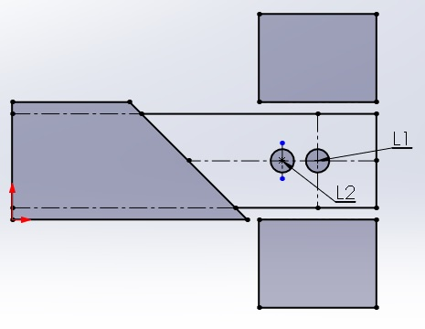
Figure 29 Gudgeon Pin Lengths Diagram
$$L_{1}=13.041 mm$$
$$L_{2}=8.694 mm$$
As the distances and forces have been found it is possible to calculate the bending moments.
$$Net Bending Moment \left(Compression\right)=\frac{F_{Comp}}{2}×L_{1}-{Fi}_{Comp}×L_{2}$$
Equation 58 Net Bending Moment Compressive
$$Net Bending Moment \left(Tensile\right)=\frac{F_{Tens}}{2}×L_{1}+{Fi}_{Tens}×L_{2}$$
Equation 59 Net Bending Moment Tensile (Vijay Baban Kamble, 2018)

Bending Stress
The bending stress can be calculated from the bending moment, the second moment of area and the distance from the neutral axis. The same equation is used for both compressive and tensile stresses. (Roylance, 2000)
$$Bending Stress=\frac{Net bending moment×Y}{I}$$
Equation 60 Bending Stress

Shear Force and Stress
Shear stress is caused by a force vector that operates parallel to the cross section of the object being analysed. The stress is derived from a shear force which is defined as counteracting forces acting on opposite sides of an object. (David R.H. Jones, 2019)
$$Shear Stress \left(Compressive\right)=\frac{\frac{F_{Comp}}{2}-{Fi}_{Comp}}{\frac{π}{4}(D_{1}^{2}-D_{2}^{2})}$$
Equation 61 Shear Stress Compressive
$$Shear Stress \left(Tensile\right)=\frac{\frac{F_{Tens}}{2}+{Fi}_{Tens}}{\frac{π}{4}(D_{1}^{2}-D_{2}^{2})}$$
Equation 62 Shear Stress Tensile

Combined Stress
As there are multiple stresses acting in different locations, they must be combined in order to produce a linear function of the applied forces and stresses. This ensures they obey Hooke’s law as steel is a material that can be defined by Hooke’s law. (Mayaguez, 2020) Hooke’s law states that a materials maximum resistance to stress cannot exceed the minimum calculated value.
$$Combined stress=\sqrt{{Bending Stress}^{2}+2({Shear Stress}^{2})}$$
Equation 63 Combined Stress
Combined stress calculated from compressive stresses is considered to be the maximum stress and has a positive value, while combined stress calculated from the tensile stresses is considered to be the minimum stress and has a negative value.

Allowable Range of Stresses and Fatigue Safety Factor
From the combined stresses it is possible to calculate the mean stress and the range of stresses; these are used to calculate the fatigue safety factor of the part. The fatigue safety factor represents the number of fatigue cycles a component is likely to survive. For a part to have a fatigue safety factor of 1 it must typically last for the same length of time as the engine warranty life. This number is calculated by dividing an allowable stress range by the actual range of stresses present in each cycle. (Rodopoulos, 2003)
The allowable range is a function of the ultimate tensile strength (UTS) of the material used to make a part and a predefined safe endurance limit, this is typically 45% of the UTS. The endurance limit is used in a Goodman diagram to mark the boundaries of allowable stress in a system. The allowable range is then found using trigonometric functions of similar triangles to find the distance between two points on a graph. (Jelaska, 2010)
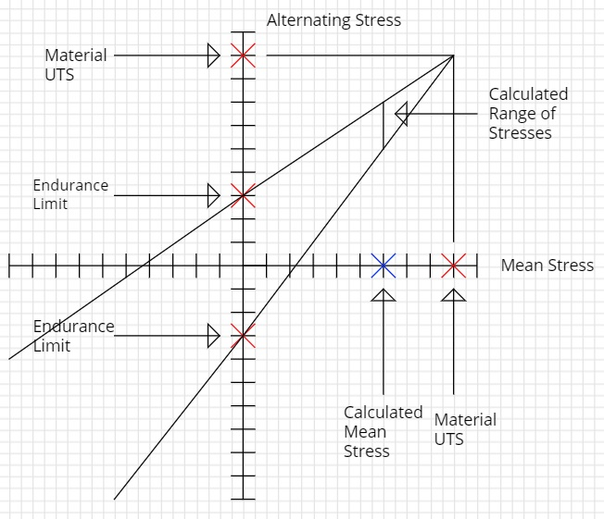
Figure 30 Goodman Diagram Example
$$Allowable Range=2EL(1-\frac{Mean Stress}{Material UTS})$$
Equation 64 Allowable Stress Range
$$Fatigue Safety Factor=\frac{Allowable Stress Range}{Actual Stress Range}$$
Equation 65 Fatigue Safety Factor

Triumph Gudgeon Pin
$$Net Bending Moment \left(Compression\right)=\frac{35645.1}{2}×13.041-1835.9409×8.694$$
Equation 66 Net Bending Moment Compressive Evaluated Triumph
$$Net Bending Moment \left(Compression\right)=216462.2044 Nmm$$
$$Net Bending Stress \left(Compression\right)=\frac{216462.2044×7.95}{2612.2028}$$
Equation 67 Bending Stress Compression Evaluated Triumph
$$Net Bending Stress \left(Compression\right)=658.7829 N/{{mm}^{2}}$$
$$Shear Stress \left(Compression\right)=\frac{\frac{35645.1}{2}-1835.9409}{\frac{π}{4}\left({15.9}^{2}-{10.17}^{2}\right)}$$
Equation 68 Shear Stress Compressive Evaluated Triumph
$$Shear Stress \left(Compression\right)=136.2608 N/{{mm}^{2}}$$
$$Combined Stress \left(Compression\right)=\sqrt{{658.7829}^{2}+2({136.2608}^{2})}$$
Equation 69 Combined Stress Compression Evaluated Triumph
$$Combined Stress \left(Compression\right)=σ_{Max}=686.3883N/{{mm}^{2}}$$
As tensile forces and stresses are considered to have negative values, equations have been altered to give negative results.
$$Net Bending Moment \left(Tension\right)=\frac{16939.4}{2}×13.041+1839.8432×8.694$$
Equation 70 Net Bending Moment Tension Evaluated Triumph
$$Net Bending Moment \left(Tension\right)=126448.9545 Nmm$$
$$Net Bending Stress \left(Tension\right)=-(\frac{126448.9545×7.95}{2612.2028})$$
Equation 71 Net Bending Stress Tension Evaluated Triumph
$$Net Bending Stress \left(Tension\right)=-384.8358 N/{{mm}^{2}}$$
$$Shear Stress \left(Tension\right)=-(\frac{\frac{16939.4}{2}+1839.8432}{\frac{π}{4}\left({15.9}^{2}-{10.17}^{2}\right)})$$
Equation 72 Shear Stress Tension Evaluated Triumph
$$Shear Stress \left(Tension\right)=-87.8727 N/{{mm}^{2}}$$
$$Combined Stress \left(Tension\right)=-(\sqrt{{384.8358}^{2}+2\left({87.8727}^{2}\right)})$$
Equation 73 Combined Stress Tension Evaluated Triumph
$$Combined Stress \left(Tension\right)=σ_{Min}=-404.403 N/{{mm}^{2}}$$
$$σ_{Max}=686.3883 N/{{mm}^{2}}$$
$$σ_{Min}=-404.403 N/{{mm}^{2}}$$
$$σ_{Range}=686.3883-\left(-404.403\right)=1090.7913 N/{{mm}^{2}}$$
$$σ_{Mean}=\frac{686.3883+(-404.403)}{2}=140.9927 N/{{mm}^{2}}$$
$$Material UTS=1400 N/{{mm}^{2}}$$
$$Endurance Limit=0.45×1400=630 N/{{mm}^{2}}$$
$$Allowable Range=(2×630)(1-\frac{140.9927}{1400})$$
Equation 74 Allowable Range Evaluated Triumph
$$Allowable Range=1133.1066 N/{{mm}^{2}}$$
$$Fatigue Safety Factor=\frac{1133.1066}{1090.7913}$$
Equation 75 Fatigue Safety Factor Evaluated Triumph
$$Fatigue Safety Factor=1.0388$$
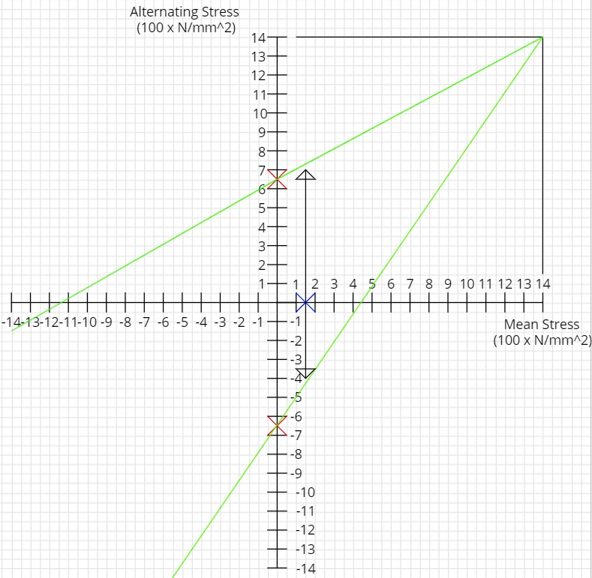
Figure 31 Triumph Gudgeon Pin Goodman Diagram

Ford Gudgeon Pin
$$Net Bending Moment \left(Compression\right)=\frac{32947.7}{2}×13.041-1164.0894×8.694$$

Equation 76 Net Bending Moment Compression Evaluated Ford
$$Net Bending Moment \left(Compression\right)=204714.8846 Nmm$$
$$Bending Stress \left(Compression\right)=\frac{204714.8846×13}{21178.7364}$$
Equation 77 Bending Stress Compression Evaluated Ford
$$Bending Stress \left(Compression\right)=125.6587 N/{{mm}^{2}}$$
$$Shear Stress \left(Compression\right)=\frac{\frac{32947.7}{2}-1164.0894}{\frac{π}{4}({26}^{2}-{12.64}^{2})}$$
Equation 78 Shear Stress Compression Evaluated Ford
$$Shear Stress \left(Compression\right)=37.7603 N/{{mm}^{2}}$$
$$Combined Stress \left(Compression\right)=\sqrt{{125.6587}^{2}+2({37.7603}^{2})}$$
Equation 79 Combined Stress Compression Evaluated Ford
$$Combined Stress \left(Compression\right)=σ_{Max}=136.5349 N/{{mm}^{2}}$$
$$Net Bending Moment \left(Tension\right)=\frac{13662.1}{2}×13.041+1165.9883×8.694$$
Equation 80 Net Bending Moment Tension Evaluated Ford
$$Net Bending Moment \left(Tension\right)=99220.8253 Nmm$$
$$Bending Stress \left(Tension\right)=-(\frac{99220.8253×13}{21178.7364})$$
Equation 81 Bending Stress Tension Evaluated Ford
$$Bending Stress \left(Tension\right)=-60.904 N/{{mm}^{2}}$$
$$Shear Stress \left(Tension\right)=-(\frac{\frac{13662.1}{2}+1165.9883}{\frac{π}{4}\left({26}^{2}-{12.64}^{2}\right)})$$
Equation 82 Shear Stress Tension Evaluated Ford
$$Shear Stress \left(Tension\right)=-19.724 N/{{mm}^{2}}$$
$$Combined Stress \left(Tension\right)=-(\sqrt{{60.904}^{2}+2\left({19.724}^{2}\right)})$$
Equation 83 Combined Stress Tension Evaluated Ford
$$Combined Stress \left(Tension\right)=σ_{Min}=-66.9878 N/{{mm}^{2}}$$
$$σ_{Max}=136.5349 N/{{mm}^{2}}$$
$$σ_{Min}=-66.9878 N/{{mm}^{2}}$$
$$σ_{Range}=136.5349-\left(-66.9878\right)=203.5227 N/{{mm}^{2}}$$
$$σ_{Mean}=\frac{136.5349+(-66.9878)}{2}=34.7736 N/{{mm}^{2}}$$
$$Material UTS=1000 N/{{mm}^{2}}$$
$$Endurance Limit=0.45×1000=450 N/{{mm}^{2}}$$
$$Allowable Range=(2×450)(1-\frac{34.7736}{1000})$$
Equation 84 Allowable Range Evaluated Ford
$$Allowable Range=868.7038 N/{{mm}^{2}}$$
$$Fatigue Safety Factor=\frac{868.7038}{203.5227}$$
Equation 85 Fatigue Safety Factor Evaluated Ford
$$Fatigue Safety Factor=4.2683$$
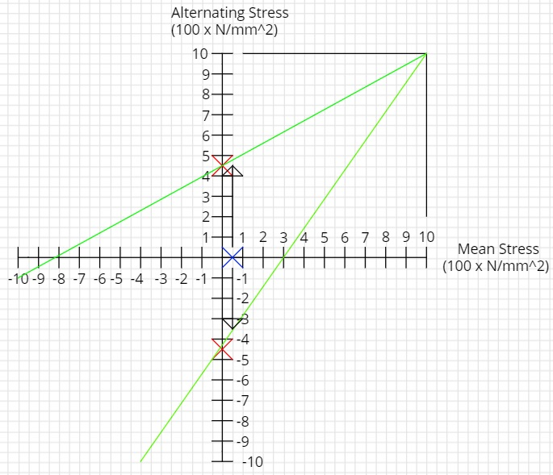
Figure 32 Ford Gudgeon Pin Goodman Diagram

Key Point Stress Calculations
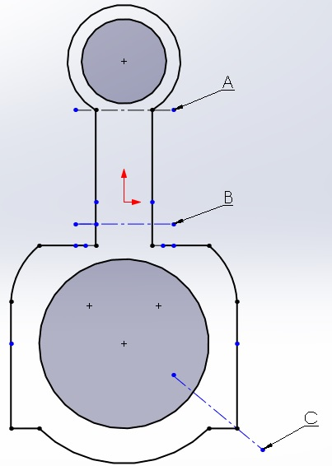
Figure 33 Connecting Rod Key Points Diagram
Each point is selected as they are the locations where stress concentrations are likely to be highest; this is confirmed in the FEA study as the highest stress values are found at the point where the “small end” meets the shank of the rod, where the shank meets the “big end” and a cross-section of the bolt holes. The stresses acting at each point consist of compressive and tensile components calculated from their respective forces. (Ashby, 2011)
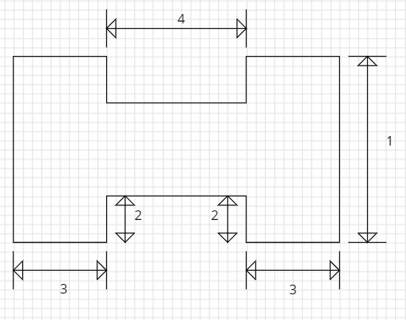
Figure 34 Connecting Rod Cross-Section Diagram
Each dimension for the connecting rods at points “A” and “B” that correspond to the locations indicated in the diagram above are measured using the same digital Vernier Callipers as all other measurements in this study. At point “C” the cross-section is far simpler, it is a rectangle with the bolt hole through a section.
Due to the geometry of the areas being analysed stress concentration factors are present; the stress concentration factors present at each point are 1.386, the factor is used to find the final endurance limit. This is done by dividing the initial endurance limit by the stress concentration factor. (Bin Zheng, 2013)

Compressive Stress
The compressive stress acting at each location is simply the compressive force divided by the cross-sectional area at each point. This is because stress is defined as the ratio between the force and the area over which it is being applied. (Toolbox, 2020). This stress is described as the minimum stress or “$σ_{Min}$” these stresses are also considered to have negative values.
$$Compressive Stress=\frac{F_{Compression}}{Area}$$
Equation 86 Compressive Stress

Tensile Stress
Due to the connecting rod being attached to the crank shaft at an angle, the vertical force acting in tension only works over half of the cross-sectional area. The key points of the stress calculations remain the same. (Courses, 2020). This stress is described as the maximum stress or $"σ_{Max}"$.
$$Tensile Stress=\frac{F_{Tensile}}{\frac{Area}{2}}$$
Equation 87 Tensile Stress

Triumph Point A
$${Area}_{A}=97.5054 {mm}^{2}$$
$$Compressive Stress @ Point A=-(\frac{35645.1}{97.5054})$$
Equation 88 Compressive Stress at Point “A” Evaluated Triumph
$$Compressive Stress @ Point A=σ_{Min}=-365.5705 N/{{mm}^{2}}$$
$$Tensile Stress @ Point A=\frac{16939.4}{\frac{97.5054}{2}}$$
Equation 89 Tensile Stress at point "A" Evaluated Triumph
$$Tensile Stress @ Point A=σ_{Max}=347.4556N/{{mm}^{2}}$$
$$σ_{Max}=347.4557N/{{mm}^{2}}$$
$$σ_{Min}=-365.5705N/{{mm}^{2}}$$
$$σ_{Range}=347.3557-\left(-365.5705\right)=713.0261N/{{mm}^{2}}$$
$$σ_{Mean}=\frac{347.4557+(-365.5705)}{2}=-9.0574N/{{mm}^{2}}$$
$$Material UTS=1000N/{{mm}^{2}}$$
$$Endurance Limit=0.45×1000=450N/{{mm}^{2}}$$
$$Final Endurance Limit=\frac{450}{1.386}=324.6753N/{{mm}^{2}}$$

$$Allowable Range=(2×324.6753)(1-\frac{9.0574}{1000})$$
Equation 90 Allowable Range Evaluated Area "A" Triumph
$$Allowable Range=643.4692N/{{mm}^{2}}$$
$$Fatigue Safety Factor=\frac{643.4692}{713.0261}$$
Equation 91 Fatigue Safety Factor Evaluated Area "A" Triumph
$$Fatigue Safety Factor=0.9024$$
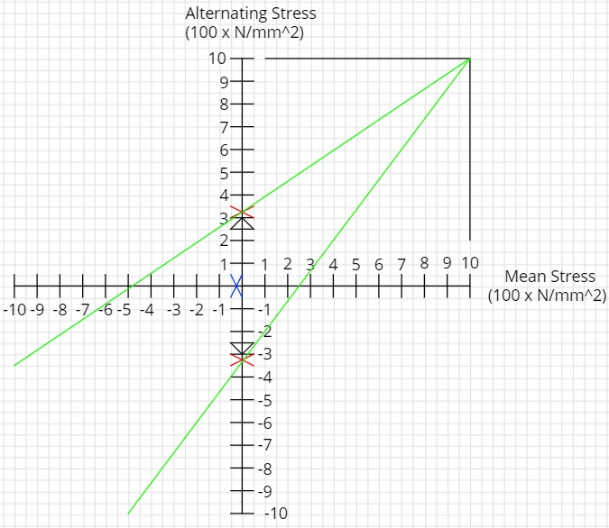
Figure 35 Triumph Point "A" Goodman Diagram

Ford Point A
$$Area A=306.1882 {mm}^{2}$$
$$Compressive Stress @ Point A=-(\frac{32947.7}{306.1882})$$
Equation 92 Compressive Stress Evaluated Area "A" Ford
$$Compressive Stress=σ_{Min}=-107.606 N/{{mm}^{2}}$$
$$Tensile Stress @ Point A=\frac{13662.1}{\frac{306.1882}{2}}$$
Equation 93 Tensile Stress Evaluated Area "A" Ford
$$Tensile Stress @ Point A=σ_{Max}=89.2399 N/{{mm}^{2}}$$
$$σ_{Max}=89.2399 N/{{mm}^{2}}$$
$$σ_{Min}=-107.606 N/{{mm}^{2}}$$
$$σ_{Range}=89.2399-\left(-107.606\right)=196.8459 N/{{mm}^{2}}$$
$$σ_{Mean}=\frac{89.2399+(-107.606)}{2}=-9.1831 N/{{mm}^{2}}$$
$$Material UTS=750 N/{{mm}^{2}}$$
$$Endurance Limit=0.45×750=337.5N/{{mm}^{2}}$$
$$Final Endurance Limit=\frac{337.5}{1.386}=243.5065 N/{{mm}^{2}}$$
$$Allowable Range=(2×243.5065)(1-\frac{9.1831}{750})$$
Equation 94 Allowable Range Evaluated Area "A" Ford
$$Allowable Range=481.0499 N/{{mm}^{2}}$$
$$Fatigue Safety Factor=\frac{481.0499}{196.8469}$$
Equation 95 Fatigue Safety Factor Area Evaluated Area "A" Ford
$$Fatigue Safety Factor=2.4438$$

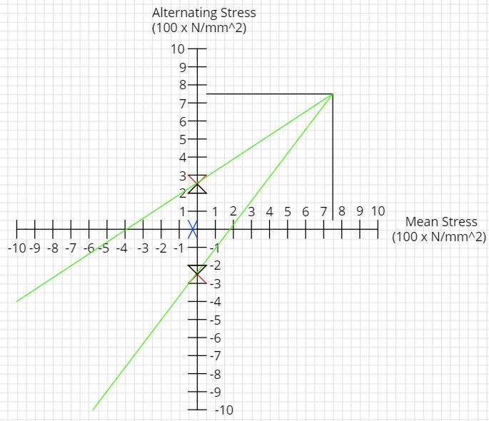
Figure 36 Ford Point "A" Goodman Diagram

Triumph Point B
$$Area B=169.894 {mm}^{2}$$
$$Compressive Stress @ Point B=-(\frac{35645.1}{169.864})$$
Equation 96 Compressive Stress Evaluated Area "B" Triumph
$$Compressive Stress @ Point B=σ_{Min}=-209.8449N/{{mm}^{2}}$$
$$Tensile Stress @ Point B=\frac{16939.4}{\frac{169.894}{2}}$$
Equation 97 Tensile Stress Evaluated Area "B" Triumph
$$Tensile Stress @ Point B=σ_{Max}=199.4466N/{{mm}^{2}}$$
$$σ_{Max}=199.4466 N/{{mm}^{2}}$$
$$σ_{Min}=-209.8449N/{{mm}^{2}}$$
$$σ_{Range}=199.4466-\left(-209.8449\right)=409.2915 N/{{mm}^{2}}$$
$$σ_{Mean}=\frac{199.4466+(-209.8449)}{2}=-5.1992 N/{{mm}^{2}}$$
$$Material UTS=1000N/{{mm}^{2}}$$
$$Final Endurance Limit=324.6753 N/{{mm}^{2}}$$
$$Allowable Range=(2×324.6753)(1-\frac{5.1992}{1000})$$
Equation 98 Allowable Range Evaluated Area "B" Triumph
$$Allowable Range=645.9745 N/{{mm}^{2}}$$
$$Fatigue Safety Factor=\frac{645.9745}{409.2915}$$
Equation 99 Fatigue Safety Factor Evaluated Area "B" Triumph
$$Fatigue Safety Factor=1.5783$$
Figure 37 Triumph Point "B" Goodman Diagram

Ford Point B
$$Area B=333.024 {mm}^{2}$$
$$Compressive Stress @ Point B=-(\frac{32947.7}{333.024})$$
Equation 100 Compressive Stress Evaluated Area "B" Ford
$$Compressive Stress @ Point B=σ_{Min}=-98.9349 N/{{mm}^{2}}$$
$$Tensile Stress @ Point B=\frac{13662.1}{\frac{333.024}{2}}$$
Equation 101 Tensile Stress Evaluated Area "B" Ford
$$Tensile Stress @ Point \text{B=}σ_{Min}=82.0487 N/{{mm}^{2}}$$
$$σ_{Max}=82.0487 N/{{mm}^{2}}$$
$$σ_{Min}=-98.9349 N/{{mm}^{2}}$$
$$σ_{Range}=82.0487-\left(-98.9349\right)=180.9836 N/{{mm}^{2}}$$
$$σ_{Mean}=\frac{82.0487+(-98.9349)}{2}=-8.4431 N/{{mm}^{2}}$$
$$Material UTS=750 N/{{mm}^{2}}$$
$$Final Endurance Limit=\frac{337.5}{1.386}=243.5065 N/{{mm}^{2}}$$
$$Allowable Range=(2×243.5065)(1-\frac{8.4431}{750})$$
Equation 102 Allowable Range Evaluated Area "B" Ford
$$Allowable Range=481.5305 N/{{mm}^{2}}$$
$$Fatigue Safety Factor=\frac{481.5305}{180.9836}$$
Equation 103 Fatigue Safety Factor Evaluated Area "B" Ford
$$Fatigue Safety Factor=2.6606$$
Figure 38 Ford Point "B" Goodman Diagram

Triumph Point C
$$Area C=350.3195 {mm}^{2}$$
$$Compressive Stress @ Point C=-(\frac{35646.1}{350.3195})$$
Equation 104 Compressive Stress Evaluated Area "C" Triumph
$$Compressive Stress @ Point C=σ_{Min}=-101.7531 N/{{mm}^{2}}$$
$$Tensile Stress @ Point C=\frac{16939.4}{\frac{350.3195}{2}}$$
Equation 105 Tensile Stress Evaluated Area "C" Triumph
$$Tensile Stress @ Point C=σ_{Max}=96.7083 N/{{mm}^{2}}$$
$$σ_{Max}=96.7083 N/{{mm}^{2}}$$
$$σ_{Min}=-101.7531 N/{{mm}^{2}}$$
$$σ_{Range}=96.7083-\left(-101.7531\right)=198.4614 N/{{mm}^{2}}$$
$$σ_{Mean}=\frac{96.7083+(-101.7531)}{2}=-2.5224 N/{{mm}^{2}}$$
$$Material UTS=1000N/{{mm}^{2}}$$
$$Final Endurance Limit=324.6753 N/{{mm}^{2}}$$
$$Allowable Range=\left(2×324.6753\right)(1-\frac{2.5224}{1000})$$
Equation 106 Allowable Range Evaluated Area "C" Triumph
$$Allowable Range=647.7127 N/{{mm}^{2}}$$
$$Fatigue Safety Factor=\frac{647.7127}{198.4614}$$
Equation 107 Fatigue Safety Factor Evaluated Area "C" Triumph
$$Fatigue Safety Factor=3.2637$$
Figure 39 Triumph Point "C" Goodman Diagram

Ford Point C
$$Area C=334.2947 {mm}^{2}$$
$$Compressive Stress @ Point C=-(\frac{32947.7}{334.2947})$$
Equation 108 Compressive Stress Evaluated Area "C" Ford
$$Compressive Stress @ Point C=σ_{Min}=-98.5588 N/{{mm}^{2}}$$
$$Tensile Stress @ Point C=\frac{13662.1}{\frac{334.2947}{2}}$$
Equation 109 Tensile Stress Evaluated Area "C" Ford
$$Tensile Stress @ Point C=σ_{Max}=81.7369 N/{{mm}^{2}}$$
$$σ_{Max}=81.7369 N/{{mm}^{2}}$$
$$σ_{Min}=-98.5588 N/{{mm}^{2}}$$
$$σ_{Range}=81.7369-\left(-98.5588\right)=180.2957 N/{{mm}^{2}}$$
$$σ_{Mean}=\frac{81.7369+(-98.5588)}{2}=-8.411 N/{{mm}^{2}}$$
$$Material UTS=750 N/{{mm}^{2}}$$
$$Final Endurance Limit=\frac{337.5}{1.386}=243.5065 N/{{mm}^{2}}$$
$$Allowable Range=(2×243.5065)(1-\frac{8.411}{750})$$
Equation 110 Allowable Range Evaluated Area "C" Ford
$$Allowable Range=481.5513 N/{{mm}^{2}}$$
$$Fatigue Safety Factor=\frac{481.5513}{180.2957}$$
Equation 111 Fatigue Safety Factor Evaluated Area "C" Ford
$$Fatigue Safety Factor=2.6709$$

Figure 40 Ford Point "C" Goodman Diagram

Buckling Loads
While calculating the forces and stresses acting on each connecting rod provides good information about the operating parameters of the parts, it is advisable to find the maximum force each rod is capable of withstanding before buckling, this is called the buckling load.
The way a member is connected at each end dictates how the buckling load is calculated; a connecting rod can be described as a member that is pinned at both ends. The buckling load is completely independent of stress and strain and is calculated using Euler’s Column Formula and the second moment of area about the neutral axis for a rectangle. In order to find the lowest buckling load, the smallest cross-section in each connecting rod is used, this is due to steel following Hooke’s law meaning the load cannot be greater than its lowest value. (Lagace, 2009)
$$I=\frac{bd^{3}}{12}$$
Equation 112 Second Moment of Area About Neutral Axis for a Rectangle
$$P_{e}=\frac{π^{2}EI}{L^{2}}$$
Equation 113 Euler's Buckling Load for Pinned Ends
The Young’s modulus “E” is also required to calculate the buckling load.
$$Young^{'}s modulus for Triumph connecting rod=210×{10}^{9}$$
$$Young^{'}s modulus for Ford connecting rod=190×{10}^{9}$$
(AmesWeb, 2020)

Triumph Buckling Load
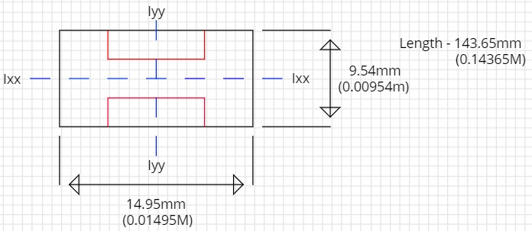
Figure 41 Triumph Second Moment of Area Diagram
$$I_{xx}=\frac{(0.01495)({0.00945}^{3})}{12}$$
Equation 114 Rectangular Second Moment of Area Evaluated "X" Triumph
$$I_{xx}=1.0817{×10}^{-9} M^{4}$$
$$I_{yy}=\frac{(0.00945)({0.01495}^{3})}{12}$$
Equation 115 Rectangular Second Moment of Area Evaluated "Y" Triumph
$$I_{yy}={2.6313×10}^{-9} M^{4}$$
The smallest second moment of area is used to calculate buckling load.
$$P_{e}=\frac{π^{2}(210{×10}^{9})({1.0817×10}^{-9})}{{0.14363}^{2}}$$
Equation 116 Euler's Buckling Load Evaluated Triumph
$$P_{e}=108676.4764 N=108.676 KN$$

Ford Buckling Load
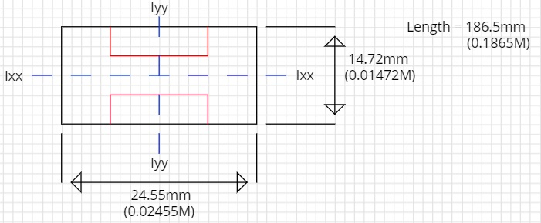
Figure 42 Ford Second Moment of Area Diagram
$$I_{xx}=\frac{(0.02455)(0.01472^{3})}{12}$$
Equation 117 Rectangular Second Moment of Area Evaluated "X" Ford
$$I_{xx}={6.5252×10}^{-9} M^{4}$$
$$I_{yy}=\frac{(0.01472)({0.02455}^{3})}{12}$$
Equation 118 Rectangular Second Moment of Area Evaluated "Y" Ford
$$I_{yy}={20.1966×10}^{-9} M^{4}$$
The smallest second moment of area is used to calculate buckling load.
$$P_{e}=\frac{π^{2}({190×10}^{9})({6.5252×10}^{-9})}{{0.1865}^{2}}$$
Equation 119 Euler's Buckling Load Evaluated Ford
$$P_{e}=351794.8695 N=351.795 KN$$

Comparisons
Now all the data has been collected it is possible to compare them to each other to show the differences in loading of connecting rods in a car and motorcycle and the impact this may have on design considerations during manufacturing.
In order to better understand how each data set for each connecting rod compares to the corresponding data set in the second rod each section will be compared like for like.

FEA Comparison
Simply from looking at the construction of each of the connecting rods it is clear that the Ford rod is significantly more reinforced than its Triumph counterpart. A second difference in the construction of the rods that became clear through modelling is the inclusion of machined faces and indexing pins between the top and bottom of the Triumph connecting rod as opposed to what essentially amounts to a rough break between the Ford connecting rod top and bottom. This shows that more care was put into the Triumph construction to avoid the build-up of stress concentrations at the points where the two rod halves meet. ((UNSW), 2020)
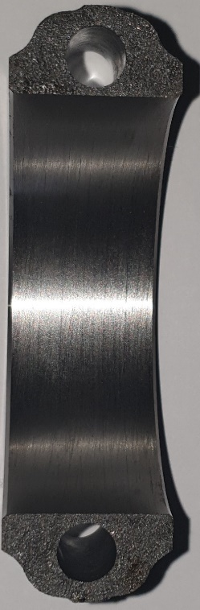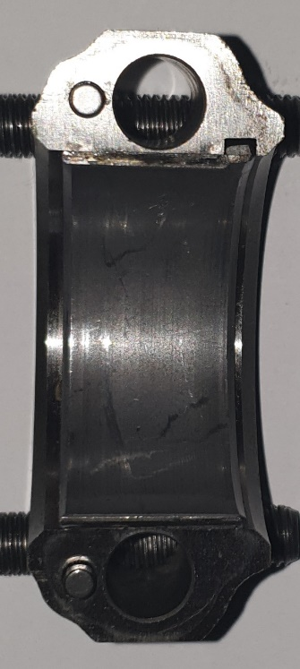
Figure 43 Ford and Triumph Connecting Rod Bottom Caps
There are also key differences in the design of the bolts used to secure each rod together.
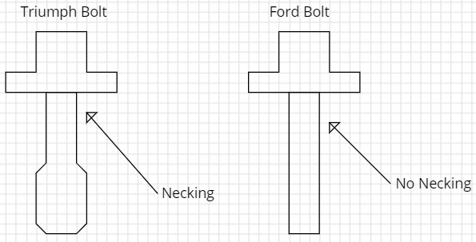
Figure 44 Connecting Rod Bolt Design Comparison
Despite the smaller size of the Triumph connecting rod the bolts used have a thicker gauge and a finer thread. The implementation of a narrow section in the bolt above the threaded section called necking; this technique is used so a more durable material can be used over the entire length of the bolt, making the main shank less stiff and providing a pre-defined failure point to make maintenance easier should a bolt snap under load. As steel obeys Hooke’s law the overall stiffness of the bolt shank cannot exceed the minimum stiffness of any section of the bolt, (Williams, 2015) The contact surface between the bolt cap and the rod also has a larger diameter as stiffness is directly proportional to area. (Ken Youssefi, 2020)
$$Stiffness \left(K\right)=\frac{Young^{'}s Modulus ×Area}{Length}$$
Equation 120 Stiffness
None of these design considerations are present in the Ford bolts, indicating that more emphasis was put into increasing the durability of the bolts used by Triumph, this could be due to the increased inertia loads acting through the Triumph bolts. (Halford, 2006)
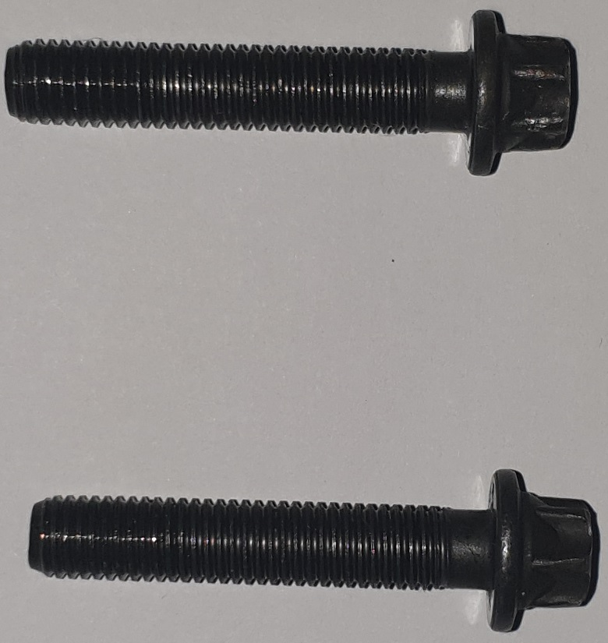
Figure 45 Ford Connecting Rod Bolts
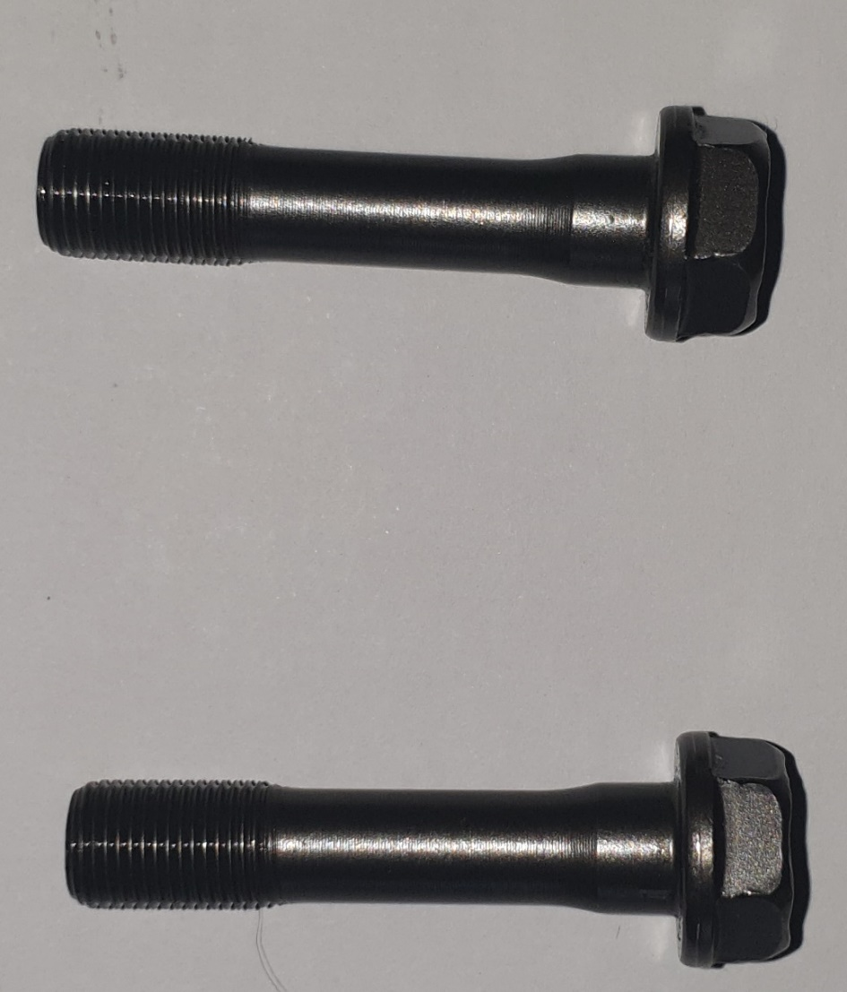
Figure 46 Triumph Connecting Rod Bolts

Calculated Comparison
Looking first at the Gudgeon pins; the Ford Gudgeon pin has a fatigue safety factor 4.1089 times greater than that of the Triumph, indicating that the Ford engine is designed to last significantly longer than the Triumph in constant use. This theory is reinforced when the fatigue safety factors at the key locations in the connecting rod are considered. Fatigue safety factors at each key rod point in the Ford are at least double those of the Triumph. At point A on the Triumph connecting rod the fatigue safety factor is below 1, this indicates that the rod may be unable to last the full warranty lifetime if it is consistently run at peak RPM. The increased durability of the Ford connecting rod is further reinforced by the buckling load of the Ford connecting rod being over three times that of the Triumph.
The increased attention paid to overall durability in the Ford connecting rod indicates the purpose the vehicle was designed for; in the United Kingdom the primary mode of transportation for the majority of the population is by car, whereas a small minority make use of motorcycles, and an even smaller minority of those use it as their primary mode of transportation. (Statista, 2020). This could be due to the use of a motorcycle being in-opportune for general use due to lack of carrying capacity, or even impractical for large parts of the year such as during the winter or in bad weather.

Conclusion
Due to cars being used more frequently and for longer durations than motorcycles it would make sense that they are engineered to last far longer than motorcycles which are typically viewed as recreational vehicles by most of the public.
However design considerations have been made in the construction of each rod to optimise them for their primary use; a car connecting rod is likely to be over-built to increase longevity, while the connecting rod in a motorcycle especially one such as the Triumph Daytona 675r is lightened and optimised for a more sporting environment. If the connecting rod from the Ford was used in the same high speed operating conditions as the Triumph the mass of the connecting rod as well as the bolt design would likely fail quickly due to the massive increase in inertia loads, whereas the motorcycle connecting rod in a slower environment would withstand the conditions with ease.

Recommended Further Work
Further work could be carried out to calculate the forces acting through the connecting rod bolts to provide further insight into the design considerations made for each connecting rod; this can be easily done and even used to find if the bolts used are single use or multiple use.
The finite element analysis section could be repeated using more powerful computers to provide a more accurate representation of the stresses acting on the entire connecting rod and the impacts these may have.

Works Cited
(NASA), N. A. (2020, March 22). Newton's Second Law. Retrieved from grc.nasa.gov: https://www.grc.nasa.gov/WWW/k-12/airplane/newton2.html
(UNSW), U. o. (2020, April 4). Reducing Stress Concentrations. Retrieved from Materials.unsw.edu.au: http://www.materials.unsw.edu.au/tutorials/online-tutorials/1-reducing-stress-concentrations
A.L. Guzzomi, D. H. (2007). Variable inertia effects of an engine including piston. Perth: The University of Western Australia.
A.L. Guzzomi, D. H. (2008). Variable Inertia Effects of an Engine Including Piston Friction and a Crank or Gudgeon Pin Offset. Journal of Automobile Engineering, 397-414.
All Metals & Forge Group. (2020, March 13). AISI / SAE 4340 ALLOY STEEL. Retrieved from steelforge.com: https://www.steelforge.com/alloy-steel-4340/
AmesWeb. (2020, March 30). Young's Modulus of Steel. Retrieved from amesweb.info: https://amesweb.info/Materials/Youngs-Modulus-of-Steel.aspx
Ape Race Parts. (2020, March 13). 2009 Triumph Daytona 675. Retrieved from aperaceparts.com: http://aperaceparts.com/tech/2009%20Triumph%20Daytona%20675.html
Ashby, M. F. (2011). Chapter 14 - Case Studies: Process Selection. In M. F. Ashby, Materials Selection in Mechanical Design (Fourth Edition) (pp. 415-436). Elsevier.
AZO Materials. (2020, March 13). AISI 4130 Alloy Steel (UNS G41300). Retrieved from azom.com: https://www.azom.com/article.aspx?ArticleID=6742
AZO Materials. (2020, March 13). Chromium Molybdenum Steel and High Temperature Applications. Retrieved from azom.com: https://www.azom.com/article.aspx?ArticleID=14790
Baguley, H. (1994). Why do Finite Element Analysis. NAFEMS (The National Agency for Finite Element Methods and Standards).
Bin Zheng, Y. L. (2013). Stress and Fatigue of Connecting Rod in Light Vehicle Engine. The Open Mechanical Engineering Journal, 14-17.
Boyce, M. P. (2012). 3 - Compressor and Turbine Performance Characteristics. In M. P. Boyce, Gas Turbine Engineering Handbook (Fourth Edition) (pp. 139-176). Butterworth Heinemann.
Cartecc. (2020, March 7). Inertial forces and -torques . Retrieved from kfz-tech.de: https://www.kfz-tech.de/Engl/Biblio/Verbrennung/Massenkraefte01.htm
Caton, J. A. (2018). The Thermodynamics of Internal Combustion Engines: Examples of Insights. MDPI, 1-30.
Center, N. R. (2020, March 23). Stress and Strain. Retrieved from nde-ed.org: https://www.nde-ed.org/EducationResources/CommunityCollege/Materials/Mechanical/StressStrain.htm
Chao Cheng, A. K. (2015). Modeling of Piston Ring-Cylinder Bore-Piston Groove Contact. SAE International.
Courses, M. &. (2020, March 25). Tension and Compression in Connecting Rods. Retrieved from emweb.unl.edu: http://emweb.unl.edu/Mechanics-Pages/Luke-schreier/unzip/Tension%20and%20Compression%20in%20Connecting%20Rods%20VI.htm
Dassault Systemes. (2020, March 12). Analysis Solvers. Retrieved from Solidworks.com: http://help.solidworks.com/2018/english/SolidWorks/cworks/c_Analysis_Solvers.htm
David R.H. Jones, M. F. (2019). Chapter 10 - Dislocations and Yeilding In Crystals. In M. F. David R.H. Jones, Engineering Materials 1 (Fifth Edition) An Introduction to Properties, Applications and Design (pp. 157-167). Butterworth Heinemann.
Dung Viet Nguyen, V. N. (2018). Numerical Analysis of the Forces on the Components. Applied Sciences, 1-12.
Engineer, C. (2006). Quick and Easy Way for Solving Bending Moment and Shear Force Problems. Retrieved from civilengineer.webinfolist.com: https://civilengineer.webinfolist.com/mech/easybmsf.htm
EPI Inc. (2014, August 8). Piston Motion Basics. Retrieved from epi-eng.com: http://www.epi-eng.com/piston_engine_technology/piston_motion_basics.htm
Femto. (2020, March 12). Get an impression of the usage and possibilities of FEA. Retrieved from Femto.eu: https://www.femto.eu/stories/what-is-fea/
Feng Yu, J. X. (2019). The vibration reduction design of single-cylinder engine based on the balance shaft. Vibroengineering Prodedia, 18-23.
Ford Racing. (2020, March 13). Four-Cylinder Engine Section. Ford Technical Data Sheet. Ford Motor Company.
G.F. Hundy, A. T. (2016). Chapter 4 - Compressors. In A. T. G.F. Hundy, Refrigeration, Air Conditioning and Heat Pumps (Fifth Edition) (pp. 59-87). Butterworth Heinemann.
Ghojel, J. (2010). Review of the Development and Applications of the Wiebe Function: A Tribute to the Contribution of Ivan Wiebe to Engine Research. International Journal of Engine Research, 297-312.
Hailemariam Nigus. (2015). Kinematics and Load Formulation of Engine Crank. Mechanics, Materials Science and Engineering Journal, Magnolithe.
Halford, G. R. (2006). Fatigue and Durability of Structural Materials. ASM International.
Horedt, G. (2004). Polytropes: Applications in Astrophysics and Related Fields. Springer Science & Business Media.
Jelaska, D. (2010). Fatigue Safety Factor General Formula Proposition for the Prestressed Components Subjected to Arbitrary CA Stress Cycling Process. Split: University of Split-FESB.
Kazuo Nakayama, M. A. (1988). Machining Characteristics of Hard Materials. CIRP Annals, 89-92.
Ken Youssefi, T. A. (2020). Structure and Stiffness. San Jose: San Jose State University.
Lagace, P. A. (2009). The Column and Buckling. Cambridge: Massachusetts Institute of Technology (MIT).
Mahle. (2010). Weatherly Index 002 Catalog No. PI-20-09. Weatherly Index 002. Mahle-Aftermarket.
Matweb. (2020, March 13). Aluminium 201.0-T6 Casting Alloy. Retrieved from matweb.com: http://www.matweb.com/search/datasheet_print.aspx?matguid=cb43b5d9252f45f29fd488ff9ad9bdae
Mayaguez, U. o. (2020, March 25). Combined Loads. Retrieved from Academic.uprm.edu: http://academic.uprm.edu/pcaceres/Courses/MMII/IMoM-6B.pdf
MDME. (2020, March 23). How to Find Bending Moment. Retrieved from learneasy.info: http://www.learneasy.info/MDME/MEMmods/MEM30006A/Bending_Moment/Notes/Bending-Moment.pdf
MDME: Manufacturing, D. M. (2020, March 23). 2nd Moment of Area. Retrieved from learneasy.info: http://www.learneasy.info/MDME/MEMmods/MEM30006A/Area_Moment/Area_Moment.html
Metric Conversions. (2020, March 7). Bar to Newtons per metre squared conversion. Retrieved from Metric-conversions.org: https://www.metric-conversions.org/pressure/bar-to-newtons-per-metre-squared.htm
Mitsuhiro Okayasu, Y. M. (2015). Material Properties of Various Cast Aluminum Alloys Made. Open Access Metals, 1440-1453.
Motorcycle Specs. (2020, March 7). Triumph Daytona 675R. Retrieved from Motorcyclespecs.co.za: https://www.motorcyclespecs.co.za/model/triu/triumph_daytona_675R%2014.htm
Motrolix. (2020, March 7). Ford 1.6L Sigma Engine. Retrieved from FordAuthority.com: https://fordauthority.com/fmc/ford-motor-company-engines/ford-sigma-engine-family/ford-1-6l-sigma-engine/
Naveed Anwar, F. A. (2017). Chapter Four - Response and Design for Shear and Torsion. In F. A. Naveed Anwar, Structural Cross Sections (pp. 251-328). Butterworth Heinemann.
P.L.DHAR. (2017). Thermal system design and simulation. Elsevier LTD.
Parks, N. (2018, March 13). How to Calculate Piston Force. Retrieved from Sciencing.com: https://sciencing.com/calculate-piston-force-7476402.html
Pranav Nagar, S. M. (2011). Friction Between Piston and Cylinder of an IC Engine: a Review. SAE Technical Paper, 7.
Richard Gentle, P. E. (2001). Thermodynamics. In P. E. Richard Gentle, Mechanical Engineering Systems (pp. 7-111). IIE Core Textbooks Series.
rodopoulos, C. (2003). Safety Factor and Fatigue Life Estimates. Springer, Dordrecht.
Roylance, D. (2000). Stresses in Beams. Cambridge: Massachusetts Institute of Technology (MIT).
S.H. Cho, S. A. (2001). A Simple Model to Estimate the Impact Force Induced by Piston Slap. Journal of Sound and Vibration, 229-242.
Statista. (2020, April 6). Number of Cars on The Road in the United Kingdom (UK) 2000-2018. Retrieved from statista.com: https://www.statista.com/statistics/299972/average-age-of-cars-on-the-road-in-the-united-kingdom/
The Engineering Tool Box. (2020, March 7). Radian. Retrieved from Engineeringtoolbox.com: https://www.engineeringtoolbox.com/radian-d_942.html
The National Programme on Technology Enhanced Learning (MPTEL) India. (2020). Superfinishing Processes, Honing Lapping and Superfinishing. MPTEL India.
Toolbox, E. (2020, March 25). Stress, Strain, and Young's Modulus. Retrieved from Engineeringtoolbox.com: https://www.engineeringtoolbox.com/stress-strain-d_950.html
ToolBox, T. E. (2020, March 20). Metals and Alloys - Densities. Retrieved from engineeringtoolbox.com: https://www.engineeringtoolbox.com/metal-alloys-densities-d_50.html
University, C. (2020, March 8). Derivation of Slider-Crank Model. Retrieved from engr.colostate.edu: https://www.engr.colostate.edu/~allan/thermo/page2/page2.html
University, P. (2020, March 9). Work. Retrieved from Chemed.Chem.Perdue.edu: http://chemed.chem.purdue.edu/genchem/topicreview/bp/ch5/work.html
V. Ramamurti, S. S. (2012). Design Considerations of Gudgeon Pin in Reciprocating Air Compressors by Semi Analytic Approach. Journal of Mechanical Engineering Research, 75-88.
Vijay Baban Kamble, P. K. (2018). Design and Analysis of Gudgeon Pin to Minimize Stress Concentration: A Review. International Journal for Research in Applied Science & Engineering Technology, 2098-2101.
Williams, M. (2015, Fubruary 16). What is Hooke's Law. Retrieved from Phys.org: https://phys.org/news/2015-02-law.html
X-Engineer. (2020, March 20). Kinematic Analysis of the ICE Piston. Retrieved from x-engineeri.com: https://x-engineer.org/automotive-engineering/internal-combustion-engines/ice-components-systems/kinematic-analysis-of-the-ice-piston/
Zhifeng Xie, Q. X. (2018). A new closed-form method for inertia force and moment calculation in reciprocating piston engine design. Science China Technological Sciences, 879-885.

Figures
Figure 1 Ford Connecting Rod Figure 2 Triumph Connecting Rod 1
Figure 3 Ford Sigma 1.6L Engine Information (Motrolix, 2020) 3
Figure 4 Triumph Daytona 675R Engine Information (Motorcycle Specs, 2020) 3
Figure 5 Connecting Rod Dimension Diagram 4
Figure 6 Triumph Connecting Rod Dimensions Figure 7 Ford Connecting Rod Dimensions 4
Figure 8 Triumph Piston Mass Figure 9 Ford Piston Mass 5
Figure 10 First and Second Order Inertia Forces 7
Figure 11 Combined Inertia Forces 8
Figure 12 Ford Maximum Compressive and Tensile Forces 9
Figure 13 Triumph Maximum Compressive and Tensile Forces 9
Figure 14 Solidworks Equations 16
Figure 15 Ford Con-rod Model Figure 16 Triumph Con-rod Model 17
Figure 17 Ford Cylinder Assembly Figure 18 Triumph Cylinder Assembly 18
Figure 19 Ford Connecting Rod FEA Von Mises Stress 21
Figure 20 Ford Connecting Rod FEA Displacement 22
Figure 21 Ford Connecting Rod FEA Strain 23
Figure 22 Triumph Connecting Rod FEA Von Mises Stress 24
Figure 23 Triumph Connecting Rod FEA Von Mises Stress Plan View 24
Figure 24 Triumph Connecting Rod FEA Displacement 25
Figure 25 Triumph Connecting Rod FEA Displacement Plan View 25
Figure 26 Triumph Connecting Rod FEA Strain 26
Figure 27 Triumph Connecting Rod FEA Strain Plan View 26
Figure 28 Gudgeon Pin Radii 29
Figure 29 Gudgeon Pin Lengths Diagram 33
Figure 30 Goodman Diagram Example 35
Figure 31 Triumph Gudgeon Pin Goodman Diagram 38
Figure 32 Ford Gudgeon Pin Goodman Diagram 40
Figure 33 Connecting Rod Key Points Diagram 41
Figure 34 Connecting Rod Cross-Section Diagram 42
Figure 35 Triumph Point "A" Goodman Diagram 44
Figure 36 Ford Point "A" Goodman Diagram 46
Figure 37 Triumph Point "B" Goodman Diagram 47
Figure 38 Ford Point "B" Goodman Diagram 49
Figure 39 Triumph Point "C" Goodman Diagram 50
Figure 40 Ford Point "C" Goodman Diagram 52
Figure 41 Triumph Second Moment of Area Diagram 53
Figure 42 Ford Second Moment of Area Diagram 54
Figure 43 Ford and Triumph Connecting Rod Bottom Caps 55
Figure 44 Connecting Rod Bolt Design Comparison 56
Figure 45 Ford Connecting Rod Bolts 57
Figure 46 Triumph Connecting Rod Bolts 58

Equations
Equation 1 RPM to Radian per Second Conversion 4
Equation 2 Revolutions Per Second 4
Equation 3 Time Per Revolution 4
Equation 4 Time Taken Per Degree of Crank Travel 5
Equation 5 Ford Average Cylinder Pressure 5
Equation 6 Triumph Average Cylinder Pressure 5
Equation 7 Bar to Newton per Square Metre Conversion 5
Equation 8 Gas Force Equation 5
Equation 9 Piston Reciprocating Mass 6
Equation 10 Piston Rotating Mass 6
Equation 11 First Order Inertia Force 7
Equation 12 Second Order Inertia Force 7
Equation 13 Combined Inertia Force 7
Equation 14 Net Force 8
Equation 15 Connecting Rod Angle 8
Equation 16 Connecting Rod Force 9
Equation 17 Swept Cylinder Volume 10
Equation 18 Compression Ratio 10
Equation 19 Clearance Volume 10
Equation 20 Piston Displacement 10
Equation 21 Simulated Cylinder Volume 10
Equation 22 Polytropic Index 11
Equation 23 Pressure Simulation 11
Equation 24 Wiebe Function 11
Equation 25 Combustion Pressure 12
Equation 26 Side Force 12
Equation 27 Side Friction Force 12
Equation 28 Radial Force 13
Equation 29 Radial Friction Force 13
Equation 30 Total Work done 13
Equation 31 Total Friction Force 13
Equation 32 Work Lost Through Friction 13
Equation 33 Net Work Done by the Cylinder 13
Equation 34 Piston Acceleration 27
Equation 35 Triumph Compressive Piston Acceleration Evaluated 27
Equation 36 Triumph Tensile Piston Acceleration Evaluated 28
Equation 37 Ford Compressive Piston Acceleration Evaluated 28
Equation 38 Ford Tensile Piston Acceleration Evaluated 28
Equation 39 Gudgeon Pin Mass 29
Equation 40 Gudgeon Pin Mass Evaluated, Triumph Total 29
Equation 41 Gudgeon Pin Mass Evaluated, Triumph Total 29
Equation 42 Length of the Pin Section Jutting Out 29
Equation 43 Length of the Pin Section Jutting Out Evaluated Triumph 30
Equation 44 Length of the Pin Section Jutting Out Evaluated Ford 30
Equation 45 Mass of the Pin Jutting Out Evaluated Triumph 30
Equation 46 Mass of the Pin Jutting Out Evaluated Ford 30
Equation 47 Pin Inertia Force 30
Equation 48 Pin Inertia Force Triumph (Compressive) 30
Equation 49 Pin Inertia Force Triumph (Tensile) 30
Equation 50 Pin Inertia Force Ford (Compressive) 30
Equation 51 Pin Inertia Force Ford (Tensile) 31
Equation 52 Second Moment of Area for a Hollow Cylinder 31
Equation 53 Second Moment of Area Evaluated Triumph 31
Equation 54 Second Moment of Area Evaluated Ford 31
Equation 55 Distance to the Neutral Axis 31
Equation 56 Distance to Neutral Axis Evaluated Triumph 31
Equation 57 Distance to Neutral Axis Evaluated Ford 32
Equation 58 Net Bending Moment Compressive 33
Equation 59 Net Bending Moment Tensile (Vijay Baban Kamble, 2018) 33
Equation 60 Bending Stress 33
Equation 61 Shear Stress Compressive 34
Equation 62 Shear Stress Tensile 34
Equation 63 Combined Stress 34
Equation 64 Allowable Stress Range 35
Equation 65 Fatigue Safety Factor 35
Equation 66 Net Bending Moment Compressive Evaluated Triumph 35
Equation 67 Bending Stress Compression Evaluated Triumph 36
Equation 68 Shear Stress Compressive Evaluated Triumph 36
Equation 69 Combined Stress Compression Evaluated Triumph 36
Equation 70 Net Bending Moment Tension Evaluated Triumph 36
Equation 71 Net Bending Stress Tension Evaluated Triumph 36
Equation 72 Shear Stress Tension Evaluated Triumph 36
Equation 73 Combined Stress Tension Evaluated Triumph 36
Equation 74 Allowable Range Evaluated Triumph 37
Equation 75 Fatigue Safety Factor Evaluated Triumph 37
Equation 76 Net Bending Moment Compression Evaluated Ford 38
Equation 77 Bending Stress Compression Evaluated Ford 38
Equation 78 Shear Stress Compression Evaluated Ford 39
Equation 79 Combined Stress Compression Evaluated Ford 39
Equation 80 Net Bending Moment Tension Evaluated Ford 39
Equation 81 Bending Stress Tension Evaluated Ford 39
Equation 82 Shear Stress Tension Evaluated Ford 39
Equation 83 Combined Stress Tension Evaluated Ford 39
Equation 84 Allowable Range Evaluated Ford 40
Equation 85 Fatigue Safety Factor Evaluated Ford 40
Equation 86 Compressive Stress 42
Equation 87 Tensile Stress 43
Equation 88 Compressive Stress at Point “A” Evaluated Triumph 43
Equation 89 Tensile Stress at point "A" Evaluated Triumph 43
Equation 90 Allowable Range Evaluated Area "A" Triumph 44
Equation 91 Fatigue Safety Factor Evaluated Area "A" Triumph 44
Equation 92 Compressive Stress Evaluated Area "A" Ford 45
Equation 93 Tensile Stress Evaluated Area "A" Ford 45
Equation 94 Allowable Range Evaluated Area "A" Ford 45
Equation 95 Fatigue Safety Factor Area Evaluated Area "A" Ford 45
Equation 96 Compressive Stress Evaluated Area "B" Triumph 46
Equation 97 Tensile Stress Evaluated Area "B" Triumph 46
Equation 98 Allowable Range Evaluated Area "B" Triumph 47
Equation 99 Fatigue Safety Factor Evaluated Area "B" Triumph 47
Equation 100 Compressive Stress Evaluated Area "B" Ford 48
Equation 101 Tensile Stress Evaluated Area "B" Ford 48
Equation 102 Allowable Range Evaluated Area "B" Ford 48
Equation 103 Fatigue Safety Factor Evaluated Area "B" Ford 48
Equation 104 Compressive Stress Evaluated Area "C" Triumph 49
Equation 105 Tensile Stress Evaluated Area "C" Triumph 49
Equation 106 Allowable Range Evaluated Area "C" Triumph 50
Equation 107 Fatigue Safety Factor Evaluated Area "C" Triumph 50
Equation 108 Compressive Stress Evaluated Area "C" Ford 51
Equation 109 Tensile Stress Evaluated Area "C" Ford 51
Equation 110 Allowable Range Evaluated Area "C" Ford 51
Equation 111 Fatigue Safety Factor Evaluated Area "C" Ford 51
Equation 112 Second Moment of Area About Neutral Axis for a Rectangle 52
Equation 113 Euler's Buckling Load for Pinned Ends 53
Equation 114 Rectangular Second Moment of Area Evaluated "X" Triumph 53
Equation 115 Rectangular Second Moment of Area Evaluated "Y" Triumph 53
Equation 116 Euler's Buckling Load Evaluated Triumph 53
Equation 117 Rectangular Second Moment of Area Evaluated "X" Ford 54
Equation 118 Rectangular Second Moment of Area Evaluated "Y" Ford 54
Equation 119 Euler's Buckling Load Evaluated Ford 54
Equation 120 Stiffness 56

Acknowledgements
With a special thanks to Karen Slade for tirelessly proofreading every assignment, report, and presentation submitted in the duration of this course, and the Engineering faculty of UWTSD for providing the learning environment to grow and develop.
Additional thanks to Peter Slade, Maddison Slade, Nick Evans, Philippa James, Alexis “Lexie” Kushmaul, Phoebe Lillis, Francesca Lonie, and Sean Russ for their endless support and patience over the last 4 years and many more before that.

