University Of Wales Trinity Saint David (UWTSD)

Student name: Virag Pusztai

Student number: 2242115

Tutor: Scott James

Course: BA International Hotel Management, Marketing Essentials (BMIH4005)

Submission deadline: 20th of November 23:59

Submitted: 20th of November 2023.

Assignment Title: A Comparison of The Marketing Methods of Two Multinational Hotel Brands: Six Senses and Holiday Inn

World count: 1613

A Comparison of The Marketing Methods of Two Multinational Hotel Brands: Six Senses and Holiday Inn
Introduction
Effective marketing strategies are pivotal in shaping success within the dynamic hospitality industry (Tajeddini et al., 2020). This essay delves into the divergent approaches of Six Senses and Holiday Inn. Six Senses, an exclusive luxury brand, contrasts with the globally recognized, more accessible Holiday Inn, reflecting the multifaceted nature of the hospitality market. This analysis dissects the marketing strategies of Six Senses and Holiday Inn, presuming that Holiday Inn caters to a youthful audience, contrasting with Six Senses' focus on an affluent, older demographic. This research seeks to uncover these brands’ complexity and effects on the highly competitive hospitality industry. This paper explores an in-depth discussion of the marketing strategy used by Holiday Inn and Six Senses. Such key points encompass a situational assessment based on SWOT and PESTLE approaches, a comparison of marketing mixes, segmentation, targeting, positioning analysis, and current matters affecting the hospitality environment.
Situational Internal/External Analysis
Using SWOT and PESTLE framework helps shine the dark spots of Six Sense and Holiday Inn, which are its internal and external environment. Six Senses might demonstrate strengths in its luxury placement (Six Senses, n.d). The global presence of Holiday Inn has proven to be an integral advantage. Six Sense’s weaknesses include reduced coverage, but Holiday Inn could suffer due to being regarded as standardized. Firstly, Six Senses can exploit external chances originating from the trend towards upper-class travel, while Holiday Inn might profit from being well-known in various regions worldwide. Economic downturns that affect luxury expenditure are possible threats to Six Senses. Also, Holiday Inn faces high levels of saturated competition in the mid-range hospitality market (2020, p. 166). Such a dual framework enables an insightful view of brands’ competitive positions and possible strategies.
They are comparing the marking mixes of Six Sense and Holiday In, which provides deep insights into their orientation strategies. However, the six senses, focusing on elite luxury, depart from an accessibly globalized holiday inn (Loxton, 2020, p166). The unique market positions of the competitors are based on diversities in product offerings, pricing models, and promotional strategies (Trebicka et al. 2023). Although Six Senses can leverage prestige, Holiday makes its case for the affordability and attractiveness of its services to a broader customer base. Tajeddini et al. (2020) state that exploring these distinctions is crucial for achieving strategic effectiveness. For instance, similarities like both brand’s dedication to quality service could reflect an industry standard. These observations inform strategic implications; Six Senses could leverage exclusivity for premium pricing, while Holiday Inn might emphasize widespread accessibility in targeted promotions (Camilleri, 2018).
Understanding these nuances is pivotal for crafting strategies aligned with each brand's unique market positioning (Wheeler, 2017). Adaptations to contemporary issues are crucial in the dynamic hospitality landscape. For Six Senses and Holiday Inn, responses to geopolitical, such as the Ukraine war, necessitate agility. If geopolitical tensions impact travel patterns or safety perceptions, Six Senses may need to reassess its exclusive positioning, potentially emphasizing secure, curated experiences. Conversely, Holiday Inn may need to address any concerns affecting its global accessibility swiftly. Digital communication tools and tailored marketing campaigns could be pivotal in maintaining customer trust (Ebrahim, 2020). Assessing and adapting to geopolitical shifts is essential for both brands to stay resilient in an ever-changing global environment, ensuring they align their strategies with evolving consumer sentiments and geopolitical realities, safeguarding their market presence and customer loyalty.
Marketing Mix
Examining the 7 Ps helps illuminate Six Senses and Holiday Inn's distinct marketing approaches, with Six Senses emphasizing exclusive luxury experiences while Holiday Inn provides standard accommodations (IHG 2019a). Pricing strategies differ significantly between hotels; Six Senses boasts premium offerings at premium rates, while Holiday Inn provides more budget-conscious accommodations. Geographic reach and physical presence underscore differences in location between Six Senses exclusive sites and Holiday Inn's global footprint. Promotion strategies vary between Six Senses and Holiday Inn, with Six Senses emphasizing exclusivity through its campaigns while Holiday Inn stresses affordability and convenience. Representatives representing staff may reflect luxury-trained personnel compared with Holiday Inn's standardized service model. Processes involved with operational efficiency vary by brand positioning. Physical evidence representing each brand reveals their distinct identities and target market positioning; Six Senses being luxurious while Holiday Inn is functional are good examples.
Such variations mirror specific, deliberate decisions taken to promote the unique identity of the six Senses and highlight a particular niche that Holiday Inn targets. Thus, we obtain information not only concerning Six Seasons’ tactics but also regarding Holiday Inn policy. The insight is critical, especially in understanding their similarities and dissimilarities. In this respect, Holiday Inn’s offer is far more affordable than the six senses. The two firms also value quality services and want to set industry standards. These differences suggest strategic implications: Six Senses can exploit it for higher prices and experience customized to attract niche customers. On the other hand, Holiday Inn will provide cheap accommodations worldwide with reliability for a larger audience. This distinction is vital as it forms the core strategic decision for these two brands to make meaningful connections with their targeted customers and stay ahead of one another amid fierce competition in the hospitality industry. However, a more involved assessment of my original hypotheses expressed within my thesis reveals complicated findings about my claims, such as how
For instance, Holiday Inn accommodates youthful guests, and Six Senses welcomes more affluent, elderly individuals. Holiday Inn’s strategies might attract young market sections that are aimed by price and approachability (Indeed 2022); in opposition to Six Senses, it is orientated to a wealthy senior demography looking to find outstanding experiences (six Sense 2023). They are partially verifying assumptions stressed market segmentation's importance in specifying targets to develop suitable market-oriented programs. However, we must admit that customers’ tastes differ greatly depending on the brand. Both of them have something that might catch the eye of a particular class of people. Therefore, we should understand that there is a need for continuous market research to help make up proper adjustable marketing strategies for every period.
Segmentation, Targeting, and Positioning
Studying Six Senses’ and Holiday Inn’s customers using SimilarWeb data highlights target markets. Globally, Similar Web places the company at No. 136,090, totaling 444.5K monthly visits (2023). The traffic coming from their website is also high in that it has a high bounce rate of 58.95%, and most of it originates from the United States, comprising 16.04%. Its decline from 655.2K visitors to 444.5K suggests a possible consumer shift. Holiday Inn is one of the most popular brands, with about 593K monthly visitors. The low bounce rate (53.23%) and a large percentage of visitors from the U.S. (58.18%) (SimilarWeb, 2023). The digital marketing channels of these two brands focus on Search and Direct sources, which makes America, the UK, Canada, Singapore, and Mexico noteworthy markets for these brands. It fits Holiday Inn’s slightly higher search dominance over its broad market strategy than Six Senses, which emphasizes premium and high-end positioning. These include vital understandings that guide targeted marketing approaches towards different groups of customers and changes in consumer behaviours.
A closer analysis of Six Senses and Holiday Inn’s targeting strategies shows a more nuanced approach. In this case, Six Senses’ design is connected with a niche target audience that demands a unique experience. Holiday Inn employs more generic methods. Holiday Inn’s international footprint is extensive, with different kinds of customers. As such, this resort takes an inclusive approach to cater to as many travellers as practicable (IHG 2019b). The data indicates that both brands used precision marketing to tailor to specific customer profiles. This analysis provided essential insight into improving marketing campaigns to increase engagements within different market areas.
These positioning tools help to understand where Six Senses stands relative to Holiday Inn, its main competitor. Six Senses stands out among other luxury hotels that offer low traffic. This fact should be regarded as a quality instead of an insult since it appeals only to connoisseurs ready to pay for comfort. Holidays Inn provides readily available and trustworthy solutions for a more comprehensive client range due to its international ranking and monthly visitors. The two products belong to different niches, but they all compete in the hospitality sector, proving the essence of differentiation as consumers’ need varies. Understanding these unique vantage points is essential to sharpen marketing strategies and remain competitive in a dynamic market environment.
The underlying story of both Six Senses’ and Holiday Inn’s marketing approach lies in their integration of segmentation, targeting, and positioning into their respective marketing strategies. The target segment of Six Senses includes a class of high-end, sophisticated consumers seeking unique product offers but prepared to pay a premium price as they are keen on luxury. Holiday Inn’s inclusive market strategy is revealed in affordable pricing, global penetration, and reliability, the characteristics of the situational analysis explaining how environmental cues shape the firm’s strategic choices. Connecting these elements shows that each brand positions itself in the market. This relationship is between segmentation, targeting, positioning, and the entire marketing and environmental sphere.
Conclusion
The thesis showed us that Holiday Inn addressed younger audiences, whereas Six Senses approached high-income rich people. This hypothesis was proven partially correct, pointing out that the whole process is complicated and requires regular investigation to improve the targeting strategy. The research outlined delicate nuances of marketing mix structure; situational analysis revealed differences in the competitive strengths and weaknesses of Six Senses and Holiday Inn hotels and the exclusive groups of customers to each hotel type. The hospitality market is very dynamic, with high customer needs and preferences; therefore, targeting and positioning strategies were crafted to suit their tastes and show market responsiveness, considering that a custom approach is essential for gaining success. For instance, shows have involved the significance of continuous consumer interest polls in geopolitics occurrences. Hospitality marketers should continuously change and adapt to meet the dynamic world and evaluate how such issues as changing consumer behavior and geopolitical events affect them.
Reference List
Adam, M., Putra, T.R.I. and Ibrahim, M., 2023. Marketing Strategy for Tourism Potential in the Framework of Regional Development as a Tourist Destination. Indatu Journal of Management and Accounting, 1(1), pp.12-20.
Brunela Trebicka, Azeta Tartaraj and Ariola Harizi (2023). Analyzing the relationship between pricing strategy and hotel customer retention: A study in Albania. F1000Research, 12, pp.690–690. doi:https://doi.org/10.12688/f1000research.132723.1.
Camilleri, M. Anthony. Travel marketing, tourism economics and the airline product: An introduction to theory and practice. Springer International Publishing, 2018.
Ebrahim, R.S., 2020. Trust's role in understanding social media marketing's impact on brand equity and loyalty. Journal of Relationship Marketing, 19(4), pp.287-308.
IHG (2019a). IHG further expands its luxury footprint by acquiring Six Senses Hotels Resorts Spas. [online] InterContinental Hotels Group PLC. Available at: https://www.ihgplc.com/en/news-and-media/news-releases/2019/ihg-further-expands-luxury-footprint-with-acquisition-of-six-senses-hotels-resorts-spas.
IHG (2019b). Our global presence. [online] InterContinental Hotels Group PLC. Available at: https://www.ihgplc.com/en/about-us/our-global-presence.
IHG Hotels (2023). IHG Hotels & Resorts showcases impressive growth for its Holiday Inn brand family in Southern Europe. [online] InterContinental Hotels Group PLC. Available at: https://www.ihgplc.com/en/news-and-media/news-releases/2023/ihg-hotels-and-resorts-showcases-impressive-growth-for-its-holiday-inn-brand-family.
Indeed (2022). How to use target marketing. [online] Indeed Career Guide. Available at: https://www.indeed.com/career-advice/career-development/benefits-of-targeting.
Kretschmer, T., Leiponen, A., Schilling, M. and Vasudeva, G., 2022. Platform ecosystems as meta‐organizations: Implications for platform strategies. Strategic Management Journal, 43(3), pp.405-424.
Loxton, M., Truskett, R., Scarf, B., Sindone, L., Baldry, G. and Zhao, Y., 2020. Consumer behavior during crises: Preliminary research on how coronavirus has manifested consumer panic buying, herd mentality, changing discretionary spending, and the role of the media in influencing behaviour. Journal of Risk and Financial Management, 13(8), p.166.
SimilarWeb (2023). Similarweb.com - Digital World Market Intelligence Platform. [online] SimilarWeb.com. Available at: https://www.similarweb.com/.
Six Senses (2023). Six Senses Award Season 2023. [online] Six Senses. Available at: https://www.sixsenses.com/en/corporate/media-center/press-releases/2023/six-senses-awards-season-2023.
Six Senses (n.d.). Five Star Luxury Resorts | Exotic Spas | Development. [online] www.sixsenses.com. Available at: https://www.sixsenses.com/en/about-us/development.
Spyropoulou, S., Katsikeas, C.S., Skarmeas, D. and Morgan, N.A., 2018. Strategic goal accomplishment in export ventures: the role of capabilities, knowledge, and environment. Journal of the Academy of Marketing Science, 46, pp.109-129.
Tajeddini, K., Martin, E. and Ali, A., 2020. Enhancing hospitality business performance: The role of entrepreneurial orientation and networking ties in a dynamic environment. International Journal of Hospitality Management, 90, p.102605.
Wheeler, A., 2017. Designing brand identity: an essential guide for the whole branding team. John Wiley & Sons.
Appendix
Six senses Data
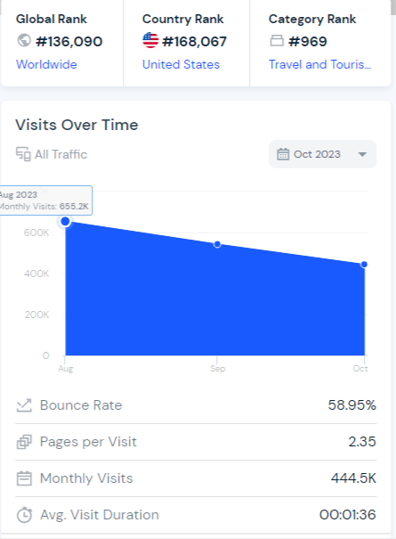
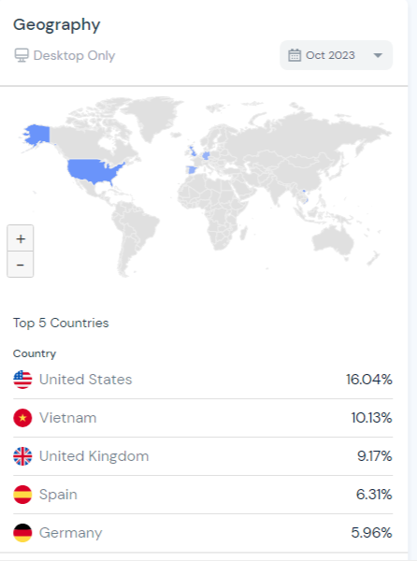
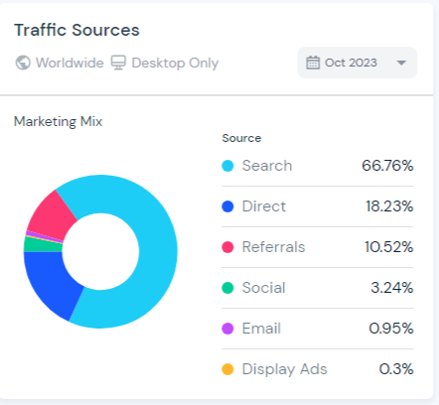

Holiday Inn Data


