City Hotel Financial Assessment Report

Report Title: Financial Assessment and Strategic Recommendations for City Hotel

Student Information:
Name: Aniko Takacsne Feher
Student ID: 245369
Module Title: Financial Management for the Hotel Industry
Lector’s name: Tristan Hawkins
Word count: 1838
AI Declaration: In order to analyze the financial performance and risk exposure of City Hotel / Financial management for the hotel industry, I declare that I did not use artificial intelligence tools to prepare the report.

Executive Summary
The City Hotel is a UK independent hotel chain that has gone into bankruptcy over the past three years after losing revenues, occupancy and customer satisfaction. This price pressure coincides with broader industry dynamics where price increases, inflation, and evolving consumer preferences have negatively affected the hospitality sector (Saffery, 2023). The UK’s economic system has exacerbated these pressures, with rising inflation driving up prices for staples and services such as food, electricity and salaries. Increased interest rates have further burdened debt servicing and reduced consumer spending, further driving down hotel and dining demand (ONS, 2024; KPMG UK, 2024).
This report explains City Hotel’s financial condition, profitability, liquidity, and solvency in great detail. The report lists fixed costs as the leading causes of decline, inefficiencies and increasing competition (eHotelier, 2024; Social Tables, 2024; PwC UK, 2024) from other lodging alternatives like Airbnb.
The report proposes cost reduction measures, including cutting overhead expenses, streamlining employee productivity and renegotiating contracts to restore City Hotel’s financial stability and profitability. Revenue-creating strategies such as dynamic pricing and seasonal offers are also suggested to drive up occupancy during off-peak times (Movylo, 2024; CORE, 2024). Retention measures — like loyalty rewards and better guest experience — aim to promote sustainable loyalty (FHA-HoReCa, 2023; Adzoyi, Blomme & Honyenuga, 2021).
It requires a robust risk management process to handle fluctuations in demand, workforce security, and regulatory compliance. Typical controls include employee training, audits and scalable operating procedures that all follow best practices to maintain City Hotel’s resilience (The Times, 2024; UK Hospitality, 2024).
Conclusion: This report presents City Hotel with a business strategy to manage the cost, increase the revenue and mitigate the risk. By implementing these measures, City Hotel will be able to enhance liquidity, increase customer retention and gain long-term value in an aggressive marketplace (SAGE Publications, 2024; Social Tables, 2024).
Table of Contents
Executive Summary ................................................................................................... 2
- Introduction ................................................................................................................ 4
- Financial Performance Analysis ............................................................................... 5
2.1 Income Statement Analysis .................................................................................... 5
2.2 Balance Sheet Analysis .......................................................................................... 6
2.3 Financial Ratios Analysis ....................................................................................... 7
- Key Drivers of Decline ............................................................................................. 10
3.1 Internal Factors ..................................................................................................... 10
3.2 External Factors .................................................................................................... 10
3.3 Positioning and Competitive Alternatives ............................................................ 10
- Risk Management Analysis ..................................................................................... 12
4.1 Market Risks ........................................................................................................ 12
4.2 Operational Risks ................................................................................................. 12
4.3 Financial Risks ..................................................................................................... 13
4.4 Regulatory Risks .................................................................................................. 13
- Conclusion and Recommendations ......................................................................... 14
5.1 Cost Optimization ................................................................................................ 14
5.2 Revenue Enhancement ......................................................................................... 14
5.3 Operational Efficiency ......................................................................................... 14
5.4 Debt Restructuring ............................................................................................... 15
Summary of Feasibility ............................................................................................ 15
References ................................................................................................................. 16
Appendices ................................................................................................................ 18
Appendix A: Financial Ratio Calculation Methods ................................................... 18
Appendix B: Bowman’s Strategy Clock Analysis ..................................................... 22
Appendix C: Industry Benchmark Data ..................................................................... 23

1. Introduction

City Hotel is an independent restaurant, bar, and event venue business based in the UK. Over the last three years, the hotel has experienced significant financial losses, which reflects the wider UK hospitality sector (UK Hospitality, 2024). The hotel lost revenue, customer satisfaction and rooms prices, and became financially vulnerable. The British economy has exacerbated these issues further as inflation has pushed prices for food, energy and labour up. In addition, recent interest rate increases have challenged City Hotel’s debt servicing capabilities, and a decline in discretionary spending has also led to a drop in demand for non-essential services, such as hotel rooms and meals (Financial Times, 2024; House of Commons Library, 2024).

What leads to such losses demands a deep analysis of what goes on in- and outside-, and possible interventions. It compares City Hotel financial condition through an extensive ratio model, and its performance to the benchmark to know where the hotel matches or is out of sync with the rest of the industry. External influences like evolving consumer habits and increased competition from other forms of accommodation such as Airbnb have exacerbated the need for City Hotel to react to a shifting market environment (PwC UK, 2024; Syrve, 2024).

The report also discusses risk management procedures to identify and mitigate threats to the hotel’s survival. The key internal drivers are high operating expenses, while external factors — changing customer expectations and rising competition — bring in more active changes (The Times, 2024). This report contains tailored recommendations to improve profitability, liquidity, and solvency due to the magnitude of these challenges. These recommendations are driven by the prevailing hospitality industry and the wider economic climate for UK hotels. The role of City Hotel will be reviewed from both a business and strategic point of view to see whether it is in a competitive, changing market.

2. Financial Performance Analysis

This report analyses City Hotel’s income statement, balance sheet and financial ratios to help determine its financial health and make suggestions for improvements.

2.1 Income Statement Analysis
The City Hotel’s revenue slipped 55.7% from £5.25m to £2.32m in 2021-23, which reveals financial pressure. This drop, only partially offset by reductions in employee and external costs, underscores the need for stringent cost management (Adzoyi, Blomme & Honyenuga, 2021). Inflationary pressures on essential goods and rising wages have further challenged the hotel’s expense management (ONS, 2024; UKHospitality, 2024). The operating income of -£1.2 million in 2023 illustrates the critical need for cost-cutting measures to restore stability.
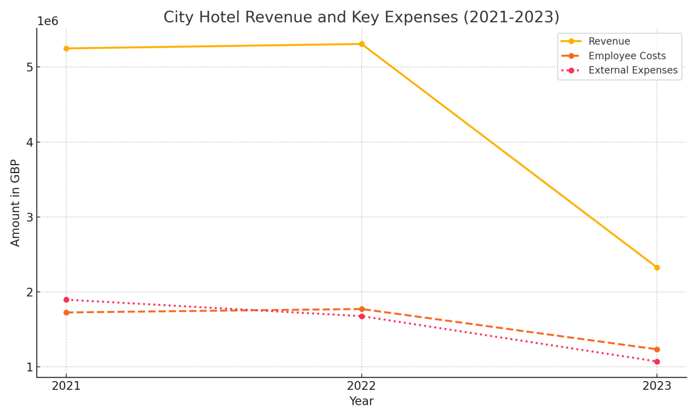
Diagram 1: Revenue and Key Expenses (2021-2023) – although employee and external expenses decreased slightly, they remain high relative to reduced revenue, indicating a need for further cost-cutting measures (Saffery, 2023).

2.2 Balance Sheet Analysis
The balance sheet displays a large decrease in liquidity as cash positions drop 60% from £740,590 in 2021 to £295,510 in 2023. Ledger growth as a result of debt dependence reduced financial flexibility, with higher interest rates increasing the burden on debt servicing resources (House of Commons Library, 2024). Without restructuring, City Hotel’s solvency would be endangered as increasing debt impedes the hotel’s operations (CORE, 2024).
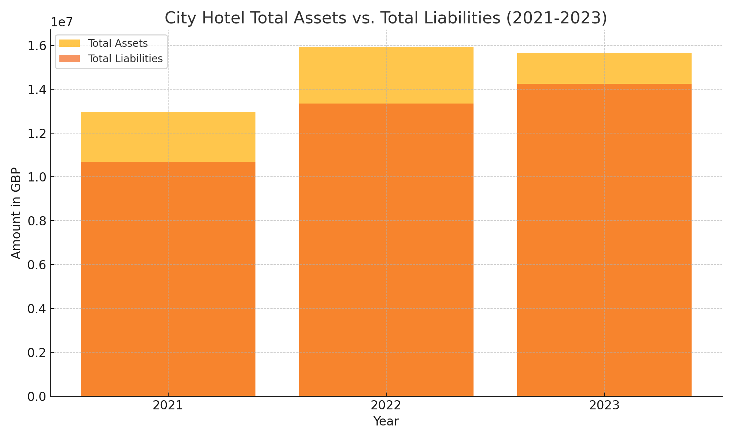
Diagram 2: Total Assets vs Total Liabilities (2021-2023) – as liabilities increase, assets stagnate or shrink, the restructuring cost becomes evident. If you are extending debt without a revenue base that will drive City Hotel bankrupt, restructuring is required (UK Hospitality, 2024).

2.3 Financial Ratios Analysis

These metrics provide valuable insight into City Hotel’s profitability, liquidity and solvency exposures that influence the hotel’s strategic options and future growth.

Profitability Ratios
Thanks to good management of direct costs, City Hotel had a stable gross profit margin, which hovered around 92% (Adzoyi, Blomme & Honyenuga, 2021). But the operating profit margin declined significantly from 12.65% in 2021 to -52.41% in 2023 and inefficiencies and overhead costs are driving down profits (Social Tables, 2024). That’s why lowering costs and making your operation more efficient is essential to getting back to profit.
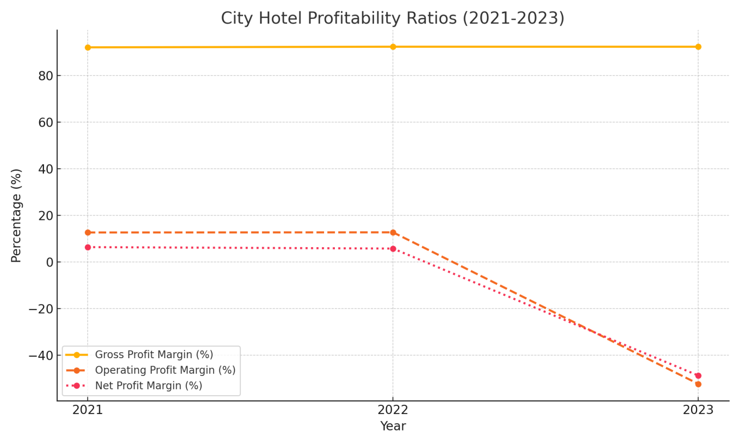
Diagram 3: These changes in profitability ratios (2021-2023) show you how you can optimise the hotel and get it back on track.

Liquidity Ratios
Its ratio now sank from 0.97 in 2021 to 0.64 in 2023, much lower than the industry average of 1.0–1.5 (Saffery, 2023). No exception was the quick ratio, which signalled an immediate liquidity crisis that made it difficult for the hotel to provide short-term accommodation. This liquidity issue could constrain short-term financing and make cash flow optimization (i.e., revenue growth and price reduction) imperative.
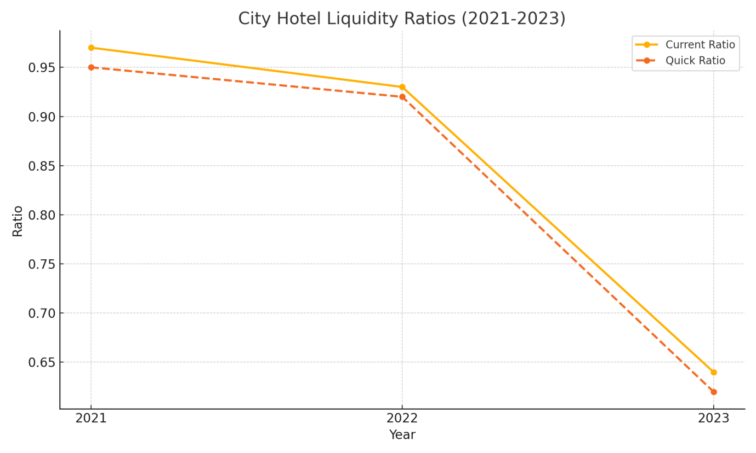
Diagram 4: Liquidity Ratios Comparison (2021-2023) benchmarks these ratios to the market’s standards to identify areas where City Hotel might lack financial elasticity.

Solvency Ratios
Its debt-to-equity ratio climbed from 4.74 to 10.1 between 2021 and 2023, exceeding the industry norm of 2.0 and implying high debt usage (UKHospitality, 2024). The negative interest coverage ratio also highlights the fact that the hotel is not producing the operational revenue required to pay off the debt. Solvency issues of this kind drive restructuring and targeted debt downgrades to improve liquidity.
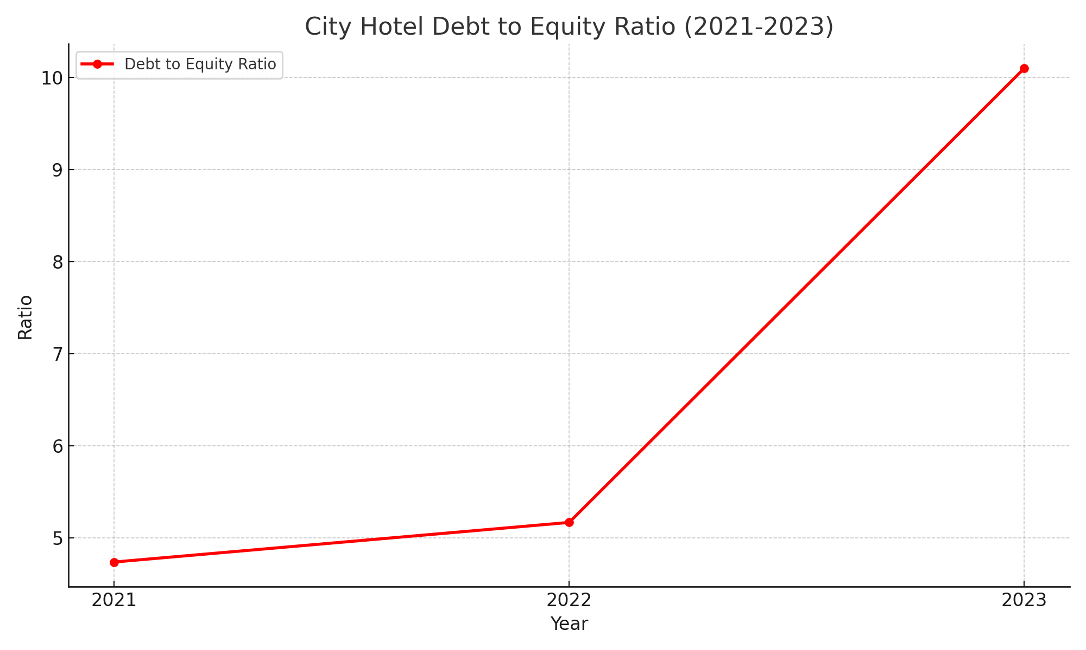

Diagram 5: Debt-to-Equity Ratio (2021-2023). This rapidly growing debt to equity ratio is undermining City Hotel’s capacity to generate financial mobility and rendering debt management and restructuring extremely challenging.

Key Insights and Strategic Implications
City Hotel’s immediate objective, the review explains, is to raise liquidity and margins to hold on. Debt restructuring and cash flow optimization (cost containment and revenue optimization) will be necessary to reduce the hotel’s high leverage and bring it back into solvency. Without such efforts, City Hotel may be unable to sustain its growth or attract additional funds.

3. Key Drivers of Decline
Below is a comprehensive breakdown of the major internal and external causes for City Hotel’s financial woes.
3.1 Internal Factors
- Unpredictable Costs: Uncertain staffing costs results in poor profits, especially when low occupancy. It would relieve some of the pressure if staffing were shifted according to demand (eHotelier, 2024).
- Process inefficiencies: Cost overruns and asset utilisation inefficiencies have affected profit. Streamlining these could reduce expenses.
3.2 External Factors
• Financial Pressures: Inflation, higher interest rates and less consumer demand have heightened operating costs and lowered demand for non-essential services, reducing occupancy and revenues (Financial Times, 2024; House of Commons Library, 2024).
• Competition: Greater competition from short-term renting platforms such as Airbnb requires City Hotel to optimize its experience for the customer or change its rates to gain access to customers (Adzoyi, Blomme & Honyenuga, 2021; PwC UK, 2024).
3.3 Positioning and Competitive Alternatives
In Bowman’s Strategy Clock, the City Hotel Low Price/Low Value rank now indicates lower-end service. City Hotel could use the following strategies to improve its competitiveness:
1. Uniqueness: Optimizing for guest satisfaction so that it is worth the moderate price bump serves the consumer’s appetite for differentiated experiences (Syrve, 2024).
2. Context-Based Differentiation: Specifying target groups such as business travellers will encourage loyalty and lower the barrier to entry.
Those investments (as outlined in Appendix B) would further reinforce City Hotel’s position and prospects.
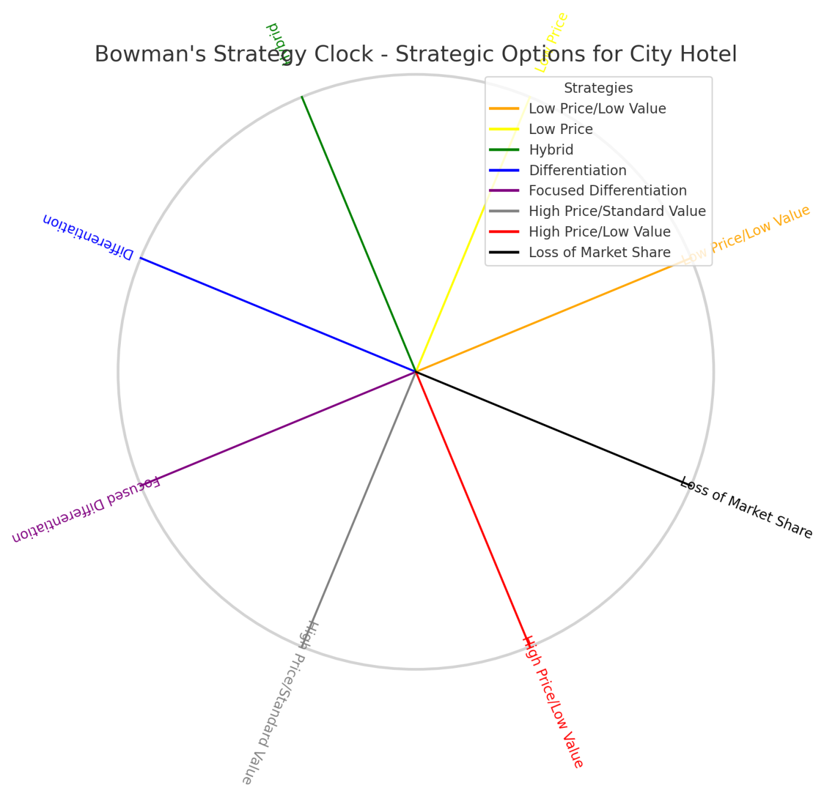
Diagram 6: Bowman’s Strategy Clock - City Hotel Strategic Strategies.

4. Risk Management Analysis

City Hotel is exposed to various markets, operational, financial and regulatory risks that impact cash flow and stability. It requires strategic plans to mitigate these risks and keep the hotel financially viable (SAGE Publications, 2024).

4.1 Market Risks
Seasonal changes in demand, competition from short-term rentals like Airbnb, can harm sales and turnover (Movylo, 2024). Inflation and declining consumer consumption also impact guests’ willingness to pay for non-essential services (KPMG UK, 2024).
- Action: Reduce
- Strategy: Use dynamic and off-peak pricing models to lock demand all year round. Seasonal discounts and rewards programs will further smooth occupancy volatility and eliminate dependence on peak season traffic.

4.2 Operational Risks
Employee burnout, increasing operating costs and service fragmentation have operational consequences for customer experience and reputation (The Times, 2024). Slave labour costs and wage demands in the industry drive up personnel expenses and even instability (UKHospitality, 2024).
- Action: Reduce
- Strategy: Manage operational risks through specific employee training and standard operating procedures (SOPs) to ensure a high quality service. Employer retention programs that provide rewards and promotions will result in less turnover, lower recruiting costs, and more employee longevity (Social Tables, 2024).

4.3 Financial Risks
- Risky assets: high debt levels, cash flow constraints, and insolvency (CORE, 2024). As interest rates have climbed, City Hotel’s debt is now getting much bigger, and it’s essential that we work on restructuring debt (House of Commons Library, 2024).
- Action: Reduce
- Strategy: Refinance debt by negotiating new terms or lower interest rates to generate cash flow. Building up an emergency fund for the unexpected will be a safety net that will decrease the need for short-term capital and give more resilience to financial shocks (Saffery, 2023).

4.4 Regulatory Risks
City Hotel risks regulatory penalties for failure to comply with health, safety and labour laws resulting in fines, court action or reputational damage (UKHospitality, 2024). It’s important to abide by these rules or face penalties and disruption.
- Action: Avoid
- Strategy: You must conduct compliance audits and provide employee training on health, safety and regulations on a regular basis. Such moves reduce regulatory exposure, protect the hotel’s image and ensure continuous operations (eHotelier, 2024).

5. Conclusion and Recommendations

City Hotel balance sheets need individualized actions to reduce costs, revenue and pay down debt. Such proposals are anchored to the hotel’s balance sheet sustainability and long-term expansion within the existing landscape.

5. 1. Cost Optimization
Action: Identify and scale staff to service off-peak needs and negotiate supplier agreements to cut fixed costs.
Feasibility: They are budget friendly and require very little capital at the start. Lower operating expenses will create greater cash flows and will overcome City Hotel’s immediate liquidity issues (Social Tables, 2024; ONS, 2024).
5. 2. Revenue Enhancement
Action: Use variable pricing, deals, and incentives to increase occupancy and conversion rates.
Feasibility: These recurring revenue programs are affordable and effective and will enable City Hotel to capture market share when demand is high and generate consistent revenues. Optimising occupancy and retention is responsive to market demand and enhances profitability (FHA-HoReCa, 2023; Saffery, 2023).
5. 3. Operational Efficiency
Action: Standardize service and train employees to better serve the customer and eliminate staff turnover.
Feasibility: It takes very little time but it pays back for the long-term by reducing hiring costs and ensuring customer retention. Early workflows not only save money but also reinforce City Hotel’s position in the market (eHotelier, 2024).

5. 4. Debt Restructuring
Action: Contact lenders about extending or lowering the loan amount, and set up a cushion fund for last-minute expenses.
Feasibility: It’s imperative to refinance the debt because City Hotel’s high debt-to-equity ratio hinders access to capital. Longer amortization periods will free up short-term debt and allow the hotel to concentrate on cash flow and efficiency (UKHospitality, 2024; House of Commons Library, 2024).
Summary of Feasibility
Such proposals offer an alternative to City Hotel’s liquidity, profitability and solvency issues. In order to reduce costs, increase revenues and pay down debt, City Hotel will be able to grow cash reserves, rationalize operations and establish itself in a more volatile environment.

References
• Adzoyi, L., Blomme, R.J. & Honyenuga, B.Q. (2021). Hospitality and Tourism Management in Emerging Markets: A Case Study Approach. London: Routledge.
• CORE (2024). Financial and Operational Strategies for Hotel Resilience. Available at: core.com [Accessed 10 Nov. 2024].
• FHA-HoReCa (2023). Industry Guide to Customer Retention and Loyalty in Hospitality. Available at: fha-horeca.com [Accessed 10 Nov. 2024].
• Financial Times (2024). More muddling through won't deliver the growth Britain craves. Available at: ft.com [Accessed 10 Nov. 2024].
• House of Commons Library (2024). Economic update: A better short-term outlook for 2024. Available at: commonslibrary.parliament.uk [Accessed 10 Nov. 2024].
• KPMG UK (2024). UK Economic Outlook - September 2024. Available at: kpmg.com [Accessed 10 Nov. 2024].
• Movylo (2024). Effective Revenue Strategies for Hospitality Businesses. Available at: movylo.com [Accessed 10 Nov. 2024].
• Office for National Statistics (2024). Business insights and impact on the UK economy. Available at: ons.gov.uk [Accessed 10 Nov. 2024].
• PwC UK (2024). Hotels Forecast 2023 - 2024. Available at: pwc.co.uk [Accessed 10 Nov. 2024].
• Saffery (2023). UK Hospitality Sector Financial Insights. Available at: saffery.com [Accessed 10 Nov. 2024].
• SAGE Publications (2024). Risk Management in the Hospitality Industry. Available at: sagepub.com [Accessed 10 Nov. 2024].
• Social Tables (2024). Operational Efficiency Best Practices. Available at: socialtables.com [Accessed 10 Nov. 2024].
• Syrve (2024). Your Guide to UK Hospitality Trends in 2024. Available at: syrve.com [Accessed 10 Nov. 2024].
• The Times (2024). Hospitality industry in 'survival mode' after budget blow. Available at: thetimes.co.uk [Accessed 10 Nov. 2024].
• UKHospitality (2024). Facts and Stats: The Current UK Hospitality Landscape. Available at: ukhospitality.org.uk [Accessed 10 Nov. 2024].

Appendices

Appendix A: Financial Ratio Calculation Methods

This Appendix outlines the calculation of the three main ratios in this report (Profitability, Liquidity and Solvency). Below are the formula, example and definition of these ratios.

1. Profitability Ratios
These ratios of profitability define the profits that the hotel is making in terms of revenue and cost.
- Gross Profit Margin
Formula:
Gross Profit Margin = (Revenue−Cost of Goods Sold) / Revenue×100
Example Calculation
2021: (5.248.290 – 411.600) / 5.248.290 x 100 = 92.16%
2022: (5.307.480 – 401.510) / 5.307.480 x 100 = 92.43%
2023: (2.325.440 – 176.250) / 2.325.440 x 100 = 92.42%
Interpretation: A higher gross profit margin means that the hotel is successfully reducing the cost of sales to the cost of goods sold. In City Hotel’s case, the gross profit margin should be at least 90% if direct costs are being taken care of (Adzoyi, Blomme & Honyenuga, 2021).
- Operating Profit Margin
Formula:
Operating Profit Margin = (Operating Income / Revenue) x 100
Example Calculation
2021: (664.160 / 5.248.290) x 100 = 12.65%
2022: (674.730 / 5.307.480) x 100 = 12.71%
2023: (-1.218.850 / 2.325.440) x 100 = -52.41%
Interpretation: This ratio is the core operations profits divided by non-operating expenses. City Hotel’s declining operating margin by 2023 reflects rising operating inefficiencies.
- Net Profit Margin
Formula:
Net Profit Margin = (Net Income / Revenue) x 100
Example Calculation
2021: (333.930 / 5.248.290) x 100 = 6.36%
2022: (304.650 / 5.307.480) x 100 = 5.74%
2023: (-1.134.950 / 2.325.440) x 100 = -48.80%
Interpretation: This ratio represents the profitability of everything including expenses, taxes, and interest. The fact that City Hotel’s net profit margin will shrink to -48.80% by 2023 proves that it is in deep trouble.

- Liquidity Ratios

Liquidity ratios determine whether or not the hotel can pay its short-term debt with existing resources.
- Current Ratio
Formula:
Current Ratio = Total Current Assets / Total Current Liabilities ​
Example Calculation
2021: 1.891.970 / 1.957.360 = 0.97
2022: 1.965.340 / 2.107.750 = 0.93
2023: 1.285.880 / 2.014.600 = 0.64
Interpretation: A current ratio lower than 1 means that the current liabilities exceed the current assets, and could indicate a liquidity issue. On 2023, City Hotel’s current ratio of 0.64 clearly points to the necessity of a proper cash handling process.
Quick Ratio
Formula:
Quick Ratio = (Total Current Assets – Inventories) / Total Current Liabilities
Example Calculation
2021: (1.891.970 – 35.230) / 1.957.360 = 0.95
2022: (1.965.340 – 36.350) / 2.107.750 = 0.92
2023: (1.285.880 – 29.470) / 2.014.600 = 0.62
Interpretation: Because inventory isn’t counted in the quick ratio, it’s a conservative indicator of liquidity. The City Hotel’s quick ratio of 0.62 in 2023 signals a lack of liquidity and difficulty in financing short-term commitments.
Solvency Ratios
Solvency ratios are used to calculate whether or not the hotel will pay off its long-term debt.
- Debt to Equity Ratio
Formula:
Debt to Equity Ratio = ​Total Liabilities / Total Equity
Example Calculation
2021: 10.684.940 / 2.256.180 = 4.74
2022: 13.338.050 / 2.583.030 = 5.16
2023: 14.243.390 / 1.410.580 = 10.10
Interpretation: This split represents the debt/equity financing City Hotel has incurred. An increasing debt-to-equity ratio — 10.1 in 2023 — implies a growing debt load, and hence increased risk.
- Interest Coverage Ratio
Formula:
Interest Coverage Ratio = Operating Income / Interest Expense
Interpretation: This is the ratio used to determine City Hotel’s ability to deduct interest from the operating profits. An negative ratio in 2023 would be a failure to generate enough operating income to pay down the debt.

Calculation: As interest expenses are not stated, this is an abstract calculation. However, negative operating income for 2023 implies that the interest coverage ratio would fall below 1 as a result of not being able to cover interest expense.
Appendix B: Bowman’s Strategy Clock Analysis for City Hotel
Bowman’s Strategy Clock presents you with eight value-priced strategic options. City Hotel's low perceived value and price pressure have put the hotel in a Low Price/Low Value situation where it will likely lose more market share without any strategic measures.
- Present Position: City Hotel’s challenges mirror the Low Price/Low Value triangle, where low differentiation and price competition reduce profits.
- Strategic Options:
- Differentiation: This model emphasizes differentiation via premium, personalised or extra services. This switch to Differentiation improves customer experience and makes it easy to make moderate price changes.
- Small-Border Differentiation: Focusing on specific niche segments, like business travellers, City Hotel can provide targeted services which increase loyalty and lower price sensitivity.
- Hybrid Strategy: Mixing moderate price increases with value-added features, like loyalty or seasonal deals, will allow you to grow without launching into hyper-price increases, as recommended in customer retention strategies.
These alternatives promote the return to a more attractive value, which is a prerequisite for economic recovery. Bowman’s Strategy Clock shown in Diagram 6 shows the recommended positions.

Appendix C: Industry Benchmark Data
Here are the City Hotel ratios versus industry medians:
- Gross Profit Margin: 70-80% typical in the UK hotel industry (PwC, 2023).
- Operating Profit Margin: 10-20% industry standard (Knight Frank, 2021).
- Current Ratio: 1.0 to 1.5 for hospitality businesses.
- Debt to Equity Ratio: Below 2.0 is considered prudent in the UK hospitality sector.

