Andreea Mocanu
1919375
Creativity and Innovation on Amazon Company
UWTSD

Executive Summary
In the following report about Amazon and its chief executive officer, Jeff Bezos, the reader will find information about the history of the firm, as well as details about what they have accomplished thus far, what their plans for the future are, and what the company's innovations are.
The report will show information on the modules that were used to explain Amazon’s innovation, as well as what its opportunities are, along with its advantages, weaknesses, and risks. At the same time, an explanation was provided not only of how the Amazon corporation implements a radical form of innovation, but also of the thought process that lies behind the innovation.
In the end, an explanation was provided regarding the effectiveness of the innovation, as well as the blunders that were produced over the course of time, in addition to the challenges and dangers that Amazon corporation presently poses.
At the same time, the various styles of leadership and management are discussed, as well as the ways in which the company encourages its workers to grow professionally, think creatively, and challenge conventional wisdom. As a result, Amazon workers are given the opportunity to develop into creative problem-solvers who achieve successful outcomes.
In the end, all of the innovation models were presented. These models included an innovation matrix, a 4P model (product, process, paradigm, and position), but also a force field analysis that shows a final score, regarding whether the innovation is for or against. The force field analysis showed that the company uses open innovation. In addition, the innovation matrix showed that the company uses open innovation.

Table of Contents
Executive Summary 2
1.0 Introduction 4
2.0 MAIN FINDINGS 5
2.0 Amazon innovation modules 5
2.1 What is amazon known for 5
2.2 Innovative opportunity 5
2.3 Type of innovation 8
2.4 Creativity thinking process 8
2.5 Assessment of the effectiveness 9
2.5.1 Barriers & Risks 11
2.6 Leadership & Management 11
3.0 Conclusion 13
4.0 References 14

1.0 Introduction
1.0 INTRODUCTION
Amazon Inc. is an American multinational technology company with its main office in Seattle, Washington. Its main business areas are e-commerce, cloud computing, online advertising, digital streaming, and artificial intelligence. People have called it "one of the most important economic and cultural forces in the world" and "one of the most valuable brands in the world." (Yasar, 2022).
It is one of the "Big Five" information technology companies in the United States, along with Alphabet (Google), Apple, Meta (Facebook), and Microsoft. Jeff Bezos started Amazon in the garage of his home in Bellevue, Washington, on July 5, 1994. It started out as a place to buy and sell books online, but it has since grown to include a lot of other things. It is now called "The Everything Store" because of this growth. (History of Domains, 2022).
Amazon has many companies, including Amazon Web Services, which deals with cloud computing, Zoox, which deals with self-driving cars, and Kuiper Systems, which deals with satellite Internet (computer hardware R&D). Some of the other companies it owns as subsidiaries are Ring, Twitch, IMDb, and Whole Foods Market. When it bought Whole Foods in August 2017 for a total of $13.4 billion US dollars, it made a big change to how big it was as a store. (STAND 8, 2023)
Amazon has a reputation for shaking up industries that have been around for a long time because of its use of new technologies and "aggressive" reinvestment of profits into capital expenditures. Amazon earned this name for itself. (Asiabusinessoutlook,2023) As of 2023, it is the world's largest online store and marketplace, cloud computing service provider through AWS, live-streaming service provider through Twitch, smart speaker provider, and Internet corporation based on revenue and market share. It is thought that by 2021, it will have passed Walmart to become the biggest store outside of China. The company's Amazon Prime subscription plan, which has more than 200 million customers all over the world, was a big part of this success. It is the second largest private employer in all of the United States. (Bag,2022)
Amazon uses companies like Amazon Prime Video, Amazon Music, Twitch, and Audible to distribute digital media and stream video and audio content. Since March 2022, it has owned the movie and TV studio Metro-Goldwyn-Mayer. Through its publishing arm, Amazon Publishing, it also puts out books. It also makes movies and TV shows through Amazon Studios, which is its production arm. Amazon also makes consumer electronics. Some of its most well-known products are the Kindle e-readers, Echo devices, Fire tablets, and Fire TVs. (Electronics, 2022)

2.0 MAIN FINDINGS

2.0 Amazon innovation modules
The work that is going to follow will make use of a variety of models, methods, and instruments in order to demonstrate the level of knowledge and comprehension that has been attained with regard to the invention that the Amazon company has produced.
One of the models is called the Innovation matrix, and it demonstrates how the company adapts to various shifts in the realms of technology, business, incremental and radical change, as well as whether the company is one that has open or closed innovation. Amazon, along with CEO Jeff Bezos, is an example of an open innovation company because they gather and accumulate as much relevant information as they can from sources outside the company.
In addition, a force field analysis is presented at the same time. This analysis seeks to provide a score on the company's innovation so that it can be determined whether or not the innovation is one that is beneficial to the company. The four points of innovation that are presented at the same time are the product, the process, the paradigm, and the position.

2.1 What is amazon known for
Amazon is not just the most successful online shop but also the most well-known provider of cloud services. Amazon.com is the domain name for the Amazon online store.
Amazon was once an internet-based bookshop. However, it has since transformed into an internet-based business operation that focuses largely on the supply of e-commerce, cloud computing, digital streaming, and artificial intelligence (AI) services. Amazon started off as a corporation that sold books over the internet when it was first founded. (Hall, 2022)
The firm employs a sales approach known as Amazon-to-buyer, and it carries a very wide variety of products across a massive inventory. Customers are able to buy nearly anything as a result of this, including clothing, beauty products, gourmet cuisine, jewellery, books, movies, electronics, pet supplies, furniture, toys, garden supplies, and other home items. (Layton, 2006)
Amazon is a worldwide firm that calls Seattle, Washington, home to its headquarters. The corporation maintains websites, software development centres, customer care centres, data centres, and fulfilment centres in several different countries, all of which are run under their respective owners' autonomous control.

2.2 Innovative opportunity
Amazon, being such a large company, managed to prove innovation and a well-established and well-done activity.
One of the most initial innovations of the Amazon company was the fact that they created their own operating system for the scanners that they use all over the world in their factories, so there is no need to offer a certain percentage to the company that owns the system operation, and at the same time offers the possibility to make the application as optimal and useful as possible for the company. (Amazon, 2017). The company also shows other opportunities on other levels such as expansion into emerging markets, expanding physical stores, investment in new ventures and acquiring complementary companies.
Amazon has a great chance to get more customers and make more money by going into new markets. This can mean expanding into new geographic areas, both in the United States and abroad, as well as into new product categories or groups of customers. For example, Amazon can go after markets where it isn't very big or isn't there at all, like some Asian or South American countries. (Voyles, 2021). Also, amazon can reach more customers and create a more tangible shopping experience by opening more physical stores. Even though the company doesn't have as many physical stores as other retailers, it has been trying out different formats, like its Amazon Go stores, which offer a convenient and new way to shop. (Garcia,2018)
Another opportunity is that amazon can diversify its income streams and speed up its growth by putting money into new businesses. This can be done by investing in or buying companies in complementary industries, such as cloud computing, advertising, or healthcare, to grow their capabilities and reach.
Amazon can diversify its products, increase its capabilities, and speed up its growth by buying companies that are similar to its own. This can be done by buying companies in similar fields, like e-commerce, technology, or logistics, to create synergies and use the best parts of each company.
At the same time, it can be seen the strengths in figure 1, the weaknesses in figure 2, and the threats in figure 3, thus showing that any company, business or person has certain negative points in addition to the opportunities they present. (Pereira, 2023)
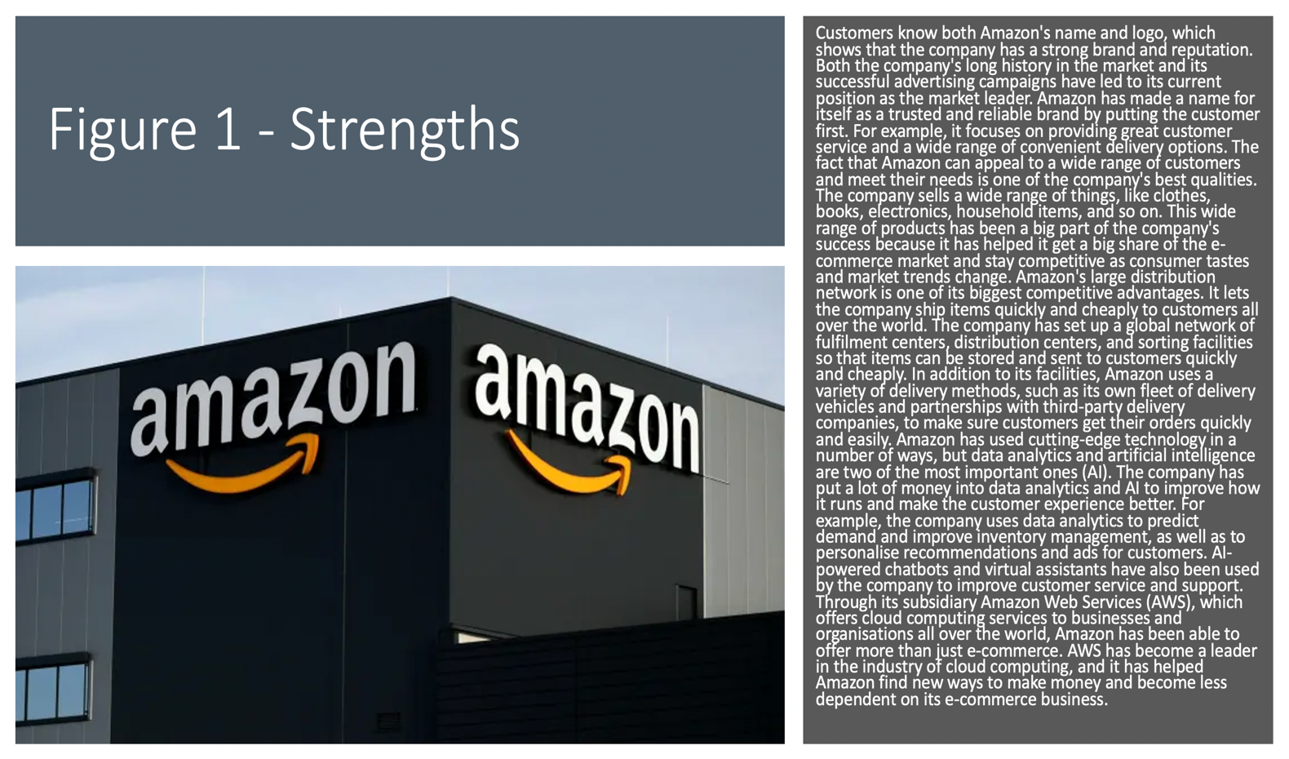
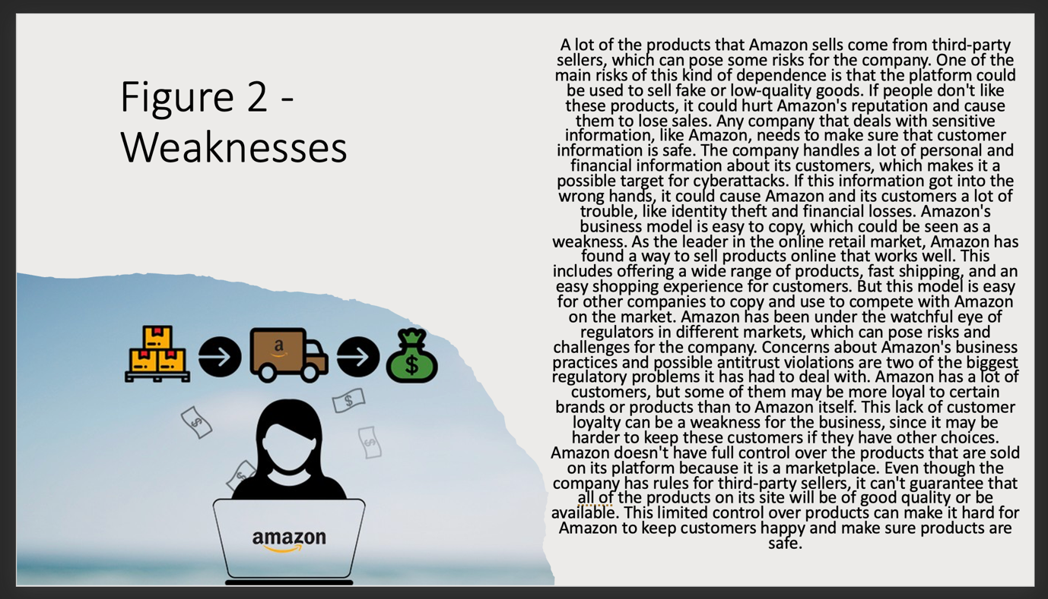

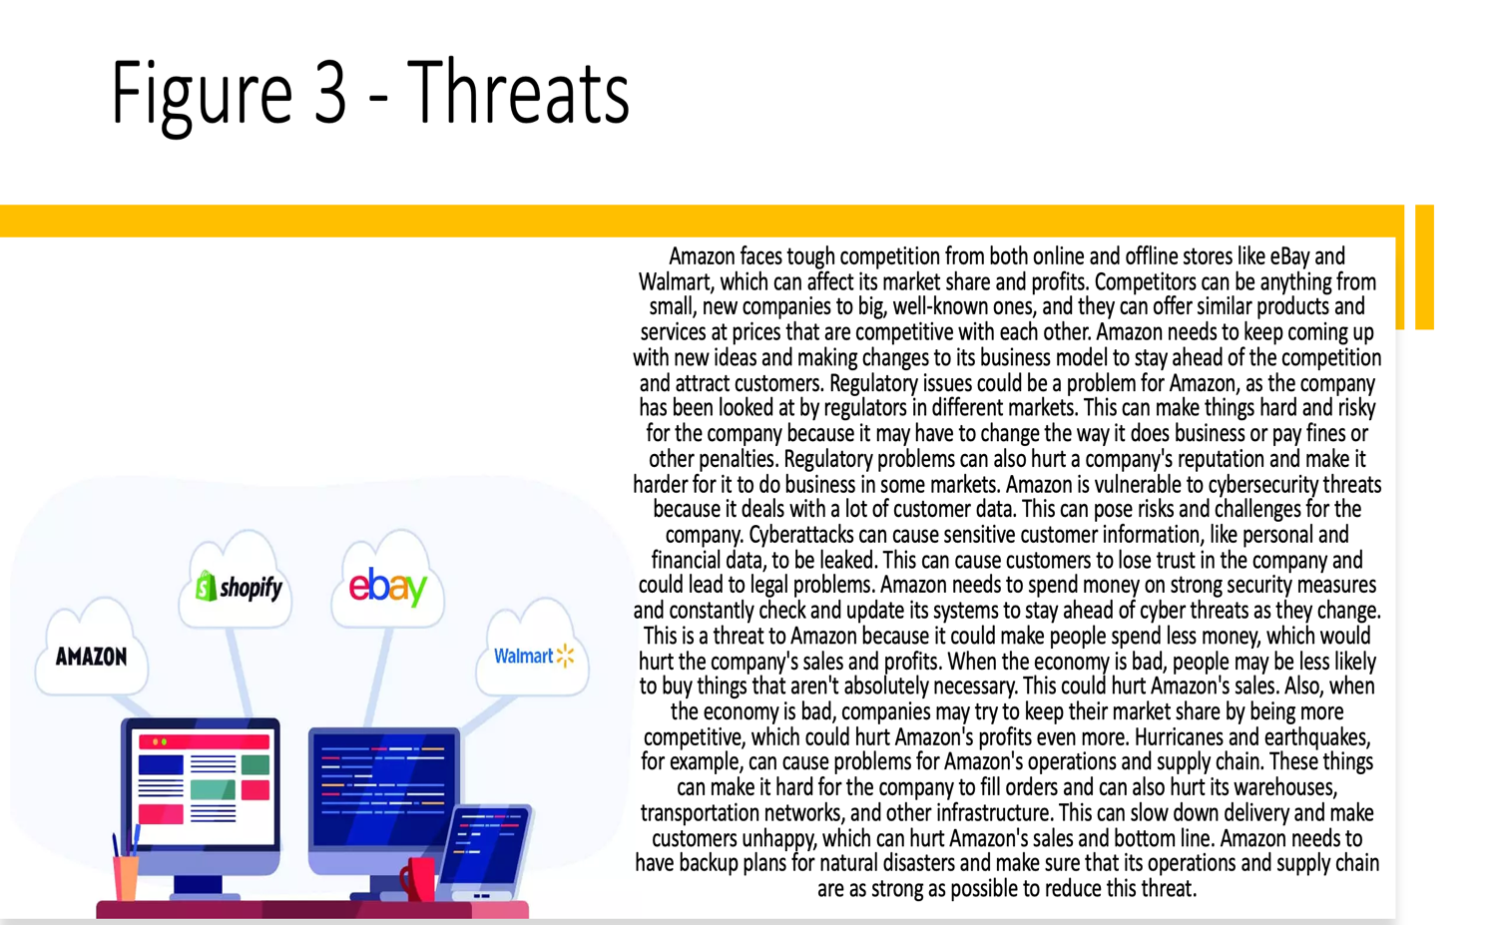

(Carpenter,2015)
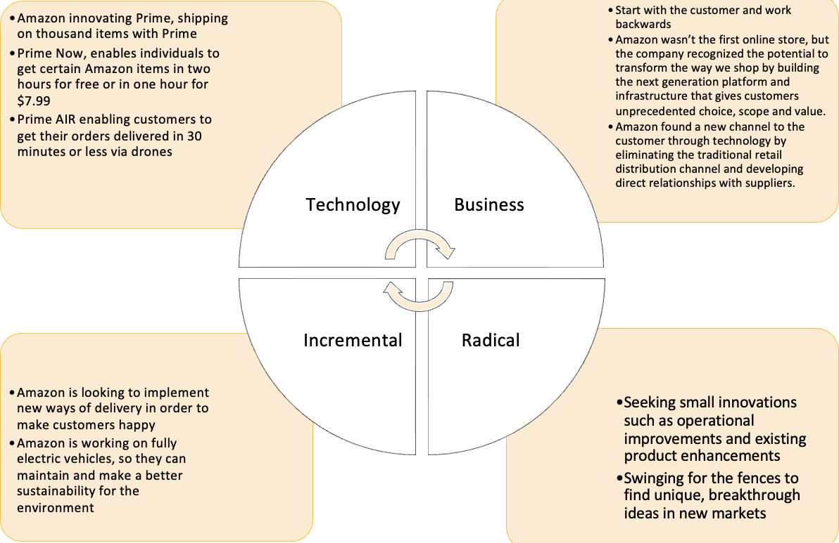

2.3 Type of innovation
A radical innovation strategy is one that makes significant changes to both the business model and the underlying technology. This describes Amazon's approach, which is an example of a radical innovation strategy. (Bieler, 2021)
Amazon's distinctive strategy of sustained and constant experimentation and innovation has made it the industry leader in customer obsession for many years. This has made Amazon the beacon for customer obsession. IT CEOs should investigate the best practises Amazon use to develop distinction and drive growth since firms are striving to become more adaptable, creative, and resilient.
The tone that is set for organisational structures, types of technology, management approaches, and process flows are all determined by culture. In addition, diversity and inclusion are essential enabling factors for the success of innovation since they help promote new perspectives and fresh ideas. The way in which Amazon approaches innovation is based on a collection of strategies, ideas, and instruments that range from cultural practises to business procedures to technological advancements. (Halkett,2022)

2.4 Creativity thinking process
Amazon has certain prescribed rules regarding thinking towards creativity, but also how to make employees become much more innovative.
Every single worker has the authority to suggest new ideas. Any employee who has a novel concept for a product is allowed to compose a vision statement for the product, as well as a hypothetical press release to accompany it, and a frequently asked questions document that describes the consumer benefits and responds to queries that potential customers may have. The proposal is evaluated by a group of Amazon's other innovators, and some of them receive funding and go on to be commercialised. This approach was responsible for the creation of a number of Amazon services, such as Prime Now, Amazon Go, and Alexa. (Amazon, 2019)
In amazon failure is something that is not just accepted, but anticipated as well.
Many businesses, have executives who talk a big game about being willing to take chances and willing to fail. But, when a project is ultimately unsuccessful, it can have a negative impact on the careers of many people involved.
On its site, Amazon says that the company encourages its employees to fail safely. It is about more than the traditional cycle of testing, failing, and trying again, which many businesses may claim. According to the employees at Amazon, conducting research on something that a person already know will be successful is not considered an experiment, and as a result, the person is not creating something new. (Aten, 2019)
Amazon also encourages and supports its staff members in pursuing their individual ideas and passions.It's true that few businesses are as large as Amazon, and even fewer offer as many chances for employees to follow their interests elsewhere inside the firm without having to give up their current job. Yet, Amazon is one of the few corporations that does. Yet, the general principle still stands. It is about coming up with creative solutions to the problem of how to encourage employees to pursue their innovative ideas. (Mautz, 2019)

2.5 Assessment of the effectiveness
Amazon DTC master plan is that Amazon has effectively established the foundational components necessary to dominate the e-commerce market. The company's performance over the past few years is a significant indicator of how well it has been catering to the ever-increasing demand placed on it by customers. (Vamanan,2023)
According to the information gathered, the company's total income for the year 2022 amounted to 469.82 billion US dollars. Amazon, which is known for being an innovator in the field of e-commerce, is known to expand to new dimensions with the new goals that it sets.
Amazon is currently working on developing a new flywheel known as "Purchase with Prime." It has been speculated that this new procedure will have an impact on the payment gateway as well as the fulfilment techniques. (Vamanan,2023)
The Amazon DTC master plan has ambitious long-term objectives in mind. Customers who shop online will soon be able to use their Amazon Prime accounts on other websites in addition to Amazon.com. Using the resources provided by your Prime membership, you will have no trouble investigating a website.
Amazon is not the first company to launch a comprehensive e-commerce utility from their end; they have done so previously. The Checkout by Amazon service was first made available by Amazon. After then, it was rebranded under the more well-known moniker Amazon Pay, which customers may already be familiar with. Both Checkout by Amazon and Amazon Pay operate on the same basic premise.
Purchase with Amazon allows customers to connect their Amazon Pay accounts with Amazon FBA. It should not be assumed that the "Purchase with Amazon" option serves merely as a payment channel. In addition to this, it offers the possibility of free shipping and guarantees a rapid arrival time for the consumer. With the launch of Amazon Prime, Amazon hopes to attract a greater number of customers. (Vamanan,2023). However, Amazon also had certain problems in the past and times when it failed in relation to innovation, as can be seen in figure 4, thus showing those moments when the company tried to create something innovative but did not go according to plan. (Borison, 2015)
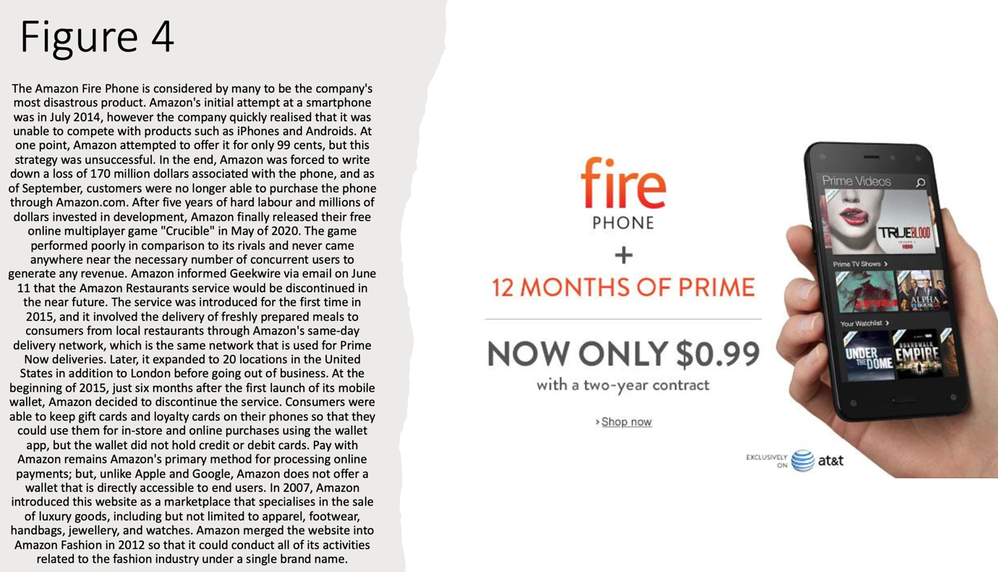
(Meisenzahl & Mary,2021)

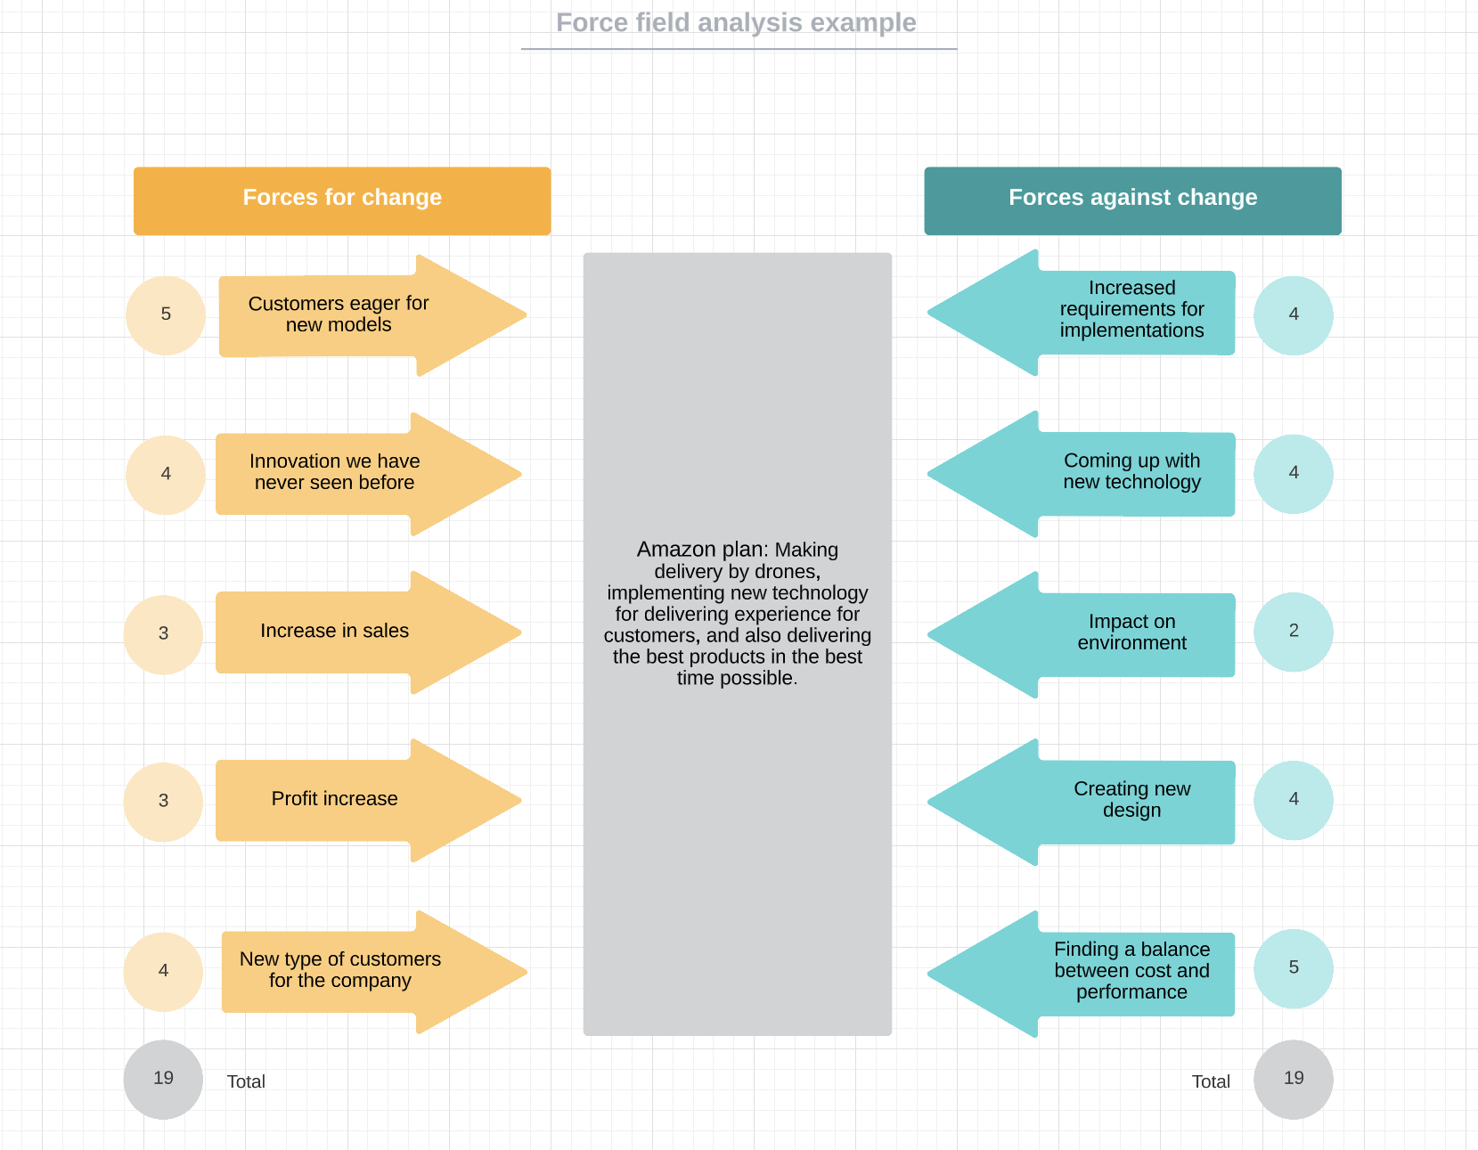
(Jung,2017) (Pandit,2014)

2.5.1 Barriers & Risks
Amazon has rapidly expanded over the years to become one of the top firms in the world in terms of both its sales and its market capitalization. But such a massive magnitude brings with it its own special set of dangers. Investing in Amazon.com stock comes with a number of possible dangers, the most significant of which include escalating levels of competition, unknown levels of profit potential and revenue growth, speculative valuation, and volatile share prices. Since it went public in 1997, Amazon has actually generated significant revenue growth, which has given investors reason to be hopeful about the company's future success.
Investors have also been led to ignore the fact that the corporation is unable to achieve consistent net profits as a result of this growth.
The market already operates under the assumption that Amazon's future performance would be strong, therefore if these bullish expectations are not satisfied, the stock of Amazon will likely decrease in value. This conjecture adds an additional layer of risk by making Amazon's stock price extremely volatile. As a result, investors are far more vulnerable to shifts in market conditions. (Downie, 2019)

2.6 Leadership & Management
Leaders are those who begin with the end goal in mind, the customer, and work their way backwards. In this way, they exert maximum effort to win and maintain the confidence of their patrons. Customers are the focus of leaders' attention, even though they are aware of and concerned with competition.
Because leaders are also owners, they focus on the long term and avoid making decisions that might reduce value in the long run. They don't merely represent their own team; rather, they operate on behalf of the whole firm. They never complain or say things like "that's not my job."
Also leaders should always be looking for ways to simplify things for their employees while yet expecting them to innovate and invent new things. They have an awareness of the world around them, are open to receiving new ideas from everywhere, and refuse to be constrained by the phrase "not invented here." Amazon is willing to face the possibility that it will be misunderstood for extended periods of time as it continues to experiment with new things. (Amazon, 2021)
Leaders never stop learning and are continuously looking for ways to develop themselves. Also, they are insatiably curious about new opportunities and take steps to investigate them.
Leaders are responsible for raising the bar of performance with each new recruit and promotion. They acknowledge those employees who possess remarkable talent and are eager to promote them inside the company. Leaders produce more leaders and take their responsibility as a mentor to others very seriously. Amazon is on a mission to improve people's lives by creating innovative opportunities for advancement, such as Career Choice. (Reddy,2022)
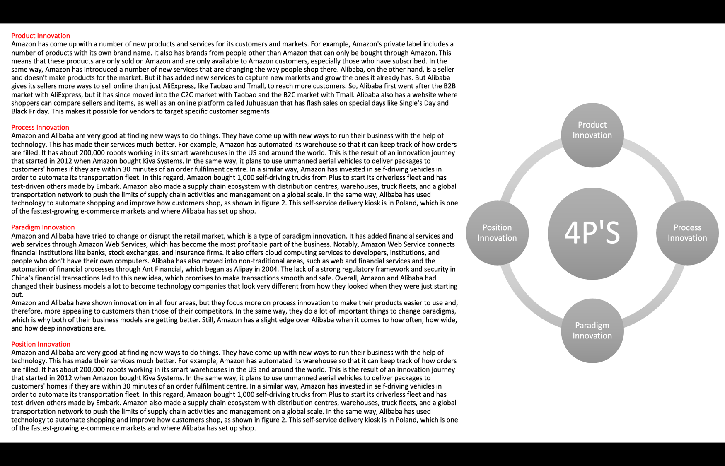
(AccurateEssays,2023)

3.0 Conclusion
In conclusion, what could be learned about the company is first of all why the Amazon company is so well known and the fact that they have a lot of services that have been presented, but also their vision regarding customer appreciation and ensuring satisfactory services.
At the same time, innovative opportunities were presented, the fact that Amazon knows how to create innovative opportunities and develop certain programs that helped the company to reach the point where it is today, but also some strengths, weaknesses and threats of the company.
At the same time, the company's type of innovation was presented, that being the radical one, but also the creative thinking processes of the Amazon company and how it urges employees to be as innovative as possible and without fear of mistakes and failure.
The efficiency assessments were presented, but at the same time evidence was also shown regarding certain failures that happened to the company in the past, which proves that Amazon knows how to learn new innovative techniques, but that does not mean that they did not make mistakes. .
In the end, the company's barriers were presented along with its risks, but also the types of management and leadership that Amazon presents, along with all the ways to encourage employees to become as creative and innovative as possible.

4.0 References
(AccurateEssays,2023) Innovation at Amazon and Alibaba – Accurate Essays. Available at: https://www.accurateessays.com/samples/innovation-at-amazon-and-alibaba/.

Amazon (2017). Amazon Fulfillment Technologies Aurora Case Study – Amazon Web Services (AWS). Amazon Web Services, Inc. Available at: https://aws.amazon.com/solutions/case-studies/amazon-fulfillment-aurora/.

Amazon (2019). 6 things that make Amazon a ‘Best Workplace for Innovators’. About Amazon. Available at: https://www.aboutamazon.com/news/workplace/6-things-that-make-amazon-a-best-workplace-for-innovators.

Aten, J. (2019). Jeff Bezos says good leaders make it okay to fail. Business Insider. Available at: https://www.businessinsider.com/jeff-bezos-says-you-should-failing-more-you-take-chances-2019-8.

Bag, N. (2022). Amazon- History, Merchant partnerships, Logistics, Products and services, Amazon Brilliance Audio, Comixology, Twitch, Website, lobbying, NB Inspire. NB Inspire. Available at: https://www.nb-inspire.com/2022/05/amazon-history-merchant-partnerships.html [Accessed 15 Mar. 2023].

Bieler, D. (2021). Learn From Amazon’s Approach To Innovation. Forrester. Available at: https://www.forrester.com/blogs/learn-from-amazons-approach-to-innovation/.

Borison, R. (2015). Here are 10 of Amazon’s biggest failures. TheStreet. Available at: https://www.thestreet.com/investing/stocks/here-are-10-of-amazon-s-biggest-failures-13364106.

Carpenter, H. (2015). Why Amazon wins | Innovate the core, innovate to transform | CustomerThink. [online] Available at: https://customerthink.com/why-amazon-wins-innovate-the-core-innovate-to-transform-2/.

Downie, R. (2019). The Biggest Risks of Investing in Amazon Stock. Investopedia. Available at: https://www.investopedia.com/articles/markets/100215/biggest-risks-investing-amazon-stock.asp.

Electronics, C.E.A. (2022). Top 100 Electronics Companies In The World To Work For Growth. CS Electrical & Electronics. Available at: https://cselectricalandelectronics.com/top-100-electronics-companies-in-the-world-to-work-for-growth/?utm_content=cmp-true [Accessed 15 Mar. 2023].

Garcia, K. (2018). Could Amazon Go Head-to-Head with Convenience Stores and QSRs? [online] Available at: https://www.insiderintelligence.com/content/could-amazon-go-head-to-head-with-convenience-stores-and-qsrs.

Hallkett, R. (2022). AWS Transformation BrandVoice: Using Customer Obsession To Drive Rapid Innovation. [online] Forbes. Available at: https://www.forbes.com/sites/aws-transformation/2022/11/07/using-customer-obsession-to-drive-rapid-innovation/?sh=3f5aa3cd5c13 [Accessed 15 Mar. 2023].

Hall, M. (2022). Amazon.com. In: Encyclopedia Britannica. Available at: https://www.britannica.com/topic/Amazoncom.

Jung, S. (2017). (PDF) Analysis of Amazon Prime Air UAV Delivery Service. Available at: https://www.researchgate.net/publication/317389269_Analysis_of_Amazon_Prime_Air_UAV_Delivery_Service.

Mautz, S. (2019). Amazon Shares 6 Ways It Creates a Culture of Innovation and How You Can Too. Inc.com. Available at: https://www.inc.com/scott-mautz/amazon-shares-6-ways-it-creates-a-culture-of-innovation-how-you-can-too.html.

Meisenzahl, D.G., Mary (2021). Jeff Bezos famously embraces failure. Here are the biggest flops Amazon has overcome under his watch. [online] Business Insider. Available at: https://www.businessinsider.com/amazon-products-services-failed-discontinued-2019-3?r=US&IR=T#quidsi-13 [Accessed 15 Mar. 2023].
Pandit, D. V., & Poojari, D. A. (2014). A Study on Amazon Prime Air for Feasibility and Profitability-- A Graphical Data Analysis. IOSR Journal of Business and Management, 16(11), 06–11. https://doi.org/10.9790/487x-161110611
Pereira, D. (2023). Amazon SWOT Analysis (2023). The Business Model Analyst. Available at: https://businessmodelanalyst.com/amazon-swot-analysis/.

Reddy, A. (2022). Amazon’s 16 Leadership Principles. Available at: https://www.linkedin.com/pulse/amazons-16-leadership-principles-arun-reddy [Accessed 15 Mar. 2023].

STAND 8. (n.d.). Amazon. Available at: https://www.stand8.io/glossary/amazon [Accessed 15 Mar. 2023].

Vamanan, D. (2023). How to increase your sales with the Amazon DTC master plan. [online] Available at: https://www.sellerapp.com/blog/amazon-dtc-master-plan/.

Voyles, B. (2021). Here’s why Amazon’s global expansion won’t come easy. SearchAWS. Available at: https://www.techtarget.com/searchaws/feature/Heres-why-Amazons-global-expansion-wont-come-easy.

Yasar, K. (2022). What is Amazon? WhatIs.com. Available at: https://www.techtarget.com/whatis/definition/Amazon.
‌

