BA Business Management
LCBB4003
Introducing The Modern Workplace
(Assessment 1 – Structure and Culture)
Eugenia Racos
Student ID: 1906576

Essay
This essay will present how culture and structure plays an important role in an organisation. This will also keep its focus on relationships between organisational culture, people and organisational performance. Lastly, there will be discussion done on theories and models of organisational design and culture.

Structure and culture of Young living
The layout and process under which the organisational components collaborate to meet business targets is described in an organisational structure (Armstrong and Taylor, 2017). Structure creates trends or arrangements to relate their characteristics to company strategy between different market areas. There are different kinds of systems and those are Functional, divided, flat and matrix (Horizontal). The movement of authority in an organisation defines all these constructs. In the other side, the organisational culture explains the deeply shared convictions reinforced by the system and policy. Young Living, a multilevel, home-product and essential oils marketing firm headquartered in Lehi, Utah, United States. Mary Young and D. Gary Young formed the organisation in 1993. Over the years, the organization's structure has become a pillar of growth (Young Living, 2020). There is a horizontal hierarchical framework in the organisation. Any middle level management levels are available. The CEO and Chief Operating Officer are top and second in the management committee and answer directly to the CEO and to the Chief Executive Officer (Young Living, 2020).
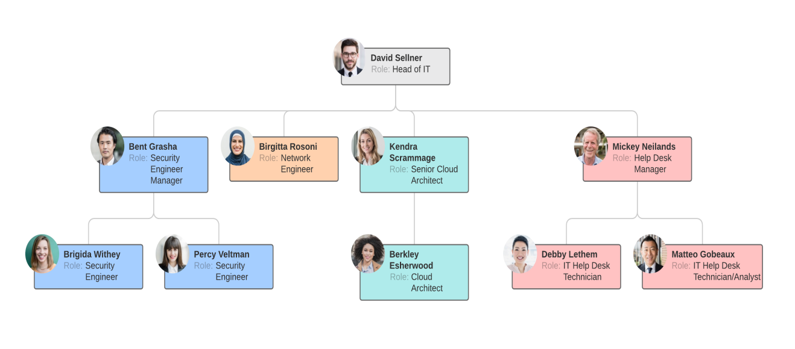
Figure 1: Functional Organisational Structure
(Source: Self developed)
Young Living has not only based its performance on quality goods and appropriate preparation, but also on compliance with the seven main principles. First of all, the member is the priority. Any member of the organisation is provided with a world-class experience. Customer loyalty is a top concern, and all employees are expected to be caring and appreciative of customers, as well as listen to them. The second value is to have the goods and the organization's lifestyle (Young Living, 2020). Their offerings are wonderful and staff are allowed to take advantage of them and share their insight with friends and collaborators. A healthy mindset is indeed the company's core principle, as it means empathy for all, a positive focus and an effort to create peace. The administration assumes that when a job is full of laughing people, employment is fruitful and fun. Employees view problems in these views as potential for growth and not resentment. The fourth principle is personal honesty that aims to create an open and truthful team of staff that can gain consumer trust (Madhani, 2014).
In the workplace, change is welcomed. The main principles are to remain creative, to strive for perfection, and to never accept the status quo. It aspires to do something differently, and transition is seen as a way of achieving more and more meaningful results. Exercising sound judgement is the sixth value. When operating in groups, good judgement is particularly valued, and workers are expected to engage in reflective thought before making decisions. Finally, good contact is still maintained. Clear, accurate, and sufficient knowledge has resulted in smooth work processes and pleasant working conditions.
Young Living appeared to have taken an important step forward in raising their income in an article written in 2018. The study applauds the firm as a world leader in essential oils. Sales for 2020 are estimated at 2.5 billion dollars, far over the expected 1 billion dollars. Over the last five years, the business enjoyed remarkable success and sales increased by more than 800 percent in 2020 (Young Living, 2020). The Chief Operating Officer, Jared Turner, expressed his truthful view on the causes of growth. The firm's staff and clients, who are enthusiastic about the labels, are committed, according to Turner. They offer the gift to their mates all over the world. This made it possible to realise the dreams of the founders; essential oils were taken everywhere in the world (Young Living, 2020). The organization's culture and structure have greatly aided development in many respects, as described below:
One of the ways through which corporate progress is accomplished is by encouraging employees to embrace transformation. The aim of organisational growth is to improve procedures and overall capabilities. Changing the way things are performed to follow better, more up-to-date practises is one way to achieve greater capabilities. This is what the AUTHOR refers to as an organisational transition. Organizational growth will only be accomplished if transition is integrated within the broader organisational priorities and workers have a favourable view of the organisation. People oppose change only when they perceive it as a danger, according to the author. Uncertainty, inconvenient situations, a shock in modern ways, and economic concerns must all be addressed (Abdullah and Siam, 2014).
Although efficiency is a key topic in the analysis of organisations, it is also one of the most often referred but not really known ideas in the philosophy of organisation. Failure to consider corporate goals, the context in which it works, the marketplace, how it performs, how it is organised and all the organisational components can contribute to poor performance assumptions. Once the company decides what it needs of its workers to do at work, what it expects to do and what it aims to do from its employees, so the system can be applied and the development of culture's values and customs can be encouraged to accomplish this awaited audacity, manner and objective. The structure not only improves operational capacity but also results in mechanisms leading to greater efficiency. Good workers who serve in a badly structured structure prefer to adjust themselves to the bad structure. This is because managers are not fully aware of the protocols, methods, practises and support programmes of the company (Banerjee and Srivastava, 2017).
One of the most important strategies to achieve a painless transition phase, according to AUTHOR, is to ensure that change is rooted in corporate culture. This is just what Young Living has achieved. Employees at Young Living see transition as a catalyst for personal development. Processes, techniques, technologies, and structures are also readily adopted by the organisation. The willingness to adapt to modern and improved methods of action is a key element in achieving performance and gaining a competitive edge (Fortes, 2018). Lauren Walker, the Supply Chain Officer, recalls warning the CEO that growing the business to $5 billion in revenue will necessitate doing it differently. The CEO was able to read between the lines, which describes why Young Living is always improving and exceeding expectations in terms of sales growth (Young Living, 2020).

Open, Supportive Communication Climate
Many managers and leaders belonging to business organisations' consider communication or interaction to be a barrier and most workers feel excluded when knowledge is not sufficient. Communication with workers has become a crucial aspect, particularly because of vast quantities of information processed and demands of staff to be updated have risen. Young Living has standardized its communication process to guarantee that the team receives adequate, exact and timely details whenever required. The right knowledge is supplied to team members while conducting projects (Young Living, 2020). Proper communication process followed by the Young Living also helped to eliminate workers' tensions and build a peaceful & fruitful working atmosphere. Finally, better sales and the multinational consumer base are reaching the bottom line. Communication plays an important role as a method for administrators who wish to have full control over their staff.
There are several advantages of effective contact which are apparent from the operations of Young Living and literary reviews in many surveys. In 2010 just 40% of UK firms had structured engagement methods a survey carried out among them (Fang, et al., 2013). They cited the major advantages of free and supportive contact. Effective collaboration or communication among staff members meant that they became completely involved in the corporate process and had various suggestions and sound choices. Effective contact often provides solutions, contributes to transparency and fairness and often provides input. These organisations, as is the case for Young Living, seek productivity and cooperation through their activities.

Hofstede Model of Organization Culture
Hofstede, argued that the cultural contribution of the organisation to regional and national influences could ultimately affect employees' behaviour. Hofstede points out that mainly 5 variables shape the culture of a work environment: masculinity versus femininity, power distance, individualism, avoidance index, and orientation in the long term. However, each individual is responsible for his or her own success in an organisation. The workers are not delegated to a particular individual. The people cannot be held responsible except for themselves. Any employee is treated equally by the management and is responsible for his job (Fortes, 2018).
Young Living is specifically considered the Long Term Orientation factor of Hofstede model, where the workers usually perform different range of tasks to meet management demands that rely upon the long-term connection with employees. Employees who note long-term investment in their ties also feel closer to Young Living and concentrate on achieving company’s long duration based aims and objectives. This not only helps them in getting skilled but Young Living also delivers compensation in both emotional (recognition at the workplace) and monitory terms (bonus or incentives) (Young Living, 2020).

Organization and Judgment-Implicit Personality Theory
A major element in Young Living's success, particularly among staff members and groups of the organisation, is the avoidance of assumptions and discrimination based on small amounts of knowledge. Employees are empowered to include facts, even in decision making, before making important decisions. The method of organising facts and making decisions shall be organised and judged (Kangas et al., 2017). People often go through the evidence provided and draw inference about past encounters, which may negatively influence their power to decide correctly. A team member may end up with multiple interpretations, and this contributes to misunderstandings. Stereotyped and perceptual protection of workers is caused by sense illusions and the resultant prejudice. These disparities are hazardous for an organization's overall performance. Employees must be empowered to broaden their understanding of the environment and its inhabitants. There are a number of interpretations, greater comprehension and needless biases and prejudices. Young Living expects its staff members and particularly when operating in teams to be thoughtful in their work (Young Living, 2020).

Role of leadership
Leaders must show the company's convictions and strengthen actions that embody certain principles. It is needed for leaders of Young Living to strive more to remain relevant in the frontline, but they must still diversify their efforts and study for potential progress.
Leaders working behaviour, the manner along with the communication style the culture of Young Living may get influenced. The culture that your workers feel cannot be delegated to create. show certain principles in their behaviour if they choose to represent specific values. The best leaders are able to blend the following qualities: The leader drives performance, stays personalised and this enhances employees’ commitment, with 13% of leaders focusing on the individual behind the information. Inside a group, leaders play a key role in utilising their actions by establishing the standard on what is appropriate in Young Living (Szczepańska-Woszczyna, 2018).

Variables that determine effective management and leadership
It has been believed that certain crucial things cannot be done without a multi-directional path, which is a basis for a high-level leadership with cross-dimensional links and an essential cause of a good organisation. Also, there are different range of variables that specifically determines both leadership and management and these are required for leaders and managers of Young Living to consider them for pulling out favourable results in terms of productivity of the organisation. Recognition and transparent communication are the two major influences that are required to understand as a variable as they can both make or break the Young Living (Lee et al., 2015).

Conclusion
Considering the above mentioned information, it is concluded that a company's competitive advantage relies on how the structure and organisational culture are planned according to an desired goals and objectives. In relation to Young Living, company has achieved a leading position considering different range of ethical values belonging to the equality and diversity and also the structure followed by the company. It is also summarised that the culture is marked by impressive communication process followed by an organisation, constructive development mindset and analytical thought prior to evaluating while taking decisions. This may result into positive impact on staff members that is creative and profitable for the company. When internal hurdles are removed, the horizontal structure may help in developing an effective team develops the communication in much more efficient ways at the workplace.

References
Books and journals
Abdullah, H.H. and Siam, M., 2014. The influence of organizational structure and organization culture on the organizational performance of higher educational institutions: The moderating role of strategy communication. Asian social science, 10(13), pp.142-154.
Armstrong, M. and Taylor, S., 2017. Armstrong’s Handbook Of Human Resource Management Practice (Fourteenth). London: KoganPage.
Banerjee, S. and Srivastava, D., 2017. Innovation, Organisational Structure, and Culture: Its Impact and Linkage on Organization-A Review. International Journal of Civic Engagement and Social Change (IJCESC), 4(1), pp.1-22.
Fang, E.A., Wu, Q., Miao, C., Xia, J. and Chen, D., 2013. The impact of new product & operations technological practices on organization structure. International Journal of Production Economics, 145(2), pp.733-742.
Fortes, M., 2018. The dynamics of clanship among the Tallensi: Being the first part of an analysis of the social structure of a Trans-Volta tribe. Routledge.
Kangas, M., Muotka, J., Huhtala, M., Mäkikangas, A. and Feldt, T., 2017. Is the ethical culture of the organization associated with sickness absence? A multilevel analysis in a public sector organization. Journal of Business Ethics, 140(1), pp.131-145.
Lee, C.H., Cho, D.Y. and Kim, Y.J., 2015. The relation of organization structure, organization culture and organization conflict of university hospital staff members. The Korean Journal of Health Service Management, 9(1), pp.95-107.
Madhani, P.M., 2014. Aligning compensation systems with organization culture. Compensation & Benefits Review, 46(2), pp.103-115.
Szczepańska-Woszczyna, K., 2018. Strategy, corporate culture, structure and operational processes as the context for the innovativeness of an organization. Foundations of Management, 10(1), pp.33-44.
Online
Young Living. 2020. [Online]. Available through: <https://www.youngliving.com/en_US/company/about/the-7-essential-values>. [Accessed on 11 May, 2021].
Young Living. 2020. [Online]. Available through: <https://www.youngliving.com/en_EU/company/about/executive-management-team>. [Accessed on 11 May, 2021].
Young Living. 2020. [Online]. Available through: < https://www.youngliving.com/en_US/company/about/mission-statement>. [Accessed on 11 May, 2021].

