PROBLEM SOLVING AND DECISION MAKING
BMSW4004

Laura Pino
1915292

Lecturer: Malani Gunaratnam

University of Wales Trinity Saint David

18/12/2020

TABLE OF CONTENTS

- Introduction ……………………………………………………………………... p. 3
- Flexibility in the Workplace the Employees’ Wellbeing………………………… p. 3
- S.W.O.T. Analysis ………………………………………………………………. p. 5
- Causes and Effects through the Fishbone Diagram……………………………… p. 6
- Range of Solution ………………………………………………………………. p. 6
- Decision Making and chosen Solution …………………………………………. p. 7
- Implement the Solution through a Specific Plan and How to Communicate it … p. 8
- Monitor the Solution …………………………………………………………… p. 9
- Conclusion ……………………………………………………………………… p. 10
- References ……………………………………………………………………. p. 11
- Appendix ………………………………………………………………………. p. 14

INTRODUCTION

During such proving times, in the current pandemic, the work of a nanny is proving essential and a source of invaluable support for families (Burgess, 2020).
Even more families, since the Covid-19 outbreak, are in need of help with childcare, especially considering that children have been forced to stay at home after school closures and their parents are working from home.
This switch has inevitably changed the dynamics and routine of workers and nannies have adapted in order to cater for an increase in demand.
In this report, I will discuss that in certain fields of work, the expectation on the employee is to be as flexible as possible with their working hours. For example, in the case of casual working agreements or zero hours contracts, analysing the situation and issues surrounding this problem specifically within the nanny industry.
Between March and April 2020, when the pandemic had first surfaced, the government had made arrangements to help self-employed or contracted nannies to recoup part of their salary through a furlough scheme, and at the same time allowing them to keep their position with the same family (House of Commons, 2020).
While, there was a large majority of nannies who were not eligible for this programme, because they were self-employed for under three years (Evans, 2020) and in these circumstances some families offered to retain the nanny with their own funds through this period. Consequently, the nanny felt obliged in their responsibility to recover the paid hours around their normal work timetable and thus, it was necessary to show more availability and flexibility to the family.

FLEXIBILITY IN THE WORKPLACE AND THE EMPLOYEES’ WELLBEING

Workplace flexibility is an open mind attitude which responds to any quick changes in prospects and conditions relating to contracted or non-contracted work (Clarke, 2017). Employees with this mental flexibility are more valued by employers because they are able to adapt to change, but to obtain the correct balance in the workplace environment, it is necessary that both parts agree on the fundamental principles of what is required (Doyle, 2020).
For example, flexibility is exhibited when stakeholders rearrange the working hours such as, staying longer than your contracted hours, start earlier at work or working more days during the week as well as other various procedures to meet the needs of the company.
These aspects tap into the ability to understand and modify themselves to the external dimension, such as the workplace.
Indeed, flexibility can have positive benefits when employees find the correct way to use this opportunity, for example, benefits include the possibility to organise their work as they like, following the deadlines of the tasks and employees can feel less fatigued from work.
When this balance between working flexibility and private life leans more towards the job, it has a negative impact on the person’s wellbeing and their daily organisation (Izak, 2020). Certainly, when flexibility lasts longer than expected, workers start to feel overworked and stressed (Howlett, 2019).
The stress in the workplace also has an impact on the employees life and it creates issues in balancing work and private life. Stress can cause mental and physical problems that will influence negatively in the productivity (Shagvaliyeva, 2014).
Indeed, workforce’s wellbeing directly affects their performance and the work productivity, as well as their commitment and job satisfaction.
The employee’s wellbeing is the engine that encourages them to produce more, therefore, it is the key to obtaining a high level of work involvement (Isham, 2020).
Hence, being able to create the correct balance between private and working life is necessary to safeguard one’s mental health.
For instance, a nanny working more hours than usual over a long period, with increased stress levels, discontent for the work they are doing and a poor mental wellbeing, will reflect in the job and, ultimately, transfer to the child. It implies a decline in the quality of attention in the work and can develop issues in transmitting serenity and positivity to the children.

S.W.O.T. ANALYSIS

In these circumstances, it is important to understand and focus on the context a person finds themselves in, if we want to analyse and solve a particular problem by taking an effective decision on a possible solution (Mind Tools, 2020).
Consequently, developing a S.W.O.T. analysis is useful because it can help visualise the situation considered and enable more awareness of the positive and negative factors and contributing to a certain situation and also to evaluate the various opportunities and possible threats that come with it. Hence, it helps one to gain a clearer understanding of what decisions could be made in the future to improve their position.

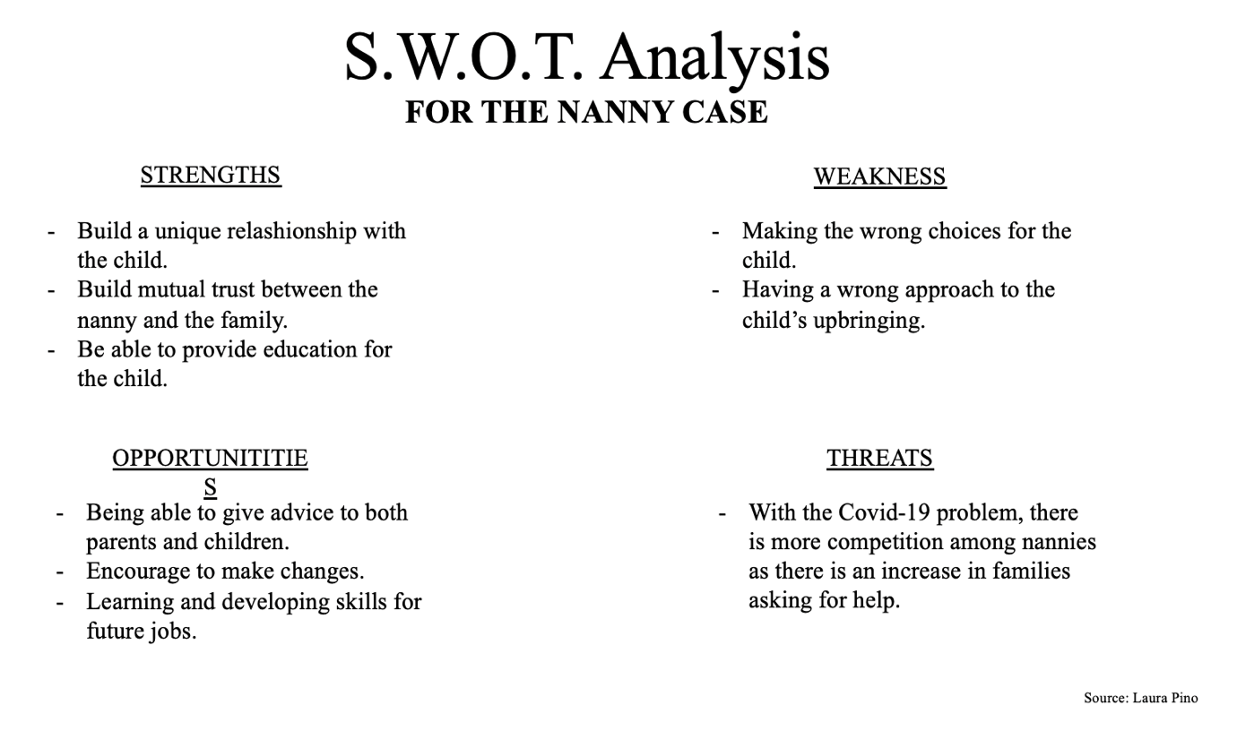

CAUSES AND EFFECTS THROUGH THE FISHBONE DIAGRAM

To identify potential causes and effects of a problem, one can use Ishikawa’s fishbone diagram, the 1943.
This is a mental scheme to approach problems and is particularly effective when there is a need to focus on them in order to find the roots of these issues and be able to implement an efficient, corrective action plan (API, 2020).

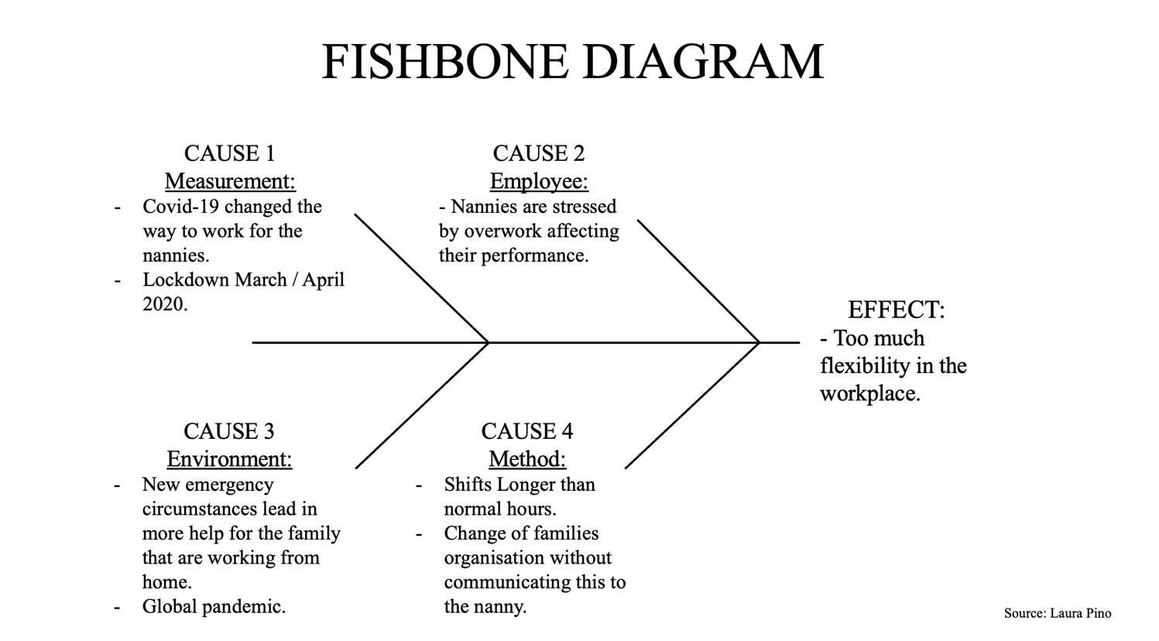

RANGE OF SOLUTIONS

As Morgan suggests (2017), once one can identify causes and effects of a particular problem, the next step is to generate options that will help in solving it.
Adair affirms (2016), that to find a valid solution, one has to have an open mind to consider a range of possibilities and choices and then try to evaluate the most plausible decision to apply to the problem.
The process described requires a form of creativity in finding appropriate solutions.
Morgan states that (2017), to increment the creativity during the process, one can use techniques such as brainstorming to evaluate and discuss the solutions of the problem; examine past experiences, to have the knowledge and skill to choose a perfect solution; subdividing the problem’s characteristics in concept mapping by clarifying the problem in categories. All these steps can automatically suggest a potential solution.
Thus, the range of solutions to nannies’ problems are: to draw up a contract which states that a fortnightly rota needs to be agreed upon at least a week before the start, and, if the nanny is summoned to work beyond their agreed shifts within 48h or less, the hourly rate is x1.5 compensation, and only if able to agree to the extra work; check-in and out of shifts with an official program or excel sheet so that all hours and divisions are accounted for (often extra time, under one hour is not always acknowledged and can accumulate over a period); when working with multiple children, hours and wages need to be calculated more accurately, agreeing set rates for more than one child, based on time frames.

DECISION MAKING AND CHOSEN SOLUTION

When a person makes a decision, after having carefully evaluated the problem, they can come up with various solutions and then adopt one that most helps them to solve the problem from the root (Beresford and Sloper, 2008).
Additionally, solutions will vary according to different people; not only because they arose from how the problem is perceived, but especially from what perspective and experience is observed.
As Cottrell suggests, (2017) through critical thinking one can make a judgment, also she affirms that people who are operating this process tend to be self-aware.
Indeed, they have a particular interest, knowledge and motivation to reflect upon an evaluation.
Without a deep reflection and evaluation of the facts, one will not be able to come to a final conclusion. Thus, the critical thinking process is an important process during these evaluations.
For this case, that I have analysed, the best solution for the nannies is the first one, which argues that if there are any changes in schedules, the family and employee must be in agreement and communicate the week before commencing; any changes in schedule after this time will be charged at a higher rate. This will encourage the employer to follow the schedule more closely and the employee will feel more respected and compensated for the inconvenience and alteration of plans.
This implies a better organisation of nannies’ private life in advance, which will lead to an improvement in mental health.
Indeed, if one has a good mental health and one conducts their life in harmony, there will be a high probability that they will work more efficiently.

IMPLEMENT THE SOLUTION THROUGH A SPECIFIC PLAN AND HOW TO COMMUNICATE IT

For a Business, setting a final goal is a fundamental part in order to provide direction and a sense for the company, increasing its worker’s motivation and ultimately its success. Planning a goal, one has to follow a specific criteria that can help one to focus their efforts and increase the opportunities to achieve it.
SMART is the acronym of specific, measurable, achievable, realistic and timely (Project Smart, 2020).
Specific means to clarify and define the goal well; measurable, because one has to know how far away from the company’s goal they are; achieve is for attainability and possibility to realise; realistic, to understand if it is relevant or reasonable; timely, because it is important to understand the time limit to achieve the goal set (Project Smart, 2020).
The nannies’ solution can be easier to monitor through an Excel system, where employer and employee can write down the worker’s hours, in order to be clear on both sides.
Moreover, every two weeks, the document must be inspected and signed by both parties, as not to create miscommunications between them.
During the process of implementing a change, leaving someone out of this development in the workplace can determinate relationships and may affect the productivity (Long, 2019).
For example, when a family has to introduce a new a change into their environment, it is fundamental that the nanny is involved and informed, otherwise the risk of a misunderstanding can affect the employee’s performance and consequently, decrease one’s commitment to the work.
Moreover, a business change needs its employees to do the job differently and to be success, the organisation has to follow specific guides such as Adkar model.
Adkar is the acronym of awareness, of the need for change; desire, to support the change; knowledge, how to change; ability to demonstrate skills and behaviours; reinforcement, to make the change persist (Hiatt, 2006).
The model is an essential tool for understanding gaps in a change process and it provides effective coaching for the employees (Hiatt, 2006).
Thus, it is important to communicate to the employees why the business is changing plans and the hypothetical risk of this; to understand the root causes of resistance and explain the desire for changing; be clear which skills they need to have to support this change; learning whilst working, tutoring by supervisors and troubleshooting; communication by senior staff to enforce change and teaching sessions to recognise problems.

MONITOR THE SOLUTION

To monitor a new implementation in a business organisation, one can follow three different type of control systems: Feedforward, Concurrent, Feedback.
The first control is used to anticipate possible problems before they occur during the translation. It is useful give the specifications of a product to the suppliers (Moodle, 2020).
Concurrent control focusses on providing immediate feedback because it lets managers amend issues as they happen.
Feedback control is used to correct services that are at the output stage and it is helpful if one is interfacing with the public (Moodle, 2020). Through their reaction the company can make changes in a product, in order to improve it and increase its productivity.
In the nannie’s case, the best way to monitor their solution is to have concurrent control, because it is a two-way system, and it allows an exchange of direct feedback.
Furthermore, the corrections can be applied immediately and in an efficient time.

CONCLUSION

In the end, an organisation that schedules their workload and expectations with sufficient notice, allowing the flexibility of its workers, reduces stress and conflicts between manager and employees.
Moreover, a good balance amongst work and private life increases worker productivity and well-being.
To keep high performances in the work environment, it is important to clarify the goals of the business in advance, especially in order to grow worker’s motivation.
Additionally, through a correct control system, one will be able to observe the goal and implement strategies to succeed where and when needed.
In conclusion, going back to the issue analysed in this paper, which is the problems nannies encounter in their jobs as a result of too much flexibility, the researcher has established, after attentive analysis, that the solution given can increase their performance and commitment for the work and will consequently improve nannies’ well-being.

REFERENZE

Adair, J. E. (2016). ‘Decision making and problem solving’. (Third edition). KoganPage.

API, (2020). ‘How to Use the Fishbone Tool for Root Cause Analysis’. Available at:
https://www.cms.gov/medicare/provider-enrollment-and-certification/qapi/downloads/fishbonerevised.pdf
(Accessed: 01/12/20).

Beresford, B. and Sloper, T., (2008). ‘Understanding the Dynamics of Decision-Making and Choice: A Scoping Study of Key Psychological Theories to Inform the Design and Analysis of the Panel Study’, The University of York. 15th January. Available at:
https://www.york.ac.uk/inst/spru/pubs/pdf/decisionmaking.pdf
(Accessed: 25/11/20).

Burgess, K., (2020). ‘Nannies go through the wringer to help parents’, The Times, 1st August. Available at:
https://www.thetimes.co.uk/article/nannies-go-through-the-wringer-to-help-parents-qv5cmbjlw
(Accessed: 27/11/20).

Clarke, S. and Holdsworth, L., (2017). ‘Flexibility in the Workplace: Implications of flexible work arrangements for individuals, teams and organisations’, University of Manchester. 03rd March. Available at:
https://archive.acas.org.uk/media/4901/Flexibility-in-the-Workplace-Implications-of-flexible-work-arrangements-for-individuals-teams-and-organisations/pdf/Flexibility-in-the-Workplace.pdf
(Accessed: 25/11/20).

Cottrell, S. (2017). ‘Critical thinking skills: effective analysis, argument and reflection’ (Third edition.). Macmillan Education/Palgrave.

Doyle, A., (2020). ‘What is Workplace Flexibility?’, Skills & Keywords. 6th July. Available at:
https://www.thebalancecareers.com/workplace-flexibility-definition-with-examples-2059699
(Accessed: 25/11/20).

Evans, T., Verma, S. and Harris, J. P., (2020). ‘Coronavirus and self-employment in the UK’, Office for National Statistics. 17th April. Available at:
https://www.ons.gov.uk/employmentandlabourmarket/peopleinwork/employmentandemployeetypes/articles/coronavirusandselfemploymentintheuk/2020-04-24
(Accessed: 28/11/20).

Hiatt, J. M. (2006). ‘ADKAR: a model for change in business, government and our community’. Prosci Learning Centre.

House of Commons, (2020). ‘Health Secretary gives update on new 'lockdown' measures announced to tackle coronavirus’, UK Parliament. 24th March. Available at:
https://www.parliament.uk/business/news/2020/march/update-on-coronavirus-24-march-2020/
(Accessed: 01/12/20).

Howlett, E., (2019). ‘Flexible work improves mental health, study suggests’, People Management. 7th August. Available at:
https://www.peoplemanagement.co.uk/news/articles/flexible-work-improves-mental-health
(Accessed: 28/11/20).

Isham, A., Mair, S. and Jackson, T., (2020). ‘Wellbeing & Productivity a review of the literature’, CUSP- Centre for the Understanding of Sustainable Prosperity. No 22. Available at:
https://www.cusp.ac.uk/wp-content/uploads/pp-wellbeing-report.pdf
(Accessed: 04/12/20).

Izak, M. and Matthijs Bal, P., (2020). ‘Paradigms of Flexibility: A Systematic Review of Research on Workplace Flexibility’, While Online Library. 06th September. Available at:
https://onlinelibrary.wiley.com/doi/full/10.1111/emre.12423
(Accessed: 03/12/20).

Long, N., (2019). ‘An Example of How to Communicate a New Process Change in the Workplace’, Chron. 01st March. Available at:
https://smallbusiness.chron.com/example-communicate-new-process-change-workplace-24810.html
(Accessed: 03/12/20).

Mind Tools, (2020). ‘SWOT Analysis How to Develop a Strategy for Success’. Available at:
https://www.mindtools.com/pages/article/newTMC_05.htm
(Accessed: 02/12/20).

Moodle, (2020). ‘Week 9- Planning, Monitoring and Reviewing Change’, Problem Solving and Decision Making.

Morgan, P., (2016). ‘The Business Student’s Guide to Study and Employability’. Sage
Publications.

Project Smart. (2020). ‘SMART Goals’. Available at:
https://www.projectsmart.co.uk/smart-goals.php
(Accessed: 01/12/20).

Shagvaliyeva, S. and Yazdanifard, R., (2014). ‘Impact of Flexible Working Hours on Work-Life Balance’, American Journal of Industrial and Business Management 20-23. 04th January.
Available at:
https://www.researchgate.net/publication/260219489_Impact_of_Flexible_Working_Hours_on_Work-Life_Balance
(Accessed: 05/12/20).

APPENDIX

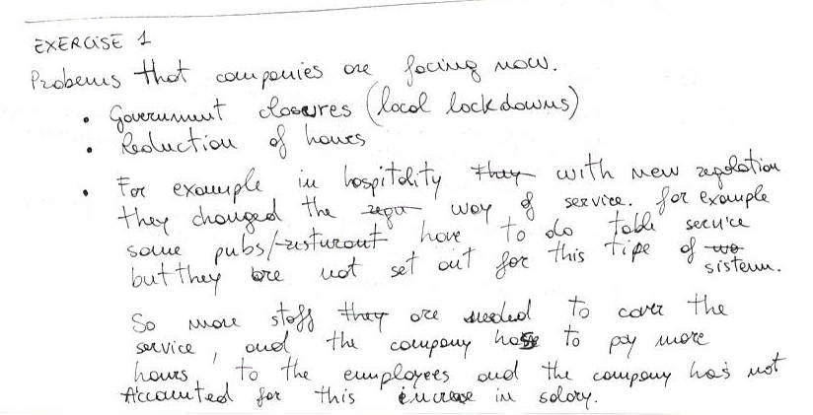
Example 1: Task completed during the class.

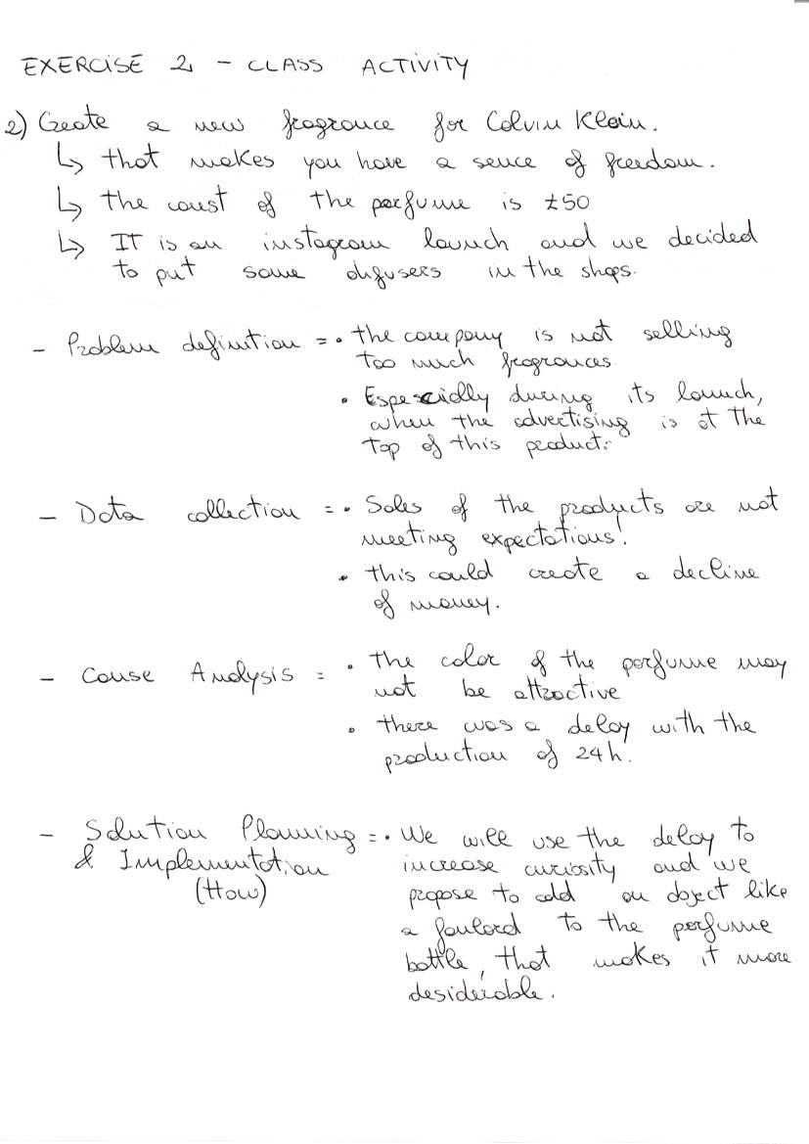
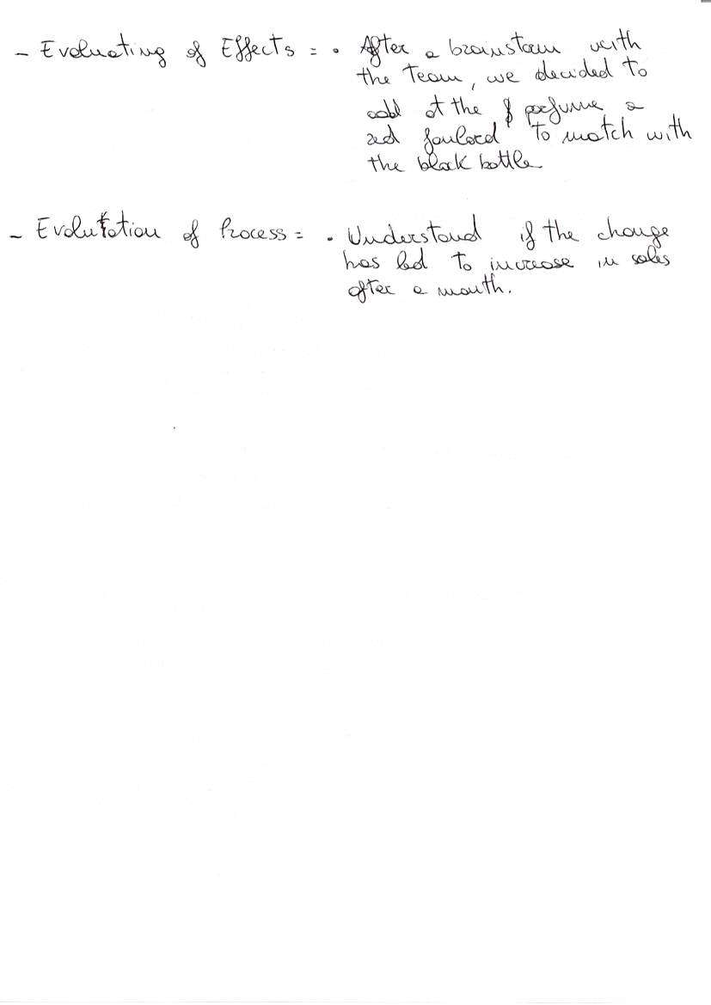
Example 2: Task completed during the class.

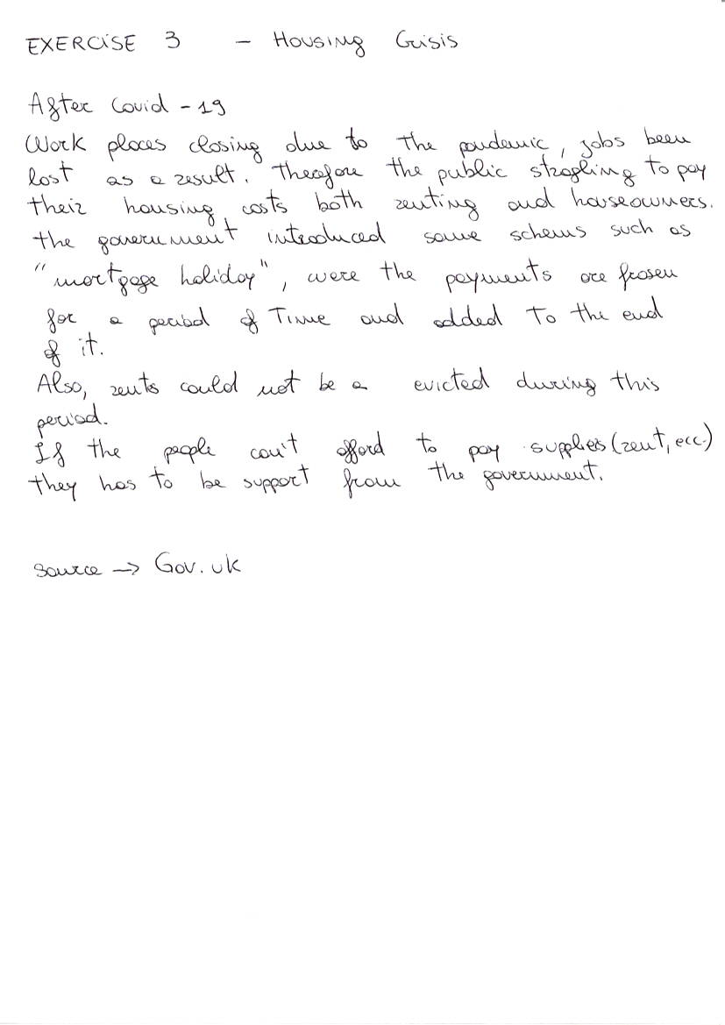

Example 3: Task completed during the class.

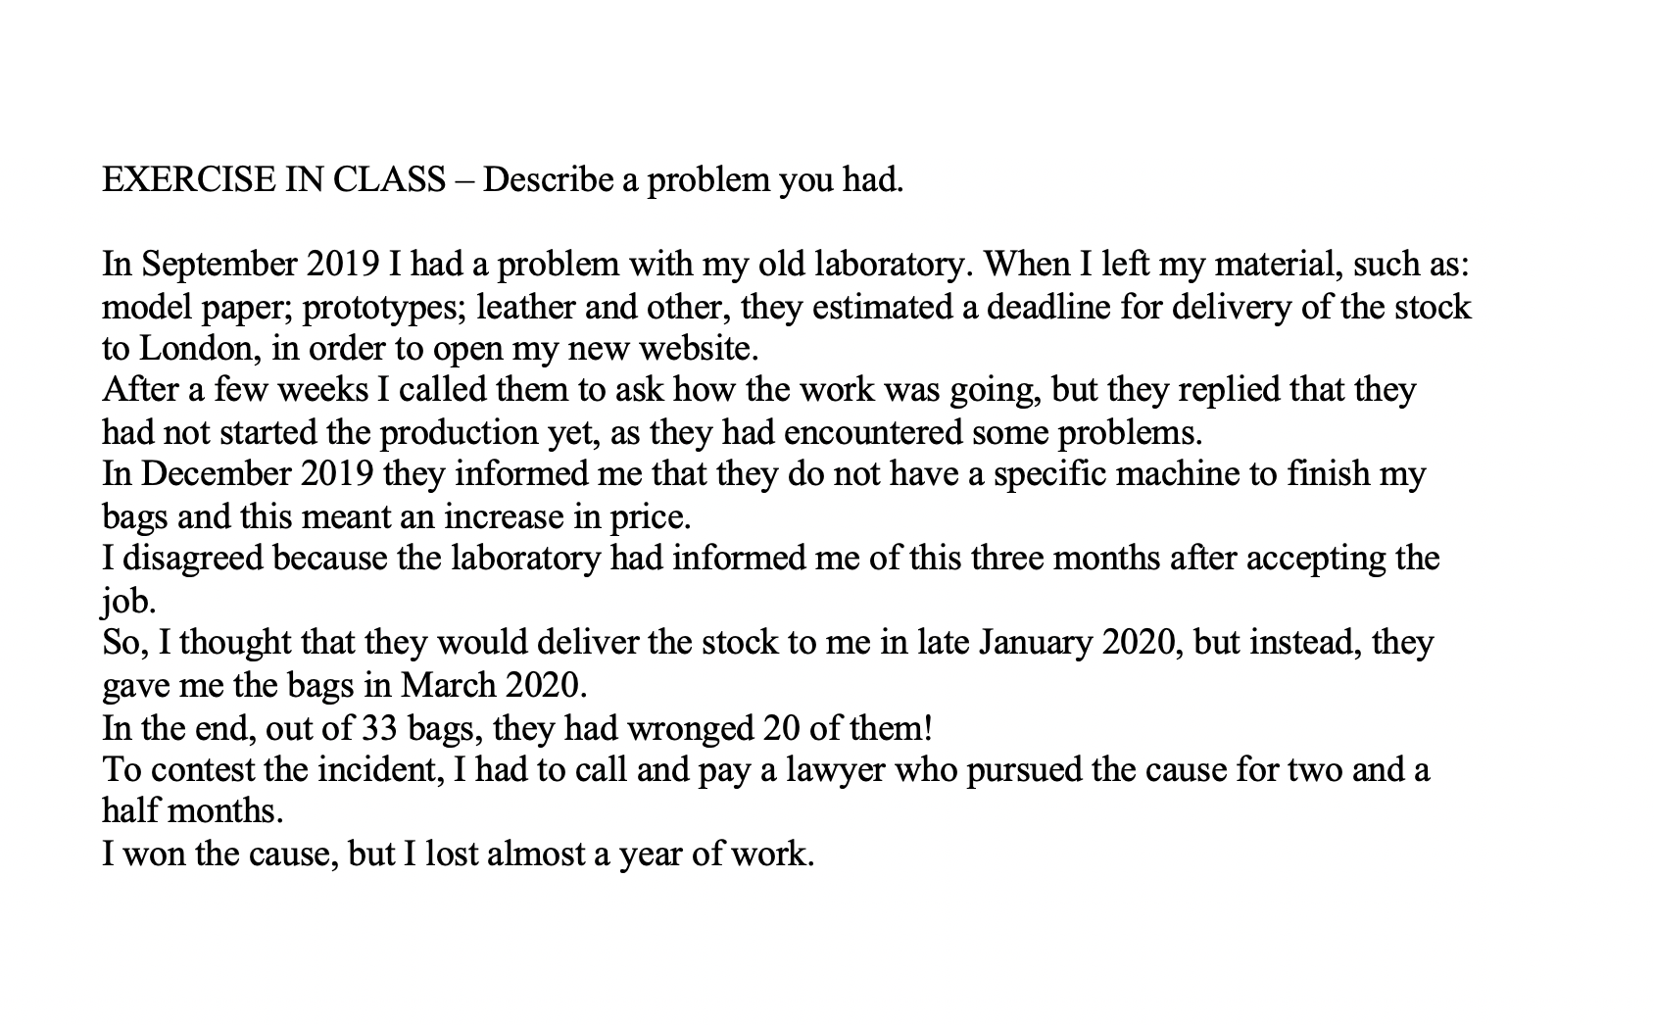
Example 4: Task completed during the class.

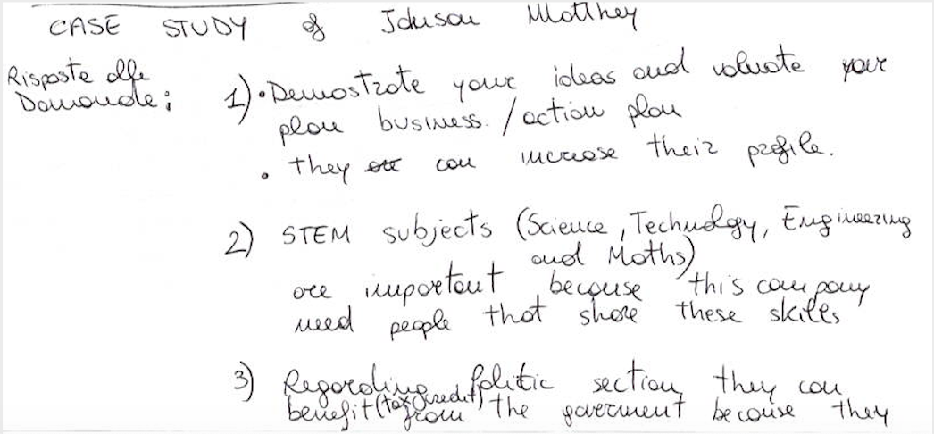

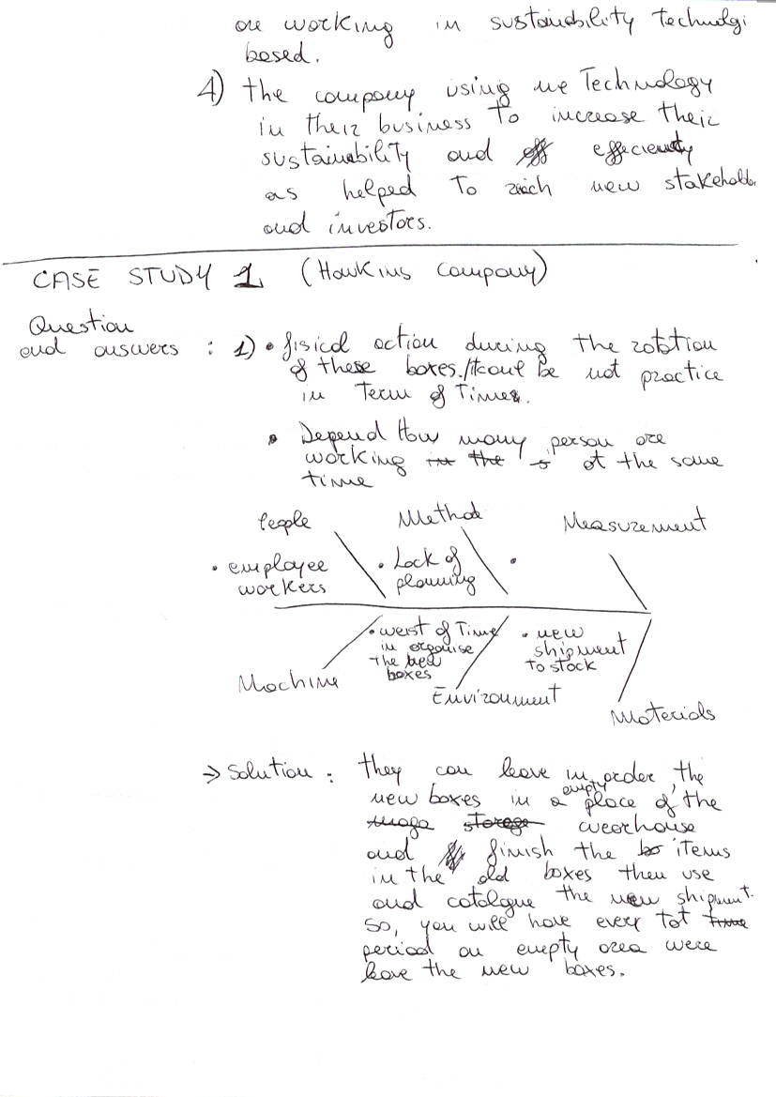
Example 5: Task completed during the class.

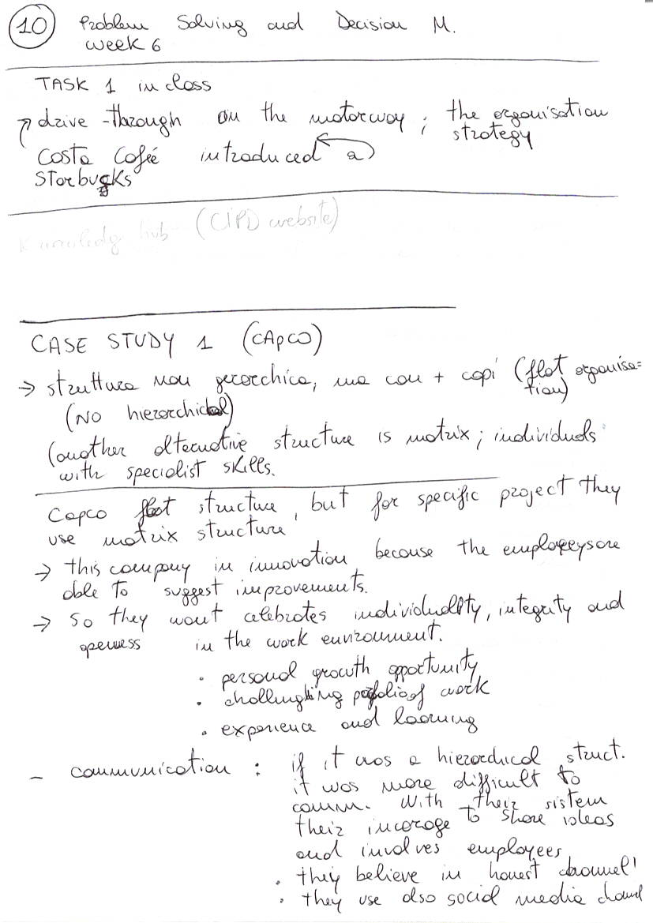
Example 6: Task completed during the class.

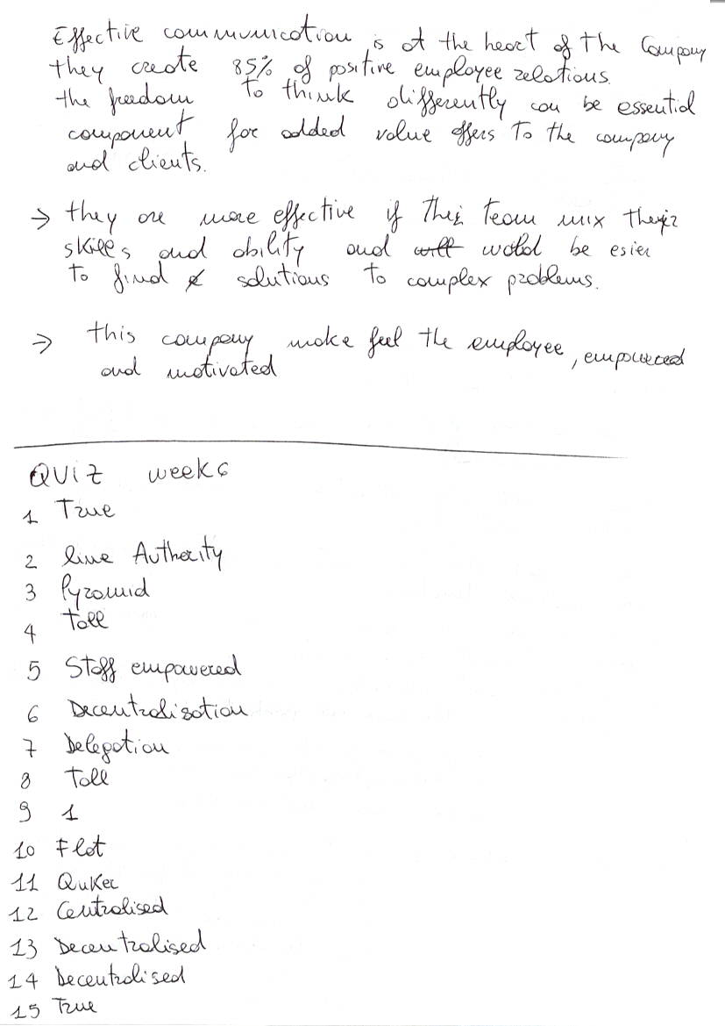
Example 7: Task completed during the class.

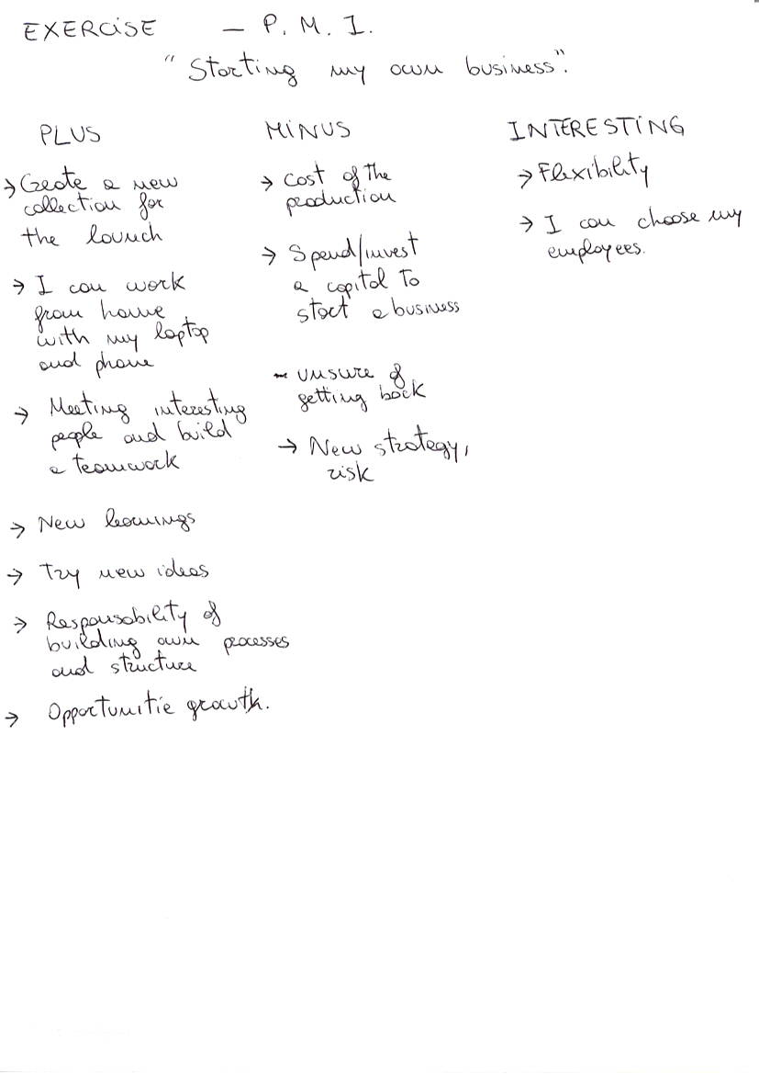
Example 8: Task completed during the class.

