Portfolio for ECEY4012
Contents:
Part one – Study Timetable – 2- 3
Part two – Ai activity – 4-7
Part three – Poster – 8
Part four – voice over – 8

Part 1
Amser /Time | Llun  Monday | Mawrth  Tuesday | Mercher  Wednesday | Iau  Thursday | Gwener  Friday | Sadwrn  Saturday | Sul  Sunday
00:00 - 00:59 | Sleeping | sleeping | sleeping | sleeping | sleeping | sleeping | sleeping
01:00 - 01:59 | Sleeping | Sleeping | Sleeping | Sleeping | Sleeping | Sleeping | Sleeping
02:00 - 02:59 | Sleeping | Sleeping | Sleeping | Sleeping | Sleeping | Sleeping | Sleeping
03:00 - 03:59 | Sleeping | Sleeping | Sleeping | Sleeping | Sleeping | Sleeping | Sleeping
04:00 - 04:59 | Sleeping | Sleeping | Sleeping | Sleeping | Sleeping | Sleeping | Sleeping
05:00 - 05:59 | Sleeping | Sleeping | Sleeping | Sleeping | Sleeping | Sleeping | Sleeping
06:00 - 06:59 | Sleeping | Sleeping | Sleeping | Sleeping | Sleeping | Sleeping | Sleeping
07:00 - 07:59 | Waking up | Waking up | Waking up | Waking up | Waking up | Waking up | Waking up
08:00 - 08:59 | Shower | Shower | Shower | Shower | Shower | Shower | Shower
09:00 - 09:59 | Breakfast | Breakfast | Breakfast | Breakfast | Breakfast | Breakfast | Breakfast
10:00 - 10:59 | Clean | Clean | Clean | Clean | Clean | work | Work
11:00 - 11:59 | Chill out | Study | Study | Study | Study | work | Work
12:00 - 12:59 | Look over work | Study | Study | Study | Study | work | Work
13:00 - 13:59 | Have lunch | Have lunch | Have lunch | Have lunch | Have lunch | work | work
14:00 - 14:59 | Get ready for uni | Clean up | Clean up | Clean up | Clean up | work | work
15:00 - 15:59 | Get ready for uni | Study | Study | Study | Study | work | work
16:00 - 16:59 | Leave for uni | Look through new job info | Look through new job info | Look through new job info | Look through new job info | work | work
17:00 - 17:59 | Uni | Socialise | Socialise | Socialise | Seeing family | Work | Getting home
18:00 - 18:59 | Uni | Socialise | Socialise | Socialise | Seeing family | Work | Shower
19:00 - 19:59 | Uni | Socialise | Socialise | Socialise | Seeing family | Getting home | Have food
20:00 - 20:59 | Get home | Gym | Socialise | gym | Seeing family | Gym | Look over left over work
21:00 - 21:59 | Shower | Shower | Shower | Shower | Shower | Shower | Look over work
22:00 - 22:59 | Have food | Have food | Have food | Have food | Have food | Look over work | Relax
23:00 - 23:59 | Get ready for bed | Get ready for bed | Get ready for bed | Get ready for bed | Get ready for bed | Get ready for bed | Get ready for bed

Part 2
I acknowledge the use of Microsoft co-pilot in my work for research purposes
Initial prompts:
- "I am a uni student in the UK studying early years, what are the best ways to revise?"
- "I am a uni student in the UK studying early years, how do I stop procrastination?"
- "I am a uni student in the UK studying early years how do I remember what to study?"

🧠 1. Revise actively, not passively
Instead of rereading notes, engage with them:
- Create mind maps linking theorists (like Piaget, Vygotsky, or Bronfenbrenner) to real-life examples from your placement.
- Teach the concept aloud as if explaining it to a parent or colleague — if you can explain it clearly, you truly understand it
- .🧠 1. Use active recall
- Don’t just reread notes — test yourself. Cover up key points and try to explain them aloud or write them from memory. This strengthens neural connections far more than passive reading.
- 🧘 6. Study in short, focused bursts
- Work for 25–30 minutes, then take a 5-minute break. This keeps your concentration sharp and prevents overload.

Refined prompts:
- "what active recall techniques work best for remembering Early years theorists like Piaget, Vygotsky, and Bronfenbrenner?"
- "what practical strategies can I use to stop procrastinating on Early years assignments and placement tasks?"
- "how can I revise actively instead of passively to remember what I study long term?"
Prompts to identify and validate sources:
- "What books explain active recall?"
- "What books help with procrastination?"
- "what books are good for revision"
Discussion of the two techniques:
I have chosen two study techniques, which are active recall and active revision. Active recall is the active engagement with what you are learning rather than just reading over notes consistently. In the study of Early Years, it could be by making mind maps that link to the theorists such as Piaget, Vygotsky and Bronfenbrenner to real-life examples from the placements, or just explaining the concepts out loud as if in conversation with another. Brown, Roediger and Mcdaniel (2014, p. 19) explain that "the more effortful the retrieval, the stronger the benefit" suggesting the harder you work to recall information, the better you will remember it.
Active revision is moving towards embedding knowledge instead of just reading information that is given. Cottrell (2024, p. 67) explains "passive revision gives the illusion of knowing but doesn't create deep understanding" instead, I should be testing myself and creating summaries of what I know and need to know and explain things in my own words and in a way that I understand. This method will be useful in my Early Years Education course as I will need to understand and apply theorists in practice rather than just memorise them and move on.
Building good study habits is vital for my studies as it will help me to avoid procrastination. Clear (2019, p. 23) states that "you do not rise to the level of your goals. You fall to the level of your systems." Meaning that instead of telling myself I will study more, I need to act on it and make it a consistent habit in my daily life, for example giving myself daily tests and discovering where I am going wrong and focusing on those areas, and giving myself a timetable so that I have a designated time where I will sit down and study and work my plans around that, studying will no longer be stressful and instead consistent.
My discussion on AI
Using Microsoft 365 for this assignment was an interesting experience. What I found worked well was the clear and practical study advice I received in my initial prompts. I was able to tell AI that I was and Early Years student, and it was able to grasp that and generate study advise specific to my course, for example, it gave me examples of theorists I could use, such as Piaget, Vygotsky and Bronfenbrenner and understood that I would need to apply their theories during my placement. Using Microsoft AI, I was able to find information faster than if I were to do regular searches or searched through a library and summarised key information rather than me read extensively to find what i needed. The answers it gave me were clear and straight to the point which helped me understand and grasp new concepts easier.
On the other hand, I did face challenges. The information AI was giving me at first on the books I was looking at were either not relevant to the topic or out of date, this showed me that I still needed to be cautions when using AI as not all the information it will give me was useful. I did however find books from my university library which were reliable academic resources. But I learned that when searching on AI I needed to be very specific in my questions to receive the best answers.
There are so many benefits to using AI as a student: it is available all hours, it can explain things both simply and in depth whichever is best fitting and can give me loads of ideas when I can think of any my own. However, I do feel as though I need to be cautions, AI can make mistakes as it did give me information which was out of date and through research when I was in college AI can also be bias about certain subjects. Therefore, I should always do my own research alongside AI to get the best results that I can, meaning I am not just copying information, but I am also learning.
In the future, I do plan on using AI responsibly. I can use AI to come up with ideas and explain concepts that I do not understand, or to summarise information. However, when using AI I now know that I must be careful and verify the information and sources it gives. AI is a helpful, but it is not always reliable.
Reference list:
Prompt answer 1:
- Journal article (Active recall research): Roediger, H.L. and Karpicke, J.D., 2006. Test-enhanced learning: Taking memory tests improves long-term retention. Psychological Science, 17(3), pp.249–255.
- Book (Constructivist learning theory): Piaget, J., 1952. The origins of intelligence in children. New York: International Universities Press.
- Book (Social constructivism): Vygotsky, L.S., 1978. Mind in society: The development of higher psychological processes. Cambridge, MA: Harvard University Press.
- Book (Ecological systems theory):
- Bronfenbrenner, U., 1979. The ecology of human development: Experiments by nature and design. Cambridge, MA: Harvard University Press.
- Journal article (Dual-coding theory): Paivio, A., 1991. Dual coding theory: Retrospect and current status. Canadian Journal of Psychology, 45(3), pp.255–287.
References for the books:
Brown, P.C., Roediger, H.L. and McDaniel, M.A. (2014) Make it stick : the science of successful learning. Cambridge, Massachusetts: The Belknap Press of Harvard University Press. Pp 3,19,36. (accessed 9/9/26)
Townley, J. (2019) “Atomic Habits: An Easy & Proven Way to Build Good Habits & Break Bad Ones by James Clear,” The objective standard, 14(1). PP 17, 23, 32 (accessed 9/9/2026)
Cottrell, S. (2024) The study skills handbook. Sixth edition. London: Bloomsbury Academic. PP 67, 72, 89. (Accessed 9/9/2026)

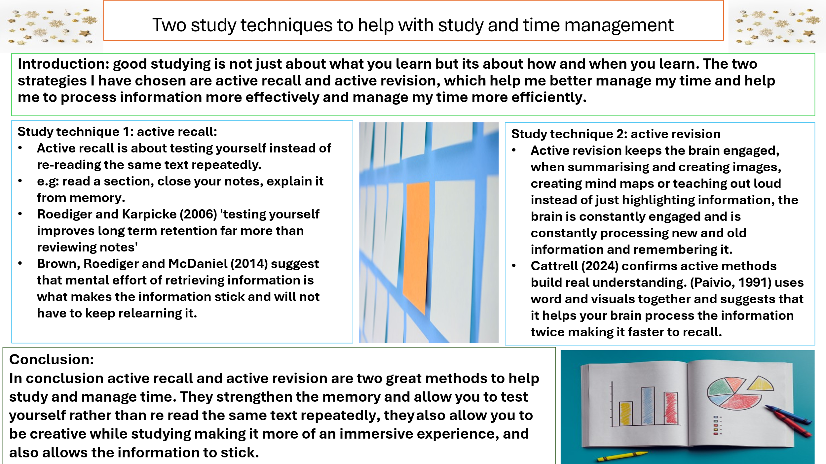
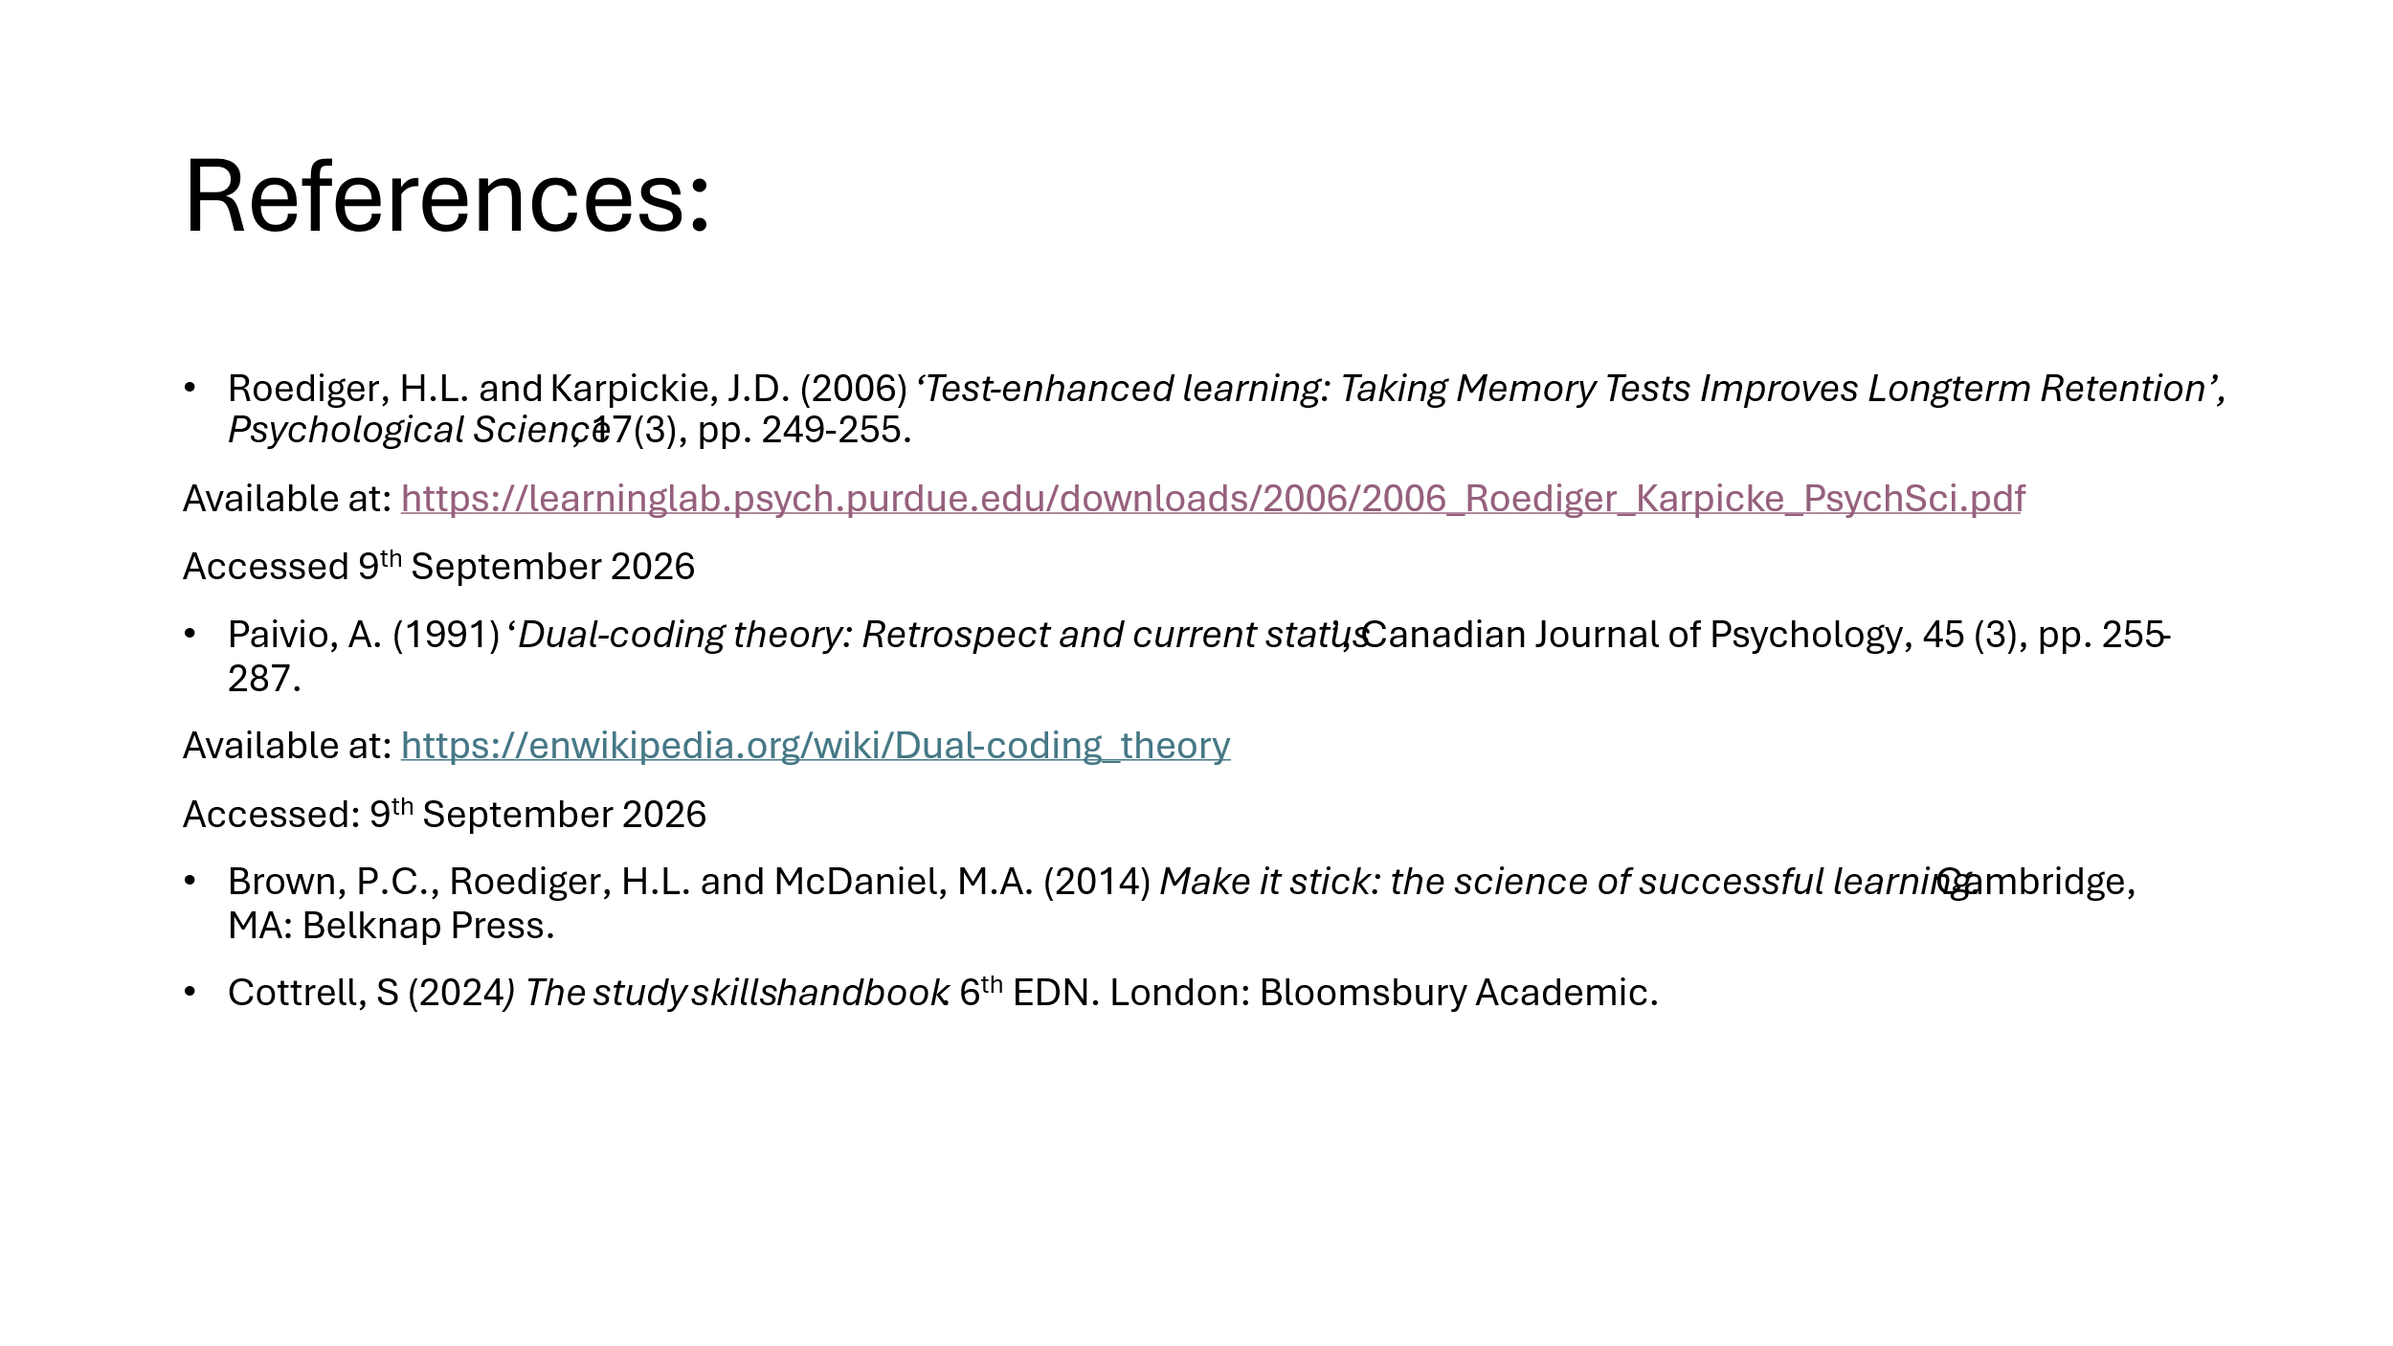

Part 4: voice over
Presentation (1).mp4

