
Eric FLOCEA
Student number 2535547
Task 1 – Reading Task Template
Upload your photo of your A3 in-class notes here:
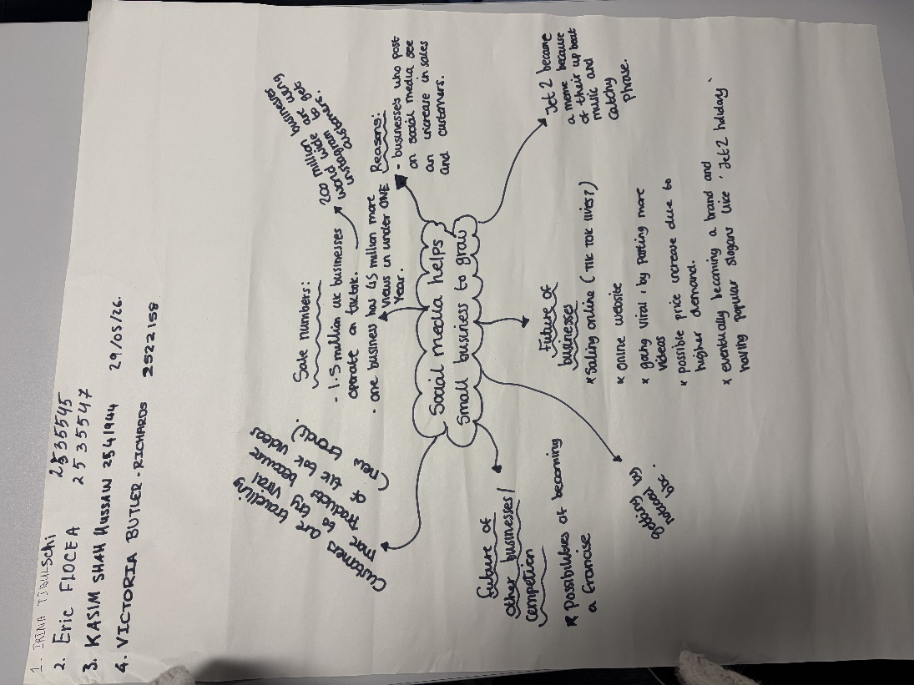

1. Answer these questions using the sentence starters below
a. What is the main idea of the text?
The main idea is that social media helps small businesses become popular.
b. What are two key points?
One key point is that viral videos bring more customers.
Another key point is that people travel to visit famous shops.
c. What part of the text did you find most important? Why?
The most important part is the sandwich shop story because social media helped the business grow.
d. Was anything unclear or difficult to understand?
I was not sure how the videos became so popular .
e. How did your group help you understand the text better?
My group helped me by explaining difficult parts in the text .
3. One sentence reflection
Question: What did you find challenging about this task?
The hardest part was understanding all the examples in the text .

