
HTML & CSS Web development
ACCA4023


Name: Louis Shortland
Module: ACCA4023
Course Name: Introduction to Web and Database Concepts
Submission Date : 26/03/26
Lecturer: Dr. Sadhana Jha
Student Number: 2433889

Table of Contents
1 Cover Page
2 Table Of Contents
3 Introduction
4 Requirements
5 Implementation
6 Evaluation
7 Conclusion
8 References
9 Appendices

Abstract
This is a report about the creation of a web site “Big Smoke Bullyz” , which is a dog breeding company. The site has been developed in HTML and CSS to promote the kennel, display the dogs available on sale and enable individuals to reach the business. The report explains the purpose behind the creation of the site, how it was constructed, and will also grade it on its ease of use, how it performs in relation to people with disabilities and how it will appear in search engines. It also contrasts it with other professional sites to identify what is good and what can be better.
3. Introduction
In this report, I am discussing the creation of a website for my dog breeding kennel, Big Smoke Bullyz. The purpose of the website is to provide information to visitors about the kennel, showcase the dogs owned by the breeder, and allow individuals to make contact if they are interested.
I used HTML to create the structure and CSS to design the layout and visual appearance. It includes multiple pages such as a home page, about page, dogs page, and contact page, all connected through a navigation menu to ensure ease of use.
This report explains the requirements, how I built the website, and how well it works. The evaluation focuses on usability, accessibility, and search engine optimisation (SEO), as these are key factors in determining the effectiveness of a website. The report also compares the website with two professional websites to identify strengths and areas for improvement.
Websites are designed using good design principles, which can be used to improve the site I created.
4. Requirements
Overview
The website created for this project focuses on Big Smoke Bullyz, a kennel that breeds and raises dogs. The website provides visitors with information about the kennel, details about the dogs, and ways to contact the breeder for enquiries.
The main goal of the website is to help my kennel have an online presence so more people can find it. This allows people who are interested in the dogs or breeding programme to easily find information about my kennel and get in contact.
I designed the website to be simple and easy for users to navigate.

Purpose of the Website
The primary purpose of the website is to act as an informational platform for the Big Smoke Bullyz kennel. It aims to:
- Provide an introduction to the kennel and its background
- Display images and information about the dogs
- Allow potential customers to contact the breeder
- Promote the kennel and increase awareness
Having a website is beneficial for breeders as it allows them to showcase their dogs to a larger audience and present their brand professionally.

Website Structure
My website consists of several pages which together provide a complete overview of the kennel.
Home Page
The home page acts as the main entry point to the website. It introduces visitors to the Big Smoke Bullyz kennel and provides images of the dogs. The page includes a navigation bar that links to the other pages of the website.
Figure 1: Home Page
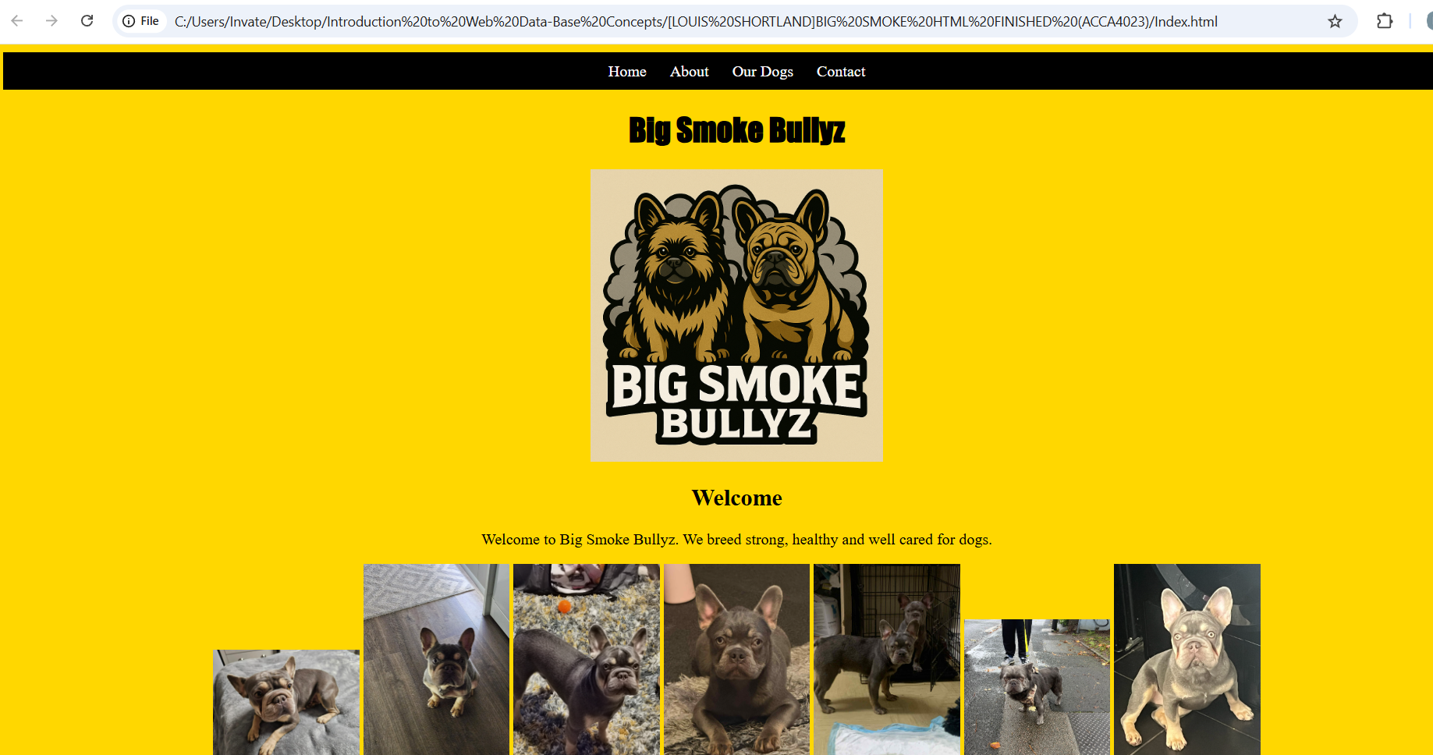

About Page
The about page provides more detailed information about the kennel. It explains the background of Big Smoke Bullyz, its goals, and the type of dogs bred by the kennel.
Figure 2: About Page
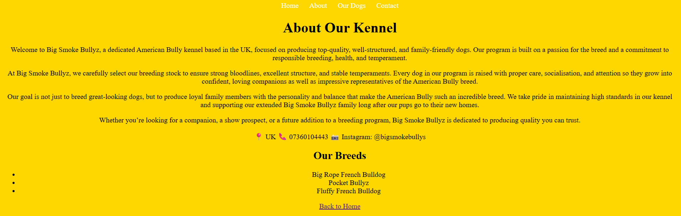

Dogs Page
The dogs page provides information about the dogs owned by the kennel. It presents details such as breed, age, and other relevant characteristics. This allows visitors to learn more about the dogs available.
Figure 3: Dogs Page
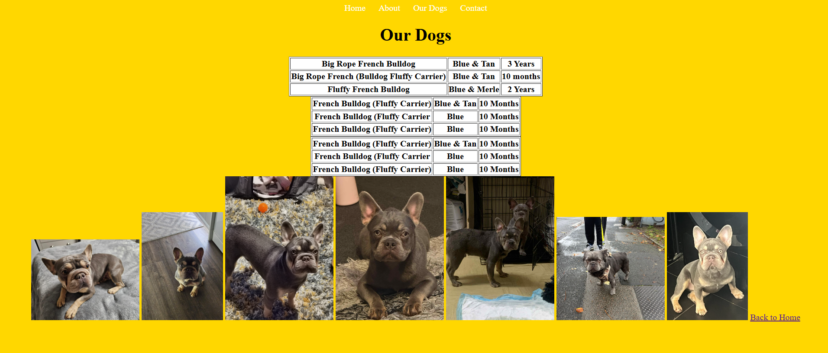

Contact Page
The contact page allows visitors to get in touch with the kennel. The page includes a contact form where users can enter their name, email address, and a message. In addition, other contact information such as a phone number and social media details are provided.
Figure 4: Contact Page


Target Audience
The main target audience for this website includes:
- People interested in purchasing a dog
- Dog enthusiasts
- Potential breeders
- People interested in learning more about the kennel
The website is designed to be accessible to users with different levels of technical ability. The layout is kept simple and easy to navigate so that users can find information without difficulty.

5. Implementation
I built the website using HTML and CSS, which are the main technologies used in front-end development.
I used HTML to build each page, including headings, images, navigation menus, and forms. CSS was used to style the website, including colours, layout, and spacing.

Page Structure
Each page of the website follows a similar structure. This ensures consistency and improves the user experience.
The typical structure of the pages includes:
- A header section containing the website title
- A navigation menu linking to other pages
- A main content area with text and images
- A footer or contact information
Using a consistent layout across all pages helps users understand how to navigate the site.

Navigation System
A navigation menu was implemented to allow users to move between different pages of the website. The navigation menu appears on each page and contains links to:
- Home
- About
- Dogs
- Contact
This ensures that users can easily navigate the website regardless of which page they are currently viewing.

Images and Content
Images were included on the website to showcase the dogs owned by the kennel. Images are an important part of the website because they help create visual interest and allow visitors to see the dogs.
Each image includes an alt attribute which describes the image. This improves accessibility and also helps search engines understand the content of the page.

Contact Form
A contact form was included on the contact page to allow users to send enquiries. The form includes fields for:
- Name
- Email address
- Message
Forms are an important feature of many websites because they allow visitors to interact with the website owner.

Validation
During validation, specific errors were identified and corrected. For example, some HTML tags were not properly closed, which caused validation errors. These were fixed by ensuring correct tag structure. Additionally, duplicate CSS rules were found and resolved by combining them into a single declaration. These corrections improved the overall quality and compatibility of the website.
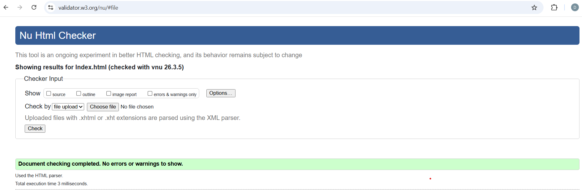

The CSS code was validated using the W3C CSS Validator. Some warnings appeared due to repeated style declarations. These were resolved by combining duplicate rules and ensuring the CSS file was organised correctly.
After these corrections, the website code successfully validated without warnings.
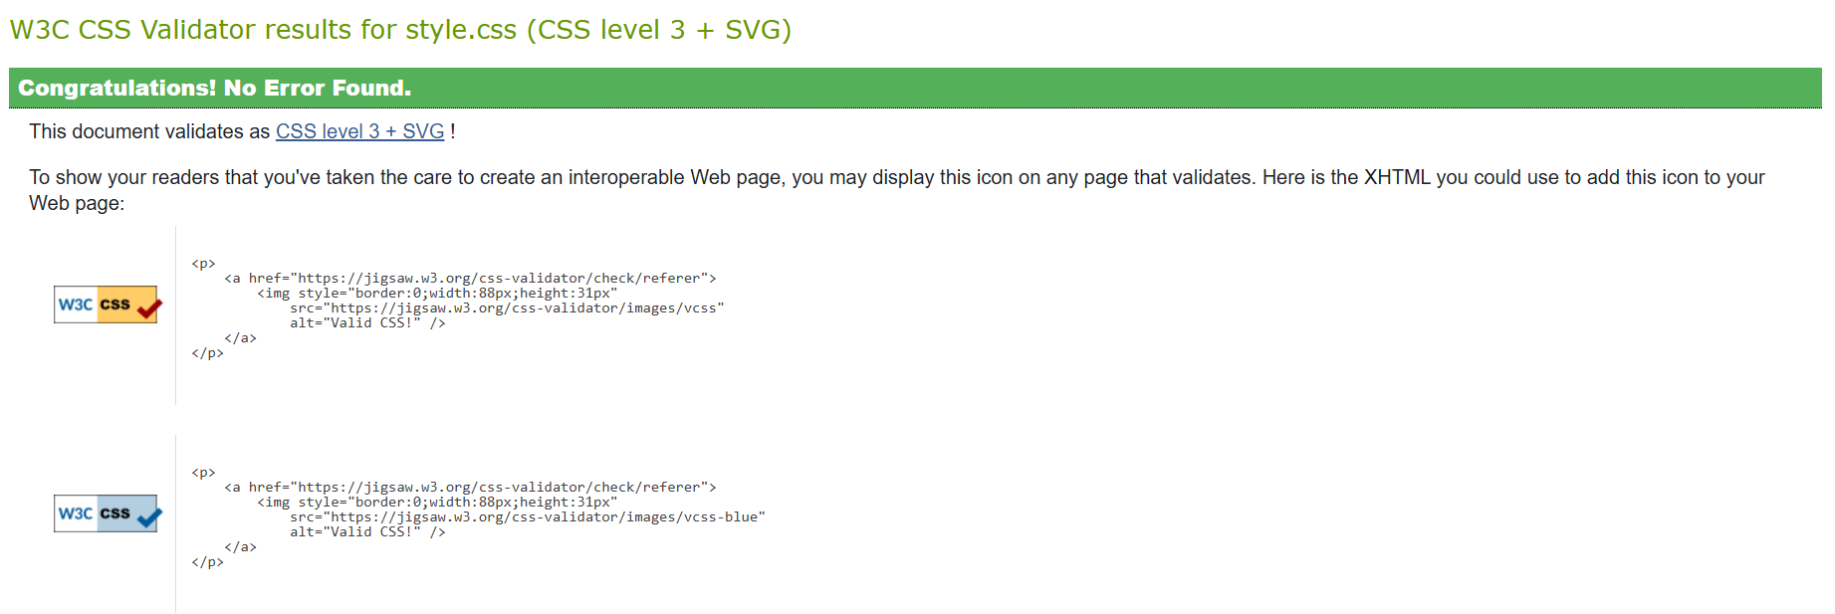

6. Evaluation
Website Usability
Usability is about how easy it is for users to use the website and complete tasks. According to Nielsen [1], users typically leave a website within 10–20 seconds if it is difficult to use, highlighting the importance of clear navigation and layout.
A study by Nielsen [1] found that users prefer websites that are simple, consistent, and easy to navigate. The study showed that clear layouts and predictable navigation significantly improve user satisfaction and task completion rates.
Additional research by A.Sutcliffe [5] found that clear navigation structures significantly improve user task completion rates and overall satisfaction when interacting with websites.
My website uses a consistent navigation menu, which helps users move between pages easily. These features allow users to quickly find information about the kennel and its dogs.
However, improvements could be made. For example, my website is not fully responsive, which may reduce usability on mobile devices. Adding responsive design and improving layout spacing would enhance the overall user experience.

.

Accessibility
My website can be evaluated using the four WCAG 2.1 principles:
- Perceivable: Images include alt text, ensuring content can be interpreted by screen readers.
- Operable: Navigation is simple and consistent, allowing users to move between pages easily.
- Understandable: Clear headings and simple language make the content easy to understand.
- Robust: The website works across modern browsers, but further testing is required to ensure compatibility with assistive technologies.

Accessibility means making sure the website can be used by people with disabilities. The Web Content Accessibility Guidelines (WCAG 2.1) [2] are based on four principles: perceivable, operable, understandable, and robust.
A study by Lazar et al. [4] found that many websites fail basic accessibility requirements, particularly in areas such as colour contrast and keyboard navigation. The study highlights the importance of testing websites using accessibility tools to ensure inclusive design.
Similarly, research by Harper and Yesilada [6] found that many websites fail accessibility standards due to poor navigation design and insufficient colour contrast, which can prevent users with disabilities from accessing content effectively.
The Big Smoke Bullyz website addresses these principles in several ways. Images include alt text, making content perceivable for screen reader users. The navigation menu is simple and consistent, supporting operability. The use of clear language and structure makes the website understandable.
However, improvements are needed. Colour contrast has not been formally tested, and keyboard navigation has not been fully evaluated. Using tools such as WAVE or aXe would help identify and fix these issues and improve overall accessibility.
.
Search Engine Optimisation (SEO)
SEO is used to help a website appear higher in search engine results.
A study by Beaird [3] found that websites with well-structured headings, relevant keywords, and properly formatted metadata rank higher in search engine results and attract more user engagement.
Ledford [7] also highlights that the use of structured headings, relevant keywords, and proper metadata significantly improves a website’s visibility in search engine results.
The Big Smoke Bullyz website applies several on-page SEO techniques. Each page includes a title tag, such as “Big Smoke Bullyz,” which helps search engines understand the content. Headings (H1 and H2) are used to structure content, improving readability. Images include alt attributes, which also support SEO.
Internal links are used through the navigation menu, allowing search engines to crawl the site more effectively. However, improvements could include adding meta descriptions and more keyword-focused content to improve search rankings.

Page Titles
Each page includes a title element which helps search engines understand the topic of the page.
Heading Structure
Headings such as H1 and H2 were used to structure the content of the pages. This improves readability and helps search engines interpret the content.
Image Alt Attributes
Images include alt text which helps search engines understand what the image represents.
Internal Links
The navigation menu creates internal links between pages, which helps search engines crawl the website more effectively.

Website Comparison
Area | BBC (bbc.co.uk) | GOV.UK (gov.uk)
Usability | Content-rich but can feel complex due to large volume of information | Simple, clean layout with very easy navigation
Accessibility | Good accessibility with alt text and structured content | Excellent accessibility, designed to meet WCAG standards
SEO | Strong use of headings, metadata, and structured content | Highly structured content optimised for search engines
Mobile Friendliness | Fully responsive with adaptive layout | Fully responsive and optimised for all devices

Comparison Discussion
Both BBC and GOV.UK are high-quality websites, but they differ in design approach. BBC provides large amounts of content, which can sometimes make navigation more complex. In contrast, GOV.UK focuses on simplicity and clarity, making it easier for users to find information quickly.
The WAVE accessibility tool was used to analyse both websites, identifying issues such as colour contrast and heading structure. GOV.UK showed fewer accessibility errors compared to BBC.
BBC also performs well but is more content. The WAVE tool identified minor contrast and structure differences between the two sites, with GOV.UK showing fewer accessibility issues overall
In terms of mobile responsiveness, both websites adapt well to smaller screens. However, GOV.UK maintains better readability due to its simpler layout.

Conclusion:
Overall, GOV.UK performs better due to its simplicity, strong accessibility focus, and highly user-friendly design. While the BBC provides more engaging content, GOV.UK offers a more efficient and accessible user experience.
The gov.uk website uses a very simple design that prioritises readability and ease of navigation. The layout is clean and focuses on presenting information clearly.

7. Conclusion
This report explains the way in which the Big Smoke Bullyz site was put together, constructed and tested. The website gives people a place to learn about the kennel. The site was made using HTML and CSS. It contains several pages where users can find useful information about the kennel. The site is user-friendly, and the tests indicate that it is accessible to individuals with disabilities and complies with straightforward search-engine guidelines. There remains room to improve. The design could be improved by making it more suitable for phone and tablet screens and easier access features could be provided in the future. Simply put, the project demonstrates the primary concepts of how to create a website and how usability, accessibility and search-engine friendliness are important to good websites.

8. References
[1] J. Nielsen, Usability engineering. Boston ; AP Professional, 1993.

[2] W3C, “Web Content Accessibility Guidelines (WCAG) 2.1,” W3.org, May 06, 2025. https://www.w3.org/TR/WCAG21/

[3] Jason Beaird, James George, The Principles of Beautiful Web Design (3rd Edition), (3rd Edition). SitePoint, 27AD.

[4] Jonathan Lazar, Daniel F. Goldstein, and Anne Taylor., Ensuring Digital Accessibility Through Process and Policy, (1st Edition). Morgan Kaufmann., 2015.

[5] A. Sutcliffe, “Designing for User Experience and Engagement,” Why Engagement Matters, pp. 105–126, 2016, doi: https://doi.org/10.1007/978-3-319-27446-1_5.

[6] W. Accessibility, Y. Yesilada, and S. Harper, “Human-Computer Interaction Series.” Accessed: Mar. 18, 2026. [Online]. Available: https://content.e-bookshelf.de/media/reading/L-12171978-7bd4434307.pdf

[7] “SEO: Search Engine Optimization Bible,” Google Books, 2026. https://books.google.co.uk/books/about/SEO_Search_Engine_Optimization_Bible.html?id=sgmxo1Alq_4C&redir_esc=y (accessed Mar. 18, 2026).
‌

Minor errors may be there in the appendix code listings, however these do not affect the functionality of the implemented website.

9. Appendices
Appendix A – HTML Code (Index)
<!DOCTYPE html>
<html lang="en">
<head>
<meta charset="utf-8">
<meta name="viewport" content="width=device-width, initial-scale=1.0">
<title>Big Smoke Bullyz</title>
<link rel="stylesheet" href="style.css">
</head>

<body>

<header>
<nav>
<a href="index.html">Home</a>
<a href="about.html">About</a>
<a href="dogs.html">Our Dogs</a>
<a href="contact.html">Contact</a>
</nav>
</header>

<h1 class="heading">Big Smoke Bullyz</h1>

<img src="bigsmoke.png" alt="Big Smoke Bullyz Banner" width="300">

<h2>Welcome</h2>

<p>Welcome to Big Smoke Bullyz. We breed strong, healthy and well cared for dogs.</p>

<img src="dog1.jpeg" alt="Dog 1" width="150">
<img src="dog2.jpeg" alt="Dog 2" width="150">
<img src="dog3.jpeg" alt="Dog 3" width="150">
<img src="dog4.jpeg" alt="Dog 4" width="150">
<img src="dog5.jpeg" alt="Dog 5" width="150">
<img src="dog6.jpeg" alt="Dog 6" width="150">
<img src="dog7.jpeg" alt="Dog 7" width="150">

<footer>
<p>Follow us on Instagram @bigsmokebullys</p>

<video width="300" controls>
<source src="movie.mov" type="video/mp4">
<source src="movie.mov" type="video/ogg">
Your browser does not support HTML5 video.
</video>

</footer>

</body>
</html>

Appendix B – HTML Code (About Page)
<html>
<html>
<head>
<meta name="viewport" content="width=device-width, initial-scale=1.0">
<style.css

<header>
<nav>
<a href="index.html">Home</a>
<a href="about.html">About</a>
<a href="dogs.html">Our Dogs</a>
<a href="contact.html">Contact</a>
</nav>

</header>

<title>About Big Smoke Bullyz</title>
<link rel="stylesheet" href="style.css">
</head>

<body>

<h1>About Our Kennel</h1>

<p>Welcome to Big Smoke Bullyz, a dedicated American Bully kennel based in the UK, focused on producing top-quality,
well-structured, and family-friendly dogs. Our program is built on a passion for the breed and a commitment to
responsible breeding, health, and temperament.</p>

<p> At Big Smoke Bullyz, we carefully select our breeding stock to ensure strong bloodlines, excellent structure,
and stable temperaments. Every dog in our program is raised with proper care, socialisation, and attention so
they grow into confident, loving companions as well as impressive representatives of the American Bully breed.</p>

<p> Our goal is not just to breed great-looking dogs, but to produce loyal family members with the personality and
balance that make the American Bully such an incredible breed. We take pride in maintaining high standards in
our kennel and supporting our extended Big Smoke Bullyz family long after our pups go to their new homes.<p/>

<p> Whether you’re looking for a companion, a show prospect, or a future addition to a breeding program, Big Smoke
Bullyz is dedicated to producing quality you can trust.</p>

<p>📍 UK
📞 07360104443
📸 Instagram: @bigsmokebullys</p>

<h2>Our Breeds</h2>

<ul>
<li>Big Rope French Bulldog</li>
<li>Pocket Bullyz</li>
<li>Fluffy French Bulldog</li>
</ul>

<a href="index.html">Back to Home</a>

</body>
</html>

Appendix C – HTML Code (Dogs Page)
<html>
<html>
<head>

<meta name="viewport" content="width=device-width, initial-scale=1.0">
<style.css

<header>
<nav>
<a href="index.html">Home</a>
<a href="about.html">About</a>
<a href="dogs.html">Our Dogs</a>
<a href="contact.html">Contact</a>
</nav>

</header>

<title>Our Dogs</title>
<link rel="stylesheet" href="style.css">
</head>

<body>

<h1>Our Dogs</h1>

<table border="1">

<tr>
<th>Big Rope French Bulldog</th>
<th>Blue & Tan</th>
<th>3 Years</th>
</tr>

<tr>
<th>Big Rope French (Bulldog Fluffy Carrier)</th>
<th>Blue & Tan</th>
<th>10 months </th>
</tr>

<tr>
<th>Fluffy French Bulldog</th>
<th>Blue & Merle </th>
<th>2 Years</th>
</tr>

</table>
<table border="1">

<tr>
<th>French Bulldog (Fluffy Carrier)</th>
<th>Blue & Tan</th>
<th>10 Months</th>
</tr>

<tr>
<th>French Bulldog (Fluffy Carrier</th>
<th>Blue</th>
<th>10 Months</th>
</tr>

<tr>
<th>French Bulldog (Fluffy Carrier)</th>
<th>Blue </th>
<th>10 Months</th>
</tr>

</table>

</table>
<table border="1">

<tr>
<th>French Bulldog (Fluffy Carrier)</th>
<th>Blue & Tan</th>
<th>10 Months</th>
</tr>

<tr>
<th>French Bulldog (Fluffy Carrier</th>
<th>Blue</th>
<th>10 Months</th>
</tr>

<tr>
<th>French Bulldog (Fluffy Carrier)</th>
<th>Blue </th>
<th>10 Months</th>
</tr>

</table>
<img src="dog1.jpeg" width="200">
<img src="dog2.jpeg" width="150">
<img src="dog3.jpeg" width="200">
<img src="dog4.jpeg" width="200">
<img src="dog5.jpeg" width="200">
<img src="dog6.jpeg" width="200">
<img src="dog7.jpeg" width="150">

<a href="index.html">Back to Home</a>

</body>

</html>

Appendix D – HTML Code (Contact Page)

<html>
<html>
<head>

<meta name="viewport" content="width=device-width, initial-scale=1.0">
<style.css

<header>
<nav>
<a href="index.html">Home</a>
<a href="about.html">About</a>
<a href="dogs.html">Our Dogs</a>
<a href="contact.html">Contact</a>
</nav>

</header>

<title>Contact Us</title>
<link rel="stylesheet" href="style.css">
</head>

<body>

<h1>Contact Big Smoke Bullyz</h1>

<form>

Name:<br>
<input type="text"><br><br>

Email:<br>
<input type="email"><br><br>

Message:<br>
<textarea></textarea><br><br>

<input type="submit" value="Send">

</form>

<p>Phone: 07360104443</p>
<p>Instagram: @bigsmokebullys</p>

</body>
</html>

Appendix E – CSS Stylesheet
body{
font-family: Arial;
background-color: #f4f4f4;
text-align: center;
}

header{
background-color: black;
color: white;
padding: 20px;
}

nav a{
color: white;
margin: 10px;
text-decoration: none;
}

table{
margin: auto;
background-color: white;
}

footer{
margin-top: 20px;
}

Part C (Provide the comparison of two Live Websites)

