

Student name: Rupa Mondal
Student ID: 2530821

Module name: Introduction to Health and Social Care
Module code: LCHS4003
Lecturer name: Sam Parker (Module Leader)

Task 1: Pharmacy services
Task 2: Residential care home
Table of Contents
Task 1: Poster 3
Task 2: A 600-word Essay: Residential care home 6
References 8

Inteoduction
Ambulance services are a vital part of the UK healthcare system, providing emergency care for accidents, injuries, sudden illness, and other medical emergencies (Fernandes and Ray, 2023). Accessed by calling 999, trained staff assess the situation and dispatch the appropriate response. Around 6,000 ambulances operate across the UK (NHS Alliance, 2024). Ambulance crews provide immediate treatment, such as CPR, oxygen therapy, bleeding control, and medication, before transporting or referring patients to appropriate healthcare services.
Brief History of the service
In the 19th Century, local chemists gave birth to the modern UK profession of the pharmacist. After the introduction of the National Health Service (NHS) in 1948, the community pharmacy evolved into the concept of a contracted NHS service, dispensing medicines prescribed by doctors and giving people advice on pharmaceutical products (Your Health Your Pharmacy, 2023). They went beyond getting medicines over time and became involved in the public health services, with medicine reviews, vaccination, and independent prescribing too. In 2024, Pharmacy First was introduced in England, increasing pharmacists’ responsibilities as front line health care providers by enabling patients to access treatment for common conditions without the need for a GP referral (NHS England, 2024).

Pharmacy services
Student Name: Rupa Mondal
Course Name: Certificate of Higher Education Skills for the Workplace (Health & Social Care)
Email Details: sam.parker@uwtsd.ac.uk

Task 1: Poster
Figure 1: Evolution of the pharmacy services in the UK
(Source: Self-developed)
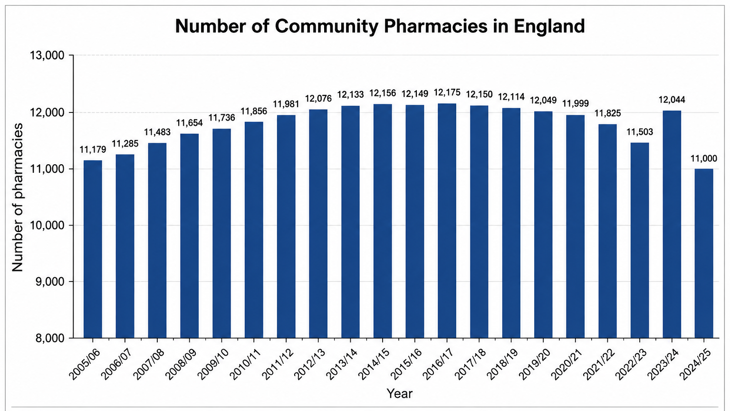
Figure 3: Decreasing number of community pharmacy in England (Source: Minhas, 2026)

(

Challenge 1: High Workload and Funding Pressure
Community pharmacies face staff shortages, increasing workloads, and limited funding. Many pharmacies receive less funding than the cost of providing NHS services, threatening their long-term sustainability (Community Pharmacy England, 2025). Expanding roles, such as Pharmacy First and independent prescribing, have further increased pressure on pharmacy staff (Robertson, 2026).

Current Functioning of the Service (Very Short Version)
In 2023–24, over 12,000 community pharmacies in England provided NHS services, including dispensing medicines, Pharmacy First, vaccinations, health checks, and advice on common illnesses (Minhas, 2026). Pharmacists work with GPs and hospitals to deliver safe, accessible care under GPhC regulations.

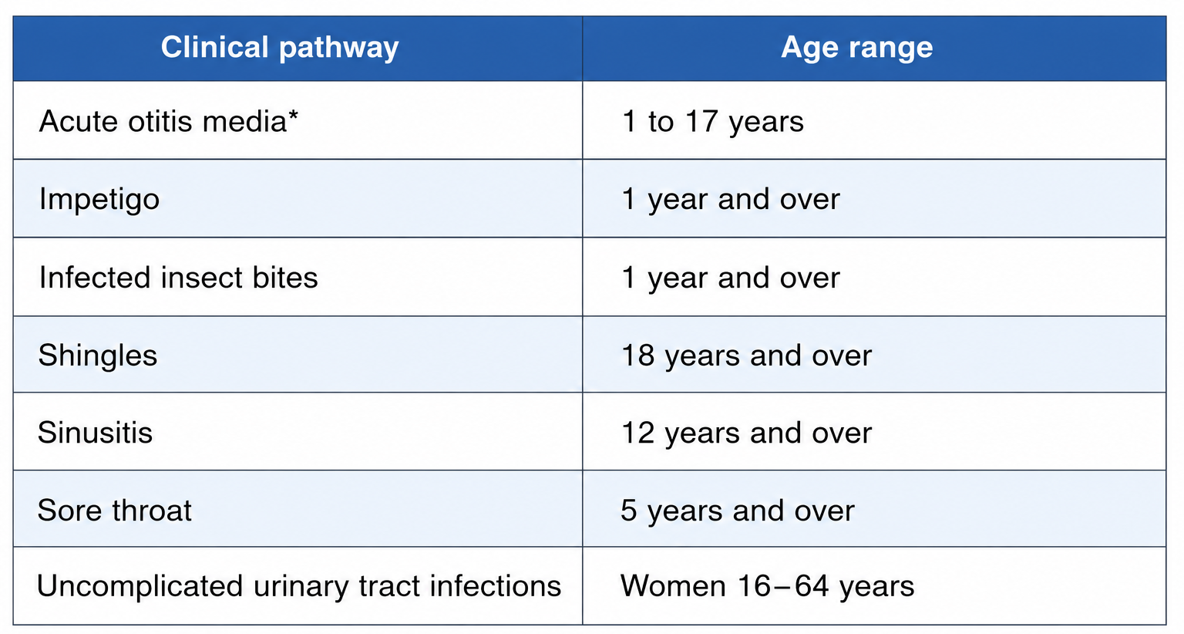
Figure 2: Conditions, pharmacists can manage with the intervention of GP (Source: NHS England, 2024)

Challenge 2: Rising Demand and Fewer Pharmacies
Demand for pharmacy services is increasing as GP appointments become harder to access. At the same time, the number of community pharmacies in England has fallen from over 12,000 to around 11,000 (Minhas, 2026). This particularly affects underserved communities. Increased investment, workforce development, and digital innovation are needed to maintain equal access to pharmacy services.

References
Community Pharmacy England, (2025). Economic Analysis of NHS Pharmaceutical Services (Independent Economic Review). [online] Available at: https://cpe.org.uk/funding-and-reimbursement/pharmacy-funding/independent-economic-review/ (Accessed on: 2 July 2026)
Minhas, A., (2026). Number of Community Pharmacies in England from 2006/07 to 2024/25. [online] Available at: https://www.statista.com/statistics/418071/community-pharmacies-in-england/ (Accessed on: 2 July 2026)
NHS England, (2024). Pharmacy First. [online] Available at: https://www.england.nhs.uk/primary-care/pharmacy/pharmacy-services/pharmacy-first/ (Accessed on: 2 July 2026)
Robertson, J., (2026). Growth in Pharmacy First Consultations ‘Not Sustainable’. The Pharmaceutical Journal. [online] Available at: https://pharmaceutical-journal.com/article/news/growth-in-pharmacy-first-consultations-not-sustainable (Accessed on: 2 July 2026)
Rutter, P. and Barnes, N., 2024. Facilitating self-care through community pharmacy in England. Exploratory Research in Clinical and Social Pharmacy, 13, p.100404. https://www.sciencedirect.com/science/article/pii/S2667276623001853
Your Health Your Pharmacy, (2023). Community Pharmacy – Past, Present and Future. [online] Available at: https://www.yourhealthyourpharmacy.co.uk/community-pharmacy-past-present-and-future-3/ (Accessed on: 1 July 2026)

Eassay

Task 2: Residential care home

One of the key elements of the UK social care system is residential care homes, which support people with disabilities and elderly whose ability to live independently is impaired. Such population are provided personal care and assistance with their daily living. Residential care homes primarily offer personal care and not nursing care that is ongoing. They ensure dignity for everyone, independence and wellbeing while ensuring support for residents in a way that meets their individual needs.
Residential care homes began to be established as part of the Poor Laws of the sixteenth centuries, when individuals who were unable to support themselves lived in workhouses and then poorhouses at the Parish level (Yerli, 2020). Awful conditions and social stigma were often associated with these institutions. After the Second World War the welfare state was introduced, the workhouse system was overturned and local authorities’ responsibility for residential care was assumed under the National Assistance Act 1948. The focus on assessing social care requirements signalled a new shift in those laws, moving away from punitive institutionalisation to a welfare approach (Glasby, 2026). The care in residential care homes became part of adult social care in England with a series of reforms which included the Care Standards Act 2000 and the Care Act 2014 that increased the strength of regulation, safeguarding and person-centred care.
Residential care homes are regulated and run today under the Care Quality Commission (CQC). Providers need to comply with the national minimum standards of safety, effectiveness, responsiveness, leadership and quality of care (Care Quality Commission (CQC), 2025). Care is provided by partnership by a multidisciplinary team comprising care staff, GP, pharmacists and social workers to meet residents’ physical, emotional and social needs. Accurate record-keeping and good communication along with individual care plans help to ensure continuity of care and allow the residents and family to have a voice in decisions made. Digital care records also have benefits for information sharing and care co-ordination between health and social care services, as their use has increased (Allsop et al., 2022).
Despite all of these progressions, there are still a lot of problems in front residential care homes. Providers are facing some serious pressure due to staff shortages and rising operational costs, while they are also seeing a growing demand because of mounting of an ageing population. Skills for Care (2025) estimates that adult social care continues to have high vacancy and turnover rates in England, which have an impact on continuity of care and quality of the care provided. In addition, because of funding restrictions, providers have been struggling to engage and retain qualified workforce to respond to an increasingly complicated and varied set of care needs (House of Commons Health and Social Care Committee, 2022). The issues bring many challenges: the need for sustainable investment, building a workforce and better integrate health and social care services.
The contribution that residential care homes can make to service users’ lives in terms of improving their lives is key. They also offer social interaction, recreational activities and emotional support to mitigate social isolation beyond supporting self-care, and support one’s overall well-being. Person centred care allows residents to live independently, with dignity and choice whilst maximising their physical and mental wellbeing. Evidence shows that strong connections to and relationships with staff, personalised care and a safe environment are key to fostering an enhanced quality of life and life satisfaction amongst residents (Borovika et al., 2025). Besides, residential care homes serve to give the families reassurances as to the presence of continuous support and protection for vulnerable persons. Nonetheless, there are need for improvements to tackle issues, such as funding crunch and shortage of workforce in residential care homes that play an important role to drive the wellbeing of vulnerable elderly people and supporting healthy ageing in the country.

References
Allsop, M.J., Chumbley, K., Birtwistle, J., Bennett, M.I. and Pocock, L., 2022. Building on sand: digital technologies for care coordination and advance care planning. BMJ supportive & palliative care, 12(2), pp.194-197. https://eprints.whiterose.ac.uk/id/eprint/180801/3/Main%20Document_accepted_Allsop%20et%20al%202021.pdf
Borovika, A., Moors, M. and Zolovs, M., 2025. Enhancing quality of life: Key factors from long-term social care residents’ perspectives. International Journal of Environmental Research and Public Health, 22(2), p.231. https://www.mdpi.com/1660-4601/22/2/231
Care Quality Commission (CQC), (2025). The State of Health Care and Adult Social Care in England 2024/25. [online] Available at: https://www.cqc.org.uk/sites/default/files/2025-10/20251024_stateofcare2425_print.pdf (Accessed on: 2 July 2026)
Glasby, J., 2026. Understanding health and social care. In Understanding Health and Social Care. Policy Press. https://cmls.org.uk/online/wp-content/uploads/2019/07/Understanding-health-and-social-care.pdf
House of Commons Health and Social Care Committee, (2022). Workforce: Recruitment, Training and Retention in Health and Social Care (HC 115). [online] Available at: https://publications.parliament.uk/pa/cm5803/cmselect/cmhealth/115/report.html (Accessed on: 3 July 2026)
Skills for Care, (2025). Latest Social Care Sector and Workforce Data Published. [online] Available at: https://www.skillsforcare.org.uk/news-and-events/news/latest-social-care-sector-and-workforce-data-published (Accessed on: 2 July 2026)
Yerli, K., 2020. The Elizabethan Poor Law of 1601 as a result of socio-political and economic conditions of the sixteenth century England. Turkish Journal of Applied Social Work, 3(1), pp.88-99. https://dergipark.org.tr/en/download/article-file/1179644

