

Postgraduate/Distance Learning
Assignment coversheet & feedback form

THIS SHEET MUST BE THE FIRST PAGE OF THE ASSIGNMENT YOU ARE SUBMITTING (DO NOT SEND AS A SEPARATE FILE)

For completion by the student:
Student Name: Cindy Poorbaugh

Student University Email: 2313752@student.uwtsd.ac.uk
Module code: HPCA7015  Module title: Foundations in Cultural Astronomy and Astrology | Student ID number:  2313752 |  |  | Educational support needs:  Yes/No
Assignment title: Essay based on a Sky Journal

Assignment due date: November 30, 2023
This assignment is for the 1st 2nd 3rd 4th 5th 6th module of the degree
I confirm that this is my original work and that I have adhered to the University policy on plagiarism.
Signed ……Cindy Poorbaugh………………………………………………………
Email submission:if you are submitting this form via email, please tick this box □x
(as a substitute for your signature) to confirm that you agree to the above declaration.
Assignment Mark
1st Marker’s Provisional mark
2nd Marker’s/Moderator’s provisional mark
External Examiner’s mark (if relevant)
Final Mark

NB. All marks are provisional until confirmed by the Final Examination Board.

For completion by Marker 1 :
Comments:

Marker’s signature: |  |  | Date:
For completion by Marker 2/Moderator:

Comments:

Marker’s Signature: |  | Date:
External Examiner’s comments (if relevant)

External Examiner’s Signature: |  | Date:

Essay based on a Sky Journal:
Word Count: 2,376
Introduction
I began my Sky Journal on October 18, 2023. The sky was overcast, but with breaks in the clouds. I was searching for Jupiter, which I knew from my electronic ephemeris, would be currently about 50° above the Eastern horizon at 10:30 pm. Before beginning my observation, I was holding Jupiter in my mind because its twelve-year cycle has book-marked two turning points in my personal cosmology — how I understand myself within my world. Jupiter, which will be a beacon for the next month, has already been an inner beacon for orienting my worldview around astrology, which has been nothing less than an enlightenment (not to be confused with ‘being enlightened’ in established spiritual systems). I will write this essay built upon this synchronicity of this sea-change, or better sky-change, which brought astrology into the foreground of my life and work. Twelve years ago, Jupiter didn’t stand alone, but functioned in tandem with Uranus, both transiting my 10th house. During my observation Jupiter again didn’t stand alone over the course of the month, it defied solitude, in keeping with its astrological and mythological meaning. First, I waited for the Moon to approach Jupiter and come into a conjunction, with the exact full Moon at 4° of Taurus and Jupiter at 11° and then coming into an exact conjunction in the first degrees of waning. As the Moon quickly moved away from Jupiter, another consort came to my attention which will present another synchronicity, this time a mythological discovery.
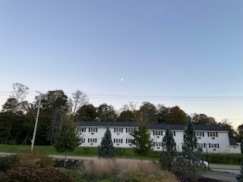
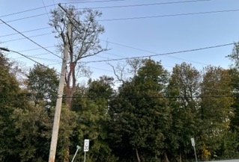
My anticipation is already somewhat cerebral and imaginary, because of the foreknowledge of the coming full Moon eclipse, and because I will not accidentally find Jupiter crossing a small section of sky between a line of tree-tops along the Eastern horizon, and the eaves of my condo roof framing the right side of a rather domestic picture. This frame reminds me of a child’s picture drawn with trees, a rooftop or two, and stars and Moon in the sky. The contained picture of the sky within a domestic, earth-bound frame represents the central theme of my essay — the multiple psychological layers which are stimulated through the pure visual experience of the sky.
Figure 1. Oct. 23, Moon rising in crux of trees. (all photos by C.Poorbaugh)
Figure 1, October 23. Moon rising
I will begin by referencing Alexandra Harris’s book, Weatherland: Writers and Artists Under English Skies to charac-
terize the experience I had with my evening observations.
In a section of the book, ‘A Flight in Cloudland’, Harris reflects
on the personal relationship that three early Romantic artists had to the sky. She points to the context of the painter, John Constable’s, use of the term ‘organ of sentiment’ to describe the clouds in the sky: the investigations of phrenologists at the time who were identifying bodily organs with various brain functions. Constable is imaging the landscape as a living being. Harris reflects on the rich ambiguity of his terminology, writing,
Figure 2. Oct. 23, Moon risen, center.
Whose organs, whose sentiments? The sky is being named as a feeling organ, but the sentiments are surely those of the perceiver. Constable’s skying was probing at the most mysterious emotional relations between man and his environment.”
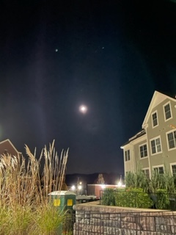
She contrasts Constable with John Keats, noting that Keats felt the cloud cover to be occulting his thoughts. She writes, “Standing in the mist we are suddenly looking around at the great interior of Keats’ brain.” She characterizes the response of Caspar David Friedrich to Goethe’s suggestion that he illustrate the vast variations in clouds as defiant — writing that, “Friedrich ’s imagination alone would shape the clouds in this art, for the clouds he painted were images of imagination itself.” Although Harris portrays both Friedrich and Keats as seeing mist as an image of mental life, writing, “To think is to walk among clouds,” her examples here and elsewhere in her book broaden ‘mental’ and ‘thinking’ to include feeling and the whole of imagination.
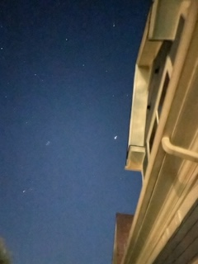
While Harris is writing about the imaginal relationship to weather, the same imaginary relationship extends to the celestial spectacle above the atmosphere. Though its movements and cycles are slower and less malleable to the senses the ‘heavenly vault’ is no less a mirror for the human mind in all its functions. Her statement that her subject is not weather, but “…the weather as it is daily recreated in the human imagination…” captures my experience that my whole mind entered this experience — from pure wonder to the mapping of symbolic meaning onto my life at this moment in time. The practice of observing the sky each night connected me to what I imagine is the primal human experience of the sky. Dane Rudhyar, imagined back to the ancient Chaldeans, and their effort to become one with the planets and to derive certain life qualities based on the light qualities, writing that, “men lay upon the ground, facing the stars, absorbing into their souls the rays of a particular star, identifying themselves with it, to know its essence and feel its exalted life.” My questions were: would I be able to feel this, even with my preconceived ideas, and what would I see in myself that I didn’t already know through this nightly relationship to my sky frame?
Figure 3. Oct.23, Moon rising West of my viewing frame.
Figure 4. Oct.23, Jupiter within my vista, close to eaves.
Jupiter and the Moon
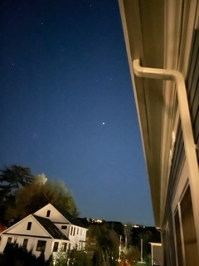
Returning to the beginning: I was searching for Jupiter and anticipating the growing fullness of the Moon. In addition to the Moon’s approach to the Lunar eclipse, I knew that it was rare that the Moon’s orbit shifted eastward far enough to appear in my small frame, visible from my balcony which faces Southeast. In Figures 1 and 2, I am searching for the location of the Moon rise so I can anticipate when it will rise far enough East to enter the small vista from my balcony. In Figure 3, the waxing crescent Moon is West of my vista, and in Figure 4, I am looking at Jupiter for the first time from my balcony, appearing very close to rising beyond the eaves.
Figure 5. Oct 24, Jupiter in vista at 9:00 pm.
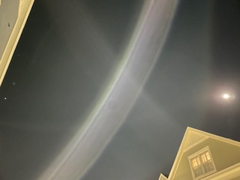
October 24th was a crystalline day. I took a photo of Jupiter and
then walked to the front of my building and was able to just
fit both Jupiter and the Moon in the frame (Figs. 5 and 6). I can vaguely see other stars and constellations, though there is considerable residual light. My iPhone camera doesn’t register the brightness and luminosity of Jupiter, but even with its bright, beauty tonight, I imagine what it would look like farther North or in the Southwest. Despite being a clear day, the evening of October 25th became cloudy. I gaze at the illuminated clouds, knowing both the Moon and Jupiter are there, and for the first time, I feel like I am having a relationship with them; there is play between their movement, my frame, my expectations, and the weather (Fig 7).
Figure 6. Oct 24, Jupter (far left) and Moon in the same frame, on the other side of my building.
October 27 is the day before the full Moon (Figure 8). I write in my journal,
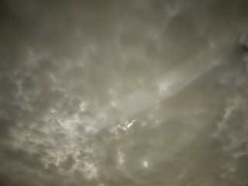
The late afternoon into sunset is clear and cloudless, so I am excited and to see Jupiter and the Moon together for the first time, and within the frame of my balcony sky-vista. This will last just a few hours before both move westward, over the roof and out of view. If would be a gift if this would repeat to-morrow night. The full Moon will be just past 4:00 pm. It is difficult to watch the movement of Jupiter and the Moon without the
awareness — out of sight — of Mars in opposition
to Jupiter.
Figure 7. Oct 25. Moon illuminating cloud cover.
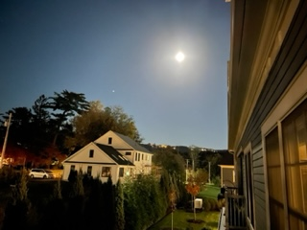
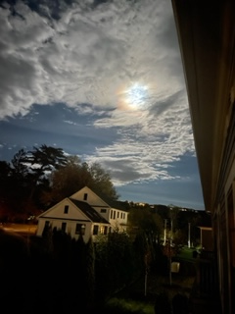
At this moment, the Moon is the changeable body, travelling to meet Jupiter after having eclipsed the Sun on October 14th, then coming into conjunction with Mars. Jupiter is the constant, keeping both diurnal time, rising to its visible height in the evening, and it’s twelve-year time clock. Twelve years ago, Jupiter came into conjunction with Uranus on my midheaven. Now it is approximately 30° past that point and illuminating my outward being in the world in the same way — my life purpose. Often, this symbolism is assigned to the Sun, but Jupiter, I believe, acts as the time clock, the beacon for this life process. But at this point in my observation, the Moon is the illuminator, her coming into visible relationship with Jupiter is the event. I have already seen and felt the Moon’s
trajectory while waxing and drawing closer to my frame, where I want to capture her with Jupiter. While the Moon is so often assigned to the biological domain of being, her role of carrier of the human imagination, as manifester of the unconscious, is also central to her meaning. In The Myth of the Goddess, Anne Baring and Jules Cashford write of the Moon —
Figure 8. Oct 27, Moon with Jupiter rising, one day before full Moon.
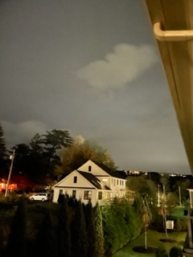
In the rhythmical phases of light and darkness the
Paleolithic tribes must have seen a pattern of growing
and decaying endlessly renewed, and this would have given them trust in life…In the full moon they may have marveled at the increase of life that overflowed into
new life. In the waning moon they would have mourned the withdrawal of life, the departure of the goddess; and
in the darkness of the lost moon they would have longer
for her and her light to return…This experience gave birth
in them to the power to see life imaginally.”
Figure 9. Oct 28, Full Moon with Jupiter rising, just visible above tree line.
After a few overcast days, as if in mourning after the full Moon, (Figure 10), the skies clear to reveal Jupiter holding court on November 1st. I am feeling at a loss. Not only am I feeling deprived of seeing a few days of the Moon just beginning to wane, on the other side of Jupiter, but her orbit is now evading my frame, and she is gone.
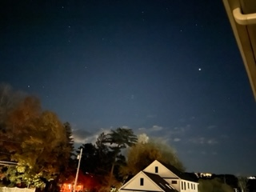
On November 1st, I write in my journal, “The clear night seems to emphasize in the deep blue the absence of the Moon (Fig. 11). But there is a star I notice rising about 50° to the east (left) of Jupiter.” Now I am paying attention to this star which is warmer in tone than Jupiter, and I am surprised to see it
even more clearly on the cloudier night of November 3rd
(Fig.12).
On November 5th I write,
Figure 10. Oct 30, Cloud cover.
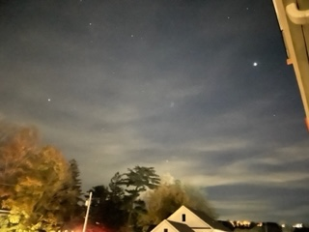
“A very clear, warm day. The time changed so I
had to remember to find Jupiter an hour earlier
before it would rise out of the frame. The bright,
warm star is there, and for the first time, I use a
star-finder ap to discover that it is Capella: the sixth-brightest star visible to us, in the constellation of Auriga. Capella is the ‘Goat Star.’”
Figure 11. Nov 1. Jupiter—and a star appearing just over the tree top in the East.
On November 6th I write, “To think that my eyes register a planet in our solar system with a star of another solar system, as a duo on a dark, translucent plane.” It is even more striking that Capella is actually two giant yellow stars, which accounts for its warm tone. On November 7th, I am almost too late to capture Jupiter, but both are in my frame (Fig. 13).
Figure 12. Nov 3, Jupiter and the unknown star.
Jupiter and Capella
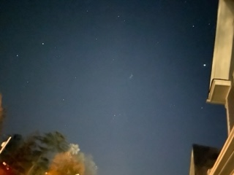
The association of the star, Capella to the mythic goddess, Almatheia came to my attention, though I have lost that original source. Weaving together several ancient sources, Carl Kerényi writes of the varied accounts of Zeus’s
early life after Rhea, his mother, gives birth to him on Mount Lycae in Arcadia, then carries him to Crete, to the
cave of Dicte. One tale tells of the child Zeus being fed by
Amaltheia and Melissa, daughters of the Cretan King
Melisseus. While Melissa fed him with honey, harkening an
earlier tale in which Zeus is fed by bees, Amaltheia feeds
him with a goat horn, belonging to her goat. In some stories,
Amaltheia herself is the goat. Another version connects Amaltheia with Capella: After being nursed by Amaltheia, the mature Zeus created his thunder-shield from her hide, and the horn of plenty, the cornucopia, from her crown. He placed her amongst the stars as the constellation, Capra, the group of stars surrounding Capella on the arm of Auriga, the charioteer.
Figure 13. Nov 7, Jupiter and Capella, the ‘Goat Star’.

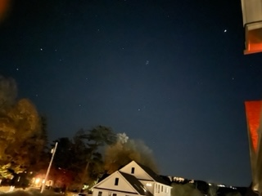
This mythic connection between the child, Zeus, and his goat-nurse was a revelation in how peripherally it came into my field of vision, though I could have just as easily focused on the constellation of Pleiades, which was also visible on clear nights, and was about midway between Jupiter and Capella. I am not able to go further into researching mythology, but I am also happy to have made this single connection. I thought of Jupiter/Zeus, slowly moving towards Capella, and wondered at the symbolism
of this solar god moving towards the earthy goddesses that
insured his survival.
Figure 14. Nov 10
On November 15th, I write in my journal:
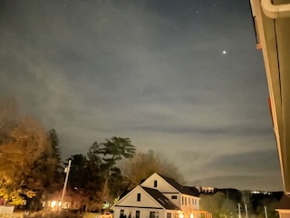
It is something I might have noticed at another time and given no importance to, the fact that my iPhone camera can register the depths and nuances of the clouds in the night sky, where my eyes cannot. This was a more pleasant surprise than the fact that the camera distorts the Moon, and Jupiter, picking up too much glare which diminishes the scale and shape. However, these variations in the ‘sight’ of the camera made me reflect on how every organism on the earth has different sight mechanisms and therefore perceives a different world. As we know through science,
we are looking back into time when we look up at these
lights in the sky. More for the imagination.
Figure 15. Nov 15. The Clouds enhance Jupiter; and obscure Capella.
Fig. 14 is one of the clearest photos of Jupiter and Capella on a clear night, with the Pleiades between them, but closer to Jupiter, who is in early Taurus, and so appears to be to the right of the constellation. I use Fig. 15 as my last photo of Jupiter standing alone, because the clouds allowed him to glow.

Conclusion

Holding the frame —- this nightly ritual of observation and the literal frame of my surrounding environment — seemed to function like a moving painting and to allow me to witness my own thinking, feeling, urge to narrate — to come upon a myth and to imagine beyond it. To feel the vast sky in this containment amplified the full Moon’s powerful presence and the regal constancy of Jupiter’s glow. It also gave me a space to reflect on the layers of consciousness and how the knowledge of astronomical facts did not have the power to disenchant the sense experience. It felt like another synchronicity at the end of the month, to find the next waxing Moon and Jupiter together (Fig. 17).

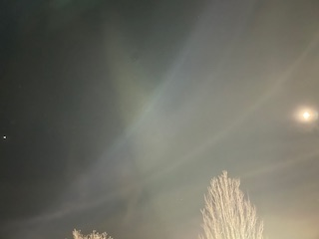

Figure 16. Nov 20, the new crescent Moon approaches Jupiter, (very close to the left edge of photo). In front of my building.

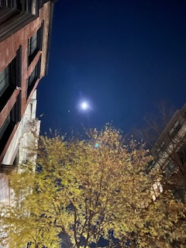

Figure 17. Nov 24, the waxing Moon and Jupiter—in another city.

References

Baring, Anne and Cashford, Jules. The Myth of the Goddess: Evolution of an Image, Arkana,
Penguin Books, London, 1993.

Harris, Alexandra. Weatherland: Writers and Artists Under the English Skies, Thames
and Hudson Ltd., 2016.

Kerényi, Carl. The Gods of the Greeks, Thames and Hudson Ltd., London and New York,
1951/, 1980

Rudhyar, Dane. The Astrology of Personality, Aurora Press, Santa Fe, N.M.,
1936/70/91,

Sky Guide, Fifth Star Labs; https://skyandtelescope.org/astronomy-news/meet-capella-goat-star/

https://www.theoi.com/Ther/AixAmaltheia.html

Alexandra Harris, Weatherland: Writers and Artists Under the English Skies, p. 244.
Ibid., p. 245
Ibid., p. 246
Ibid., p. 9
Dane Rudhyar, The Astrology of Personality, p. 8.
Anne Baring and Jules Cashford, The Myth of the Goddess: Evolution of an Image, p. 19.
Sky Guide, Fifth Star Labs; https://skyandtelescope.org/astronomy-news/meet-capella-goat-star/
Carl Kerényi, The Gods of the Greeks, p. 94.
https://www.theoi.com/Ther/AixAmaltheia.html

