Graveyard survey, St Peter’s Church Lampeter 2018. An investigation into the possible reasons of death in context.
Acknowledgements: My thanks to my lecturer, Quentin Drew for showing me around the graveyard by dates, and for advising me where to look online to compare my own results with past surveys.
Abstract: I went to St Peter’s Church in Lampeter to do an observation survey. I picked to investigate possible reasons of death in context, such as why was there so many deaths in 1867? From my recordings I can see that some deaths could be linked to certain historical events.
Contents:
Introduction ………………………………………………………………………………………………………………. 1
Literature Review ……………………………………………………………………………………………………. 1
Method ………………………………………………………………………………………………………………………… 2
Results ………………………………………………………………………………………………………………………… 2
Discussion …………………………………………………………………………………………………………………… 2
Conclusion …………………………………………………………………………………………………………………… 5
Recommendations ……………………………………………………………………………………………………… 5
Reference …………………………………………………………………………………………………………………… 6
Bibliography ………………………………………………………………………………………………………………. 7
Appendices ………………………………………………………………………………………………………………. 10
Illustrations:
Pie chart showing my recordings of the number of deaths from the 19th century …………………………………………………………………………………………………………………… 10
Pie chart showing my recordings of the number of deaths in the 20th century ……………………………………………………………………………………………………………………… 10 Introduction: Graveyards tell us the history of past societies, whether it is gender, their role or hierarchy. We can gather this information by analysing the inscriptions, size and material of headstones. ‘There have been several attempts to provide linking principles between the material culture associated with mortuary practices and the form of social organisation’ (Saxe 1970, Binford 1972, Brown 1971, Shannan 1975, Goldstein 176, Tainter 1977, Peebles & Kus 1997 in Hodder 2007: 99). Over the years, people have been trying to understand mortuary practices using social levels. The aim of my survey was to find out possible reasons for death in context, such as how many people died in the 19th century and could this link to any events. I did an observation of St Peter’s church graveyard and collected data at the same time. I will then compare my results to previous graveyard surveys that have been carried out at this graveyard. From my survey I am hoping to find links between historical events and the number of deaths in a year, for example, I am expecting to see a high rate of death during World War I.
Literature review: Graveyard surveys are becoming more popular because of the threat of church redundancy. (Cope in Jones and Rahtz 1929:1). Graveyards are becoming neglected because churches can’t afford for ground keepers and it is up to relatives to care for the graves (Jones and Rahtz 1929:1). Some graves face natural decay; soft stone erodes from excess rain. Decay means inscriptions become harder to read.
In 16th and 17th century many headstones had minimal inscriptions such as initials and the year of death (Mytum 2006), however, in St Peter’s Churchyard Lampeter the only graves with minimal inscriptions were workhouse graves. During the 18th century is where we see more inscriptions on headstones (Mytum 1989:970). 18th-century graves also tell us a lot about public health during this period, because ‘many diseases became endemic in the concentrated centres of population, and water supply and refuse disposal were often ill-considered’ (Mytum 1989:283-6) and this is shown by a high number of graves from this period.
Method: We went to St Peter’s Church Lampeter to do our graveyard survey. When we arrived our lecturer, Quintin, showed us the layout of the graveyard. As expected the graves were laid out in groups of the same century, we can tell this by the similar shapes of graves in different areas. From walking around the graves, I noticed there were more deaths in some years than others. As this was one of the first things to catch my eye at the graveyard, I decided to see if there were any possible connections in why some years there was a higher rate of death. My survey was an observational survey because I walked around taking note of the years where there was a high population of death. On my paper, I recorded gender, age and year of death. Once I got home, I compared my results to the previous student's results. I did this to have an accurate reading of my results. I recorded 320 graves which are approximately just over 15% of the graveyard.
Results: From my recordings, I can see that in the 19th century there were 79 deaths (Appendix 1), including male and female age range from 2-74 years old. In the 20th century, there were 181 deaths (Appendix 2), including male and female age range from 11-85 years old. In the 21st century, I managed to make one recording of death with an unknown age or gender. I also recorded 59 deaths with unknown age, gender and date of death.
Discussion: The 19th century also known as the Victorian period (1837-1901). The Victorian period was a time of poor health and hygiene (Hodder 2007: 111), so it is not surprising that in my recordings there were 79 deaths from this period. Pearson said most deaths in the Victorian period happened in hospitals and the deaths of children have become less common (Hodder 2007: 111).
In the 1930’s much of the Welsh faced poverty, especially farmers. In 1842-44, the Welsh rioted for better economy (Seal 1988:161). These riots were known as ‘Rebecca Riots’, carried out mostly by men and the riots turned violent. I recorded two deaths during this period, a male age unknown and a female aged 2. There is a possibility that the male died because he was a participant in the riots or died from living in such poor conditions this is likely for the young female infant too. Not long after these riots, there was the Welsh civil war, 1845-49. Surprisingly I did not record a high number of deaths during this time, a male aged 9 and a female age unknown. Both deaths are unlikely to be related to the civil war and are more likely to of died because of the effects of poverty. This surprising number I recorded of deaths during the civil war could be because I did not record the whole graveyard, and there are deaths in the graveyard from the war.
There was also an increase of population in Wales, this increase is partly because of the growth of mining settlements in Wales. The overcrowding of workers and low-quality housing made the conditions of the town a great place for diseases to thrive (Michael 2003:5). Not only did the population growth of miner’s effect public health, the coal miner’s faced health problems such as pneumoconiosis, asthma, phthisis, leptospirosis, cellulitis and tenosynovitis. Nickle and copper miners mainly faced carbon monoxide poisoning (Cule 1980). In this industry, there was not much safety in the work environment which meant there were many different accidents, ‘death of 439 miners following an explosion at the pit at Senghenydd’ (Michael 2003:9).
In 1866 and 1893 there was a Cholera outbreak in Wales which could have taken some of the 79 deceased (Jones in Michael 2003:7). In 1879, 1882, 1885 and 1886 there were outbreaks of typhoid fever across Wales approximately killing 985 people (Michael 2003:7).
From my results we can see there were 181 deaths in the 20th century, this is not surprising seeing as this was when World War I and World War II happened. During World War I recorded three deaths; a male aged 87, another male aged 61 and a female aged 28. The men were too old to be a part of the war; however, they could have faced side effects of the war such as lack of food. The female also could have died from a side effect of the war or, perhaps was a nurse for the officers and died during her service. In 1918 there was a flu epidemic in Wales, surprisingly I did not record any deaths during the period.
‘Unemployment in Wales increased from 13.4% in December 1925, to 23.3% in December 1927 and to 27.2% in July 1930’ (Michael 2003:14). I recorded two deaths at this time; a male aged 84 and a female aged 73. These deaths could be from old age or health problems. The unemployment rate was unlikely to affect them directly however, it may have affected any family they may have had. In 1927, I have three deaths recorded in this period; a male aged 61, female aged 72 and another female aged 76. Again, due to these ages, it’s unlikely that they died because of unemployment and likely to of died from old age or health problems.
In 1929, Wales faced depression until 1932. In this period, I recorded two deaths; a female aged 52 and a 7-year-old gender unknown. It is unlikely that they died directly because of the depression, however, their families were likely to be affected which then affected them. With a low income and lack of food, the young and the old would find it the hardest to survive.
World War II seems to be the period where I recorded the largest number of deaths, this is not surprising. However, I do not believe the deaths were due to the war directly because of their age. In 1939, a male aged 11 and a male aged 54. In 1940, a female aged 66, a male aged 71, male aged 69, female aged 55 and three females with an unknown age. In 1942, a male aged 32 and a female with an unknown age. In 1945, a female aged 61, female aged 85 and a male aged 58. To enter World War II, you had to be between the ages of 18 – 41 (BBC 2003), and most of the males I recorded do not fit within this age range. Majority of these deaths were possibly from the effects the war had at home, such as poor economy.
Conclusion: In conclusion, we can find out a lot of information about deceased from their headstones; gender, age and society. We can do this by size and material of headstones and society by inscriptions. From my results, you can see that perhaps some deaths did link to some of these historical events that I mentioned above.
Recommendations: To further this study I could record every grave at St Peter’s church Lampeter and see if the new recording differs to my recordings now. I could also record graves at other graveyards across Wales and compare my results to see if certain towns within Wales were effect by different events.

References
BBC. 2003. WW2 People’s War. Available from: http://www.bbc.co.uk/history/ww2peopleswar/timeline/factfiles/nonflash/a1138664.shtml [Accessed on 10/05/2018]
Cule, J. 1980. Wales and Medicine: a source-list for printed books and papers showing the history of medicine in relation to Wales and Welshmen. Aberystwyth. National Library of Wales
Hodder, I (ed). 2007. Symbolic and Structural Archaeology. Cambridge, New York,, Melbourne, Madrid, Cape Town, Singapore. Cambridge University Press
Jones, J. and Rahtz, P. 1929. How to Record Graveyards. London. Council for British Archaeology. 2nd Edition
Michael, P. (2003). Public Health in Wales 1800-2000 A Brief History. Welsh Assembly Government Initiative.
Mytum, H. 1989. Public Health and Private Sentiment: The Development of Cemetery Architecture and Funerary Monuments from the Eighteenth Century Onwards. World Archaeology. Vol 21 No 2: 283-297
Mytum, H. 2006. Popular Attitudes to Memory, the Body, and Social Identity: the rise of external commemoration in Britain, Ireland and New England. Post-Medieval Archaeology. Vol 41 No 1: 96-110
Seal, G. 1988. Tradition and Agrarian Protest in Nineteenth Century England and Wales. Folklore. Vol 99 No 2: 146-169

Bibliography
Evans, N. No Date. The Rebecca Riots. BBC Wales. Available from: http://www.bbc.co.uk/wales/history/sites/themes/society/politics_rebecca_riots.shtml [Accessed on 10/05/2018]
BBC. 2003. WW2 People’s War. Available from: http://www.bbc.co.uk/history/ww2peopleswar/timeline/factfiles/nonflash/a1138664.shtml [Accessed on 10/05/2018]
Brinley Jones, R. 1983. Wales: A Case of Identity. Comparative Education. Vol 19 No 2: 155-160
Coflein. 2006. St Peter’s Church Lampeter. Available from: www.coflein.gov.uk/en/site/270/details/st-peters-church-lampeter [Accessed on 10/05/2018]
Cule, J. 1980. Wales and Medicine: a source-list for printed books and papers showing the history of medicine in relation to Wales and Welshmen. Aberystwyth. National Library of Wales
Goldman, K, P. 1965. Mortality of Coal-Miners from Carcinoma of the Lung. British Journal of Industrial Medicine. Vol 22 No 1: 72-77
Hicks. 2003. St Peter’s Church Lampeter. GENUKI. Available from: http://www.genuki.org.uk/big/wal/CGN/Lampeter/Burials1 [Accessed on 10/05/2018]
Higginbotham, P. 2018. Lampeter Cardiganshire. The Workshouse The Story of an Institution. Available from: http://www.workhouses.org.uk/Lampeter/ [Accessed on 10/05/2018]
Hodder, I (ed). 2007. Symbolic and Structural Archaeology. Cambridge, New York,, Melbourne, Madrid, Cape Town, Singapore. Cambridge University Press
Jones, D. and Bainbridge, A. 1977. Crime in Welsh Communities in the Nineteenth Century. Social History. Vol 2 No 4: 507-514
Jones, J. and Rahtz, P. 1929. How to Record Graveyards. London. Council for British Archaeology. 2nd Edition
Michael, P. (2003). Public Health in Wales 1800-2000 A Brief History. Welsh Assembly Government Initiative.
Mytum, H. 1989. Public Health and Private Sentiment: The Development of Cemetery Architecture and Funerary Monuments from the Eighteenth Century Onwards. World Archaeology. Vol 21 No 2: 283-297
Mytum, H. 1994. Language as Symbol in Churchyard Monuments: The Use of Welsh in Nineteenth-and Twentieth-Century Pembrokeshire. World Archaeology. Vol 26 No 2: 252-267
Mytum, H. 2000. Recording and Analysing Graveyards. York. Council for British Archaeology in association with English Heritage
Mytum, H. 2006. Popular Attitudes to Memory, the Body, and Social Identity: the rise of external commemoration in Britain, Ireland and New England. Post-Medieval Archaeology. Vol 41 No 1: 96-110
Seal, G. 1988. Tradition and Agrarian Protest in Nineteenth Century England and Wales. Folklore. Vol 99 No 2: 146-169
Simpson, M. No Date. Graveyard Survey The Lost Art of Fieldwork? The Post Hole The Student Run Archaeology Journal. Available from: http://www.theposthole.org/read/article/136. [Accessed on 10/05/2018]
Tarlow, S. 1999. Bereavement and Commemoration: an archaeology of mortality. Oxford. Blackwell
TBFreeEngland. No Date. History of bovine TB. Available from: http://www.tbfreeengland.co.uk/assets/4148 [Accessed on 10/05/2018]
The National Archives. No Date. Rebecca Riots. Available from: http://www.nationalarchives.gov.uk/education/resources/rebecca-riots/ [Accessed on 10/05/2018]
Williams, H, G. 2000. Nation State versus National Identity: State and Inspectorate in Mid-Victorian Wales. History of Education Quarterly. Vol 40 No 2: 145-168

Appendices
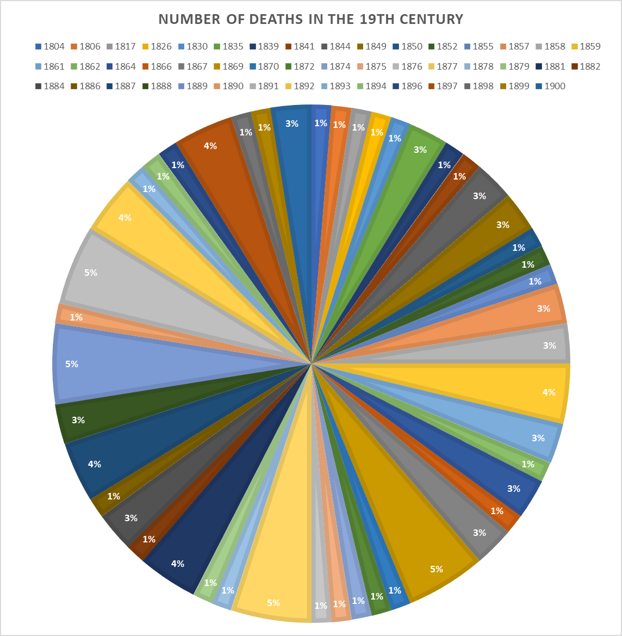
Appendix 1 – Pie chart showing my recordings of the number of deaths from the 19th century
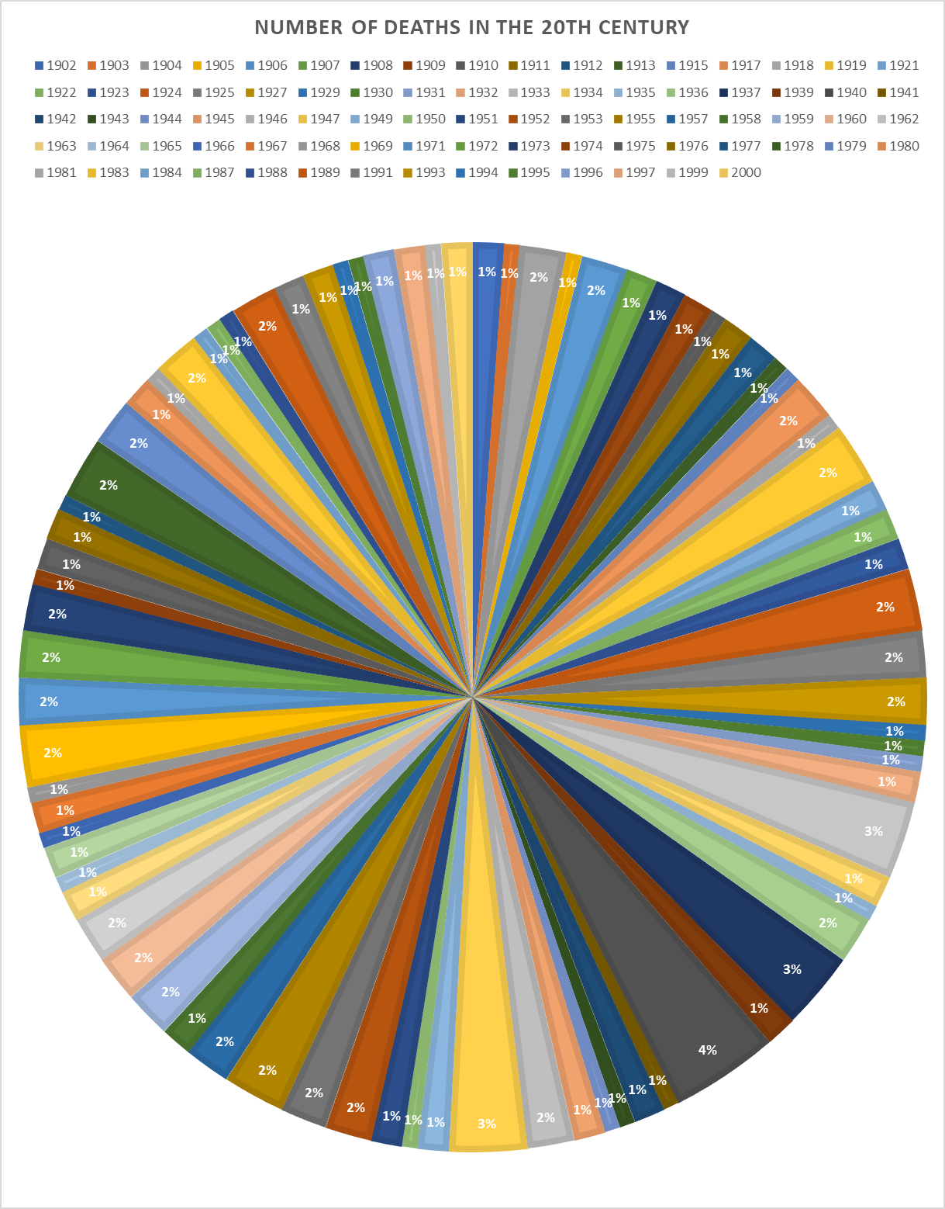
Appendix 2 – Pie chart showing my recordings of the number of deaths in the 20th century

