
Changemakers: Creativity and Value Creation
Professions (BMHP5014)

Component 1: Online portfolio of set exercises

Student name: Gnahore Badi Charlotte Legre
Student number: 2331156
Lecturer’s name: G1 Leila Surani , G2 Caroline Salami

Table of Contents
Introduction 3
Task 1- Defining Key Concepts in Practice 3
Task 2 - Mind Map 5
Task 3 - Self-Reflection of Group Activity 5
Task 4 – Case Study Analysis of a UK Innovation 6
Task 5 - Research Task 7
Task 6 - Exploring Digital Innovation in Health and Social Care 8
Task 7 - Understanding the NHS Leadership Framework 10
Task 8 – Self-Reflection Journal Entry 11
Reference 12

Assessment Component 1

Introduction
This assessment is going to explore the application of creativity, innovation, value creation, and change within health and social care practice. The report reflects the key theoretical concepts and demonstrates their practical relevance in addressing complex and challenges. The portfolio combines the academic theory with reflective and applied learning to give a structured task development. The aim of this assessment to demonstrate the development of an enterprising mindset and the ability that will help the organisation to deliver enhanced patient outcomes and service effectiveness.

Task 1- Defining Key Concepts in Practice 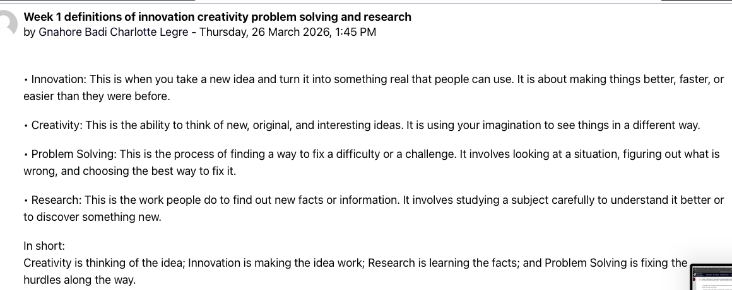
Question: Explain the following four key concepts: innovation, creativity, value creation, and change
Innovation

Innovation refers to the implementation of new ideas that enhance service effectiveness and patient outcomes. Innovation in the health and social care is important to respond to the dynamic demand and limited capabilities. For example, the adoption of virtual consultations helps the NHS improve the accessibility, readiness and transparency in service delivery (Arslan, 2025). At the sample time, the innovation helps the NHS reduce the operational pressure. This innovation of NHS reflects the Rogers’ Diffusion of Innovation Theory because this theory explains how new practices are adopted based on perceived benefits. Through the lecture I experienced, I came to recognise the innovation not only technological but also organisational that it requires the leadership support to be successfully embedded.
Creativity
Creativity involves generating novel and meaningful ideas to solve complex problems. Through the creativity, the professionals can tailor the care approaches, particularly for individuals with diverse needs. For example, through the uses of personalised music instrument, the professional can improve emotional wellbeing of dementia patients. According to Amabile’s Componential Theory, the creativity appears through the interaction of skills, knowledge, and motivation at the workplace. Through these lectures, I came to develop a deeper understanding that creativity in healthcare is essential for improving patient-centred care (Hartley, 2024).
Value Creation
Value creation involves in improving outcomes while efficiently using resources. Through the value creation embedded perception is developed within the mind of the customer. For example, early intervention of mental health can decrease the cost and improve the quality of life. Porter argues that the value creation can be achieved if outcomes are maximised relative to cost.
Change
The term “Change” posits the structured process of improving existing practices. Lewin’s Change Management Model suggests change occurs through unfreezing current practice, implementing new behaviours, and stabilising the improvement (Burnes, 2017). In healthcare, change is essential to implement innovations and improve service delivery.

Task 2 - Mind Map
Question- Choose a real problem in health or social care (Poor Communication)
Central Problem | Causes (Interconnected Factors) | Impacts (System Outcomes) | Solutions (Integrated Responses)
Poor Communication in Health & Social Care | Staff shortages leading to time pressure; lack of training in communication skills; fragmented digital systems; cultural and language barriers; hierarchical structures limiting information flow | Increased medical errors; reduced patient safety; low patient satisfaction; staff burnout; delayed treatment and misdiagnosis | Communication skills training; integrated electronic health records; multidisciplinary teamwork; use of interpreters and culturally sensitive care; leadership promoting open communication

Basically, the poor communication is important issues that impacts the patient safety and service quality (Margosyan, 2020). The poor communication problem emerges from the interconnected factors such as workforce pressures, inadequate training, and fragmented digital systems. For instances, the lack of staff in wards result in rushed handovers leading to increasing the risk of clinical errors. The misdiagnosis, reduced patient trust, and staff burnout are the main impacts of poor communication that weakens care delivery. Meadows (2008) highlighted a system thinking approach that involves in addressing coordinated solutions such as integrated electronic health records and collaborative team practices.
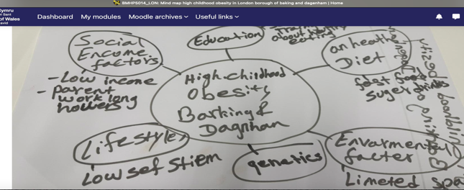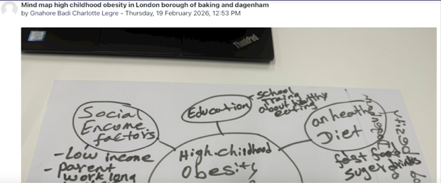

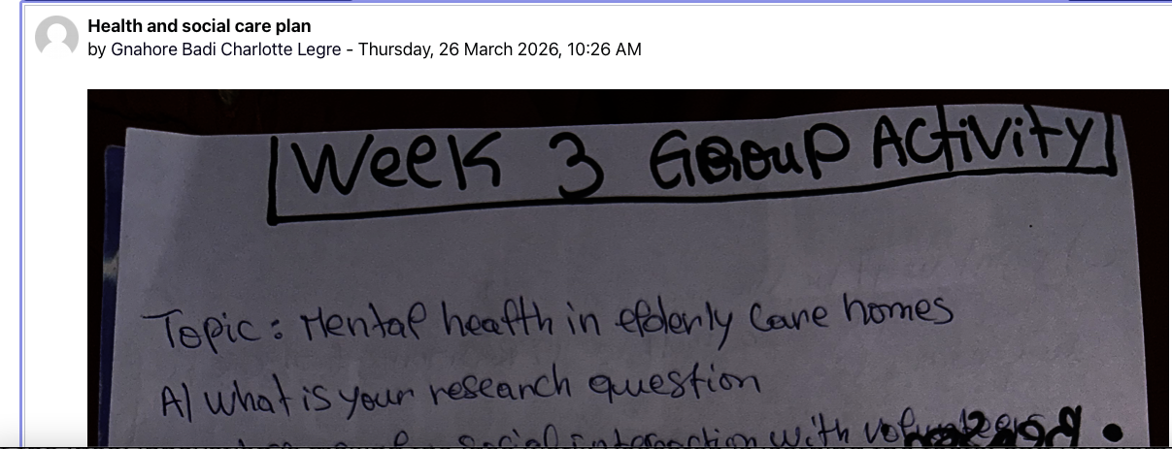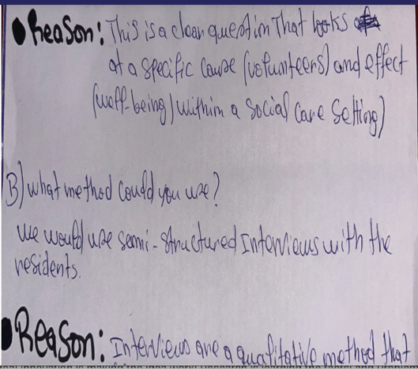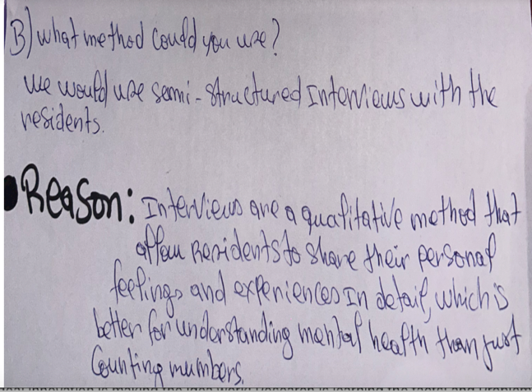

Task 3 - Self-Reflection of Group Activity
Question - Write a short self-reflection.
We have used Gibbs’ Reflective Cycle (1988) to reflect our learning because this model supports structured learning from experience. Convergent thinking refers to narrowing ideas to identify the most effective solution. To contrary, divergent thinking refers to generating multiple creative possibilities (Ruchi Sundriyal and Dr. Ravindra Kumar, 2020). During the group working, I was involved in divergent thinking by proposing several ideas to address the task. This helped us encouraging open discussion. When our group struggled to reach agreement, I recommended a pros-and-cons list to evaluate options, demonstrating convergent thinking in practice.
Through the divergent thinking, I felt more natural, and I am now comfortable to generate new ideas. I came to understand that the effective teamwork requires balancing creativity with critical evaluation. More importantly, I understood contribution I made to my group and how my contribution helped the group move from indecision to clarity, improving overall collaboration. In future, I will focus on improved group members who can collaborate and enhance the quality of decision-making through the group working.

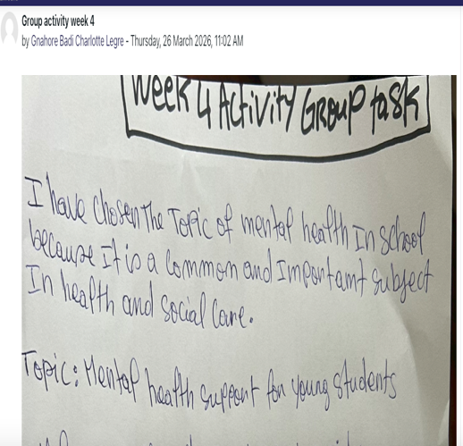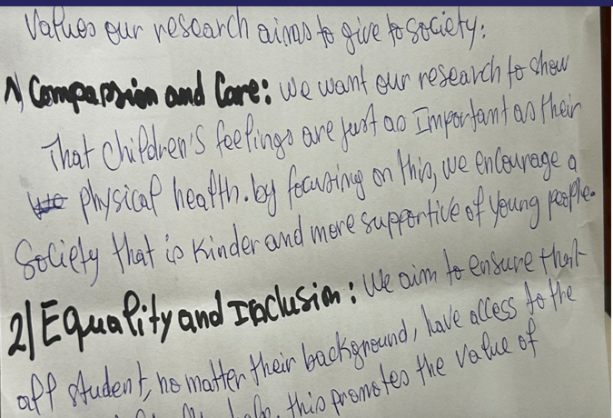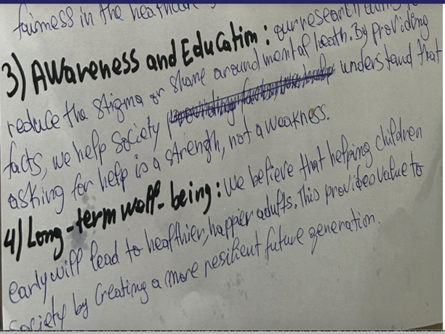

Task 4– Case Study Analysis of a UK Innovation
Question - Choose a real innovation in the NHS or UK social care “Virtual Wards”.

NHS installed virtual wards within a view to addressing the urgent pressures on hospital capacity and rising waiting lists. The hospital at home embedded by NHS enables the patients to receive hospital-level care safely in their own homes. With a view to preventing the unnecessary hospital admissions and support early discharge, this innovation came to mind of the NHS where the innovation started applying after the COVID‑19 pandemic when acute services were stretched beyond capacity.
The creativity was aligned with development of “virtual Wards” because it integrates the remote monitoring technologies, multidisciplinary care teams, and telehealth systems to reimagine traditional inpatient care. Virtual Wards integrate some digital tools such as apps and connected devices to remotely gather vital clinical data. This integration improves the clinicians to make timely decisions without physical hospital beds.
The Virtual has created substantial value for the care process because it reduced the reduced non‑elective admissions, freed hospital beds, and delivered net financial benefits (approximately £10.4 million in the Southeast region alone). However, the virtual wards improve the patient comfort and safety. This innovation related the Diffusion of Innovation Theory. As adoption of the virtual wards rely on the perceived usefulness, compatibility, and advantage over existing model.

Task 5 - Research Task
Sources | Causes of Staff Stress | How this helps understand the problem
Wei, L. C. & Mahadi, N. (2025). Stress and Burnout among Healthcare Workers: an Organizational Culture Perspective. International Journal of Academic Research in Progressive Education and Development, 14(3), 1048–1057. DOI:10.6007/IJARPED/v14-i3/26169 | Excessive job demands relative to resources, high workload, emotional demands, systemic inefficiencies. This imbalance (Job Demands-Resources model) intensifies emotional exhaustion and burnout. | Shows that stress arises not only from individual workload but system and culture. It highlights that workplace environment shapes stress levels, reinforcing the need for organizational change alongside individual support.
Alhassan, F. K. & Alhassan, H. H. (2024). Occupational Stress and Burnout in Healthcare Workers: Causes, Consequences, and Solutions. Journal of International Crisis and Risk Communication Research, Vol. 7(3), 224–236. | Occupational pressures include emotional exhaustion, high patient loads, inadequate organizational support, and poor work–life balance. These contribute to chronic stress and burnout (Wuwei, 2024). | Helps understand that everyday pressures such as poor staffing and lack of support drive stress, impacting staff well-being and care quality. Highlights the need for comprehensive interventions, not just individual coping.

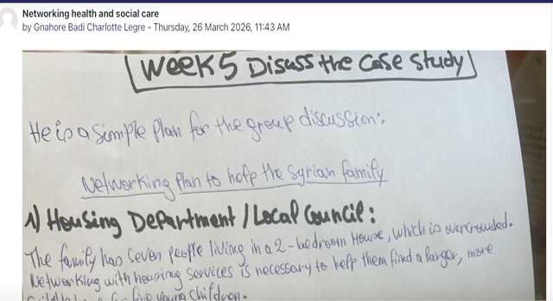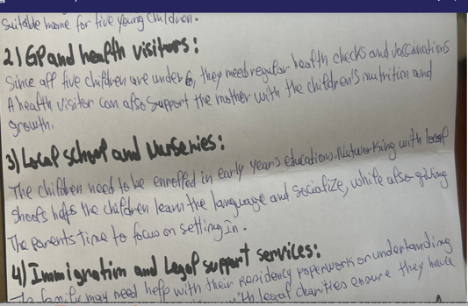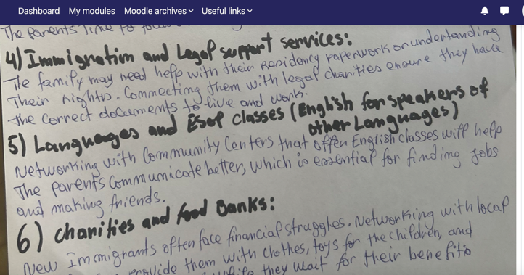
What causes does each source suggest?
The staff stress in health and social care is multidimensional because the problem is embedded in work demands and organisational contexts (Pratt, 2020). The first article outlined that the stress is within the job demand-resource model like pressure, emotional labour, high patient needs.
How do the two articles agree or differ?
While first article demonstrates that staff stress isn’t solely individual but emerges from the organisational culture and workload expectations. The second article demonstrated that the specific occupational pressures such as emotional exhaustion from continuous patient interaction with heavy pressure from the workload. Both source/article emphasis over the high workloads and poor organisational support that created the problem (Law and Rowe, 2018). Both articles came to agree that it requires systemic change, improved support structures to address the problem.

Task 6 - Exploring Digital Innovation in Health and Social Care 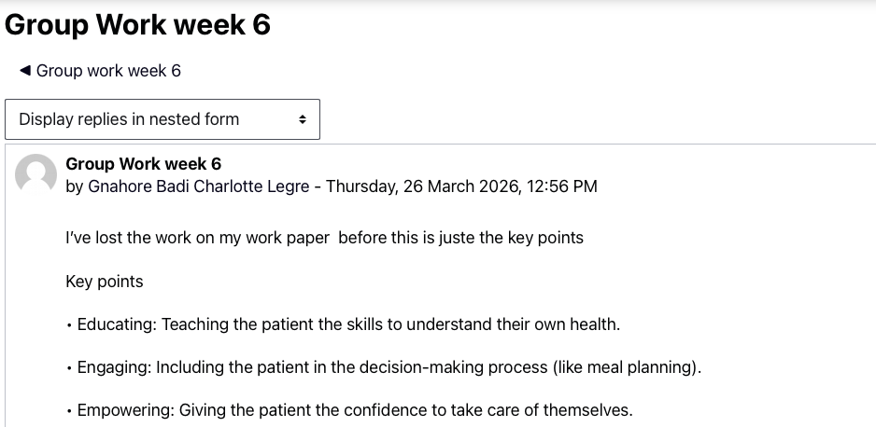
Q-1) Benefit of Wearable Health Technologies
The smartwatches and fitness trackers are important wearable technologies that offer integrated and significant benefits in managing chronic health conditions. These technologies enable continuous monitoring and personalised feedback outside clinical settings. For example, the wearable devices help the people track physiological metrics like heart rate, physical activity, and sleep patterns (Miller, 2019). People experienced with diabetes or cardiovascular disease; the continuous data stream can determine the anomalies reducing the need for frequent hospital visits and encourages patient self‑management. Wearable devices improve the patient engagement in treatment planning and helps the patient to treatment plans by making health data accessible and actionable. This engagement aligns with the Technology Acceptance Model that suggest perceived usefulness and ease of use increase adoption.
Q-2) How Electronic Health Records Improve Communication and Collaboration
Electronic Health Records (EHRs) introduction to healthcare is revolution because it improves the communication and collaboration among healthcare providers. EHRs help the professionals to centralise the patient information, medical history into a single, accessible digital platform (Mwachofi et al., 2024). The EHRs of patients reduce the fragmentation of data and enables authorised clinicians to access up‑to‑date records. Through EHRs, organisation can manage multiple data like medical history, medications, and diagnostic results, regardless of care setting in befitting manners that support decisive decision-making power. For example, when a patient is transferred from primary care to a hospital bot of the practitioners can view the same information simultaneously that reduce the duplication of medical history of the patients. Kruse et al. (2018) highlighted the necessity of the EHRs by outlining the clinical communication and decision‑making by facilitating structured documentation and real‑time updates. This technology adoption aligns with the Technology Acceptance Model because this model posits that EHRs are perceived as useful to use and ensure more effective cross‑professional collaboration and improved patient outcomes.
Q-3) Digital Technology Supporting Preventative Care and Health Promotion
The Digital technology is expected to assist in preventative care and health promotion. The digital technologies also enable the targeted behaviour change interventions and population‑level health monitoring. The Mobile health (mHealth) applications can ensure the personalised health education, reminders, and risk assessments to users (LeBlanc et al., 2022). The “Stay Well” app of NHS helps the NHS provide tailored advice on diet, exercise, and stress management.

Task 7 - Understanding the NHS Leadership Framework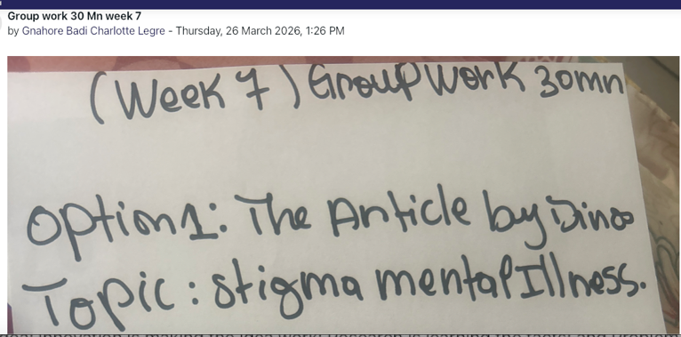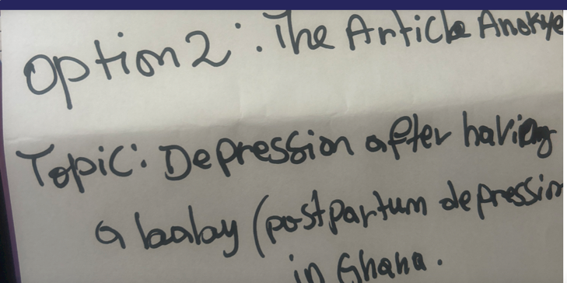
Question
- Summary of NHS Leadership Framework
The NHS leadership framework demonstrates the skills, knowledge and behaviours required for effective leadership across health and social care. The NHS framework is expected to determine the key domains like personal qualities, working with others, managing services, improving services (Julie Duval Jensen et al., 2025). These domains focus on importance of balancing clinical expertise with organisational and relational skills. According to this framework, the leaders of NHS play role in demonstrating the emotional intelligence, communicating effectively, foster teamwork. NHS leadership framework is essential in health and social care since it helps the leaders deliver safe, high-quality, patient-centred care. With a view to navigating the complex system and ease the system, it is necessary to align the leadership development with organisational strategy. The proper alignment can support the staff engagement, innovation, and value creation. The alignment of organisation objectives and leadership’s role can inspire trust, promote collaboration, and cultivate a culture receptive to new ideas.
- Leadership Behaviour – Inspiring a Shared Purpose
A leader involves in encouraging the creativity by clearly communicating the vision and rationale behind service improvements. For example, a ward manager involves in using digital tools for patient monitoring that represents how innovations enhance patient safety, reduce workload, and improve outcomes. Here the leaders play roles in connecting the team’s activities into meaningful organisational goals by motivating the staff to contribute ideas and experiment with creative solutions (Scroggs, Sattler and McMillan, 2022). The transformational leadership aligns with this approach where the leadership approach involves in suggesting leaders who inspire, and support staff foster commitment and innovation. The transformational leadership enables the team and leader to create value for both service users and the health system.
- Reflective Journal Entry
Through this activity I improve my understanding of creativity and value creation in the health and social care. Now, I can recognise that innovation is not applicable to technology rather it can be applied in everyday problem-solving and collaborative leadership. The divergent/convergent thinking exercises can improve the patient outcomes by improving the system efficiency. The insights I have experienced through this module will be applicable in my future practice by encouraging me to actively seek creative solutions. I think it will help me engage colleagues in collaborative improvement initiatives and adopt transformational leadership behaviours.

Task 8 – Self-Reflection Journal Entry
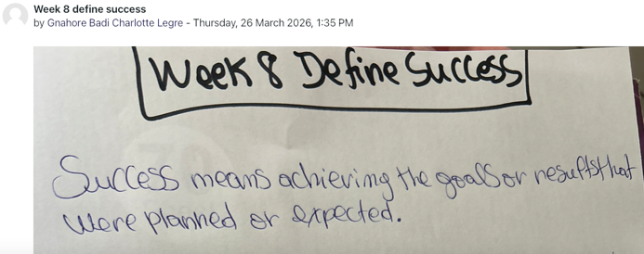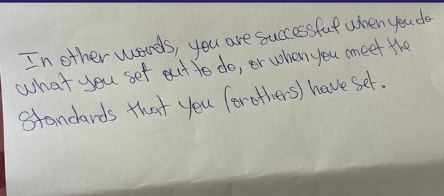
The creativity, innovation and value creation terms exploration through this module, I was able to improve my understanding and applicability of these terms in health and social care. I gained deeper understanding of how creativity, innovation, and value creation change the healthcare service to improve the access, readiness and transparency of the service. For example, the virtual wards case study strengthens my perception of innovation, showing that creative solutions can transform patient care without expensive infrastructure. Through the uses of Gibbs reflective learning cycle, I recognise the practical activities like convergent thinking that involves in problem solving and improvement of teamwork skill development. I have planned to use these insights in placements by proposing small-scale innovative solutions. I think this will foster collaborative idea generation, improves the interventions and improve the patients’ outcomes.

Reference
Arslan, G. (2025). Beyond happiness: The three waves of positive psychology and the future of wellbeing. Journal of Happiness and Health, [online] (Articles in press), pp.42–47. doi:https://doi.org/10.47602/johah.v5i2.121.
Hartley, J. (2024). Key concepts in creative industries. London; Thousand Oaks, Calif.: Sage.
Julie Duval Jensen, Loni Ledderer, Kirsten Beedholm and Raymond Kolbæk (2025). How digital documentation in electronic health records forms healthcare professionals’ identity. Qualitative Health Communication, 5(1), pp.64–79. doi:https://doi.org/10.7146/qhc.156787.
Law, K.L. and Rowe, J.M. (2018). Team-based care: Views from community health center staff. Social Work in Health Care, 57(4), pp.284–299. doi: https://doi.org/10.1080/00981389.2018.1438330.
LeBlanc, T.W., Back, A.L., Danis, M. and Abernethy, A.P. (2022). Electronic Health Records (EHRs) in the Oncology Clinic: How Clinician Interaction With EHRs Can Improve Communication With the Patient. Journal of Oncology Practice, 10(5), pp.317–321. doi:https://doi.org/10.1200/jop.2014.001385.
Margosyan, M. (2020). The Multifaceted Outcomes of Time Pressure on Creativity. GRIN Verlag.
Miller, D. (2019). Staff stress in HIV health care workers. AIDS Care, 4(4), pp.429–432. doi:https://doi.org/10.1080/09540129208253115.
Mwachofi, A.K., Khaliq, A.A., Carrillo, E.R. and Winfree, W. (2024). Technology versus humanism: how patients perceive the use of electronic health records in physicians’ offices—a qualitative study. Health Communication, 31(3), pp.257–264. doi:https://doi.org/10.1080/10410236.2014.947467.
Pratt, J.R. (2020). Dealing With Staff Stress: Part II. Home Health Care Management & Practice, 12(2), pp.56–58. doi:https://doi.org/10.1177/108482230001200211.
Ruchi Sundriyal and Dr. Ravindra Kumar (2020). Happiness and Wellbeing. International Journal of Indian Psychology, 1(4). doi:https://doi.org/10.25215/0104.020.
Scroggs, L.E., Sattler, J.L. and McMillan, B. (2022). The Undergraduate Leadership Mosaic. Journal of Leadership Education, 8(1), pp.48–58. doi:https://doi.org/10.12806/v8/i1/tf3.
Wuwei, L. (2024). How Creativity is Changing China. A&C Black.

