DIGITAL SKILLS FOR PERSONAL AND PROFESSIONAL GROWTH

Module Name: Digital Skills for Personal and
Professional Growth (BMSW4008)
Module Lead: Philippa Fitzgerald
Student Name: Dinicuta Cristian
Student ID: 2323940
Reference Style: Harvard

Table of Contents
Task 1: Questionnaire Analysis 3
Task 2: Design of the Website and Marketing Materials 7
Task 3: Importance of Using Excel in the Digital Era 13
Task 4: 3-Minute Video Advertising the Chosen Brand 16
References 17
Appendices 20
Appendix 1: Presentation 20
Appendix 2: Questionnaire 25

Task 1: Questionnaire Analysis
The survey data serves as a crucial tool for analyzing trends in customer preferences, behaviors, and expectations specific to Christian’s Massage Salon. By examining these insights, the analysis aims to identify actionable trends that can guide the salon’s strategies to effectively engage clients and foster long-term loyalty.
Key findings from this analysis shed light on various aspects of customer interaction, including the patterns in clients’ approaches to massage therapy, the criteria they prioritize when selecting a massage salon, and the influential factors that encourage repeat visits. Understanding these elements enables Christian’s Massage Salon to tailor its services and marketing strategies to meet client expectations, enhance satisfaction levels, and build a robust base of loyal clientele.
By leveraging the insights gained from this comprehensive analysis, Christian’s Massage Salon can refine its offerings and implement targeted strategies to ensure improved client experiences, heightened satisfaction, and a sustainably growing customer base.

Number of Massage Therapy Sessions
Most respondents said they rarely receive or seek massage therapy only a few times a year, which is consistent with the notion that massage is a luxury more than a regular wellness activity. This is in line with industry research that reveals customers are more likely to view massage therapy as an occasional treat unless given a reason to do otherwise (Uddin and Uddin, 2019; Balogun and Kennedy, 2020).
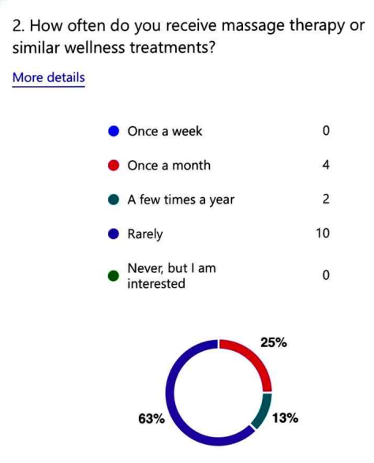
Figure 1: Frequency of Massage Therapy / Wellness Treatments
(Source: Survey Findings)
To deal with this, Christian’s Massage Salon can create programs that encourage regular visits by offering reduced prices for monthly or bimonthly bookings in membership packages. The potential of these packages to be marketed under a wellness message that encourages clients to view massage as a part of their health routine, rather than something to be indulged in occasionally. Having a consistent approach to wellness can help change the client’s perception and raise engagement frequency, which in turn could help create a more predictable revenue stream (Wu et al. 2024).
Types of Massage Therapy Preferred
Survey data has shown that customers prefer "Relaxation" and "Deep Tissue" massages, meaning they come for a massage to relieve stress and physical stress from muscle tension. As is consistent with broader industry trends, relaxation and therapeutic massages continue to be the two most sought-after offerings (Kang et al. 2022).
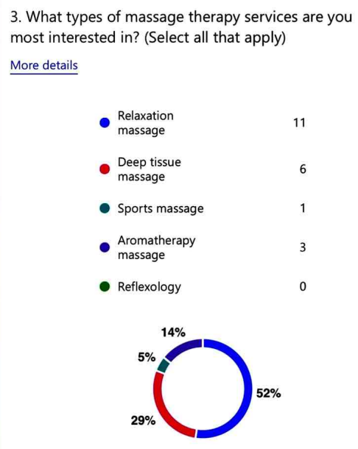
Figure 2: Type of Sought-after Services
(Source: Survey Findings)
Christian's Massage Salon can concentrate on these high-demand services and provide better service to the client by optimizing staff training so that consistently high-quality experiences will be delivered to these massage types. Other combinations might include relaxation and a deep tissue mix, perhaps to attract clients who want to achieve a mental and physical result in a single session. Further targeting marketing around the benefits of those massage styles will enhance the focus of the salon on wellness and stress relief and also work towards getting consumers to only consider massages at the salon they are going to.
Factors in Choosing a Massage Salon
Respondents who chose a salon weighed 'Quality of Service' and 'Price', illustrating clearly that customers want quality at an affordable price. Emphasis on quality and price line up with what consumers expect from the wellness industry, where luxury can typically be overshadowed by high standards and perceived value.
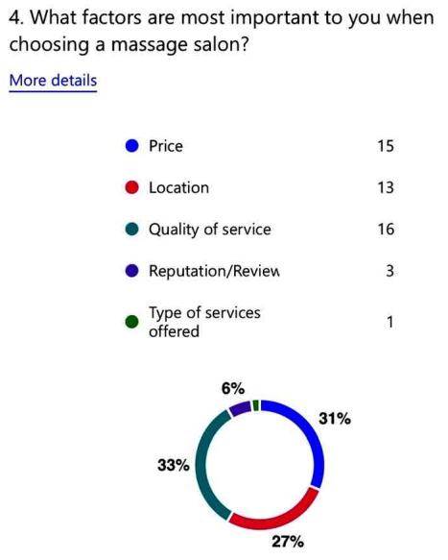
Figure 3: Important Factors in Choosing a Location
(Source: Survey Findings)
These preferences provide Christian's Massage Salon the opportunity to specialize as a high-quality, but affordable, option for customers who want reliable and professional service without paying a significant price. Such marketing messages can include quality, professional staff, and transparent pricing, to attract experience-seeking value-conscious customers who do not care about ambience or add-ons. Also, the location of the salon in a convenient place would boost accessibility (Ozuduru et al. 2014), which was mentioned in responses to the survey.
Incentivizing Frequent Visits
In an attempt to increase visit frequency, survey respondents strongly preferred tangible rewards, such as discount incentives for repeat visits and loyalty programs. Loyalty programs and discounts are effective because they create repeat clientele through increased exposure (Alshurideh, 2020), for example, customers feel they are being rewarded and exclusive, making the salon experience more satisfactory and reliable (Htet, 2024).
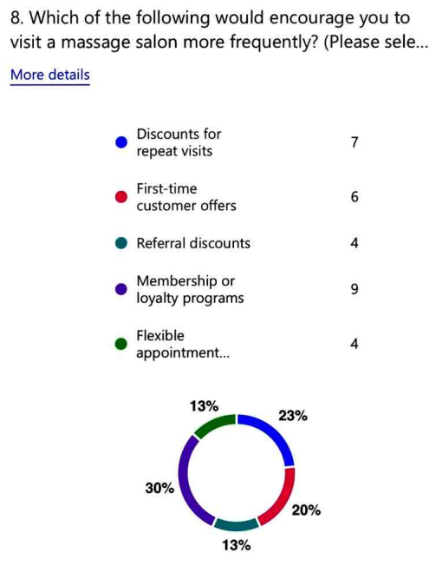
Figure 4: Factors to Improve Visit Frequency
(Source: Survey Findings)
At Christian’s Massage Salon, a loyalty program could be started that gives members a series of benefits such as higher discounts and free add-ons after a certain number of visits. Something like being a 'Gold Member' could offer customers exclusive discounts or free mini services, for regular clients as a way of showing that they belong. The third thing is that respondents liked the fact that they could schedule an appointment flexibly, and there is a notable need for more adaptive booking options that fit their schedules. This helps to make it easy for customers to commit to regular wellness visits in a busy life, by offering such conveniences.

Task 2: Design of the Website and Marketing Materials
Website URL: https://christian-massage-salon.weeblysite.com/
Questionnaire Insights and Targeted Design
The insights derived from the customer survey played a pivotal role in shaping the foundational messages conveyed through the website and marketing materials for Christian’s Massage Salon. By analyzing customer feedback and preferences, the salon was able to create tailored content and design elements that resonate with specific client groups.
These insights facilitated the development of a strategic approach that ensures each target audience is addressed in a meaningful and efficient manner. The emphasis on a visually cohesive, user-friendly design not only enhances the website’s aesthetic appeal but also improves accessibility and usability. This targeted approach strengthens customer engagement and aligns the salon’s digital presence with its overarching goals of customer satisfaction and loyalty.

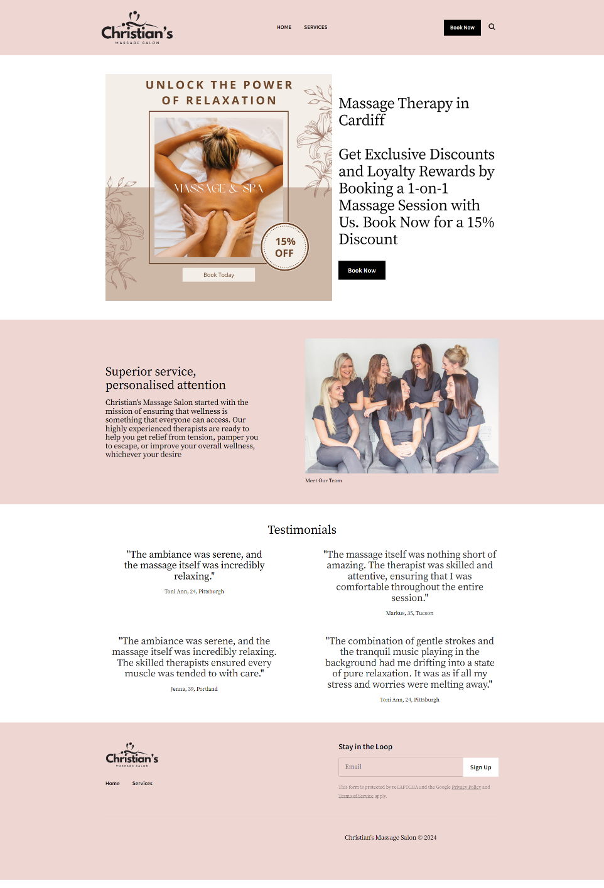
Figure 5: Home Page
(Source: https://christian-massage-salon.weeblysite.com/)
For time-conscious customers who want convenience, the Home Page uses a welcoming hero image and a prominent 'Book Now' button, which immediately addresses the need for a seamless customer experience (Mehta, 2023). The simplicity and the calming visuals align with the wellness branding of the massage service, to clients who imagine massage as a necessity for relaxation. The website starts with a brief welcome message that emphasizes the salon's quality and affordability and reflects its attraction to value-driven customers seeking value at the expense of service standards. The Home Page is all about trust and the reputation of a company (Lentz, 2024) that offers reliable service and customer testimonials have been featured on the page to set the social proof. Since the survey results reflected quality as the top priority, testimonials serve as social proof that potential clients can be reassured of a great quality of service (Klientboost, 2023; Resnick, 2023). This layout is straightforward for the user to navigate and provides a great user experience for the user (Stevens, 2024) to search for what they need and continue to book.
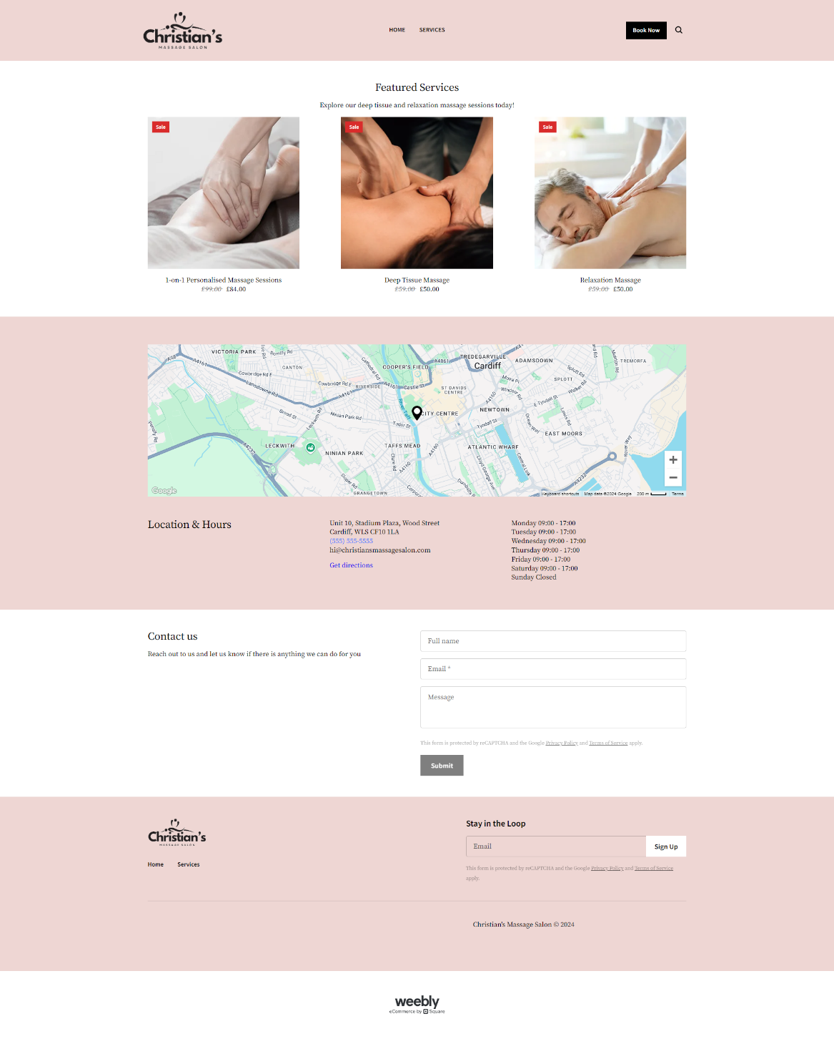
Figure 6: Services Page
(Source: https://christian-massage-salon.weeblysite.com/services)
The Services Page goes further into the details of the salon's services, focusing on relaxation and deep tissue massages both of which were found to be the most popular choices in the survey data. The purpose of this page is to provide a professional, yet inviting tone, and descriptions of each service focusing on the health and wellness benefits associated with those services. Wellness-focused clients who are already using massage as a regular part of their routine find this approach appealing, continuing to reinforce the message that massage therapy is supportive of overall wellness. This addresses the insight from the survey about finding repeat business, with discounts and loyalty programs, especially from those who seek value and affordability. The page layout is designed to allow users to easily check out service options, see offers and learn about the cost-saving benefits of returning, making the salon a more appealing option for those on a budget.
SEO Optimization for Enhanced Visibility
The questionnaire identified the importance of local accessibility, so the website needed to be incorporated with SEO practices to be seen by potential clients. Local SEO strategies were implemented by including location-based keywords (Cornwell, 2024) like “Massage Therapy in Cardiff” and “affordable massage near me.” By integrating these keywords throughout both the Home and Services pages, the site would rank well in local searches, making the salon one of many that can be found on local searches by people looking for nearby wellness services. Additionally, keyword phrases such as "Deep Tissue Massage" and "Relaxation Therapy" are prominently featured in headings, meta descriptions, and page titles. Specifically, these terms were chosen to match customer preferences identified in the questionnaire to match search intent and website content. The website is optimized for organic traffic from users who are already interested in high-demand service terms that are among the most popular in the industry. The website is also designed to be mobile-friendly to further enhance SEO and improve user experience (Lyons, 2022; WebFX, 2024), so that clients can quickly access needed information and book appointments from their device. It reflects customer preferences for flexibility and convenience — clients who may be browsing on the go. Not only does a streamlined, responsive layout help SEO ranking (Marketbrew, 2024), but it also helps with the booking process becoming smoother, which will in turn encourage conversions by removing friction from the user journey.

Marketing Materials: Consistent Messaging and Engaging Visuals
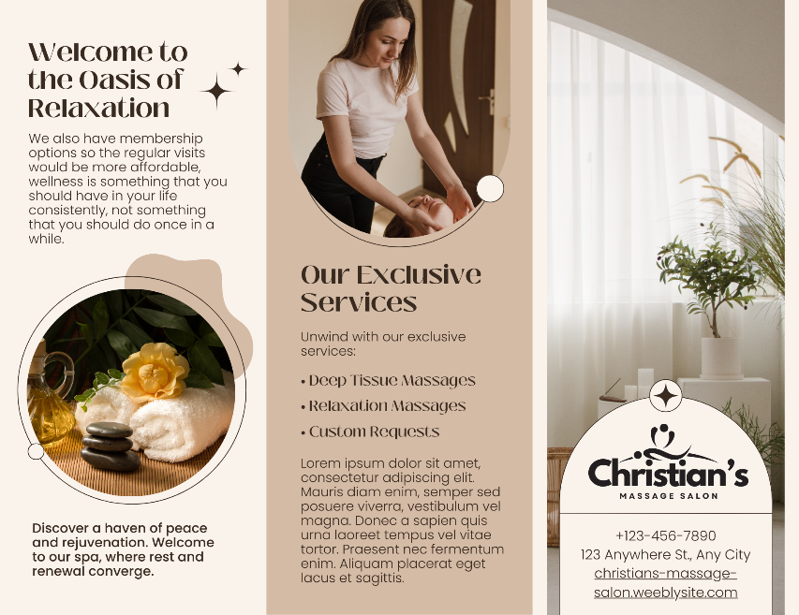
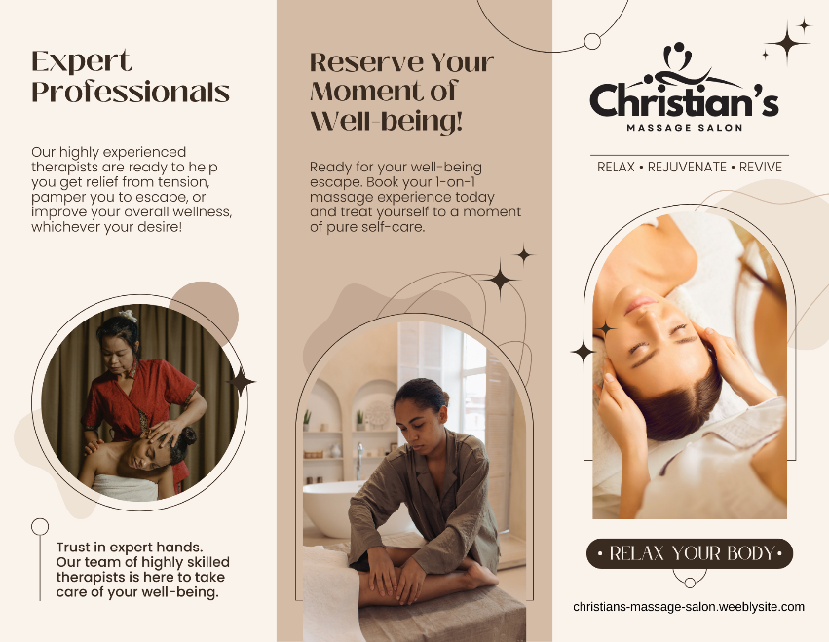
The marketing materials of Christian's Massage Salon in Canva follow the same design and branding motif as the website to maintain a consistent brand identity. This includes brochures, social media ads, and email templates, all structured to communicate the salon's core values; quality, affordability, and convenience, all responding to the insights of the questionnaire.
Figure 7: Brochure
(Source: Made using Canva)
Introductory discounts, special packages and massage therapy without serious commitment are listed as introductory discounts, special packages which appeal to the occasional relaxation seeker and the budget-conscious customer who just wants to try massage therapy.
The thoughtfully designed layout of the promotional materials combines simplicity with inviting colors and a strong wellness theme. These elements work harmoniously to attract customers who are seeking a serene and high-quality massage experience. By focusing on an aesthetic that communicates relaxation and professionalism, Christian’s Massage Salon ensures that its branding aligns with the expectations of its target audience.
To maximize outreach, these materials are strategically distributed in local businesses, community centers, and other frequently visited locations. This approach not only increases visibility but also positions the salon as an accessible and convenient wellness option within the community. Such targeted placement allows potential clients to easily discover the salon’s offerings, fostering a connection with individuals who value convenience and proximity when choosing wellness services.

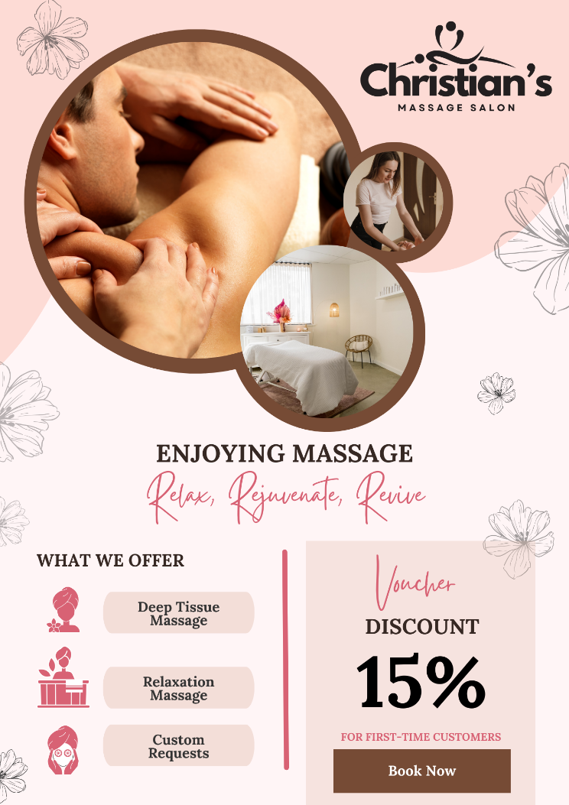
Figure 8: Facebook/Instagram Ad Creative
(Source: Made using Canva)
Social media ads were formatted to target relaxation-seeking and frequent wellness clients. These ads can include testimonials as ad copy from satisfied clients that add a much-needed layer of credibility (Meyer, 2024) and reinforce that the salon is about quality. The hashtags that the ads utilize include such as #RelaxationMassage, #DeepTissueMassage, and #RelaxRejuvenateRevivle, to boost online visibility and achieve target segments with great efficacy. Persuasive language and visuals can be used in the ad copy to meet what was learned about customer preferences in the survey, and images and text lend to a feeling of trust and professionalism.

Task 3: Importance of Using Excel in the Digital Era
Below are the financial projections for Christian’s Massage Salon from January 2025 to March 2025:
Figure 10: Financial Projection
(Source: Calculated Using Excel)
Today, in the digital age, Microsoft Excel is one of the most important free tools for businesses to manage data, conduct financial analysis, and the decisions at speed. This essay shows the nature of how Excel is used in business operations.
Essentially Excel is a vital tool for dealing with a variety of business operations such as accounting, project management and inventory control (David, 2017). For example, Excel can be used to trace monthly income and expenses as well, to determine profitability, and to plan for future growth at Christian's Massage Salon. This format is structured, which means that users can logically organize financial data identify trends more easily and make better resource allocation decisions (Carlberg, 2018). Customization of spreadsheets in Excel provides users the ability to make them create tailored financial models in accordance with their business needs. For example, a small business like Christian's Massage Salon can use Excel to do budgeting, forecasting and scheduling appointments. Formula functions in Excel allow users to calculate things without having to calculate them themselves, therefore making less human error. Beyond that, financial calculations can be made simpler using functions like SUM and AVERAGE and Excel is a tool of choice for entrepreneurs who are managing their finances independently (Thanachawengsakul, 2020).
With data analysis, businesses can make data-driven decisions effectively using Excel. All of these features – conditional formatting, data validation and pivot tables – help users consolidate the data and find out the key performance indicators (KPIs) needed for a business plan. A direct example here is Christian's Massage Salon which can track monthly revenue, track customer spending patterns and adjust the services according to demand patterns. This data-driven approach allows companies to be agile in adapting to changes, stay competitive and grow long-term. In addition, Excel allows businesses to communicate with each other and external stakeholders better through data visualization tools such as charts and graphs. In Christian's Salon example, a bar chart comparing income and expenses gives business owners a quick look at financial performance and helps them make well-informed decisions. This visual insight can act as an aid to identify what areas of the cost structure need to be controlled, or what areas should be invested in to maximize profitability.
Automated tasks with Excel will free the business owners' and employees' time to focus on challenges that are more crucial. For example, in small massage salons with limited staff, macros can be used to program Excel to automatically perform sequences of tasks, a powerful automation function. Automation reduces human input and reduces the possibility of errors, which increases productivity (Woods, 2018). Moreover, VLOOKUP and INDEX MATCH enable data retrieval more efficiently for businesses to neatly fit masses of data and extract certain information very quickly. As a small business grows, Excel will become a more sophisticated data analysis tool for the business. Because of its ability to handle large datasets, Excel is more than capable of handling tasks beyond simple bookkeeping: market analysis, competitive research, trend forecasting, and more. Because it is scalable, the ability to use Excel does not diminish as a business grows and needs increasingly complex provisions for data management.
Financial planning and budgeting are two key parts of business management which can be efficiently managed with Excel. It offers a flexible software platform for developing budget details, tracking spending, and forecasting revenue. For instance, a massager working in Christian's Massage Salon can use Excel to make up budgets, estimate monthly expenses and predict income. This empowers small businesses to use basic financial formulas, like calculating their net profit, to see the state of their financial health and set ideal goals as well as prepare for the challenges. The ability to simulate different financial scenarios, known as "what-if" analysis, is particularly beneficial for startups and small businesses navigating uncertain markets (Guerrero et al. 2019). Scenario Manager in Excel allows users to experiment with different financial conditions in a risk-free environment and evaluate what decisions could be made. Such changes as price adjustments or increases in marketing expenses can be assessed by small businesses and control finances better since they can plan proactively. Also, Excel’s tremendous compatibility with other software applications makes it a stronger commodity in the digital world. It also easily integrates with accounting software (Spraakman et al. 2015), the ones that handle CRM systems, and cloud storage solutions (Kravtsova et al. 2020), so that data can easily move from one platform to the other. In this networked digital environment today, businesses are dependent on different software tools to run their operations, and this compatibility is essential.

Task 4: 3-Minute Video Advertising the Chosen Brand

YouTube Video Advertising Link:
https://youtu.be/9lQvfDolhvU

Explanation of Storytelling Techniques
The video employs advanced storytelling techniques that emotionally engage viewers, forging a deeper connection with the brand. The founder’s introduction at the beginning personalizes the narrative and establishes credibility and trust, essential components of effective storytelling (Hong et al., 2018). Viewers are immersed in a compelling story centered on health, wellness, and personal transformation, aligning the brand with relatable, human experiences. The video emphasizes the salon’s values, particularly inclusivity and care. According to Nguyen (2021), storytelling strengthens connections between brands and audiences, transmitting purpose and meaning. By showcasing its values, the salon fosters consumer engagement, demonstrating a personalized approach to addressing authentic needs and preferences.

Furthermore, as Zuzana (2023) highlights, such storytelling techniques evoke positive emotions, generating a “buzz” and reinforcing the narrative of the salon as a sanctuary for holistic well-being, self-care, and rejuvenation. This emotional resonance encourages customers to view the salon as a space for both physical and emotional restoration. Finally, the video concludes with a clear and motivational call to action, inviting viewers to embark on their wellness journey. By leveraging storytelling, the salon not only informs but also inspires, compelling audiences to actively participate in its vision for transformative care, self-improvement, and overall community wellness.

References
Alshurideh, M., Gasaymeh, A., Ahmed, G., Alzoubi, H. and Kurd, B., 2020. Loyalty program effectiveness: Theoretical reviews and practical proofs. Uncertain Supply Chain Management, 8(3), pp.599-612.
Balogun, O. and Kennedy, A.B., 2020. Equity, diversity, and inclusion in the massage therapy profession. International Journal of Therapeutic Massage & Bodywork, 13(3), p.1.
Carlberg, C., 2018. Business Analysis with Microsoft Excel. Que Publishing.
Cornwell, J., 2024. How to Rank for Local SEO ‘Near Me’ Searches (10 Strategies), Ignite Visibility. Available at: https://ignitevisibility.com/rank-near-local-search-seo/ (Accessed: 11 November 2024).
David, M., 2017. Statistics for managers, using Microsoft excel. Pearson Education India.
Guerrero, H., Guerrero, R. and Rauscher, 2019. Excel data analysis. Springer International Publishing.
Hong, S., Kang, J.A. and Hubbard, G.T., 2018. The effects of founder's storytelling advertising. International Journal of Entrepreneurship, 22(3), pp.1-9.
Htet, N.T., 2024. Sensory Marketing Practices, Customer Satisfaction and Revisit Intention at Sense Spa (Nang Thiri Htet, 2024) (Doctoral dissertation, MERAL Portal).
Kang, Z., Xing, H., Lin, Q., Meng, F. and Gong, L., 2022. Effectiveness of therapeutic massage for improving motor symptoms in Parkinson's disease: A systematic review and meta-analysis. Frontiers in Neurology, 13, p.915232.
Klientboost, 2023. 18 [Proven] Smart Ways To Use Landing Page Social Proof. Available at: https://www.klientboost.com/landing-pages/landing-page-testimonials/ (Accessed: 11 November 2024).
Kravtsova, L., Kaminska, N. and Kravtsov, H., 2020. Cloud services in the distance learning system for future sailors. CEUR Workshop Proceedings.
Lentz, E., 2024. Building Trust on Your Website Homepage: A Design-led Approach, ArtVersion. ArtVersion. Available at: https://artversion.com/blog/building-trust-on-your-website-homepage-a-design-led-approach/ (Accessed: 11 November 2024).
Lyons, K. 2022. The Complete Guide to Mobile SEO: 8 Tips & Best Practices. Available at: https://www.semrush.com/blog/mobile-seo/ (Accessed: 11 November 2024).
Marketbrew, 2024. Achieve Optimal SEO Performance With Responsive Design. Available at: https://marketbrew.ai/a/responsive-design-seo (Accessed: 11 November 2024).
Mehta, J., 2023. The importance of having a clear call to action on your website (no date) Abmatic AI. Available at: https://abmatic.ai/blog/importance-of-having-clear-call-to-action-on-website (Accessed: 11 November 2024).
Meyer, B. 2024. 15 effective testimonial advertising examples to learn from. Available at: https://www.omnisend.com/blog/testimonial-advertising/#:~:text=Testimonial%20advertising%20is%20a%20powerful%20tool%20for%20building%20trust%20and,that%20potential%20customers%20may%20have. (Accessed: 11 November 2024).
Nguyen, T.P.A., 2021. Storytelling and visual art in advertising: an approach towards creative and impactful advertising content.
Ozuduru, B.H., Varol, C. and Ercoskun, O.Y., 2014. Do shopping centers abate the resilience of shopping streets? The co-existence of both shopping venues in Ankara, Turkey. Cities, 36, pp.145-157.
Resnick, N., 2023. The Psychology of Social Proof (and Why You Need Your Customers’ Help) (no date) HubSpot Blog. Available at: https://blog.hubspot.com/service/psychology-social-proof (Accessed: 11 November 2024).
Spraakman, G., O'Grady, W., Askarany, D. and Akroyd, C., 2015. Employers’ perceptions of information technology competency requirements for management accounting graduates. Accounting Education, 24(5), pp.403-422.
Stevens, E., 2024. 5 Effective Information Architecture Examples, And Academy. Available at: https://www.andacademy.com/resources/blog/ui-ux-design/information-architecture-examples/ (Accessed: 11 November 2024).
Thanachawengsakul, N., 2020. A conceptual framework for the development of a moocs-based knowledge repository to enhance digital entrepreneurs' competencies. International Journal of Information and Education Technology, 10(5), pp.346-350.
Uddin, M. and Uddin, M.S., 2019. Body Massage in the Context of Hospitality: A Critical Analysis from Islamic Perspective. International Journal of Global Community, 2(1-March), pp.69-82.
WebFX, 2024. Your Mobile SEO Guide: 9 Ways to Optimize for Mobile-Friendly SEO. Available at: https://www.webfx.com/seo/learn/mobile-seo/ (Accessed: 11 November 2024).
Woods, D.D., 2018. Decomposing automation: Apparent simplicity, real complexity. In Automation and human performance (pp. 3-17). CRC Press.
Wu, C., Jin, C. and Liu, Q., 2024. Bundling Variety, Usage, or Both? A Multi-Service Analysis of Pay-Per-Use and Subscription Pricing. Production and Operations Management, p.10591478241265480.
Zuzana, S., 2023. Storytelling Method as A Marketing Communication Tool in The Tourism Industry. Društvena i tehnička istraživanja, (1), pp.3-14.

Appendices

Appendix 1: Presentation
Introduction to Christian’s Massage Salon
Slide 1: Speech Que
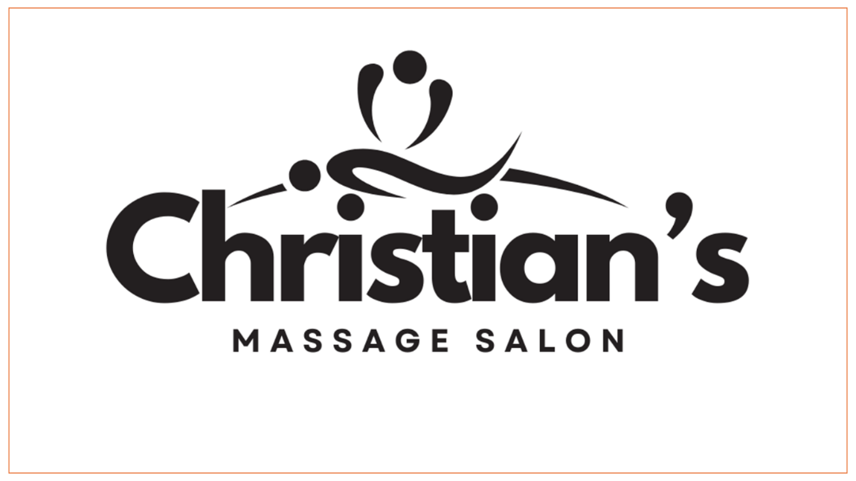
Christian’s Massage Salon, owned by Cristian, is a haven for relaxation and rejuvenation. This presentation highlights the qualities that make it the ideal destination for a serene and restorative experience.

Slide 2: Speech Que
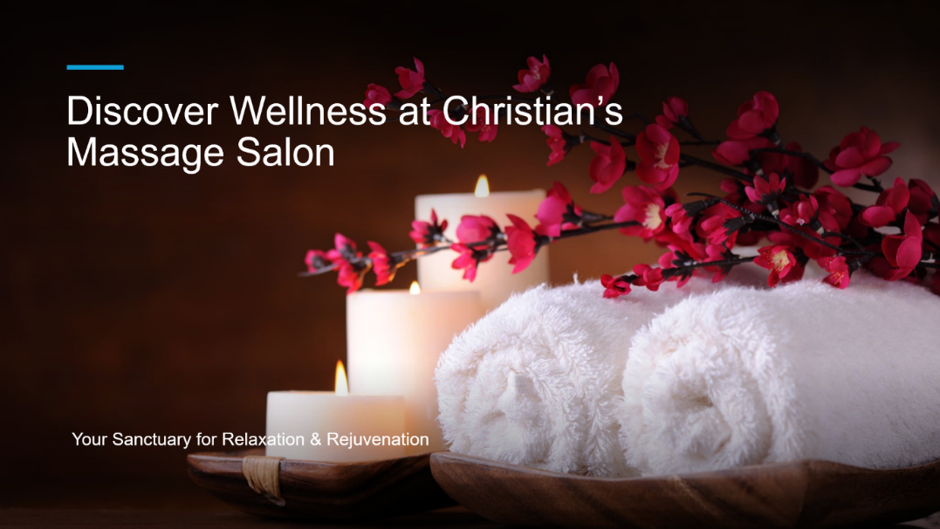
Life can be stressful, but Christian’s Massage Salon serves as a sanctuary for recharging, relaxation, and finding peace. With a team of experienced therapists, the salon provides expert care to relieve tension, promote self-care, and enhance overall wellness. It’s no wonder Christian’s Massage Salon is regarded as the ultimate wellness haven.

Slide 3: Speech Que:
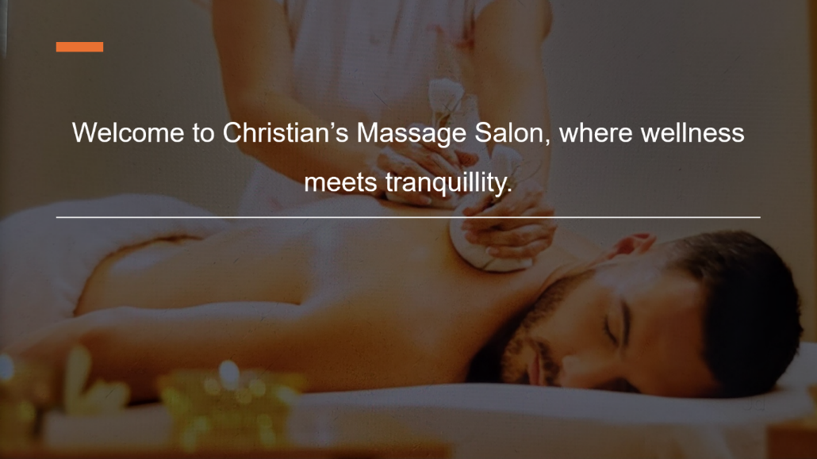
The expert therapists at Christian’s Massage Salon are committed to providing exceptional care, offering personalized services tailored to meet each client’s unique needs. Whether clients are seeking to improve their wellness, relieve tension, or enjoy a tranquil escape, the salon ensures every visit is designed to deliver maximum benefits.
Story of Christian’s Massage Salon
Slide 4: Speech Que
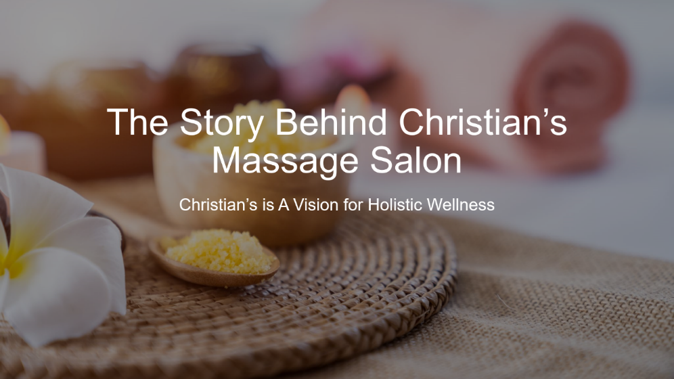
Founded by Cristian, Christian’s Massage Salon aims to make wellness accessible to all. Inspired by the benefits of massage therapy, Cristian created a space rooted in care, inclusivity, and professionalism, offering services from deep tissue to gentle relaxation massages to help clients live healthier lives.

Slide 5: Speech Que:
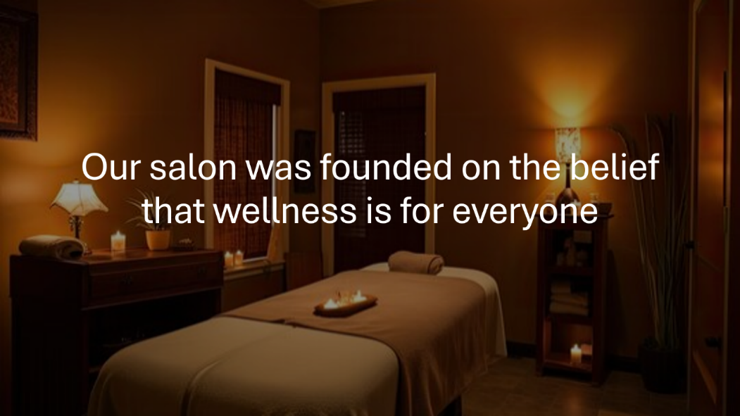
At Christian’s Massage Salon, the core principle is wellness for everyone. With expert techniques and exceptional care, the salon ensures clients receive the attention they deserve. In today’s fast-paced world, Christian’s Massage Salon serves as a sanctuary where individuals can recharge, relax, and reconnect with their inner peace.
Our Unique Services
Slide 6:
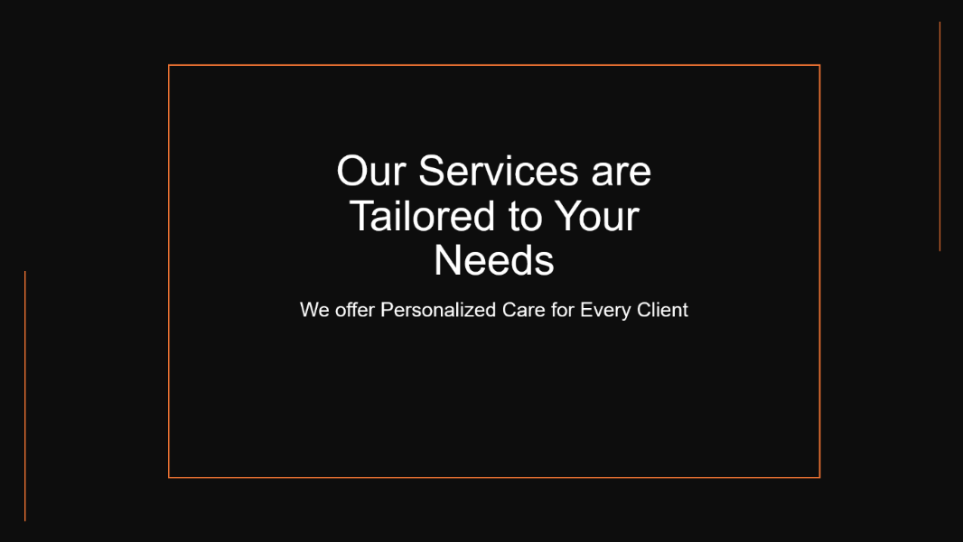
Christian’s Massage Salon tailors its services to meet each client’s unique wellness goals, offering treatments such as stress relief, muscle recovery, deep tissue massage, and aromatherapy. With flexible membership options, the salon makes regular wellness affordable, encouraging clients to prioritize consistent self-care.

Slide 7: Speech Que:
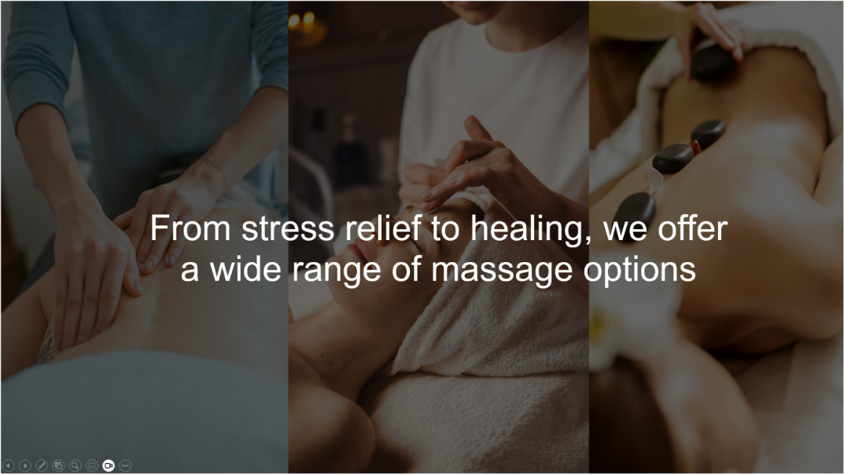
At Christian’s Massage Salon, self-care is seen as more than just relaxation. The salon’s stress-relief and healing massages are designed to improve health, reduce stress, enhance flexibility, and promote better sleep. Client satisfaction is a top priority, and the team is dedicated to delivering an exceptional experience that encourages clients to return time and time again.
Join Us at Christian’s Massage Salon
Slide 8: Speech Que:

Clients are encouraged to start their wellness journey by booking an appointment at Christian’s Massage Salon. Whether a regular or new to massage, the friendly team ensures client well-being is the top priority, delivering a warm, welcoming experience.

Appendix 2: Questionnaire
1.Which of the following age group do you belong to?
a. 18-25
b. 26-35
c. 36-45
d. 46-55
e. 56 and above

2.How often do you receive massage therapy or similar wellness treatments?
a. Once a week
b. Once a month
c. A few times a year
d. Rarely
e. Never, but I am interested

3.What types of massage therapy services are you most interested in? (Select all that apply)
a. Relaxation massage
b. Deep tissue massage
c. Sports massage
d. Aromatherapy massage
e. Reflexology

4.What factors are most important to you when choosing a massage salon?
Please select 3 options.
a. Price
b. Location
c. Quality of service
d. Reputation/Reviews
e. Type of services offered

5.How far would you be willing to travel to visit a massage salon?
a. Less than 5 miles
b. 6–10 miles
c. 11-20 miles
d. 21 miles or more
e. I prefer home visits/mobile massage services

6.What is your preferred price range for a 60-minute massage session?
a. £20–£39
b. £40–£59
c. £60–£79
d. £80 or more
e. Price is not an issue if the service is excellent

7.How would you prefer to book appointments for a massage? (Please select all that apply)
a. Online via website
b. Phone call
c. Mobile app
d. Walk-in
e. Through social media (e.g., Facebook, Instagram)

8.Which of the following would encourage you to visit a massage salon more frequently? (Please select all that apply)
a. Discounts for repeat visits
b. First-time customer offers
c. Referral discounts
d. Membership or loyalty programs
e. Flexible appointment times

9.What time of day do you prefer to schedule your massage appointments?
a. Morning (8am–12pm)
b. Afternoon (12pm–4pm)
c. Evening (4pm–8pm)
d. Weekend (Saturday/Sunday)
e. Anytime, based on availability

10.What additional services or features would you like to see offered at a massage salon? (Please select all that apply)
a. Wellness workshops (e.g., stretching techniques)
b. Organic or aromatherapy products
c. Facial or beauty treatments
d. Yoga or fitness classes
e. Meditation sessions

11.How important is the atmosphere of the massage salon to your experience?
a. Extremely important
b. Important
c. Somewhat important
d. Not important
e. I’m more focused on the quality of the massage

12.How likely are you to recommend a massage salon to others if you were satisfied with your experience?
a. Very likely
b. Likely
c. Neutral
d. Unlike

13.What is your primary reason for seeking massage therapy?
a. Stress relief and relaxation
b. Pain relief or injury recovery
c. Improve flexibility and mobility
d. General wellness and self-care
e. To complement my physical training or athletic performance

14.How do you usually find out about new wellness or massage services?
a. Word of mouth or recommendations
b. Social media (Facebook, Instagram, etc.)
c. Online search (Google, etc.)
d. Flyers or advertisements
e. Through local events or community gatherings

15.Would you prefer a male or female massage therapist?
a. Male therapist
b. Female therapist
c. No preference
d. It depends on the type of treatment
e. I prefer to decide based on the therapist’s qualifications and reviews

