University of Wales Trinity St David

Management of Sustainable Construction:

Energy Efficiency and Sustainable Materials

Assignment One: Stage A

Module Code – ACBA5000



By Alexander J Hobson
BSc Architectural Technology
Student Number - 1809857
Contents
Page 1: Cover
Page 2: Contents
Page 3: Introduction & Orientation
Page 3-4: Wall Makeup
Page 4: Roof Makeup
Page 4-5: Floor Makeup
Page 5: Thermal Bridging
Page 5-6: Shading
Page 6: Ventilation
Page 7-8: Bibliography
Page 8-11: Appendix

Introduction
As an Architectural Technician, I have been asked to provide my own suggestions on how to improve the energy efficiency of a current project on a detached building, which the design of the project has already been produced, however, the client is allowing changes to the designs in order to provide better energy efficiency.

Orientation
When looking at the current positioning of the building, it is orientated to have the front facing east. This current positioning will not maximise the sun patterns in the Swansea area, as the sun rises from the east, the maximum sunlight faces the south between 9am to approximately 4:08pm every day (gaisma.com, 2020), so changing the positioning on the building to orientate south facing would be highly beneficial, allowing more sunlight to affect the house, reducing the need for any artificial lighting during the day.

Positioning the building at the back end of the site, I have placed to requested pool at the middle of the site on the inclining land, which will all the pool not to be obstructed by the building and can take most of the sun, but also having positioned some tree plantings nearby so the pool does not get too hot during the summer periods. See figure 1.

Wall Makeup
When looking at the external walls for the building, you must be able to follow the standards that the Building Regulations Part L, 2013 commits to in order to get approval in the UK. Each element of the wall makeup must be examined in order to follow the regulations for U- Values (Thermal Transmittance), which for walls, must be 0.30 W/(M^2K) (HM Government, 2013)

In order to comply with the Building Regulations, I have calculated that the wall construction will be comprised (inside to outside) of 12mm plasterboard, 100mm lightweight block, 100mm fiberglass insulation, 50mm cavity (minimum for building regulations compliance), and 102mm red brick. I have adapted these materials from source Homebuilding.co.uk (Pullen, 2016) to make sure that they become compliant with the required U-Value value of 0.30 W/(m2^K), while this construction will allow it to be 0.29 W/(m2^K). See figures 2&3.

Roof Makeup
The roof construction I have decided will be beneficial to the design of the project, would be going through with a warm roof construction. A warm roof construction involves having the insulation being fixed to the rafters or above the rafters. The advantage of having this type of roof construction is that all the heat that rises from below room will rise and heat the roof, trapping the majority of the heat instead of having mass heat transfer. (firstinarchitecture.co.uk, n.d.)

The required U-Value for part L of the building regulations is a rating of 0.25W/(m2^K), and the roof makeup I have designed for consists of fiberglass insulation under rafters at 82mm, plasterboard at 12mm, more fiberglass insulation fully fitted on the rafter at 102mm, and then the slate tiling which (for each tile) is 4mm thick. With these values this U-Value calculation comes to just under the requirements at 0.24W/(m2^K). See figures 4&5

Floor Makeup
When looking at the floor construction, you must be able to make sure that the materials are meeting the U-Value requirements of 2.5W/(m2^K) as demanded within the Building Regulations Part L.

The materiality I will be using to construct the floor in the design will be aerated concrete slab at a thickness of 100mm, fiberglass insulation at a thickness of 100mm, and then on top sand/cement screed at 50mm. With these floor materials, this brings me a U-Value of 0.22W/(m2^K) which easily will provide the resistance for heat loss that will need to be required. See figures 3&6.

The important elements of the floor construction is to make sure that it is fully insulated to avoid heat loss through the floor, and to make sure that the DPM layer is safely placed above the sand blinding, to ensure that the hardcore below does not perforate the DPM and allow the moisture from below to get onto the insulation.

Thermal Bridges
The general definition for what a thermal bridge in construction is, is when there is an area in the structure that there is higher heat transfer (or loss), with the reasoning being that there is a lack of, break, or reduction of insulation in the affected area. The areas that are typically affected by thermal bridging are places in which holes had to be placed, such as where window frame, door openings for fitting the door frame, and other places as such. (rsenergy.co.uk, 2019)

The way to mitigate against thermal bridging would be to make sure to insulate around the affected areas, this will mean that heat loss around these areas is be lessened, aswell as an example with windows, adding triple glazing will also combat heat transfer through the glass.

Shading
When looking into shading, what the aim is, is to be able to make sure that the building fabric is not under prolonged sunlight, with the use of devices in order to control sun direction. During the summer, the sun will be prominent outside with intense light, and equally will require high cooling energy consumption, so to be able to maximise the control over the sunlight is beneficial for being efficient with energy usage.

The employment of devices to control sunlight can be through passive means, such as making sure the overhang is worked out to combat the sunlight during the summer time where the orientation of the sun if higher and has longer exposure to the building due to typically drier weather, however during the winter, the sun projection is lower, allowing the building to absorb some of the heat that will be radiating onto the structure, allowing the building to use the heat energy from the sun, meaning less energy uses from other means. (Prowler, 2016)

I believe that employing this method into my design will be beneficial, as in Swansea the temperature during the summer where the effects of the sun would be at its harshest, are not strong enough to have a major effect on the heat gains through the building.
Ventilation
When looking at the most energy efficient ways of going about ventilating your household, natural ventilation is a fully passive way to make your house breathe.

Natural ventilation is described as being a wind driven, cross ventilation, which there are different pressures on either side of the rooms draw air into the building, while pressures on the other side are pushing the wind out of the building, creating an air flow throughout. This type of ventilation is required to remove stale (stagnant) air from the house, and provide fresh air in order to maintain a healthy living space for occupants. (designingbuildings, 2020)

Natural ventilation is provided to the household through a number of means, one for example is by following the building regulations requirements on needing all new build windows to have trickle vents in the frame of the window itself, which can be opened or closed by a sliding grate.

Bibliography
designingbuildings, 2020. designingbuildings.co.uk. [Online]
Available at: https://www.designingbuildings.co.uk/wiki/Natural_ventilation_of_buildings
[Accessed 13 02 2020].
firstinarchitecture.co.uk, n.d. firstinarchitecture.co.uk. [Online]
Available at: https://www.firstinarchitecture.co.uk/detail-post-pitched-roof-details/
[Accessed 13 02 2020].
gaisma.com, 2020. [Online]
Available at: https://www.gaisma.com/en/location/swansea.html
[Accessed 10 02 2020].
HM Government, 2013. assets.publishing.service.gov.uk. [Online]
Available at: https://assets.publishing.service.gov.uk/government/uploads/system/uploads/attachment_data/file/540326/BR_PDF_AD__L1A__2013_with_2016_amendments.pdf
[Accessed 11 02 2020].
Prowler, D., 2016. [Online]
Available at: https://www.wbdg.org/resources/sun-control-and-shading-devices
[Accessed 12 02 2020].
Pullen, T., 2016. homebuilding.co.uk. [Online]
Available at: https://www.homebuilding.co.uk/which-wall-material-has-the-best-u-value/
[Accessed 11 02 2020].
RIBA, n.d. ribaproductselector.com. [Online]
Available at: https://www.ribaproductselector.com/Docs/7/20857/external/COL257154.pdf
[Accessed 12 02 2020].
rsenergy.co.uk, 2019. rsenergy.co.uk. [Online]
Available at: https://rsenergy.co.uk/index.php/2019/01/07/what-is-thermal-bridging/?gclid=EAIaIQobChMIlNyKkoDM5wIVFp3VCh1wMQh9EAAYASAAEgKkgfD_BwE
[Accessed 12 02 2020].

Appendix

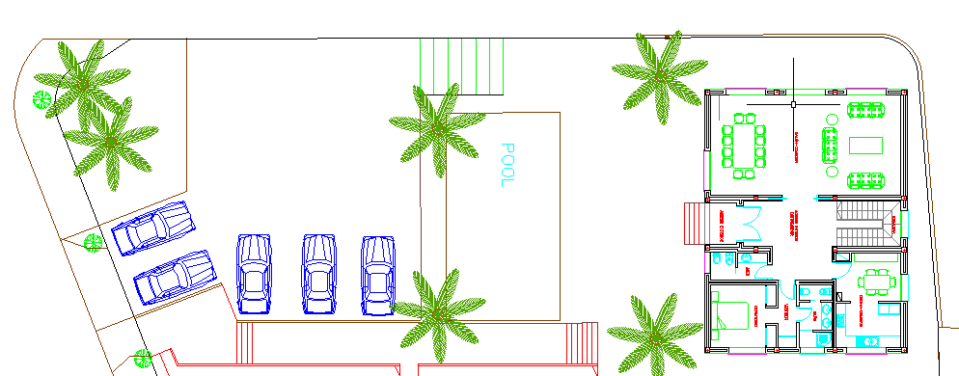
Figure 1:

Figure 2:

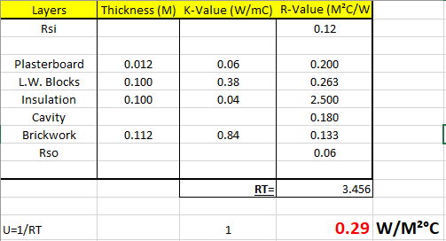

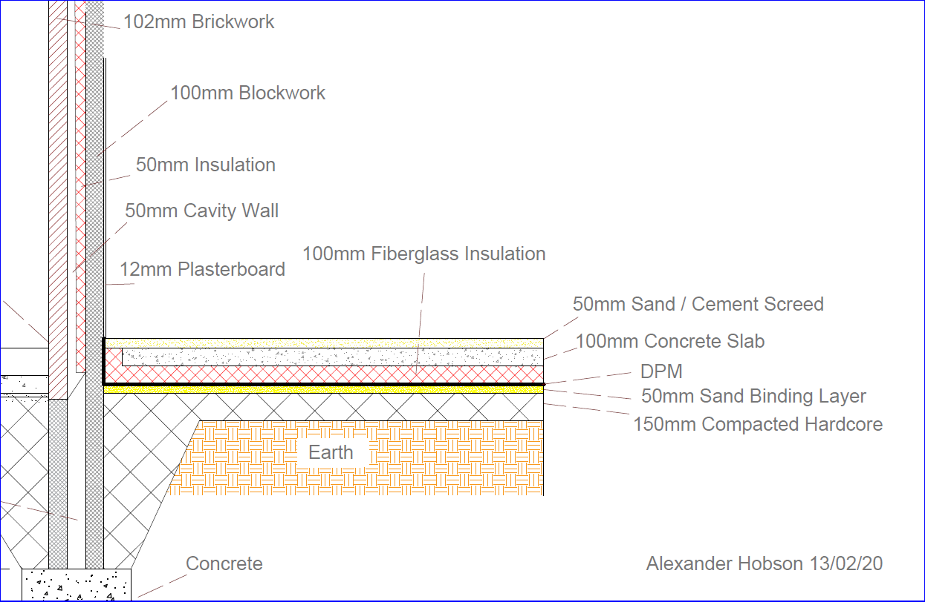
Figure 3:

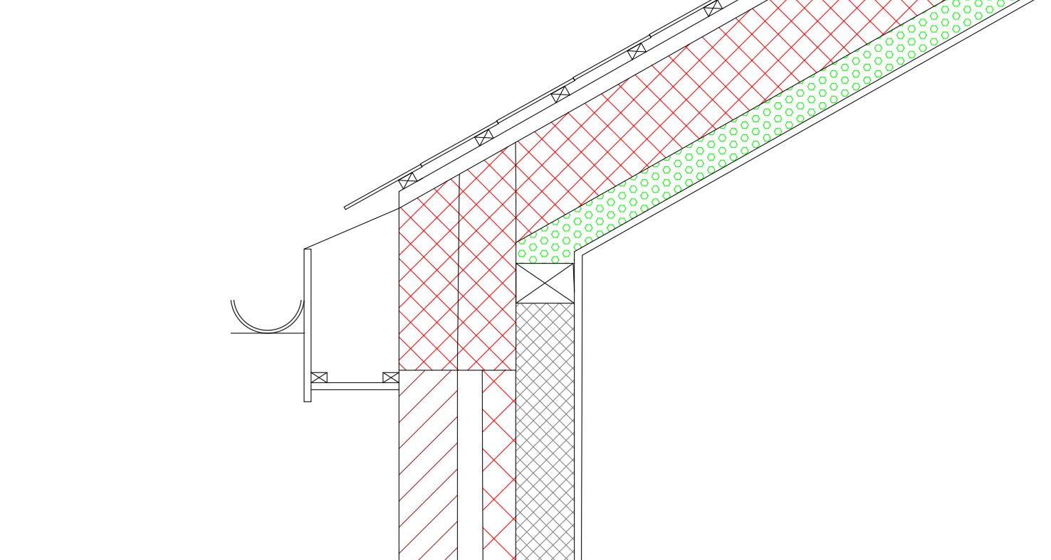
Figure 4:
Gutter
Plasterboard
Insulation
Slate Tiles
Soffit

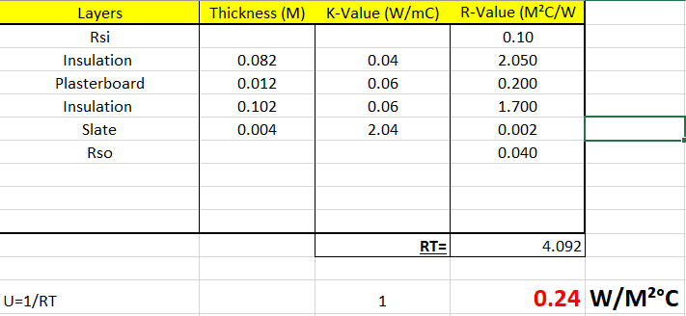
Figure 5:

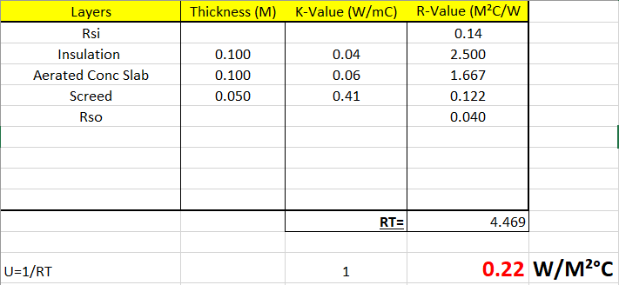
Figure 6:

Figure 7:


