

PROGRAMME: MASTER OF BUSINESS ADMINISTRATION
MODULE: INTERNATIONAL BUSINESS CONCEPTS
MODULE NO:LCMB7034
STUDENT NAME:CHANDRU SUBBAIAH
STUDENT ID:2507406
LECTURER NAME:JEAN WANG
TERM :02

TABLE OF CONTENTS
Section 1: International Industry Analysis 3
1. Introduction 3
2. Industry & country overview 3
2.1 Industry Context in India 3
2.2 Size, Scope & Economic Importance 4
2.3 Competitive Landscape & Firm Positioning 5
3. Porter’s diamond model 7
3.1 Factor Conditions 7
3.2 Demand Conditions 8
3.3 Related & Supporting Industries 8
3.4 Firm Strategy, Structure & Rivalry 9
4. Caterpillar in India 10
4.1 Company Overview 10
4.2 PESTLE analysis 10
4.3 Cage Framework 12
4.4 Entry Mode & Strategy 14
4.5 Opportunities & Risks 14
4.6 Critical Evaluation 16
5. Conclusion 17
Section 2: Reflective Account 19
1. Description 19
2. Feelings 20
3. Evaluation 20
4. Analysis 21
5. Conclusion 21
6. Action Plan 22
Reference list 23

Section 1: International Industry Analysis

1. Introduction
International business environment can be described as a complicated set of economic, political, legal and cultural forces that affect the companies that operate on the international level. India has become a major international market, with a robust economic growth of 8.2% GDP in 2024 and substantial growth in infrastructure investments (D&B, 2025). The construction equipment market is a key aspect of this development and is expected to reach USD 7.8 billion in 2024 and experience an annual increase of more than 8% CAGR over the next 10 years (CMI, 2026). This industry supports the growth of infrastructure, urbanisation and industrial growth. This report will concentrate on global competitiveness with the frameworks of Porters Diamond, PESTLE and Cage and analyse Caterpillar as one of the most successful multinationals. This report critically analyses the competitiveness of the construction equipment industry in India and examines the strategic position and success factors of Caterpillar in this industry.

2. Industry & country overview

2.1 Industry Context in India
Construction equipment industry is a category of heavy machinery involved in infrastructure and industrial processes such as earthmoving equipment (excavators, loaders), mining equipment, road construction equipment and material handling equipment. The machines are required in the massive construction, mining and civil engineering jobs. In India, the industry is directly associated with the booming infrastructure growth with the equipment demand to be propelled by the highways, railway, airports and urban development projects. In 2025, the earthmoving equipment industry had more than 56 % of the market share, which underscores its supremacy in the industry (Mordor Intelligence, 2025).
This industry is greatly influenced by the infrastructure-led growth model in India. The speed of demand in construction machinery has been boosted by government projects like the National Infrastructure Pipeline (NIP), estimated to cost about US1.7 trillion in investment by 2030, and higher capital expenditure of ₹11.21 lakh crore (US128 billion) in 202526 (IBEF, 2025). There are also programmes like Make in India that promote manufacturing and localisation at home and enhance the supply chain within the industry and lessen the reliance on imports. Asia continues to be the construction equipment demand powerhouse in the world, and India is being further strengthened as a part of the global value chains. India therefore is a high growth, attractive investment destination to multinational companies that are interested in long term growth.

2.2 Size, Scope & Economic Importance
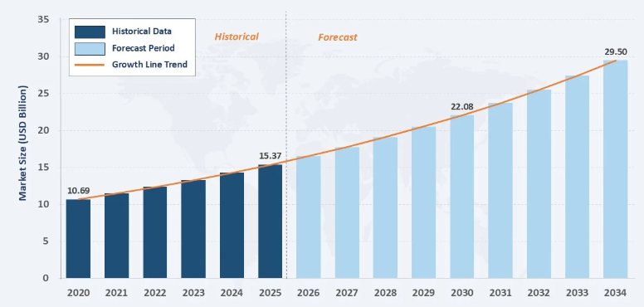
Figure 1: India Construction Equipment Market Size, Share, Trends & Forecast
(Source: IMARC, 2025)
The construction equipment sector in India has grown in size tremendously, and it is a strategic aspect of the larger construction and infrastructure ecosystem. The market is estimated to be USD 15.37 billion in the year 2025 and is expected to increase to USD 29.5 billion in the year 2034 with a compound annual growth rate (CAGR) of 7.52% (IMARC, 2025). Other estimates show even greater growth, with growth rates as high as 11.91% CAGR between 2025 and 2032, attributed to increased construction activity and technological progress. This illustrates the size and the potential expansion of the sector in the long-term (Marketsandata, 2024).
The industry is of critical enabling role to the development of India economically. The construction sector, in general, is a contributor to the GDP of India of about 9 % and is the provider of more than 12 % of total employment that amounts to about 73.4 million jobs (CAAPL, 2025). There is also a high multiplier effect of the sector with the infrastructure investment contributing up to 2.5-3.5 times economic output, which underscores its significance in the growth of the nation.
There are three structural factors that are the drivers of demand. On the one hand, there is rapid urbanisation, which means that the population requires housing and urban infrastructure. Second, mining industry needs heavy machinery to extract and move materials. Third, the ongoing investment in the public infrastructure such as highways, railways and industrial corridors is also contributing to the equipment demand.
The industry has a complex value chain, consisting of manufacturing, distribution, equipment financing, rental services and after-sales maintenance. Remarkably, the market share of after-sale services is on the rise, reaching almost 31 %, which evidences the increasing significance of lifecycle support and the business model relying on services (Imarc, 2025). This combined system boosts efficiency, industry competitiveness and sustainability over the long term.

2.3 Competitive Landscape & Firm Positioning
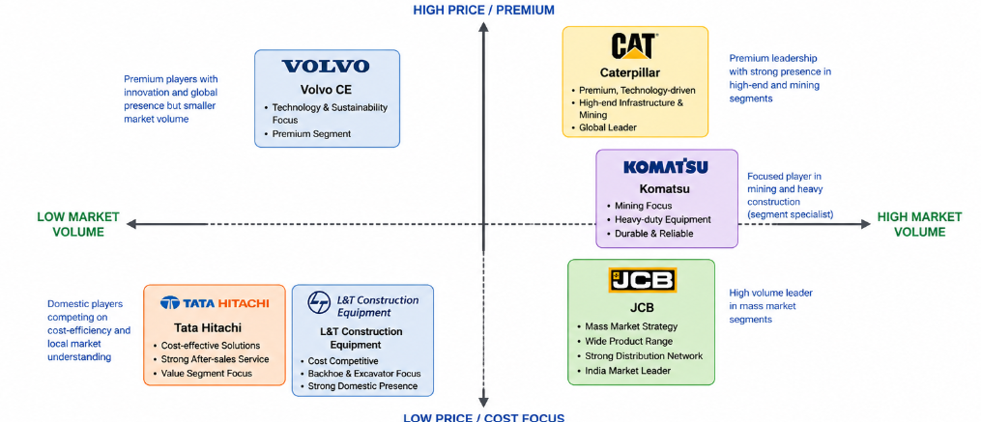
Figure 2: Competitive Landscape & Firm Positioning
(Source: Self-Created)

The Indian construction equipment market has a medium-level of concentration but very competitive structure, which is characterised by the presence of the multinational corporations and the powerful home-based companies. Domestic firms such as Tata Hitachi and Larsen and Toubro (L&T Construction Equipment), also play a key role in the market and are capitalising on cost-effectiveness and domestic expertise. The technological innovation, the quality of their products, and global brand equity are the key areas in which multinational companies like Caterpillar, Komatsu and Volvo Construction Equipment compete (Kumar, 2025). In the same fashion, JCB has about 41.9 % share in the excavator market, cementing its dominance in mass-market equipment(6Wresearch, 2026) . Caterpillar, on the other hand, has a premium, technology-oriented approach, emphasising high-performance machinery, new digital technologies, especially in mining and mega-infrastructure projects. Komatsu has taken a niche and focuses on durability and efficiency in heavy mining machines, whereas Volvo CE focuses on fuel efficiency and sustainability as its key differentiators.
In general, pricing pressure, localisation and service networks help to define the dynamics of competition. The domestic companies struggle on the basis of cost advantage, but global actors focus on the aspect of innovation and lifecycle services. Importantly, JCB controls the market segments based on the volume, whereas Caterpillar continues to dominate the segments based on the premium and mining-centered segments, marking the presence of dual-structure market, which is characterised by the cost leadership and differentiation strategies.

3. Porter’s diamond model
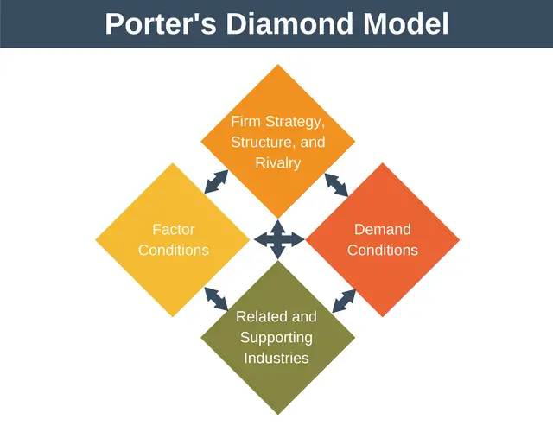
Figure 3: Porter’s Diamond Model
(Source: Muhammad and Hussain, 2025)

3.1 Factor Conditions
The factor conditions in India offer both structural constraints and competitive advantages of the construction equipment industry. One of the strong points is the availability of skilled and semi-skilled labour especially in the fields of engineering and manufacturing. Every year, India generates more than 1.5 million engineering graduates, which has resulted in a high technical work force that helps in designing equipment, manufacturing, and repairing the equipment (Forbes, 2025).Multinational companies like Caterpillar can open up local production and research facilities through this talent pool. Cost competitiveness is another important benefit. Labour and production costs in India are far cheaper than those in developed economies with manufacturing costs estimated to be 20-30% less than the Western markets. This helps in localisation strategies and promotes exports. Infrastructure constraints are however a major weakness. India, although there is an improvement, stands at position 38 in the World Bank Logistics Performance Index, which shows inefficiency in transport systems and supply chain systems (ET Infra, 2023). Last-mile connectivity and logistical delays cause an operational cost to equipment manufacturers and distributors.
In general, the high human capital and low costs of India does not make it any less competitive, but there are still gaps in infrastructure that limit productivity and efficiency in the industry.

3.2 Demand Conditions
One of the key sources of competitiveness in the construction equipment industry is India domestic demand conditions. The infrastructure development of the country is mainly backed by massive government investment and creates a long-term market of heavy machinery. India, as an example, intends to build more than 200,000 km of national highway by 2025 and this means that major demands will be placed on earth moving and road constructions machinery.
Moreover, urbanisation that is estimated to have hit 40 % of the population by 2030 is increasing housing pressure, metro or smart cities (PIB, 2024). The resulting developments generate an unending need of construction equipment in various segments. Demand characteristics in India however are different. Market is very sensitive to prices and buyers are more concerned with the cost of operation and price than with the sophisticated features. This poses a threat to premium manufacturers like Caterpillar, who have high priced, technology intensive products that might not find a large rate of adoption in cost conscious markets. Consequently, companies need to respond by providing financing options, rental programs or cost-efficient product lines. Consequently, as much as India represents a big and expanding market, its sensitivity in pricing determines the competitive forces, as well as the strategic positioning of firms in the market.

3.3 Related & Supporting Industries
The related and other supporting industries of the construction equipment industry are also strong, which supports the competitiveness of the Indian construction equipment industry. The steel sector, a key input provider, is among the biggest in the world with India contributing more than 140 million tonnes of crude steel in 2023. This guarantees a secure and economical provision of raw materials needed in the production of equipment (PIB, 2024b). The logistics and distribution networks are also important. Growth of warehousing and freight corridors, such as the Dedicated Freight Corridor (DFC) initiative, enhances connectivity and cuts transit duration between industrial centres (Banerjee, 2022). There are still logistical inefficiencies in some areas, which impact the delivery on time and after-sales support. In general, the availability of strong supplier sectors and the rising logistics are boosting industrial environment in India, but uneven growth remains to restrict full operational effectiveness.

3.4 Firm Strategy, Structure & Rivalry
India Construction equipment business is marked with stiff competition rivalry, which spurs innovation, efficiency and strategic differentiation. The most important players in the competition include JCB, Caterpillar and Komatsu, that compete in many segments, and each of them has a different competitive strategy (Xia, Cassiman and Wehrheim, 2025). JCB controls the market with a mass-market, high-volume approach, with a huge dealer network and high localisation. On the other hand, Caterpillar concentrates on upscale, technology-intensive products, with a target market of the high-end infrastructure and mining development, whereas Komatsu concentrates on long-lasting heavy machinery used in the mining sector.
Local companies like Tata Hitachi and L&T Construction Equipment also create additional competition by capitalising on cost benefits and a familiarity with local markets (Potharla, 2025). These firms are providing relatively competitive priced equipment that is designed to suit Indian operating conditions, to force multinational firms to adjust pricing and product strategies. The industry structure supports the cost leadership and differentiation strategy, which results in a dual competitive environment (Kharub, Mor and Rana, 2022). Local companies are doing well in terms of affordability and accessibility whereas global companies are competing on the basis of innovation, quality and lifecycle services. In turn, its Indian market is not only highly competitive; it is also strategically diverse, which compels firms to be constantly innovative and localise their activities. This active rivalry improves the competitiveness in the industry in general, but decreases the profitability, especially in price-sensitive markets.

4. Caterpillar in India

4.1 Company Overview
Caterpillar Inc. is a major multinational enterprise in the heavy machinery sector, whereby it has over 190 countries with a wide network of dealers worldwide, and this makes it one of the most internationally diversified companies in this sector (Caterpillar, 2025). In 2025, the firm posted total revenues of about USD 67.6 billion which is an indication of high demand of its products and services across the world. Its main business areas are construction equipment, mining machinery (resource industries) and energy and transportation systems that comprise the backbone of its operations. Caterpillar also ventured in India in 1930s and has since then developed several manufacturing plants in other areas like Tamil Nadu to serve the local demand as well as the export markets. In 2025, the company has achieved revenues of over 11,400 crore in India, implying its increased presence in the country (Tracxn, 2026). This excellent global magnitude and local production capacity makes Caterpillar be competitive in the fast growing construction equipment market in India.

4.2 PESTLE analysis
Factor | Key Insight | Opportunity / Threat
Political | Infrastructure investment is one of the policy priorities of India, and capital expenditure by the central government is 10 lakh crore in FY2023-24, which is a significant rise compared to prior years (PIB, 2025). | Opportunity
Economic | The IMF forecasts that India will keep its status as the fastest-growing major economy with its GDP growing by 6.6% in 2024 (IMF, 2024). | Opportunity
Social | In India, the urban population is 35% as of 2022, and urbanisation is increasing steadily, creating a demand in infrastructure in both housing and transport sectors (The World Bank, 2023). | Opportunity
Technological | Indian companies are only 27% digitally mature meaning that they are slow to adopt modern technologies like AI and automation in industries (Nasscom, 2025). | Threat
Legal | India has a rank of 63 out of 190 countries in terms of Ease of Doing Business (World Bank, 2020 used in recent policy analysis) which is one of the most complex in terms of regulations despite reforms(Make In India, 2020). | Threat
Environmental | The BS-VI emission norms (since 2020) will necessitate substantial engine-level upgrades, which will add 10-15% to the costs of equipment manufacturers (Borkhade, Bhat K and Mahesha, 2022). | Threat
Table 1: PESTLE Analysis
(Source: Self-Created)
Critical Evaluation
The analysis proves that India provides an environment of growth, backed by policies especially infrastructure investment directly which has an effect on the demand of construction equipment. The magnitude of government capital spending provides the pipeline of high demand, and the market becomes very appealing to companies such as Caterpillar. This attractiveness is enhanced by economic stability as GDP growth is steady at more than 6% that helps in expansion of industries. Long-term construction and mining equipment demand is supported by the social trends like urbanisation. Structural risks are still of importance. In India, there is limited adoption of technology, limiting the demand of high-cost, high-technology machinery produced by Caterpillar. This brings about a strategic mismatch between global product offerings and local market preparedness. Bureaucracies and compliance issues also add to operational uncertainty brought about by legal and regulatory complexity. Also, the environmental standards like BS-VI standards increase costs of production and R&D making the margin less flexible in a price sensitive market. India on the whole has high demand potential and moderate operational risk and Caterpillar needs to implement a localised cost sensitive strategy, not global standardisation only.

4.3 Cage Framework
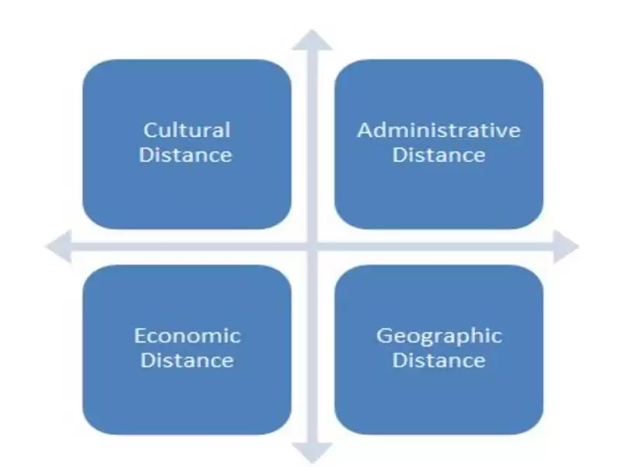
Figure 4: CAGE FRAMEWORK
(Source: Judijanto, 2025)
The CAGE framework is all about Cultural, Administrative, Geographic and Economic distance that offers an orderly way of assessing the difficulties that Caterpillar would face in its operation in the Indian market as compared to its homeland, the United States.
Cultural Distance
Purchasing behaviour in India is greatly affected by cultural differences. Indian customers are very price-sensitive and are concerned with the cost of ownership and the affordability unlike the developed markets like the US where consumers are very demanding in terms of technology, efficiency and lifecycle performance. A study by the Boston Consulting Group (2022) found that more than 70% of Indian industrial buyers are more focused on cost than on advanced features (Basavaraj, 2024). This poses a problem to Caterpillar whose premium pricing principle might not be in line with the local expectations. Also, the business practices that are based on relationships and dependency on dealer networks also influence the market.
Administrative Distance
The regulatory environment of India is quite different as compared to the US, leading to administrative differences. Though India permits 100 % foreign direct investment (FDI) in the construction industry under the automatic route, the process of regulation, complexities in taxation and compliance are a challenge (IBEF, 2023). The differences in state-specific regulations and bureaucratic procedures may make the operation more complicated and slow the implementation of the project. These are some of the reasons that compel Caterpillar to implement flexible governance and compliance strategies.
Geographic Distance
The physical distance between the US and India influences logistics, supply chains and efficiencies. The high geographical area and differences in infrastructure of India enhance transport expenses and delivery time. The World Bank (2023) estimates that logistics expenses in India comprise about 13-14% of GDP, which is much higher than the global average of 8-10% (PIB, 2023). This raises the expenses of transporting parts and supplying gadgets across territories. To counter this, Caterpillar has invested into the local manufacturing and supply chain in order to lessen on imports.
Economic Distance
Economic disparities are reflected in the purchasing power and income levels. In 2023, the GDP per capita of India is around USD 2,600, as opposed to more than USD 76,000 in the United States (Macrotrends, 2024). This large gap constrains the accessibility of the luxury construction equipment and solidifies the need of the affordable ones. As a result, Caterpillar is struggling to scale up premium products in a price-sensitive market.

4.4 Entry Mode & Strategy
The entry and growth strategy of Caterpillar in India is a progressive move between the strategy of collaboration and total operational control, which is in tandem with the market conditions and the regulatory environment. The company first ventured into the Indian market by joint ventures, with the most notable being with Hindustan Motors in the 1980s. This collaboration helped Caterpillar break into a new market, local understanding of the market and create early distribution channels within a highly controlled market. Joint ventures especially worked well at a time when India had stringent policies regarding foreign investment. As a result of economic liberalisation and the establishment of more favourable foreign direct investment (FDI) policies, Caterpillar shifted to wholly owned subsidiaries (Szilágyi and Kovács, 2022). This was a strategic move that enabled the company to have a better hold over operations, technology, quality standards and brand positioning. The creation of completely owned companies helped Caterpillar to coordinate its international strategies with local implementation and consistency in offering products and efficiency.
One of the main pillars of the Caterpillar strategy in India is the localisation of manufacturing. The company has established large-scale production facility in Tamil Nadu such as Thiruvallur and Hosur which cater to both the local and export markets. Localisation lowers production and logistics, reduces dependency on imports and makes them more responsive to local demand. Industry reports suggest that localisation strategies can save manufacturing expenses by up to 2025% in emerging markets (PWC, 2024). In sum, the shift of Caterpillar towards wholly owned subsidiaries as opposed to joint ventures, coupled with effective localisation activities, can be regarded as an effective strategic response to the changing business environment in India that has allowed the company to stay afloat in a cost-conscious and high-growth market.

4.5 Opportunities & Risks
Opportunities
The Indian market has a lot of growth prospects to Caterpillar, mainly due to high rates of infrastructure development. The National Infrastructure Pipeline (NIP) is a long-term investment plan by the government, which identifies more than 9,000 projects in sectors like road, railway and energy, which provide a long-term demand of construction equipment. This growth of infrastructure has a direct effect of stimulating demand in earth moving and heavy machinery. Moreover, the mining industry is growing, and India is aiming to produce 1.5 billion tonnes of coal by 2030, necessitating sophisticated mining technology and machinery (PIB, 2025b). This goes hand in hand with the high-performance mining machinery that Caterpillar has as its strength. Moreover, digital and intelligent equipment, such as telematics and predictive maintenance, is in demand. The digital solutions market in the global construction equipment will continue to expand and as the emerging economies such as India, there is a growing adoption of the same. The trend presents Caterpillar with a chance to make use of its technological strengths and innovate to differentiate.
Risks
Risk | Impact Level | Explanation | Mitigation Strategy
Strong Competition (JCB & local firms) | High | Dominant players like JCB and cost-efficient domestic firms create intense competition, particularly in high-volume segments, limiting Caterpillar’s market share growth. | Enhance localisation, expand dealer/service networks, and differentiate through advanced technology and lifecycle services.
Price Pressure | High | Indian customers are highly price-sensitive, reducing demand for premium equipment and putting pressure on profit margins. | Introduce cost-effective product variants, adopt flexible pricing, and expand leasing/financing solutions.
Policy Uncertainty | Medium | Delays in infrastructure approvals, land acquisition issues and regulatory changes can disrupt project timelines and equipment demand. | Maintain strong government engagement, diversify across sectors, and adopt flexible production planning.
Supply Chain Disruptions | Medium | Dependence on global supply chains exposes Caterpillar to delays, cost fluctuations and geopolitical risks affecting component availability. | Increase local sourcing, build resilient supply chains, and maintain strategic inventory buffers.
Environmental Regulations | High | Stricter emission norms and sustainability requirements increase compliance costs and require continuous investment in cleaner technologies. | Invest in green technologies, develop fuel-efficient equipment, and align with sustainability standards to maintain compliance and competitiveness.
Table 2: Risk Analysis
(Source: Self-Created)

4.6 Critical Evaluation
The presence of two strategic tensions of global standardisation and local responsiveness can be traced in the operations of Caterpillar in India. Although the company enjoys good brand equity, high-level technology and globalisation, its high-end positioning poses a problem in a price-sensitive market where cost-oriented players like JCB dominate the market. The analysis reveals that despite the huge growth potential of India as a result of infrastructure development and mining, the market structure restricts the scalability of the high-end equipment without the need to change its structure. Importantly, cost disadvantages are minimised partly by localisation strategy of Caterpillar, including the development of manufacturing and supply chain, though it might not be enough to compete successfully in the segment of the market, which is based on volumes. Moreover, environmental compliance and regulation make operations more expensive, making it less flexible in pricing policies. Strategically, Caterpillar needs to use a hybrid approach involving differentiation using technology with cost optimisation to suit the market environment in the local market. Lack of localisation of product offering and pricing structure may lead to decreased competitiveness in spite of good fundamentals of demand. Thus, long-term success in India requires a balance between innovation and cost-effectiveness and enhancing distribution and after-sales services.

5. Conclusion
The construction equipment industry in India has been critically evaluated in this report and the strategic position of Caterpillar in this market has been analysed. According to the findings, India is a high-growth, strategically important market, which is backed up by good infrastructure investment, growing urbanisation and rising demand in mining and transportation industries. The Diamond analysis by Porter indicates that India has favourable factor conditions and demand drivers, but issues like inefficiency of infrastructure and price sensitivity continue to be a challenge. The competitive environment presents a market with a dual structure with the domestic companies competing based on the cost efficiency with multinational companies concentrating on the technological differentiation. In this scope, Caterpillar has a solid presence in the high-end and mining segments but is constrained in expanding its presence because of the high competition and price pressure.
The PESTLE and CAGE analyses also indicate that although India has very favorable opportunities, it has its regulatory, economic and cultural issues which must be carefully managed as part of strategic management. The localisation is important because of the differences in income levels, preferences of customers and the environment where companies operate. In general, the ability of Caterpillar to adjust its global strategy to the local market conditions is essential to its success in India. This involves the improvement of cost competitiveness, increasing service networks and aligning products with customer needs. Innovation and affordability will enable Caterpillar to reinforce its competitive advantage and leverage the potential of long-term growth of the Indian construction equipment market.
Section 2: Reflective Account
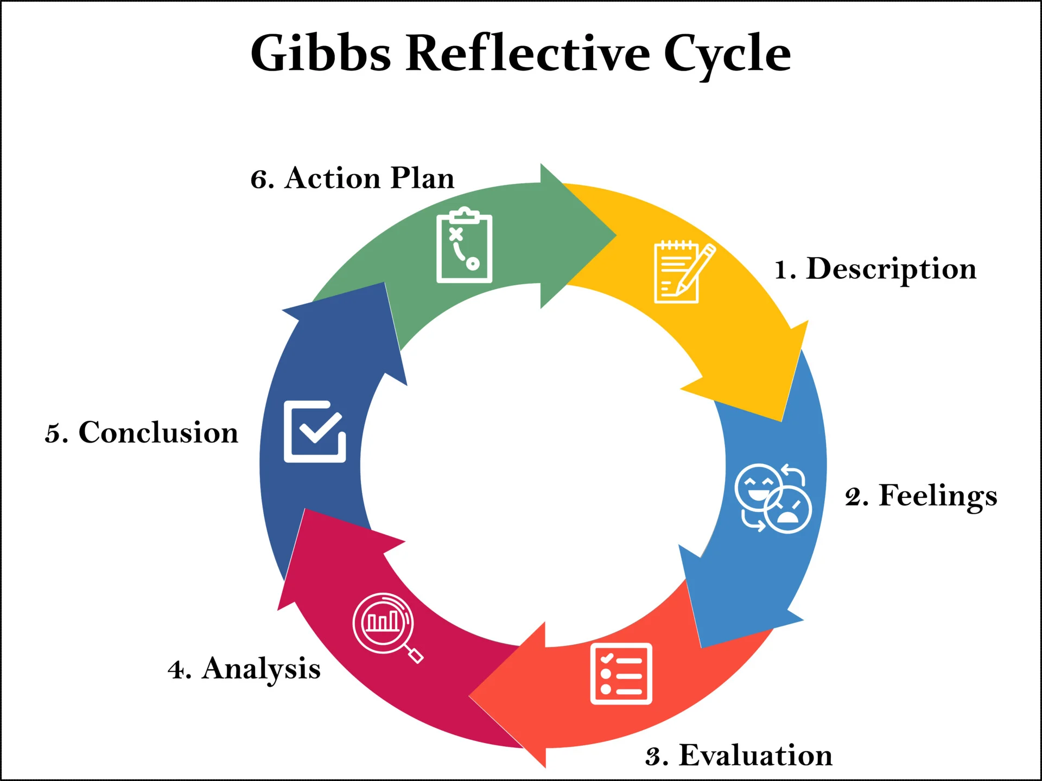
Figure 5: Gibbs Reflective Cycle
(Source: Roedema et al., 2022)

1. Description
In the preparation of Section 1 of this report, I have carried out an extensive review of the construction equipment business in India and appraised the strategic location of Caterpillar as a multinational corporation. The first step was to choose the right country-industry mix that would enable access to enough and credible data. India was selected because of its fast rate of economic growth and infrastructure development whereas the construction equipment industry has been selected on the basis of its close connection with the national development. The research methodology included the gathering of information in the form of academic journals, governmental publications, and industry reports that were released in 2021-2026. I also made sure that the data was up to date and pertinent to the analysis to ensure the credibility of the analysis. I then organised the report into major parts, such as the industry overview, Porters Diamond analysis and a review of Caterpillar in terms of the PESTLE and CAGE frameworks. In the process, I paid attention to merging theoretical notions with empirical data. This involved not just the familiarity with the frameworks but also its effective application to the chosen context. This was also done by comparing various firms in the industry and determining the major competitive dynamics, which were used to derive a holistic view of the market.

2. Feelings
At the onset of the assignment, I was not sure how to handle the task, especially regarding the choice of valid data, and the ability to apply several theoretical frameworks simultaneously. The need to utilise more recent data was another complication, with various sources of information sometimes having conflicting statistics. This gave me some confusion and lowered my confidence in how accurate my analysis was. As I went on, I got more at ease with the research process. I learned to recognise reliable sources and fact-check information, which enhanced my self-esteem. The implementation of models like Porters diamond and PESTLE became clearer where I learnt how to relate them to the industry real-life situations. At the conclusion of the assignment, I became less afraid of my analytical skills and was pleased with my work. The report writing experience not only helped me to pick up on the concepts of international business but also boosted my general academic confidence.

3. Evaluation
The ability to use various analytical frameworks to analyse the industry and the strategic position of Caterpillar was one of the primary strengths of my work. This enabled me to provide a well-organised and detailed analysis, which is in line with the requirements of a postgraduate. I also effectively used current statistical data, which increased the validity and applicability of my results. One more good thing was that I was able to relate theory and practice. I did not merely state concepts, but applied them to the Indian construction equipment industry, a factor that enhanced the overall quality of the report. But it also had certain limitations. One of the key issues that I encountered was maintaining data consistency. Various sources tended to give different figures and this demanded further effort in proving and matching. It was also hard to sometimes get out of descriptive writing and further critical analysis. My work could have had more evaluation and justification of arguments in certain areas. These challenges notwithstanding, the whole experience was positive and it helped me in learning a lot.

4. Analysis
This assignment has shown the value of critical thinking and systematic analysis in international business. Using the Porters Diamond Model enabled me to learn the effect of national factors on the competitiveness of an industry, such as factor conditions, demand conditions and competitive rivalry. On the same note, the PESTLE framework helped me to analyse external environmental issues like political stability, economic growth and regulatory problems. Application of CAGE framework also helped me to learn more about cross-country differences, especially with regard to cultural, administrative, geographic and economic distance. This made me realise the essence of localisation strategies in the international markets. Indicatively, I was enlightened that although India has a lot of growth potential, income and consumer behaviour disparities would necessitate companies to adjust their strategies. The assignment also helped to reaffirm the need to use credible data and evidence to argue. I have also learnt that one needs to perform a critical analysis of data besides gathering data to be an effective analyser. This is in line with what is expected in postgraduate study where students are expected to show higher-order thinking skills. In general, the process has helped me to better analyse a complex business environment and use theoretical concepts in practice.

5. Conclusion
In conclusion, this assignment was a valuable learning experience that enhanced both my academic and analytical skills. I learned more about the international business frameworks and how they can be applied in the analysis of real world industries. It also helped to enhance my research skills especially in finding credible sources and employing up to date data. I struggled with the aspects of the data consistency and critical analysis, but overcoming them through the process of constant learning and adjustment was possible. The experience has taught me the significance of organised thinking, development of arguments and evidence-based analysis. Generally, the assignment played a very important role in my personal and professional growth by enhancing my skills to critically analyse tricky business scenarios and make sound decisions.

6. Action Plan
There are several areas that I intend to improve in future assignments. First, I will improve my research approach by accessing more academic databases like Google Scholar and ScienceDirect to make sure that I get access to high-quality sources. This will assist in strengthening my work. Second, I will concentrate on becoming more critical and go beyond the description and give more thorough analysis and support of arguments. This will entail challenging assumptions and contrasting various views. Third, I will become better at time management by beginning the research process earlier and devoting enough time to revising and refining my work. This will aid in maintaining proper organisation and cohesion in my writing. Through these enhancements, I would like to create more analytical, well-structured and high quality work in future assessments.

Reference list
6Wresearch (2026) Excavator Market Share in India | Looking for Key Players?, 6wresearch.com. Available at: https://www.6wresearch.com/market-takeaways-view/excavator-market-share-in-india (Accessed: 26 April 2026).
Banerjee, Dr.K. (2022) ‘Dedicated Freight Corridor (DFC): Current Scenario and Socio Economic Befefit-An Analytical Study’, SSRN Electronic Journal [Preprint]. Available at: https://doi.org/10.2139/ssrn.4168041.
Basavaraju, C. (2024) ‘The Role of Artificial Intelligence (AI) in Shaping Sustainable Business Practices and the Evolving Landscape of Management Consulting - NORMA@NCI Library’, Ncirl.ie [Preprint]. Available at: https://norma.ncirl.ie/7787/1/chiragbasavaraju.pdf.
Borkhade, R., Bhat K, S. and Mahesha, G. (2022) ‘Implementation of Sustainable Reforms in the Indian Automotive Industry: From Vehicle Emissions Perspective’, Cogent Engineering. Edited by S.L. Fegade, 9(1). Available at: https://doi.org/10.1080/23311916.2021.2014024.
CAAPL (2025) Industry Research Report on Construction Equipment Sector in India. Available at: https://www.jkipl.in/wp-content/uploads/2025/09/32.-Industry-Research-Report.pdf (Accessed: 26 April 2026).
Caterpillar (2025) Caterpillar Inc. - Financials - Quarterly Results, Caterpillar.com. Available at: https://investors.caterpillar.com/financials/quarterly-results/default.aspx (Accessed: 26 April 2026).
CMI (2026) India Construction Equipment Market 2024–2033, Custom Market Insights. Available at: https://www.custommarketinsights.com/report/india-construction-equipment-market/ (Accessed: 26 April 2026).
D&B (2025) Report on Indian Construction Industry. Available at: https://goelconstruction.co.in/wp-content/uploads/2025/05/Industry-Report-on-Indian-Construction-Industry_05-March-2025_Final-Report.pdf (Accessed: 26 April 2026).
ET Infra (2023) India rises up to 38 rank on World Bank’s Logistics Performance Index, ETInfra.com. ETInfra. Available at: https://infra.economictimes.indiatimes.com/news/logistics/india-rises-up-to-38-rank-on-world-banks-logistics-performance-index/99697764 (Accessed: 26 April 2026).
Forbes (2025) Why are so many of India’s 1.5 million fresh engineers every year unemployable?, Forbesindia.com. ForbesIndia. Available at: https://www.forbesindia.com/article/upfront/column/why-are-so-many-of-indias-1-5-million-fresh-engineers-every-year-unemployable/2988705/1 (Accessed: 26 April 2026).
IBEF (2023) RBI notifies 100% FDI in construction sector under automatic route, India Brand Equity Foundation. IBEF. Available at: https://www.ibef.org/news/rbi-notifies-100-per-cent-fdi-in-construction-sector-under-automatic-route (Accessed: 26 April 2026).
IBEF (2025) Growth of Construction Equipment Industry in India - Infographic, India Brand Equity Foundation. Available at: https://www.ibef.org/industry/infrastructure-sector-india/infographic (Accessed: 26 April 2026).
IMARC (2025) India Construction Equipment Market Size, Report, 2034, Imarcgroup.com. Available at: https://www.imarcgroup.com/india-construction-equipment-market (Accessed: 26 April 2026).
Imarc (2025) India Construction Equipment Market Size, Report, 2034, Imarcgroup.com. Available at: https://www.imarcgroup.com/india-construction-equipment-market (Accessed: 26 April 2026).
IMF (2024) World Economic Outlook, International Monetary Fund. Available at: https://www.imf.org/en/publications/weo (Accessed: 26 April 2026).
Judijanto, L. (2025) ‘Bibliometric Analysis of Research on the CAGE Distance Framework in International Business’, The Eastasouth Management and Business, 4(01), pp. 143–151143–151. Available at: https://doi.org/10.58812/esmb.v4i01.736.
Kharub, M., Mor, R.S. and Rana, S. (2022) ‘Mediating role of manufacturing strategy in the competitive strategy and firm performance: evidence from SMEs’, Benchmarking: An International Journal, 29(10). Available at: https://doi.org/10.1108/bij-05-2021-0257.
Kumar, B.R. (2025) ‘Sustainable Finance Initiatives in Equipment Manufacturing and Automobile Segment’, Sustainable Finance, pp. 443–476. Available at: https://doi.org/10.1007/978-3-032-03333-8_13.
Macrotrends (2024) India GDP Per Capita 1960-2024, Macrotrends.net. Available at: https://www.macrotrends.net/global-metrics/countries/IND/india/gdp-per-capita (Accessed: 26 April 2026).
Make In India (2020) India jumps 14 places in World Bank’s Doing Business Report 2020 | Make In India, www.makeinindia.com. Available at: https://www.makeinindia.com/india-jumps-14-places-world-banks-doing-business-report-202 0 (Accessed: 26 April 2026).
Marketsandata (2024) India Construction Equipment Market: Projections to 2032, Markets and Data. Available at: https://www.marketsandata.com/industry-reports/india-construction-equipment-market (Accessed: 26 April 2026).
Mordor Intelligence (2025) India Construction Equipment Market Report | Industry Growth, Size & Forecast Analysis, Mordorintelligence.com. Available at: https://www.mordorintelligence.com/industry-reports/india-construction-equipment-market (Accessed: 26 April 2026).
Muhammad, N. and Hussain, M. (2025) ‘Leveraging Porter’s Diamond Model: Public Sector Insights’, The critical review of social sciences studies, 3(2), pp. 2255–2271. Available at: https://doi.org/10.59075/kkteax93.
Nasscom (2025) NASSCOM AI ADOPTION INDEX Tracking India’s Sectoral Progress on AI Adoption. Available at: https://www.ey.com/content/dam/ey-unified-site/ey-com/en-in/insights/ai/documents/ey-nasscom-ai-adoption-index.pdf (Accessed: 26 April 2026).
PIB (2023) Strong, Stable, Decisive and Transparent Government is the key to achieve dream of our Hon’ble PM of making India a 5 trillion-dollar economy: Nitin Gadkari, Pib.gov.in. Available at: https://www.pib.gov.in/PressReleaseIframePage.aspx?PRID=1920770®=3&lang=2 (Accessed: 26 April 2026).
PIB (2024a) ECONOMIC SURVEY OF RURAL-URBAN POPULATION. Available at: https://www.pib.gov.in/PressReleasePage.aspx?PRID=2042542®=3&lang=2#:~:text=Posted%20On:%2007%20AUG%202024,in%20the%20table%20as%20follows: (Accessed: 26 April 2026).
PIB (2024b) PRODUCTION AND IMPORT OF CRUDE STEEL, Pib.gov.in. Available at: https://www.pib.gov.in/PressReleasePage.aspx?PRID=2080160®=3&lang=2 (Accessed: 26 April 2026).
PIB (2025a) Infrastructure Development in India, Pib.gov.in. Available at: https://www.pib.gov.in/PressReleasePage.aspx?PRID=2098788®=3&lang=2 (Accessed: 26 April 2026).
PIB (2025b) Ministry of Coal’s Year End Review-2025, Pib.gov.in. Available at: https://www.pib.gov.in/PressReleasePage.aspx?PRID=2213723®=3&lang=1 (Accessed: 26 April 2026).
Potharla, S. (2025) ‘From Debt to Divestiture: How Indian and Global Firms Reshaped through Corporate Restructuring’. Available at: https://doi.org/10.2139/ssrn.5348941.
PWC (2024) Localising supply chains and its impact on performance. Available at: https://www.pwc.com/m1/en/publications/documents/2024/localising-supply-chains-and-its-impact-on-performance.pdf (Accessed: 26 April 2026).
Roedema, T., Rerimassie, V., Broerse, J.E.W. and Kupper, J.F.H. (2022) ‘Towards the reflective science communication practitioner’, Journal of Science Communication, 21(4), p. A02. Available at: https://doi.org/10.22323/2.21040202.
Szilágyi, J.E. and Kovács, B. (2022) ‘Acquirement of Land Rights by Foreign Investors: An International Investment Law Perspective’, Legal Studies on Central Europe, pp. 55–75. Available at: https://doi.org/10.54171/2022.jesz.aoalcbicec_3.
The World Bank (2023) Urban population (% of total population) - India | Data, Worldbank.org. Available at: https://data.worldbank.org/indicator/SP.URB.TOTL.IN.ZS?locations=IN (Accessed: 26 April 2026).
Tracxn (2026) CATERPILLAR INDIA PRIVATE LIMITED - 2026 Company Profile & Financials - Tracxn, Tracxn.com. Available at: https://tracxn.com/d/legal-entities/india/caterpillar-india-private-limited/__CNAc5RdE6vtE84F_xFTawYJjRe4xnAKTeGuBxtDS4Ik#principal-business-activity (Accessed: 26 April 2026).
Xia, D., Cassiman, B. and Wehrheim, D. (2025) ‘Escaping Product Market Rivalry Through Innovation’, Management Science [Preprint]. Available at: https://doi.org/10.1287/mnsc.2024.08304.

