Leadership and Change
(BMPF7023)
Ieuan Davies - 2241054
2024

Introduction

I am currently a Health Board Clinical Lead (HBCL) with the Welsh Ambulance Service NHS Trust (WAST) and have been in my current role since 2018.
Career progression-wise within the trust, I have been a Trainee Emergency Medical Technician (TEMT), Emergency Medical Technician (EMT), Paramedic, Clinical Team Leader (CTL and Advanced Paramedic Practitioner (APP).

Prior to joining WAST I spent 10 years at Dwr Cymru -Welsh Water based on Anglesey with my last role being a Water Leakage Inspector.

In regards organisational - leadership change relevant to my current role & specifically the influence of organisational culture in the context of change initiatives, the written assignment will aim to explore and discuss:

- The complex nature of challenges for the leadership role within times of organisational change.

- A range of strategies for leading change in the context of challenges facing the organisation from within.

The current HBCL job description stipulates that I must ensure that agreed systems are in place to ensure a strong clinical presence within the Health Board area to enable the Trust to operate to the required professional clinical standards.

This involves working in partnership with senior management teams and Heads of Operations to ensure the development and maintenance of sound clinical performance management arrangements and the development of clinical performance measurement systems. Along with the Regional Clinical Lead, I am accountable for the improvement of the requisite clinical metrics determined by the organisation.

Additionally, the HBCL should contribute to the overall operational and strategic development of the Trust to deliver clinical services of the highest possible standards, being heavily involved in clinical development and delivery.

The HBCL will ensure the delivery of key objectives across a broad set of clinical priorities in both the urgent and acute care work streams. In addition, this role will collaborate with specialist groups to develop opportunities for the organisation to increase its clinical delivery abilities

The HBCL will undertake an active clinical and leadership role in line with their scope of practice and job plan ensuring that safe and effective care is delivered to the highest standard.

From a Clinical Leadership perspective, I am expected to use expert knowledge to influence the clinical leadership agenda of the organisation to enhance quality improvement in care provision, alongside leading on practice changes aimed at delivering improved health outcomes. Taking a lead role in the development of locally based clinical initiatives, including the assessment, action planning, clinical support, service delivery and evaluation is also an expectation.

The HBCL role has a strong clinical service development emphasis, including monitoring and reviewing outputs to ensure and improve clinical outcomes, patient safety, and the quality of care delivered, alongside promoting the improvements of quality and clinical effectiveness.

As can be seen from the above introduction, my HBCL role encompasses a wide remit spanning a broad range of workstreams and aligns with WASTs position in being seen and recognised as a ‘clinically led service’

The written assignment will critically evaluate several change management modules, alongside their influences relevant to organisational culture in the context of change initiatives, however, I will refine the change that I wish to implement as to focus on a singular, highly relevant and current clinical objective, namely that of Clinical Indicators (CI) and current level of performance.

Combined with other equally relevant outcomes:
- Clinical indicators measure the quality and effectiveness of healthcare.

- They identify areas needing improvement in patient care.

- Used for benchmarking healthcare service performance.

Furthermore, they:
- Can be used to monitor and identify improvement areas.

- Lead to targeted care quality enhancements.

- Improve patient outcomes and reduce healthcare costs over time.

Specific to an ambulance service, clinical indicators:
- Include response times, patient satisfaction, and clinical performance

- Essential for assessing pre-hospital care efficiency and quality.

- Improvements correlate with better patient care and survival rates.

- CI performance is reportable to the WG and published via the Emergency Ambulance Services Committee (EASC – Ambulance Quality Indicators)

To explain the rationale for developing CIs and their significance, the written assignment will discuss how pre-2015, WASTs Clinical Response Model (CRM) solely concentrated on achieving the government-set target of responding to all ‘Red’ category calls (immediately life-threatening conditions such as a cardiac arrest) within an eight-minute time frame. This previous model has been in existence since 1974.

A substantial number of resources and systems of work were established to try and achieve the eight-minute target time, which in turn led to a convoluted set of circumstances, none of which benefited the patient. Some examples of which:

- No peer-reviewed literature exists, that explicitly states that getting to a patient within eight minutes leads to better patient outcomes – one can ask themselves ‘Why not seven minutes 30 seconds or 10 minutes’ – there is simply no evidence to support setting an explicit eight-minute target time.
- In adhering to this particular CRM, especially in regard to reporting compliance to set performance targets, if patient contact was achieved within the eight-minute target time, this was deemed compliant, regardless of patient outcome i.e. even if the patient subsequently died, whereas, reaching a patient within eight minutes and one second would be deemed non-compliant, despite perhaps the patient experiencing an excellent episode of care.

In 2015, WAST (2015) alongside the Welsh Government trialled a new response model that focused on the quality of care (via developing condition-specific CIs) provided rather than the time it took to reach the patient, an initiative that was subsequently supported by the Emergency Ambulance Steering Committee (EASC) published ‘Amber Review’ report (2018) which highlighted the benefits of the clinical response model trial, resulting in an outcome which supported the principle; ‘to get the best response even if this is not the quickest response’

The adoption of the new CRM in 2015 and to current date, has not been without its challenges regarding performance outcomes of the clinical indicators being reported upon. Some of the Clinical Indicators' overall ‘compliance’ percentages that are reportable are not compliant due to many reasons, one of which can be attributed to recognised ‘barriers’ amongst WAST staff compliance in regards to accurately completing the electronic patient record form (ePCR) and from which the clinical indicator compliance data is extracted i.e. if the ePCR isn’t completed correctly, then the CI data is incomplete or ‘skewed’ leading to a perceived omission in the care delivered as part of the overall care bundle i.e. in the case of the ‘neck of femur’ (broken hip) CI, not recording on the ePCR a ‘second’ pain score that the patient expresses after receiving analgesia is enough to break the ‘jigsaw/chain’ of that particular CI (all pieces of the jigsaw must be present to ensure that a CI care bundle achieves 100% compliance)

Clinical Indicators as a collective term, of which all are reportable to the WG & EASC, will be explored in greater detail within the main body of the written assignment, alongside the ‘test of change’ I propose to introduce, however, the introduction should provide an insight into the rationale for the piece of work, which as a result of the challenges faced, is an example of key workstream challenges I’m currently experiencing within my own role, primarily as a result of the influence of organisational change (staff refusal to change) in the context of attempting to implement change initiatives.

The main body will also aim to undertake a critical appraisal of theories or models of organisational culture and their relevance/contribution to influencing organisational change on change initiatives.

Main Body

Current Position
WAST has embedded key principles from the ‘People and Culture Plan (WAST, 2023) which aims to create an environment that attracts, retains, and develops exceptional talent and expertise. The plan also acknowledges that ‘Our people are our greatest asset’ and how vital continuous investment is if the Trust is going to achieve its stated aims & objectives.

By adopting the plan, the Trust wishes to reiterate their commitment to staff and volunteers and celebrate the Trust’s success. It will help measure progress, celebrate successes, and enable learning opportunities to be identified resulting from any challenges faced post-rollout of the plan itself. The plan aims to foster a culture of excellence, collaboration, and inclusivity that will enable the Trust to achieve its strategic goals alongside delivering exceptional care to the patients and supporting our partners and stakeholders.

Key infographics published within the plan are as follows:

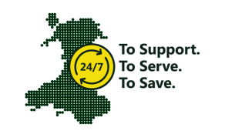
Fig 1: (People and Culture Plan, WAST 2023)
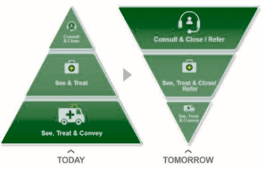
Fig 2: (People and Culture Plan, WAST 2023)

The Plan refers to its source material, namely - The Kings Fund ‘ABC Framework’ (The Kings Fund, 2020) in respect of the three ‘Cs’, namely:

- Culture
- Capacity
- Capability

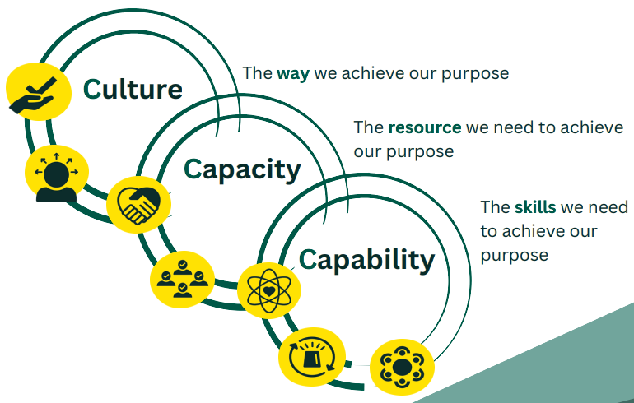
Fig 3 (above): (People and Culture Plan, WAST 2023)

Points 1-3 above should themselves be read in the context of the ‘ABC’ Framework as shown in figure four below:

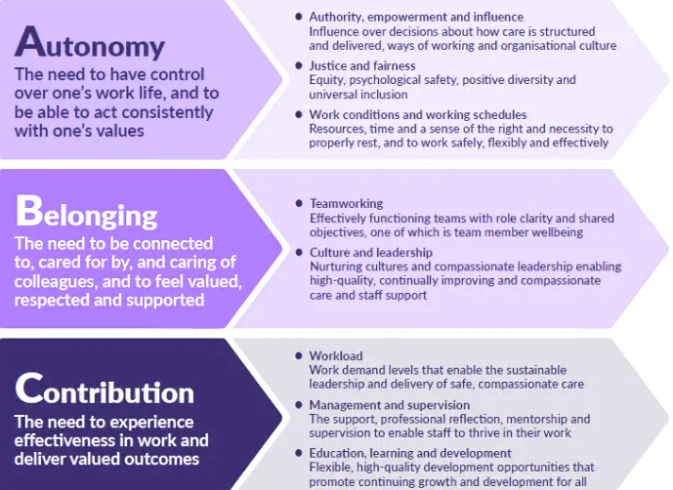
Fig 4: (ABC Framework, The Kings Fund 2020)

Additionally, given that the Trust recognises that ‘its’ people are core/integral to the delivery of any outcomes (with my role identified as a senior manager) the ‘People and Culture Plan’ was ‘built’ around:

- Autonomy
- Belonging
- Contribution

The Kings Fund (2020) itself highlighted that to ensure wellbeing and ongoing motivation within the workplace, alongside reducing work-based ‘stress’, that staff have three core needs:

- Autonomy – the need to have control over their work lives, and to be able to act consistently with their values

- Belonging – the need to be connected to, cared for, and caring of others around them at work, and to feel valued, respected and supported

- Contribution– the need to experience effectiveness in what they do and deliver valued outcomes.

All three must be achieved to maximise potential productivity (whatever ‘productivity’ as a term is relevant to the host organisation, which in respect of WAST is an improved CI compliance)

The term ‘stakeholder’ in describing the importance of staff participation and commitment to a cause’ is also relevant to this written assignment and will be discussed within the work.

In outlining the current position that exists within WAST in regard ‘organisational culture,’ the Kings (2020) Framework outlines some key recommendations to be considered by regulators, improvement bodies, and all workplace leaders who influence the working environment/workplace experience of staff daily – thus, apply to me as a clinical manager.

Key Recommendations:

- Authority, empowerment and influence - introduce mechanisms for staff to shape the cultures and processes of their organisations and influence decisions about how care is structured and delivered.
- Justice and fairness - Nurture and sustain just, fair and psychologically safe cultures and ensure equity, initiative-taking and positive approaches to diversity and universal inclusion.
- Work conditions and working schedules - Introduce minimum standards for facilities and working conditions for staff in all health and care organisations.
- Teamworking - Develop and support effective multidisciplinary teamworking for all staff across health and care services.
- Culture and leadership - Ensure health and care environments have compassionate leadership and nurturing cultures that enable both care and staff support to be high-quality, continually improving and compassionate.
- Workload - Tackle chronic excessive work demands, which exceed the capacity of staff to sustainably lead and deliver safe, high-quality care and which damage their health and wellbeing.
- Management and supervision - Ensure all staff have the effective support, professional reflection, mentorship and supervision needed to thrive in their roles.
- Learning, education and development - Ensure the right systems, frameworks and processes are in place for staff learning, education and development throughout their careers. These must also promote fair and equitable outcomes.

The above narrative illustrates where WAST is placed currently in regard organisational culture, however, some of it is aspirational – ‘what good will look like,’ but similar to other organisations, WAST does suffer from internal challenges in trying to achieve ‘good.’

Organisational culture and its influence on change initiatives has been explored/critically evaluated within published literature, for example, Maksic (2023) uses Peter Drucker’s famous saying “Culture eats strategy for breakfast” as an introduction to their argument that alignment between culture and the pace of change is imperative. A culture embracing change management ensures smoother digital transformation, where innovation and adaptability become essential for sustained growth.

Maksic (2023) further suggests that an agile and adaptable organisational culture is not just desirable, but a strategic necessity in the digital age, and directs the reader to a renowned model by Cammeron & Quinn (2006) which is based upon a competing values framework that categorises organisational cultures into four distinct quadrants.

The model is based on two pairs of competing values: stability vs flexibility and inwards or outwards looking. The vertical axis of the model looks at whether an organisation is more focused on stability or flexibility, and the horizontal axis looks at whether the organisation is more inwards or outwards looking.

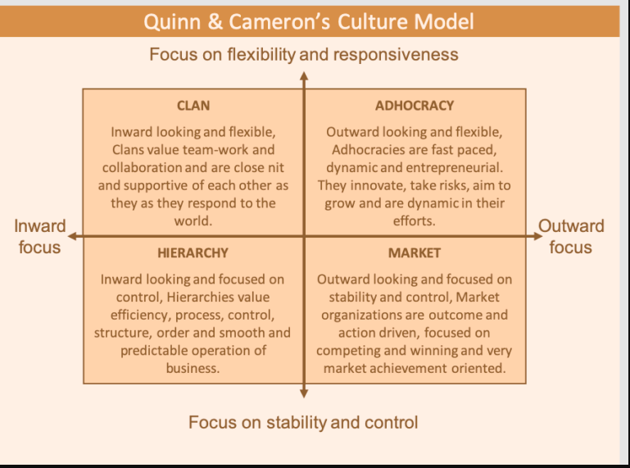
Fig 5: (Cameron-Quinn-Culture-Model-2-768x568.png (768×568) (secureservercdn.net)

In respect of WAST and from reviewing the vertical & horizontal axis of the above culture model, it would appear that ‘Clan’ aligns closest to the ‘Our People and Culture’ embedded plan (aspirational), however, elements of Hierarchy still persist within the Trust in relation to staff behaviours – resistant to change i.e. unwilling to relinquish ‘control’, key advocates of ‘structure’ as in ‘we’ve always done it this way’

Larson & Joy (2023) argue that most transformation efforts fail because the culture, not the strategy itself was lacking. They suggest that for successful change/transformation to happen, that the organisation itself ensures that its culture:

- Is clearly defined and measurable
- Aligned to the organisations strategy and purpose
- Manifests in what it does and how it does things, not just what it says
- Is underpinned by strong bonds/relationships of trust

Both authors further cite two separate studies by McKinsey & Forbes which found that between 75 and 90 percent of strategic change efforts ‘fail’ because of cultural barriers within the organisation itself.

They make a pertinent point regarding my own clinical/managerial role alongside the part to play in ensuring effective change happens, by arguing that culture starts at the top i.e. leaders and decision-makers in the organisation set the tone. An example which they use to convey the message is that ‘if your goal is your destination, and your strategy is your charted path to get there, culture is the vehicle you take’
People working in sub-optimal cultures often resist change, Larson & Joy (2023) suggest that the combination of a mediocre strategy and a strong culture is more conducive to change than having a mediocre culture and a strong strategy.

O’Riordan (2021) challenges Larson & Joy (2023) view albeit an earlier paper, by ensuring that having short planning cycles is a critical factor, alongside ensuring ‘flexibility and regular check points are planned into the project/test of change. If these key components are present, then there is a greater chance of succeeding with the change ‘planned.’

However, O’Riordan (2021) does support the previous authors standpoint, by virtue of agreeing that the most powerful driver of success is ‘employee engagement’. The most successful examples of achieving organisational change, regardless of the type of change sought, are the ones who take the staff (people) with them on the journey from the very beginning.

The WalkMe Team (2021) suggest in their Change Management Blog, that matters to consider in regards ‘how does organisational culture affect change’, can include:
- Innovation – Creating a culture of innovation means inviting participation from everyone. And it means using the right systems, mechanisms, and tools to boost innovation.
- Agility – Agile software development has given rise to agile change management, agile management, and other agile disciplines. Inculcate these systems into your work environment and the culture will gradually shift to reflect those changes (*Software i.e. the digital electronic patient clinical record -ePCR platform has been identified as a barrier to staff fully completing the CI care bundles, which in turn affect the over performance figure reported externally)
- Openness to Change – Prudence is wise in some circumstances. But risk averse attitudes can easily prevent you from money-making investments – the kind that can help your company stay competitive and successful.
- Speed – Acclimate employees to speed, so they become more alert and ready for spur-of-the-moment changes. A culture ready to act, react, and deliver will help contribute to an organization that is able to deliver products and services more quickly.
- Digital Literacy – Digital literacy is necessary in today’s world. Companies should create a “digital culture” that encourages digital fluency. And, as with the other characteristics mentioned here, the best way to cultivate this attribute is by introducing systems that cultivate it (see agility for relevance to my planned test of change)
- Lifelong Learning – It is becoming widely recognized that lifelong learning will become a prerequisite for the workforce of the future. Enterprises that integrate employee training solutions into their business will create a workforce that is more productive, relevant, engaged, and open to change.
Latta (2009) introduces a process model of organisational change in cultural context (OC3 Model) derived from ethnographic analysis. The model delineates the differential impact of organizational culture at every stage of change implementation.

Eight stages of cultural influence are identified and illustrated. Research propositions are stated to encourage refinement of the model (please see figure six below)
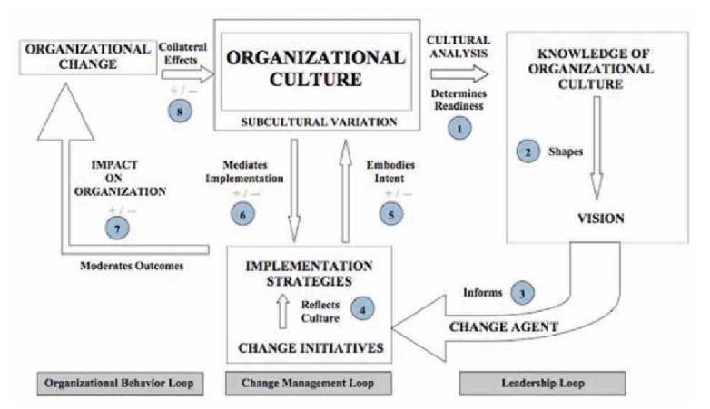
Fig 6:

All the above information informs my test of change, albeit an ‘incremental’ approach/test in the initial stages. I will need to ensure that an ‘optimal’ culture is present when commencing the planned change program, the aim of which will be to increase performance/compliance towards the overall CI compliance bundle, specifically the ‘neck of femur’ CI.

It is interesting to note however, that the common denominator or ‘theme’ that runs through the various cited authors and their respective papers/blogs/models, is the need for staff (those participants actively engaged in the test of change) to have an ‘optimal’ working environment and a leader who is seen to be acutely aware of their particular needs and able to provide sufficient and effective leadership. Being forearmed with this level of insight prior to commencing any incremental test of organisational change is invaluable and aligns to O’Riordan (2021) key principles of ensuring sufficient flexibility is built into the program alongside regular check points and short planning cycles.

O’Riley et al (1991) identifies seven ‘Core’ Characteristics of Organisational Culture (Culture eats policy for breakfast – Peter Drucker) It adopts a behavioural approach to Organisational Culture.

- Innovation & Risk Taking
- Attention to Detail
- Outcome Orientation
- People Orientation
- Team Orientation Aggressiveness
- Stability

WAST’s culture by default (both for employees & patients) is ‘People-Orientated’, and as a result means that its goals and outcomes will be achieved through prioritising ‘our’ people and peoples practices.

WAST use ‘Culture Champions’ (2023) who believe in, support and cultivate a positive workplace culture, they inspire others to believe in the host organisations vison and values, alongside celebrating colleagues accomplishments.



Fig 7: WAST Culture Champions & Behaviours (2023)

O ‘Reilly et al (1991) developed a tool/instrument called – Organisational Culture Profile (OCP) which consists of a set of ‘value statements’ that can be used to assess to what extent certain values characterise a target organisation alongside an individual’s preference for that particular configuration of values.

The paper identifies that one of the OCP approach main strengths, is that it demonstrates that the fit between an individual’s preference for a particular culture, and the culture of the organisation the person joins, is directly related to commitment, satisfaction and turnover (productivity) outputs.

This is the status quo that I would be attempting to achieve in order as to encourage those staff willing to participate in the clinical indicator test of change.

Evaluating O’Reilly et al (1991) OCP instrument and the paper by Brewis et al (2019), clearly identifies that one of the ‘downsides’ of adopting such change, is that it is wholly reliant on ‘the individuals own preference for a particular culture adopted by the organisation, which in turns means that if the individual doesn’t adapt/buy ‘in’, then the host organisation will not realise the benefits as they would otherwise see with individuals who adapt to the organisational culture/test of change.

Lazarsfeld-Jensen et al (2014) suggests that organisations have learnt from past experiences/ practicies that were not conducive to organisational/cultural change i.e. ‘rites of initiation, barbed humour and contempt for those Paramedics who had especially undertook higher education Paramedic programmes. This ‘failure to fit or adapt’ to the organisation manifested in high attrition rates in paramedics ‘voting with their feet.’

This trend in part was ‘addressed’ by the Ambulance Service that the paper reviewed, via introduction of practice educators and organisational ‘cultural champions’, similar to what WAST has also introduced.

Lucas et al (2016) explored ‘understanding complaints’ about Paramedics (UK perspective) and identified ‘Pressurised Services’ as key themes in regards organisational structures and service pressures directly affecting paramedics cognitive load i.e. “not enough staff, late finishes etc”, which in turn dissuades the staff member from ‘buying’ into the host organisation ‘organisational’ culture, or crucially from my perspective any ‘planned test of change program’.

External factors can also influence change, and in such instances CIPD (2013) support undertaking a PESTLE analysis (please see the appendix) studying the key external factors (Political, Economic, Sociological, Technological, Legal and Environmental) that influence an organisation. It can be used in a range of different scenarios and can guide people professionals and senior managers in strategic decision-making.

A PESTLE analysis audits six external influences on an organisation:

- Political: Tax policy; environmental regulations; trade restrictions and reform; tariffs; political stability – WAST potentially affected by the political landscape at that time (political party in power)
- Economic: Economic growth/decline; interest, exchange, inflation and wage rates; minimum wage; working hours; unemployment (local and national); credit availability; cost of living – WAST potentially affected by funding arrangements as a commissioned service via the seven health boards in Wales.
- Sociological: Cultural norms and expectations; health consciousness; population growth rates; age distribution; career attitudes; health and safety – WAST potentially affected by staff failing to adopt/unwillingness to engage with any organisational change process.
- Technological: Innovative technologies are continually emerging (for example, in the fields of robotics and artificial intelligence), and the rate of change itself is increasing. How will this affect the organisation’s products or services? – WAST potentially affected by failing to update/comply with its digital information plan.
- Legal: Changes to legislation impacting employment, access to materials, quotas, resources, imports/exports, and taxation – WAST potentially only mildly affected but do have an open relationship with Trade Union partners.
- Environmental: Global warming and the increased need to switch to sustainable resources; ethical sourcing (both locally and nationally), including supply chain intelligence. Pandemics and other emergencies. – WAST potentially affected by a resurgence in a pandemic similar to what was experienced during the COVID 19 pandemic.

The benefits of undertaking a PESTLE analysis in respect of organisational change, is that it helps in understanding the context for change and is most effective when used in association with a SWOT analysis to understand opportunities and threats around labour changes, such as skills shortages or current workforce capabilities.

A SWOT analysis process generates information that is helpful in matching an organisation or group’s goals, programs, and capacities to the environment in which it operates. The ‘SWOT’ itself is only a data capture exercise - the analysis follows later.
- Strengths: positive tangible and intangible attributes, internal to an organisation and within the organisation’s control
- Weaknesses: internal factors within an organisation’s control that detract from the organisation’s ability to attain the desired goal. Which areas might the organisation improve?
- Opportunities: external attractive factors that represent the reason for an organisation to exist and develop. What opportunities exist in the environment, which will propel the organisation? Identify them by their ‘time frames.’
- Threats: external factors beyond the organisation’s control which could place the organisation mission or operation at risk. The organisation may benefit by having contingency plans to address them if they should occur. Classify them by their severity and probability of occurrence.

In respect of the proposed organisational culture/change initiative test that I wish to implement, alongside being based upon the information/critical analysis work discussed prior within the written assignment, is that Kotter’s 8-Step Change Management Model is the most applicable change management model for my objective.

Apty (2020) argues that organisational change frequently meets with resistance but is also essential if an organisation wishes to advance with its resolute workstream strategies and objectives, from an overarching corporate position down to local level delivery. Adopting a change management tool or ‘model’ can effectively support staff to accept and advance in a timely manner to implementing change. Kotter’s model breaks down into eight- steps (fig 8) the approach to change management.

Figure nine also incorporates elements of Lewin’s three stage model, namely:
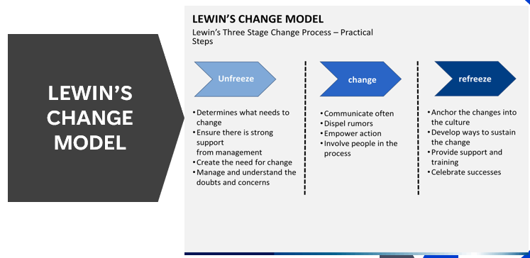
Fig 8: Schein 1996

- Unfreeze - The motivation to change/prepare staff that change is needed (stages 1-4 of figure nine)
- Change - The change process begins (stages five to seven in figure nine)
- Refreeze – The change is embraced/has happened (stage eight of figure nine)

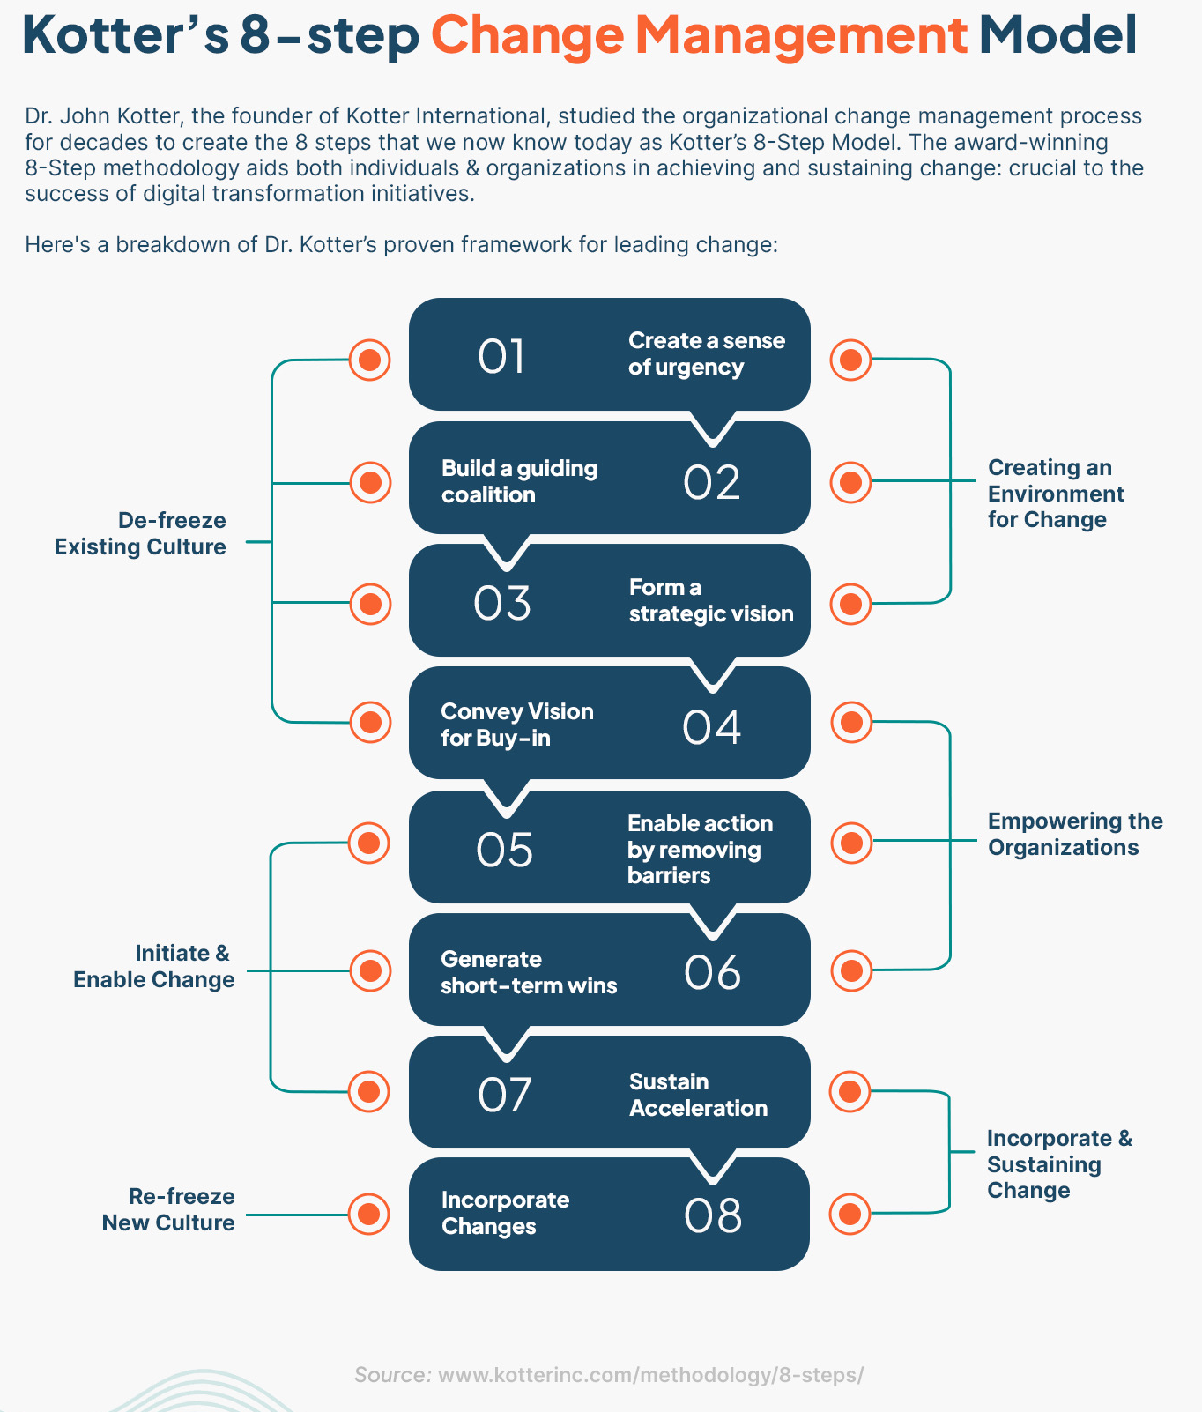

Fig 9: Kotter’s 8-Step Change Management Model

Apty (2020) also supports the idea that at least 75% of the staff need to support your change to enable it to happen.

Step 1 – Establish a sense of urgency:
Inform the staff of the need to change – explain the benefits to ‘all’ (provide some authentic data to support the need for urgency i.e. clinical indicators performance not achieving compliance.

Step 2 – Form a coalition (stakeholders)
Ensure that the team are clear why change needed – it is difficult for one person alone to undertake oversight of the project, hence the need for a cohesive coalition.

Step 3 – Develop a strategic vision and initiatives
Create a clear and (sensible) achievable vison (incremental change if needed) Use of the 5 Whys strategy would be beneficial at step three.

Step 4 – Communicate the vision
Have a consistent and repeated message (mantra) – maximise/leverage all opportunities to share the test of change (WAST communication team)

Step 5 – Empower the stakeholders & remove barriers
Identify any icebergs/barriers and allow the stakeholders to undertake the test of change i.e. improve digital literacy in regards fully documenting & fulfilling all required clinical indicator information required for compliance within the patient ePCR record.

Step 6 – Try and ensure short-term wins
Ensure timely review of objectives and aim to undertake incremental change as to achieve ‘short term’ wins that boost staff morale i.e. concentrating/focussing on one clinical indicator per cycle.

Step 7 – Maintain Momentum/Sustain Acceleration
‘Slow is fast – fast is slow’ – try and maintain a ‘constant’ improvement at the risk of rapid short term wins or fostering an expectation that the process will be quickly achieved (constant review of any plan, do, study, act cycles will help alleviate this step’s pitfalls)

Step 8 – Embed/Incorporate changes into the organisations culture
Anchor and embed the change into culture – imperative that the organisations leader ingrain this as organisational DNA in moving forwards.

Based on steps 1-8 (incorporating Lewin’s 3 stage model as seen in figure nine) this is my chosen change management model. The next section will identify the change I wish to implement and why it is needed.

Current Position:
As discussed within the introduction section of the written assignment, WASTs current clinical indicator (CI) compliance performance is not achieving the expected targets set out by the Welsh Government. It is important for the reader to realise that these CI report on the delivery of clinical care that WAST provide patients who are dealt with after contacting WAST via the traditional 999 route or other pathways.

Multiple factors can skew the compliance data reported and previous quality improvement projects undertaken within WAST identified that ‘human error’ contributed to the problem. Furthermore, ‘human error’ is better explained in that clinical staff are not accurately capturing or recording all the pre-requisite clinical data that individually make up the collective/overall care bundles when using the Trust issued ePCR form (digital patient record form).

WAST report/submit CI data to EASC based on the following clinical indicators:
- Hypoglycaemia (low blood sugar)
- Neck of Femur (broken hip)
- Stroke
- ST Elevation Myocardial Infarction (STEMI – ‘Heart Attack’)

Each CI has its own unique clinical ‘jigsaw’, which when each clinical component (jigsaw piece) is joined together, it duly ‘completes’ the care bundle reported (see figure ten below for an infographic developed for staff awareness) If one of the jigsaw pieces is omitted i.e. not recorded or captured on the ePCR, then this means that the ‘overall’ care bundle is non-compliant
For example – not recording a second pain score for the neck of femur CI affects the overall compliance reported to EASC.

Figure 11 below is the reportable CI data for January 2024 on a pan Wales basis for all conditions.

In respect of the Neck of Femur (NoF) fracture data (highlighted in yellow), it shows that 376 patients were treated for a NoF, of which 214 fully compliant to the complete care bundle. The reported overall performance compliance as a result was 63.7%, which is below the expected measure.
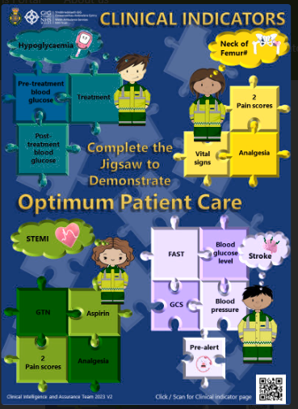
Fig 10: WAST Clinical Indicators
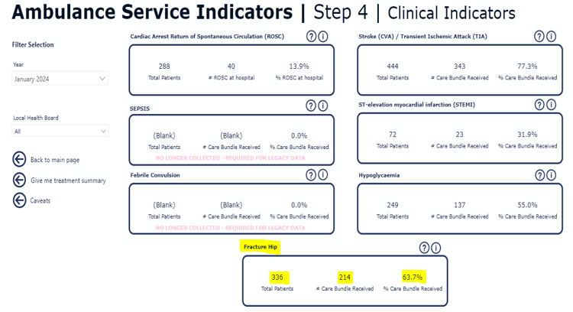
Fig 11: WAST Ambulance Service Indicators
The CI data is also subject to run chart scrutiny, whereby the evidence (trend) clearly demonstrates that the regular omission of documenting a secondary pain score alongside capturing within the ePCR itself that analgesia was administered, is contributing directly to a perceived lack of quality and equitable care being delivered for these patient groups experiencing a fractured neck of femur (this is one currently poorly performing CI)

Interestingly, when reviewing historical data for NoF CI compliance pre introduction of the electronic patient records and when paper patient clinical records were completed by staff, the data showed that overall compliance to the care bundle regularly exceeded the reporting criteria.

Upon a further ‘deep-dive’ of the data, this consistent achievement was attributed to the fact that owing to ‘paper copies’ and a manual (human audit) as opposed digital, that it was easier to identify which member of staff was not completing the clinical records fully in respect of each CI unique ‘jigsaw’ piece. Once highlighted, that staff members Clinical Team Leader would initiate a supportive discussion, highlighting to the individual the need to improve on their CI ‘blind spot’ i.e. “remember to add a second pain score”. The introduction of a digital solution for ePCR inhibits the ease in which a manager can access such individual staff member compliance at a ‘granular’ level.

My proposed change project would involve using Quality Improvement methodology, but crucially as an ‘incremental’ test of change. The Health Foundation (2001) supports the view that Quality improvement involves the use of a systematic and coordinated approach to solving a problem using specific methods and tools to bring about a measurable improvement within a healthcare setting.

I would specifically use the Quality Improvement Guide (2014) model for improvement methodology to implement my test of change (figure 12 below)
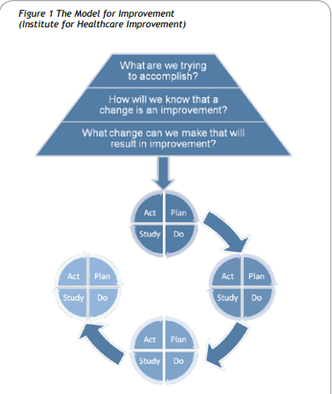
Fig 12: The Quality Improvemnet Guide (2014)

By adopting the model (fig 12) we begin by asking:
- What are we trying to accomplish? -this is the AIM and provides direction i.e. my test of change is improving compliance to the neck of femur CI by ensuring that all the ‘jigsaw pieces are completed.
- How will we know that a change is an improvement? – These are the MEASURES and describe our current and future position i.e. the current CI compliance/performance data that is reported to WG/EASC
- What change can we make that will result in an improvement? – These are the CHANGES that inform us of how we are going to get there – tweaking the ePCR data collection points, thus barring a clinician closing the record until a pain score/administration of analgesia is correctly recorded for a NoF condition code i.e. the clinician cannot proceed any further with completing the ePCR until these key jigsaw pieces of information are entered onto the system. This will be in conjunction with Senior Paramedic being given access to a bespoke CI dashboard from which they can drill down to a ‘granular’ level each team members individual CI performance data, supported by instigating ‘Nudge’ theory methodology.

The second part of the model involves implementing the Plan, Do, Study Act approach, whereby:

Plan - Plan what you are going to do differently – ‘who, what, where and when.’
Do – Conduct the plan and collect information on what worked well and what issues need tackling
Study – Gather the team together once test undertaken to discuss findings with the aim of ‘refining’ the test so that it can be repeated i.e. what is the data telling us, what worked and did not work, what should be adopted, adapted or indeed abandoned.
Act - Use this new knowledge to plan the next test. Agree the changes and amend the outcome measures if necessary. We plan, we do it, we study it, and then we act on those results. We change our plan based on what the results have shown us, and then we start another PDSA cycle to re-test.

The model in figure 12 would be used until we had implemented the change into the organisations values and DNA, thus ensuring that the lessons learnt would be projected onto a bigger platform and ultimately support effective clinical change in respect of improved compliance to reportable CI performance data.

Conclusion
In conclusion, having identified within the written assignment a clinical ‘quality’ data issue & patient centred which directly impacts on the WG/EASC reportable levels of quality indicators performance information, and notwithstanding the contributary factors discussed i.e. poor staff ePCR clinical indicator ‘jigsaw’ completion standards & being unable currently to source individual team members ‘granular’ level of individual CI performance, then the proposed test of change in respect of the wider Organisational Change process has validity and a sound clinical rationale as evidenced/based on the written assignment itself.

The proposed test of change has been developed utilising approved and proven NHS Change Management/Quality Improvement methodology and thus any outcomes for improvement identified can be embedded soundly into clinical practice and subsequently be seen as ‘business as usual’ acceptance by the Trust itself, alongside being seen as safe and open to any scrutiny in being wholly evidence based, as is the pre-requisite for any new change program within the NHS itself.

References
Ambulance Service Indicators - Emergency Ambulance Services Committee (nhs.wales)

Apty (2020) Kotter’s 8-Step Model – A Beginner’s Guide to Change Management. Available at: The Kotter 8 Step Change Management model (apty.io) (Accessed 11th March 2024)

Berwick DM (2003), ‘Errors today and errors tomorrow’, New England Journal of Medicine, 348: pp 2570-2572

Brewis, Joanna and Godfrey, Richard. (2019) From extreme to mundane? The changing face of paramedicine in the UK Ambulance Service. In: Wankhade, Paresh; McCann, Leo and Murphy, Peter eds. Critical Perspectives on the Management and Organization of Emergency Services, Volume London. Routledge, pp. 179–199.

Cameron, K.S. & Quinn, R.E. (2006). Diagnosing And Changing Organisational Culture: Based On The Competing Values Framework. San Francisco. CA: Jossy- Bass.

CIPD (2023) PESTLE Analysis. Available at: PESTLE analysis | CIPD (Accessed 11th March 2024).
Larson, M. & Joy, K. (2023). The Role Of Organisational Culture In Change Management. Available at: The role of organizational culture in change management | MNP (Accessed 7th March 2024).

Latta, G. F. (2009). A Process Model of Organizational Change in Cultural Context (OC3 Model): The Impact of Organizational Culture on Leading Change. Journal of Leadership & Organizational Studies, 16(1), 19-37. Available at: https://doi.org/10.1177/1548051809334197 (Accessed: 7th March 2024).

Lazarsfeld-Jensen, A., Bridges, D. and Carver, H. (2014) Graduates welcome on-road: A culture shift in ambulance preceptorship made clear through retrospective analysis’, Focus on Health Professional Education: A Multi-Disciplinary Journal, 16 (1) pp. 20-30

Lucas, G., Gallagher, A., Zasada, M., Zubin, A., Jago, R., Banks, S. and Van der Gaag, A. (2016) ‘Understanding complaints about Paramedics: A qualitative exploration in a UK context’, Australasian Journal of Paramedicine, 2019 (16), pp. 1-7. Available at:
Understanding-complaints-about-paramedics-uk-context.pdf (Accessed 19th November 2023).

Maksic, M.(2023) Culture: The Key To Change Management Success. Available at: The Role of Organizational Culture in Change Management - Play Media (play-media.org) (Accessed: 7th March 2024).

Nolan, TW (2007), ‘Execution of Strategic Improvement Initiatives to Produce System-Level Results’, IHI Innovation Series White Paper, Institute for Healthcare Improvement, Cambridge, Massachusetts (www.ihi.org)

O ‘Reilly, C, A., Chatman, J. and Caldwell, D, F. (1991) People and organisational culture: A profile comparison approach to assessing people-organisational fit’, Academy of Management Journal, 34 (3) pp. 487-516

O’Riordan, B. (2021) Why Transformations Fail And How They Can Succeed With People Power. Available at: Why Transformations Fail And How They Can Succeed With People Power (forbes.com) (Accessed: 7th March 2024).

Quality improvement made simple. The Health Foundation; 2021 (www.health.org.uk/publications/quality-improvement-made-simple

Schein, E.H., (1996). Kurt Lewin’s change theory in the field and in the classroom: Notes toward a model of managed learning. Systems practice, 9(1), pp.27-47

The Kings Fund (2020) The Courage Of Compassion. Available at: The Courage Of Compassion: Supporting Nurses And Midwives To Deliver High-Quality Care | The King's Fund (kingsfund.org.uk) (Accessed: 7th March 2024).

WalkMe Team (2021) How Does Organizational Culture Affect Change? Walkme The Change Management Blog, 24th March. Available at: How Does Organizational Culture Affect Change? (walkme.com) (Accessed: 7th March 2024).

WAST (2015) Clinical Response Model - Clinical Response Model - Welsh Ambulance Services NHS Trust (Accessed 5th March 2023).

WAST (2018) A Review Of Calls To The Welsh Ambulance Service Categorised As Amber. Available at: easc.nhs.wales/publications/amber-review/ (Accessed 5th March 2024).

WAST (2023) Culture Champions. Available at: Culture Champions (sharepoint.com) (Accessed: 19th November 2023).

WAST (2023) Our People And Culture Plan 2023-2026. Available at: People and Culture Plan 2023-26.pdf (Accessed: 7th May 2024).

1000 Lives Improvement (2014), The Quality Improvement Guide: The Improving Quality Together Edition Cardiff: 1000 Lives Improvement.

Appendix

