
Assignment 1
Learning in the Digital Era

21 November 2025
london campus
[Company address]
Module Name: Software Solutions for Business Assessment
Module Code: ACCA 4026
Student Name: Delia Deliu Alexandrina
ID: 2509861
Group No: 3
Lecturer’s Name: Kwame Assa-Agyei
Submission Deadline: 15 December 2025

Introduction 3
Main Body 3
Task 1: e-Commerce Website builders/software solutions 3
1.1 WooCommerce 3
1.2 Wix 3
Task 2: Mind-map of contemporary software applications 3
Describe mind mapping and explain the benefits of using mind mapping in business operations 3
Create a mind map of contemporary software applications that are used to support day-to-to-to-today business/ Organisation operations 3
Task 3: Office Applications for creating, storing, presenting, and analysing information/data 3
Explain four office software solutions for business operations 3
MS Word 3
MS PowerPoint 4
MS Excel 4
MS Access 4
Test any two features from the following Mail merge, IF Function, VLOOKUP, Pivot Table, Goal Seek in MS Excel 4
Mail Merge 4
If Statement 4
Task 4: Communication and Collaboration applications 4
Analyse one contemporary Communication and one Online Collaboration applications/tools used frequently in modern business world 4
MS Outlook 4
MS Teams 4
Test one feature of a freely available Communication and one feature of a Collaboration application 5
MS Outlook 5
Ms Teams 5
Conclusion 5
References 5
Bibliography 5

Introduction
In the modern digital era, technology is crucial for the operation of businesses, educational institutions, and individuals, affecting information management, communication, collaboration, and online presence. This assignment examines key technological tools, starting with e-commerce website builders like WooCommerce and Shopify, which aid in online store management with features for product handling, payment processing, and customer engagement. It then discusses mind mapping as a technique that enhances creativity and decision-making by visually organizing information. The report also analyzes Microsoft Office tools (Word, PowerPoint, Excel, and Access) for their utility in document creation, presentations, data analysis, and database management. Lastly, it evaluates communication and collaboration tools such as Microsoft Teams for remote work support and Trello for project management, highlighting their roles in improving efficiency and teamwork. The overall emphasis is on leveraging digital solutions to enhance productivity and competitiveness in a connected world.

Task 1: e-Commerce Website builders/software solutions

1.1 WooCommerce

WooCommerce is an open-source e-commerce plugin that integrates with WordPress, transforming a standard website into a comprehensive online store. The core plugin is free, and it can be enhanced with customizable themes, additional plugins, and hosting options. Key features include the ability to add product types, manage inventory, and implement checkout, shipping, and coupon functionalities [1]. It also offers an extensive library of extensions for various needs such as payments and subscriptions, providing full control over site files, data, and SEO [1]. The benefits of WooCommerce stem from its flexibility and ownership, allowing users to customize their online store and manage costs effectively, as payment is typically required only for hosting and premium features.
Businesses seeking deep customization, control over their data, and those planning to incorporate rich content alongside their e-commerce site are optimal candidates for WooCommerce [2]. However, users should be aware of several trade-offs, including the necessity for hands-on management of hosting, security, and performance, as well as the potential for plugin sprawl, which can lead to increased costs and compatibility challenges [2].
In comparison to alternatives, such as Shopify, WooCommerce offers greater control and flexibility at the expense of simplicity and speed, with Shopify providing a more straightforward and managed solution. The choice between the two platforms typically hinges on a business’s specific requirements regarding customization, hosting preferences, and overall strategy.
⸻.

1.2 Shopify

Shopify is a comprehensive hosted e-commerce platform designed to facilitate the launch, operation, and growth of online stores by providing essential tools such as website creation, checkout, payment processing, and optional in-person sales hardware [3]. Users can rapidly establish an online presence by selecting a plan, customizing a theme, and adding products.
Key features include:
-Ready-made storefront themes and a user-friendly drag-and-drop editor for quick setup [3].
-Secure checkout and integrated payment processing (Shopify Payments and various third-party gateways).
- A robust app ecosystem offering thousands of applications for subscriptions, reviews, advanced shipping, and marketing automation [3].
- Point-of-sale (POS) capabilities for in-person transactions and support for multichannel selling on platforms like Instagram, Amazon, and Facebook [3].
-24/7 customer support and managed hosting to ensure uptime, security, and PCI compliance.
The benefits driving users to choose Shopify are its quick market readiness, eliminating concerns over hosting and technical setup, and the polished design that promotes high conversion rates. Its extensibility allows users to easily add functionalities through apps without the need for coding skills.
Shopify is best suited for small to medium-sized businesses seeking a reliable, low-maintenance store that can scale, particularly those that wish to manage both online and physical sales. Potential trade-offs include monthly fees and transaction costs, which could exceed those of self-hosted solutions, especially as additional apps and higher service plans are added. Additionally, users have less control over their platform since they operate within Shopify’s guidelines and limitations, albeit with the convenience of managed services.

[1] WooCommerce, “WooCommerce Features,” WooCommerce.com. Accessed: Feb. 2025.
[2] WPBeginner, “Shopify vs WooCommerce: Which is the Better Platform?” WPBeginner, 2024.
[3] Shopify, “Features – Online Store Essentials,” Shopify.com. Accessed: Feb. 2025.

Task 2: Mind-map of contemporary software applications

Describe mind mapping and explain the benefits of using mind mapping in business operations.

Mind mapping is a visual technique for organizing ideas, information, and thoughts in a way that enhances understanding and recall. It typically starts with a central idea, with related concepts branching outwards resembling a tree structure. This method utilizes various elements such as words, diagrams, colors, and symbols to clarify and enhance the information’s meaning. The concept of mind mapping gained prominence through Tony Buzan’s work, which emphasized its capacity to engage both hemispheres of the brain, thereby improving learning and creativity [1]. Buzan noted that mind mapping facilitates natural thought processes by allowing the brain to make dynamic connections between ideas rather than following linear paths.
In educational and business environments, mind mapping proves particularly advantageous. In business settings, it aids teams in brainstorming, planning projects, solving problems, and communicating ideas more effectively. By structuring complex information visually, mind maps allow teams to grasp the overall picture, thereby enhancing decision-making capabilities. The impact of this visual method on productivity is notable, as individuals can swiftly recall details and understand task relationships. A study highlighted in the Journal of Business and Psychology pointed out that visual techniques, like mind mapping, bolster memory and creativity by promoting active engagement with the material [2].
Moreover, mind maps are instrumental in the brainstorming process, which is vital for generating innovative solutions and maintaining competitiveness among businesses. As ideas are added without immediate concern for order, patterns and connections emerge organically, facilitating the identification of strong concepts and the synthesis of similar thoughts into broader ideas. This visual representation also minimizes confusion and helps teams remain focused on their objectives.
Communication within teams is another area where mind mapping excels. By arranging information around a central theme, mind maps serve as straightforward tools for presenting plans and strategies, making meetings more efficient and reducing the likelihood of misunderstandings due to their clear visual layout.
Additionally, mind mapping is beneficial for problem-solving. Complex business challenges often have multiple causes and solutions, which can be daunting. Mind maps allow teams to decompose problems into smaller components, exploring options more effectively by representing each element, such as potential causes or solutions, as branches. According to Buzan, this structure enhances critical thinking by permitting a creative and non-linear exploration of issues [1].
The advent of digital mind mapping tools like MindMeister, XMind, and Miro has streamlined this process, enabling online collaboration, image integration, template creation, and instant sharing. Digital mind maps particularly support remote work by facilitating real-time contributions. Research indicates that these tools can enhance team engagement and foster quicker idea generation by merging visual thinking with interactive functionalities [3].
Mind mapping emerges as a powerful technique utilized by businesses to organize information, boost creativity, and improve communication. It effectively aids teams in deciphering complex ideas, generating innovative thoughts, and discovering solutions. Whether implemented on paper or with digital resources, mind mapping stands out as a versatile tool for thinking, planning, and collaboration, securing its place as a widely embraced visual method in contemporary organizations.
[1] T. Buzan, The Mind Map Book: Unlock Your Creativity, Boost Your Memory, Change Your Life. BBC Active, 2010.
[2] J. Farrand, F. Hussain, and E. Hennessy, “The Efficacy of the ‘Mind Map’ Study Technique,” Medical Education, vol. 36, no. 5, pp. 426–431, 2002.
[3] B. Eppler, “A Comparison Between Concept Maps, Mind Maps, Conceptual Diagrams, and Visual Metaphors as Complementary Tools for Knowledge Construction and Sharing,” Information Visualization, vol. 5, no. 3, pp. 202–210, 2006.

Create a mind map of contemporary software applications that are used to support day-to-to-to-today business/ Organisation operations.

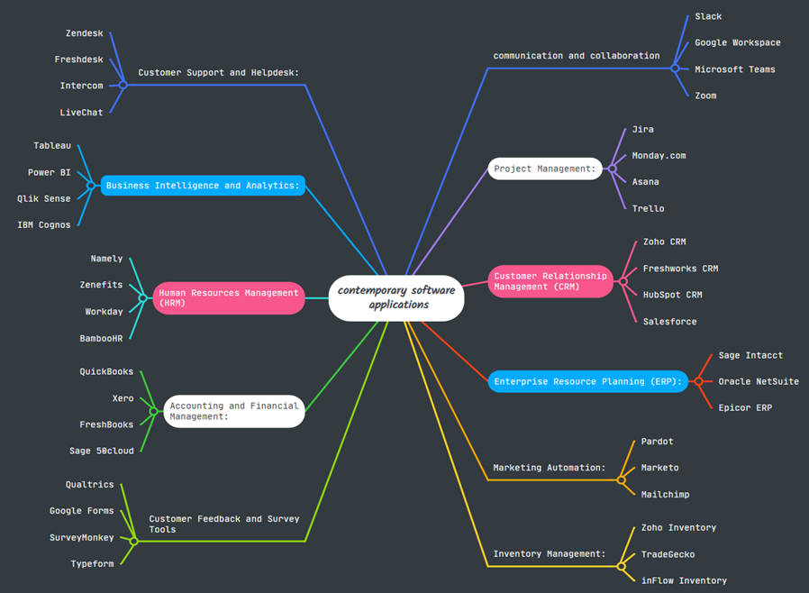

Task 3: Office Applications for creating, storing, presenting, and analysing information/data

Explain four office software solutions for business operations.

MS Word
Microsoft Word is a leading word-processing application, part of the Microsoft Office suite, designed to facilitate the creation of professional documents and is utilized by a diverse user base including students, educators, businesses, and organizations. Although it appears straightforward, Word encompasses a variety of advanced features that enhance productivity in academic and office tasks [1].
Main Features:
Key functionalities include robust text editing capabilities, enabling users to swiftly write, copy, delete, and format text. Features like spell-check, grammar-check, and auto-correct help enhance writing quality by identifying mistakes and improving clarity through an intelligent language technology editor [2]. Formatting and layout control are simplified, with options to modify font settings, alignment, margins, and spacing, alongside the use of styles for consistent formatting across whole documents—beneficial for lengthy texts such as essays and reports [2].
Page design tools within Word allow the insertion of various elements such as tables, charts, images, and graphics, enabling the creation of visually appealing documents without the need for separate design applications. Moreover, a plethora of templates for resumes, newsletters, and brochures aid users in initiating projects with professional flair [1].
The References tab stands out for academic use, providing necessary functionalities to create citations and bibliographies in multiple referencing styles (e.g., APA, MLA). Collaboration features are facilitated through Microsoft 365 integration, allowing real-time co-authoring, comment addition, and change tracking, thus fostering teamwork in various contexts [1].
Benefits:
Word’s user-friendly interface is familiar to millions, promoting ease of use but also accommodating advanced users with sophisticated capabilities like mail merge [2]. It assists in generating polished documents that meet professional standards and is compatible with various file formats, ensuring consistent formatting during document sharing [1]. Editing tools such as spell-check and the Editor assist users in enhancing their writing over time, while cloud storage mitigates the risk of data loss, allowing document access across devices [1].
Integration with other Microsoft Office applications streamlines processes further, enabling seamless inclusion of content from Excel, PowerPoint, and Outlook [2].
Limitations:
Despite its strengths, Word presents challenges, particularly for new users who may find complex features intimidating [2]. Performance issues can arise when handling large documents filled with media, leading to lag or software freezes, especially in collaborative environments [1]. Additionally, Word is not tailored for advanced graphic design, lacking diverse design tool capabilities that professional software offers; layouts can also shift unexpectedly across different systems [2].
The necessity of a Microsoft 365 subscription for the most advanced features may deter some users, while the free online version, albeit with limited features, requires constant internet access [1]. Lastly, inconsistencies in formatting can occur when documents are shared between different versions of Word on various devices, impacting the document’s appearance [2].
[1] Microsoft, “Microsoft Word: Features and Overview,” Microsoft.com, 2024. [Online]. Available: https://www.microsoft.com/en-us/microsoft-365/word
[2] S. McFedries, Microsoft Word 365 In Depth. Redmond, WA: Microsoft Press, 2022.

MS PowerPoint Microsoft PowerPoint is a widely used presentation software integral to the Microsoft Office suite, designed to create slideshows for a multitude of settings such as lessons, meetings, pitches, and training sessions. It stands out due to its flexibility and capability to visually convey information, making it a preferred choice in educational institutions and businesses alike [1].
Key features of PowerPoint include slide creation, where users can employ a variety of layouts, including blank and pre-designed options, to effectively organize content ranging from text to images and videos [2]. The application also offers themes that ensure a unified design throughout the presentation. Moreover, animations and transitions enhance engagement by controlling how elements appear or shift between slides, capturing and maintaining audience attention [2].
PowerPoint also excels in visual design capabilities, allowing users to incorporate diverse graphics like SmartArt, which facilitates the creation of complex diagrams [1]. Users can edit images directly within the software, ensuring a polished, professional appearance. The Slide Show mode presents the slides in full screen and provides tools like a timer and speaker notes, aiding presenters in managing their delivery seamlessly [1].
An important aspect of PowerPoint is its multimedia support, enabling the integration of audio, music, sound effects, and videos. This feature is particularly beneficial for creating interactive and dynamic presentations that enhance viewer comprehension [2]. Furthermore, collaboration tools integrated through Microsoft 365 allow multiple users to edit presentations simultaneously, fostering teamwork and communication [1].
The benefits of using PowerPoint are substantial. Its visual nature aids in better information retention compared to traditional text-heavy methods, with the flexibility to address various presentation needs ranging from business proposals to educational projects [2]. Compatibility with other Microsoft applications streamlines data sharing and saves time, while an intuitive interface enables quick learning for users familiar with the Office suite [1]. The support for multimedia enriches presentations, making them more engaging and effective in communicating ideas [2].
Nonetheless, PowerPoint does have limitations. Overuse of animations and extravagant designs can detract from professionalism, leading to audience distraction [2]. Additionally, excessive text on slides can lead to information overload, compromising clarity [1]. The effectiveness of presentations can also depend on technological infrastructures, posing risks such as file size problems that may hinder sharing and presentation due to slow load times or crashes [2].
Complex design requirements might exceed PowerPoint’s capabilities compared to specialized design software, which could be a drawback for graphic designers [1]. Lastly, there exists a tendency for presenters to overly rely on slides, thus diminishing the quality of the delivery [2].

[1] Microsoft, “PowerPoint: Presentation Software Overview,” Microsoft.com, 2024. [Online]. Available: https://www.microsoft.com/en-us/microsoft-365/powerpoint
[2] D. M. Stinson, Microsoft PowerPoint 365 Step by Step. Redmond, WA: Microsoft Press, 2023.
⸻

MS Excel

Microsoft Excel is a widely utilized spreadsheet software, integral to the Microsoft Office suite, designed for data analysis, calculation, and organization across various domains such as business, education, and research. Its fundamental capabilities include the storage of data in tabular form, execution of mathematical calculations, creation of visual charts, and efficient information analysis, which collectively enhance decision-making processes [1].
Main Features
Excel operates through workbooks, which contain multiple worksheets organized in grids of rows and columns. Each cell within these grids can hold diverse types of data including text, numbers, dates, or formulas [2]. The software’s formulas and functions are critical for performing both basic calculations (addition, subtraction, multiplication, division) and advanced computational tasks through functions like SUMIF, VLOOKUP, HLOOKUP, INDEX, MATCH, and IF statements [2]. These tools enable automation in calculations, significantly aiding professionals such as accountants and analysts.
Data analysis is enhanced by Excel’s sorting, filtering, and conditional formatting capabilities. Users can sort data in multiple orders and filter it to display only the pertinent information, while conditional formatting highlights significant data points to facilitate trend identification [2]. Furthermore, the ability to create various types of charts and graphs, including line graphs, bar charts, and PivotTables, allows users to visualize and summarize large datasets effectively [1]. PivotTables also provide an interactive way to manipulate and filter data for analytical insights [2].
Excel additionally includes data validation and protection features, allowing users to establish strict entry rules and password-protect workbooks or worksheets to safeguard sensitive information [1]. In its modern iterations, particularly with Microsoft 365, Excel emphasizes collaboration by supporting simultaneous edits, comments, and changes by multiple users, while enabling cloud storage through OneDrive to ensure accessibility from various devices [1].
Benefits
The primary advantages of using Excel encompass its efficiency in organizing and analyzing data, moving away from manual calculations and paper records to instant data handling [2]. Its extensive flexibility enables it to serve a broad array of tasks from personal budgeting to complex financial forecasting, with built-in functions that streamline repetitive processes [2]. The visual representation of data through charts and graphs enhances comprehension of large datasets, fostering informed decision-making and effective reporting [1].
Collaboration features in Excel support teamwork in project management, financial tracking, and stakeholder reporting, while the reliability of formulas minimizes human error, ensuring data accuracy and consistency vital for financial and research applications [2].
Limitations
Despite its numerous benefits, Excel does present challenges. Its complexity can pose difficulties for beginners, as advanced functions require time and training to master [2]. Additionally, risks associated with incorrect formulas or data entries necessitate vigilant validation to ensure data accuracy [1]. Performance issues may arise with exceptionally large datasets, where specialized tools like SQL or Python-based applications might be more suitable [2].
While multi-user editing is feasible in Microsoft 365, Excel falls short in providing the comprehensive security and relational database management that tools like Microsoft Access offer, which can lead to version control complications [1]. Finally, Excel files can become cumbersome in size due to extensive formatting or embedded objects, complicating their accessibility and sharing capabilities [2].

[1] Microsoft, “Excel – Overview and Features,” Microsoft.com, 2024. [Online]. Available: https://www.microsoft.com/en-us/microsoft-365/excel
[2] R. Walkenbach, Excel 365 Bible, 2nd ed. Hoboken, NJ: Wiley, 2022.

MS Access
Microsoft Access is a database management system (DBMS) included in the Microsoft Office suite, designed for the efficient storage, management, and retrieval of large amounts of structured data. Unlike Excel, which focuses on calculations and data analysis, Access is tailored for creating databases with multiple related tables, forms, queries, and reports, making it popular in various settings such as businesses and schools for managing customer data, inventory, and sales records [1].
Key features of Access include its relational database structure, enabling users to create and link multiple tables, which minimizes data redundancy and maintains integrity [2]. Users can design Forms for a simplified data entry interface, enhancing user experience and reducing error likelihood by preventing direct table access [2]. Queries allow for comprehensive data analysis, with simple searches and complex functions employing SQL for advanced operations [2]. Reports facilitate data presentation in a structured format, crucial for decision-making and stakeholder communication, with options to automate generation for regular reviews [1].
Access further supports Macros and Automation to streamline repetitive tasks, increasing efficiency and reducing manual workloads [2]. It also utilizes VBA programming for advanced custom function creation and integration with other Office applications, which helps to enhance workflows [1].
The benefits of Access are significant, particularly its ability to manage large datasets effectively compared to Excel, with its relational structure enhancing data retrieval and compliance with accuracy standards [2]. Access provides customization options that enable tailoring forms, queries, and reports to specific business needs [1]. Its data analysis capabilities allow for quick extraction of insights from large datasets, supporting informed decision-making and reporting [2]. Collaboration is enhanced through its multi-user access feature on shared networks, fostering real-time updates and efficiency improvements while reducing reliance on paper records [1].
Despite these advantages, Access does have limitations. Beginners may find it complex to navigate relational database design and utilize features like queries and macros without training [2]. Furthermore, while it supports multiple users, it may not perform as well under heavy simultaneous access compared to enterprise-level systems like SQL Server, which can present risks in larger database environments [1]. Scalability is another concern, as Access is more suitable for small to medium-sized businesses and not designed for high-volume transaction systems [2].
Moreover, Access’s dependence on the Microsoft environment limits its portability, requiring the software to be installed for full functionality and offering only limited web access unless integrated with platforms such as SharePoint [1]. File size restrictions pose another hurdle, as databases cannot exceed 2 GB, necessitating migration to more robust systems for larger datasets [2]. Lastly, Access’s focus on structured data makes it less applicable for unstructured data like multimedia files that may need specialized software for analytics [1].

[1] Microsoft, “Microsoft Access – Features and Overview,” Microsoft.com, 2024. [Online]. Available: https://www.microsoft.com/en-us/microsoft-365/access
[2] R. L. Green, Access 365 Bible. Hoboken, NJ: Wiley, 2022.

Test any two features from the following Mail merge, IF Function, VLOOKUP, Pivot Table, Goal Seek in MS Excel

Mail Merge

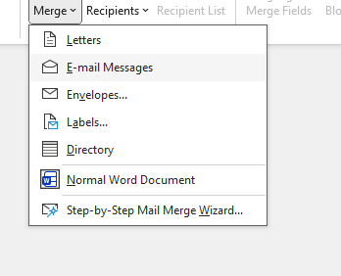

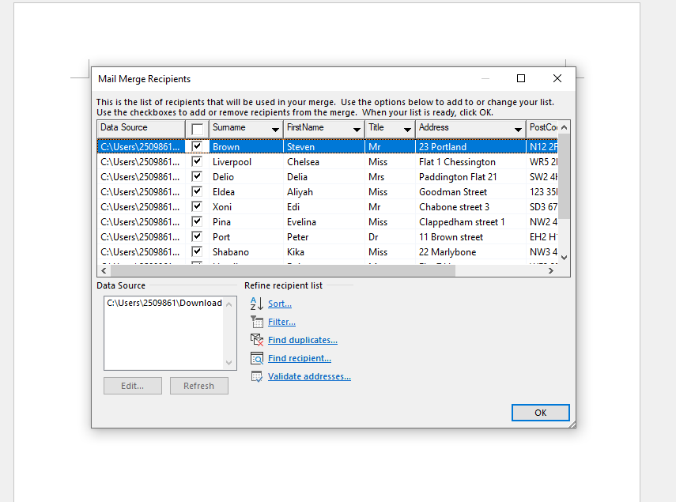

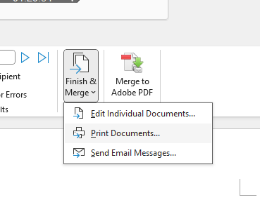

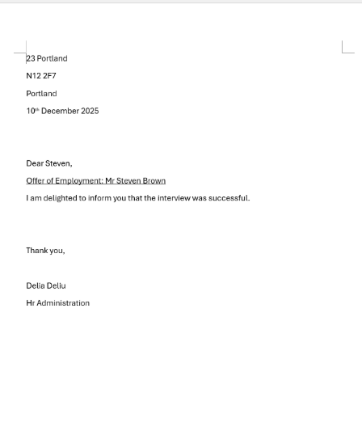



If Statement





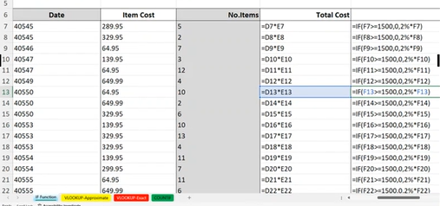

Task 4: Communication and Collaboration applications
Trello
Trello is a web-based collaboration and project management tool developed by Atlassian. It uses the Kanban methodology to visually organize tasks and projects, making it particularly popular for teams managing workflows and tasks in professional and educational environments [3].
Features:
1. Boards, Lists, and Cards: Trello’s core structure consists of Boards (projects), Lists (stages of work), and Cards (tasks). Cards can include checklists, attachments, labels, due dates, and comments [3].
2. Collaboration and Assignment: Team members can be assigned to cards, leave comments, tag others, and track progress in real-time [3].
3. Power-Ups and Integrations: Trello supports Power-Ups (plugins) to extend functionality, including calendar views, automation tools (Butler), time tracking, and integration with apps like Slack, Google Drive, and Microsoft Teams [3].
4. Automation: Trello’s Butler feature allows users to automate repetitive tasks, such as moving cards, setting reminders, or updating labels [3].
5. Templates: Trello offers pre-built templates for various project types, helping teams get started quickly [3].
Benefits:
1. Visual Task Management: Kanban-style boards provide an intuitive overview of tasks, making it easy to track progress and identify bottlenecks [3].
2. Flexibility: Trello can be used for a wide range of projects, from software development and marketing campaigns to personal task management [3].
3. Collaboration: Multiple team members can work simultaneously on cards, leave comments, and attach files, promoting real-time collaboration [3].
4. Simplicity: User-friendly interface reduces the learning curve, enabling quick adoption without extensive training [3].
5. Remote Work Support: Teams can collaborate from different locations, accessing boards via web browsers or mobile apps, supporting flexible work [3].
Limitations:
1. Limited Advanced Project Management: Trello lacks advanced project management features such as Gantt charts, resource allocation, or complex reporting found in tools like Monday.com or Jira [3].
2. Scaling Challenges: Large projects can lead to cluttered boards, making task management challenging [3].
3. Dependency on Internet Connection: Trello is cloud-based, so offline functionality is limited [3].
4. Limited Native Time Tracking: Time tracking requires Power-Ups or third-party integrations [3].

MS Teams
Microsoft Teams is a communication platform integral to the Microsoft 365 ecosystem, designed to facilitate effective communication within organizations. With its primary focus on messaging, video conferencing, and voice calls, Teams serves as a central hub for workplace communication, especially relevant in remote and hybrid work situations [1].
Features of Microsoft Teams include:
1. Chat and Messaging: Users can engage in instant messaging with individuals or groups, sharing text, images, files, links, and GIFs. Threaded conversations help maintain context [2].
2. Video and Audio Calls: Teams supports high-quality calls among multiple participants, offering features like screen sharing, background blur, and meeting recording [1].
3. Channels and Teams: Organizations can create distinct teams for departments or projects, with specific channels for focused topics, ensuring organized dialogues [2].
4. Integration with Microsoft 365: Users can share and co-edit documents from Word, Excel, PowerPoint, OneDrive, and SharePoint directly within Teams, enhancing collaborative efforts [1].
5. Calendar and Scheduling: Integrated with Outlook, Teams provides a calendar feature that facilitates easy scheduling of meetings and appointments [2].
6. Bots and Apps: Users can enhance the platform’s functionality through bots, connectors, and third-party apps for tasks such as workflow automation and reporting [1].
Benefits:
1. Enhanced Collaboration: By centralizing communication, Teams streamlines collaboration, reducing reliance on multiple communication tools [1].
2. Remote Work Support: Teams enables effective communication and collaboration across distributed teams, facilitating hybrid work settings [2].
3. Productivity Improvement: Integration with Microsoft 365 allows seamless document co-authoring, task management, and meeting scheduling [1].
4. Communication Efficiency: Threaded chats and searchable histories promote quicker responses and easier access to past conversations [2].
5. Security and Compliance: Teams provides robust enterprise-grade security, including data encryption and multi-factor authentication, while adhering to industry compliance standards [1].
Limitations:
1. Complexity for New Users: The platform’s extensive features can be overwhelming for those unfamiliar with its navigation [2].
2. Performance Issues: In larger organizations, usage can lead to lagging, delayed notifications, or connectivity challenges during peak times [1].
3. Over-reliance on Microsoft Ecosystem: Teams works best within the Microsoft 365 framework; integration with other tools may be limited [2].
4. Meeting Fatigue: Continuous video meetings on Teams can result in fatigue, affecting productivity if not properly managed [1].

[1] Microsoft, “Microsoft Teams – Overview and Features,” Microsoft.com, 2024. [Online]. Available: https://www.microsoft.com/en-us/microsoft-teams
[2] S. Sawhney, Mastering Microsoft Teams. Microsoft Press, 2022.
[3] Atlassian, “Trello – Features and Overview,” Atlassian.com, 2024. [Online]. Available: https://www.atlassian.com/software/trello

Test one feature of a freely available Communication and one feature of a Collaboration application.

MS Outlook
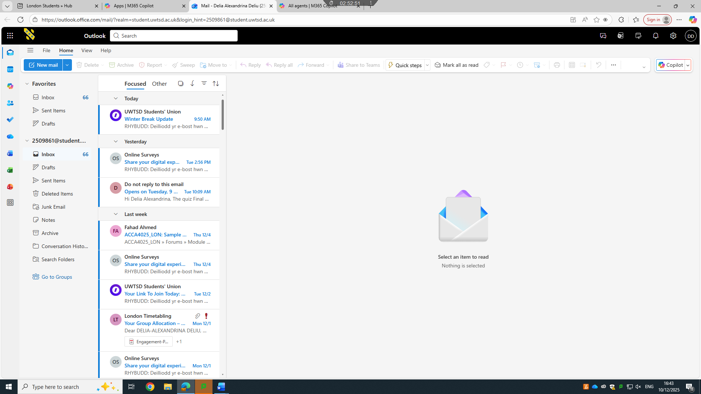
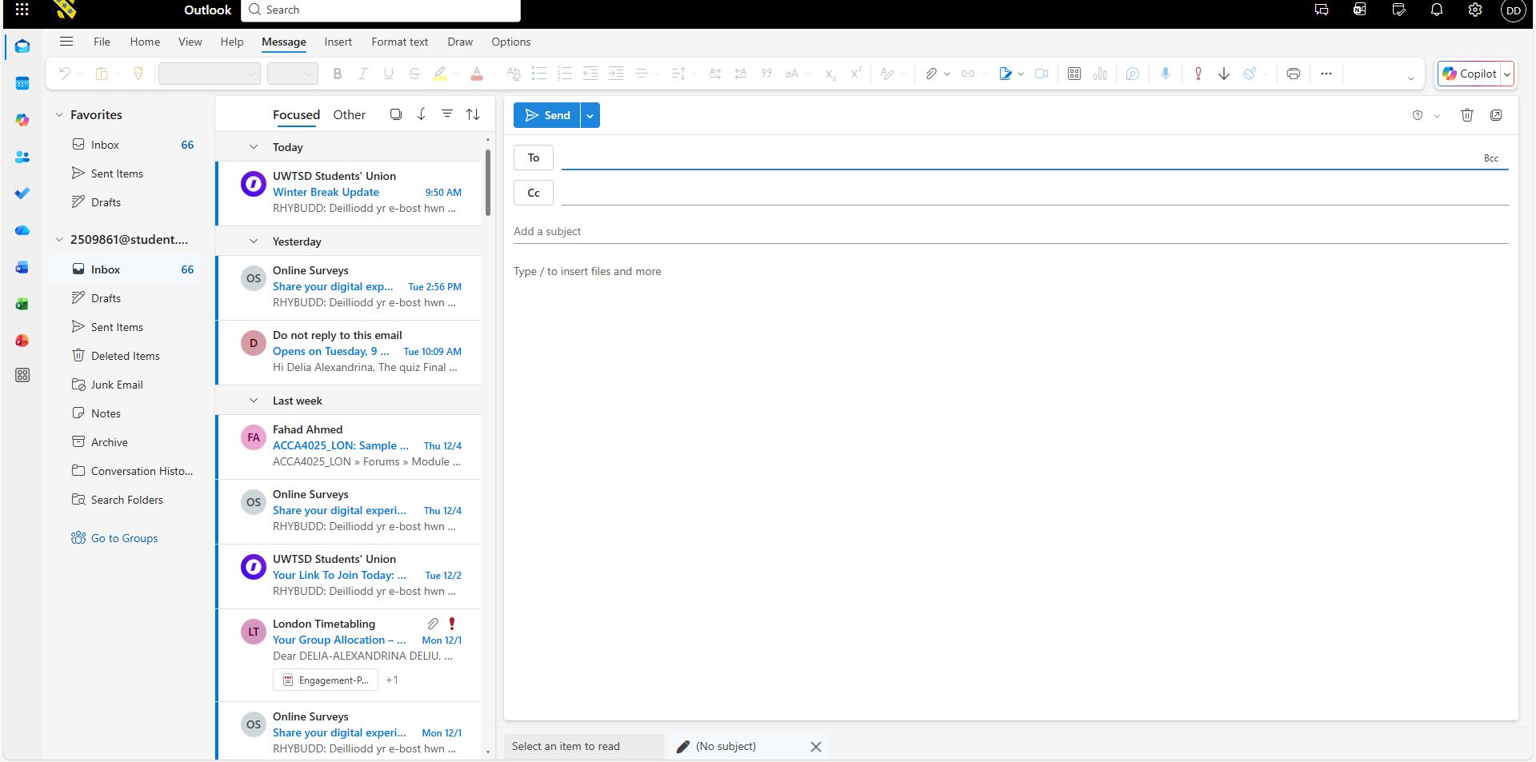
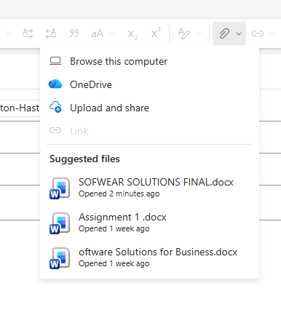
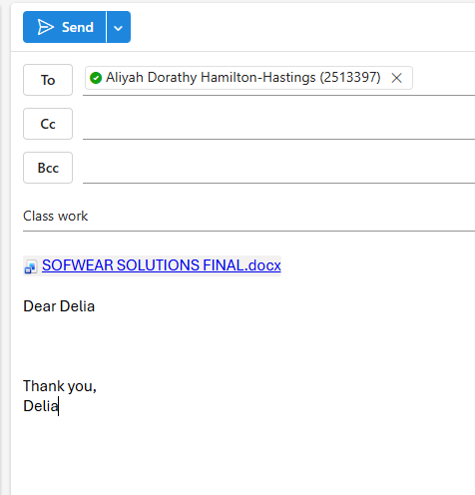
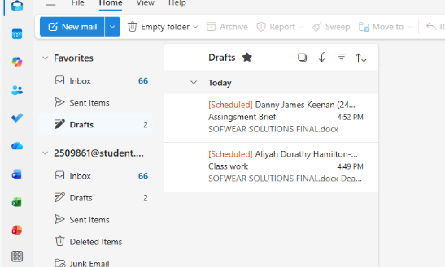

Ms Teams
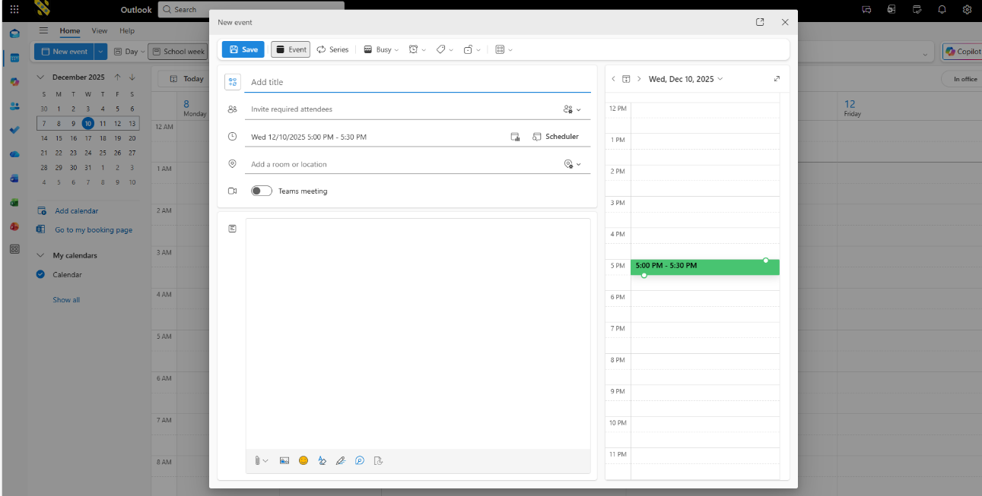
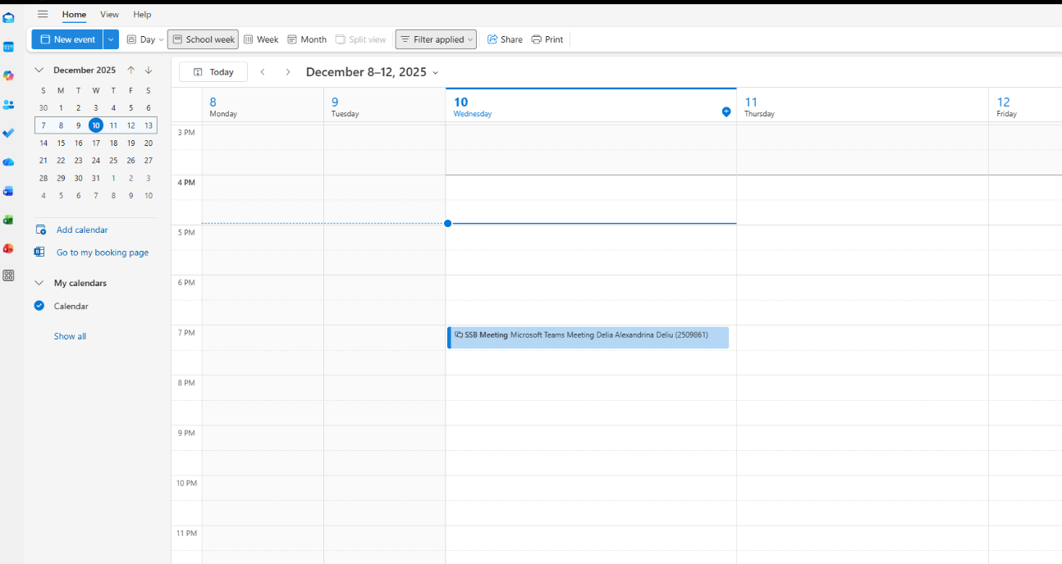


Conclusion
In today's digital-first business environment, technology plays an essential role in boosting operational efficiency, communication, and growth. The report highlights various software applications that support daily business activities, emphasizing their impact on organizational performance. E-commerce platforms such as WooCommerce and Shopify illustrate how technology enables online retail, with WooCommerce providing extensive customization for businesses seeking more control and Shopify focusing on simplicity for rapid deployment.
Mind mapping tools like Miro and MindMeister are examined for their effectiveness in supporting cognitive and collaborative processes, helping teams to visualize and structure complex information, which fosters creativity and minimizes misunderstandings, particularly for remote and hybrid teams.
The Microsoft Office suite is discussed for its critical applications—Word, PowerPoint, Excel, and Access—which serve vital functions in documentation, data management, and analysis across various industries. These tools streamline complex tasks, improve accuracy, and enhance collaboration.
Additionally, collaboration and communication tools such as Trello and Microsoft Teams are noted for maintaining connectivity in modern work settings. Trello's Kanban format enhances task management and accountability, while Microsoft Teams centralizes communication and collaboration, thereby optimizing digital workflows.
In conclusion, the analysis asserts that technological tools are integral to all aspects of business operations, including sales, idea generation, data management, and communication. As digital transformation progresses, the integration of these technologies will be crucial for organizations aiming to innovate, adapt, and thrive in a competitive marketplace, ultimately leading to enhanced productivity and business performance.

