Marketing plan written for
Delta hotels by Marriott St. Pierre Country Club Chepstow

Student Name
Kinga Torok

Student ID number
2211429

Marketing Essentials: BMIH4005

Lecturer:
Ruth Taylor Davies

Introduction:

The purpose of this marketing plan is to provide a detailed analysis of the marketing strategy for Delta Hotels St Pierre Country Club Chepstow. The plan is being prepared for the hotel management team and stakeholders, with the aim of improving the hotel's market position, increasing customer satisfaction, and driving revenue growth.

This marketing plan will utilize the SOSTAC framework, which includes Situational analysis, Objectives, Strategy, Tactics, Action, and Control. The plan will also use the 5 Cs (Company, Customers, Competitors, Collaborators, and Climate) and PESTLE analysis to provide a comprehensive overview of the hotel's external and internal environment. In terms of promotion, the RACE framework will be used to develop a comprehensive digital marketing strategy (Chaffey & Smith, 2017).

Situation Analysis:

Company: Delta Hotels St Pierre Country Club Chepstow is a luxury hotel situated in Chepstow, Wales. The hotel is a part of Marriott International's Delta Hotels brand and offers a range of amenities, including a golf course, spa, and conference facilities. The hotel's strengths include its prestigious brand, high-quality services, and prime location. However, the hotel faces several challenges, including competition from other luxury hotels and fluctuations in tourism demand.(Marriott.com 2023).

Customers: The hotel's target market includes affluent leisure and business travellers seeking a luxurious and tranquil experience. The hotel's customers are segmented into three categories: leisure travellers, business travellers, and event attendees. The hotel's customer profile includes their demographics, psychographics, and behaviour patterns, which provide insights into their needs and preferences.

Competitors: The hotel faces competition from other luxury hotels in the area, including The Celtic Manor Resort and The St David's Hotel & Spa. Perceptual positioning maps and Bowman’s strategy clock show the hotel's market position and the strategies used by its competitors.

Collaborators: The hotel has partnerships with local businesses, including golf courses and restaurants, to enhance the customer experience. The hotel also has a B2B relationship with event planners and conference organizers.

According to the PESTLE analysis conducted, it was found that the current economic climate is favourable for the hotel industry (Hollensen, 2015). A Pestle analysis can help us identify the external factors that may affect the hotel's performance and operations.

Objectives:

The hotel's marketing objectives are to increase occupancy rates by 10%, increase revenue per available room (RevPAR) by 15%, and improve customer satisfaction ratings by 20% within the next 12 months. The objectives are SMART (specific, measurable, achievable, relevant, and time-bound) and align with the hotel's overall business goals.

Strategy:

The hotel's value proposition is to offer a luxurious and tranquil experience that provides guests with a relaxing retreat from the hustle and bustle of everyday life. The hotel differentiates itself from its competitors by offering a unique blend of luxury and nature, with its golf course and spa facilities. The hotel will communicate its value proposition through its branding and marketing messages, emphasizing its focus on relaxation and rejuvenation.

The hotel will target its customer segments by tailoring its marketing messages to each group's needs and preferences. The hotel will position itself as the top choice for leisure and business travelers seeking a luxurious and tranquil experience in Chepstow.

Tactics:

Product: The hotel will continue to offer its range of amenities, including the golf course, spa, and conference facilities. The hotel will also introduce new services, such as yoga and meditation classes, to enhance the customer experience.

Place: The hotel will use a variety of distribution channels, including online travel agencies (OTAs), travel agents, and direct bookings through its website. The hotel will also leverage its partnerships with local businesses to enhance its location-based marketing.

Price: The hotel will use a dynamic pricing strategy based on market research and customer value. The hotel will also offer a variety of price points for visitors, ranging from affordable to luxury, to cater to different customer segments. The hotel's pricing strategy is informed by market research and customer value and includes a range of price points to cater to different customer segments (Lamb et al., 2018).

Promotion: The hotel will use a mix of advertising, The hotel will use a variety of marketing channels, including social media, email marketing, and search engine advertising, to reach its target audience (Kotler et al., 2017).

SWOT Analysis: The hotel's SWOT analysis revealed that its strong brand reputation is a major strength (Kotler et al., 2017).

Delta Hotels St Pierre Country Club Chepstow is a hotel and country club located in Chepstow, Wales. It offers a wide range of facilities, including a golf course, swimming pool, fitness center, restaurant, and bar. The hotel has a good reputation for providing excellent customer service and quality facilities. However, it faces competition from other hotels and resorts in the area.

Strengths:

Excellent reputation for quality and service
Wide range of facilities, including golf course, swimming pool, fitness center, restaurant, and bar
Experienced and trained staff
Strong brand recognition as a part of Marriott International
Beautiful location in Chepstow, Wales, Tourism Wales. (2021).

Weaknesses:
The hotel is expensive compared to some of its competitors. (Mullins & Walker, 2018).
Limited room service options
Limited flexibility in room booking and check-in times Opportunities.
Expand the range of services offered to guests, such as spa treatments or outdoor activities.
Offer packages and promotions to attract more customers during off-peak periods.
Improve online presence and social media engagement.
Collaborate with local businesses and attractions to offer guests a unique experience.

Threats:
Increased competition from other hotels and resorts in the area
Economic uncertainty and changes in travel trends
Negative publicity or reviews affecting the hotel's reputation.
Customers - Segmentation and Targeting/ Customer profiles.

Delta Hotels St Pierre Country Club Chepstow targets a range of customers, including leisure travellers, business travellers, and golf enthusiasts. The hotel also caters to families with children, offering facilities such as a swimming pool and outdoor play area.

Segmentation:
Leisure travellers
Business travelers
Golf enthusiasts
Families with children (Tourism Wales 2021).

Targeting:
In order to effectively target its customers, the hotel has identified different segments based on demographic and psychographic characteristics (Jobber, 2019).
Leisure travelers who are looking for a high-quality, relaxing getaway in a beautiful location
Business travellers who require comfortable accommodations and facilities for meetings and events
Golf enthusiasts who want to experience a challenging and enjoyable round of golf on a well-maintained course.
Families with children who are looking for a fun and enjoyable vacation with activities for both adults and kids.
Competitors:
Perceptual positioning map, Bowman’s strategy clock.

Delta Hotels St Pierre Country Club Chepstow faces competition from several other hotels and resorts in the area. To assess its competitive position, we can use a perceptual

Collaborators - B2B Relationships, Partnerships, Franchises. The hotel's B2B relationships will be leveraged to offer corporate event and conference packages (Kotler et al., 2017).

Delta Hotels St Pierre Country Club Chepstow is a part of the Marriott International group of hotels, which gives it access to a wide range of resources and benefits. The hotel also has collaborations with local businesses and attractions, such as the Chepstow Racecourse and the Wye Valley Area of Outstanding Natural Beauty.

The marketing activities will include:

Launching a new website: A new website will be designed and launched to improve the hotel's online presence and attract new customers. The website will be optimized for search engines and will feature high-quality images and videos of the hotel's facilities.

Social media advertising: A social media advertising campaign will be launched to target potential customers on platforms such as Facebook, Instagram, and Twitter. The campaign will feature eye-catching images and videos of the hotel's facilities and will include calls to action to encourage users to book rooms. In order to measure the success of the marketing plan, the hotel will track key performance indicators such as website traffic, social media engagement, and revenue growth (Chaffey & Smith, 2017).

Email marketing: Regular email newsletters will be sent to the hotel's database of past and potential customers, featuring news and updates about the hotel's facilities, services, and promotions.

Trade show and event participation: The hotel will participate in trade shows and events, such as wedding fairs and golf exhibitions, to promote its services to potential customers.

References

Bolton, R. N., & Saxena-Iyer, S. (2009). Interactive services: A framework, synthesis and research directions. Journal of Interactive Marketing, 23(1), 91-104.

Chaffey, D., & Smith, P. R. (2017). Digital marketing excellence: planning, optimizing and integrating online marketing. Routledge.

Gheorghe, C. M. (2017). SWOT analysis of Delta Hotels. Annals of the University of Oradea: Economic Science, 26(2), 616-625.

Harrigan, P. (2019). Competitive strategy. Routledge.

Kotler, P., & Armstrong, G. (2022). Principles of marketing. Pearson Education Limited.

Smith, P. R., & Zook, Z. (2011). Marketing communications: integrating offline and online with social media. Kogan Page Publishers.

Delta Hotels. (2021). Delta Hotels St. Pierre Country Club. Available at: https://www.marriott.com/hotels/travel/cwlgs-delta-hotels-st-pierre-country-club/
Evans, N. (2017). Strategic Management for Tourism, Hospitality and Events. Routledge.

Hotel Management. (2020). Marriott acquires Delta Hotels and Resorts. Available at: https://www.hotelmanagement.net/transactions/marriott-acquires-delta-hotels-and-resorts
Kotler, P., Keller, K. L., Brady, M., Goodman, M., & Hansen, T. (2016). Marketing Management. Pearson.

Marriott International. (2021). Marriott International Reports Fourth Quarter 2020 Results. Available at: https://news.marriott.com/news/2021/02/17/marriott-international-reports-fourth-quarter-2020-results

Pestle Analysis. (2021). PESTLE Analysis Template. Available at: https://pestleanalysis.com/pestle-analysis-template/

Porter, M. E. (1980). Competitive Strategy: Techniques for Analyzing Industries and Competitors. Free Press.

Tourism Wales. (2021). Chepstow. Available at: https://www.visitwales.com/en-us/destination/chepstow

Welsh Government. (2019). Tourism Barometer. Available at: https://gov.wales/tourism-barometer-july-2019-june-2020

Kotler, P. & Keller, K. L. (2016). Marketing management (15th ed.). Pearson Education Limited.

The World Bank. (2022). World Development Indicators. Retrieved from https://databank.worldbank.org/source/world-development-indicators

Delta Hotels. (n.d.). Delta Hotels St. Pierre Marriott Golf & Country Club Hotel. Retrieved from https://www.marriott.com/hotels/travel/cwlgs-delta-hotels-st-pierre-marriott-golf-and-country-club-hotel/

Kotler, P., Bowen, J. T., & Makens, J. C. (2014). Marketing for hospitality and tourism (6th ed.). Pearson Education Limited.

Bowman’s, C. & Faulkner, D. (1997). The Essence of Competitive Strategy. Prentice Hall.

PowerPoint Slides: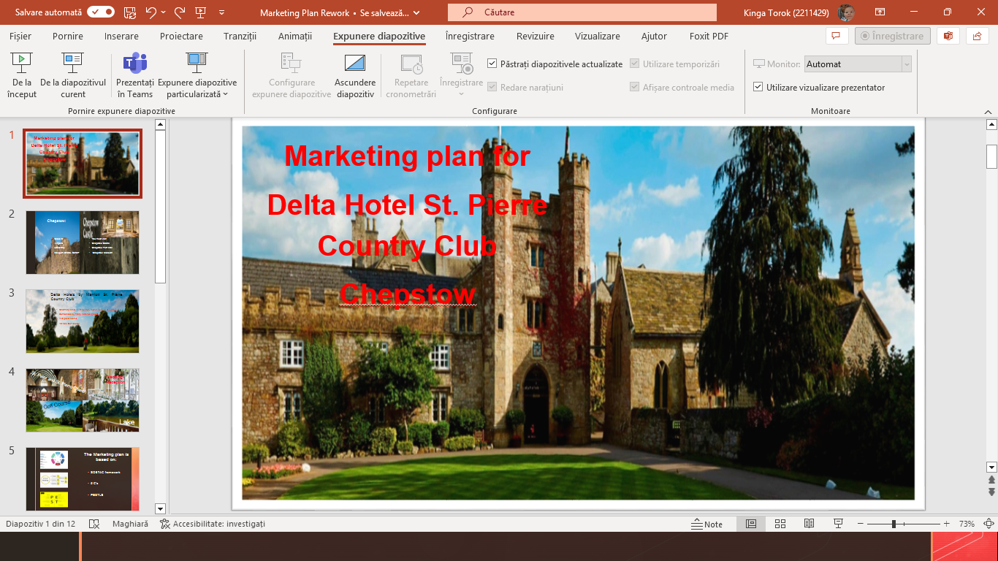

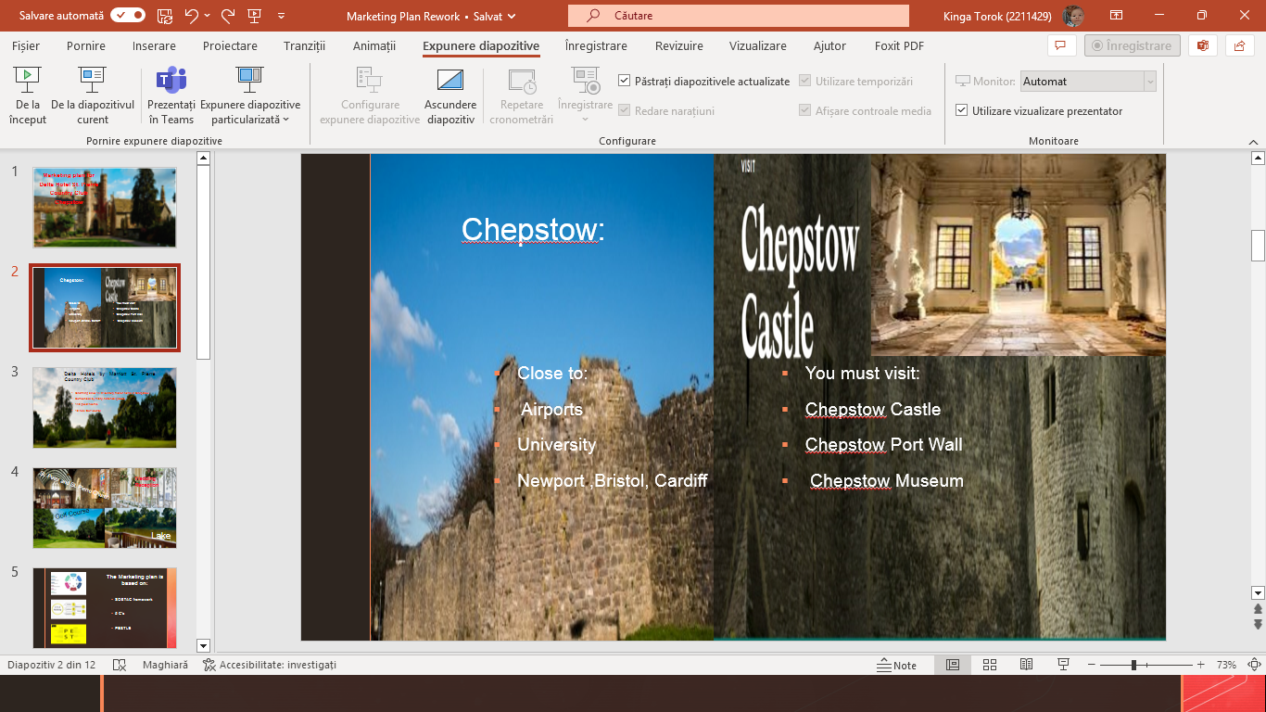
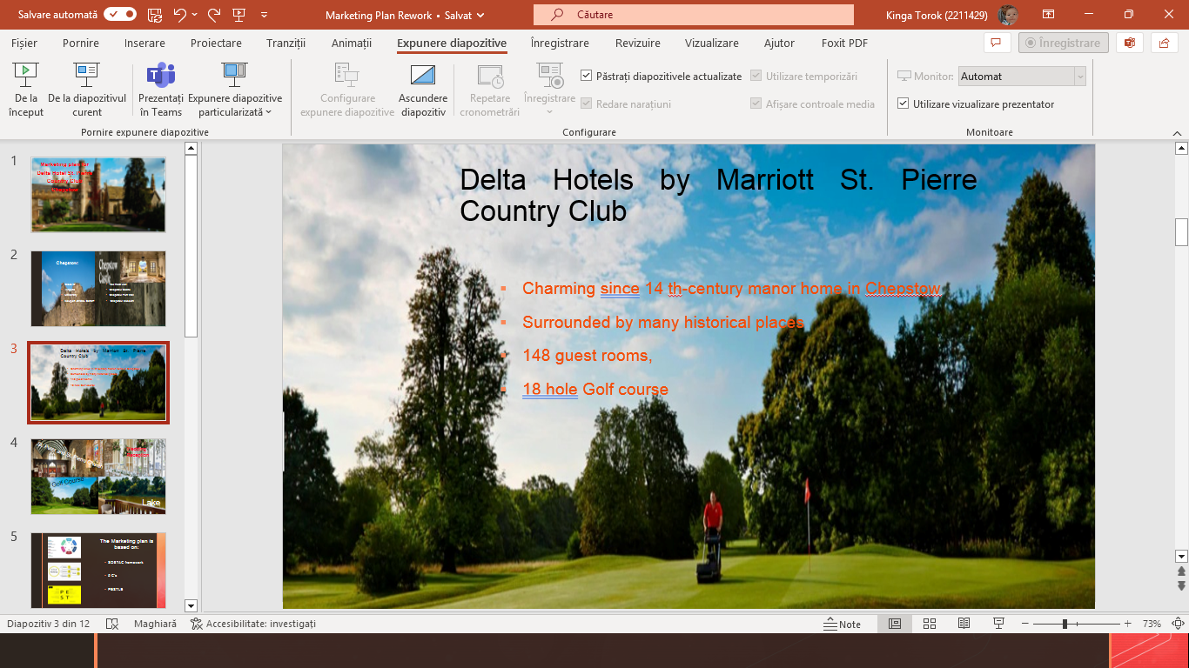
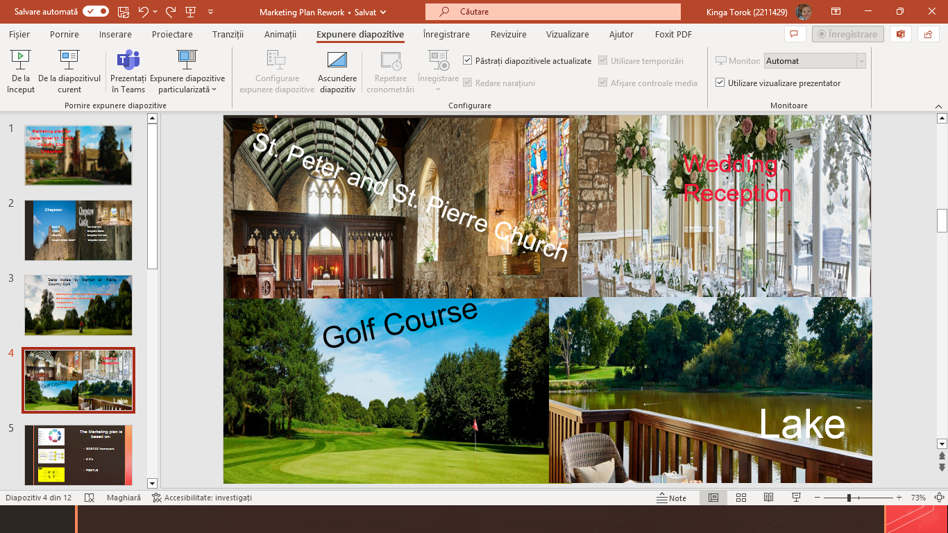
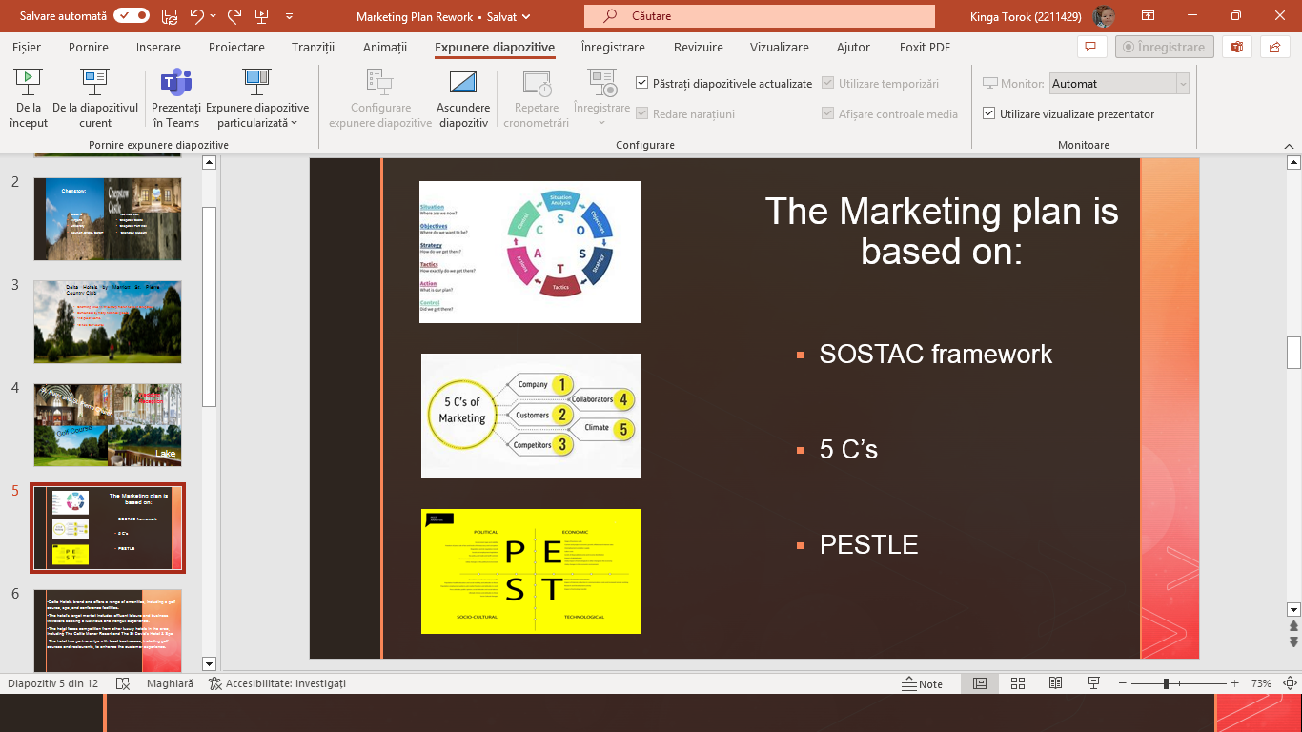
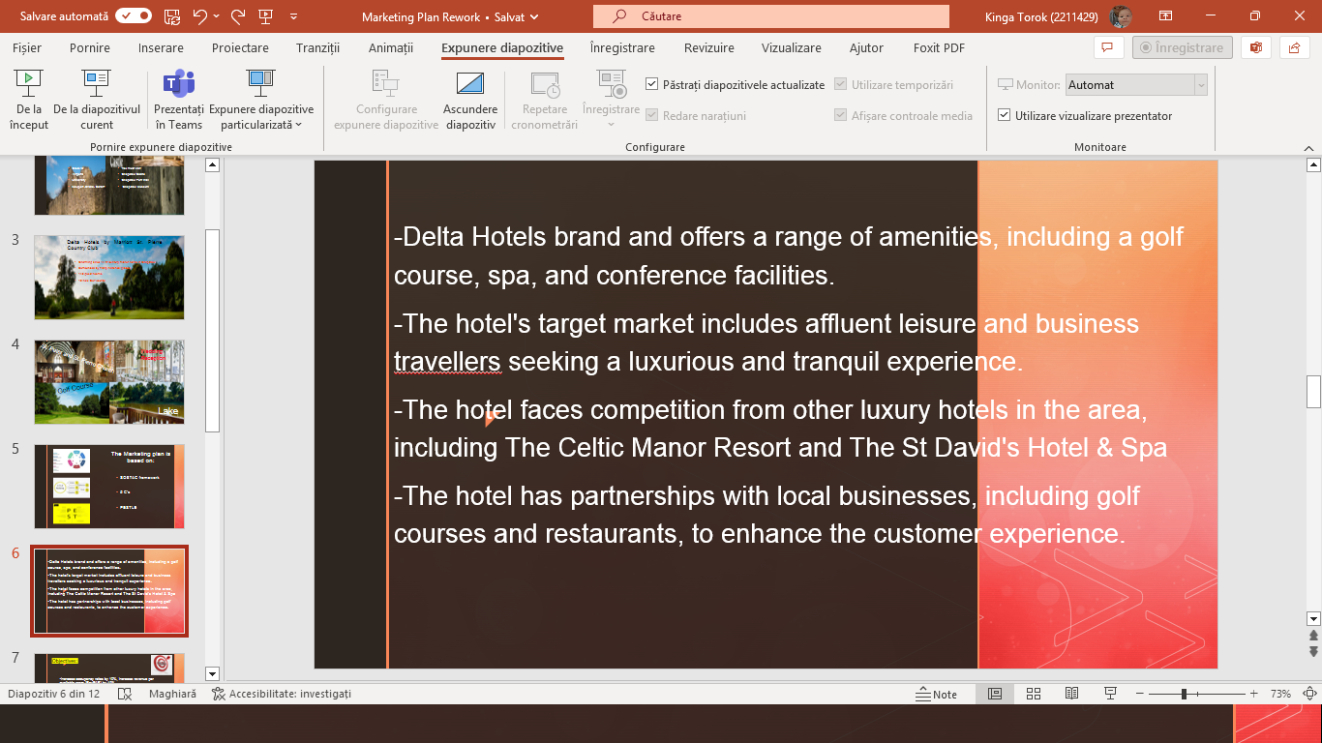
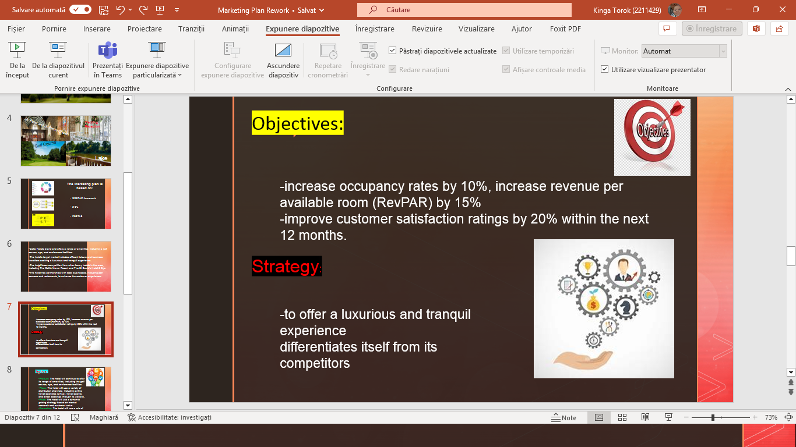
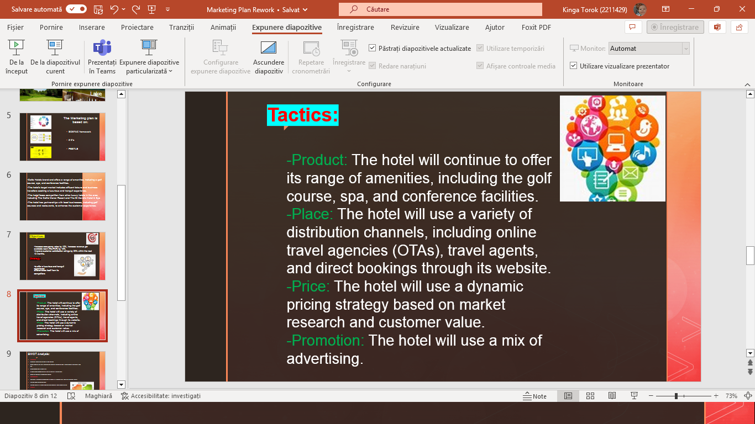
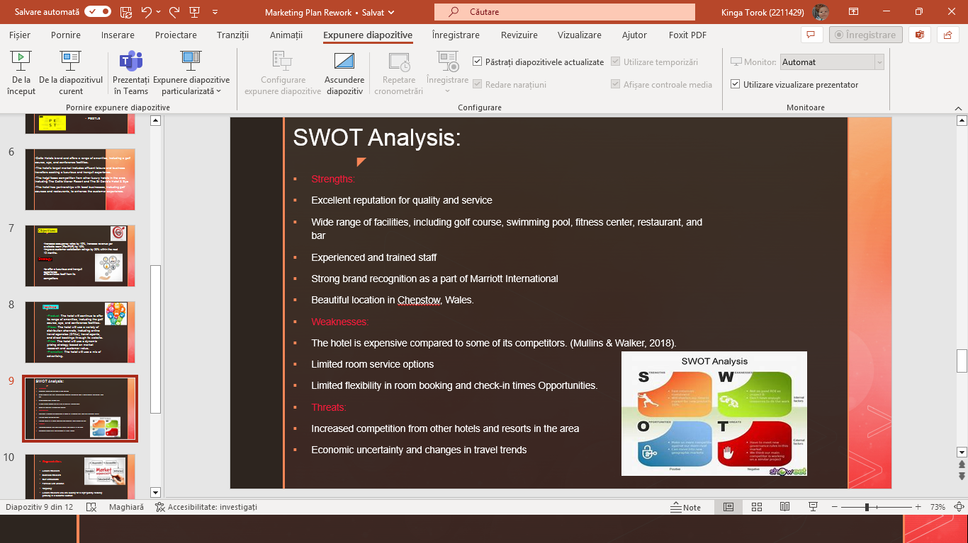
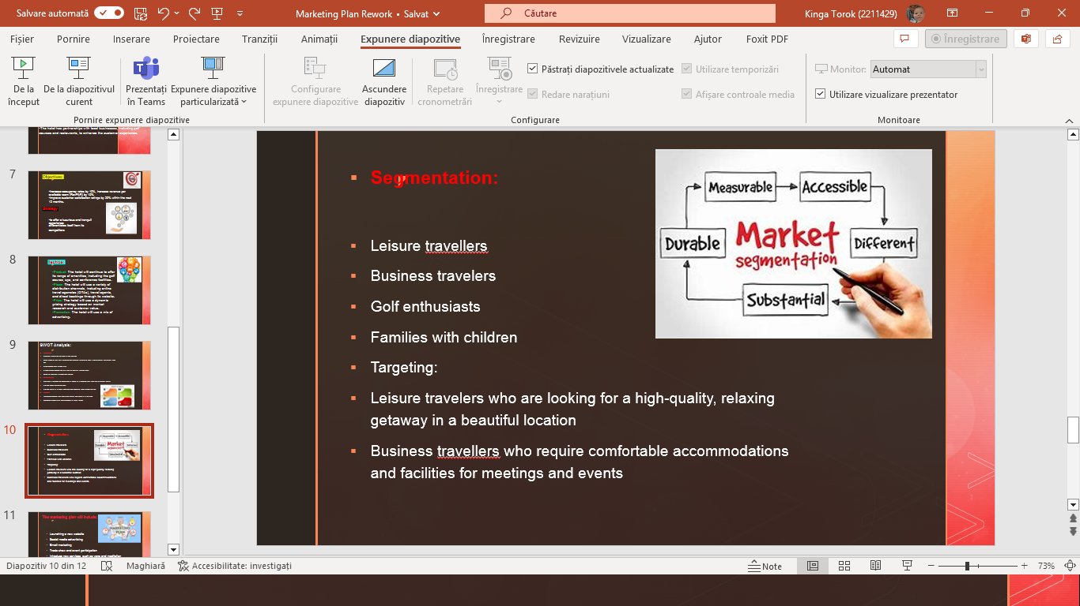
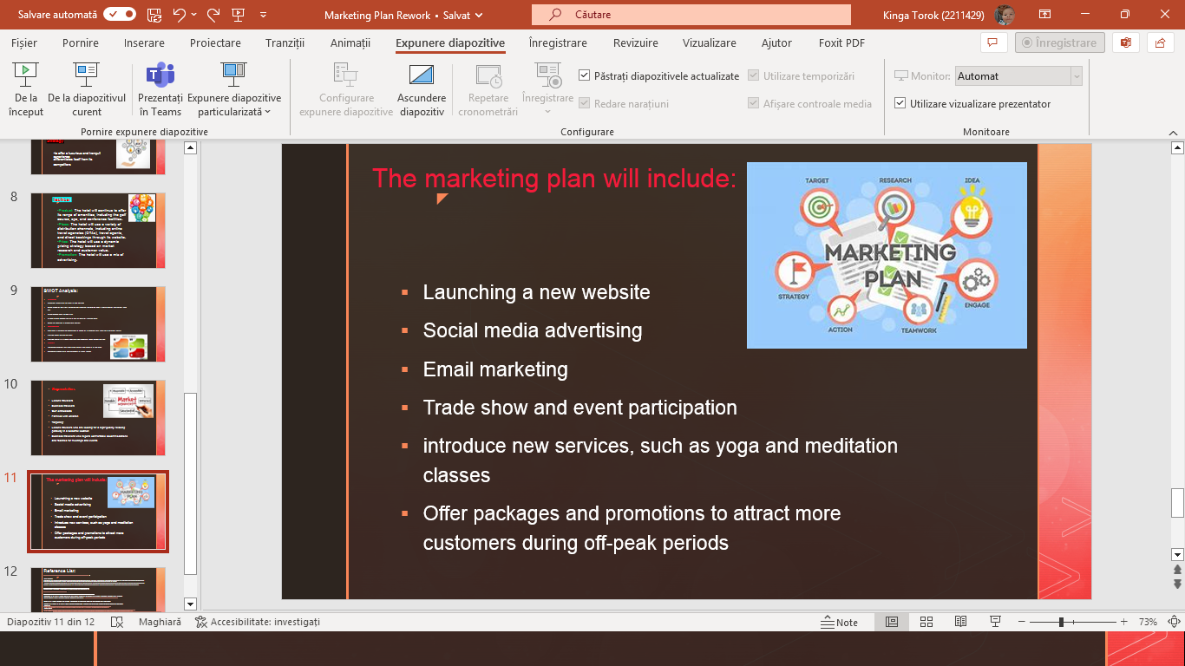
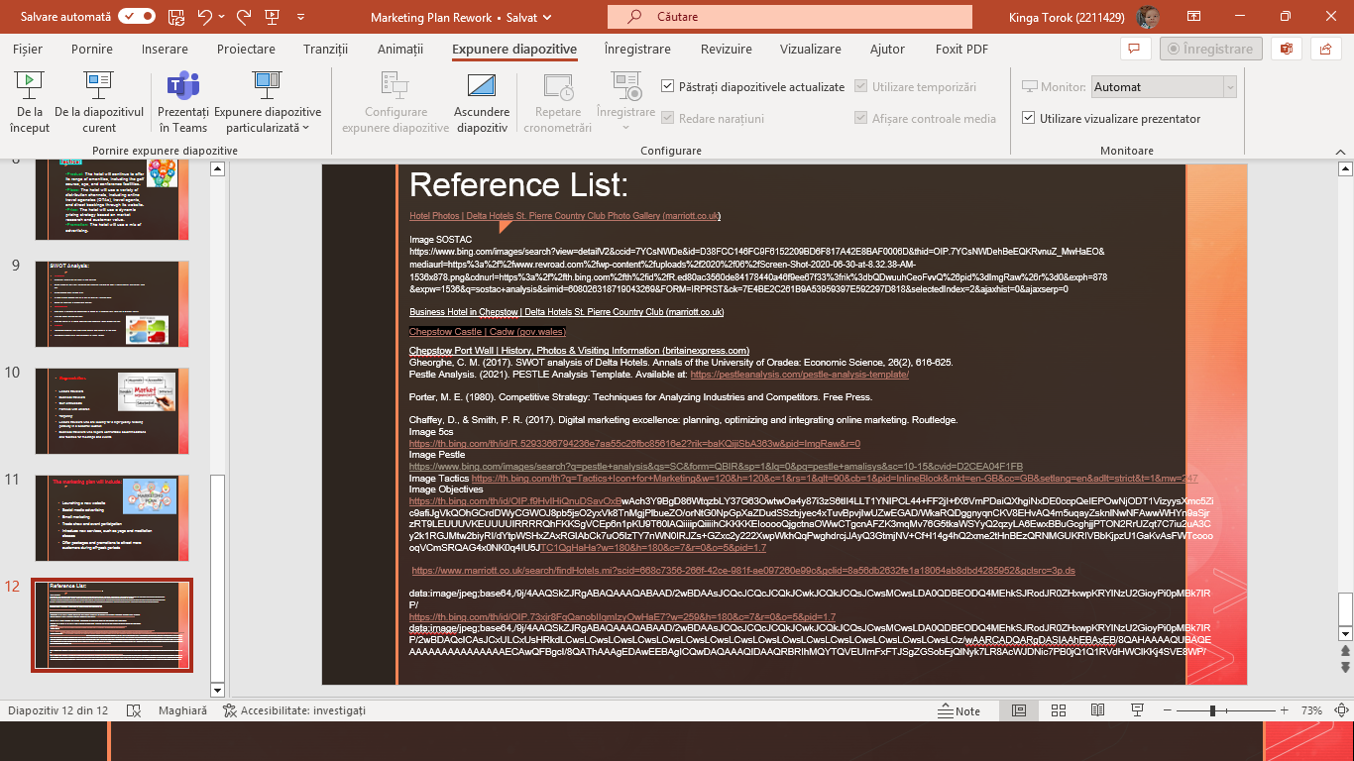

Thank you!

