

Student Name – Declan Thomas
Student Number – 1908075
Lecturer – Deborah Hughes
Module Name – Construction Management
Assignment 1 Programme Control

Table of Contents
TASK DESCRIPTION 3
Introduction 4
Gannt chart. 5
Develop, evaluate and produce site specific reports for time, cost and resources of the work activities. Costs should be relevant to the element of your choice. 5
Addressing performance issues in terms of productivity and incentivisation to the client specific to the scenario 7
References 8

TASK DESCRIPTION

Coursework

Please note this is an academic assessment that relates specifically to the module studied. It is a fictional proposal.

Task A

- You are to assume that UWTSD has received planning consent for a new start up innovation company hub in SA1. [See attached plan and elevation].

The construction is described in the drawings provided on Teams.
Work is proposed to start on 6th March 2023.

- Produce a Gannt chart utilising suitable software showing the critical path. Show a programme from concept design through to handover with detailed programming for the construction phase of a specific element of your choice (25%)
- Develop, evaluate and produce site specific reports for time, cost and resources of the work activities. Costs should be relevant to the element of your choice (25%)
- You need to explain possible ways of addressing performance issues in terms of productivity and incentivisation to the client specific to the scenario (25%).

Task B
You will need to choose ONE of the following scenarios to address.

- There is a strike by the local concrete company which is set to begin on the first day you require concrete. The strike is due to last 5 weeks. Show how this affects the project within the report addressed to the client and how is it generally dealt with from a contractual point of view (Gantt chart). (25%).
or
- The M and E has had to be redesigned just as the work is about to begin due to new information received about Covid transmission. This is predicted to take 4 weeks. Show how this affects the project within the report addressed to the client and how is it generally dealt with from a contractual point of view (Gantt chart). (25%).
or
- There is a delay in the manufacture of the bespoke windows. The delay is due to be 5 weeks. Show how this affects the project within the report addressed to the client and how is it generally dealt with from a contractual point of view (Gantt chart). (25%).
or
- The client changed their mind when they saw the first room and has issued an instruction to change the carpet design. The new carpets have been ordered and will arrive in 4 weeks. Show how this affects the project within the report addressed to the client and how is it generally dealt with from a contractual point of view (Gantt chart). (25%).

Introduction

For this assignment we are to assume that the university of Wales Trinity Saint David has received planning consent for a new start up of the innovation company hub in SA1. We have been given many plans and drawings to liaise with. All the construction aspects are on these drawings.
Firstly, I shall produce a Gannt chart using Microsoft project to show the critical path and to show a detailed programme from the concept design stage all the way through to the handover stage. We have been told that the proposed start date is to be the 6th of March 2023. Also, the detailed programme for the construction phase shall show a specific element of my choice. Following this, I shall develop, evaluate and produce site specific reports for time, cost and resources of the work activities. I shall be using screenshots of my overviews to show this. This cost will be relevant to the element of my choice. Thirdly, I will explain possible ways of addressing any performance issues on site in terms of productivity and incentivisation. I will then also create a scenario to make a delay in my programme. I will then address this issue and show how it affects the programme and critical path.
I will show screenshots of several overview reports of the programme to elaborate my points spoken about.

Gannt chart.

Please see attached and sent to Deborah completed Gannt chart. I have shown a programme from concept design through to handover with detailed programming for the construction phase of a specific element of my choice. The Gannt chart will show in detail programme and the specific element I have chosen. The element I have chosen for this project is the roofing element.

Develop, evaluate and produce site specific reports for time, cost and resources of the work activities. Costs should be relevant to the element of your choice.

Time

Below I have attached a screenshot taken from Microsoft projects showing the time for my elemental choice of which is the roofing element for this project. As you can see, its shows the overall time of the project and shows the delay that has occurred within the programme, this is due to the 4-week delay in delivery from the manufacture. This then delays the project due to this issue.

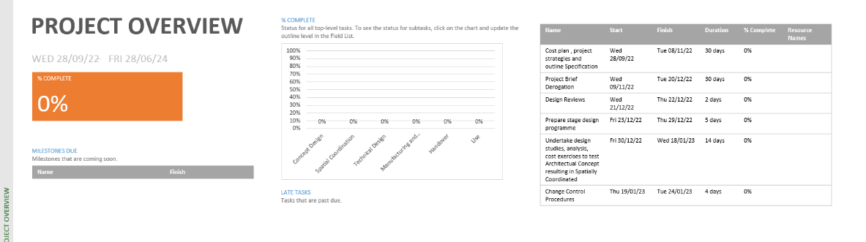

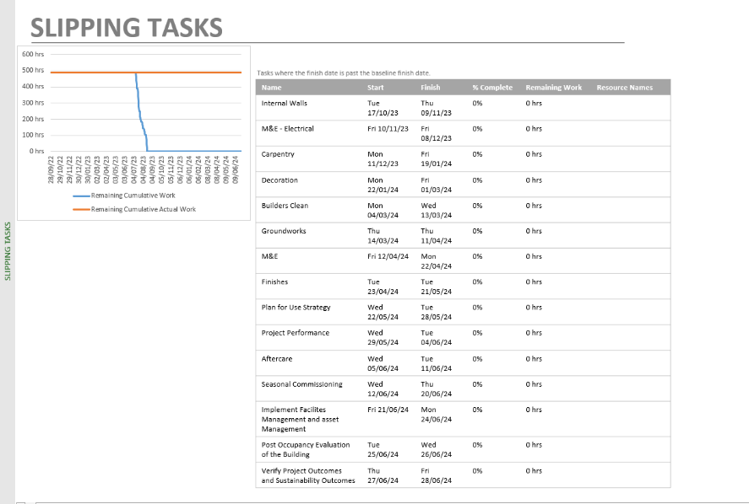

Cost
Below I have attached a screenshot taken from Microsoft projects cost overview for my elemental choice of which is the roofing element for this project. The below cost overview report shows us the overall cost of my chosen elemental choice of which is the roofing of the project. The overall cost for the roofing element is £964,120.00. This includes the plant, materials and labour.

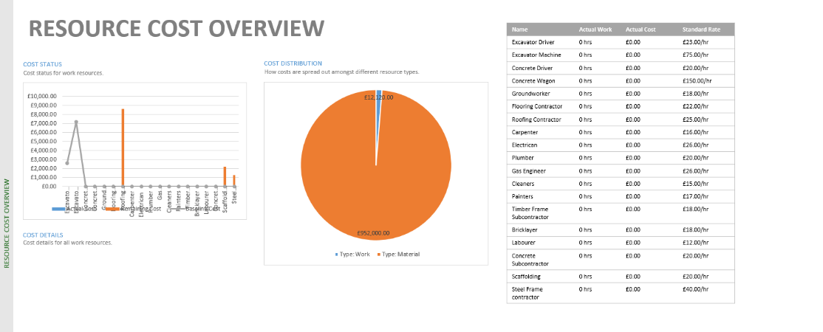

Resources

Below I have attached a screenshot taken from Microsoft projects resource overview for my elemental choice of which is the roofing element for the project. As you can see from the below screenshot, the resources used are roofing contractor, scaffolding and steel frame contractor.
The resource overview gives us the full duration of work for the chosen contractors and the start and finish dates.

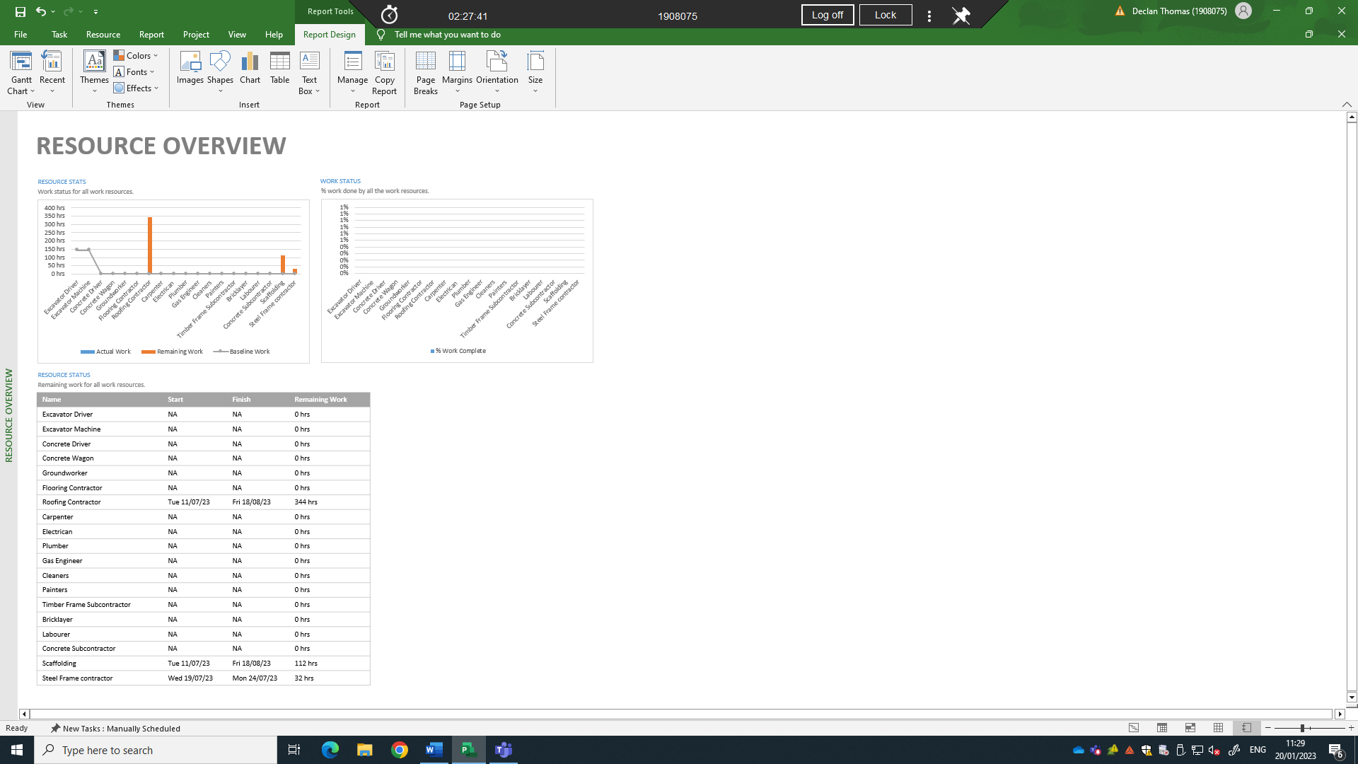

Addressing performance issues in terms of productivity and incentivisation to the client specific to the scenario

Dear Client,

I regret to inform that there has been a delay in the programme of works. Please see below a screenshot of the programme which shows a delay has occurred and how it affects the programme and critical path. The delay is a 4-week delay in manufacturing of the roof materials and has affected the programme due to this problem. Please see below tracking Gannt of programme once the delay has occurred.
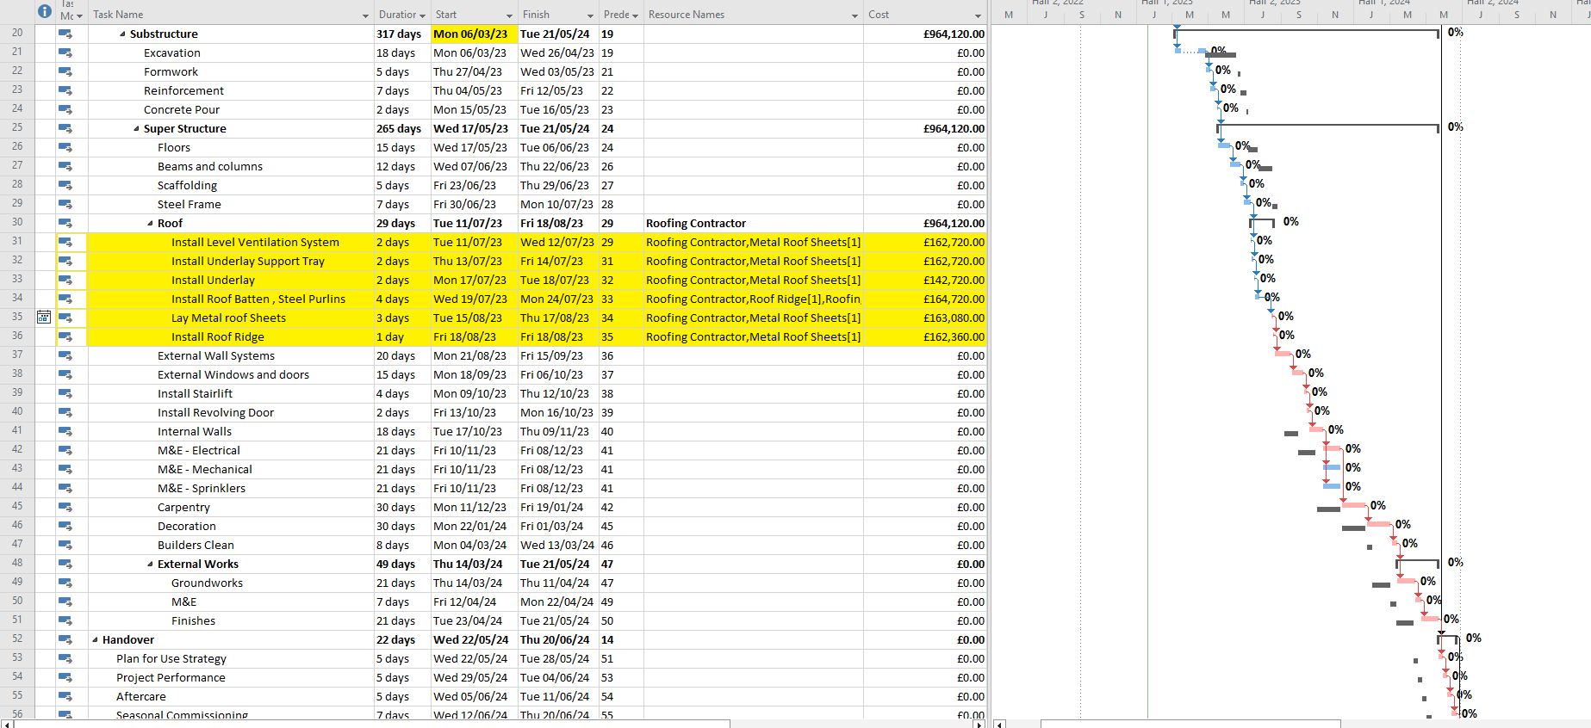

As you can see once the 4-week delay has occurred it then affects the whole programme as shown above. In terms of productivity this affects the labour and subcontractors that would have been installing the roofing materials once arrived. The productivity following this could decrease, but to keep the productivity going other works can be given the labour. This then doesn’t decrease the productivity and can move ahead on other aspects of work to get ahead then. This then helps the programme not fall behind. Communication is key when delays happen. Holding meetings with the team to organize other works can help boost the productivity back up. To avoid these delays with the manufactures, its key that going forward the quantity surveyor and site manager will be in regular contact with the supplier to ensure there is no delays or issues with the materials and deliveries. If there are any issues and they are captured early the programme can then be rearranged or changed to suit the delay. This will then not knock the productivity. Once the materials come in from the manufacturer, we will ensure that we will have more labour to carry out these works than the original labour allocated to this element. This will then help speed up the works and allow the works to be completed much faster than usual. This will then hopefully help with regaining track of programme and help get back on schedule as per original programme. (Williams, 2021)

To help avoids any other issues like this for all the other main elements we could have offsite manufacturing. By moving the building process away from the physical site and into a controlled factory environment has multiple advantages. It allows efficiency, predictability, sustainability and no disruptions. The matter of delay which has happened now, this wouldn’t have happened if there was off site manufacturing. Going forward where possible we will be using this procedure. (Offsite Hub, 2017)

References
(2017, April 18th). Retrieved from Offsite Hub: https://www.offsitehub.co.uk/industry-news/news/six-benefits-of-offsite-construction/
Williams, E. (2021, June 25th). Retrieved from Constructconnect: https://www.constructconnect.com/blog/5-ways-to-improve-productivity-in-construction

