Business Plan for

Tandoor Table

Produced By:

GROUP MEMBERS: (Group 8)
Student Name | Student No.
Mihai Serban | 2244688
Stefan Bertland Tudor | 2240407
Md Belal Hussain | 2225724
Syed Maksum Zabid | 2245066

Dated: 12 November 2024

Module Name: Entrepreneurship
Module Code: BMIH5001
Lecturer Name: Charlotte Joyner

CONTENTS

 |  |  |  | PAGE
1. | Executive Summary |  |  | …………………. 3
2. | The Business Idea |  |  | …………………. 4
3. | The Team |  |  | …………………. 6
4. | Market Research |  |  | …………………. 9
5. | Marketing Plan |  |  | …………………. 13
6. | Key Resources |  |  | …………………. 17
7. | Finances & Start-Up Support |  |  | …………………. 18
APPENDICES:
Appendix A |  |  |  | SWOT Analysis
Appendix B |  |  |  | PEST Analysis
Appendix C |  |  |  | Copy of Pitch Supporting Material

AI Declaration:

I confirm that I have not used any AI tools in the research and creation of this assignment. I confirm that I have not presented any AI generated materials as my own work. I confirm I have copies of my drafts, notes, and other resources I used, which I may be asked to provide in evidence.

1. EXECUTIVE SUMMARY
Tandoor Table will be found in the hospitality industry in London, UK. Tandoor Table will provide an option for dining for locals and tourists with actual Indian dishes that will emphasise tandoor cooking methods. The major Strengths that Tandoor Table established are the adherence to offering customers the highly authentic food and the commanding position in one of the most culturally diverse cities in the world, London. By definition, its weaknesses are high costs and low brand recognition among clients. Tandoor Table will need a space of 2000 square feet from which a section will be designated for kitchen, dining and office sections.

2. THE BUSINESS IDEA

2.1 The Product/Service
Tandoor Table is a London-based restaurant specializing in authentic Indian cuisine, with a focus on traditional tandoor cooking. Operating in the hospitality industry, it caters to both locals and tourists seeking a cultural dining experience. The restaurant offers a menu featuring classic tandoor dishes like chicken tikka, lamb kebabs, and vegetarian options, prepared with fresh, high-quality ingredients.
Tandoor Table’s value proposition lies in its blend of culinary authenticity and a modern dining experience. It aims to appeal to health-conscious diners looking for flavorful, freshly made meals. Positioned in a resilient UK hospitality sector, Tandoor Table aligns with current trends in experiential dining and health-focused catering, giving it a competitive edge in London’s dynamic restaurant market (BDO, 2024).

2.2 SWOT Analysis Summary
Strengths
- Authentic Cuisine: Tandoor Table offers a menu centered around traditional tandoor cooking, delivering a unique and genuine Indian culinary experience. This focus on authenticity differentiates the restaurant from competitors and appeals to customers seeking cultural dining.
- Prime Location: Situated in London, a city with a rich culinary diversity and strong demand for ethnic foods, Tandoor Table benefits from high foot traffic and a large customer base of both locals and tourists.
Weaknesses
- High Operating Costs: The restaurant faces significant expenses related to rent, quality ingredients, and skilled labor, impacting its profit margins, particularly during off-peak periods.
- Low Brand Recognition: As a new entrant in London’s competitive restaurant market, Tandoor Table currently has limited brand awareness, which may hinder its ability to attract customers initially.
Opportunities
- Expansion of Delivery Services: With the increasing popularity of food delivery, there is an opportunity to grow revenue by partnering with major delivery platforms like Uber Eats and Deliveroo. This will help Tandoor Table reach a wider audience, including those preferring to dine at home.
- Hosting Cultural Events: The rise in cultural tourism and interest in experiential dining presents an opportunity to host themed events, such as Indian festival celebrations. This can enhance customer engagement and build a loyal customer base.
Threats
- Intense Competition: The Indian restaurant market in London is highly competitive, with established players like Dishoom and Cinnamon Club dominating the scene. Competing for market share may require significant marketing efforts and promotional discounts.
- Rising Ingredient Costs: The cost of sourcing high-quality, locally produced ingredients is increasing, which could squeeze profit margins. To mitigate this, Tandoor Table plans to negotiate better supplier agreements and explore seasonal menu adjustments to optimize costs.

3. THE TEAM

3.1 Key Personnel

Name and Company Position: Syed Maksum Zabid - Restaurant Manager
Skills and Experience: Includes experience in hospitality management, operations, and customer satisfaction, with extensive experience that equips one with a sharp knowledge of staff management, budgeting, and managing high-traffic dining establishments.
Role and Responsibilities: Direct the operations of the day-to-day, ensuring that every aspect of a guest experience is seamless and all service efforts are effective. Manage customers; maximise customer service, inventory management, and budgetary control. Collaborate with the Head Chef and Marketing Specialist to design food in-house according to branded requirements.

Name and Company position: Md Belal Hussain - Head Chef.
Skills and Experience: Experience with Indian cuisine, especially tandoor cooking techniques. Head chef in an authentic Indian restaurant with existing knowledge of the use of traditional Indian spices and preparation techniques.
Role and Responsibilities: Operations Kitchen leadership with meal and authenticity quality. Development of menus and procurement; maintaining the highest standards of hygiene in the kitchen. Train the kitchen staff in coordination with efficiency; ensure costs are controlled in conjunction with the Restaurant Manager.

Name and company position: Stefan Bertland Tudor - Marketing Specialist.
Skills and Experience: Digital marketing background, with skills in social media and SEO and in creating content. Marketing campaigns for restaurants and expanding their brand using social media.
Roles and Responsibilities: Heads the marketing functions, including social media, local SEO, and influencer partnerships. Making plans for promotions and events so that one can develop campaigns for increasing the interest of customers and the visibility of the brand. Develops and executes strategies for customer retention, like loyalty programs and online reviews.

Name and company position: Mihai Serban - Head Waiter.
Skills and Experience: Good customer-facing experience in fine dining; good communication skills to interact with guests; trained to manage staff at service levels, including achieving quality service.
Role and Responsibilities: Supervise wait staff while ensuring efficient, courteous service. Serve as a contact for customers; problems resolved with guests ensured to achieve guest satisfaction. Collaborate with the Restaurant Manager to orient and motivate employees, creating a warm welcome for guests.

3.2 Skills Gaps & Key Partners

3.2.1 Additional Staff Requirements (Roles and Responsibilities):
- CRM specialist: This ensures that a firm’s efficiency of operation and the quality of customer service delivered are optimally improved.
- Assistant cook: Uses tandoor cooking methods and thus serves the purpose of offering unique knowledge of Indian food preparation.
- Digital Marketers: Targets online communication for consumers to be aware of a brand due to the absence of intricate internal marketing expertise.

3.2.2 Training and Development:
- Training of customer service: Ensured through receiving services of a local training agency, which guarantees high quality of guest interaction. With the increased economic instability, many businesses have realised that nothing sets them apart from the competition (Mouawad, and Kleiner, 1996).
- Certification: Held by trainers who meet all requirements of certification in the United Kingdom to make all the employees in the kitchen represent qualified health.
- Workshop: Organized by a marketing consulting company to improve the effectiveness of online communications.

- 3.2.3 Outsourced Support / Key Partners:
Supplier Partnership: An organic local supplier will ensure quality and minimal importation of items, prices depending on contracts made. Companies that report their supplier’s performance observe that those who communicate effectively are rated highly by the firm (Brownell, and Reynolds, 2002).
- Accounting Firm: Provides precise bookkeeping and legal services involving taxes and provides support in this area.
- Provider of IT Services: Controls online booking for bookings and POS systems that ensure right digital functions are effectively run.
4. MARKET RESEARCH

4.1 Market Information, Trends and External Factors
The Indian restaurant industry in the UK has been thriving, with an ever-growing market size, driven by the country's growing appreciation for diverse cuisines and the increasing interest in authentic dining experiences (Lumina Intelligence, 2024). London, as a major cultural and culinary hub, serves as the focal point for this industry, housing a variety of Indian restaurants catering to both local and international customers. The demand for Indian cuisine, especially dishes prepared using traditional methods like tandoor cooking, has seen consistent growth, influenced by trends towards cultural dining and experiential meals (MICHELIN Guide, 2024).

Industry Trends and Consumer Preferences
- Shift Towards Authentic and Experiential Dining: Consumers are increasingly seeking out authentic, culturally rich dining experiences. According to a report by Food & Wine (2023), London’s Indian dining scene has seen a significant rise in demand for traditional cooking methods, such as tandoor, that offer a distinct flavor profile. Restaurants that focus on authenticity and high-quality ingredients tend to attract both food enthusiasts and cultural tourists.
- Health-Conscious and Sustainable Dining: The trend towards health-conscious dining has also impacted the Indian restaurant industry. Many consumers prefer dishes that emphasize fresh, locally sourced ingredients and sustainable practices. Research by BDO (2024) indicates a growing preference for restaurants that align with environmentally friendly practices, such as using biodegradable packaging and reducing food waste. This aligns well with Tandoor Table’s focus on nutritious offerings made from locally sourced ingredients.
- Digital Transformation in the Hospitality Industry: The integration of digital amenities has become a standard expectation among consumers. A study by Hospitality Tech (2023) highlights the importance of features like mobile ordering, digital loyalty programs, and virtual concierge services in enhancing customer satisfaction. Restaurants that have embraced these technologies have reported higher retention rates and improved operational efficiency.
- Competitive Landscape: The competition in London’s Indian restaurant market is intense, with major players like Dishoom, Cinnamon Club, and Tayyabs leading the industry. These competitors have established strong brand recognition and customer loyalty by offering unique dining experiences and high-quality dishes (Cooper, 2023). However, there remains a gap in the market for mid-range, authentic tandoor-focused dining options, which Tandoor Table aims to fill.

4.2 Customer Profiles
The primary target market for Tandoor Table consists of:
- Young Professionals (Aged 25-35): This demographic seeks convenience, high-quality food, and unique dining experiences. They are likely to dine out frequently and value digital conveniences such as online reservations and loyalty programs.
- Families (Aged 35-50): Families often look for affordable, child-friendly dining options. They value a welcoming atmosphere, a diverse menu that caters to different tastes, and health-conscious meal choices.
- Tourists: London attracts millions of international visitors each year who are eager to explore the city’s diverse culinary offerings. Cultural tourists, in particular, are drawn to authentic Indian cuisine, making them a key target group for Tandoor Table.
Customer Profiles
Customer profile | Young People | Families | Tourists
Age | 25 – 30 | 35 – 50 | 15 - 50
Profession | Generally, students or workers | Self-earner or worker by profession or non-worker | Any profession
Motivations to visit | Find different meals | Appreciate good value for money | Interested in trying out the local food
Likes and habits | get to experience cultures and interact | Homely, real food | In search of exciting, authentic restaurants
Behaviour | go out for restaurants with deliveries for flexibility | Would like dining places that are suitable for children | Decisions and perceptions shaped by rating and inhabitants’ suggestions found on the Internet.

4.3 Competitor Profiles
The Indian restaurant market in London is competitive, with key players like Dishoom, Cinnamon Club, and Tayyabs offering unique experiences. Tandoor Table will differentiate itself by focusing on authentic tandoor-cooked dishes, mid-range pricing, and a casual yet modern dining atmosphere.
- Dishoom
- Strengths: Renowned for recreating the ambiance of 1950s Bombay cafés, with a diverse fusion menu and strong brand recognition.
- Weaknesses: Premium pricing and long wait times limit accessibility for casual diners.
- Competitive Strategy: Tandoor Table offers a more accessible and relaxed dining option for those prioritizing authenticity over a fusion experience.
- Cinnamon Club
- Strengths: Upscale fine dining with creative Indian cuisine, attracting high-end clientele.
- Weaknesses: High pricing and limited traditional dish variety.
- Competitive Strategy: Tandoor Table’s diverse, traditional tandoor menu at a mid-range price provides a compelling alternative for quality-conscious but budget-sensitive diners.
- Tayyabs
- Strengths: Known for bold, flavorful Punjabi cuisine and affordable pricing.
- Weaknesses: Crowded, no-frills environment may deter diners seeking a refined setting.
- Competitive Strategy: Tandoor Table’s refined ambiance offers an appealing option for those seeking both quality and comfort.

Unique Selling Proposition
Tandoor Table’s emphasis on authentic tandoor cooking, moderate pricing, and a relaxed yet modern atmosphere provides a competitive edge by addressing gaps in affordability, menu diversity, and customer experience present in its competitors.

5. MARKETING PLAN

5.1 Price
Tandoor Table’s pricing strategy focuses on providing high-quality, authentic Indian dishes at a reasonable price, making it accessible to a wide range of customers. The updated price range reflects the menu offerings as follows:
- Starters: Priced between £4.00 and £7.00, including popular options like Onion Bhaji (£4.00), Paneer Tikka (£7.00), and Chicken Samosa (£5.50).
- Main Courses: Priced between £10.00 and £14.00, with highlights such as Rogan Josh (£14.00), Butter Chicken (£10.00), and Tandoori Grill (£11.00).
- Biriyani: Priced from £10.00 to £13.00, offering options like Lamb Biriyani (£11.00) and Veg Biriyani (£10.00).
- Desserts and Sides: Desserts range from £3.00 to £8.00, featuring items like Gulab Jamun (£3.00) and Kulfi (£8.00). Sides include Mango Chutney (£3.00) and Steamed Rice (£2.00).
- Drinks: Priced between £1.00 and £3.50, with offerings like Mango Lassi (£1.00), Indian Chai (£3.00), and Cold Coffee (£3.00).
The pricing is competitive, aiming to attract customers looking for an affordable yet premium Indian dining experience. This strategy aligns well with the mid-range positioning of Tandoor Table compared to competitors like Dishoom and Tayyabs.

5.2 Product
Tandoor Table’s product focus is on traditional Indian tandoor-cooked dishes, presented with a modern, visually appealing twist. The branding incorporates vibrant colors and traditional Indian motifs, reflecting the authenticity of the cuisine. Packaging for takeaway orders is designed to be eco-friendly, using biodegradable materials, and branded with Tandoor Table’s logo and tagline, “Experience the Authentic Taste of India.”
The interior design of the restaurant features warm, inviting decor, inspired by traditional Indian themes, creating a comfortable and culturally immersive atmosphere for diners. The menu design is clear and appealing, highlighting customer favorites and specialty dishes.

5.3 Placement
Tandoor Table’s services are offered through multiple channels to maximize accessibility:
- In-House Dining: The restaurant provides a welcoming environment for dine-in customers, featuring comfortable seating and a relaxed atmosphere suitable for both casual meals and group gatherings.
- Takeaway and Delivery: Customers can order takeaway directly from the restaurant or through popular delivery platforms like Uber Eats, Deliveroo, and Just Eat. An online ordering system on the restaurant’s website will offer additional convenience, reducing reliance on third-party apps.
- Strategic Partnerships: Collaborations with nearby hotels, local attractions, and businesses will help attract tourists and business travelers, enhancing foot traffic and visibility.

5.4 Promotion
Tandoor Table’s promotional strategy will leverage a mix of digital marketing, community engagement, and a strong focus on customer feedback.
- Digital Marketing:
  - The restaurant will maintain an active presence on Instagram, Facebook, and TikTok, sharing high-quality images and videos of dishes, cooking techniques, and special events. The content will highlight the tandoor cooking process and showcase customer favorites like Chicken Tikka and Rogan Josh.
  - Influencer Collaborations: Partnerships with local food influencers and bloggers will help boost brand awareness, particularly among younger, tech-savvy diners.
  - SEO and Paid Ads: The restaurant will use local SEO and targeted ads on Google to reach customers searching for Indian cuisine in London. Keywords like “best Indian restaurant in London” and “authentic tandoor dishes” will drive online visibility.
- Traditional Marketing:
  - Flyer Distribution: Flyers featuring the menu and special promotions will be distributed in high-traffic areas nearby, such as local markets and tourist spots.
  - Community Events: Tandoor Table will host events such as tasting nights and festival-themed dinners (e.g., Diwali and Holi celebrations), offering a unique cultural experience to attract a diverse customer base. Organizing these types of themed nights and cultural celebrations can enhance customer engagement, boost restaurant appeal, and encourage repeat visits (Limepack, 2023; TouchBistro, 2023).
- Customer Loyalty and Feedback:
  - A digital loyalty program will reward repeat customers with points that can be redeemed for free drinks, desserts, or exclusive discounts on main dishes. This strategy aims to foster customer loyalty and increase visit frequency, as loyalty program participants tend to spend 53% more and visit 40% more often (Square, 2023).
  - Additionally, the restaurant will actively encourage customers to leave reviews on platforms like Google, TripAdvisor, and Yelp. Highlighting positive feedback on social media can attract new customers, while promptly addressing any issues demonstrates a commitment to service improvement. Effective management of online reviews is crucial, as 94% of diners are influenced by online feedback when choosing a restaurant (Rewards Network, 2023).
- Special Promotions:
  - Seasonal promotions: Tandoor Table will introduce seasonal promotions, such as a “Summer Tandoor Feast” featuring a discounted set menu, to attract new customers and increase traffic during slower periods. Seasonal marketing campaigns are effective in driving brand awareness and boosting sales, particularly during off-peak times (Talon.One, 2023).
  - Themed discounts: Additionally, themed discounts like “Family Meal Deals” offered on weekends will target group dining and encourage larger orders, helping to increase the average spending per visit. Family meal promotions are a proven strategy for attracting families looking for value and convenience (Eat This, Not That, 2024).
By utilizing a comprehensive marketing approach that combines online and offline strategies, Tandoor Table aims to build brand awareness, attract a diverse clientele, and establish itself as a premier destination for authentic Indian cuisine in London.

6. KEY RESOURCES
6.1 Premises
Tandoor Table will require a physical space of approximately 2000 square feet to accommodate kitchen operations, a dining area, and administrative offices. Ideally, the restaurant will be located in a high-footfall area in central London to attract both locals and tourists. The annual rental cost for such a property is estimated at £23,000, based on current market rates for commercial spaces in similar locations (Roulac, 2001). This strategic location will support customer accessibility and enhance brand visibility, ensuring alignment with operational and marketing goals.

6.2 Equipment
Efficient operations at Tandoor Table will require high-quality kitchen and service equipment. The most critical items include:
- Kitchen Appliances: A tandoor oven and stoves to maintain authenticity and deliver high-quality dishes. These will be sourced from Caterkwik, with a total estimated cost of £3,000 (Caterkwik, 2024).
- POS System: Essential for smooth billing and inventory management, a POS system will be leased from Square at a monthly fee of £30 (Square, 2024).
- Furniture and Interior Fixtures: Comfortable chairs, tables, and decor to create a modern yet welcoming dining experience, sourced from Ikea. The estimated cost will vary depending on customizations.
This combination of durable kitchen appliances, efficient technology, and appealing interior design will ensure competitive and seamless operations.
6.3 Key Suppliers
The day-to-day operations of Tandoor Table will depend on reliable suppliers for authentic Indian spices, fresh produce, and essential materials:
- Spices: Authentic Indian spices will be sourced from TajSpices, ensuring quality and flavor consistency. The estimated cost for spices is £200 per month (TajSpices, 2024).
- Fresh Produce: Meat, poultry, fish, dairy, and vegetables will be procured from Fairway Foodservice, known for delivering fresh, high-quality ingredients. Monthly costs are projected to be £1,500 (Fairway Foodservice, 2024).
These partnerships ensure the restaurant operates at optimal standards, delivering quality and authenticity in every dish.
7. FINANCES AND START-UP SUPPORT

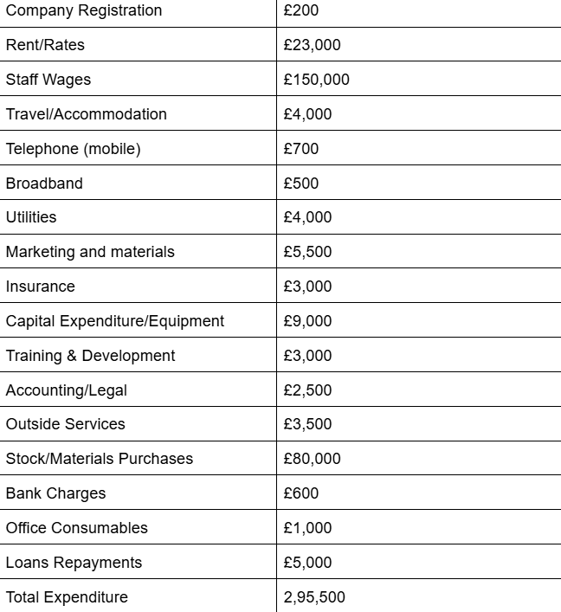

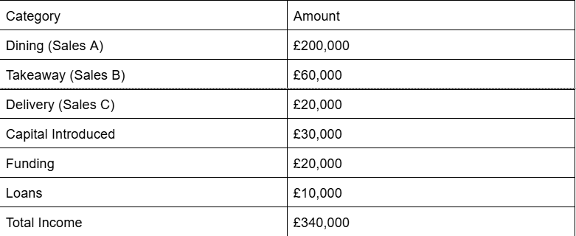

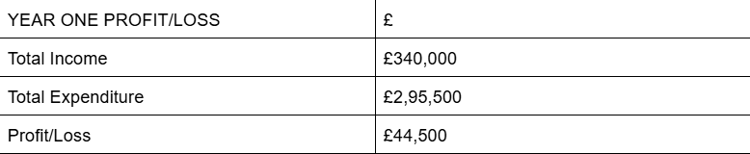

7.1 Financial Summary
The financial projections for Tandoor Table in Year 1 are carefully estimated using industry research, data from the UK hospitality market, and internal business planning. This section explains how the figures were derived, linking them to the business plan’s key components, including the team structure, marketing strategies, and resource needs.
Income Breakdown
- Dining Sales (£200,000):
  - In-house dining is projected to be the largest source of income. With 50 seats available and an average turnover rate of two seatings per day, the restaurant can serve approximately 100 customers per day. Assuming an average spend of £20 per customer, Tandoor Table expects monthly sales of £16,667 and an annual total of £200,000.
  - This estimate aligns with local dining trends in London, where there is high demand for mid-range, authentic dining experiences (BDO, 2024). The restaurant’s strategic location and unique menu are expected to attract a mix of locals and tourists, contributing to strong sales performance.
- Takeaway Sales (£60,000):
  - The takeaway market has seen significant growth, driven by consumer preference for convenience. Tandoor Table anticipates steady demand for takeaway orders, especially during weekdays when customers prefer quick meals. With an estimated average order value of £15 and a modest projection of 4,000 orders annually, the total income from takeaway services is expected to reach £60,000.
  - This figure is supported by our marketing plan, which includes partnerships with delivery platforms like Uber Eats and Deliveroo to increase visibility and access (Square, 2024).
- Delivery Sales (£20,000):
  - Delivery services are expected to generate £20,000 in Year 1. The estimate assumes an average order value of £20 with around 1,000 delivery orders over the year. The restaurant’s investment in online visibility through local SEO and social media marketing will help capture this demand.
  - The rise of food delivery services, particularly in urban areas, provides a strong foundation for this income stream, supported by consumer trends favoring home dining (Hospitality Tech, 2023).
- Capital Introduced (£30,000):
  - The founding partners have contributed £30,000 as initial capital. This amount is allocated to cover essential start-up costs, such as equipment purchases, interior design, and initial marketing efforts. The capital introduction is crucial for setting up the business infrastructure and aligns with the financial planning in the Key Resources section of the business plan.
- Start-Up Funding (£20,000):
  - Tandoor Table has secured a £20,000 grant from the UK Government’s Start-Up Loans scheme, designed to support new businesses in the hospitality sector. This funding is part of a broader initiative to encourage entrepreneurship in the food and beverage industry, providing essential financial support during the critical launch phase (GOV.UK, 2024).
- Loan (£10,000):
  - An additional £10,000 loan has been secured from a local bank to provide a cash flow buffer in the first year. This loan comes with a favorable interest rate and a two-year repayment plan, ensuring minimal financial strain during the initial growth period.
Expenditure Breakdown
- Rent and Rates (£23,000):
  - Rent costs are based on average commercial rental rates for a 2000 sq. ft. space in central London. The selected location is a key resource for attracting high foot traffic and aligns with the strategic placement outlined in the Marketing Plan (Caterer.com, 2023).
- Staff Wages (£150,000):
  - The staff wages cover the salaries for core team members, including a Restaurant Manager, Head Chef, kitchen staff, and front-of-house employees. The wage estimates are based on industry standards for skilled positions within the London hospitality sector. Competitive wages are necessary to attract and retain experienced personnel, as highlighted in the Team section of the business plan (Caterer.com, 2023).
- Stock/Materials Purchases (£80,000):
  - The cost of stock includes high-quality ingredients sourced locally to ensure freshness and authenticity. The menu’s focus on tandoor-cooked dishes requires specific spices, fresh meats, and vegetables, which are sourced from reputable suppliers like TajSpices. This expenditure aligns with the emphasis on quality in the Product section of the Marketing Plan (TajSpices, 2024).
- Marketing and Materials (£5,500):
  - This budget supports both digital and offline marketing strategies. Key activities include social media advertising, influencer partnerships, local SEO efforts, and flyer distribution. These initiatives are crucial for building brand awareness and attracting customers, as detailed in the Promotion section of the Marketing Plan (Talon.One, 2023).
- Capital Expenditure/Equipment (£9,000):
  - The capital expenditure covers essential kitchen equipment, including a tandoor oven, refrigeration units, and a point-of-sale (POS) system. High-quality equipment is vital for efficient operations and maintaining the authenticity of tandoor-cooked dishes (Caterkwik, 2024).
- Loan Repayments (£5,000):
  - The loan repayment plan covers the interest and principal for the £10,000 loan secured to support initial cash flow needs. The structured repayment schedule is designed to minimize financial pressure during the first year of operation.
Profit/Loss Analysis
- Total Income: £340,000
- Total Expenditure: £295,500
- Profit/Loss: £44,500 (Profit)
The projected profit of £44,500 demonstrates a positive financial outlook for Tandoor Table in its first year. This result is driven by strong in-house dining sales, effective marketing strategies, and efficient cost management. The financial plan aligns with the business’s goals of establishing a strong market presence and achieving sustainable growth.

APPENDICES

Appendix A – SWOT Analysis
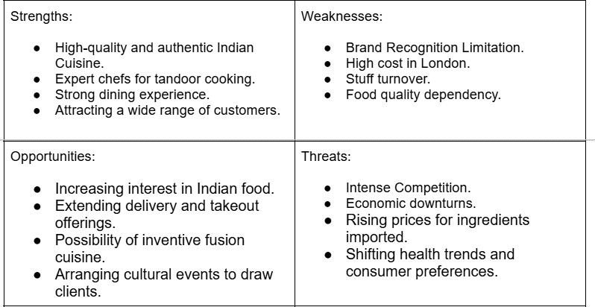


Appendix B – PEST Analysis

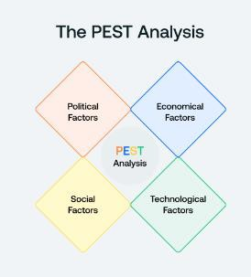
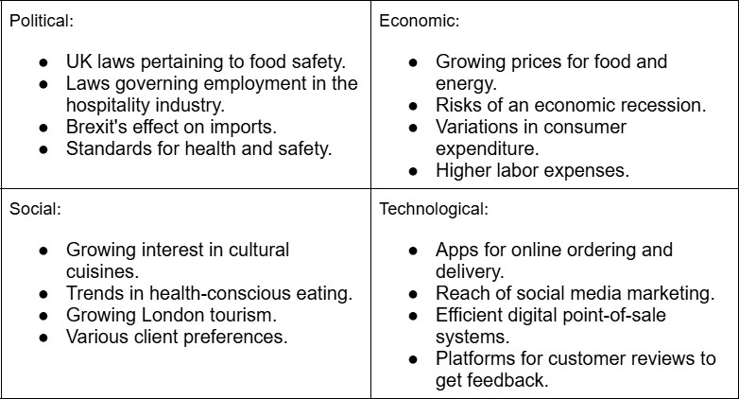
Appendix C – Copy of Pitch Supporting Material

Slide 1: Title
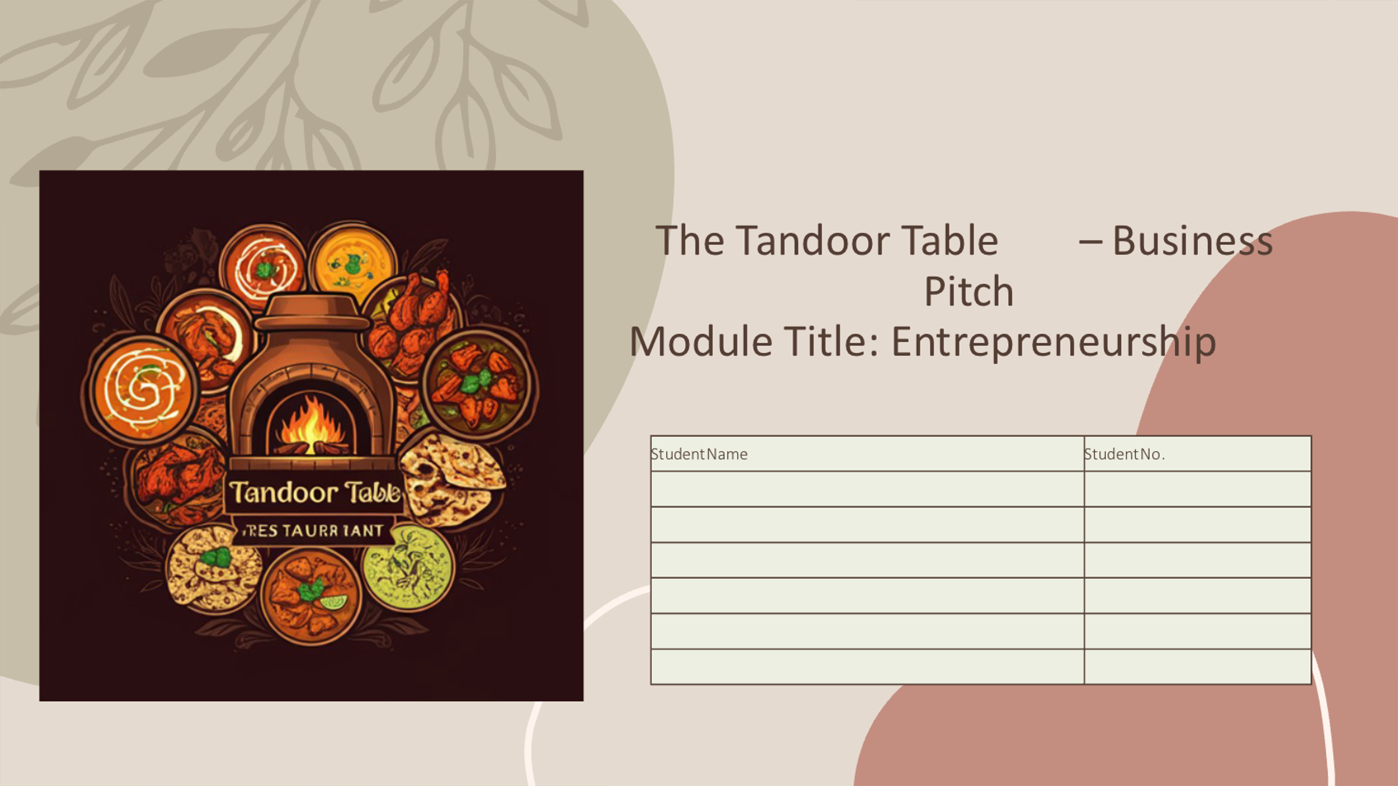
Slide 2: Executive Summary
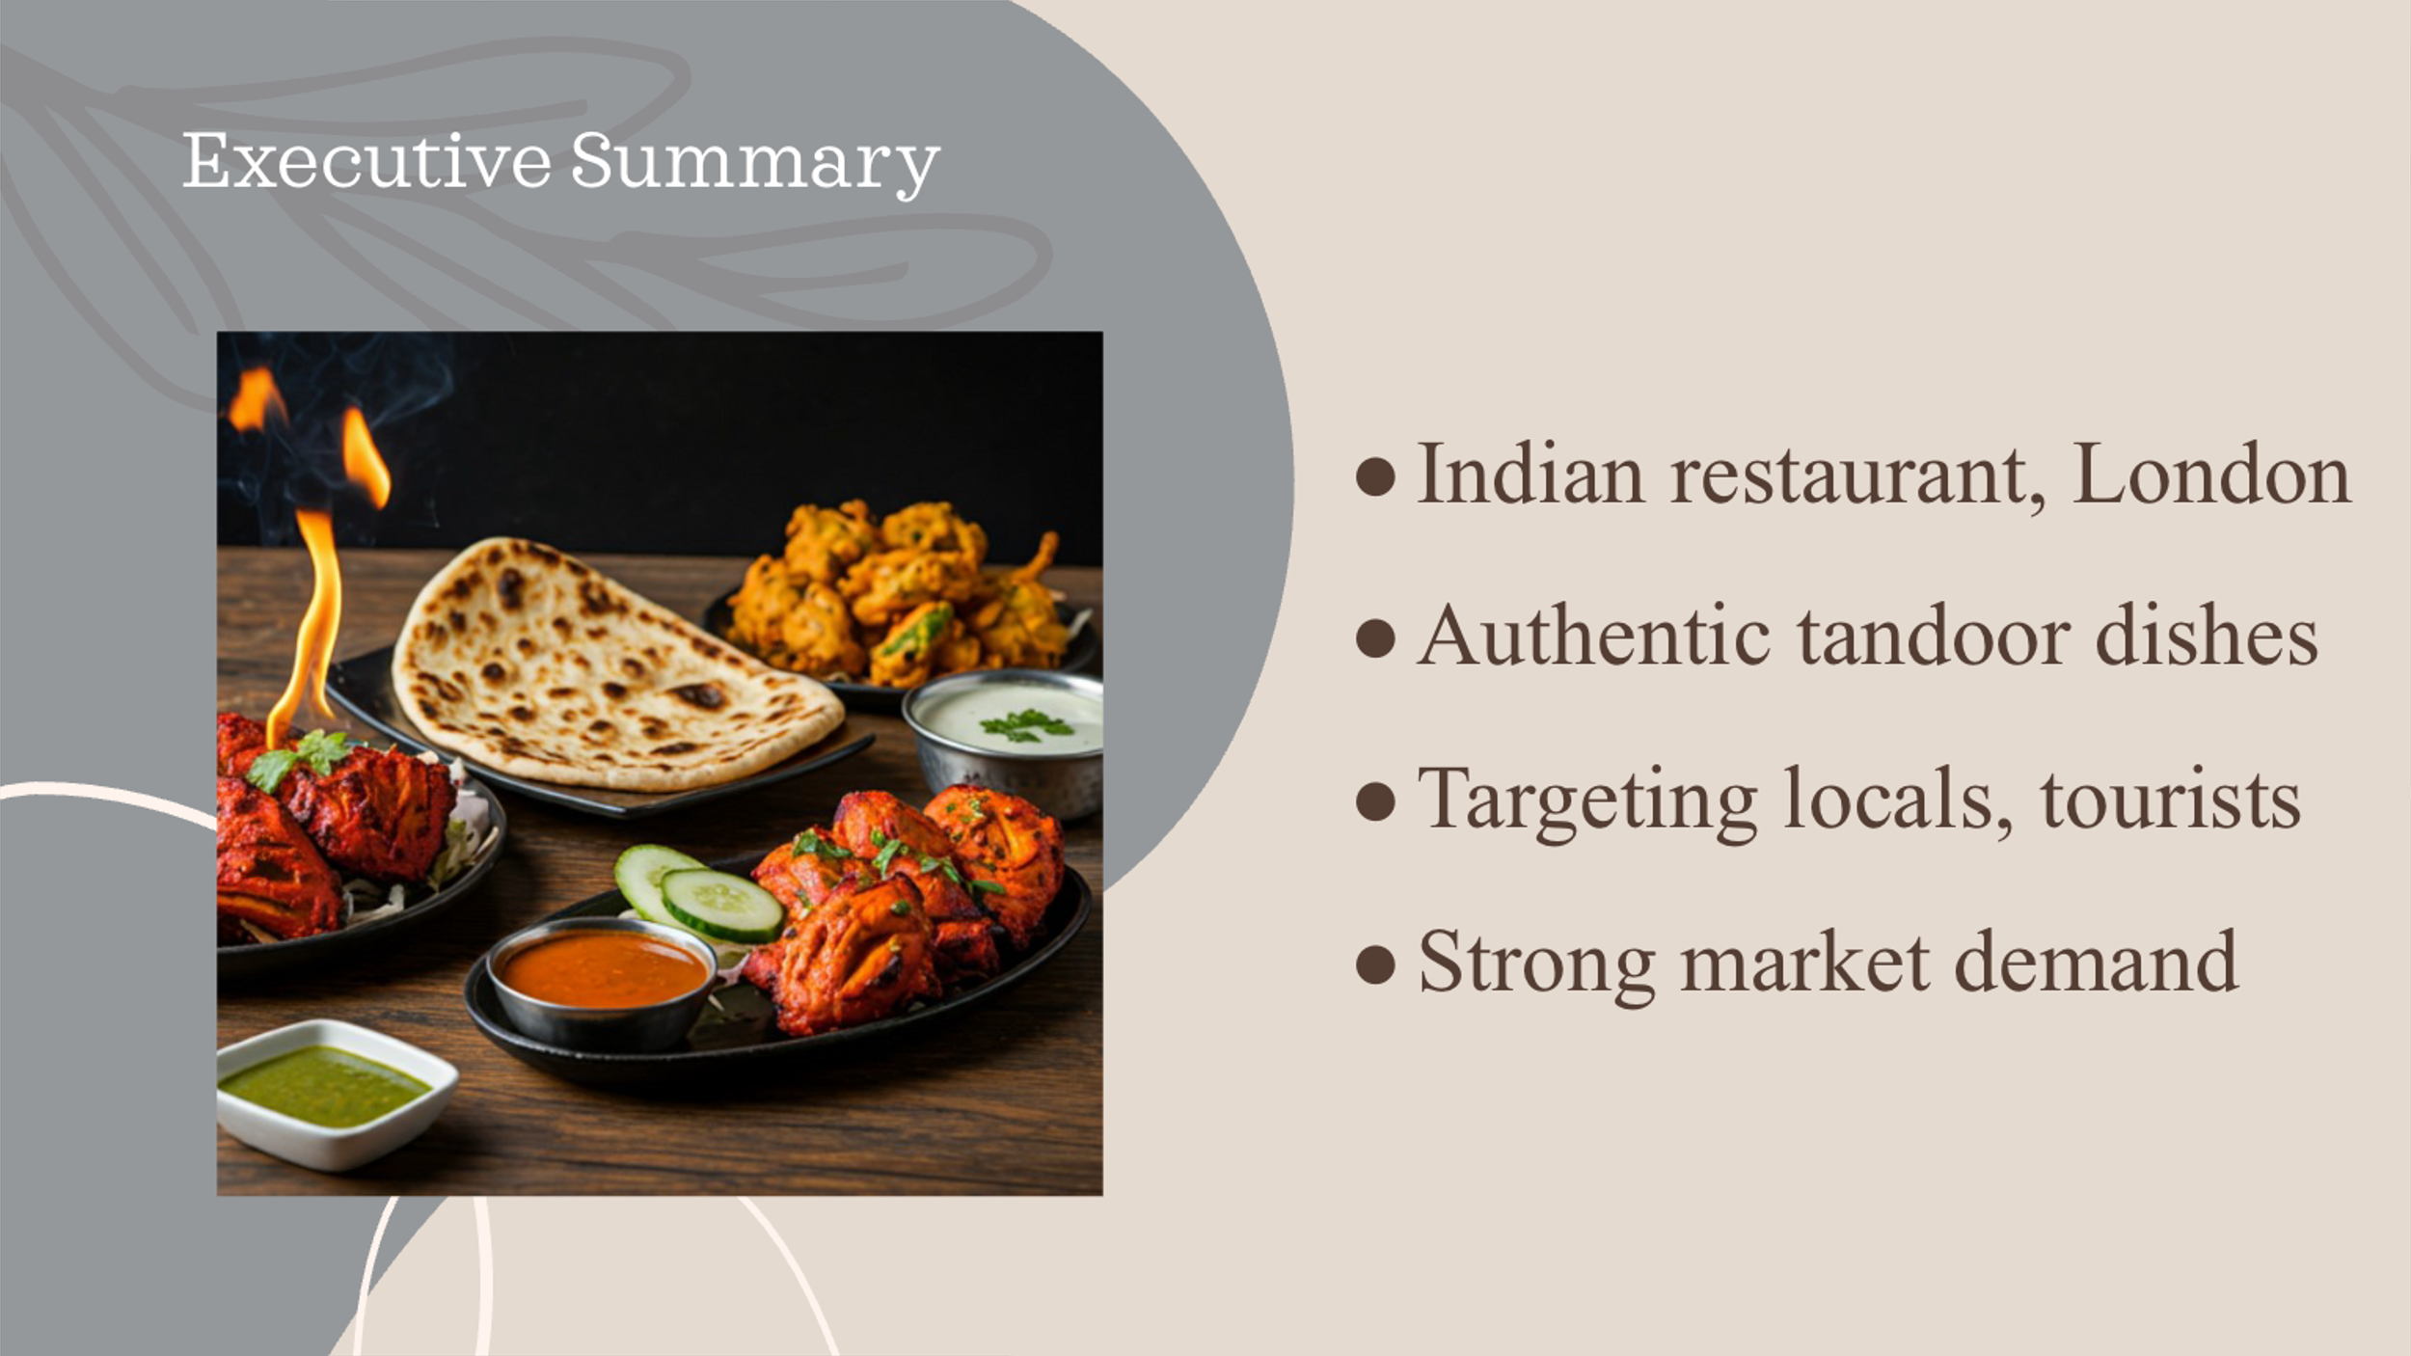

Slide 3: Business Idea
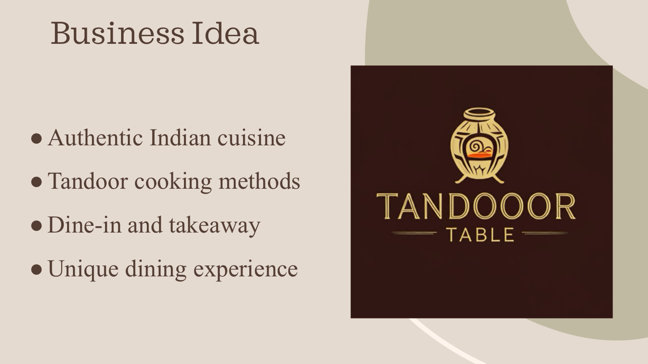
Slide 4: Menu
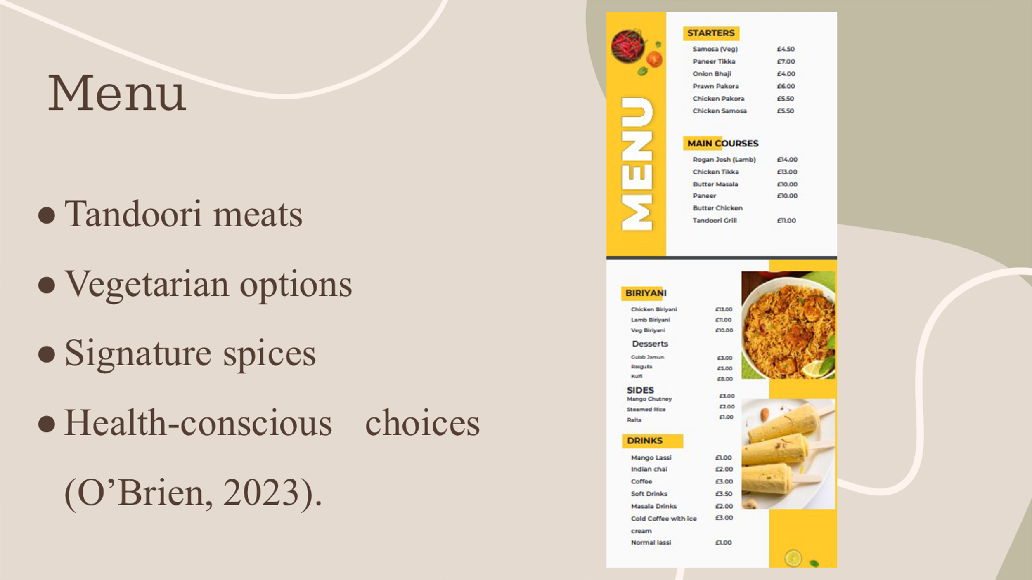

Slide 5: Market Research
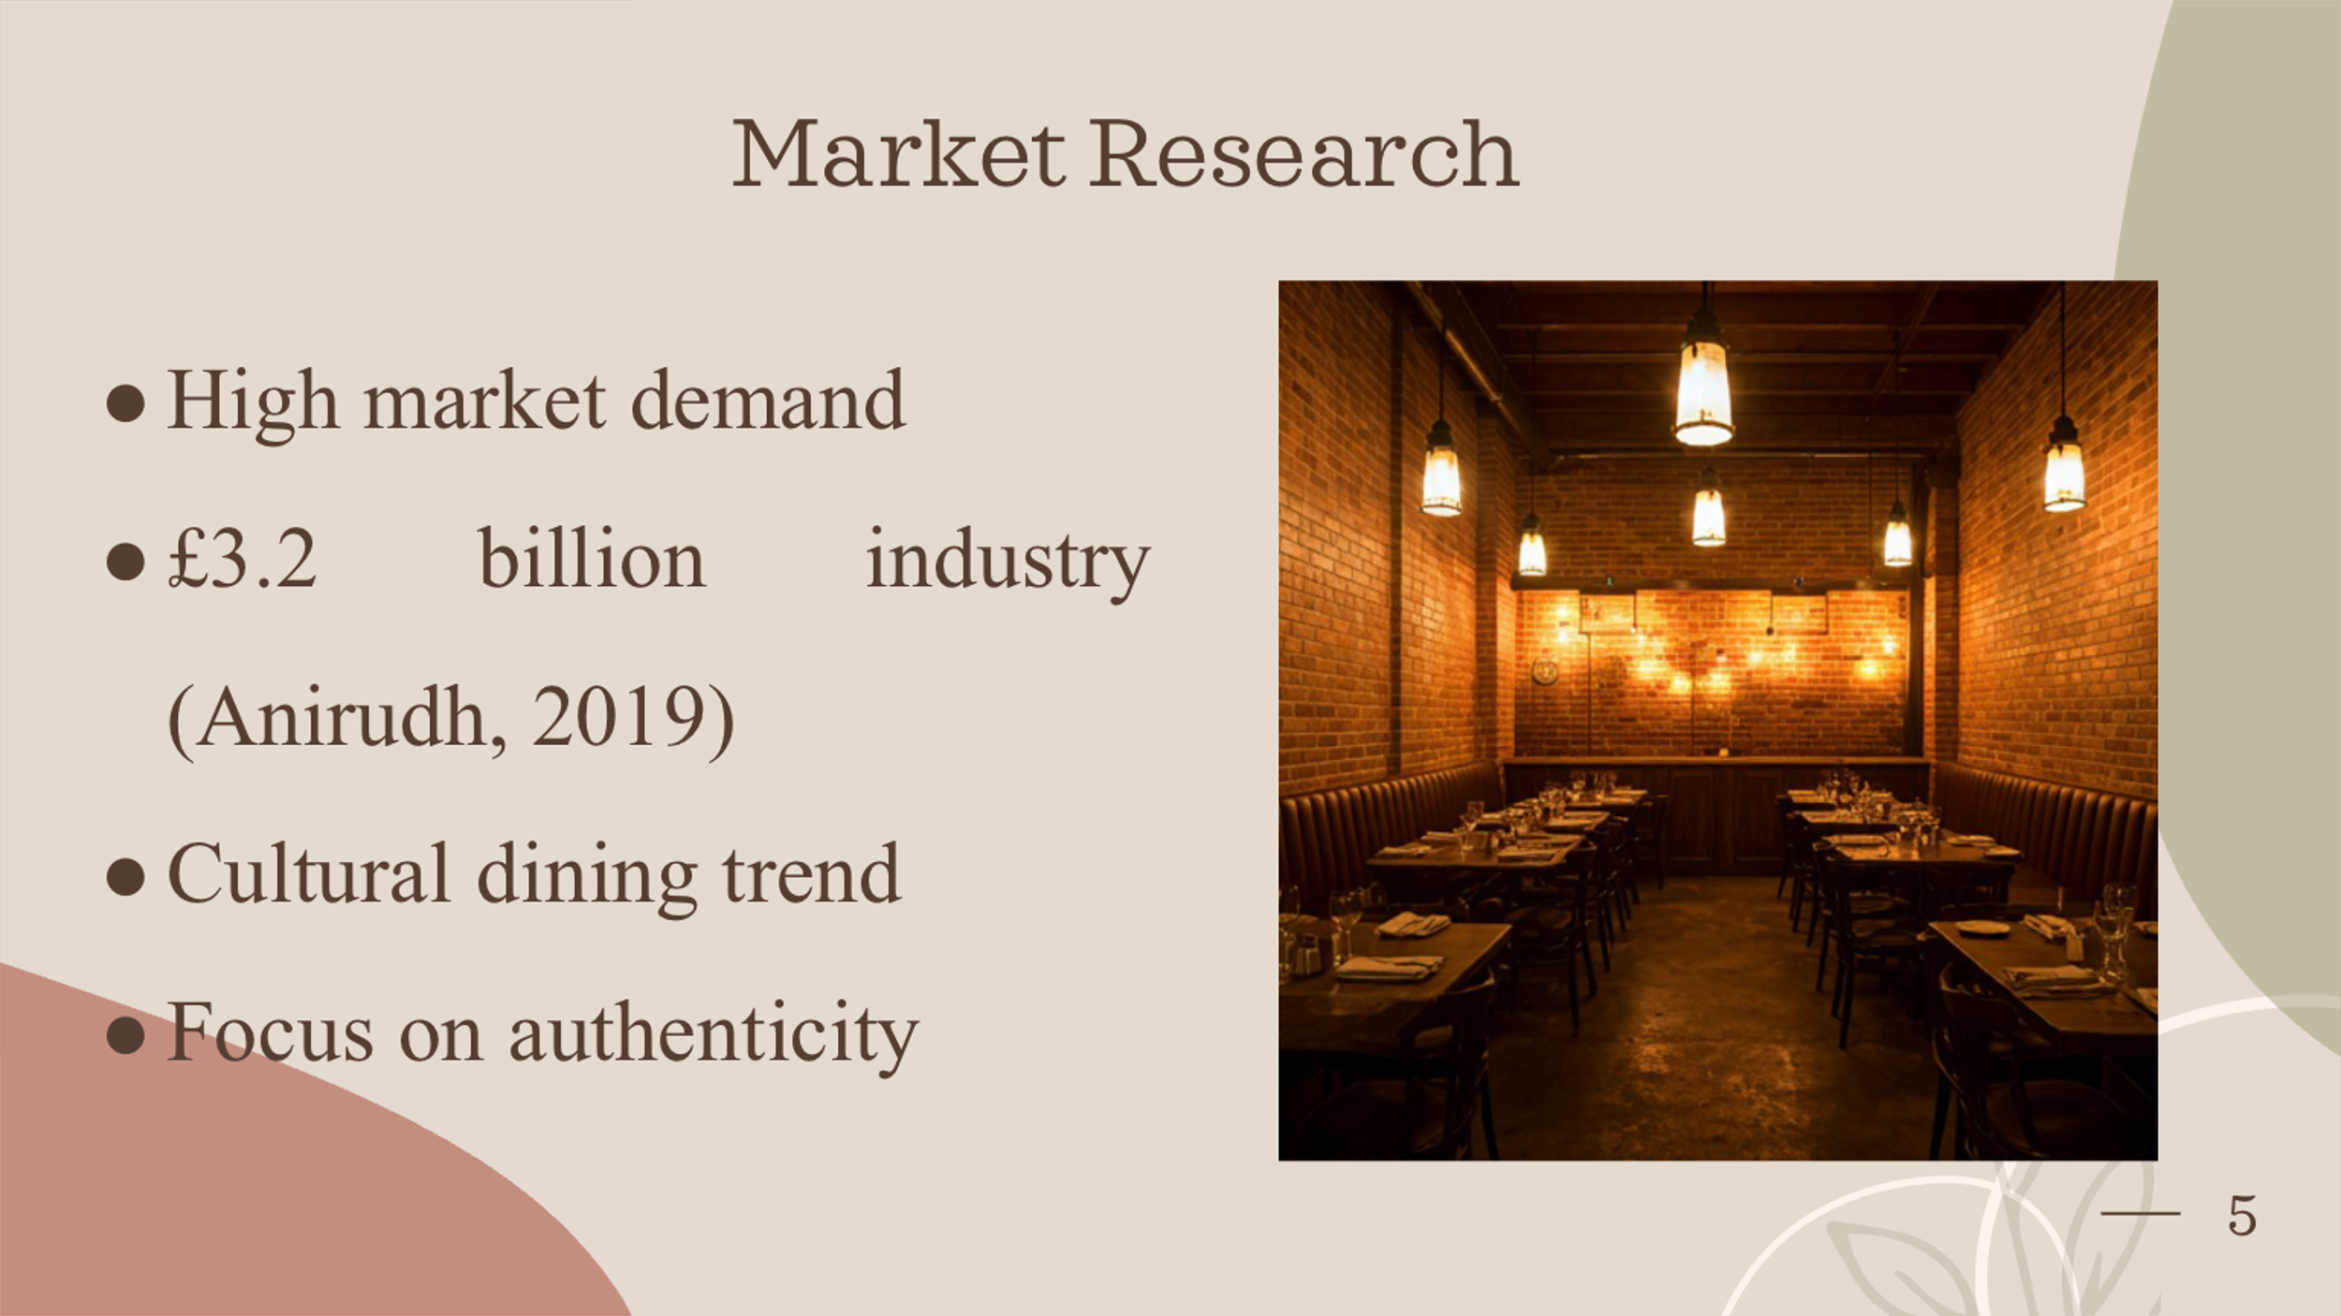
Slide 6: Target Market


Slide 7: Competitor Analysis
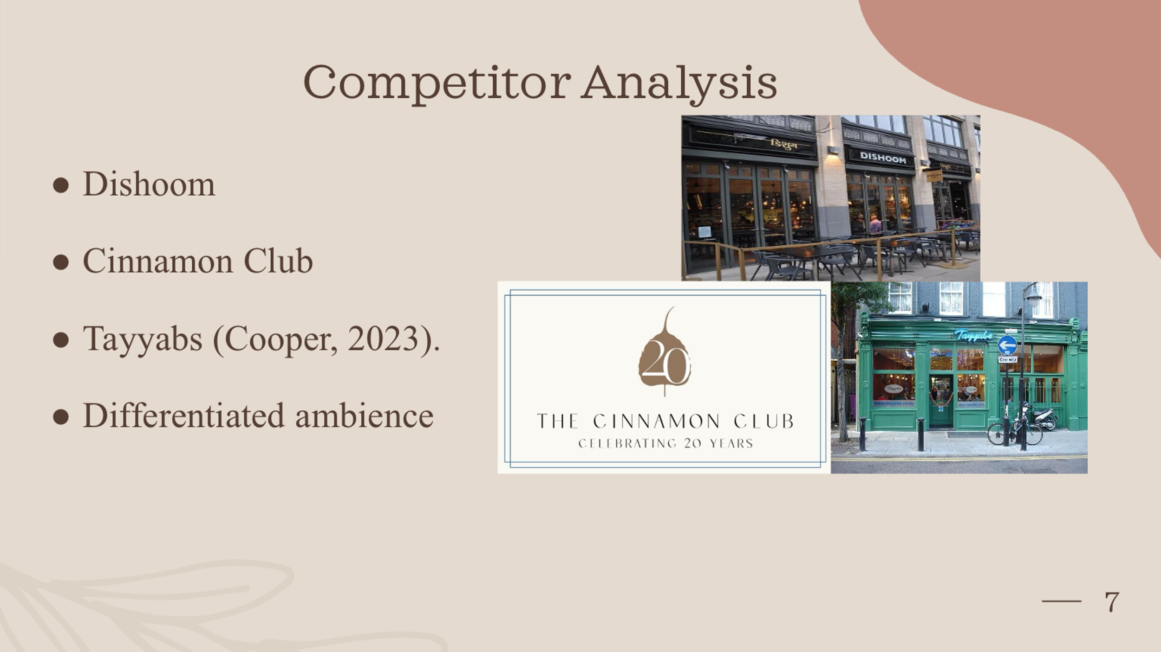
Slide 8: Marketing Plan


Slide 9: Operational & Key Resources
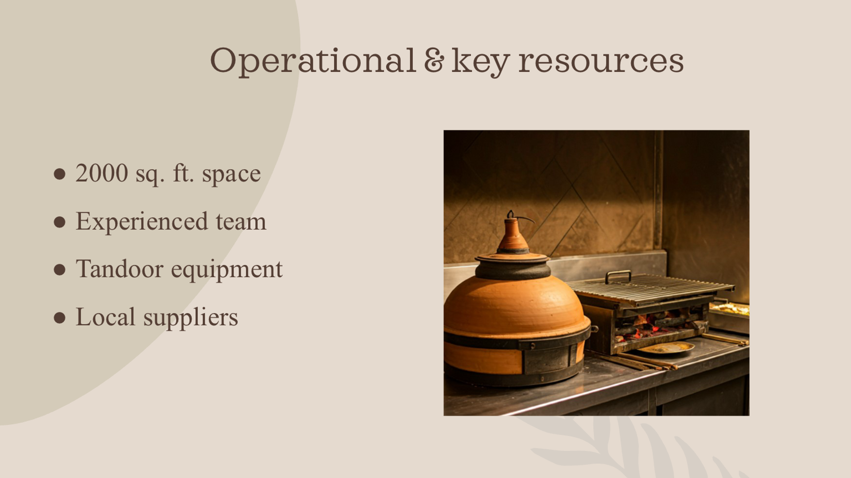
Slide 10: Financial Projections
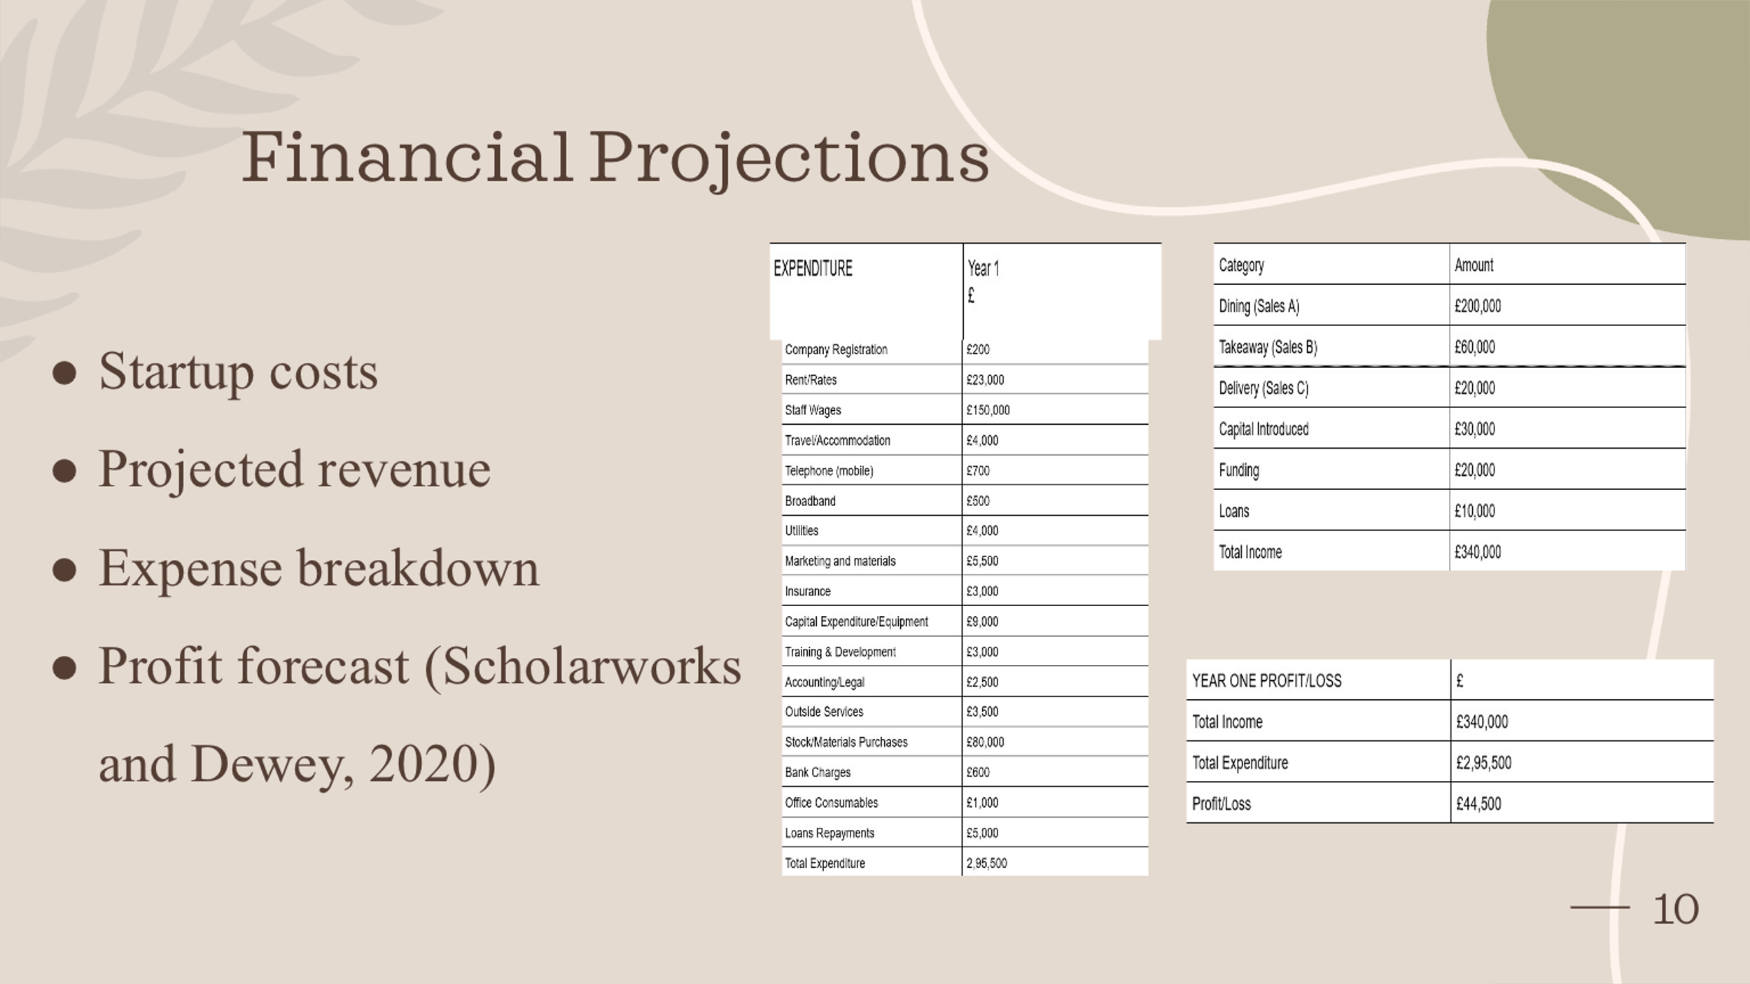

Slide 11: Competitive advantage and sustainability
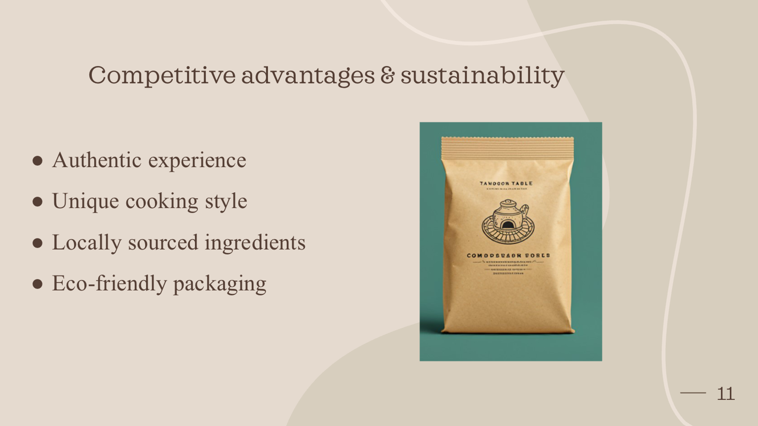
Slide 12: Advertising


Slide 13: Conclusion
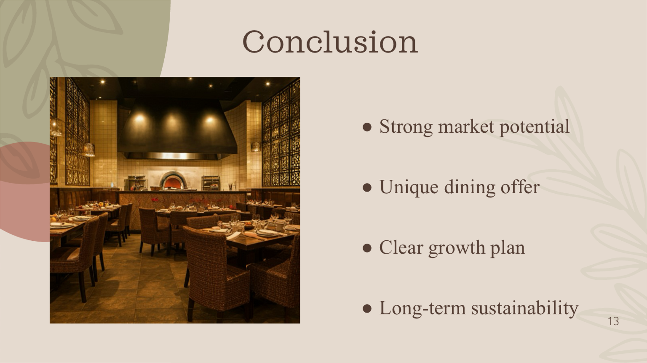
Slide 14: Q&A


Slide: Thank you


REFERENCE LIST:

- Aniruddh (2019) Unstoppable popularity of Indian cuisine, IndBiz | Economic Diplomacy Division. Available at: https://indbiz.gov.in/unstoppable-popularity-of-indian-cuisine/ [Accessed 9 November 2024].
- BDO, 2024. Restaurants and Bars Report 2024. [PDF] Available at: https://www.bdo.co.uk/getmedia/8a260315-d4b0-4840-ae04-79ad692dad38/BDO-Restaurant-and-bars-report-2024.pdf [Accessed 10 Nov. 2024].
- Brownell, J. and Reynolds, D., 2002. Strengthening the purchaser-supplier partnership. Available at:https://ecommons.cornell.edu/server/api/core/bitstreams/a39dd47e-ef4e-45b4-a204-28bb3bb28603/content [Accessed 9 November 2024].
- Caterkwik, 2024. Restaurant Equipment Quotes. [online] Available at: https://www.caterkwik.co.uk [Accessed 10 November 2024].
- Cinnamon Club, 2024. The Cinnamon Club Restaurant. [online] Available at: https://www.cinnamonclub.com [Accessed 10 November 2024].
- Cooper, L. (2023) London’s Best Indian Restaurants, Time Out London. Available at: https://www.timeout.com/london/restaurants/londons-best-indian-restaurants [Accessed 9 November 2024].
- DesiBlitz, 2023. 7 popular Indian restaurant chains in the UK. [online] Available at: https://www.desiblitz.com/content/7-popular-indian-restaurant-chains-in-the-uk [Accessed 08 November 2024].
- Dishoom, 2024. Welcome to Dishoom. [online] Available at: https://www.dishoom.com [Accessed 10 November 2024].
- Eat This, Not That, 2024. Best Restaurant Chain Family Meal Deals. [online] Available at: https://www.eatthis.com/best-restaurant-chain-family-meal-deals-2024/ [Accessed 17 November 2024].
- Food & Wine, 2023. Exploring London’s Indian Dining Scene: An Industry Worth Billions. [online] Available at: https://www.foodandwine.com/london-indian-dining-scene-7550089 [Accessed 10 November 2024].
- Fairway Foodservice, 2024. Suppliers. [online] Available at: https://www.fairwayfoodservice.com/suppliers/ [Accessed 10 Nov. 2024].
- GOV.UK, 2024. Start-Up Loans for New Businesses. [online] Available at: https://www.gov.uk/start-up-loans [Accessed 09 November 2024].
- Hospitality Tech, 2023. Digital Transformation in the Hospitality Industry. [online] Available at: https://hospitalitytech.com/hotels-and-digital-revolution-ways-improve-guest-experiences [Accessed 11 November 2024].
- Limepack, 2023. 50 Fresh Event Ideas for Restaurants to Boost Engagement and Profits. [online] Available at: https://www.limepack.eu/blog/restaurant-eu/50-fresh-event-ideas-for-restaurants-boost-engagement-profits [Accessed 09 November 2024].
- London.gov.uk (2024) Cultural tourism vision for London | London City Hall, www.london.gov.uk. Available at: https://www.london.gov.uk/programmes-strategies/arts-and-culture/cultural-places-and-creative-spaces/cultural-tourism-vision-london [Accessed 9 November 2024].
- Lumina Intelligence, 2024. UK Restaurant Market: Size, Growth & Share Predictions. [online] Available at: https://www.lumina-intelligence.com/blog/foodservice/uk-restaurant-market-size-growth-share-statistics-2024/ [Accessed 10 Nov. 2024].
- Mawson, E. and Fearne, A., 1997. Organizational buyer behaviour: A study of UK restaurant chains. British Food Journal, 99(7), pp.239-243 Available at : https://www.researchgate.net/publication/235290707_Organizational_buyer_behaviour_a_study_of_UK_restaurant_chains [Accessed 09 November 2024].
- MICHELIN Guide. (2024). Indian Restaurants in The UK & Ireland. [online] Available at: https://guide.michelin.com/gb/en/article/features/indian-restaurants-in-the-uk-and-ireland [Accessed 09 November 2024].
- O’Brien, C. (2023) Eating the Present, Tasting the Future. Penguin Random House India Private Limited.
- Okonkwo, I. et al. (2023) ‘Localization and Global Marketing: Adapting Digital Strategies for Diverse Audiences’, Journal of Digital Marketing and Communication, 3(2), pp. 66–80. Available at: https://tecnoscientifica.com/journal/jdmc/article/view/311/173 [Accessed 9 November 2024].
- Rewards Network, 2023. The Importance of Restaurant Customer Reviews. [online] Available at: https://www.rewardsnetwork.com/blog/restaurant-customer-reviews/ [Accessed 17 November 2024].
- Roulac, S., 2001. Corporate property strategy is integral to corporate business strategy. Journal of Real Estate Research, 22(1-2), pp.129-152. Available at: https://www.researchgate.net/profile/Stephen-Roulac-2/publication/5142139_Corporate_Property_Strategy_is_Integral_to_Corporate_Busine ss_Strategy/links/0deec53a0dc6887989000000/Corporate-Property-Strategy-is-Integral-to-Corporate-Business Strategy.pdf [Accessed 9 November 2024].
- Scholarworks, S. and Dewey, S. (2020) Strategies to Reduce Restaurant Employee Turnover Rates Strategies to Reduce Restaurant Employee Turnover Rates. Available at: https://scholarworks.waldenu.edu/cgi/viewcontent.cgi?article=10827&context=dissertations [Accessed 9 November 2024].
- Shankar, V. et al. (2021) ‘Digital Marketing Communication in Global marketplaces: a Review of Extant research, Future directions, and Potential Approaches’, International Journal of Research in Marketing, 39(2). Available at: https://doi.org/10.1016/j.ijresmar.2021.09.005 [Accessed 9 November 2024].
- Square, 2023. How to Start a Restaurant Loyalty Program. [online] Available at: https://www.squareup.com/us/en/the-bottom-line/reaching-customers/how-to-start-restaurant-loyalty-program [Accessed 10 November 2024].
- Square, 2024. Restaurant POS Systems. [online] Available at: https://squareup.com/us/en/point-of-sale/restaurants [Accessed 10 November 2024].
- TajSpices, 2024. Online Indian Grocery Store UK. [online] Available at: https://tajspices.co.uk/ [Accessed 10 November 2024].
- Talon.One, 2023. Seasonal Marketing Campaigns: 9 Best Ways to Benefit from Promotions. [online] Available at: https://www.talon.one/blog/seasonal-marketing-campaigns-9-best-ways-to-benefit-from-promotions [Accessed 11 November 2024].
- Tayyabs, 2024. Tayyabs Punjabi Restaurant. [online] Available at: https://www.tayyabs.co.uk [Accessed 10 November 2024].
- Wandosell, G. et al. (2021) ‘Green Packaging from Consumer and Business Perspectives’, Sustainability, 13(3), p. 1356.
- Zakeer, F. (2023). 'Eating the Present, Tasting the Future review: Tracing the diverse foodways of India'. The Federal, 17 August. Available at: https://thefederal.com/category/features/eating-the-present-tasting-the-future-review-tracing-the-diverse-foodways-of-india-94438 [Accessed 10 November 2024].

