Assignment feedback

Student Name: Evan Fray
Student University Email: 1700724@student.uwtsd.ac.uk
Module code: HPHE5008  Module title: Using one of the establishments visited examine the strengths and weaknesses of their collection rationale | Student ID number: 1700724 |  | Educational support needs:  No
Assignment title:
Graveyard Survey
Assignment due date: 05/01/2019
Assignment Number: 2
(i.e. 1,2,3)
Marker’s signature: |  | Date:
Provisional.
NB. All marks are provisional until confirmed by the final examination board.

Using one of the establishments visited examine the strengths and weaknesses of their collection rationale
Museums around the world choose different ways to present their collections to the public, with each method having its own strengths and weaknesses. The museum which I am going to look at is called St Fagans National Museum of History which is situated in Cardiff, Wales. It was first opened in 1948 as the United Kingdom’s first open air museum and has since become the most popular heritage visitor attraction in Wales. Before the museum was created there were a couple of issues, the biggest being the amount to space needed to create an open area museum. This is due to this type of museum requiring a very large amount of land in order to be functional, fortunately a suitable amount of land for the museum in St Fagans was donated by the Earl of Plymouth, (https://museum.wales/stfagans/stfagans-history/ 28/12/2018) which allowed the museum to be constructed.
Originally the museum was known as the Welsh Folk Museum, with a focus on preserving and displaying Welsh culture which included Welsh oral traditions, customs and traditional buildings with the belief that “A folk museum must illustrate not only the material side of life and culture, but also the activities of the mind and spirit… It is not only a matter of great importance but also of extreme urgency.” (Prof G J Williams 1958). Throughout the museums history they have updated their collections to include more modern collections such as the Rhyd-y-car ironworkers’ cottages from Merthyr Tudful, which were relocated to St Fagans in 1987.
The first exhibit that I will look at is the Museum’s most recent addition to their exhibitions called ‘Wales is..’ which aims to show Welsh identity and Welsh culture:
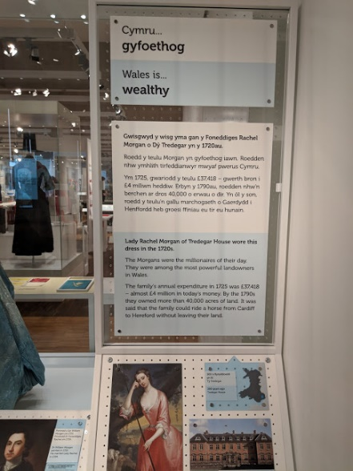
Image of a display in the Wales is exhibit
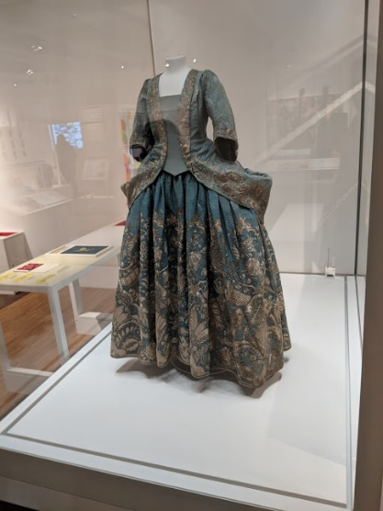

(Photos courtesy of Evan Fray)
This is the general layout of this exhibition room, which displays different aspects of Welsh history. This is a major strength for this exhibition, since the neutral background of the exhibit allows a wide variety of different periods to be displayed at the same time without causing a clash with other displays in the collection. In addition to this it allows the displays to be changed over at any time, without having to make major changes to the exhibition, which gives the Museum unlimited options as to what they choose to display, which in turn gives an easy platform to present Welsh history and culture. On the other hand, the white background could also be seen as bland, boring and sterile, offering no stimulation for the exhibit, a way to improve this could be to use a selection of neutral colours rather than to just use white for the background.
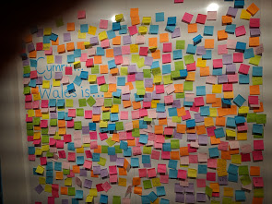
Images of interactive displays at the ‘Wales is ..’ exhibition
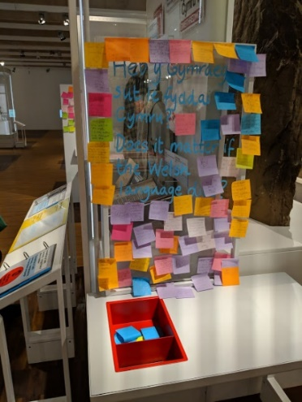

(Images courtesy of Evan Fray)
These images show some of the interactive exhibits that the museum have on display to allow the public to voice their opinion on important political matters, as can be seen in the second image it asks if it matters if the Welsh language dies, which has resulted in many responses from the public. However, due to the manner in which they allow the public to interact with the display it gives the person total anonymity, which despite the positives this brings it can also allow an opportunity for people to push political agendas which may be harmful to the community. One way in which this could be improved upon is to have the same display, but rather than have the messages displayed, they could be posted in a comment box and any messages which the museum staff find appropriate can be displayed alongside the message to encourage others to engage with the display.
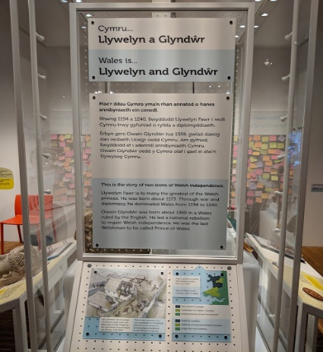
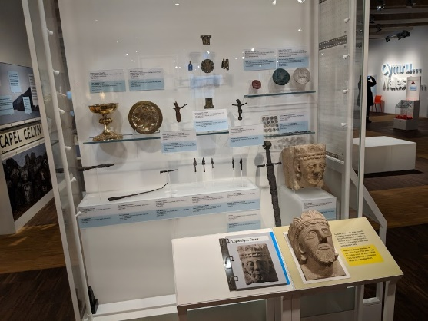
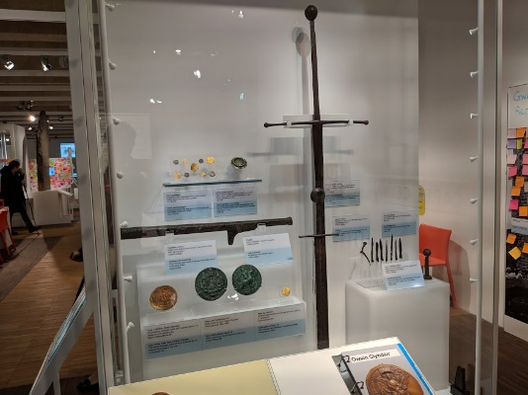
Display showing information about Llywelyn Fawr and Owain Glyndwr

(Pictures courtesy of Evan Fray)
One of the highlights of this exhibit presents two very important figures in Welsh culture and identity, Llywelyn Fawr who ruled the majority of Wales from 1194 to 1240 and Owain Glyndwr who was the last Welshman to be called the Prince of Wales, making these individuals two of the biggest influencers on Welsh identity and independence. This is a major strength for the exhibition by having two major figures of Welsh identity which gives the exhibition a greater impact on the public when presenting welsh culture and identity, in addition to this it also gives the other displays a bigger impact by associating with the display when trying to present Welsh culture to the public, as well as giving more engagement to exhibitions which continue on from this one, which only helps to serve the museums purpose of teaching and increasing awareness of Welsh culture and Welsh identity. However, by having such major figures in Welsh identity in the first exhibitions there is a possibly that it could result in the public having very high expectations for the rest of the Museum’s collections that are on display and as a result of this may disappoint the visitors, consequently giving them a bad experience of the Museum. A way to improve this could be to move the display to another exhibit or to create an exhibit which is focussed around them or on Welsh independence in general.
Moving on from this exhibition, there is another collection on display at the Museum which focusses on the everyday life of Welsh people throughout history and their attitudes towards important events in life such as marriage and death.
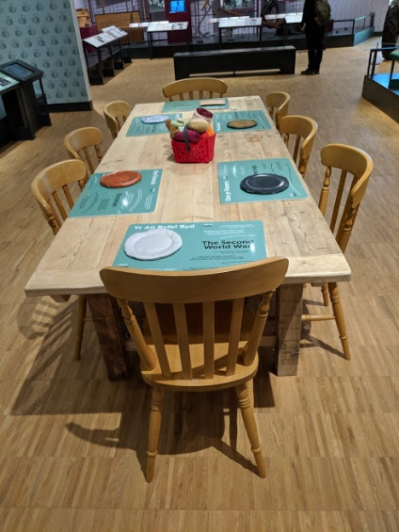
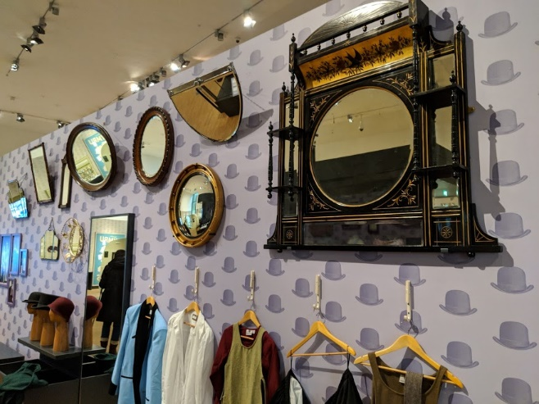
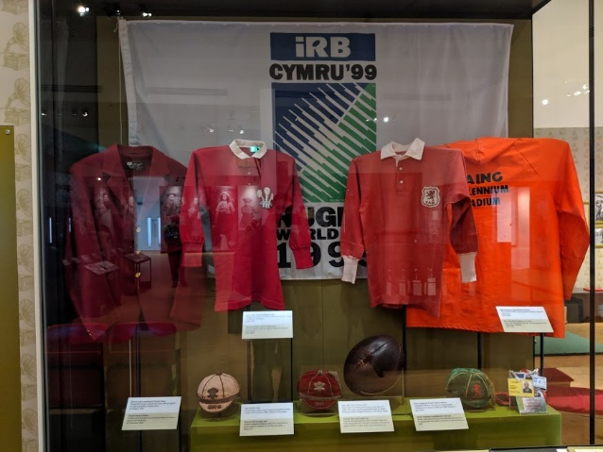
Display showing everyday life in Wales

(Pictures courtesy of Evan Fray)
These are some of the displays which presents everyday life in Wales, some of the aspects which are displayed include leisure, dress and eating. One of the main strengths that this display has is that it shows the progression of material culture and how people interacted with it, from early seventeen hundred to the modern day. This allows the public to make a direct comparison of what life was like for Welsh people in the past to the present day. In addition to this the Museum has also made use of interactive displays in this exhibit to give visitors a more immersive experience, as well as providing another avenue for them to learn and experience Welsh culture and life throughout history. However, by having interactive displays it could lead to visitors being distracted from the message that the display is trying to portray, especially if there aren’t any displays with sufficient information or displays which would complement the interactive materials, so that they can be used to engage visitors with the exhibit in the most effective manner possible. A way to improve this could be to replicate what has been done at the Tank Museum in Bovington, wherein at their Battlefield Afghanistan exhibition, they have provided costumes for young children to wear as well as physical objects such as a mock replicas of situations that soldiers faced in Afghanistan, such as mine sweeping, as well as life at the barracks for them to interact with them. What St Fagans could do is complement their interactive material with more ‘hands on’ displays that could be used to further engage visitors and give them a more immersive experience.

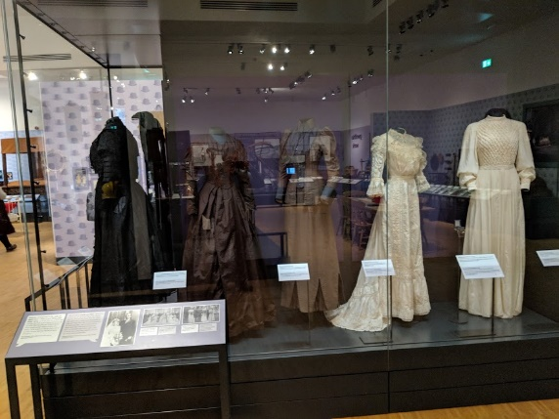
Displays showing Welsh attitudes towards death and marriage
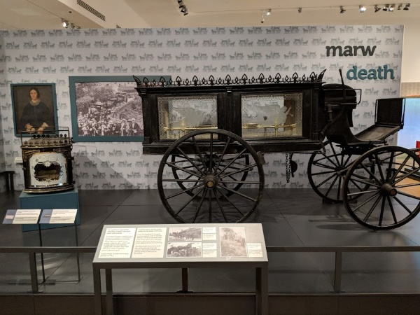

(Pictures courtesy of Evan Fray)
These displays present the attitudes that the Welsh have towards death and marriage, the main strengths of these displays are that all the dresses of the marriage display as well as the objects which are on display for the death collection are all authentic originals, which gives the displays a greater impact on the public by giving them a more “real” experience. However, none of the objects which are displayed have any links to one another other than they are in the same exhibition room, this negatively impacts upon the visitors’ immersive experience of the displays due to the lack of flow between the exhibits. To improve this the layout of the exhibition could be revised to encourage the movement of the visitors from one area of the exhibition to another, for example the exhibit could move from leisure, to marriage and then lead on to death, having this kind of layout could enhance the visitors’ immersive experience which this exhibit is aiming to give them.
Following on from this exhibition, the Museum also has a display showing various crafts such as carpentry, metalwork, pottery and many more which are supplemented by video displays explaining the craft, its historical context in Wales and the various stages of creating an object using the techniques described.
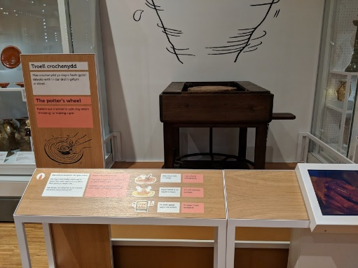
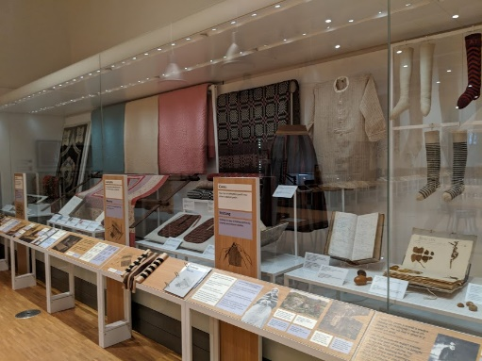
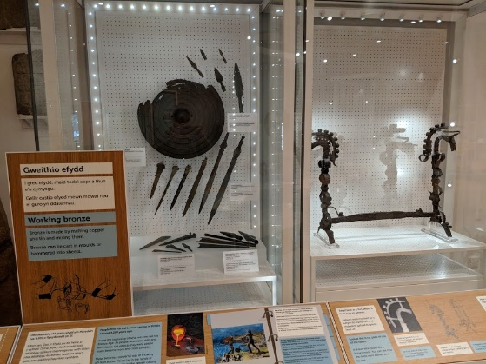
Displays showing different crafts

(Pictures courtesy of Evan Fray)
The main strengths of this display are that it shows a wide range of crafts that are practised, as well as showing how Welsh craftsmen and women use these crafts over time, creating objects which are on display. These are shown with another of the exhibit additions, which are the video displays on carpentry which complement the objects and physical displays very well, providing a stimulating addition to the exhibition. In addition to this the weaving display also includes interactive materials consisting of materials that could be felt giving another avenue for visitors to engage with, particularly visitors who have young children. However, most of the exhibition is heavily reliant on the physical objects that are displayed, without sufficient historical background information being presented in written form to educate the visitor. There is also a lack of video displays to demonstrate a range of crafts and this I believe is an opportunity missed as the carpentry video is a valuable asset to the exhibition.
This exhibition also has the issue whereby it is completely separate from the other exhibitions and thus has no link to the overall layout of the Museum. To improve upon these issues the action that could be taken is to add more supporting text to the relevant displays at the crafts exhibition, drawing the visitors’ attention to how the exhibitions link to each other. In addition to this the Museum could possibly consider either moving the exhibition building so that it can link in with other exhibitions on the museum grounds, or for a more practical solution the Museum could consider adding another exhibition, which connects to the crafts display from either the previous exhibition or to encourage visitors to see another part of the Museum.
The Museum also holds a selection of reconstructed buildings, as well as historic buildings, which have been moved to the Museum grounds, all of which originate from different time periods which include an Iron Age roundhouse, Medieval castle and a more recent addition of a Medieval courthouse. The Museum also holds more modern reconstructions such as a bakery, sweet shop, ironmongers, as well as a group of fully furnished miners houses which range from the year 1805 to 1985, which represent what home life was like for the miners of the time.
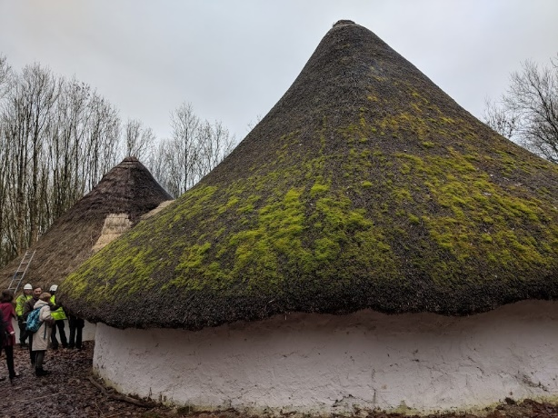
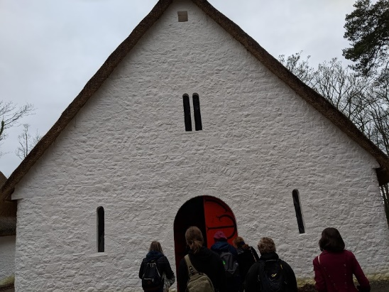
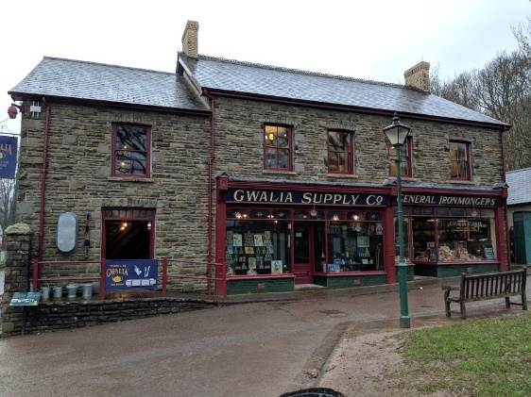
Pictures showing the various historic buildings on display
(Pictures courtesy of Evan Fray)
The main strengths of these buildings are that it gives the public a physical space where they can be fully engaged with the objects that are inside, as well as with the buildings themselves. However, the more modern buildings are currently being used for shops which restricts the type of engagement the visitors can have. In addition to this the historic buildings do not have many materials that the public can engage with, with the exception of the castle. One way to improve this, would be to take advantage of the opportunities that a historic building can provide for the Museum. There is a lot of potential for the buildings to be used as support material, to give visitors an immersive experience of the material through the use of interactive materials, such as costumes, to create an atmosphere where the public can physically engage with the heritage that is being presented to them. Another issue is a recurring one that can be seen throughout the Museum being that the buildings as well as the exhibitions that are at the site have very little to no connection between each exhibit. This can be improved upon by the Museum providing materials which could link each exhibit to each other. Another way to deal with this issue could be for the Museum to add signs to encourage visitors to go to particular exhibits in a desired order.
In conclusion, I believe that the collection rationale at St Fagans National Museum of History is a very effective one and has allowed them to present Welsh culture and identity to the public in a successful manner. Through the use of interactive displays, reconstructions as well as video displays, visitors are able to explore and experience Welsh culture and identity. However, despite this success there are a small number of issues which can be easily addressed, which primarily relates to the lack of cohesion and linking of exhibitions and should be a key area for action to address when the Museum next reviews its displays and layout.
Word count: 2174
Bibliography
Photos taken by Evan Fray
Extract from Prof G J Williams’ radio appeal on behalf of the Welsh Folk Museum, 1958
https://museum.wales/stfagans/stfagans-history/ 28/12/2018

SELF-REFLECTION SHEET.

PLEASE COMPLETE BEFORE SUBMISSION AND ATTACH TO YOUR WORK

Date: 04/01/19 Module: HPHE5008 Name: Evan Fray

Guidance: You might consider the following elements:

- Argument: does it have one/ is it backed by sufficient evidence/ how lucid is it?
- Structure: how clear is it / is my essay easy to follow/ does it help my argument?
- Analysis: is more/less analytical than narrative/ does it address the question?
- Reading: was this sufficiently broad/ have I referenced properly?
- How might I improve my performance in future?

Strengths
I think that I have been able to assess the Museum’s collection rationale very well

Weaknesses:
I have not been able to talk about each aspect of the museum in as much detail as I would have liked

General Comments:
I found it very helpful to be able to put into practise what I have learnt in lectures

Please give a mark for your work: 58

(for eg: 1st = 70+: 2/1 = 69-60: 2/2 = 59-50: 3rd = 45-49: pass = 40-44: fail = 39- )

