Student name: MD Golam Ambiya

Student Id: 2120022

Module name: effective team working and communication

Module code: BMSW4002

Tutor name: Obinna Nkwocha

Assignment Title:

Effective Team working for Team success

Executive summary:
The report is based on case study of Next and how team member would be effective by using models and how they will succeed in the future by using effective team worker techniques. There are several qualities that team members need to have and use for the group to function effectively. Reliability, goal orientation, effective communication, support, responsibilities that are balanced, listening ability, and respect are a few of these factors. Even though we could ignore some of these elements, the lack of even one of these can significantly affect how well the team gets along. Each element is therefore equally crucial and required. It emphasises the value of teamwork inside organisations and how it affects how individuals behave. The definitions of the terms "team," "team work," and "team effectiveness" are given at the outset of this paper. In this report explained by describing management theoretical theories about the significance of teamwork and team success in the workplace.

Table of content:

Introduction…………………………………………………. 4

Model of team work………………………………………… 4-5

Team roles for creative effective………………………..5-7

Impact of effective teamwork on team success……….7-8

Conclusion/recommendation……………………………..9

References……………………………………………………10

Introduction:
A team is a group of individuals who cooperate to achieve a common goal and rely on each other for expertise, skills, resources, and information. A group of people who work together to carry out interdependent tasks in service of a common objective or mission is referred to as a team. Some teams, like design teams focusing on new goods or teams committed to ongoing process improvement, have a limited shelf life.Teamwork and team are now a feature of contemporary organisations and are required in order to achieve and maintain success. Church (2000) Many organisations moved from individual to team acting over the past 30 years. According to others, cooperation in the sense of employee dedication is more important than management and compliance in light of the new, advanced technologies. 1989 (Huszczo) The utilisation of teamwork is widespread (Church, 1998), and it appears to be a fad or "fashion" that everyone must participate in a team for it to be effective.
The ability to work well in teams is crucial since it allows them to complete tasks and address issues more successfully. You may create a community where individuals feel secure and accepted by promoting idea sharing, teamwork, and healthy connections within your team.
Model of team work:
Any company's success has always depended heavily on how well its team’s function. However, as more businesses implement remote and hybrid work arrangements, CEOs must improve their team-management abilities. (creedy,2020). There are only as excellent as the company when they keep themselves with, as effective leaders are aware. Great leaders are aware of this, and they understand how crucial it is for them to develop their teams. Although many leadership are aware of the idea of team growth, it is crucial to comprehend the fundamental ideas involved in creating a team and the benefits that proper implementation may have for progressive leadership. (university). Creating a sense of teamwork out of disparate individuals requires careful team building. a team that is simultaneously working cooperatively and interdependently to achieve a particular set of objectives. The idea behind team development is straightforward in theory: gather a group of bright and motivated people and give them a mission to complete. Team building involves strategic preparation and effort.
According to case study next new team leader should use the model of Tuckman’s Team and Group Development. The model states that four stages experienced by the team members.
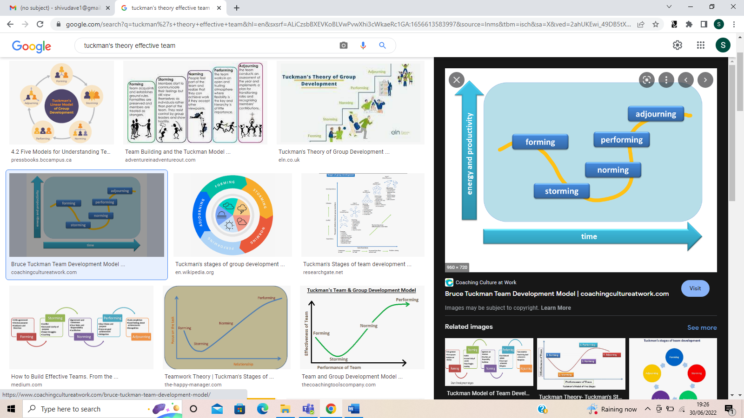(Fig 1.0)
Forming: During the team-forming phase, members must rely on the leadership for practically all guidance, direction, and teaching. There is typically a lot of nervous energy, a lot of questions, and plenty of ambiguity. Energy levels are typically high and positive. To assign duties and aid in setting goals, next leaders must take a more active role. They must also be ready for this phase to take a while, as team members may need some time to get to know one another and feel comfortable working together.
Storming: Every team must get through this phase in order to advance. Though there is still a great deal of ambiguity, people are beginning to understand what to do or how it should be done. Personalities will conflict, competitors for power will emerge, and making decisions will still be difficult. This phase of leadership testing involves dispute resolution and setting an example for others. Leaders must motivate team members to put aside any problems that may arise and return their attention to the current job.
Norming: Team members feel more confident in their skills and expertise, and roles and duties are obvious. Large choices are reached by team consensus, and smaller teams or groups handle minor initiatives. (hygger,2018)
Maintaining the team's focus and direction under this situation is a struggle for the leader. By encouraging a sense of "us" rather than "I," leaders may reinforce the bond that has already developed within the group and refocus it to create better results.
Performing: At this point, each team member has a thorough understanding of the why in addition to the what and the how. Everyone on the team fully supports the company culture and follows it without outside direction, so they all know what to do.
Teams with more experienced and self-driven leaders can concentrate on developing both their own leadership abilities and team members' talents. Leaders should seize the chance to train, mentor, and develop individuals as your team gets more capable and eager to learn in order for them to reach their filled possible. (Belbin,2022).
Adjourning: Companies with short-term initiatives, restructuring, or agile workplaces experience this stage more frequently. While some group members struggle with the idea of perpetual change, others see it as an opportunity to grow and learn new skills.
In both situations, leaders are crucial in creating occasions for introspection and celebration.
Strong team development is essential for every organisation or workplace to be successful. Over the course of the 5 steps of team building, leaders will encounter a range of things, both positive and negative. If the various processes are used as a framework, there would be more advantages than disadvantages for leaders. Due to appropriate team development, the next new team manager would have several opportunities to build rapport on a foundation of acceptability. When people trust one another, they are more likely to share ideas, collaborate effectively, and make decisions that will benefit everybody and the project. According to the case study, it appears that the following team members will not succeed if they do not show interest when it is time to speak and are unable to do so. Poor communication may lead to low morale and missed opportunities for understanding and development. Communication has a crucial role in the development of a team, increasing its capacity for creativity and innovation. Teams that work well together accomplish goals. Although collaboration has many benefits, its fundamental objective is to inspire individuals to work together to produce extraordinary things. (Fapohunda, 2013)
Team roles for creative effective:
Teams that operate well together know how to interact and divide the work among themselves to the benefit of each member's skills and abilities. Despite differences in working styles, communication styles, and skill levels, the perfect team can come together to achieve its shared objectives. Building teams by simply bundling employees and hoping for the best is frequently a bad idea. The teams require direction on how to collaborate successfully. Different employee personalities are also considered. A company leader should Set objectives for each organisation so that everyone is clear on what is expected of them. Consider each person's strengths when assigning certain duties or when encouraging the team members to divide up different roles among themselves. And also, should know how to Team disputes should be settled right away to prevent them from getting worse over time. If a group is unable to settle disputes amicably, mediate as necessary. If issues can't be resolved despite your input, think about changing the staff teams. A company leader should use model for this team roles so they can understand their responsibilities. Belbin Team Role Model is very important for each company. in the following paragraph states that how this model will help to the company leader and team members. (Frost,2019).
Belbin team role model:
A person's behavioural traits are identified and categorised in accordance with a team role by the Belbin Team Role model. Often, a team's most successful members have a variety of complementary skills. A team will function at its best when duties are assigned according to skill sets of the team members. This article looks at the various Belbin roles for teams, how understanding them may provide you unique insights, and whether they might enhance teamwork. (BBC,2021).
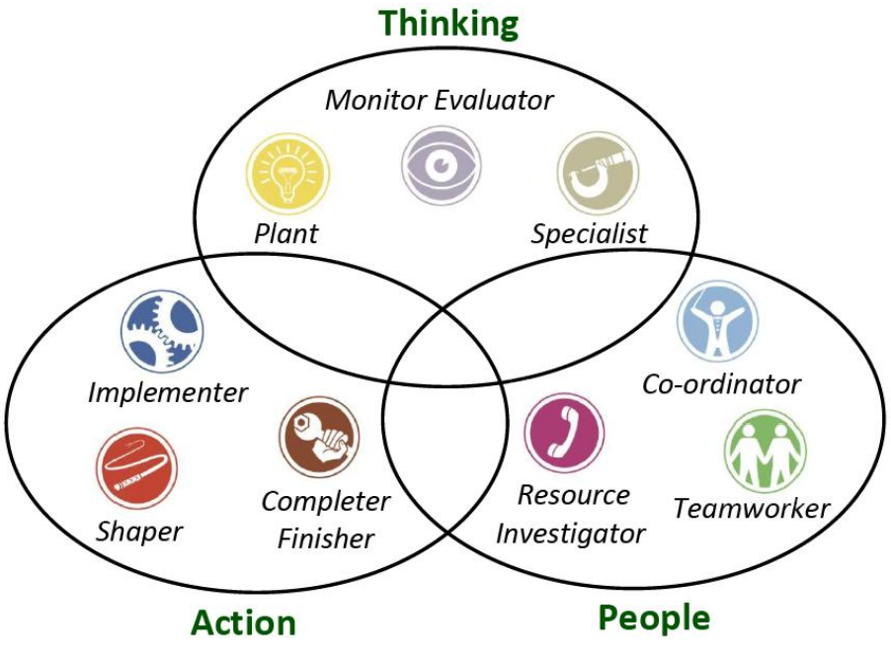(Fig 1.1)
The plant: Because they encourage growth and development, these teammates are referred to as plants. They are creative, individualists, and capable of developing original solutions to problems.
Monitor evaluator: These strategic problem solvers favour a logical approach over an instinctive or emotional one in their tactics. Before presenting a firm, impartial solution, they like to carefully outline a team's possibilities.
These individuals prefer working alone since it enables them to stay impartial while evaluating the contributions of co-workers, much like the next team member. Because of their ability to consistently make excellent decisions, these individuals usually assume administrative roles. They could find it difficult to inspire those around them, and some individuals might feel that their criticisms are unfair. They could take a while to get to a decision because of their meticulous, systematic mindset.
Specialist: These people are bringing to a group their in-depth expertise in a certain field. These extremely dedicated and disciplined people are a valuable resource, but their thinking is often more constrained. By employing this model strategy, the following team leader will become too concerned with details, perhaps overwhelming teams with information.

Social roles: Belbin classifies the main team roles as being interpersonal or social:
Team workers:
Since they are extroverted, flexible, and smart, some group members are the group's negotiators. They are crucial for maintaining team cohesiveness and making sure that everyone gets along. They can interact with every team member because of their versatility. They typically volunteer to assist a teammate if they see them struggling with their work.
According to scenario They may be confused under pressure and hesitant to take any action that would be unpopular, despite their dedication to team unity being more important than anything else for an efficient unit. They avoid conflict and want to stay impartial in talks.
The following team positions are categorised by Belbin as being action-oriented:
Implementers are capable of transforming team members' abstract ideas into tangible, executable strategies because they are organised, dependable, and disciplined. They are essential for strategically developing the team's work since they take a methodical and task-oriented approach. However, Due to the way they monitor their work, implementers are less flexible and able to change than other team members. They can need some persuasion before changing their approach, and they might take a bit time to adjust to change. (Fapohunda, 2013).
Moreover, it is very essential to to consider team roles when selecting team members or recruiting new staff as In addition to meeting job criteria, a recruiting and selection policy guarantees that a firm will uphold its commitment to giving employees equal opportunity. Following such a policy will enable to recruit the ideal candidates for the company.
Impact of effective teamwork on team success
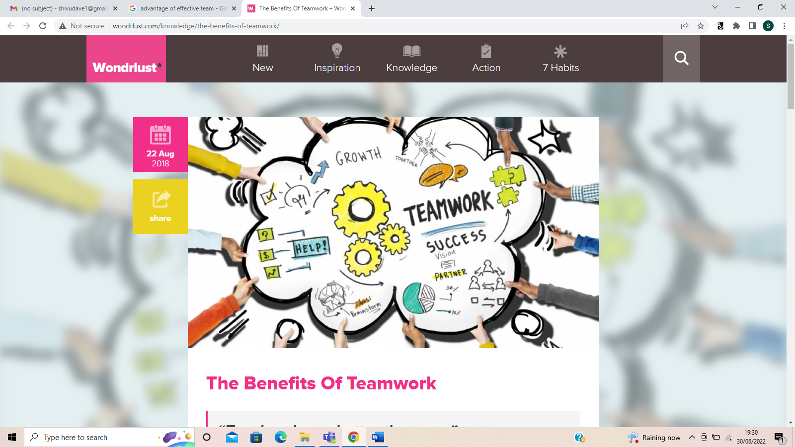(fig1.3)
Working together and encouraging excellent cooperation among your staff can benefit your business and provide it a competitive edge. Employees develop ties that can develop into trust and camaraderie when they work as a team and achieve. It is in our nature. Additionally, it's beneficial for your company since staff members who get along well with one another are more likely to: Clearly communicate with one another, Together, encourage one another and work cooperatively.
Problem solving: Teams are formed by people with a variety of viewpoints, skill levels, and working styles. A group of people working together is often more effective at solving difficulties than one person working alone.
New ideas and opportunities: Collaboration among your staff members may inspire the development of ground-breaking new ideas, products, or events as well as the identification of novel business opportunities.
Strong relationships: Friendships between co-workers are much more likely to last when they get along well. Team members learn more about one another's personalities and get a deeper understanding of each other's strengths and weaknesses. Two advantages of stronger relationships are the development of trust and enhanced communication.
Flexibility: When working in teams, people can more easily share knowledge and abilities. People's ability to cover for sick team members may lead to greater flexibility.
According to case study the barriers of effective team working there Team communication breakdowns can be caused by employees who refuse to communicate or are not aware of the appropriate channels to use. Lack of communication serves as a pressure release valve and is one of the largest obstacles to altering attitudes. The two-edged blade of team communication must be understood by managers, and they must be able to spot instances in which poor communication is impeding the success of the group. Separate office environments that limit employee interaction are one example of a literal barrier to communication. To make sure everyone on the same page and to encourage interaction among co-workers, use daily team meetings. To achieving workplace objectives, a work group is created. These objectives may be for a single task, or they may be long-term objectives outlining the duties of the department. The team cannot function effectively if management does not adequately communicate the team's goals or if each team member's specific roles in achieving those goals are not made evident. And leader should Job responsibilities become warped if employees are unsure of what they are supposed to be accomplishing. Always give your employees definite, quantifiable objectives. For instance, a sales team could set a financial target and, if it is attained, receive a reward, like a team supper. (Anon,2021).

Conclusion/recommendation:
Teamwork is increasingly important in contemporary organisations. Teams can provide competitive benefits through higher staff satisfaction, creativity, and innovation if they are effectively formed, managed, and executed. The effect of cooperation can, however, be counterproductive if teams are given the incorrect duties, are managed ineffectively, or are not given enough assistance, resources, or autonomy to do their tasks. Management must be aware of any teams that may develop their own goals and criteria that differ from those of the team. As a result, managing cooperation can be difficult, yet successful management can produce excellent results.

References:
Creedy, V. (2020). Six Factors for Team Effectiveness. [online] www.ddiworld.com. Available at: https://www.ddiworld.com/blog/six-team-effectiveness-factors. [accessed on 25 june 2022].
University, D. (n.d.). Why is team development important to a leader? [online] www.cmo.com.au. Available at: https://www.cmo.com.au/brand-post/content/662563/why-is-team-development-important-to-a-leader/. [accessed on 25 june 2022].
Small Business - Chron.com. (n.d.). How to Build a Cohesive Staff Team. [online] Available at: https://smallbusiness.chron.com/build-cohesive-staff-team-25011.html. [accessed on 26 june 2022].
Indeed (2021). The 9 Belbin Team Roles (With Examples and Definitions). [online] Indeed Career Guide. Available at: https://uk.indeed.com/career-advice/career-development/belbin-team-roles. [accessed on 26 june 2022].
Fapohunda, T. (2013). Towards Effective Team Building in the Workplace. [online] ResearchGate. Available at: https://www.researchgate.net/publication/258344173_Towards_Effective_Team_Building_in_the_Workplace [accessed on 27 june 2022].
Anon, (2021). What Makes a Good Team Leader? A Guide to Effective Team Leadership - ValiantCEO. [online] Available at: https://valiantceo.com/team-leadership-guide/. [accessed on 27 june 2022].
Belbin (2022). Belbin Team Roles. [online] Belbin. Available at: https://www.belbin.com/about/belbin-team-roles. [accessed on 28 june 2022].
Liz McKeon. (n.d.). Manager Training: Elevate your management and leadership skills for success. [online] Available at: https://www.lizmckeon.com/products/manager-training-elevate-your-management-and-leadership-skills-for-success [accessed on 29 june 2022].

