Environmental Forces Impacting Ryanair: A Comprehensive Analysis

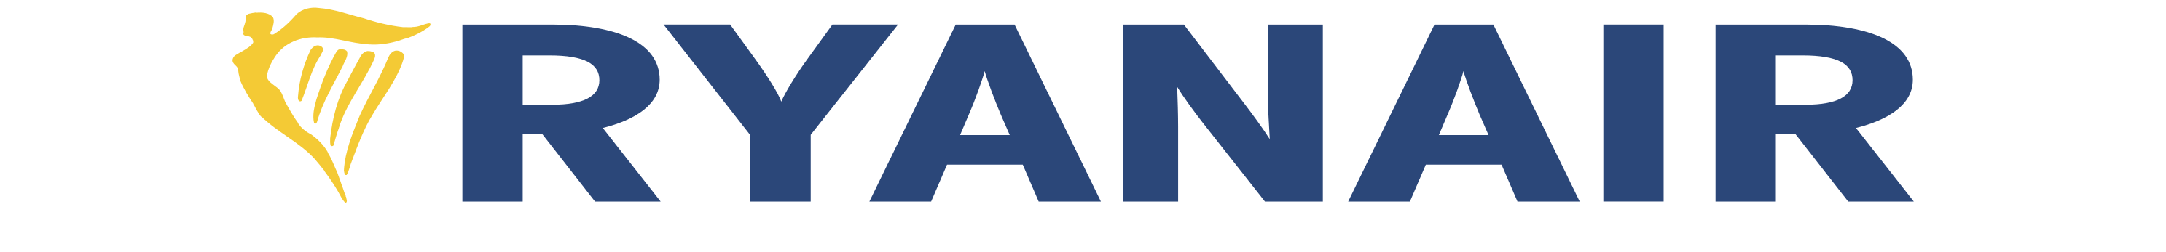

Ben Parker -2316960

BMMB7006D- Global Business Challenges
Anthony Burns

Table Of Contents
Introduction
1.0 Executive Summary
1.1 Overview of Ryanair's Position in the Airline Industry
1.2 Purpose of the Report

PESTEL Analysis
2.1 Introduction to PESTEL Analysis
2.2 Political Forces
2.3 Economic Forces
2.4 Social Forces
2.5 Technological Forces
2.6 Legal Forces
2.7 Environmental Forces

Competitive Landscape
3.1 Porter's Five Forces Analysis
3.1.2 Threat of New Entrants
3.1.3 Bargaining Power of Buyers
3.1.4 Bargaining Power of Suppliers
3.1.5 Threat of Substitute Products or Services
3.1.6 Intensity of Competitive Rivalry

SWOT Analysis
4.1 Introduction to SWOT Analysis
4.1.2 Strengths
4.1.3 Weaknesses
4.1.4 Opportunities
4.1.5 Threats

Strategic Analysis
5.1 Current Position of Ryanair
5.2 Micro-economic Decisions
5.3 Future Organisational Strategies
5.4 The Future of Ryanair and Ansoff's Matrix Application
5.4.1 Market Penetration
5.4.2 Market Development
5.4.3 Product Development
5.4.4 Diversification

Diagrams
6.1 Diagram: Ryanair Share Price Trends
6.1.2 Diagram: Ryanair Share Price Trends
6.2 Diagram: Supply and Deman Curve
6.3 Diagram: Ansoff’s Matrix Diagram

7.1 References

1.0 Executive Summary
As Ryanair's Managing Director, I will be assessing the external factors impacting Ryan Air. This report examines the environmental forces affecting Ryanair and aims to thoroughly examine the external factors affecting Ryanair and their potential impact on the airline industry. The analysis Includes a PESTLE Analysis as well as a SWOT Analysis and evaluation of the current Business position.

1.1 Introduction:
Ryanair, as a leading low-cost airline, operates in a dynamic and competitive environment. To sustain and enhance its market position, it is essential to understand and adapt to the ever-changing external influences and factors.
1.2 Purpose of the Report
The purpose of this report is to assess the current environmental forces acting on Ryanair, its position in the global business landscape, and the positive and negative effects this may have on Ryanair.
2.1 Introduction to PESTEL Analysis
Below the impacts acting on Ryanair will be split into a PESTEL analysis, a PESTEL Analysis breaks down the influences on a business into 6 Subcategories, Political, Economic, Social, Technological, Environmental and Legal. In doing this it will enable a comprehensive consideration of all business-influencing factors.
Originally designed as the ETPS system by Francis J. Aguilar in 1964 and eventually evolving into the PESTLE analysis by the 1980s (Aguilar,1964), its use in business is well documented and will be applied to Ryanair.
2.2 Political Forces
International political forces affecting Ryanair include taxation on revenue and compliance with aviation policies such as the Hague Convention, Vienna Protocol, and Warsaw Convention. The Warsaw Convention holds airlines responsible for luggage damage and accidents during flights, while the Hague Convention addresses unlawful seizure of aircraft and child abduction. The recent COVID-19 pandemic further highlighted the influence of international policies, leading to a £701 million loss for Ryanair due to travel bans and changes in air travel policies (The Guardian, 2021)
A result of Britain’s Exit from the European Union, this will bring in numerous regulatory changes to Air travel in the form of Visa’s and further regulations in the coming years. This may also have a detrimental impact on routes, schedules, and operations.
Furthermore as the location of Ryanair is based in Dublin, Republic of Ireland, this may cause disruption to services in the UK and its flights into Europe, these regulatory changes will lead to increased wait times and bureaucracy between UK and EU Airports, which may leave some Customers with negative sentiments towards the “no frills” travel.
2.3 Economic Forces
For Ryanair, Global Economics are vital to success, As previously mentioned, because of the COVID-19 pandemic, Ryanair Passenger numbers dropped by 99% In 2020 (Ryanair, 2021). The pandemic caused serious disruption across the world and left many longing for a holiday; now that the illness is in the news less and less, as shown in diagrams 6.1 and 6.1.2, the Share price of Ryanair holdings has increased 104% between May 2020 and December 2023, Higher than pre-pandemic prices at the time of writing.

The deteriorating economic environment, often referred to as the "cost of living crisis," marked by rising inflation, stagnant wages, and ongoing conflicts in Ukraine and the Israel-Palestine region; those of which are spreading into the Red Sea and causing problems with the global supply chain with many cargo vessels ceasing operations, putting more pressure on an already unstable Air Cargo Operations. As a result, the efficiency of airfreight is further compromised, affecting passenger air travel routes. (Thomas, C, BIFA YFN, 2023)
In addition, with a population with less disposable income they are becoming increasingly unlikely to travel on holiday. Despite being a low-cost airline, offering affordable flights is just one part of the equation. If consumers lack the disposable income to enjoy holidays, they may opt for more local getaways or choose not to travel at all, affecting Ryanair's business.
The Ongoing Ukraine Conflict has left a supply shortage of Russian Oil, as Global bodies have sanctioned Russia and its citizens, Russia has retaliated and cut off the world from its oil exports, as a result, the supply of oil is being strangled with reports of Saudi-Arabia artificially limiting the supply of oil to drive the price up,( Masud, F, BBC News, 2023) using simple supply and demand (6.2), this has led to price increases of Oil derived products such as Petrol and Diesel, as well as Jet Fuel (Comprised of Mostly Kerosene, a crude oil byproduct), this cost increase of Fuel has to be passed on to customers or it is an effective loss, Ryanair must engage in contingency Efforts such as cost hedging to keep costs as low as possible for the end user. In addition, it may be beneficial for Ryan Air to consider following in the footsteps of Virgin Atlantic and using a sustainable alternative, a possibility that is explored later in the report.
Ryanair's main rival, EasyJet, significantly lags in size. Ryanair boasts a fleet of 558 planes compared to EasyJet's 279. Additionally, Ryanair operates in 230 airports, while EasyJet serves only 138. Reflecting its larger scale, Ryanair achieved a gross profit of £9.3 billion in comparison to EasyJet's £3 billion.
The notable difference is expected, Ryanair served a total of 142 million passengers, while EasyJet served 8 million. EasyJet follows a "Low-cost+" model, aiming to be as cost comparative to Ryanair as possible but with added benefits such as more generous baggage allowances, more comfortable seating arrangements, and improved customer service. This strategic differentiation becomes crucial for EasyJet to offset the challenges posed by its smaller size when compared to Ryanair.

2.4 Social Forces:
Changes in consumer preferences post-COVID-19 require Ryanair to reassess its service offerings, including luggage options, seat selection, fast boarding, airport lounges, and in-flight services. While maintaining the essence of a budget airline, it is crucial to acknowledge that customers may accept limited customer service as part of the trade-off for lower ticket prices. However, hidden costs, subpar experiences, or compromises in safety are factors that customers are unwilling to tolerate. Balancing affordability with quality and transparency becomes pivotal in adapting to evolving consumer expectations.
With the growing focus on corporate responsibility and boycotting of products and service which disregard the environment and a rise in participants in activist groups such as Just Stop Oil. Ryanair needs to address environmental concerns. The push for low carbon emissions is more significant now more than ever, and stakeholders are closely watching, especially when Virgin Atlantic are making major inroads into helping reduce emissions and attempting to become net zero Virgin Atlantic had set a goal to achieve net-zero carbon emissions by 2050(Virgin Atlantic, 2023), In response, Ryanair aims for net-zero carbon emissions by 2030 and 12.5% sustainable aviation fuel use. The airline must keep pace with innovations such as electric planes, sustainable fuel used across all routes and digital boarding passes to avoid falling behind in an industry moving towards sustainability.
2.5 Technological Forces:
Technological advancements, particularly in an increasingly digital world impact both customers and Ryanair. While these developments can lead to more efficient systems, they can also render equivalent traditional systems obsolete. For example, the digital boarding pass has streamlined the check-in process, reducing the need for staff managing large groups of customers checking in. When implemented correctly, these advancements create a smoother experience for end-users. However, recent customer backlash has been highlighted due to charges for using a digital boarding pass, although Ryanair denies this practice (BBC, 2023).
The aviation industry faces mounting pressure to adopt sustainable technologies like electric-powered aircraft. EasyJet's collaboration with Wright Electric on the Wright-1, an electric plane set for use by 2032, highlights the push for investment in eco-friendly options. While Ryanair currently operates the 737-800 and 737-MAX8, adapting to electric vehicles may become necessary given industry trends and competition. For short-haul flights, like those across the Irish Sea or London to Paris, a short-range, low-capacity electric aircraft could be an ideal fit.
With the post-pandemic shift to virtual meetings, enticing multinational companies back to business flights poses a challenge for airlines like Ryanair. To differentiate itself, Ryanair could explore offering premium services, such as quiet partitions or exclusive seating arrangements for business passengers willing to pay extra. To optimise seat utilisation, Ryanair could implement dynamic pricing, selling any unsold premium seats at reduced rates closer to the flight date. This strategy ensures flexibility and maximises revenue potential.

2.6 Legal Forces:
The aviation industry is subject to a myriad of regulations, ranging from safety standards to environmental requirements, as previously mentioned, Various conventions and regulations apply to aviation such as those implemented by the FAA (Federal Aviation Administration) and compliance is non-negotiable, failure to comply with these requirements will result in harsh penalties for Ryanair and will not be perceived well in the eye of the public which would damage Ryan Air’s reputation. Any aviation company caught cutting corners makes a bad name for itself, with Southwest Airlines of America being outed by a whistleblower who stated that the airline had allegedly cut corners when calculating safety buffers concerning luggage weight in the hold, resulting in the FAA Proposing a Fine of $3.92 million.
Ryan Air could look to join IATA (The International Air Transport Association) which while it does not have legal authority in the sense of being a governmental body, its influence within the aviation industry is significant. It sets standards for areas such as safety, security, efficiency, and environmental sustainability, and its guidelines are widely followed by airlines worldwide. Airlines voluntarily become members of IATA to access its services, benefit from industry collaboration, and adhere to its established practices and standards.
In summary, legal factors have a profound impact on Ryanair's operations, requiring the airline to stay informed about changes in regulations, ensure compliance, and establish robust legal frameworks in its contracts and business practices. Failure to address legal considerations can lead to legal challenges, financial penalties, and potential damage to the airline's reputation.

2.7 Environmental Forces
The aviation industry, including Ryanair, faces increased scrutiny due to environmental concerns and international agreements like the Paris Agreement, which aims for net-zero emissions by 2030 (United Nations, 2023). Compliance is mandatory for all airlines, making early adopters advantageous in navigating sustainable technologies like hybrid jet engines, Alternative, sustainable and synthetic fuels, and electric planes and helping to set them apart from other airlines in the eyes of the consumer.
In the current era, climate-conscious organisations, and individuals (Such as Jack Sweeney, who went viral on platforms for showing the environmental impact of celebrity travel). The environmental impact of airlines has never been more in the public eye than it is now. (Rains, T, 2022)
This practice aims to raise awareness about the carbon footprint associated with air travel, encouraging public figures and the general public to consider more sustainable transportation options. As companies increasingly prioritise positive environmental impact, this shift is taking a significant role on the global stage.
Beyond emissions, Ryanair's expansion affects local biodiversity and ecosystems. This report will explore ways to minimise negative effects and potentially contribute to conservation efforts.
As Ryanair grows and introduces more routes, noise pollution concerns escalate. While airport noise is widely accepted, new destinations may raise issues for previously unaffected stakeholders. Non-compliance could lead to sanctions, fines, and operational restrictions.

Despite being a minor concern compared to expansion, Ryanair must address environmental impacts on local ecosystems. Mitigation measures, including wildlife management and habitat preservation, may be necessary. Given Ryanair's focus on secondary airports, investing in infrastructure improvements becomes imperative for both environmental responsibility and operational efficiency.
In a comprehensive overview, Ryanair operates within a dynamic landscape influenced by a number of factors:
- Political: Navigating regulatory compliance and considering the implications of Brexit are critical aspects of Ryanair’s operations.
- Economic: Ryanair’s financial performance is significantly impacted by the ever-changing global economic conditions and fluctuations in fuel prices.
- Social: Adapting to evolving consumer preferences, particularly in the aftermath of the COVID-19 pandemic, is a paramount aspect of Ryanair’s strategy.
- Technological: Embracing digital transformation and continually modernising the aircraft fleet and operational processes are imperative for maintaining competitiveness.
- Legal: Strict adherence to aviation regulations, compliance with competition laws, and honouring contractual agreements are non-negotiable in Ryanair’s operations.
- Environmental: The challenges and opportunities presented by climate change, emissions reduction, noise pollution, biodiversity impact, and sustainable aviation technologies are integral considerations in Ryanair’s business strategy.
Effectively navigating this multifaceted landscape demands strategic foresight, rigorous regulatory compliance, and an initiative-taking stance toward sustainability and social responsibility. As Ryanair strive to maintaining its competitive edge, addressing emerging challenges is a fundamental aspect of the commitment to excellence.

3.1 Porter's Five Forces
Porter's Five Forces analysis assesses the competitive forces within an industry Originally Devised by business Mogul Michael Porter in 1979 (Porter, M.E, 1979), it is still a vital tool used by businesses even today to assess the intensity of competition and attractiveness of the market. Below is a Porter's Five Forces analysis for Ryanair:
3.1.2 Threat of New Entrants:
- Low: The airline industry has high entry barriers due to substantial capital requirements for aircraft, regulatory approvals, and infrastructure. Existing major players have established brand recognition and extensive route networks, making it difficult for new entrants to compete on a large scale, for a new entrant into the budget airline to be successful, it would need to be an existing business diversifying into Airlines, essentially what was the case was with Virgin Atlantic in 1984(Virgin Atlantic, 2023)
3.1.3 Bargaining Power of Buyers (Customers):
- High: Customers, particularly in the low-cost airline sector, have significant bargaining power. There are various options available to consumers, making price sensitivity a key factor, however, brand loyalty and the cost of switching can mitigate this power to some extent but by adding too many options and extras, these costs have to be passed to consumers, which will drive them away, in this sector of budget airlines, the price is the first, second and third consideration of its consumers.
3.1.4 Bargaining Power of Suppliers:
- Moderate: Aircraft manufacturers like Boeing and Airbus hold some power due to the limited number of suppliers for large commercial aircraft. However, the bargaining power of suppliers is moderated by the fact that airlines often make Large bulk purchases, and there is competition between aircraft manufacturers to cater to the Airline's demands, in the case of Ryanair, Boeing holds more power than Airbus because Ryanair’s entire fleet is made up of two models of Boeing’s aircraft to keep costs down and ensure simplicity and parity between flights for pilots switching aircraft, as they will be familiar with a particular brand, and the costs of switching may incur extra training costs, which would have to be considered if Ryanair were to switch to airbus models of aircraft as well as a large contract and discount to make the switch
3.1.5 Threat of Substitute Products or Services:
- Moderate: The threat of substitutes is moderate. While other modes of transportation such as trains and buses can be substitutes for short-haul flights, air travel remains the preferred choice for long distances and has very little threat of substitutes, However, in certain cases, travellers might choose alternatives based on convenience or cost such as flights across the Irish Sea where a Ferry is available, or across to France from the UK, where the Eurotunnel is available
3.1.6 Intensity of Competitive Rivalry:
- High: The airline industry is intensely competitive, with multiple low-cost carriers and traditional airlines all competing for market share and price wars, frequent route expansions, and aggressive marketing are common strategies. The focus on cost leadership and the similarity of services increases the rivalry among competitors with price being Ryanair’s main Competitive edge, with short-haul flights coming in as low as £15, it is not often they are beaten on a last-minute getaway, however, the conditions and terms of which this flight is conducted sometimes leaves much to be desired, such as early morning hour landings, parties being unable to choose their seats, limited luggage capacity and landing in remote airports.
Ryanair operates in an industry defined by high competition and low-profit margin. The low-cost carrier model has contributed to increased rivalry and price sensitivity among customers. While the threat of new entrants and substitute products is low, bargaining power lies with buyers and, to some extent, with suppliers. Overall, Ryanair's success hinges on maintaining cost leadership, operational efficiency, and differentiation to address the intense competitive forces within the airline industry from the likes of EasyJet and Vueling.
Ryanair endeavours to set itself apart from other airlines by infusing cheekiness into its social media presence. This approach aims to establish the airline as an endearing and personable brand. Notably, they executed a memorable stunt featured on Twitter, granting an individual a complimentary ticket for a holiday with friends.

4.1 Introduction to Swot Analysis
Below is a SWOT Analysis conducted on Ryanair, A SWOT is an analysis tool used to assess the internal strengths and weaknesses of a company, and the external threats and opportunities available to the business.
4.1.2 Strengths:
- Low-Cost Model: Ryanair's low-cost business model allows it to offer competitive prices, attracting a large customer base, typically targeting fiscally aware consumers with no added extras.
- Extensive Route Network: The airline has an extensive network covering multiple destinations, providing travellers with a wide range of options.
- Operational Efficiency: Ryanair is known for its operational efficiency, quick turnaround times, and high aircraft utilisation, contributing to cost savings.
- Strong Market Position: Ryanair is a leading low-cost carrier in Europe, enjoying a strong market position and brand recognition.
- Innovation and Adaptability: The company has a history of innovation, adapting to changing market conditions, and implementing cost-effective strategies.
4.1.3 Weaknesses:
- Customer Service Perception: Ryanair has faced criticism for its customer service, including charges for additional services and the perception of a no-frills experience.
- Over-Reliance on Ancillary Revenues: The airline heavily relies on ancillary revenues, such as fees for baggage and priority boarding, which can be a point of contention with customers and not a consistent stream of revenue.
- Limited Business Class Offering: The focus on low-cost travel means limited services for business-class travellers, potentially missing a premium segment of the market.
4.1.4 Opportunities:
- Market Expansion: Opportunities exist for further market expansion into new regions, capturing additional market share and diversifying revenue streams.
- Partnerships and Alliances: Forming strategic partnerships or alliances with other airlines can open new opportunities for code-sharing and route expansion.
- Sustainability Initiatives: Investing in sustainable aviation technologies and adopting eco-friendly practices can enhance Ryanair's reputation and attract environmentally conscious travellers.
- Air Transport bodies: Ryanair can look to join IATA, to gain the benefits from access to key information and international advocacy as well as assistance with environmental initiatives.
4.1.5 Threats:
- Intense Competition: The airline industry is highly competitive, and increased competition, especially from other low-cost carriers, poses a threat to market share.
- Fuel Price Volatility: Fluctuations in fuel prices can impact operational costs, affecting profitability and financial performance.
- Economic Downturns: Economic uncertainties and downturns can lead to reduced consumer spending on travel, affecting the demand for Ryanair's services.
- Regulatory Changes: Changes in aviation regulations, particularly post-Brexit, can introduce complexities and challenges for Ryanair's operations.
- Wars: With growing political instability in Ukraine, Palestine and the Red Sea Region, growing tensions may disrupt routes and operations as well as increase charges (war risk surcharge).The war surcharge is a fee that some airlines and shipping companies may apply to cover additional costs or risks associated with operating in regions deemed to be at higher risk of war or other geopolitical conflicts. This may price out Ryanair if the need to apply war risk charges becomes necessary.

The aviation industry is a dynamic and fiercely competitive industry demanding strategic planning to navigate through constantly evolving market conditions. Ryanair, a leading low-cost carrier in Europe, has strategically positioned itself as a major player.
Below is a comprehensive strategic analysis of Ryanair's current position in the international market, delves into past micro-economic decisions, and provides insights into potential future organisational strategies.

5.1 Ryanair's Current Position:
Ryanair presently holds a strong position in the international airline industry, renowned for its low-cost business model and operational efficiency, the airline has successfully captured a substantial market share and emerged as the preferred choice for price-sensitive travellers in Europe. Ryanair's expansive route network, aggressive expansion strategies and unwavering commitment to being the cheapest airline for short-haul flights have collectively contributed to its market dominance.

5.2 Micro-economic Decisions:
The adoption of a low-cost model stands as one of the central micro-economic decisions driving Ryanair's success, by meticulously minimising operational costs through practices such as high aircraft utilisation and swift turnaround times, Ryanair has positioned itself as a cost-efficient airline capable of offering competitively low-ticket prices. this strategic decision not only attracts a large customer base but also fortifies the airline against economic downturns, allowing it to endure periods where consumers do not have disposable income.
A key strategy employed by Ryanair revolves around the monetisation of ancillary services such as charging fees for services like baggage and priority boarding has allowed the airline to maintain its low base fares while simultaneously generating supplementary revenue streams, however, this decision has not been without its challenges. The imposition of additional charges has occasionally led to customer dissatisfaction, creating a negative perception of Ryanair’s no-frills experience and creating a False sentiment that Ryanair is attempting to rip off its customer.
Operational efficiency has been a consistent focus for Ryanair. The airline's commitment to quick turnaround times and high aircraft utilisation aligns seamlessly with its low-cost model, directly contributing to cost reduction. This Operational decision reinforces the airline's competitiveness in the market, ensuring it can provide affordable travel options while maintaining profitability, crucial on the slim margins that Ryanair are operating its aircraft for.
5.3 Future Organisational Strategies:
Looking ahead, one potential strategy for Ryanair could involve further market expansion and diversification into new regions. This might encompass entering emerging markets or forming strategic partnerships to access new routes, aiming to capture additional market share and diversify revenue streams. By expanding its global footprint, Ryanair can mitigate risks associated with reliance on specific regions and capitalise on emerging opportunities, like for example, it has recently been reported that Ryanair is interested in exploring the market of low-cost accommodation, and would be on-brand for its business model, it has already implemented the “Rooms” section of its website pulls hotels from Experian, however Ryanair may be interested in pursuing a similar format to that of Tui, who have their own branded hotels and packages.
The global emphasis on environmental sustainability previously mentioned suggests that Ryanair might consider investing in sustainable aviation technologies. This could involve adopting eco-friendly fuels or incorporating more fuel-efficient aircraft into its fleet such initiatives not only appease changing consumer preferences but also international efforts to reduce carbon footprints in the aviation industry and embracing sustainability can enhance Ryanair's corporate social responsibility profile and appeal to environmentally conscious travellers as well as price sensitive travellers.

Addressing historical criticism of customer service could be a strategic focus for Ryanair in the future. Initiatives to improve the overall customer experience, such as offering more services bundled into the base fare or revisiting the fee structure may be considered and by enhancing customer satisfaction Ryanair can strengthen brand loyalty and potentially attract a broader customer demographic, however, this should be approached with care as too many revisions or services bundled into the base fare will drive up its price and dissuade the price sensitive consumer, many of which go to Ryanair specifically for the price and not the extra services on offer.
Forming strategic alliances with other airlines presents an intriguing opportunity for Ryanair. Such alliances could involve code-sharing agreements, shared resources, and expanded route networks, which Ryanair has said is inevitable that major flight operators such as BA (The Guardian, 2014) rely on Ryanair for short-haul connections and engage in collaborative efforts with other carriers in regards to Code sharing between national carriers and could contribute to increased operational efficiency and potentially lower costs for the consumers and Airlines.
5.4 The Future for Ryanair and Ansoff’s Matrix
In the future, Ryanair's micro-economic decisions may adapt to post-Brexit aviation regulations, requiring adjustments in compliance, route planning, and operations. Navigating regulatory changes is crucial for sustained operational excellence.
To address customer feedback, Ryanair may innovate ancillary services, potentially introducing flexible pricing or loyalty programs to enhance satisfaction and maintain revenue. Balancing affordability and enhanced services are pivotal for customer retention.
Continued technology investment is essential for Ryanair's future decisions. Advancements in digital services, online platforms, and innovative technologies will drive operational efficiency and improve the customer experience in a digitised market.
Ansoff's Matrix (Ansoff, HI, 1965) is a strategic planning tool that helps businesses determine their growth strategies. The matrix consists of four growth strategies: Market Penetration, Market Development, Product Development, and Diversification, originally developed in 1965 by H Igor Ansoff, the matrix presents 4 methods of analysing and planning their growth strategies and is structured around two key dimensions: products and markets.
5.4.1 Market Penetration:
This strategy involves selling more of the existing services (low-cost air travel) to the current market (European and short-haul flights).
Application to Ryanair: By introducing loyalty programs, expanding routes in existing markets, or offering promotions to attract more passengers could be ways for Ryanair to penetrate its current market further, as mentioned previously in the report this should be considered with care as deviating from the cost leadership model could prove dangerous fiscally.

5.4.2 Market Development:
This strategy involves entering new markets with existing products or services.
Application to Ryanair: Ryanair could explore opportunities in new regions or countries where there is potential for growth in the demand for low-cost air travel. This might involve expanding its services to long-haul flights or targeting underserved regions; however, this is potentially the most difficult growth method as it relies on Ryanair striking gold or directly competing with other airlines for market share.
5.4.3 Product Development:
This strategy involves developing new products or services for existing markets.
Application to Ryanair: Introducing new services or features, such as premium cabins, in-flight entertainment, or partnerships with other travel-related services and expansion into more business-oriented services all of which could be avenues for product development within its current market.
5.4.4 Diversification
This strategy involves entering new markets with new products or services.
Application to Ryanair: Diversification could involve venturing into related industries, such as travel packages, hotel bookings, or ground transportation services. It could also involve exploring new business models, such as partnerships with travel technology companies, this method was previously discussed in the report and explored the market of budget hotels and rooms, which when packaged with low-cost flights could evolve into low-cost holidays.
Ryanair’s social media presence is widely viewed, and their cheekiness is aimed at a younger demographic who are looking to travel with friends, by looking at diversifying to package holidays for young people, this may help improve their continued success.
In summary, Ryanair's current success reflects its adept use of a low-cost model and strategic decisions. Future strategies will focus on balancing cost leadership, addressing customer concerns, adapting to regulations, and embracing sustainability and technology. The airline's economic choices will be crucial in navigating the dynamic airline industry, ensuring lasting success, and responding to emerging challenges. Achieving this will shape Ryanair's future trajectory and ensure long-term success in the international market.

Diagrams
6.1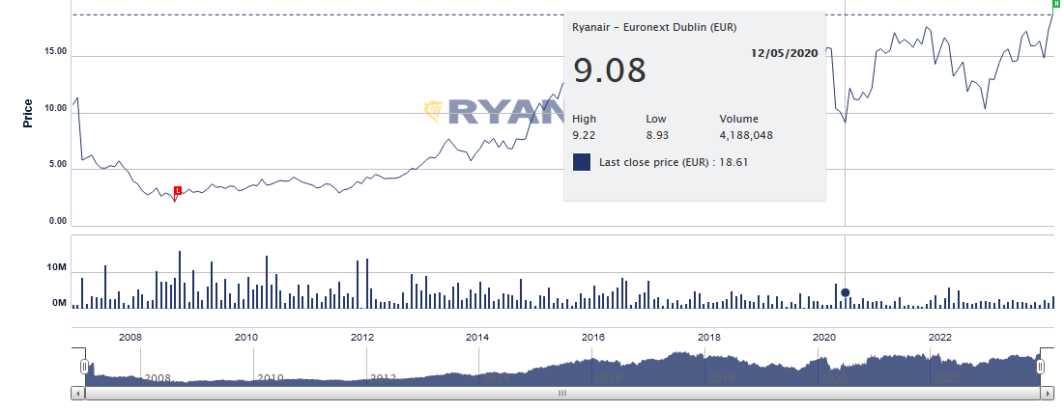
6.1.2

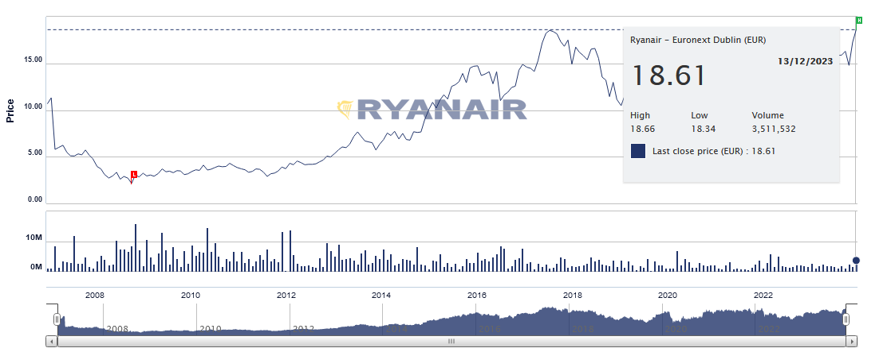
6.2
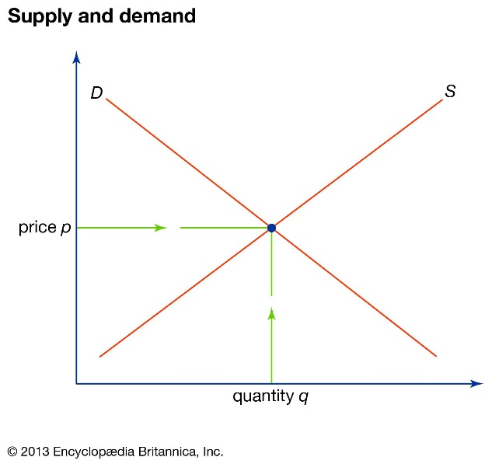
6.3
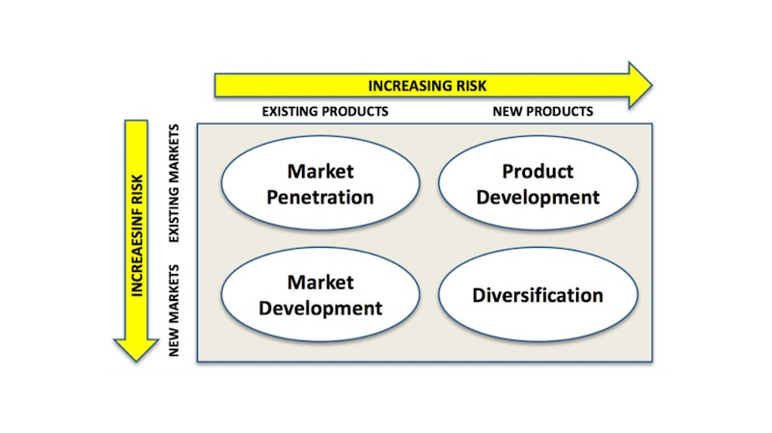

7.1 References

Ansoff, H.I. (1958) ‘A model for diversification’, Management Science, 4(4), pp. 392–414. doi:10.1287/mnsc.4.4.392.
Ansoff, H.I. (1965) Corporate strategy: An analytical approach to business policy for growth and expansion. New York: McGraw-Hill.
Austin, L.H.& K. (2023) Ryanair denies passengers must pay to download boarding pass, BBC News. Available at: https://www.bbc.co.uk/news/business-67613343 (Accessed: 15 December 2023).
Blackburn, N. et al. (2023) EasyJet vs Ryanair: The battle to be the stingiest airline on Planet Earth, SANspotter. Available at: https://www.sanspotter.com/EasyJet-vs-ryanair/ (Accessed: 14 December 2023).
Domonoske, C. (2023) Why oil prices are relatively high right now, NPR. Available at: https://www.npr.org/2023/10/03/1203416504/why-oil-prices-are-relatively-high-right-now (Accessed: 14 December 2023).
Ellis, C. (2023) How close are we to electric planes? – air charter service, Air Charter Service United Kingdom. Available at: https://www.aircharter.co.uk/about-us/news-features/blog/how-close-are-we-to-electric-planes (Accessed: 14 December 2023).
Hague Convention: International child access (2023) Kabir Family Law. Available at: https://www.kabirfamilylaw.co.uk/international-child-access/ (Accessed: 14 December 2023).
Irving, C. (2020) Southwest Airlines allegedly cut corners, pilots struggled to get planes to take off, The Daily Beast. Available at: https://www.thedailybeast.com/southwest-airlines-allegedly-cut-corners-pilots-struggled-to-get-planes-to-take-off?ref=scroll (Accessed: 14 December 2023).
Masud, F. (2023) Oil cartel leader says demand expected to grow, BBC News. Available at: https://www.bbc.co.uk/news/business-66985654 (Accessed: 15 December 2023).
Our mission to net zero by 2050 (2023) Our mission to net zero by 2050 | Virgin Atlantic. Available at: https://corporate.virginatlantic.com/gb/en/media/press-releases/our-mission-to-net-zero-by-2050.html (Accessed: 15 December 2023).
Our news (2021) Ryanair Reports Q1 Loss Of €185m As Traffic Falls By 99% – Ryanair’s Corporate Website. Available at: https://corporate.ryanair.com/news/ryanair-reports-q1-loss-of-e185m-as-traffic-falls-by-99/ (Accessed: 15 December 2023).
Our story (2023) Our story | Virgin Atlantic. Available at: https://corporate.virginatlantic.com/gb/en/our-story.html (Accessed: 14 December 2023).
Porter, M.E. (1989) ‘How competitive forces shape strategy’, Readings in Strategic Management, pp. 133–143. doi:10.1007/978-1-349-20317-8_10.
Rains, T. (2022) How Elon Musk, Donald Trump, Taylor Swift, and others are trying to dodge jet tracking, Business Insider. Available at: https://www.businessinsider.com/how-celebrities-like-elon-musk-taylor-swift-dodge-jet-tracking-2022-11?r=US&IR=T#so-its-not-a-surprise-celebrities-are-trying-to-dodge-jet-trackers-but-it-isnt-easy-19 (Accessed: 15 December 2023).
Ryanair Company profile - office locations, competitors ... - craft. Available at: https://craft.co/ryanair (Accessed: 14 December 2023).
Ryanair reports record £701m loss after Covid forced it to slash flights (2021) The Guardian. Available at: https://www.theguardian.com/business/2021/may/17/ryanair-loss-covid-flights-vaccine (Accessed: 15 December 2023).
Ryanair says Spring 2020 was worst spell in airline’s 35-year history (2020) The Independent. Available at: https://www.independent.co.uk/travel/news-and-advice/ryanair-coronavirus-passengers-boeing-737-max-a9639271.html (Accessed: 15 December 2023).
Ryanair tie-up with amadeus paves way for codeshare deals with national carriers (2014) The Guardian. Available at: https://www.theguardian.com/business/2014/sep/24/ryanair-amadeus-deal-flight-sharing (Accessed: 15 December 2023).
Share price (2023) Ryanair. Available at: https://investor.ryanair.com/investors-shareholders/share-price/ (Accessed: 14 December 2023).
Statista Research Department (2023) Number of ryanair passengers 2011-2023, Statista. Available at: https://www.statista.com/statistics/864922/ryanair-annual-passenger-figures/ (Accessed: 14 December 2023).
Supply and demand (2023) Encyclopædia Britannica. Available at: https://www.britannica.com/money/topic/supply-and-demand (Accessed: 14 December 2023).
Sustainability: Ryanair’s corporate website (no date) Sustainability | Ryanair’s Corporate Website. Available at: https://corporate.ryanair.com/sustainability/ (Accessed: 14 December 2023).
The Paris Agreement (2015) United Nations. Available at: https://www.un.org/en/climatechange/paris-agreement (Accessed: 14 December 2023).
Wright, (2023) Aircraft. Available at: https://www.weflywright.com/aircraft (Accessed: 15 December 2023).

Word Limit- 4728/5000

