Executive Summary
The report aims to analyze the leadership approach of Wang Wei as the Chief Executive Officer(CEO) of S.F. Express. In addition, this report includes four parts. The first part is the background information. It introduces Wang Wei’s character and the management mode of S.F. Express, which will be conductive to the follow-up analysis of Wang Wei’s leadership and management approach. The second part is leadership and management approach. It helps analyst in understanding the critical evaluation of models of Wang Wei’s leadership and management. The third part, named maximize the strengths. It makes recommendations and highlighting advisable strategies for Wang Wei. The fourth part, named minimize the weaknesses. It particularizes the limitation of Wang Wei’s leadership and management approach, which reveals the shortcomings of the method and looks forward to the future development and some of its limitations come from observation.
Introduction
Leadership is a kind of activity or a series of activities. It can observe activities occurring in a group, organization or institution, including a leader and followers. They voluntarily agree with the common goal and work together to achieve these goals (Kenneth E. Clark, Mariam B. Clark, 1996).
Leadership is the process of leading a group to lead a group of people to pursue the goals held by a leader or to be shared by the leader and his or her followers (John Gardner, 1993).
Leadership is a process of social impact, in which one can get the help and support of others to accomplish a common task (Martin Chemers, 2014).
Based on the above definitions of leadership, form several theories and consideration, this report believes that the most important thing in leadership is: In the pursuit of the same task or goal, the leader has the ability to make his or her followers do what they don't want to do and do it well.

Main Findings
- Background Information
1.1 Background Information：the Company Profile

SF EXPRESS Co., Ltd. was established in 1993.
1993-1997, the company was at the beginning of the business, mainly in the Pearl River Delta region, while actively expanding the other domestic markets.
1997-2002, the company was in the period of business integration. The management of the company is reintegrating the business, changing from the original franchise mode to the "direct business" mode, and the local branches are unified by the headquarters, so as to enhance the leadership and control ability of the headquarters.
2002-2007, the company entered the stage of management optimization
2007-2018, the company is in the leading stage of competition, and has established a good brand in the market. It covers 31 provinces, autonomous regions, municipalities directly under the central government, more than 300 cities and more than 1900 county-level cities, with an income of up to 30 billion yuan (S.F. Express Official Website, 2018).

  - Background Information：Chief Executive Officer（CEO）
——Wang Wei

In the view of Liu Sen, the former chief executive of S.F. Express, Wang Wei is the richest man he has ever seen, which is mostly due to the career habits that Wang Wei had retained in the early days of his pioneering work. Without innovation and change for two months, he will have a feeling of danger (Li Lan,2014).
In 2013, the number of S.F. EXPRESS employees increased by more than 50 thousand (Li Lan, 2014). In order to manage such a large number of employees in the whole country, besides the process and institutionalized external leadership, Wang Wei also pays attention to the staff's internal leadership and the most important thought in his leadership is using his "Four-heart Secret" (China Daily, 2011).
The first is love. Wang Wei stressed that the premise of love is true heart. It is particularly important to care about and care for employees and colleagues around the family like feelings. As a leader, once the leader has love, the leader will put himself or herself into stuffs’ position. Second is the heart of sharing. If the leaders' love of their employees is hypocritical, they will not be willing to share their success and wealth with their employees. Only if a leader has a real love, there will be a heart to share with the staff. The third is cruel heart. Wang Wei believes that Leadership is not just as simple as sharing success and wealth with staff. Like parents' expectations for their children, leaders need to let their employees receive experience, however, the process of experience may be very hard. This kind of cruel heart is not out of hatred, but the result of love and the heart of sharing. The last one is perseverance (Li Lan,2014).

- Leadership and Management Approaches

“In the early 1900’s, for what they looked at the business of their day: a seemingly mindless game of chance at which any donkey could win provided only that he be ruthless. But that is, of course, how any human activity looks to the outsider unless it can be shown to be purposeful, organized, systematic; that is, unless it can be presented as the generalized knowledge of a discipline.”
--Peter F. Drucker
2.1 Differences in leadership and management

From different perspectives, leadership has different definitions. This report agrees: Leadership is the process of the leader affecting a group to achieve common goals. (Northouse, P.G., 2016). However, definitions of management, or human resource management, are by no means identical, or even especially similar (Rees, G and French, R., 2016). Boxall and Purcell (2000) argue that ‘The management of human resources in the employment relationship of the enterprise. We do not associate human resource management with the high commitment model of labor management or any particular ideology or management style.’ On the other hand, management is work (Peter F. Drucker, 2012). Management is the special work of the modern organization, and it is the work of the modern organization. Therefore, based on leadership and management definitions, this report analysis that leadership is always connected with followership, people always follow leaders. However, management is always associated with reporting, people always report to managers. Abraham Zaleznik (1997) pointed that there are fundamental differences between managers and leaders (see the below table- Rees, G and French, R., 2016).

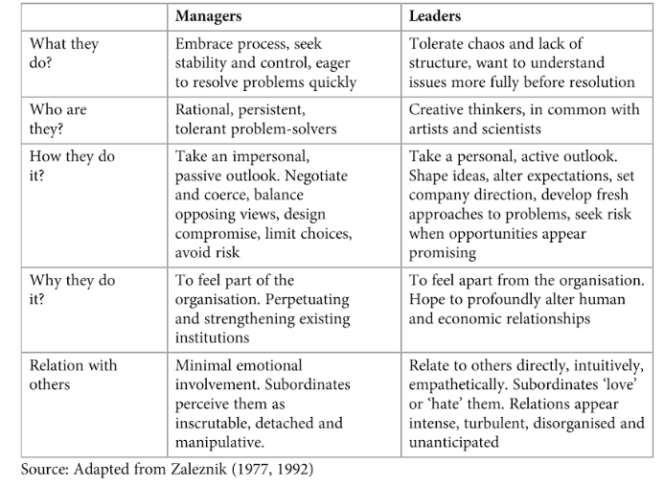

2.2 Trait Approach
The trait approach is used for individual consciousness and development. By analyzing their own characteristics, leaders can understand their strengths and weaknesses, and feel how the other people in the organization look at them (Peter G. Northouse, 2018). Based on trait approach theory, this report uses Big Five Personality Factors to analyze Wang Wei’s personality in leadership.
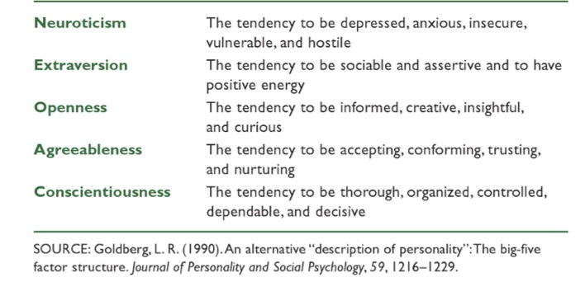

The trait approach is different from the other approaches because it focuses exclusively on the leader, not on the followers or the situation (Peter G. Northouse, 2018). This makes the trait approach more direct in theory than other approaches. In fact, trait approach focus on the quality of the leaders.

2.3 Situational Approach
The premise of the situation theory is that different situations require different ways of leadership. From this point of view, in order to become an effective leader, the leader needs to adapt to the requirements of different situations (Peter G. Northouse, 2012).
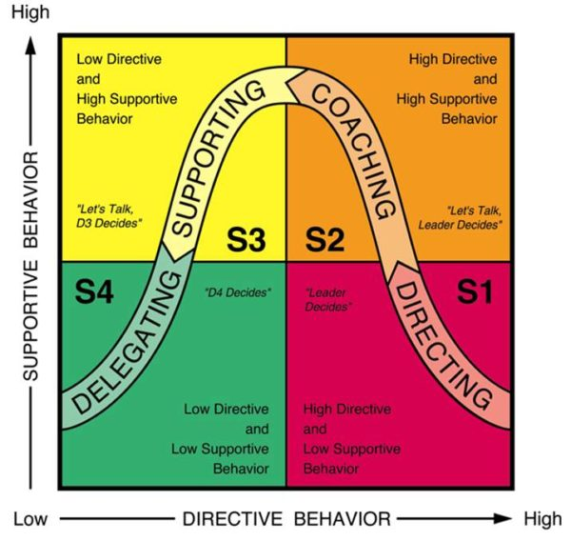

(Figure from: Situational Leadership- Go italk, 2017)
Wang Wei’s leadership is more suit in S1- Directing part. From Five-Factor Model, Wang Wei's character is prudent and trusting his staff. His character features lead to his leadership style. 1997, S.F. company is still in the franchise mode. However, Wang Wei found that under such a mode, local companies have strong rights, which is not conducive to the direct management of the head office. As a result, the model is converted to a direct model. Local companies are led by the head office, direct instructions and tasks to reduce support for local companies.

2.3.1 Development Level
A major part of the situational approach model concerns the development level of followers. Development level is the degree to which followers have the competence and commitment necessary to accomplish a given goal or activity (Blanchard et al, 2013). If the followers are interested in and confident in their work and know how to achieve their goals, they are at a high level of development. If they don't have any skills at their hands, they believe they have enough motivation or confidence to do the job.
The same situation came in S.F. Express, Wang Wei always say “The frontline couriers are the loveliest person in S. F. Express, without them, there is no S.F. Express.” (China Daily, 2011) Wang Wei regularly trains managers to discuss the latest information on the express industry and reward the employees who have done the job well. Although Wang Wei is the CEO of S.F. Express, he often works with the frontline express staff to experience the changes in their work and to develop new strategies. This can not only promote the development of the company, but also greatly improve the loyalty of employees.

- Maximize the Strengths
First, the trait approach is simple and direct. The second advantage of the trait approach is that it has almost a hundred years of historical research to support it, and possesses the breadth and depth of other theories that cannot be compared. In addition, the situational approach also has several advantages, especially for the practitioner, the first advantage is that it has withstood the time test of the market. The second advantage of situational leadership is its practicality. The leadership of the situation is easy to understand, intuitionistic and easy to apply in various environments (Peter G. Northouse, 2012).
From the perspective of employees, most of the employees in S.F. Express are not with highly educated, and have no good knowledge reserves. Through the analysis of trait approach and situational approach, they can understand Wang Wei better. From Wang Wei's point of view, these two approaches can make him understand himself better, find his new “position”, find his own shortcomings, and strengthen his own advantages.
- Minimize the Weaknesses
The following limitation point out several weaknesses of trait approach and situational leadership, then help to provide a more balanced picture to illustrate the general utility of these approaches in Wang Wei’s leadership. First of all, the most important thing is that trait approach fail to define a clear standard of leadership. Second, the situational leadership is that there are only a few studies. Study the proven options and propositions. The third weakness is the situational leadership involve the conceptualization of ambiguities in a subordinate model (Peter G. Northouse, 2012).
After all, the analysis of trait approach and situational approach are limited, and a variety of different analytical approaches will be used to better analyze Wang's leadership in order to minimize the limitation.

- Recommendations and Conclusion
In this report, the author recommends Wang Wei:
1. Become more openness
2. Give staff more support, in situational approach, develop directing part (S1) into supporting part (S3)
In this fast-growing era, people who get more information can become a winner. If Wang Wei has never been willing to communicate with others, he will lose the latest news and miss the best opportunities for development. On the other hand, if Wang Wei always adopts low support and high leadership for employees, it will not only consume his own energy, but also reduce the improvement space of employees. As an employee, it is not a machine that only obeys orders, a good employee always has critical thinking and can be able to work spontaneously. In other words, it is good leadership to be able to lead a “general” employee to become a “good” employee.
To sum up, this report uses trait approach and situational approach to analyze Wang Wei's leadership style, give advice on his way of leadership and give the author’s own idea about leadership.

- References and Bibliography
- S.F. Express Official Website (2018)
http://www.sf-express.com/cn/sc/
- Li Lan (2014) Wang Wei's S.F. Express Management-Business Circles-Page 68
- China Daily (2011) Wang Wei, Chairman of SF EXPRESS: Fear of Changing Policies
http://www.chinanews.com
- Northouse, P.G. (2016) Leadership Theory and Practice-6th Edition-Sage Publications-Page 5
- Boxall, P. and Purcell, J. (2000) Strategic human resource management: where have we come from and where should we going? -International Journal of Management Review-Vol 2, No 2. Page 183-203
- Rees, G and French, R. (2016) Leading, managing and developing people-5th Edition
https://books.google.co.uk/books?isbn=1843984377
- Peter F. Drucker (2007) Managing For Results: Economic Tasks and Risk-taking Decision-ALLIED PUBLISHERS PVT. LIMITED-Page 227 (tenth reprint)
- ZALEZNIK, A. (1977) Managers and leaders: are they different? -Harvard Business Review-Vol 55 (May-June)-Page 67-78.
- ZALEZNIK, A. (1992) Managers and leaders: are they different? -Harvard Business Review-Vol 72. No 2-Page 126-135.
- Peter F. Drucker (2012) Management: Tasks, Responsibilities, Practices
https://books.google.co.uk/books?isbn=1136006893
- Kenneth E. Clark, Mariam B. Clark (1996) Choosing to Lead
https://books.google.co.uk/books?isbn=1882197127
- John Gardner (1993) On Leadership
https://books.google.co.uk/books?isbn=0029113121
- Martin Chemers (2014) An Integratory Theory in Leadership
https://books.google.co.uk/books?isbn=1317778405
- Peter G. Northouse (2018) Leadership: Theory and Practice-8th Edition
https://books.google.co.uk/books?isbn=150636229X
- Peter G. Northouse (2012) Leadership: Theory and Practice-6th Edition
https://books.google.co.uk/books?isbn=1452203407
- Go italk (2017) Situational Leadership Figure
https://goitalk.com/situational-leadership/
- Blanchard et al (2013)- Peter G. Northouse (2018) Leadership: Theory and Practice-8th Edition
- Goldberg L.R. (1990) An Alternative “Description of Personality”: The Big-Five Factor Structure- Journal of Personality and Social Psychology-59, 1216-1229

