PROJECT MANAGEMENT
Konstantina Malamova
BA Business Management
Level 5 Term 3 Group 1

Table of Contents
Introduction 3
Discussion 3
Conclusion and recommendation 11
References 13
Appendices 15
Appendix 1: Crossrail route 15
Appendix 2: Project life cycle 15

Introduction
The essay has presented an analysis of the cross-railway project within the Elizabeth line, London UK. It has discussed the core elements associated with the project such as budget, time, stakeholders and risk factors. An analysis of the appropriateness of different project management tools has been presented. The initialisation of the project planning has been analysed with the identification of stakeholder analysis, risk matrix and financial requirement. The issues faced by the project managers while implementing the project have been evaluated with the identification of the success and failure factors of the project and eventually developed recommendations to formulate effective project management.

Discussion
Overview of the project
The cross-railway project is the largest construction project in Europe to deliver the Elizabeth line east-west railway across London. It was announced to be a 10-year programme that was outlined in 2008 and has expected to fully operate in 2019. It has been evaluated that the project got the approval in 2008 for the completion of the tunnelling in 2015 and systems and architectural finishing work whereas the msiion of the project remain constant. It is the newest railway call in London, which has aimed to increase railway capability by 10% and can bring 1.5 million people in 45 minutes of central London (Crossrail, 2022). The main construction is 26 miles railway tunnel that weaves the way through the complicated underground geography of London at a depth of upto 40 meters. The project has offered the opportunity for new employees from the local regions and has driven safety and health measures leaving a positive impact on the environment [Refer to appendix 1].
Review of the core elements of the project by evaluating project management principles, approaches and methodology
According to Gutiérrez Fernández et al. (2019), the principles of project management are the fundamental rules that need to be identified following the successful management of the project with formal structure, project sponsor, goal and outcome along with risk management. Crossrail has been projected with the principle of developing project sponsorship to provide satisfactory service to customers with hybrid frequency and with the adoption of rapid transit system to the capital suburbs of east and west London. The principle of the formal structure was adhered to throughout the project with the inclusion of procurement that can manage maximum of the contactors that has been awarded to be companies and has gained the supply base outside of London The project has principles of developing sustainable goals with more than 80% of the construction machinery being filtered with reduce of the pollution through emission of the toxic materials, whereas 98% of the material from the sites are reused taht has been wasted. This has been associated with the inclusion of 4.5 million tonnes of materials for the creation of new 600-acre nature reserves (Constructsteel, 2022). Thus, the Crossrail project is a new railway development called the Elizabeth line that represents the largest current infrastructure development in Europe formulated through agile project methodology.
The estimated time of the project was to be completed within 10 years and has come into full operation in 2019. In the financial year 2022, TfL has documented an agreement with the UK government for investment in the project worth £825 million and the current financial estimation increased by £3.8 billion more than was anticipated in 2010 (London, 2020). Major stakeholders of the project are the Mayor of London, the department for transport, engineers, staff, managers of the project, contractors, local people and workers. Moreover, the risk management principle is associated with the project due to the failure of procurement bringing 20% risk and requiring further bailouts (Cips, 2019). Thus, it brings a rise in the cost of the project structure for supply chain disruptions in the pandemic and lacking availability of sufficient resources. The principles of the project has been alined with the formulation of the project with successful agile approaches with initialisation of various phases of the project.
Critically evaluate the appropriateness of different project management tools and techniques
Project management tools and techniques are developed to increase efficiency in the delivery of the project. Analysing the nature and size of the project, tools and techniques are adopted to be utilised in phases of project implementation. They are essential drives for the attainment of the success of the business and contribute to rebooting the communication structure. Project initial documentation is the project tool that contains basic information about the project that can guide the project and layout justification of the project. It can assist the project management team to evaluate whether those project requirements are fulfilled and asset project managers to take an informed decision (Noguera et al. 2018). In project management, WBS serves as a planning tool and takes a large step-by-step approach to the completion of large projects. The adoption of the work breakdown structure can contribute to the reduction of complicated activities and control the development of the task in steps (Latief et al. 2018). CBS is an effective project management tool to break down the data cost and thus increases efficiency in the management of the project.
Resource breakdown structure is the tool approach adopted by the project managers to list out necessary resources that are required to complete each task in the project plan. It thus assists in analysing the project materials, tools and equipment along with software for the estimation of the initial budget required for the completion of the project. Risk management tools such as risk registers and risk logs have been developed to identify the risks that are associated with the implementation of the project and thus assist in the reduction or removal of the risk. Assessment of the risk is conducted with the development of a risk register that has contributed to the reduction of chances of incidents in the delivery of the project (Saeidi et al. 2019). Stakeholder management is the aspect that can be formulated with the application of a stakeholder matrix that has assisted in having a clear understanding of their high and low impact on the project and analysing their power and interest (Xia et al. 2018). It, therefore, brings a visual presentation of the individuals who have influenced the project and evaluates the aspect of how they are connected. Moreover, the scheduled management tool is applied in project management by preparing a Gantt chart that can assist in the accurate scheduling of the project activities and estimate the delivery of the project [Refer to appendix 2].
Evaluation of initial project planning through the life cycle of a project
The initialisation of the project plan ensures the beginning of the project with the identification of the project objectives, scope, purpose and deliverables. Project lifecycle theory is associated with the development of a holistic view and assists in determining the different aspects of the project. From the initialisation of the project plan, the project life cycle is the sequence of phases through which a project progresses.
Initiation phase
The first phase of the project life cycle is project conception and initialisation. The Elizabeth line has been initialised to transform travel across London and the southeast transport system has drastically shifted and researched the additional capacity to transform the accessibility with spacious designing new stations and walways in platforms. The analysis of the data gained through the research on transport requirements developed objectives to shorten the travel time and increase the capability to run 24 trains per hour.
Planning phase
The second phase is planning where the project charter has been developed, analysing the breakdown deliverables and even assisting in the determination of dependencies with assigning of resources. The Crossrail project has developed the planning by analysing the stakeholders and assessing the resources required for the completion of the project such as track laying, rail fasteners and sleepers. In the planning stage of Elizabeth, the line budget has been calculated which has increased by more than 4 billion pounds over a total cost of 18.8 billion pounds (Crossrail, 2022a). Thus the phase has contributed to developing the link between the project goal and the work that needs to be completed to achieve them.
Execution phase
Execution of the project is the phase where the project team has implemented the plan by putting them into action. The project of the Elizabeth line was approved in 2007 and the construction began in 2009 within the central section and executed the plan to connect existing lines that become part of the route. In 2016, the project programmed the surface work to upgrade tracks and electrification of the key sections of the Crossrail route (Crossrail, 2022b). However, the execution stage is not fully completed and requires further strategic implementation.
Monitoring and controlling phase
The fourth phase of the project life cycle is to monitor the project with an active review of the status of the project. It even assists in evaluating potential barriers to the delay of the project and developing the strategies to implement necessary changes in the delivery of the project.
Monitoring of the ground risk and potential impact of the project over building and environment can be promoted by the project manager of Crossrail. Regarding minimising ground movement, a tunnel boring machine crew needs to be allotted to monitor the progress of the project (Crossrail, 2022c).
Closure
The fifth phase of the project life cycle is the closure which is the last phase of finalising all activities associated with the project management process. The key benefit of the process is the phase information through archived and the planned work is completed to pursue new endeavours. The Crossrail project requires the upgradation of work that requires closure over the festive period that will be published as a part of the transport for London’s wider service changes for the season.
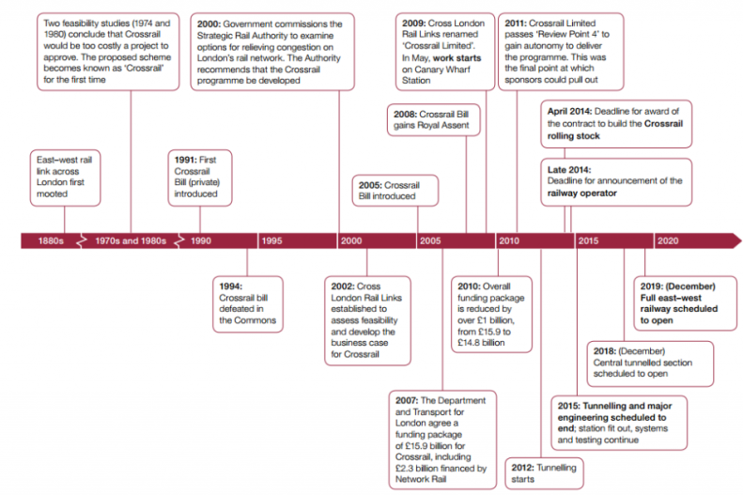
Figure 1: Project timeline
(Source: Learninglegacy, 2018)
Stakeholder Analysis
Stakeholders name | Internal/external | Power | Interest | Responsibility | Frequency
Sponsors | External | High | Low | They have the initiative to conduct the supply of raw materials and ensure the availability of resources | Monthly
Team manager | Internal | High | High | They play the role of managing the framework associated with the project | Frequently on a daily basis
Engineers | Internal | High | High | They have the responsibility to design the project for quality and efficient delivery | Weekly
Contractor | External | Low | High | Arrange the resources and allocate requires labour to formulate the project | Weekly
Project staff | Internal | Low | High | Increase the coordination with the team and manager of the project | Regularly
Newspaper and social media | External | High | High | Publishing the updated information about the implementation of Crossrail project | Weekly
Government of UK | External | High | Low | Examines the legal formalities associated with the project | Monthly
Regional people | External | Low | High | Analysis of the impact of the business | Circumstantially
Labours | Internal | Low | Low | Works in monitorship of the project staff | Regularly
Table 1: Stakeholder analysis of the Crossrail project
(Source: Self-developed)
In consideration of the above table, it can be assessed that project team members, engineers and social media have high power and high interest in the Crossrail project. The government of the UK and the sponsor have high power and low interests. Regional people of London, project staff and contractors have low power with high interest in the project. Further, labours associated with the Crossrail project have low interest and low power.
Risk Matrix
Type of risk | Risk description | Impact | Probability | Priority | Mitigation strategy
Financial risk | Lack of availability of financial investment due to exceeding budget | Moderate | High | Moderate | Adoption of the bottom-up cost estimation
Operational cost | The issue arises due to poor investment and lack of funding | Moderate | High | High | Increasing communication with investors
Resource risk | Lack of availability of resources | High | Moderate | High | Regulation in supply chain operations
Technological risk | Lack of technical experts | Moderate | Low | Low | Conduct training programme
Performance risk | Lack of capability of strategic planning | High | Low | High | Increasing collaboration with clear objectives
Table 2: Risk analysis of the Cross rail project
(Source: Self-developed)
In consideration of the above table, it can be detected that the risks associated with the Crossrail project are a poor financial investment bringing financial and operational risk that has a moderate impact with high probability and priority. Lack of availability of resources has a high impact with moderate probability and high priority. Moreover, technical issues and performance risk has been assessed as having moderate and high impact simultaneously and has detected measures to overcome them.
Financial Requirement
The project is being jointly sponsored by the UK government and the department of transport and the mayor through the transport of London. The requirement of the resources is based on the contribution of the finance and the delay of the project has increased £3 billion over budget. London business investors have significantly ranged from £2,000 million to perhaps £3,000 NPV to project ways of alternative funding mechanisms (Learninglegacy, 2019). Moreover, approximately £825 million should be used over the cost of Crossrail's central section and requires funding for network rail elements of the project which will be £18.6 billion.
Critical evaluation of success/failure factors by signifying issues in the implementation of the project
The Crossrail project has driven over its budget and has faced delays in schedules as the management team has clung to unrealistic opening dates (The Guardian, 2019). The desire was to open the tunnels by December of 2018 for the central section of the west-east railway line in London to carry passengers. The lack of fulfilment of the target has decreased the value of the project and has brought a loss of downward cost pressure. Further, the changes in the design and the scheduling have increased the cost of most of the contacts of the project along with the cost of civil engineering workers. While conducting the project with a high degree of autonomy for the sponsor of autonomy, the transport department of London has a lack of understanding about the risks in delivery and lacks to meet the deadline of December 2018 (The Guardian, 2019). in anticipation of the scheme opening phase, the project has faced the threat of rehiring the staff laid off.
A temporary pause in the construction arises due to the sudden outbreak of the pandemic that has brought the aspect that the Elizabeth line will delay by three years and cost has increased by £4bn more than the estimated budget. The sudden pandemic outbreak eliminated the schedule pressure with the constraint of how many people worked on the site and reduced the number of half to about 2,000 workers (The Guardian, 2020). It has even been evidenced that the project hoped to start the intensive testing of train services or trail running positively in 2021 whereas testing remain incomplete due to incomplete stations in bond street and are not involved in the testing phase. Thus this has brought the failure of delivery of the project on the scheduled opening date as the project has yet not been completed and could not gain success.

Conclusion and recommendation
It can be summarised from the above discussion that the Crossrail project is the largest construction project that was approved in 2007 and implemented in 2008 with a target to open up in 2018. The mayor of London and the transport foundation of London had greater authority in the project that has been raised through the Crossrail business rate supplement and community infrastructure levy. However, the project got delayed due to the pandemic outbreak and lack of focus on the attainment of objectives that eventually increased the budget of the project. The changes in the resources, labour and civil engineers have increased and added barriers to the completion of the project.
Thus, it can be recommended that the training of the project staff can assist in increasing the coordination to attain the objectives of the project. It can boost the performance of the project and enhance the quality of the project with an increase in dedication to delivering the project within the scheduled hours. An increase in communication with the sponsors has supported the involvement of the maximum finance to formulate the project. Hence, this can assist in contributing to the enhancement of the capability of the project operations with efficiency.

References
BBC, 2021. Crossrail needs an extra £450m and delayed until 2022. Available at:https://www.bbc.com/news/uk-england-london-53847738[Accessed on 7th December 2022].
Cips, 2019. Procurement is a key risk on Crossrail. Available at:https://www.cips.org/supply-management/news/2019/january/procurement-a-key-risk-on-crossrail/[Accessed on 7th December 2022].
Constructsteel, 2022. The case study of the Crossrail project with construction innovation. Available at:https://constructsteel.org/projects/case-study-crossrail/[Accessed on 7th December 2022].
Crossrail, 2022a. The project. Available at:https://www.crossrail.co.uk/project/[Accessed on 7th December 2022].
Crossrail, 2022b. Key milestones for the Crossrail project. Available at:https://www.crossrail.co.uk/news/articles/key-milestones-for-crossrail-project-during-2016[Accessed on 7th December 2022].
Crossrail, 2022c. Stabilising the ground during tunnelling. Available at:https://www.crossrail.co.uk/project/tunnelling/stabilising-the-ground-during-tunnelling[Accessed on 7th December 2022].
Gutiérrez Fernández, A.M., Rijswijk, F.V., Ruhsam, C., Krofak, I., Kogler, K., Shadrina, A. and Zucker, G., 2019, September. Applying business architecture principles with domain-specific ontology for ACM modelling: A building construction project example. In International Conference on Business Process Management (pp. 388-399). Springer, Cham.
Latief, Y., Kusumaningtyas, G.R. and Supriadi, L.S.R., 2018, December. Work breakdown structure (WBS) dictionary development for the construction works of flyover projects. In IOP Conference Series: Earth and Environmental Science (Vol. 195, No. 1, p. 012003). IOP Publishing.
Learninglegacy, 2018. Project and programme management. Available at:https://learninglegacy.crossrail.co.uk/learning-legacy-themes/project-and-programme-management/attachment/project-initiation-timeline-topic-header-png/[Accessed on 7th December 2022].
Learninglegacy, 2019. Finance funding and value capture of Crossrails. Available at:https://learninglegacy.crossrail.co.uk/wp-content/uploads/2017/09/1C-002-Finance-Funding-and-Value-Capture.pdf[Accessed on 7th December 2022].
London, 2020. Project at a glance. Available at:https://www.london.gov.uk/sites/default/files/crossrail_-_project_at_a_glance.pdf[Accessed on 7th December 2022].
Noguera, I., Guerrero-Roldán, A.E. and Masó, R., 2018. Collaborative agile learning in online environments: Strategies for improving team regulation and project management. Computers & Education, 116, pp.110-129.
Saeidi, P., Saeidi, S.P., Sofian, S., Saeidi, S.P., Nilashi, M. and Mardani, A., 2019. The impact of enterprise risk management on competitive advantage by moderating role of information technology. Computer standards & interfaces, 63, pp.67-82.
The Guardian, 2019. Crossrail delays are caused by clinging to the unrealistic timeframe. Available at:https://www.theguardian.com/uk-news/2019/may/03/crossrail-delays-caused-by-desire-to-cling-to-unrealistic-timeframe[Accessed on 7th December 2022].
The Guardian, 2020. Crossrail delay again with over budget. Available at:https://www.theguardian.com/uk-news/2020/aug/21/crossrail-delayed-again-until-2022-and-another-450m-over-budget-tfl-covid-19[Accessed on 7th December 2022].
Xia, N., Zou, P.X., Griffin, M.A., Wang, X. and Zhong, R., 2018. Towards integrating construction risk management and stakeholder management: A systematic literature review and future research agendas. International Journal of Project Management, 36(5), pp.701-715.

Appendices

Appendix 1: Crossrail route
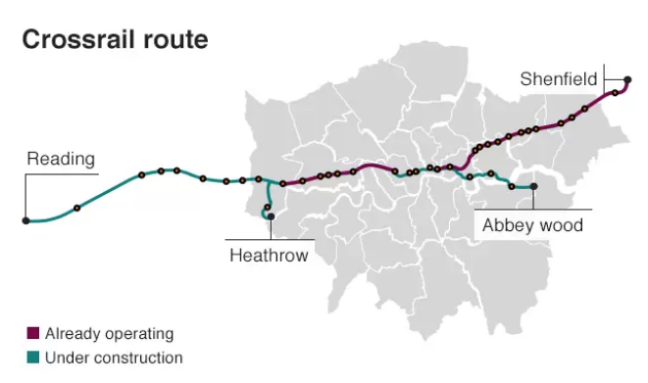
(Source: BBC, 2021)

Appendix 2: Project life cycle
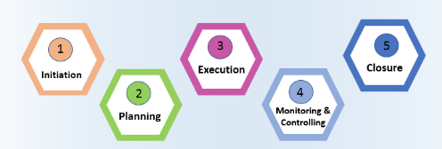
(Source: Gutiérrez Fernández et al. 2019)

