

MSc Data and Artificial Intelligence

Data Mining & Visualisation

Exploratory Data Analysis – Report

Lecture: Dr Nouh Elmitwally

Student Marin Karakolev ID: 2029731

Contents
1
1. Abstract 4
2. Introduction 5
3. Critical Literature Review 6
4. Dataset Description 10
4.1 Target Variable Distribution 10
4.2 Feature Composition 11
4.3 Critical Observations 12
4.4 Summary 12
5. Data Preprocessing 13
5.1 Missing Values Assessment 13
5.2 Outlier Detection 14
5.3 Multicollinearity Assessment 15
5.4 Feature Scaling 16
5.5 Feature Selection 17
6 Model Development 18
6.1 Logistic Regression 18
6.2 Random Forest 20
6.3 K-Means Clustering 21
7. Results Analysis and Model Evaluation 24
7.1 Performance of the Classification Models 24
7.2 Comparison of Logistic Regression and Random Forest 24
7.3 K-Means Clustering Results 25
8. Discussion of Findings 28
9. Business Recommendations 29
10. Conclusion 30
11. References 31

Table 1. WCSS values for different numbers of clusters 22
Table 2. Performance comparison of the classification models 24
Table 3. Summary of the identified customer clusters 27

Figure 1. Analytical framework for telecom customer churn prediction and retention strategy development (adapted from Ullah et al., 2019) 7
Figure 2. Distribution of churned (1) and non-churned (0) customers 10
Figure 3. Missing Values Matrix 13
Figure 4. Boxplot of totmrc Mean 14
Figure 5. Correlation Heatmap 15
Figure 6. Standardization of predictor variables using the WEKA Standardize filter 16
Figure 7. Configuration of the Logistic Regression model in WEKA using 10-fold cross-validation 18
Figure 8. Classification performance of the Logistic Regression model in WEKA 19
Figure 9. Configuration of the Random Forest model in WEKA using 10-fold cross-validation 20
Figure 10. Classification performance of the Random Forest model in WEKA 21
Figure 11. Elbow method used to determine the optimal number of clusters 22
Figure 12. Configuration and output of the K-Means model in WEKA 23
Figure 13. Configuration and output of the K-Means model in WEKA (part 2) 24
Figure 14. Distribution of customers across the five K-Means clusters 26

1. Abstract
Customer churn prediction is an important application of machine learning in the telecommunications industry, enabling organizations to identify customers at risk of leaving and support targeted retention strategies. This study aims to evaluate the performance of Logistic Regression and Random Forest for customer churn prediction and to examine the contribution of K-Means clustering for behavioral customer segmentation. Using a dataset of customer records containing ten behavioral predictor variables, the models were implemented in WEKA and evaluated using 10-fold cross-validation. Random Forest achieved the highest classification accuracy (57.85%), outperforming Logistic Regression (55.76%), while K-Means identified five distinct behavioral customer segments. Although predictive performance was moderate, the findings suggest that combining supervised classification with customer segmentation provides a broader understanding of customer churn and may support more effective customer retention strategies.

2. Introduction
Customer churn represents a major challenge for service-based industries, particularly the telecommunications sector, where customers frequently switch to competing providers. As digital technologies continue to expand across all aspects of society, telecommunications have become an essential component of modern infrastructure, making customer retention increasingly important for maintaining competitiveness and long-term business success [1].
Consequently, customer churn prediction has evolved from a purely analytical task into a strategic business objective, enabling organizations to identify customers at risk of leaving and implement targeted retention strategies. Machine learning (ML) has become one of the most widely adopted approaches for addressing this challenge because of its ability to identify complex behavioural patterns within large customer datasets [2].
Aim
To employ machine learning classification methods to determine whether a customer is likely to churn based on selected behavioral features, and to enhance this analysis through clustering techniques that reveal underlying patterns and support informed decision-making.
Objectives
- To design, implement and evaluate multiple classification models capable of categorizing customers according to relevant behavioral attributes.
- To apply clustering methods to uncover additional structures, groupings or relationships within the dataset that complement the supervised analysis.
- To critically examine the effectiveness and appropriateness of the applied techniques in relation to the dataset characteristics and analytical aims.
- To interpret and present the analytical findings clearly, ensuring that the insights generated are meaningful and applicable within real-world telecommunications contexts.

3. Critical Literature Review

Customer churn has been widely studied across service industries because retaining existing customers is generally more cost-effective than acquiring new ones. Research has therefore focused on identifying customers who are likely to discontinue a service before churn occurs by analyzing customer- and service-related indicators [10]. Within the telecommunications sector, the development of churn prediction has progressed from traditional statistical techniques to advanced machine learning algorithms, ensemble methods and, more recently, Explainable Artificial Intelligence (XAI). Although predictive performance has improved considerably, the literature does not identify a single modelling technique that consistently outperforms all alternatives. Instead, recent studies suggest that the choice of model should be guided not only by predictive accuracy but also by the characteristics of the available data, business requirements and the intended use of the results.
Early studies demonstrated that traditional machine learning algorithms, particularly Decision Tree and Random Forest, could effectively predict customer churn using Call Detail Records (CDRs). Ullah et al. (2019) proposed a structured analytical framework (Figure 1) combining feature selection, classification and customer segmentation to support customer retention planning rather than simply predicting churn.
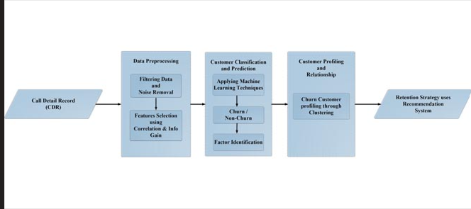
Figure 1. Analytical framework for telecom customer churn prediction and retention strategy development (adapted from Ullah et al., 2019)

The framework illustrates a sequence of data preprocessing, feature selection, classification, customer segmentation and retention strategy development. By integrating Decision Tree and Random Forest classifiers with feature selection, Ullah et al. (2019) demonstrated that combining predictive modelling with customer profiling could support more informed retention decisions. Nevertheless, the framework relied primarily on static Call Detail Records, which represent customer behavior at a particular point in time. Such data may not adequately capture changes in customer behavior, service usage or market conditions. In addition, although the framework improved prediction, it provided limited explanation of individual predictions, reducing its practical value for managers who require transparent and easily interpretable decision support.
More recent research has moved beyond improving predictive accuracy alone by placing greater emphasis on model interpretability and practical business application. Explainable Artificial Intelligence (XAI) techniques, including SHAP and LIME, have been incorporated into machine learning models to improve transparency, while predictive analytics has increasingly been integrated into Customer Relationship Management (CRM) systems to support targeted retention strategies. At the same time, ensemble learning methods have demonstrated superior predictive performance compared with many traditional algorithms, although these improvements have often been accompanied by increased model complexity and greater computational requirements [4].
Despite these developments, several methodological challenges remain evident in literature. Existing studies differ considerably in their approaches to feature engineering, handling class imbalance, model validation and performance evaluation. As a result, direct comparison between published studies is often difficult because improvements reported for one algorithm may partly reflect differences in preprocessing techniques or dataset characteristics rather than genuine superiority of the model itself. Furthermore, relatively few studies evaluate interpretable models, ensemble learning techniques and behavioral customer segmentation within the same analytical framework using identical datasets and evaluation procedures [9]. This methodological inconsistency limits the generalizability of many published findings and provides a clear motivation for the present study, which evaluates Logistic Regression, Random Forest and K-Means within a unified analytical framework.
Recent research has also concentrated on improving predictive performance through ensemble learning. Ouf et al. (2024) and Hegde (2025) reported that XGBoost, combined with preprocessing techniques such as SMOTE-ENN, feature normalization and data balancing, achieved high predictive accuracy on telecommunications churn datasets. These findings demonstrate that effective preprocessing can be as important as algorithm selection in determining predictive performance. However, many of these studies rely on benchmark datasets that have been extensively preprocessed before modelling. Consequently, the reported performance may not necessarily reflect the conditions encountered in operational telecommunications environments, where customer behavior is more dynamic and data quality is often less consistent.
Alongside improvements in predictive performance, increasing attention has been given to model interpretability. Chang et al. (2024) demonstrated that XAI techniques improve understanding of the variables influencing churn predictions, while Abdelhady and Mohamed (2025) integrated predictive analytics into CRM systems to support personalized customer retention strategies. Although these approaches improve transparency, they do not completely resolve the trade-off between predictive performance and interpretability. Ensemble methods generally achieve higher predictive accuracy than simpler algorithms, yet their internal decision-making processes remain more difficult for business users to understand and explain. Consequently, organizations must balance predictive performance with the need for transparent and actionable decision support.
Customer segmentation represents another important area of churn research. As telecommunications datasets continue to increase in size and complexity, conventional analytical techniques become less effective, creating a need for more advanced segmentation methods [11]. Unlike supervised classification algorithms, clustering techniques identify groups of customers with similar behavioral characteristics without requiring predefined class labels. This supports the development of more targeted retention strategies. However, clustering results remain sensitive to feature scaling, variable selection and the choice of clustering parameters. In addition, the business interpretation of customer segments may vary depending on the analytical approach adopted. For this reason, clustering is generally more effective when used to complement predictive models rather than replace them.
Overall, the literature indicates that no single modelling technique consistently provides the best solution for customer churn prediction. While ensemble methods generally deliver superior predictive performance, they often do so at the expense of interpretability and implementation complexity. Conversely, simpler models are easier to explain but may sacrifice some predictive capability. At the same time, relatively few studies combine supervised prediction and behavioral segmentation within a single evaluation framework, making direct comparison between different modelling approaches difficult. These observations provide the rationale for the methodology adopted in the present study, where Logistic Regression, Random Forest and K-Means are evaluated within a unified analytical framework to compare interpretable, ensemble and unsupervised approaches to telecom customer churn prediction.

4. Dataset Description
The original dataset "Telecom Customer Churn", contains approximately 100,000 anonymized customer records and 100 predictor variables, together with a binary target variable indicating customer churn (0 = customer remains with the provider; 1 = customer leaves the provider). For the purposes of this study, a reduced analytical dataset was created by selecting the ten behavioral variables identified as the most relevant for churn prediction, together with the target variable (churn). This reduced dataset was subsequently used throughout the preprocessing, modelling and evaluation stages. This study builds upon the exploratory data analysis (EDA) conducted in Assignment 1, where the dataset was cleaned, pre-processed and visually explored. Missing values, outliers and variable distributions were examined during the initial analysis, providing the foundation for the predictive modelling performed in this report. The predictor variables describe different aspects of customer behavior, including contract characteristics, billing information, service usage and customer support interactions. All variables are represented numerically, although several originate from categorical attributes that have been encoded for machine-learning analysis.

4.1 Target Variable Distribution
Figure 2 illustrates the distribution of churned and non-churned customers. Of the 100,000 observations, 50,2% of customers remained with the provider, while 49,8% of customers churned.

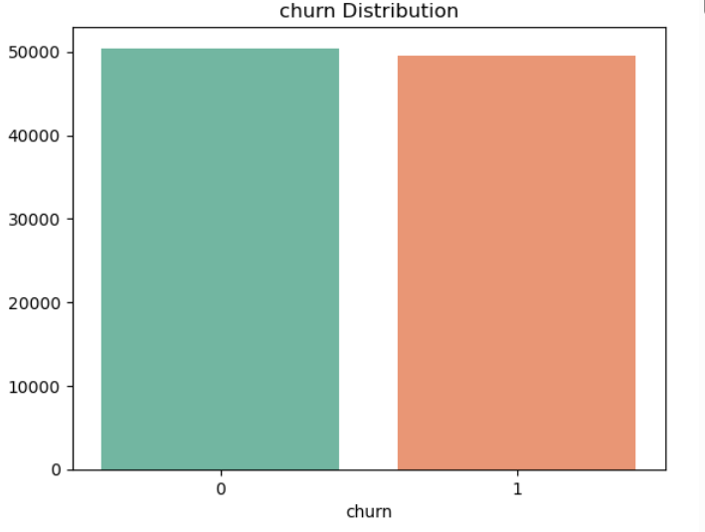
Figure 2. Distribution of churned (1) and non-churned (0) customers
The difference between the two classes is minimal, indicating that the dataset is effectively balanced. This characteristic simplifies the modelling process because algorithms are less likely to favor one class over the other during training. In contrast, many telecom churn datasets reported in the literature contain substantially fewer churned customers, requiring additional techniques such as oversampling or class weighting (Ouf et al., 2024; Hegde, 2025). For this dataset, the balanced class distribution allows standard classification algorithms to be evaluated without introducing additional sampling procedures.

4.2 Feature Composition
The predictor variables describe different aspects of customer activity and service usage within the telecommunications network. Several variables measure calling behavior, including mou_Mean, avg6mou, avg3mou, mou_cvce_Mean, mou_peav_Mean, mou_opkv_Mean and mou_rvce_Mean, which represent different patterns of monthly voice usage. The variable avg3qty summarizes recent usage intensity, while totmrc_Mean reflects the customer's average monthly recurring charges. In addition, eqpdays records the age of the customer's mobile equipment, providing an indication of device lifecycle.
Together, these variables capture different dimensions of customer behavior, including service consumption, spending patterns and equipment characteristics. Rather than relying on demographic information, the dataset focuses primarily on behavioral indicators that may distinguish customers who remain with the provider from those who churn.
Previous studies have shown that variables related to service usage, billing behavior and customer activity are among the strongest predictors of telecom churn. The variables included in this dataset therefore provide a suitable basis for evaluating predictive machine-learning models.
Although all predictors are represented numerically, several variables derived measures summarizing customer behavior over different time periods. This numerical representation simplifies statistical analysis and model training while requiring careful interpretation when assessing feature importance or model coefficients.

4.3 Critical Observations
The initial examination of the dataset identified several characteristics relevant to the modelling stage.
- Balanced target variable. The almost equal number of churned and non-churned customers reduces the likelihood of majority-class bias and removes the need for class-balancing techniques before model training.
- • Reduced feature set. The study used ten behavioral predictor variables selected from the original dataset. While this simplifies model interpretation and reduces computational complexity, the limited number of predictors may restrict the ability of the models to capture all factors associated with customer churn.
- Encoded categorical variables. Numerical encoding enables direct use of machine-learning algorithms but may conceal the original categorical relationships between customer attributes.
- Static data structure. The dataset represents customer information at a single point in time rather than as a sequence of observations. Consequently, behavioral changes over time cannot be analyzed, and temporal prediction methods are outside the scope of this study.

4.4 Summary
The dataset provides an appropriate basis for investigating customer churn prediction because it combines a balanced target variable with a wide range of behavioral, contractual and service-related characteristics. At the same time, the dataset presents several methodological considerations, including the presence of encoded categorical variables and the possibility of correlated predictors. These issues will be addressed during the preprocessing stage before developing and comparing the Logistic Regression, Random Forest and K-Means models presented in the following sections.

5. Data Preprocessing

Data Cleaning Summary
A series of data quality checks was carried out during the preprocessing stage to ensure that the dataset was suitable for machine-learning analysis. The assessment focused on four key aspects: missing values, outliers, class distribution and correlations between predictor variables. These checks were performed before model development to verify data quality and identify any issues requiring further preprocessing. These cleaning steps ensure that the dataset is free from structural issues that could bias model training or distort feature importance, providing a reliable foundation for subsequent preprocessing and modelling.

5.1 Missing Values Assessment
A missing-value matrix was generated to examine the completeness of the dataset.
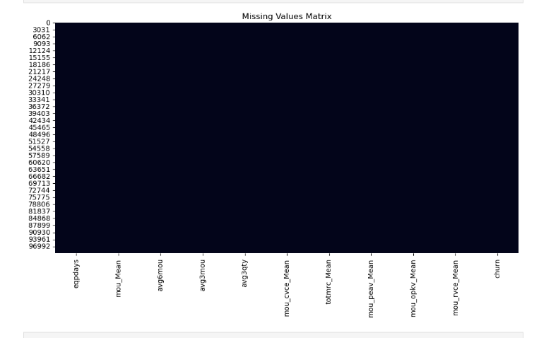
Figure 3. Missing Values Matrix
The results show that none of the predictor variables contain missing observations. Consequently, no data imputation was required, and all customer records were retained for subsequent analysis. The absence of missing values simplifies the preprocessing workflow and ensures that the full dataset can be used during model training.

5.2 Outlier Detection
Outlier analysis was performed using a boxplot of totmrc_Mean, which represents the average monthly recurring charge for each customer.
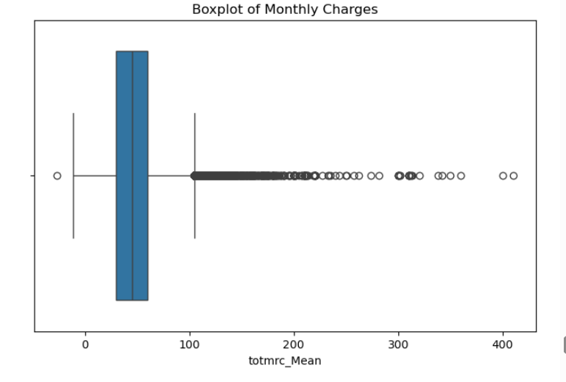
Figure 4. Boxplot of totmrc Mean
The boxplot identifies a number of observations outside the upper quartile range. These observations represent customers with relatively high monthly charges and reflect genuine customer behavior rather than data errors. Since the objective of the study is to model real customer behaviour, these observations were retained. Removing them could reduce the natural variation within the dataset and potentially affect the predictive performance of the models. Class weighting was not considered necessary before training the classification models.

5.3 Multicollinearity Assessment
A correlation heatmap was generated to examine relationships among the predictor variables.
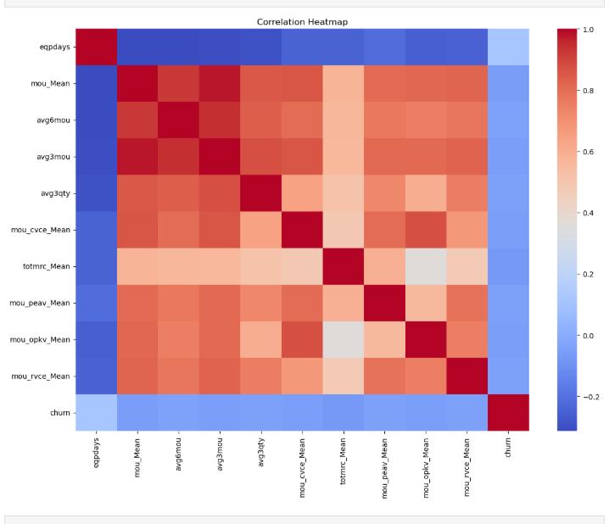
Figure 5. Correlation Heatmap
The heatmap indicates that several variables describing customer usage exhibit positive correlations. In particular, variables such as mou_Mean, avg6mou, avg3mou, mou_cvce_Mean and totmrc_Mean measure related aspects of customer activity and monthly service usage, making some degree of correlation expected. Because all predictors are numerical, including encoded versions of originally categorical attributes, some correlation patterns may reflect encoding structure rather than purely behavioural relationships. At this stage, no predictors were removed because preserving the complete feature set allows subsequent feature selection methods to determine the most informative variables while maintaining consistency across the evaluated models
Summary
The data quality assessment showed that the dataset required only minimal preprocessing. No missing values were detected, the identified outliers represented valid customer behaviour and were therefore retained, the target variable exhibited a balanced class distribution, and the observed correlations reflected relationships between variables describing similar aspects of customer activity. Overall, the dataset was considered suitable for feature engineering and the development of the Logistic Regression, Random Forest and K-Means models presented in the following sections. The outcomes of the cleaning stage also informed subsequent preprocessing steps, including feature scaling and feature selection, ensuring consistency and robustness across all evaluated models.

5.4 Feature Scaling
Feature scaling was applied during the preprocessing stage to ensure that the numerical predictors were measured on a common scale before model development. Variables such as mou_Mean, avg6mou, avg3mou, avg3qty and totmrc_Mean have different numerical ranges, which may influence algorithms that rely on gradient-based optimization or distance calculations.

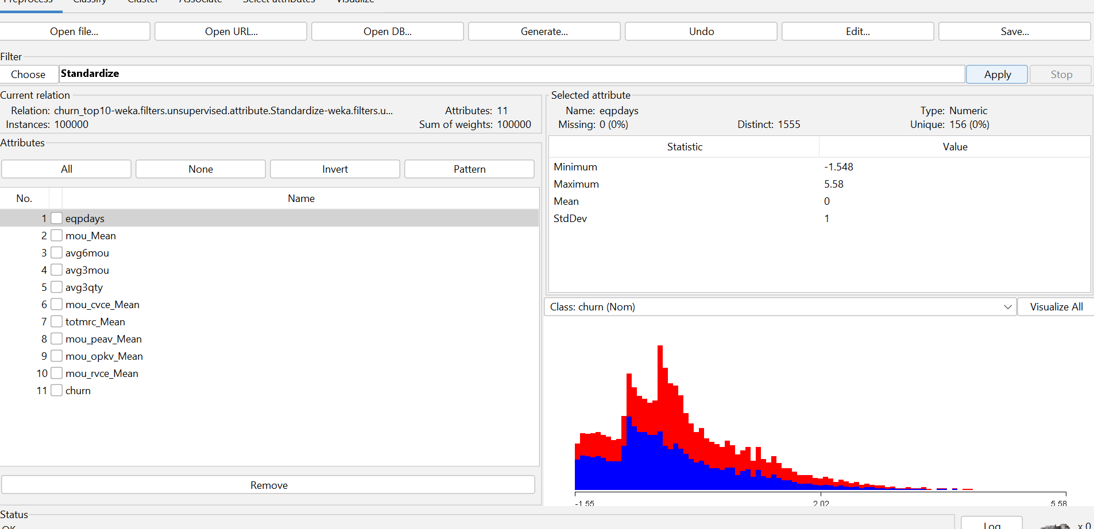
Figure 6. Standardization of predictor variables using the WEKA Standardize filter
.
The Standardize filter in WEKA was used to transform each predictor to a mean of zero and a standard deviation of one. Standardization improves numerical stability and prevents variables with larger values from dominating the learning process [12].
Feature scaling is particularly important for algorithms such as Logistic Regression and K-Means, whereas Random Forest is generally insensitive to differences in feature scales because it uses threshold-based splits rather than distance measures [12]. Nevertheless, the same standardized dataset was used throughout this study to maintain a consistent preprocessing procedure across all evaluated models.

5.5 Feature Selection
Feature selection was examined to determine whether the predictor variables contained redundant information that could affect model interpretation. The dataset includes ten behavioural predictors describing customer activity, including call usage, monthly charges and equipment age.
The correlation analysis indicated that several usage-related variables, including mou_Mean, avg6mou, avg3mou and totmrc_Mean, were moderately correlated. Such relationships are expected because these variables describe similar aspects of customer behaviour [12].
Although correlated predictors were identified, no variables were removed before model development. Given the relatively small number of predictors, retaining the complete set preserved the available behavioural information while allowing consistent comparison across Logistic Regression, Random Forest and K-Means. The assessment of feature relationships was therefore used primarily to support interpretation of the modelling results rather than to reduce the dimensionality of the dataset.

6 Model Development

This chapter describes the implementation of the machine-learning models used to analyze customer churn. Based on the objectives of this study, two supervised classification algorithms (Logistic Regression and Random Forest) were developed to predict whether a customer would remain with or leave the telecommunications provider. In addition, K-Means clustering was applied to identify behavioral groups within the customer base and to provide complementary insights beyond supervised prediction.
All models were implemented using WEKA 3.8. Feature standardization was performed during preprocessing, and the same standardized dataset was used throughout the experiments to ensure consistency. Model performance was evaluated using 10-fold cross-validation, allowing all observations to contribute to both training and testing while reducing the likelihood of biased performance estimates.

6.1 Logistic Regression
Logistic Regression was selected as the baseline classification model because of its simplicity and interpretability. The algorithm estimates the probability that a customer belongs to the churn or non-churn class based on the predictor variables included in the dataset.
The model was implemented in WEKA using the default Logistic classifier and evaluated using 10-fold cross-validation to obtain a robust estimate of predictive performance while ensuring that all observations contributed to both training and validation.
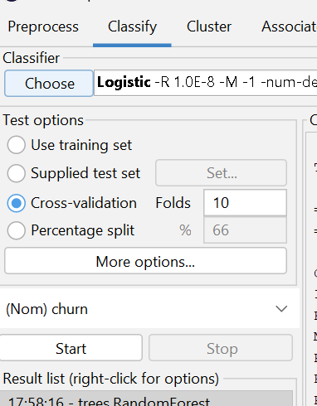
Figure 7. Configuration of the Logistic Regression model in WEKA using 10-fold cross-validation
The evaluation focused on commonly reported metrics including classification accuracy, precision, recall, F1-score and ROC-AUC, which together provide a comprehensive assessment of classification performance.
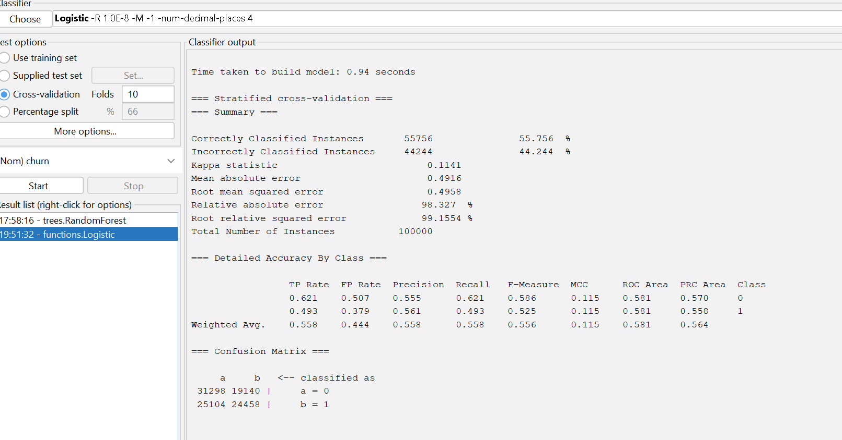
Figure 8. Classification performance of the Logistic Regression model in WEKA
.
The classification results obtained from Logistic Regression are presented in Figure 8. A detailed interpretation of these performance metrics is provided in next chapter, where the results are compared with those obtained from Random Forest and K-Means clustering.
The resulting performance metrics are presented in Figure 8. The model achieved an overall classification accuracy of 55.76%, with a weighted F1-score of 0.556 and a ROC-AUC value of 0.581. These results provide a baseline for comparison with the remaining models developed in this study.

6.2 Random Forest
Random Forest was selected because it combines multiple decision trees to improve predictive performance and reduce the risk of overfitting. Unlike Logistic Regression, Random Forest can model complex nonlinear relationships and interactions between behavioral variables without requiring strict statistical assumptions.
The model was implemented in WEKA 3.8 using the default Random Forest classifier and evaluated using the same 10-fold cross-validation procedure to ensure a fair comparison with Logistic Regression.
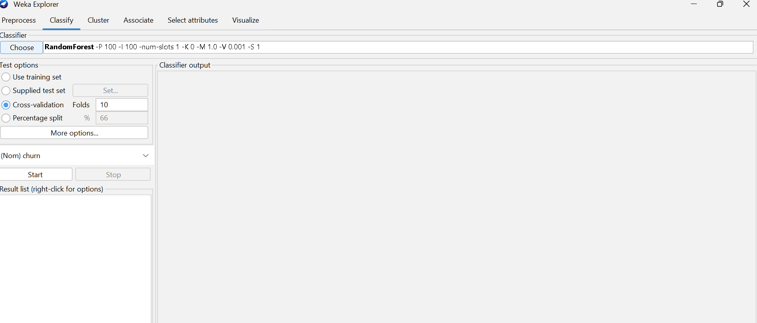
Figure 9. Configuration of the Random Forest model in WEKA using 10-fold cross-validation
The Random Forest model achieved an overall classification accuracy of 57.85%, slightly outperforming Logistic Regression. This suggests that the ensemble approach was able to capture additional behavioral patterns within the customer data.

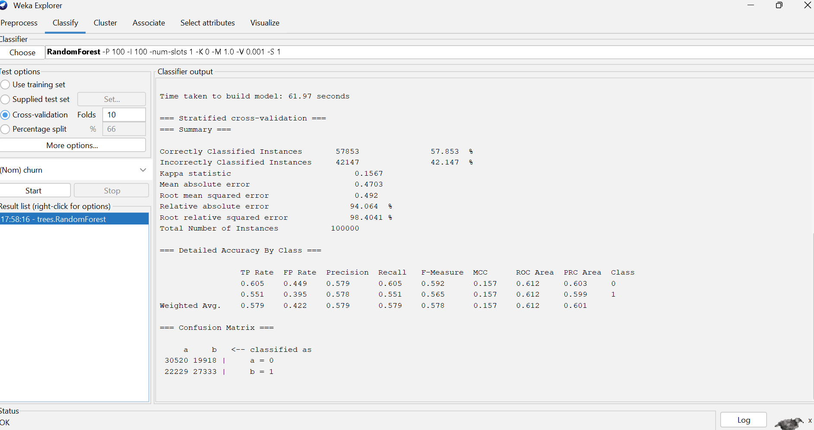
Figure 10. Classification performance of the Random Forest model in WEKA
A detailed comparison between the Random Forest and Logistic Regression models is presented in next chapter.

6.3 K-Means Clustering
K-Means clustering was applied to complement the supervised classification models by identifying groups of customers with similar behavioral characteristics [13]. Unlike Logistic Regression and Random Forest, K-Means is an unsupervised learning algorithm and therefore does not use the churn variable during model development. Instead, customers are grouped according to similarities in the selected behavioral variables.
Because K-Means relies on Euclidean distance, the analysis was performed using the standardized dataset prepared during the preprocessing stage. Standardization ensured that variables measured on different scales contributed equally to the clustering process.
Determination of the Number of Clusters
To determine an appropriate number of clusters, the Simple KMeans algorithm was evaluated using between two and six clusters. The within-cluster sum of squared errors (WCSS) was recorded for each solution to assess cluster compactness.

Table 1
Table 1. WCSS values for different numbers of clusters
Clusters | WCSS
2 | 4749.63
3 | 3925.37
4 | 3166.51
5 | 2639.84
6 | 2485.20

Figure 11. Elbow method used to determine the optimal number of clusters
The WCSS decreased as the number of clusters increased. However, the reduction became noticeably smaller after five clusters, indicating diminishing returns from adding further clusters. Based on the elbow method, K = 5 was selected for the final clustering analysis because it provides an appropriate balance between cluster compactness and model complexity.
The final K-Means model was implemented in WEKA 3.8 using five clusters. The algorithm converged after 70 iterations, producing the cluster solution shown in Figure 12&13.
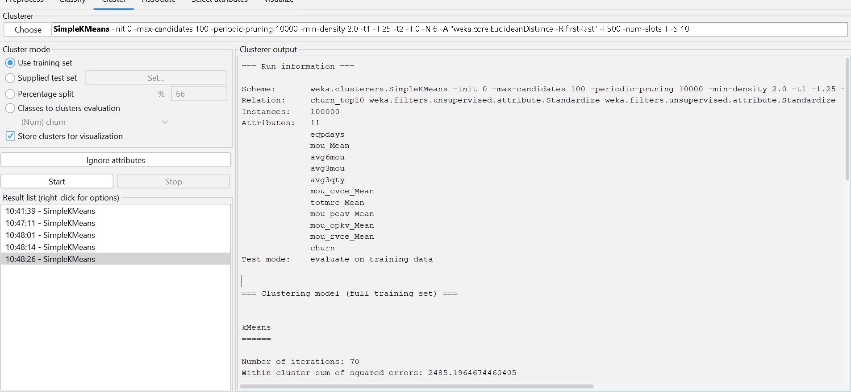
Figure 12. Configuration and output of the K-Means model in WEKA
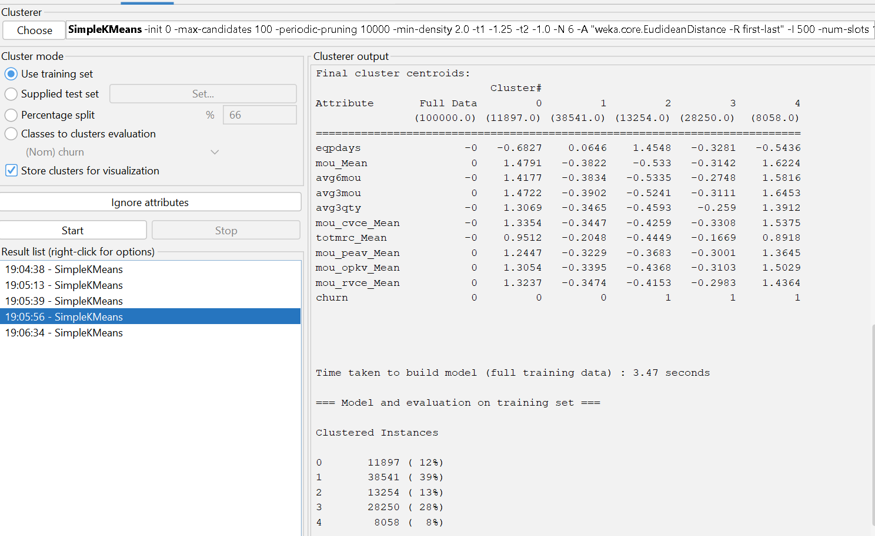
Figure 13. Configuration and output of the K-Means model in WEKA (part 2)

7. Results Analysis and Model Evaluation

7.1 Performance of the Classification Models
The predictive performance of the two supervised classification models is summarized in Table 2. Both Logistic Regression and Random Forest were evaluated using the same 10-fold cross-validation procedure, providing a consistent basis for comparison.
Table 2. Performance comparison of the classification models
Metric | Logistic Regression | Random Forest
Accuracy | 55.76% | 57.85%
Precision | 0.557 | 0.579
Recall | 0.558 | 0.579
F1-score | 0.556 | 0.578
ROC-AUC | 0.581 | 0.612

Random Forest achieved the highest classification accuracy (57.85%), exceeding Logistic Regression by approximately 2.1 percentage points. Similar improvements were observed for the weighted F1-score and ROC-AUC, indicating that the ensemble model provided more consistent classification across both customer groups.
Despite this improvement, the overall predictive performance of both models remained moderate. This suggests that the ten behavioral predictor variables capture only part of the information associated with customer churn. Consequently, the choice of algorithm alone was insufficient to produce substantial improvements in predictive accuracy.

7.2 Comparison of Logistic Regression and Random Forest

Although Random Forest achieved the strongest predictive performance, the improvement over Logistic Regression was relatively modest. One explanation is that the selected behavioral variables provide limited information for distinguishing between customers who churn and those who remain. As a result, both models were constrained by the characteristics of the available dataset rather than by their underlying algorithms.
Logistic Regression offers a high level of interpretability because the influence of individual predictor variables can be examined through the estimated model coefficients. This makes the algorithm particularly suitable when organizations require transparent and explainable decision-making. However, Logistic Regression assumes a linear relationship between the predictor variables and the probability of churn, limiting its ability to model more complex behavioral interactions.
Random Forest overcomes this limitation by combining multiple decision trees, enabling the model to capture nonlinear relationships and interactions among customer behavior variables. This flexibility is reflected in its higher accuracy and ROC-AUC values. Nevertheless, the relatively small improvement suggests that increasing model complexity does not necessarily produce substantially better predictions when only a limited set of behavioral predictors is available.
From a business perspective, the results indicate that Random Forest provides slightly stronger predictive performance, whereas Logistic Regression remains valuable when model transparency and interpretability are priorities. The selection of an appropriate model therefore depends not only on predictive accuracy but also on organizational requirements and the intended use of the predictions.

7.3 K-Means Clustering Results
To complement the supervised classification models, K-Means clustering was applied to identify groups of customers with similar behavioral characteristics. Following the elbow method presented in Chapter 6, the final clustering model was developed using five clusters.

Figure 14. Distribution of customers across the five K-Means clusters
Figure 14 illustrates the distribution of customers across the five identified clusters. Cluster 1 represents the largest customer segment, accounting for approximately 39% of all observations, followed by Cluster 3 with 28%. The remaining clusters are considerably smaller, indicating that customer behavior is distributed across several distinct profiles rather than concentrated within a single group.
Table 3. Summary of the identified customer clusters
Cluster | Customers | Percentage | Main Characteristics | Churn Profile
0 | 11,897 | 12% | High service usage and above-average monthly charges | Mainly retained customers
1 | 38,541 | 39% | Low service usage and relatively low monthly charges | Mainly retained customers
2 | 13,254 | 13% | Low service usage and older mobile devices | Mainly churned customers
3 | 28,250 | 28% | Moderate service usage and spending | Mainly churned customers
4 | 8,058 | 8% | Very high service usage and high monthly charges | Mainly churned customers

Table 3 summarizes the customer segments identified by K-Means clustering, including the size of each cluster, its main behavioral characteristics and the predominant churn profile. The centroid values reveal clear differences in customer behavior. Cluster 0 is characterized by above-average values for monthly voice usage (mou_Mean, avg6mou and avg3mou) together with relatively high monthly recurring charges (totmrc_Mean). The centroid value for the churn attribute indicates that this cluster is dominated by customers who remained with the provider.
In contrast, Cluster 1, which contains the largest proportion of customers, exhibits below-average values across most usage and billing variables. Despite lower service consumption, the centroid values also indicate that this cluster is largely composed of non-churn customers. This suggests that lower levels of service usage alone are insufficient to explain why customers decide to leave a telecommunications provider.
The remaining clusters are characterized by a higher proportion of churned customers. Cluster 2 contains customers with relatively older mobile devices and consistently below-average service usage, while Cluster 3 represents customers with more moderate behavioral characteristics who nevertheless left the provider. Cluster 4, although the smallest segment, is characterized by high service usage and above-average monthly recurring charges despite being dominated by churned customers. A possible explanation is that some higher-value customers discontinue their service because of factors such as pricing, competition or customer satisfaction, which are not directly captured by the behavioral variables included in this data set.
Overall, the clustering results suggest that customer churn cannot be explained solely by service usage or spending patterns. Customers with both relatively high and relatively low levels of activity appear within the churned group, indicating that churn behavior is influenced by multiple interacting factors. Unlike Logistic Regression and Random Forest, which estimate the probability of churn for individual customers, K-Means identifies behavioral customer segments that may not be immediately apparent through supervised classification alone. Combining predictive models with customer segmentation therefore provides a more comprehensive understanding of customer behavior and may support the development of more targeted and effective customer retention strategies.

8. Discussion of Findings

The results indicate that no single modelling technique fully explains telecom customer churn. Random Forest achieved the highest classification accuracy (57.85%), outperforming Logistic Regression (55.76%) across all evaluation metrics. Although the improvement was modest, the ensemble model demonstrated a greater ability to capture relationships among the behavioral variables.
One possible explanation for the moderate predictive performance is the reduced feature set used in this study. The analysis was conducted using only the ten most predictive variables provided within the dataset. Although these behavioral variables capture important aspects of customer activity, they do not fully represent the wide range of factors that may influence churn decisions. Variables related to customer satisfaction, complaint history, service quality and competitive market conditions were not available. Consequently, both Logistic Regression and Random Forest were constrained by the information contained within the available predictors rather than solely by the capabilities of the algorithms themselves.
The K-Means analysis complemented the supervised classification models by identifying five behavioral customer segments. The results showed that customers with both high and low service usage were represented within the churn group, indicating that customer attrition cannot be explained by usage behavior alone. This finding suggests that churn is influenced by multiple interacting factors, many of which may not be captured by the behavioral variables included in the reduced dataset.
Overall, the findings are broadly consistent with previous research, which reports that ensemble methods such as Random Forest generally outperform simpler linear models. However, unlike studies reporting substantially higher predictive accuracy, the present study achieved only moderate performance. This difference is likely to reflect the restricted feature set available for analysis rather than the choice of machine-learning algorithm. Nevertheless, combining supervised prediction with behavioral customer segmentation provides a more comprehensive understanding of customer churn than either approach in isolation.

9. Business Recommendations

The findings of this study provide several practical recommendations for telecommunications service providers aimed at improving customer churn management.
First, the Random Forest model should be preferred when the primary objective is to achieve high predictive accuracy in customer churn prediction. In this study, it consistently outperformed logistic regression across all evaluation metrics. However, Logistic regression remains a valuable tool in situations where model transparency and interpretability are essential. Its ability to clearly demonstrate the influence of individual variables on the likelihood of customer churn facilitates managerial decision-making and enables more effective communication of results to stakeholders.
Second, predictive models should be integrated with customer segmentation. Combining supervised classification algorithms with behavioral segmentation enables organizations to develop more targeted and personalized customer retention strategies. Rather than applying the same interventions to all customers, telecommunications providers can tailor their marketing campaigns, pricing offers, and loyalty programmes to the specific characteristics and needs of different customer segments. This approach can improve the effectiveness of retention initiatives while optimizing the associated costs.
Furthermore, the moderate predictive performance observed in this study indicates that the quality and scope of the available data have a significant impact on model accuracy. Therefore, organizations should invest in collecting and integrating additional customer-related information, such as customer satisfaction measures, complaint history, service quality indicators, frequency of interactions with customer support, and digital channel usage. Incorporating these additional variables is likely to enhance the models' ability to identify customers who are genuinely at high risk of churn.
Finally, predictive models should not be regarded as static solutions. They should be regularly updated and retrained using the most recent customer data to reflect changes in customer behavior, market dynamics, and competitive conditions. Continuous monitoring of model performance and periodic recalibration will help maintain predictive accuracy and improve the effectiveness of customer retention strategie

10. Conclusion

This study evaluated the performance of Logistic Regression, Random Forest and K-Means for telecom customer churn analysis using a reduced dataset containing the ten most predictive behavioral variables. Among the supervised classification models, Random Forest achieved the strongest predictive performance, while K-Means provided additional behavioral insights by identifying distinct customer segments.
Although the overall classification accuracy remained moderate, the findings suggest that this outcome is likely to reflect the limited range of predictor variables available for analysis rather than the limitations of the machine-learning algorithms themselves. Customer churn is a complex phenomenon influenced by behavioral, operational and customer-related factors, many of which were beyond the scope of the available dataset.
Overall, the study demonstrates that combining supervised prediction with behavioral segmentation provides a broader understanding of customer churn than either approach alone. Future research should evaluate a more comprehensive set of customer attributes and compare additional machine-learning techniques to determine whether richer datasets can improve predictive performance while maintaining model interpretability.

11. References
[1]
Sumana Sharma Poudel, Suresh Pokharel, and Mohan Timilsina, “Explaining customer churn prediction in telecom industry using tabular machine learning models,” Machine learning with applications, vol. 17, pp. 100567–100567, June 2024, doi: 10.1016/j.mlwa.2024.100567.
[2]
V. Sharma, K. K. Gupta, and N. Dhanda, “Predicting Customer Churn Using Machine Learning Technique,” 2026 Second International Conference on Multi-Agent Systems for Collaborative Intelligence (ICMSCI), pp. 794–799, Mar. 2026, doi: 10.1109/icmsci67830.2026.11469657.
[3]
P. Hegde and M. Shah, “Predictive Analytics System for Customer Churn in Telecom Using Artificial Intelligence Approaches,” 2025 IEEE 4th World Conference on Applied Intelligence and Computing (AIC), pp. 877–882, July 2025, doi: 10.1109/aic66080.2025.11211936.
[4]
M. Güllü, R. Dede, and İ. Duru, “Telecom Customer Churn Prediction: In-Depth Analysis with Artificial Intelligence Algorithms and Explainable Artificial Intelligence,” 2025 International Conference on Electrical, Communication and Computer Engineering (ICECCE), pp. 1–6, Aug. 2025, doi: 10.1109/icecce67514.2025.11257947.

[5]
I. Ullah, B. Raza, A. K. Malik, M. Imran, S. U. Islam, and S. W. Kim, “A Churn Prediction Model Using Random Forest: Analysis of Machine Learning Techniques for Churn Prediction and Factor Identification in Telecom Sector,” IEEE Access, vol. 7, no. 2169–3536, pp. 60134–60149, 2019, doi: 10.1109/access.2019.2914999.

[6]
Shimaa Ouf, K. T. Mahmoud, and M. A. Abdel-Fattah, “A proposed hybrid framework to improve the accuracy of customer churn prediction in telecom industry,” Journal of big data, vol. 11, no. 1, May 2024, doi: 10.1186/s40537-024-00922-9.
[7]
V. Chang, K. Hall, Q. A. Xu, F. O. Amao, M. A. Ganatra, and V. Benson, “Prediction of Customer Churn Behavior in the Telecommunication Industry Using Machine Learning Models,” Algorithms, vol. 17, no. 6, pp. 231–231, May 2024, doi: 10.3390/a17060231.
[8]
M. G. Abdelhady and Karim. A. Mohamed, “Leveraging artificial intelligence for predictive customer churn modeling in telecommunications: a framework for enhanced customer relationship management,” Scientific Reports, Dec. 2025, doi: 10.1038/s41598-025-30108-z.
[9]
Oksana Nikiforova, Andrejs Romanovs, Vitaly Zabiniako, and Jurijs Kornienko, “Detecting and Identifying Insider Threats Based on Advanced Clustering Methods,” IEEE access, pp. 1–1, Jan. 2024, doi: 10.1109/access.2024.3365424.
[10]
J. Ahn, J. Hwang, D. Kim, H. Choi, and S. Kang, “A Survey on Churn Analysis in Various Business Domains,” IEEE Access, vol. 8, pp. 220816–220839, 2020, doi: 10.1109/access.2020.3042657.
[11]
Q. Lin, H. Zhang, X. Wang, Y. Xue, H. Liu, and C. Gong, “A Novel Parallel Biclustering Approach and Its Application to Identify and Segment Highly Profitable Telecom Customers,” IEEE Access, vol. 7, pp. 28696–28711, Jan. 2019, doi: 10.1109/access.2019.2898644.
[12]
M. Herrera et al., “The Impact of Feature Scaling In Machine Learning: Effects on Regression and Classification Tasks,” IEEE Access, pp. 1–1, Jan. 2025, doi: 10.1109/access.2025.3635541.
[13]
K. P. Sinaga and M.-S. Yang, “Unsupervised K-Means Clustering Algorithm,” IEEE Access, vol. 8, no. 1, pp. 80716–80727, 2020, doi: 10.1109/access.2020.2988796.

