
Component 1: Design and Implementation of a Relational Database System
Introduction to Web and Database Concepts - ACCA4023

Sadhana Jha

November 1, 2025
UNIVERSITY OF WALES TRINITY SAINT DAVID

Contents
Scenario Analysis 2
Entity Relationship Diagram (ERD) 2
1. List of attributes and their descriptions 2
2. List of relationships and their meaning. 2
3. ER diagram: 2
Normalization 2
Sample Data Population 2
Query Development 2
Testing and Validation 3
Design Decisions and Future Work 3
1. Design Decisions: 3
2. Future Work: 3
References: 3

Scenario Analysis

MediLink Pharmacy is a neighbourhood pharmacy that supplies medicines and health-related products to people living in the surrounding community. As the number of customers increases, the pharmacy has to manage more information than before. This includes details about medicines available in stock, suppliers who provide those medicines, customer purchases, and prescriptions issued by doctors.

Currently, much of this information is recorded using paper notes or basic spreadsheet files. While this approach may work for small amounts of data, it becomes difficult to manage when the pharmacy becomes busier. Staff must manually update stock levels and record transactions, which can lead to errors if information is not entered correctly.

For example, if a medicine is sold but the stock record is not updated immediately, the pharmacy might think that the medicine is still available. Situations like this can cause problems when customers urgently need medication. Pharmacies rely on accurate records so that medicines can be provided when required. Database systems are often used to organise and manage this type of information more efficiently [1].

To improve the way records are handled, MediLink Pharmacy plans to create a database using Microsoft Access. The goal of this system is to organise pharmacy information in a structured way so that staff can find records quickly and monitor medicine availability more easily.

Entity Relationship Diagram (ERD)
System Design Overview
The database was designed to represent the main activities that occur in the pharmacy. Several tables were created to store different types of information.
The main tables in the system include:
- Supplier
- Medicine
- Customer
- Prescription
- PrescriptionItem
- Sale
- SaleItem

Each table focuses on a different part of the pharmacy’s operations. For example, the Supplier table stores details about companies that provide medicines to the pharmacy. The Medicine table stores information about the products that are available for sale.
Every record stored in a table has a unique identifier. These identifiers allow the system to connect related records together. For instance, medicines can be linked to their suppliers, and sales transactions can be connected to the customer who made the purchase.

Planning the database structure in advance helps ensure that information can be stored and retrieved in a logical way once the system is implemented [2].

Attributes and Description

Supplier Table
SupplierID (Primary Key)
This field acts as the main identifier for each supplier stored in the system. It ensures that every supplier can be uniquely recognised when linking supplier information with other tables.

SupplierName
This attribute records the name of the organisation that delivers medicines to the pharmacy.
ContactNumber
This field stores the supplier’s telephone number so pharmacy staff can quickly contact the company when placing new orders.

SupplierEmail
This attribute stores the email address used for sending purchase requests or communicating with the supplier.

Location
This field records the city or area where the supplier company operates.

Medicine Table
MedicineID (Primary Key)
This field uniquely identifies each medicine stored in the database.

MedicineName
This attribute stores the commercial name of the medicine available in the pharmacy.

MedicineCategory
This field groups medicines based on their type, such as pain relief, vitamins, digestive medicine, or allergy treatment.

PurchaseCost
This attribute stores the amount the pharmacy pays when buying the medicine from the supplier.

RetailPrice
This field records the price customers pay when purchasing the medicine from the pharmacy.

QuantityAvailable
This attribute shows the number of units currently stored in the pharmacy inventory.
ExpiryDate
This field records when the medicine should no longer be sold or used.

SupplierID (Foreign Key)
This field links the medicine record to the supplier who provided the product.

Customer Table
CustomerID (Primary Key)
This field uniquely identifies each customer who is recorded in the database.

CustomerName
This attribute stores the full name of the customer purchasing medicines.
DateOfBirth
This field stores the customer’s birth date, which may be relevant when checking certain medicine restrictions.
PhoneContact
This attribute records the phone number of the customer.
HomeAddress
This field stores the residential address of the customer.

Prescription Table
PrescriptionID (Primary Key)
This field uniquely identifies each prescription entry recorded in the system.

PrescriptionDate
This attribute records the date when the prescription was issued.

DoctorName
This field stores the name of the doctor who authorised the prescription.

CustomerID (Foreign Key)
This field connects the prescription to the specific customer who received it.

PrescriptionItem Table
PrescriptionItemID (Primary Key)
This field uniquely identifies each medicine listed within a prescription.

PrescriptionID (Foreign Key)
This attribute connects the medicine entry to the correct prescription.

MedicineID (Foreign Key)
This field identifies which medicine appears in the prescription.

QuantityPrescribed
This attribute records how many units of the medicine were prescribed.

UsageInstructions
This field stores directions explaining how the medicine should be taken.

Sale Table
SaleID (Primary Key)
This field uniquely identifies each sales transaction recorded in the pharmacy.

TransactionDate
This attribute stores the date when the purchase occurred.

CustomerID (Foreign Key)
This field links the sale to the customer who made the purchase.

PaymentType
This attribute records the method used to pay for the purchase, such as cash or card.

SaleItem Table
SaleItemID (Primary Key)
This field uniquely identifies each item included in a sales transaction.

SaleID (Foreign Key)
This attribute links the item to the specific sale transaction.

MedicineID (Foreign Key)
This field identifies which medicine was sold.

UnitsSold
This attribute records the number of medicine units purchased in the transaction.

SellingPrice
This field stores the price of the medicine at the time of the sale.

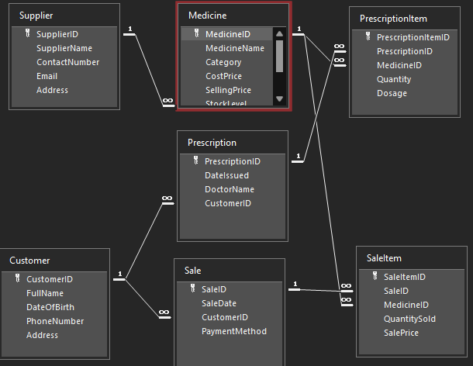

Relationships and Meaning

Supplier and Medicine
A supplier provides medicines that the pharmacy sells. The database records which supplier delivers each medicine so that the pharmacy can track where products come from.
Cardinality:
One supplier may provide several medicines, but each medicine is associated with only one supplier.
Participation:
Every medicine must be connected to a supplier, but a supplier may exist in the system even if no medicines have been recorded yet.

Customer and Prescription
Customers may receive prescriptions from doctors when certain medicines are required. Each prescription entry is connected to the customer who received it.
Cardinality:
A customer may have multiple prescriptions over time, but a prescription belongs to only one customer.
Participation:
A prescription cannot exist without a linked customer record.

Prescription and PrescriptionItem
A prescription can contain more than one medicine. The PrescriptionItem table records each medicine listed on a prescription separately.
Cardinality:
One prescription may include several prescription items.
Participation:
Each prescription item must be connected to a prescription entry.

Medicine and PrescriptionItem
Medicines listed in prescriptions are connected through the PrescriptionItem table.
Cardinality:
A single medicine may appear in many different prescriptions.
Participation:
Every prescription item must reference a medicine that already exists in the medicine table.

Customer and Sale
When customers purchase medicines, a transaction is recorded in the Sale table.
Cardinality:
One customer can have multiple sales transactions.
Participation:
Each sale must be connected to a customer.

Sale and SaleItem
A sales transaction may contain several medicines. Each product purchased during a transaction is stored in the SaleItem table.
Cardinality:
One sale may include several sale items.
Participation:
Each sale item must belong to a sale transaction.

Medicine and SaleItem
This relationship shows which medicines were purchased during a sale.
Cardinality:
A medicine may appear in many sales transactions.
Participation:
Each sale item must reference a medicine stored in the medicine table.

Each foreign key ensures referential integrity, meaning that child records cannot exist without corresponding parent records. This constraint prevents orphan records and maintains logical consistency [5].

Normalization

When the database structure was prepared, the tables were arranged step by step to keep the information organised and easy to maintain. The aim was to make sure that each table stores only the information that belongs to it and that the same details are not repeated in several places.

First Stage (1NF)
In the first stage, the data was arranged so that each column contains a single piece of information. Instead of placing multiple values inside one field, separate records are used for each entry.
For example, in the pharmacy system every medicine is stored as its own record in the Medicine table. The table includes fields such as the medicine name, stock quantity, and expiry date. Each of these fields contains one value for that specific medicine. Storing the data this way keeps the table clear and prevents confusion when information is updated.

Second Stage (2NF)
After the first stage was completed, the tables were reviewed to make sure that all the information stored in them relates directly to their unique identifier.
Each table uses a primary key, such as MedicineID, CustomerID, or SaleID. All the other attributes in the table describe the record represented by that key. For example, the Medicine table stores details about a single medicine, including its price, stock quantity, and expiry date. These attributes describe the medicine identified by the MedicineID.
This step helps make sure that unrelated information is not mixed together in the same table.

Third Stage (3NF)
In the final stage, the tables were adjusted to ensure that information is stored in the most suitable location. Instead of repeating the same details in multiple tables, related information is stored separately and connected through identifiers.
For instance, supplier details such as supplier name and contact information are stored only in the Supplier table. The Medicine table simply stores the SupplierID to indicate where the medicine comes from. If supplier details change, they only need to be updated once in the Supplier table.
Organising the database in this way keeps the information consistent and reduces unnecessary duplication across the system.

Data Integrity Constraints
The database enforces three major integrity constraints:
1. Entity Integrity
Primary keys cannot be NULL.
2. Referential Integrity
Foreign keys must match existing primary keys.
3. Domain Integrity
Data types are enforced.
These mechanisms align with core DBMS integrity rules [1].

Sample Data Population
The database was populated with realistic sample data to test the system. Each table contains at least five records representing suppliers, medicines, customers, prescriptions, and sales transactions. For example, medicines such as Paracetamol, Ibuprofen, Amoxicillin, Insulin, and Vitamin D were included in the Medicine table. These medicines were linked to suppliers and used in prescription and sale records.

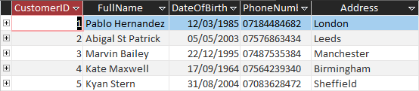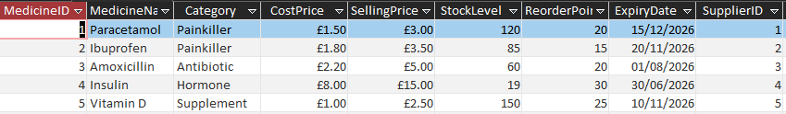
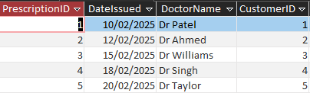
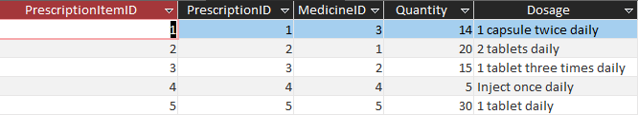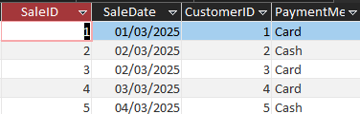
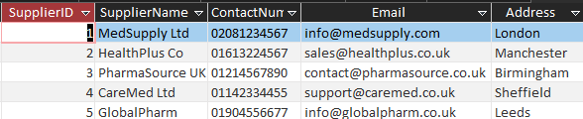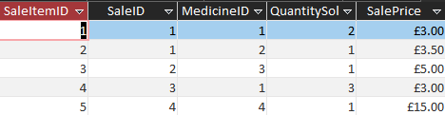

Query Development
Several queries were created to demonstrate how the database can be used to retrieve useful information.

Query Prescription Tracking
Prescription Tracking Query shows the quantity and dosage
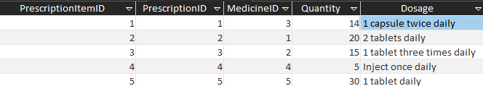

Query Low Stock
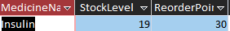
Low Stock Query shows medicines where stock levels fall below the reorder point

Query Total Revenue
Total Revenue Query calculates total sales revenue using the method QuantitySold × SalePrice.
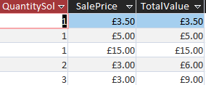

Testing and Validation

Testing included:

The prescription tracking query was tested first. When the query was executed, it displayed the customer’s name together with the doctor who issued the prescription and the medicines included in the prescription. The results were compared with the prescription records stored in the tables. The information displayed by the query matched the data that had been entered, confirming that the query was working correctly.

The low stock query was then tested. This query was designed to display medicines where the available quantity was below a specified threshold. When the query was run, it correctly displayed the medicines with lower stock levels. The results were checked against the stock values stored in the Medicine table to confirm their accuracy.

Finally, the total revenue query was tested. This query calculated the total income generated from medicine sales by combining quantity values with medicine prices. The result returned by the query matched the total value expected from the sales records stored in the database.

These tests confirmed that the queries were able to retrieve correct information and that the tables were connected properly. Running these checks helped verify that the database system can be used to monitor prescriptions, track stock levels, and review pharmacy revenue.

Design Decisions and Future Work

Design Decisions
Several decisions were made during the development of the database.

One decision was to store different types of information in separate tables. This helps keep the system organised and prevents the same information from appearing multiple times [4].

Another decision was to create linking tables such as PrescriptionItem and SaleItem. These tables allow multiple medicines to be connected to a single prescription or sale transaction.

Structuring the system in this way reflects how pharmacy transactions work in real situations where more than one medicine may be prescribed or purchased at the same time.

Future Work
Although the database meets the requirements of the assignment, several improvements could be added in the future.

One improvement would be generating reports that summarise stock levels, sales activity, and prescription records.

Another improvement could involve using barcode scanners during sales transactions. This would allow medicines to be scanned quickly and stock levels to update automatically.

The system could also be connected to electronic prescription services used by healthcare providers.

Finally, the database could be expanded into an online platform where customers can request prescription refills remotely.

References:

[1] A. Silberschatz, H. F. Korth and S. Sudarshan, Database System Concepts, 8th ed., McGraw-Hill, 2023.
[2] D. J. Hoffer, R. Venkataraman and H. Topi, Modern Database Management, Pearson, 2021. [3] R. Elmasri and S. Navathe, Fundamentals of Database Systems, 8th ed., Pearson, 2023.
[4] C. J. Date, Database Design and Relational Theory, 2nd ed., O’Reilly Media, 2023.
[5] M. Stonebraker and U. Çetintemel, “One Size Fits All: An Idea Whose Time Has Come and Gone,” IEEE Data Engineering Bulletin, vol. 45, no. 1, pp. 3-11, 2022.

