EFFECTIVE TEAM WORKING & COMMUNICATION
SEDA KOCA
1921328
BMSW4002_LON
TIMOTY HOPKINS

Table of Contents
1. Introduction 3
2. Models of Communication 3
2.1. Shannon and Weaver Communication Model………………………………………………………………………4
2.2. Wilbur Schramm Communication Model……………………………………………………………………………..6
2.3. Berlo's SMCR Communication Model…………………………………………………………………………………..7
3. Communication Skills 8
4. Conclusion 10
5. References 11
6.Appendices……………………………………………...………...………………………………………………………………………………13

Introduction

Communication and teamwork both go hand in hand. For ensuring a team to work effectively and efficiently, an appropriate communication should prevail across the lines of the organisation. All the members should understand the value of using proper communication skills to interact with each other. Effective communication skills that increase productivity are essential for strong teamwork. Most problems in workplaces are caused by a lack of communication. This report will discuss the three models of communication which tend to have changed the approach of people towards communication. This report will also highlight the essential communication skills that are necessary to make sure that there is no existence of poor communication skills. This study will also refer to some case studies and my own workplace situation and suggest ways to improve communication.
I work in a clinic as a hair transplant consultant and I also prepare all the equipment and make sure everything is sterile. I told one of the employees a few days before one operation that the equipment should come from sterilization. On the operation days I was preparing everything, and I realized one equipment was still in the sterilization. We realized that when I told him that the equipment should come from the sterilization; he understood the equipment should go to the sterilization. My workplace is really busy and sometimes we do not listen each other well. If they repeat my request, we could have been avoided this misunderstanding. This is also an example for active listening.

- Models of Communication

There are many models of communication that signify the process of communication, thereby implying its various applications (Keyton, 2017). Communication is an essential aspect of everyone's life. Everyone starts talking, communicating at a very tender age but do they know how to communicate more appropriately so that it touches the right chord of the receiver. Below are some essential models of communication:

  - Shannon and Weaver Communication model:

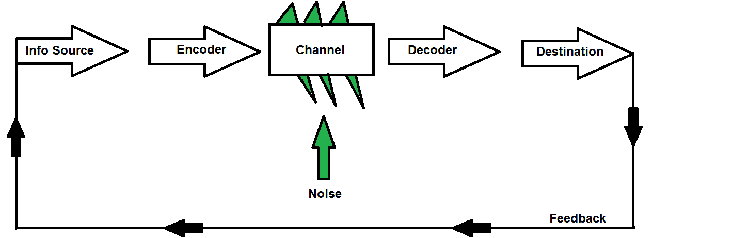

Figure 2.1.1. Shannon and Weaver Communication Model (Beyer, 2012)

Proposed by Claude Elwood Shannon in the year 1948, this model was considered the jack of all trades and master of none as it was comparatively more technical and complicated than others thereby failing due to the issues accompanying it. This model stated that four main components are contributing to this model of communication. The sender encodes a message and sends it through a communicative channel to the receiver who decodes and sends feedback. Later another component “noise” was identified to be causing a disturbance in the path of communication. This model is criticised for lacking certain important aspects (Panda, 2018). This model is argued to be more effective for interpersonal communication and not for mass communication. Another con of this communication model is that here feedback is considered to be of less importance. Feedback is considered to be the most important factor as it would ensure that the message has been received appropriately. Another important factor in this model is that noise even though serves as a hindrance but as inevitable as it may be caused due to some disturbances in the distribution channels for which the receiver needs to take time, interpret the meaning of the message, understand it and then send a response back (Petersons and Khalimzoda, 2016).
Considering the case of Maria and Pedro, there was a confusion/ miscommunication which got created because of the noise that got in through the telephone network which made Pedro think that he was called to the kitchen whereas Maria asked him to get chicken. This model fits into this case because here noise acts as a catalyst. This confusion could have been avoided if Pedro tried to interpret the message given by Maria and then acted accordingly. This model, if used effectively, could have solved the confusion as this model gives the option of feedback. If Pedro had redialed to his wife for reconfirmation, then this situation could have been avoided.
In my own workplace, catalyst is to be busy. When we try to do many things at the same time, we can get confused and misunderstand each other. In fact, if we take notes by spending only 10 seconds, we can avoid this confusion. In this way, we confirm that our message has been received correctly.
SEDA
REQUEST AN ACTIVITY
LISTENING AN ACTIVITY
STAFF
ORAL COMMUNICATION
FEEDBACK
VERBAL EXPRESSION
A QUEATION
SENDER
ENCODER
CHANNEL
DECODER
RECEIVER
"OK"
VERBAL EXPRESSION
 |  |  | BUSY PLACE  NOISE |  | ACTIVE LISTENING
CLINIC
BUSY PLACE

Figure 2.1.2. Shannon & Weaver Communication Model Example

  - Wilbur Schramm Communication Model:
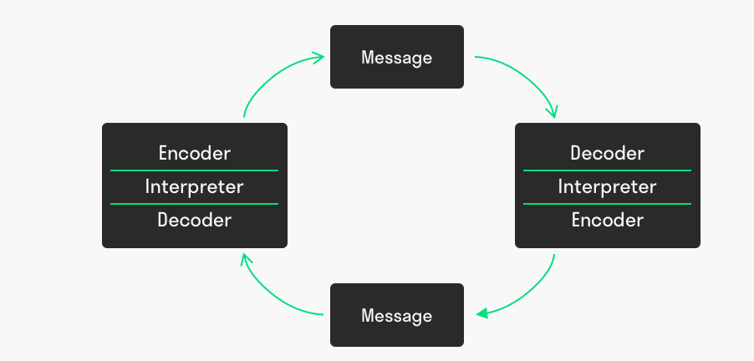
Figure 2.2.1. Wilbur Schramm Communication Model (Janse, 2019)

Contrasting to the above-stated communication model of Shannon Weaver another active and interactive model was identified to be convenient and perfect to be used for different kinds of communication, ie. interpersonal and intrapersonal communication. Communication is the key to everything. In 1954 Wilbur Schramm proposed a circular model that stated communication as a two-way channel. This was derived from Osgood's circular model which emphasised on encoding and decoding of any message. This model was considered as an absolute perfect approach to communication as it took into view the attitude, behaviour of individuals when they are exchanging information regarding anything. He believed that in a communication system two people are the most important, one is the sender who is allocated the duty of sending information and another who is receiving it (Ellestrom, 2018). He argued that a message revolves around in a circular model and probably a few components were explaining the communication process in this model. They are the source/ sender who is in the job of making and sending the message, the signal which is the language in which the message is sent to make it more understandable and appropriate. The next component is the decoder where the receiver is expected to interpret and analyse the message. Last is the receiver who receives the final message.
This model also identifies a few limitations that this model can cause misinterpretation of messages when the senders are more than one person so there if this model is applied then the final information will differ from the actual information. The second limitation is that just like the Shanon Weaver Model this model also doesn’t aim to work in case of mass communication (Lim, 2017). Let’s take an example to explain the mechanism of this model. Suppose there are two people named Liv and Eli who are planning for a day out the next week. Liv seems pretty more excited than Eli for the day out. She asks Eli to suggest some more ideas that they can spend their day with more fun and enjoyment. But Eli being extremely engaged in her phone doesn’t respond to Liv. Scramm identifies this as a barrier in communication. If Eli had responded to Liv then that would have been considered an effective communication. Working in the organisation, British Broadcasting Corporation several issues were identified like employees planned and initiated a project without communicating it properly to the team leader which acted as barriers to communication. This model could help the organisation identify these issues and improve themselves.

  - Berlo’s SMCR Communication Model:
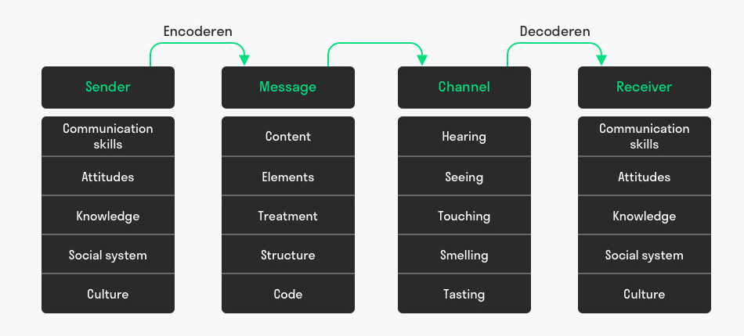
Figure 2.3.1. Berlo’s SMRC Communication Model (Janse, 2019)

Soon after the model was proposed and initiated by the Shannon Weaver Model in 1949, David Berlo proposed another simple model of communication called the SMCR model which mainly consisted of 4 major components: Sender, Message, Channel and Receiver. This model also focused on encoding and decoding but they were done much earlier before the message was analysed and sent from the sender’s end and received by the receiver. Each of the four components that are being identified in this model is believed to be influenced by diverse factors (Kovalevskaya and Kratenok, 2019).
The sender is the one who is responsible for sending the message. He is identified as the source who discovers and establishes the message. A sender and receiver attribute the same characteristics and are expected for having skills like communication skills. The model indicated that a sender should have efficient communication skills so that he can make sure an appropriate message is framed and sent to the receiver. The second characteristic which the sender exhibits are knowledge. The sender should be extremely knowledgeable to be familiar and acquainted with every information given to him. Next, the sender should be clear about proper attitudes to predict the effect of the message. This model also argued that the culture and social system also greatly influence the sender. Next, the M that stands for the message is expected to be influenced by factors like elements, code, content, treatment, and structure. Third the C which is the channel which refers to any medium through which a message is sent to the receiver, i.e., ear, eyes, physical contact, etc (Brantley, 2018).
An example of this model can be the case example where all the mishaps and miscommunication caused as there was no feedback. In this case study, the supervisor of the organisation speaks in English and communicates her message to everyone in the morning but as she speaks quickly and in a different accent, few foreigners find it difficult to understand her and as scared of losing their jobs do not ask for further clarification which leads them to trouble in case of giving medications to the patients.

- Communication Skills

When communicating only adequate knowledge of different models won't just help an organisation in communicating effectively but having exceptional communication skills is also necessary. These skills are necessary to convey a lot of messages and information to a multitude of people. Communication skills help in establishing trust as it takes into account everyone's decisions and ensures that everyone in an organisation knows about their responsibilities and duties and fulfills it. These skills also strive to prohibit any problems and issues existing in the organisation (Bashir, Syed, and Kumar, 2016). These skills offer clarity and direction to an organisation thereby enhancing productivity and elevating team building. Some extremely essential communication skills need to be improved significantly for improving the environment of the organisation (Serrat, 2017). They are:
Active Listening:- This constitutes to the non -verbal communication and plays an important role in communication. Listening actively to someone not only makes the information more understandable but also portrays the feelings and attitudes of the speaker during communicating their messages. Suppose an organisational head is discussing some important topics in a meeting and the members of the team don't seem to listen to it carefully. This makes the communication extremely vacant and the relationship between the members and the manager is ruined. So to ensure active listening throughout the organisation should create such a positive environment where everyone has the freedom to share their opinions and motives.
Nonverbal communication:- Along with exchanging messages and dialogues through speech and texts, this kind of communication refers to the gestures, eye movement, behaviours, emotions, and feelings of the individual (Kovalevskaya and Kratenok, 2019). It is extremely essential to understand and interpret a person’s feelings and thoughts without the need for words. Studies reveal that most of the time a person's words and emotions are analysed through his body language. The way he walks waves his hands, stands, rolls his eyes tells a lot of things about the person. In an organisation, when a new employee is appointed he might face difficulty in approaching the supervisor of the organisation for some issues but at that time his gestures, body movements, and expressions are sufficient to convey his emotions to the people present there and they might embrace their problems. So it is vital to understand the non-verbal signals and signs as it helps in building a trustworthy and reliable relationship.
There are different methods of improvement of these kinds of communication skills (Semenova et al, 2018). They are:
- Being empathetic and kind while listening to someone can help him gain confidence and put forth his opinions and thoughts in public
- Being responsible and initiating conversation from the individual’s side can also improve communication skills. Often there are chances of misinterpretation and miscommunication during nonverbal communication. During that time communication plays as a key.
- Preparing oneself before the beginning of a conversation can help in communicating the appropriate message to the right set of people at the right time.
- While communicating, putting oneself at the position of the receiver can help the sender in making the receiver understand the messages and information perfectly.

- Conclusion

To conclude it can be rightly stated that communication is a key to process lives and drive it in the right way. It is extremely essential to understand the importance of communication and apply it rightly to ensure it reaches the right set of people flawlessly. This article attempted to put forth only three important models of communication out of the huge swarms of the communication model. This also focused on explaining the several drawbacks of the application of these models in practical life. Additional to this, the following article also briefly determined and interpreted the several communication skills that could be used to ensure that people actively and empathetically listen and understand each other.

- References
Bashir, S., Syed, S. and Kumar, S., (2016) Impact of Effective Communication Skills on Organizational Change Initiatives. Available at: https://www.researchgate.net/profile/Salman_Memon2/publication/336059333_Impact_of_Effective_Communication_Skills_on_Organizational_Change_Initiatives/links/5dd6cfc0458515dc2f41e11f/Impact-of-Effective-Communication-Skills-on-Organizational-Change-Initiatives.pdf
Beyer, G., (2012) The Shannon-Weaver Model. Available at: http://garthbox.com/the-shannon-weaver-model/
Brantley, W.A., (2018) A new research agenda for project management communication theory. Available at: https://www.researchgate.net/profile/Bill_Brantley/publication/301701702_A_New_Research_Agenda_for_Project_Management_Communication_Theory/links/5723fa0808aef9c00b811f82.pdf
Elleström, L., (2018) ‘A medium-centered model of communication’, Semiotica, 2018(224), pp.269-293. Available at: https://www.degruyter.com/view/journals/semi/2018/224/article-p269.xml
Janse, B., (2019) Schramm Communication Model. Available at: https://www.toolshero.com/communication-skills/schramm-communication-model/
Janse, B., (2019) Berlo’s SMRC Model of Communication. Available at: https://www.toolshero.com/communication-skills/berlos-smcr-model-of-communication/
Keyton, J., (2017) ‘Communication in organisations’, Annual Review of Organizational Psychology and Organizational Behavior, 4, pp.501-526. Available at: https://www.annualreviews.org/doi/abs/10.1146/annurev-orgpsych-032516-113341
Kovalevskaya, I.I. and Kratenok, I.V., (2019) Communication Design: programme of study for specialty 1-26 80 05 Marketing. Available at: http://edoc.bseu.by:8080/bitstream/edoc/79798/1/Communication_Design.pdf
Lim, F.P., (2017) ‘An analysis of synchronous and asynchronous communication tools in e-learning’, Advanced Science and Technology Letters, 143(46), pp.230-234. Available at: https://www.researchgate.net/profile/Francis_Lim7/publication/313673458_An_Analysis_of_Synchronous_and_Asynchronous_Communication_Tools_in_e-Learning/links/5c441688299bf12be3d55625/An-Analysis-of-Synchronous-and-Asynchronous-Communication-Tools-in-e-Learning.pdf
Panda, S., Critical understanding of ICT course-Epc 4. Available at: https://www.gcbtcollege.in/studymaterial/ictSem4.pdf
Petersons, A. and Khalimzoda, I., (2016) ‘Communication Models and Common Basis for Multicultural Communication in Latvia’, Proceedings of the International Scientific Conference. Volume IV (Vol. 423, p. 433). Available at: http://journals.rta.lv/index.php/SIE/article/view/1555
Semenova, L.V., Zaitseva, N.A., Rodinova, N.P., Glagoleva, L.E., Fursov, V.A., Radina, O.I. and Tsutsulyan, S.V., (2018) ‘Improving the training of personnel based on the model of interaction between educational organisations and centers for assessing qualifications’, Modern journal of language teaching methods, 8(3), pp.356-368. Available at: https://www.researchgate.net/profile/Liudmila_Semenova/publication/327733017_IMPROVING_THE_TRAINING_OF_PERSONNEL_BASED_ON_THE_MODEL_OF_INTERACTION_BETWEEN_EDUCATIONAL_ORGANIZATIONS_AND_CENTERS_FOR_ASSESSING_QUALIFICATIONS/links/5ba166fe299bf13e603bbb33/IMPROVING-THE-TRAINING-OF-PERSONNEL-BASED-ON-THE-MODEL-OF-INTERACTION-BETWEEN-EDUCATIONAL-ORGANIZATIONS-AND-CENTERS-FOR-ASSESSING-QUALIFICATIONS.pdf
Serrat, O., (2017) Knowledge solutions: Tools, methods, and approaches to drive organisational performance (p. 1140). Springer Open. Available at: http://library.oapen.org/bitstream/handle/20.500.12657/28041/1001955.pdf?sequence=1

- Appendices
6.1. Maria and Pedro
 |  | ENCODER |  | CHANNEL |  | DECODER |  | RECEIVER
  SENDER
 | Maria | TELEPHONE NETWORK COMPONY | MOBILE PHONE |  |  |  | Pedro
 |  |  |  |  | TELEPHONE NETWORK COMPONY
 |  |  |  |  | ACTIVE LISTENING
VERBAL EXPRESSION
A QUEATION
 |  |  |  | NOICE
BUILDING SITE
NOISY PLACE
 |  |  |  | FEEDBACK
"OK"
VERBAL EXPRESSION

A1. Pedro works on a building site which is probably very noisy place, so he couldn’t hear well.
A2. Shannon and Weaver Model of Communication, because this model has noise section, which does not let message get to receiver as what is sent.
A3. Pedro could go to the quieter place to speak. He knows that his workplace is noisy, and it is very likely to misunderstand.
A4. Berlo’s SMRC Model of Communication. According to him, receiver must also have a very good listening skill. If the receiver doesn’t listen well, the message doesn’t go to the receiver as what is sent. The receiver is also effective decoding the message in a right way.
6.2. Barry and Barriers to Communication

A.1. The employees have different culture and ethnic backgrounds. And English is not their first language for most of them, which is really hard to explain them how important food safety. Especially with high turnover of employees, training is often hurried, and some new employees start to work without training.
When Barry saw the uncooked meat are on the table, he directly thought how long are those meat stay in the room temperature and became nervous, because the employees are not following the rules for food safety.
A.2. Barry should persist to his boss about the employees must have the training about food safety. And they shouldn’t change too many employees.
Writing two simple rules on a wall can’t be enough, because their English is not good, and they may not to read them. He may put the pictures about these rules to remind them.
A.3. He should be dominant. He can do metaphor and he can tell the employees about his own experience. He should be open their advises, he can ask them how to improve communication between each other and what can be helpful for them to remind the rules.

6.3. Trouble at Home, Trouble with Training
- Jennifer had a problem with her boyfriend and also with her roommate. She was thinking these problems, so she couldn't do her job properly.
- She couldn't listen well her training, so she faced with losing her job.

- She should do anything in power to get placement.
- E: evaluate the professional context.

