Daniels Zelinskis (2104718)
Computer Networks and Cybersecurity
Introduction to Web and Database Concepts
Gareth Jones
University of Wales Trinity Saint David

Contents

Introduction 3
Requirements 4
Implementation 5
Validation 8
6.A. Evaluation 10
6.B. Evaluation 12
References 14

Introduction

Website provided to you is directory and contact pages. Currently, directory and contact pages are very popular due to their simplicity and minimalization. They are a great help tool to develop small businesses effectively and efficiently. In addition, these types of websites have shown to attract users due to high level SEO and usefulness.
The purpose of this website is to introduce the customer to my services, increase interest among young people in the culture of Swansea (Wales) and introduce tourists who never been to our beautiful city of Swansea. In my opinion, Swansea is one of the cultures enriched with beautiful nature. Therefore, I would like to expand the knowledge about this city to attract tourists and to develop its culture. I aim to accomplish this by showing the hidden beauty of the city inside and out. The website presents the information about my work, a brief introduction to the history of the city, photos and the opportunity to contact me for further enquiries.
Swansea is a multi-culture city that has attracted many students from different countries. Thus, this website will be of very interest for all population within the region and for those who are first visiting the city.

Requirements

Website is essential in every aspect of our life. The ability to design and hand-code a website is critical in the development of a successful website. The aim of this study was to design and hand-code a website. Therefore, this report overviews the design and hand-coding of “Swansea”. The website presents my services of Swansea in South Wales. The website was hand-coded using HTML and CSS. In addition, the report includes the implementation of the pages of the website and the validation. On the website were some errors that were corrected. Furthermore, the website design was further evaluated for website usability, website accessibility (reference WCAG 2.1) and search engine optimisation (SEO). The results showed good for website usability, good for website accessibility and good for SEO. Therefore, these results suggest a well-functioning “Swansea” website with good website usability and accessibility as well as high ranking SEO. Overall, “Swansea” website provide up-to-date information on my services, but further work will be required to keep up with the new service improvements.

Implementation

Screenshots of all pages of the completed website. The pages were too large for a single screenshot on the screen, so I divided each page into two parts (not counting the first page (Home))
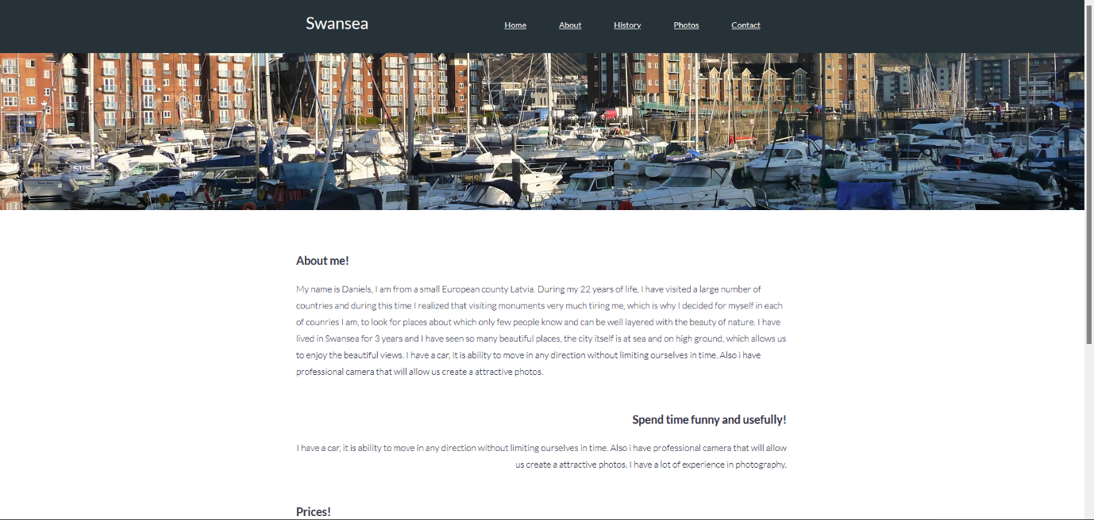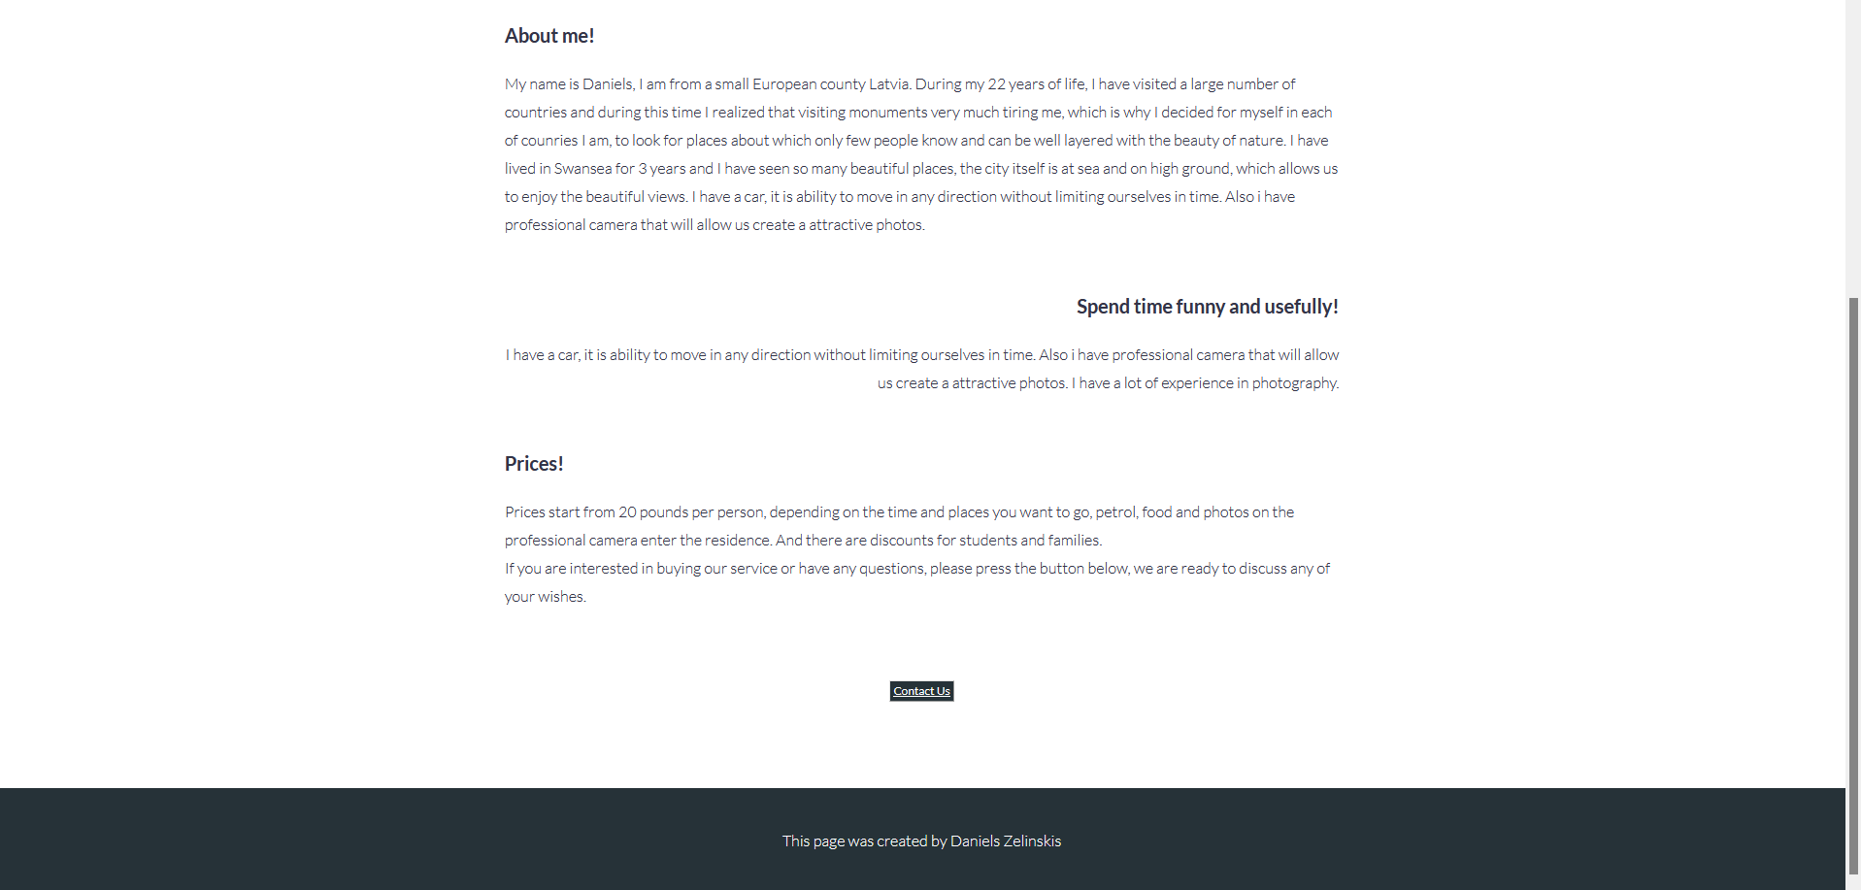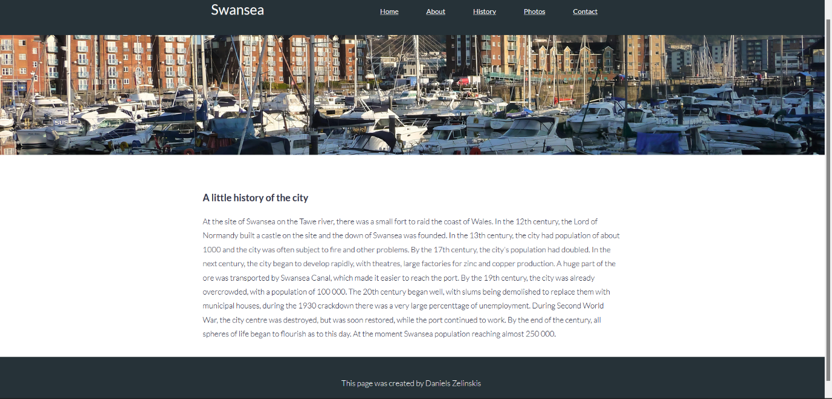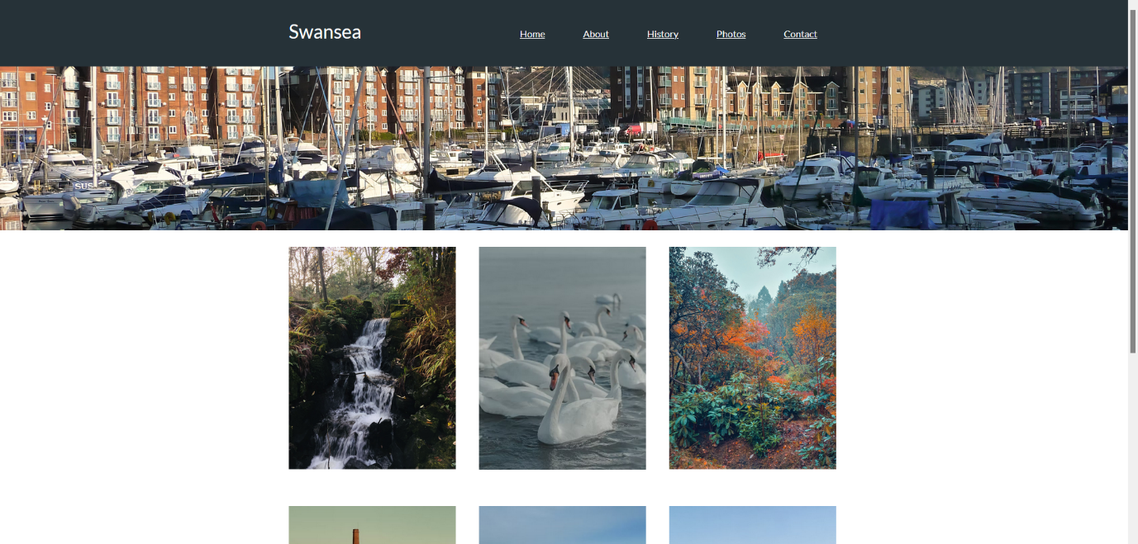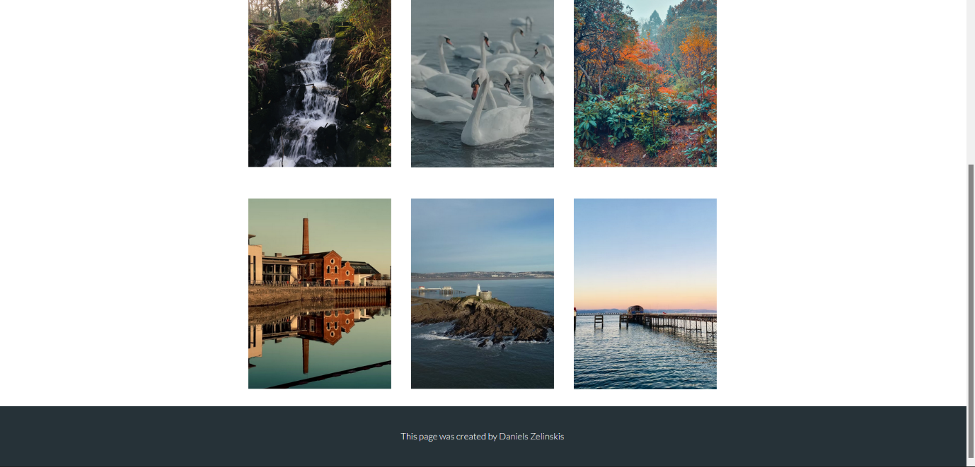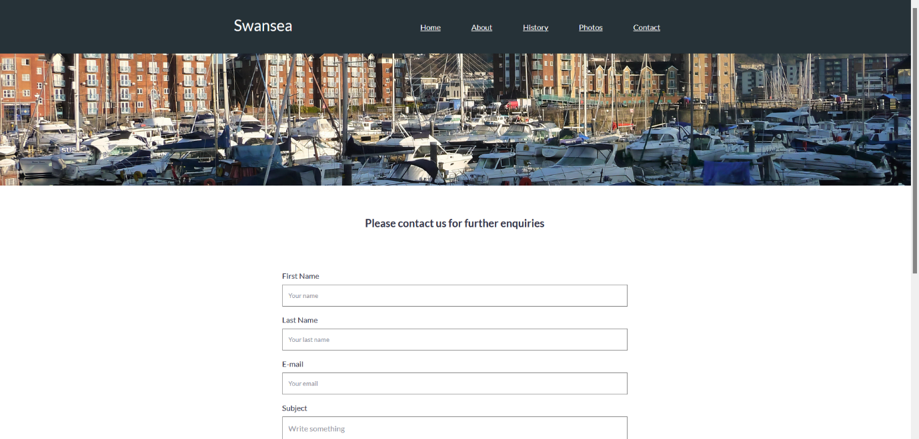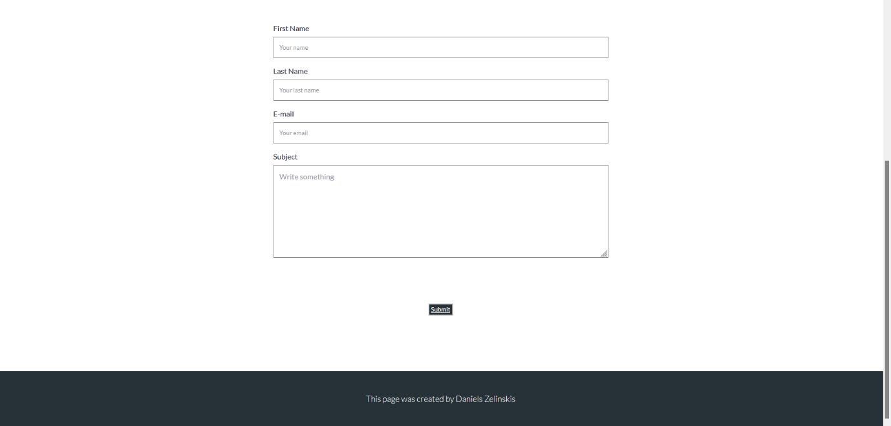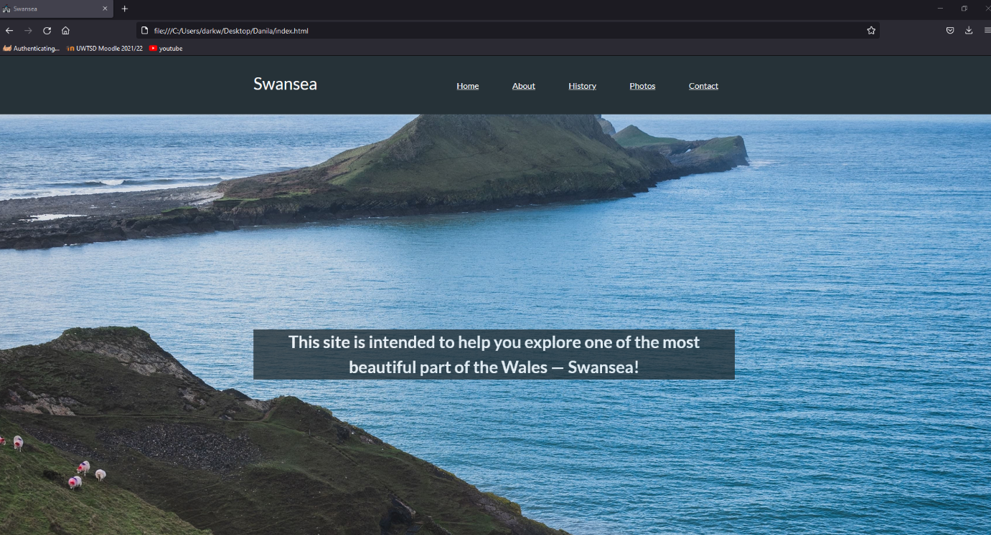

Validation

Two complete CSS codes were checked, no errors were found.
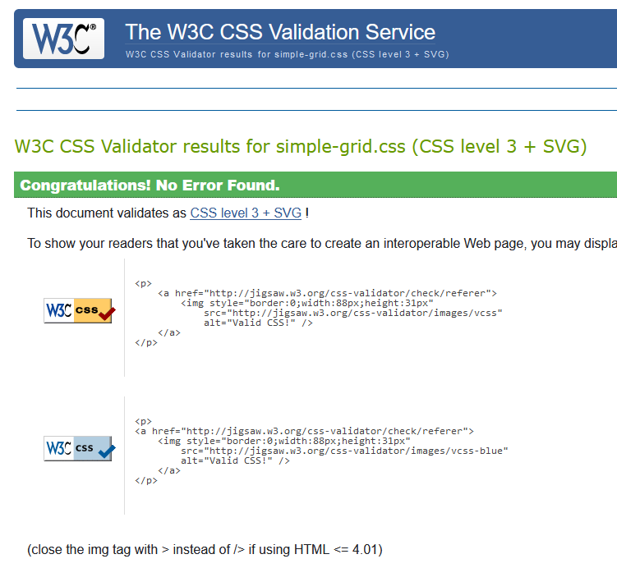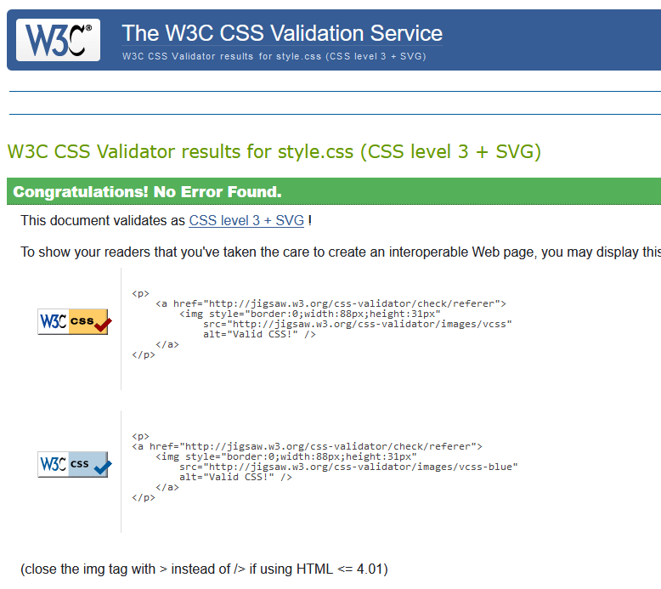

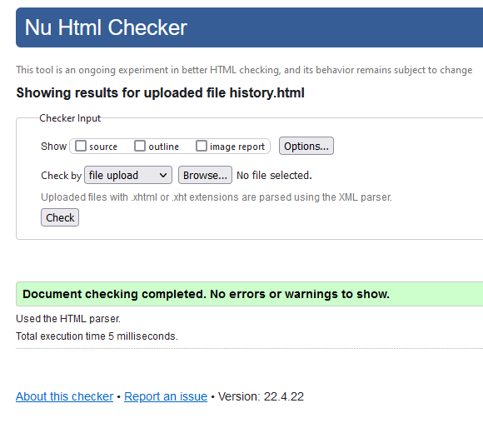
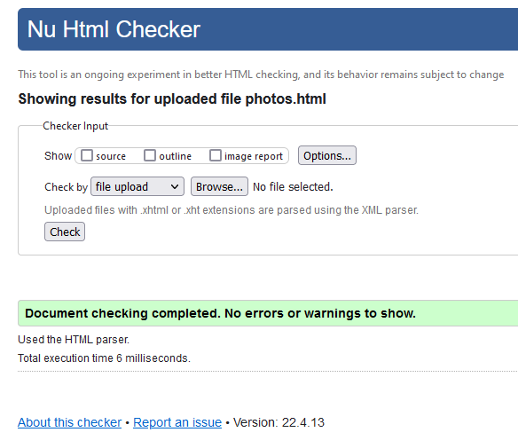
After checking all the HTML codes, it was found that o1 of 5 had an error.
Photos.html and History.html

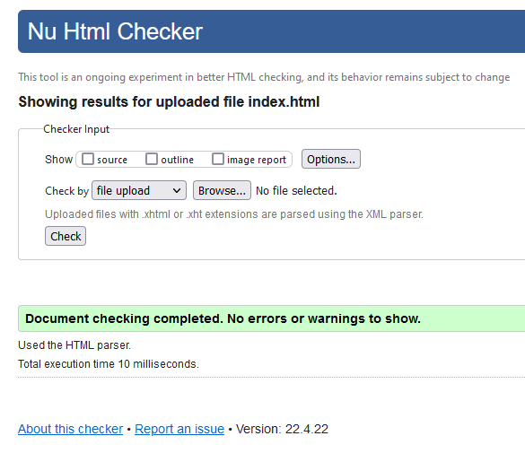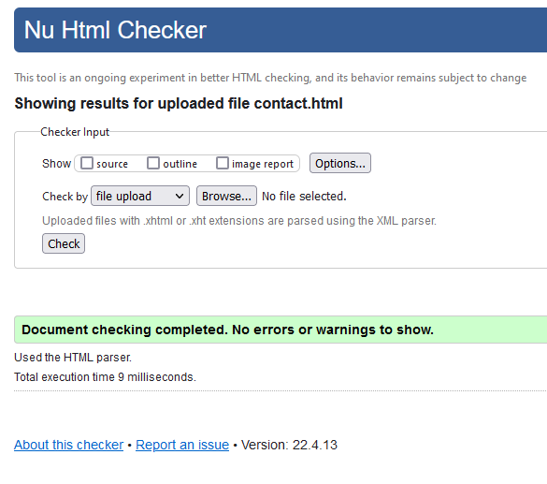
Inderx.html and Contact.html

One error was found in the About.html code, the ‘a’ element was used to move to another page, but it was later discovered that the element ‘button’ could be used in the html, which does it is job perfectly. The error was successfully fixed.
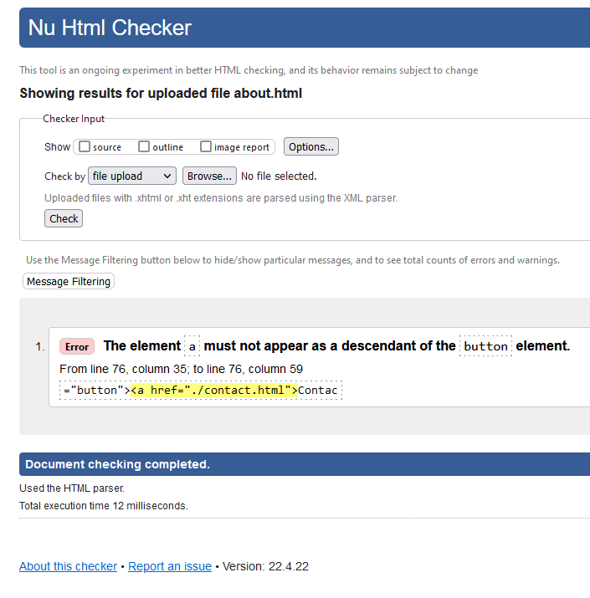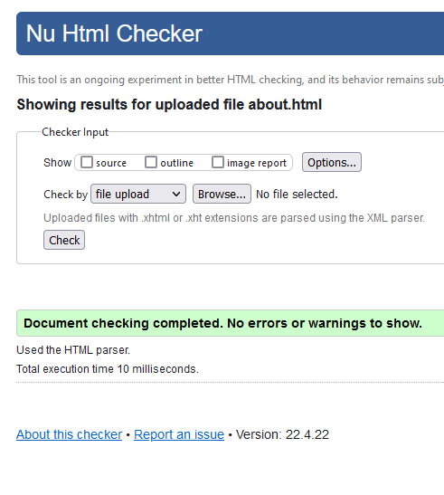
About.html before fix and after.

6.A. Evaluation

Website usability
Web usability is defined as an extent to which a website can be used by web user to achieve their specified goal with effectiveness, efficiency and satisfaction. Therefore, web usability is a target of easy and efficient usability and presenting information in a correct way that its clear and concise. The web usability requires the correct placement of items that can be found easy in the convenient locations. In addition, web usability requires of its data to work in different browsers and devices.
Website usability is one of the most important and critical factors when successfully designing a website as this increases user attention and ability to access and utilise all the website sources. In addition, it allows satisfaction of the user when using the website enhancing the user to return. Therefore, this would allow user viscosity and increase user loyalty. For example, a study by Qu et al., 2017, evaluated website usability by human physiological measures ^{[1]}. The study utilised eye-movement metrics and heart rate variability to evaluate web usability to determine how web usability affects surfing behaviour. The investigated variables were based on previously published data (satisfaction, efficiency, effectiveness, learnability and memorability) where each was tested from 1-7. The results showed that fixation, count blink and heart rate can reflect website usability. Using these variables, the study found that good usability web has a lower fixation time and a lower count as user find information quicker and spent less time. Therefore, website usability is critical in the development and utilisation of the website.
Website accessibility
Website accessibility is the requirement of a website to have no barriers or obstacles to access and interact with world wide web by users with disabilities and older population as well as people who slow internet connection and bandwidth.
Website accessibility is essential in developing websites. This allows all population to access the information and data on the website effectively that, in turn, enhances its use and return rate. For example, a study evaluated website accessibility of 9 Australian National and State/Territory Library websites over a period of 6 weeks ^{[2]}. The current criteria for Australian government website to comply with Web Content Accessibility Guidelines (WCAG) 2.0 Level AA. The website accessibility was tested automated by Sort Site by Power mapper, manually tested by experts and by users with disabilities to measure whether the websites meet the criteria of WCAG 2.0. The results showed that Sort Site evaluation was different to manual evaluation, such as heading, and labels were captured manually on 8 websites whereas Sort Site captured none. Therefore, website accessibility is critical for users with disability to access website and its content. In addition, website accessibility testing could be required to standardise the website design and functioning that could be used by all population.
Search engine optimisation: Search Engine Optimisation (SEO) is the process of improving visibility and presence of the website on search engines to people who are searching for the product.

SEO is one of the important criteria when developing a website as it allows to successfully find and access the website for users using search engines. SEO has two parts: off-page and on-page optimisation. Off-page optimisation requires other websites for building backlinks and increasing page-level authority. On-page optimisation requires targeting heading, keywords, snippets and in the URL. While no SEO rankings have been defined, there are factors that influence the search. For example, a study tested Greek media websites for their ranking under SEO. The websites include two groups, but not limited to, Group A (top 50) gazzetta.gr and in.gr, and Group B (100+) sentragoal.gr and star.gr ^{[3]}. The SEO cristae was dichotomous and non-dichotomous, such as ULR and speed/load time, respectively. The results showed that Group A had 100% positive image optimisation compared to Group B (66%). In addition, link exchange was higher in Group A than Group B. Also, the speed was higher and domain age lower in Group A compared to Group B. Therefore, these results suggest highlight the importance of SEO strategies to influence on website to successful use and growth.

6.B. Evaluation

In my opinion the website is made well, it is useful for certain people. When developing this site all nuances were invented, for example, was provided information about me, who created and who provides services. The more I open to customers, then more chance of success. It is worth considering that the design is made in a simple style, minimalistic, without any advertising, extra information and animations, that is nice to be on the pages, and each of page include with picture, that everything looks aesthetic and pleasing to the eye. The functionality of this site is also good, there are no errors and freezing, website works quickly. Please note that by clicking on the “Swansea" button in the upper left corner, you will also be moved to the front page (each of buttons working), thereby indicating that the navigation in the work was done successfully.
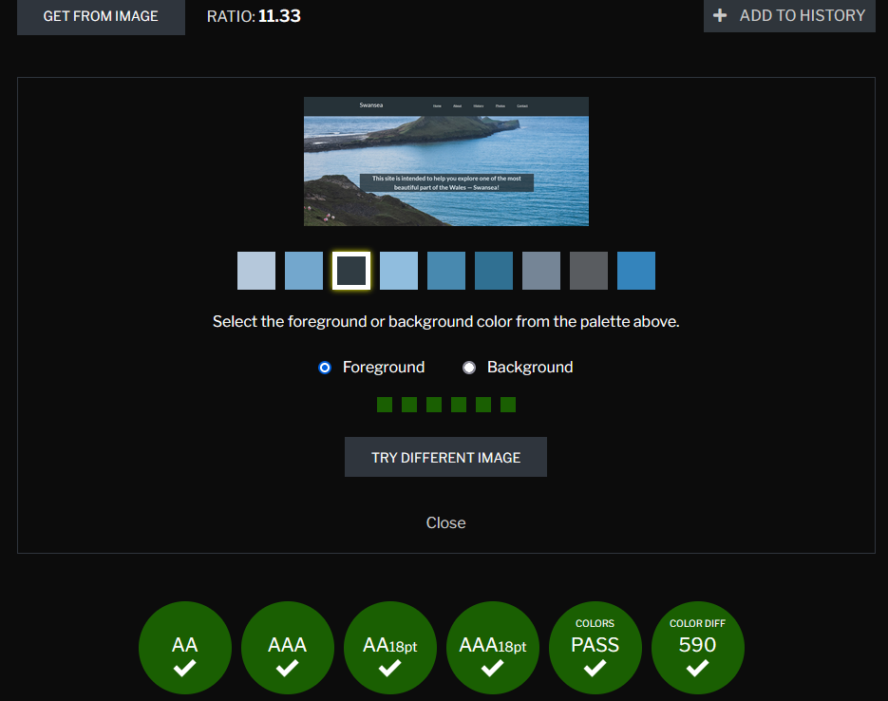
In this work I see ways to improve, to make the information more official and informative, add more photos of unusual and beautiful places. Make a search string with keywords that will simplify the work and automatic answering machine, at any time the customer can ask any question and get an answer to it immediately.
Check was carried out through the https://contrastchecker.com/

The data was positive. The contrast and brightness were completely consistent, and the entire text was readable.

References
Cirkovic, N. (2020, December 24). Swansea. Retrieved from unsplash.com: https://unsplash.com/photos/cNHlVr-I9uw
Contrast Checker. (2017). Retrieved from Acart Communications: https://contrastchecker.com/
Dorran, R. (2019, November 13). Swansea. Retrieved from unsplash.com: https://unsplash.com/photos/p0OaA8xvxlI
Lu, L. (n.d.). The 8 different types of websites and how to choose the right one . Retrieved from 99designs.co.uk: https://99designs.co.uk/blog/web-digital/types-of-websites/
SC, F. (2020, December 3). Swansea. Retrieved from unsplash.com: https://unsplash.com/photos/CztiuE01H3U
Thomas, R. (2020, October 29). Swansea. Retrieved from unsplash.com: https://unsplash.com/photos/-NEee5-aOX0
Varma, A. (2021, April 11). Swansea. Retrieved from unsplash.com: https://unsplash.com/photos/vOHs3ZvSczk
W3C. (1994-2013). Markup Validation Service. Retrieved from validator.w3.org: https://validator.w3.org/#validate_by_uri
Woodbridge, M. (2019, October 1). Swansea. Retrieved from unsplash.com: https://unsplash.com/photos/SmSiP1P6KhU

[1] Qu, Q.-X., Guo, F., & Duffy, V. G. (2017). Effective use of human physiological metrics to evaluate website usability. In Aslib Journal of Information Management (Vol. 69, Issue 4, pp. 370–388) Emerald
[2] Conway, V., Brown, J., Hollier, S., & Nicholl, C. (2012). Website Accessibility: A Comparative Analysis of Australian National and State/Territory Library Websites. In The Australian Library Journal (Vol. 61, Issue 3, pp. 170–188). Informa UK Limited
[3] Giomelakis, D., & Veglis, A. (2015). Investigating Search Engine Optimization Factors in Media Websites. In Digital Journalism (Vol. 4, Issue 3, pp. 379–400). Informa UK Limited

Appendices
CSS Codes:
Simple-grid.css

/**
*** SIMPLE GRID
*** (C) ZACH COLE 2016
**/

@import url(https://fonts.googleapis.com/css?family=Lato:400,300,300italic,400italic,700,700italic);

/* UNIVERSAL */

html,
body {
height: 100%;
width: 100%;
margin: 0;
padding: 0;
left: 0;
top: 0;
font-size: 100%;
}

/* ROOT FONT STYLES */

* {
font-family: 'Lato', Helvetica, sans-serif;
color: #333447;
line-height: 1.5;
}

/* TYPOGRAPHY */

h1 {
font-size: 2.5rem;
}

h2 {
font-size: 2rem;
}

h3 {
font-size: 1.375rem;
}

h4 {
font-size: 1.125rem;
}

h5 {
font-size: 1rem;
}

h6 {
font-size: 0.875rem;
}

p {
font-size: 1.125em;
font-weight: 200;
line-height: 1.8;
}

.font-light {
font-weight: 300;
}

.font-regular {
font-weight: 400;
}

.font-heavy {
font-weight: 700;
}

/* POSITIONING */

.left {
text-align: left;
}

.right {
text-align: right;
}

.center {
text-align: center;
margin-left: auto;
margin-right: auto;
}

.justify {
text-align: justify;
}

/* ==== GRID SYSTEM ==== */

.container {
width: 90%;
margin-left: auto;
margin-right: auto;
}

.row {
position: relative;
width: 100%;
}

.row [class^="col"] {
float: left;
margin: 0.5rem 2%;
min-height: 0.125rem;
}

.col-1,
.col-2,
.col-3,
.col-4,
.col-5,
.col-6,
.col-7,
.col-8,
.col-9,
.col-10,
.col-11,
.col-12 {
width: 96%;
}

.col-1-sm {
width: 4.33%;
}

.col-2-sm {
width: 12.66%;
}

.col-3-sm {
width: 21%;
}

.col-4-sm {
width: 29.33%;
}

.col-5-sm {
width: 37.66%;
}

.col-6-sm {
width: 46%;
}

.col-7-sm {
width: 54.33%;
}

.col-8-sm {
width: 62.66%;
}

.col-9-sm {
width: 71%;
}

.col-10-sm {
width: 79.33%;
}

.col-11-sm {
width: 87.66%;
}

.col-12-sm {
width: 96%;
}

.row::after {
content: "";
display: table;
clear: both;
}

.hidden-sm {
display: none;
}

@media only screen and (min-width: 33.75em) {

/* 540px */
.container {
width: 80%;
}
}

@media only screen and (min-width: 45em) {

/* 720px */
.col-1 {
width: 4.33%;
}

.col-2 {
width: 12.66%;
}

.col-3 {
width: 21%;
}

.col-4 {
width: 29.33%;
}

.col-5 {
width: 37.66%;
}

.col-6 {
width: 46%;
}

.col-7 {
width: 54.33%;
}

.col-8 {
width: 62.66%;
}

.col-9 {
width: 71%;
}

.col-10 {
width: 79.33%;
}

.col-11 {
width: 87.66%;
}

.col-12 {
width: 96%;
}

.hidden-sm {
display: block;
}
}

@media only screen and (min-width: 60em) {

/* 960px */
.container {
width: 75%;
max-width: 60rem;
}
}

Style.css

nav {
background-color: #263238;
}

nav li {
list-style-type: none;
color: white;
}

.logo {
font-size: 2rem;
}

.logo a {
text-decoration: none;
}

.nav-links ul {
display: inline-flex;
}

.nav-links ul li {
padding: 0 2rem;
}

nav div, a {
color: white !important;
}

.background {
height: 100%;
background: url(../assets/background.jpg);
background-position-y: center;
background-size: cover;
display: flex;
align-items: center;
}

.background-secondary {
height: 30%;
background: url(../assets/about-background.jpg);
background-position-y: center;
background-size: cover;
display: flex;
align-items: center;
}

.about h3 {
padding-top: 40px;
}

.contact-button {
margin: 80px 0;
}

button, input[type="submit" i] {
color: white;
text-decoration: underline;
background-color: #263238 !important;
}

input[type="submit" i] {
margin: 80px 0;
}

footer {
background-color: #263238;
padding: 25px 0;
margin: 0;
bottom: 0;
width: 100%;
display: flex;
justify-content: center;
margin-top: auto;
}

footer p {
color: white;
}

.background h2 {
color: white;
background-color: #263238;
opacity: 80%;

}

.header {
width: 100%;
}

input[type=text], select, textarea {
width: 100%;
padding: 12px;
border: 1px solid gray;
box-sizing: border-box;
margin-top: 6px;
margin-bottom: 16px;
resize: vertical
}

form {
padding-top: 20px;
}

.container {
border-radius: 5px;
padding: 20px;
}

.gallery img {
padding: 0;
width: 100%;
}

HTML Codes:
About.html

<!DOCTYPE html>
<html lang="en">

<head>
<meta charset="utf-8" />
<title>Swansea</title>
<link rel="icon" type="image/x-icon" href="./assets/favicon.ico">

<!-- Simple Grid -->
<link rel="stylesheet" href="./css/simple-grid.css">

<!-- Current doc CSS -->
<link rel="stylesheet" href="./css/style.css">

</head>

<body>
<div class="header">
<nav>
<div class="container">
<div class="row">
<div class="col-3">
<div class="logo"><a href="./index.html">Swansea</a></div>
</div>
<div class="col-9 nav-links right">
<ul>
<li>
<a href="./index.html">Home</a>
</li>
<li>
<a href="./about.html">About</a>
</li>
<li>
<a href="./history.html">History</a>
</li>
<li>
<a href="./photos.html">Photos</a>
</li>
<li>
<a href="./contact.html">Contact</a>
</li>
</ul>
</div>
</div>
</div>
</nav>
</div>
<div class="background-secondary"></div>
<div class="container about">
<h3>About me!</h3>
<p class="left">My name is Daniels, I am from a small European county Latvia. During my 22 years of life,
I have visited a large number of countries and during this time I realized that visiting monuments
very much tiring me, which is why I decided for myself in each of counries I am, to look for places
about which only few people know and can be well layered with the beauty of nature.
I have lived in Swansea for 3 years and I have seen so many beautiful places, the city itself is at sea
and on high ground, which allows us to enjoy the beautiful views. I have a car, it is ability to move
in any direction without limiting ourselves in time. Also i have professional camera that will allow
us create a attractive photos.
</p>
<h3 class="right">Spend time funny and usefully!</h3>

<p class="right">I have a car, it is ability to move
in any direction without limiting ourselves in time. Also i have professional camera that will allow
us create a attractive photos. I have a lot of experience in photography.
</p>
<h3>Prices!</h3>
<p class="left">Prices start from 20 pounds per person, depending on the time and places you want
to go, petrol, food and photos on the professional camera enter the residence. And there are
discounts for students and families.
<br>
If you are interested in buying our service or have any questions, please press the button below, we are ready to discuss any of your wishes.
</p>

<div class="contact-button center">
<button type="button" onclick="document.location='./contact.html'">Contact Us</button>
</div>
</div>

<footer>
<p>This page was created by Daniels Zelinskis</p>
</footer>
</body>

</html>
Contact.html:

<!DOCTYPE html>
<html lang="en">

<head>
<meta charset="utf-8" />
<title>Swansea</title>
<link rel="icon" type="image/x-icon" href="./assets/favicon.ico">

<!-- Simple Grid -->
<link rel="stylesheet" href="./css/simple-grid.css">

<!-- Current doc CSS -->
<link rel="stylesheet" href="./css/style.css">

</head>

<body>
<div class="header">
<nav>
<div class="container">
<div class="row">
<div class="col-3">
<div class="logo"><a href="./index.html">Swansea</a></div>
</div>
<div class="col-9 nav-links right">
<ul>
<li>
<a href="./index.html">Home</a>
</li>
<li>
<a href="./about.html">About</a>
</li>
<li>
<a href="./history.html">History</a>
</li>
<li>
<a href="./photos.html">Photos</a>
</li>
<li>
<a href="./contact.html">Contact</a>
</li>
</ul>
</div>
</div>
</div>
</nav>
</div>
<div class="background-secondary"></div>

<h3 class="center" style="padding-top: 40px;">Please contact us for further enquiries</h3>
<div class="container about">
<div class="container">
<form>

<label for="fname">First Name</label>
<input type="text" id="fname" name="firstname" placeholder="Your name">

<label for="lname">Last Name</label>
<input type="text" id="lname" name="lastname" placeholder="Your last name">

<label for="lname">E-mail</label>
<input type="text" id="email" name="email" placeholder="Your email">

<label for="subject">Subject</label>
<textarea id="subject" name="subject" placeholder="Write something" style="height:200px"></textarea>

<div class="submit row center">
<input type="submit" value="Submit">
</div>

</form>
</div>
</div>

<footer>
<p>This page was created by Daniels Zelinskis</p>
</footer>
</body>

</html>

History.html

<!DOCTYPE html>
<html lang="en">

<head>
<meta charset="utf-8" />
<title>Swansea</title>
<link rel="icon" type="image/x-icon" href="./assets/favicon.ico">

<!-- Simple Grid -->
<link rel="stylesheet" href="./css/simple-grid.css">

<!-- Current doc CSS -->
<link rel="stylesheet" href="./css/style.css">

</head>

<body>
<div class="header">
<nav>
<div class="container">
<div class="row">
<div class="col-3">
<div class="logo"><a href="./index.html">Swansea</a></div>
</div>
<div class="col-9 nav-links right">
<ul>
<li>
<a href="./index.html">Home</a>
</li>
<li>
<a href="./about.html">About</a>
</li>
<li>
<a href="./history.html">History</a>
</li>
<li>
<a href="./photos.html">Photos</a>
</li>
<li>
<a href="./contact.html">Contact</a>
</li>
</ul>
</div>
</div>
</div>
</nav>
</div>
<div class="background-secondary"></div>
<div class="container about" style="height: 600px !important;">
<h3>A little history of the city</h3>
<p class="left"> At the site of Swansea on the Tawe river, there was a small fort
to raid the coast of Wales. In the 12th century, the Lord of Normandy built a
castle on the site and the down of Swansea was founded. In the 13th century,
the city had population of about 1000 and the city was often subject to fire
and other problems. By the 17th century, the city's population had doubled.
In the next century, the city began to develop rapidly, with theatres, large
factories for zinc and copper production. A huge part of the ore was transported
by Swansea Canal, which made it easier to reach the port. By the 19th century,
the city was already overcrowded, with a population of 100 000. The 20th century
began well, with slums being demolished to replace them with municipal houses,
during the 1930 crackdown there was a very large percenttage of unemployment.
During Second World War, the city centre was destroyed, but was soon restored,
while the port continued to work. By the end of the century, all spheres of life
began to flourish as to this day. At the moment Swansea population reaching
almost 250 000.
</p>
</div>

<footer>
<p>This page was created by Daniels Zelinskis</p>
</footer>
</div>
</body>

</html>

Intex.html

<!DOCTYPE html>
<html lang="en">

<head>
<meta charset="utf-8" />
<title>Swansea</title>
<link rel="icon" type="image/x-icon" href="./assets/favicon.ico">
<!-- Simple Grid -->
<link rel="stylesheet" href="./css/simple-grid.css">

<!-- Current doc CSS -->
<link rel="stylesheet" href="./css/style.css">

</head>

<body>
<div class="header">
<nav>
<div class="container">
<div class="row">
<div class="col-3">
<div class="logo"><a href="./index.html">Swansea</a></div>
</div>
<div class="col-9 nav-links right">
<ul>
<li>
<a href="./index.html">Home</a>
</li>
<li>
<a href="./about.html">About</a>
</li>
<li>
<a href="./history.html">History</a>
</li>
<li>
<a href="./photos.html">Photos</a>
</li>
<li>
<a href="./contact.html">Contact</a>
</li>
</ul>
</div>
</div>
</div>
</nav>
</div>
<div class="background">
<div class="container">
<div class="row">
<div class="col-12 center">
<h2>This site is intended to help you explore one of the most beautiful part of the Wales —
Swansea!</h2>
</div>
</div>
</div>
</div>

<footer>
<p>This page was created by Daniels Zelinskis</p>
</footer>
</body>

</html>

Photos.html

<!DOCTYPE html>
<html lang="en">

<head>
<meta charset="utf-8" />
<title>Swansea</title>
<link rel="icon" type="image/x-icon" href="./assets/favicon.ico">

<!-- Simple Grid -->
<link rel="stylesheet" href="./css/simple-grid.css">

<!-- Current doc CSS -->
<link rel="stylesheet" href="./css/style.css">

</head>

<body>
<div class="header">
<nav>
<div class="container">
<div class="row">
<div class="col-3">
<div class="logo"><a href="./index.html">Swansea</a></div>
</div>
<div class="col-9 nav-links right">
<ul>
<li>
<a href="./index.html">Home</a>
</li>
<li>
<a href="./about.html">About</a>
</li>
<li>
<a href="./history.html">History</a>
</li>
<li>
<a href="./photos.html">Photos</a>
</li>
<li>
<a href="./contact.html">Contact</a>
</li>
</ul>
</div>
</div>
</div>
</nav>
</div>
<div class="background-secondary"></div>
<div class="photos">
<div class="container photos row">
<div class="col-4 gallery">
<img src="./assets/gallery1.jpg" alt="Photo 1">
</div>
<div class="col-4 gallery">
<img src="./assets/gallery2.jpg" alt="Photo 2">
</div>
<div class="col-4 gallery">
<img src="./assets/gallery3.jpg" alt="Photo 2">
</div>
</div>
<div class="container photos row">
<div class="col-4 gallery">
<img src="./assets/gallery4.jpg" alt="Photo 4">
</div>
<div class="col-4 gallery">
<img src="./assets/gallery5.jpg" alt="Photo 5">
</div>
<div class="col-4 gallery">
<img src="./assets/gallery6.jpg" alt="Photo 6">
</div>
</div>
</div>

<footer>
<p>This page was created by Daniels Zelinskis</p>
</footer>
</body>

</html>

