Module Code: BMIH6007
Module Name: International Meetings Management for the
Hotel Industry

Title: Planning and Delivering an International Event
Student Name: Roberta Isabela Bradea
Student name: 2125159
Word Count: 2500

Table of Contents
Introduction and background 3
The Event Cycle 4
Event Concept and itinerary 6
Aim and Objectives of the Meeting 7
Event Operations 9
Event Budget 10
Industry Trends 12
Cultural and Situational Considerations 14
Reference 15

Introduction and background

This report has highlighted the InnoHospitality Tech event which will be held in The Crystal, London. The Mice Industry has been organising the event which has been a fast-growing sector powering the global business and hospitality markets. The event has been created for discussing the dynamic change in technology and innovation within the Hospitality Landscape. The Crystal has been chosen because of its architectural excellence and sustainability. It has a beautiful geometric facade which personifies modern design. The sustainability of the event can be easily acknowledged as the created buildings have been considered as one of the greenest in the world. The Event location has multiple advantages as it is positioned within the heart of London which offers easy accessibility for local and international guests. The event has a closer accessibility to the Tech hubs and landmarks which lines up with the innovative character of the event (Hillmann and Guenther, 2021). The Event has a great state of art facilities which is ideal for demonstrating new hospitality challenges. It has advanced audio-visual capabilities for a better immersive attendee experience. One of the main reasons behind selecting the place is the ample place which has networking, breakout sessions and vendor displays.
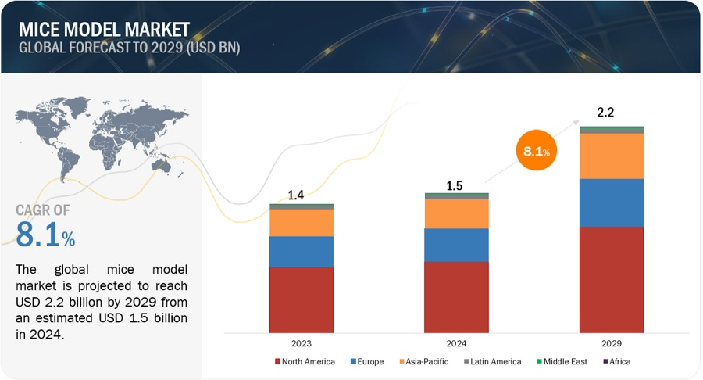
Figure 1: Global Mice Model Market
Source: (Markets and Markets, 2023)

The Event Cycle
An Event Cycle highlights the important phases between the time and event is showcased to the attendees and the day to the event. A better event needs to go through five stages like plan, organise, measure, analyse and share. For the first stage Planning, key findings need to be reviewed from the old event cycles. This sets the goals and targets for the next event. After the steps are executed, ideal participants or attendees are marked, and it is made sure that the event facilities have been planned carefully. A proper channel or structure has been followed for conducting the Event. Mice Industry have followed this first step as it has coordinated the setup and breakdown of the schedules for maximizing efficiency and minimizing disruptions. The organisation has refined the check in processes for using technology to handle the predicted attendees.
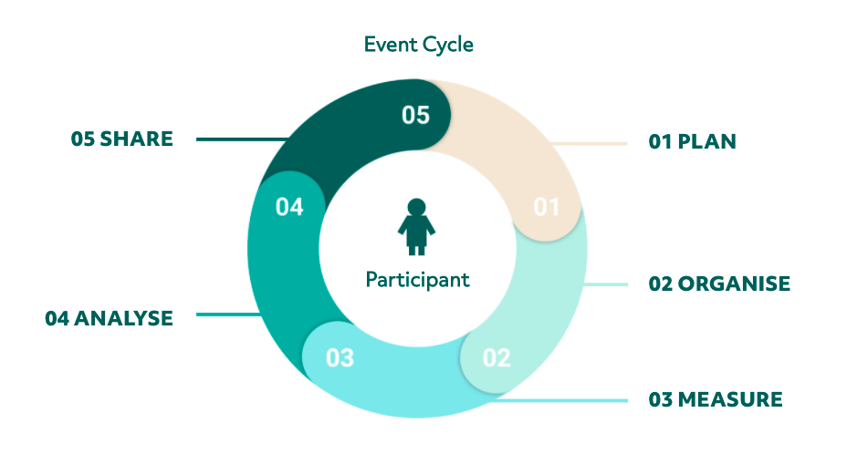
Figure 2: Event Cycle
Source: (LYYTI, 2021)
In the second stage of the Event cycle, the event is organised in either online or onsite manner. This stage is one of the most important steps because it covers the lifecycle stages from the beginning of pre-event marketing and post event follow up. Mice industry has perfectly amended the followings of the organised stage as the staff recruitment has been done in hospitality tech for easing discussions and managing exhibits. The staff have been specialized by training so that they are efficient in adopting the latest event technology (Li et al., 2021). The Mice industry has invested in high-quality audio-visual equipment for better attendee experience.
Stage | Description
Planning | Review key findings from earlier event cycles to set goals and targets for the InnoHospitality Tech event. Identify ideal participants and carefully plan event facilities at The Crystal, London. Coordinate setup and breakdown schedules for efficiency, refining check-in processes using technology.
Organising | Organise the event, both online and onsite, covering pre-event marketing to post-event follow-up. Recruit staff specialized in hospitality tech to help discussions and manage exhibits. Provide specialized training to staff for adopting the latest event technology. Invest in high-quality audiovisual equipment for better attendee experience.
Measuring | Evaluate event success through attendee feedback, participation metrics, and stakeholder satisfaction. Assess whether event goals and targets were achieved. Analyse strengths and areas for improvement to inform future event planning.
Analysing | Conduct in-depth analysis of event data and feedback to identify trends, patterns, and areas of success or improvement. Compare current event performance with past events to track progress. Examine budget use and return on investment.
Sharing | Disseminate event insights, findings, and best practices to stakeholders, team members, and relevant industry partners. Document lessons learned and recommendations for future events. Communicate event success stories and achievements to enhance organisational reputation and credibility.

Event Concept and itinerary
The event will be created for mostly focusing on the hospitality industry professionals who are anxious in adopting the tech innovation which includes hoteliers, restaurateurs, and industry consultants. It will be created for the hospitality industry-based organisations which have a high interest in digital solutions that can improve efficiency and boost customer experience. The event will highlight the dynamic changing trend towards the smart hospitality services. The event has been created for competition analysis to identify the few competitors who are hosting tech focused hospitality events.
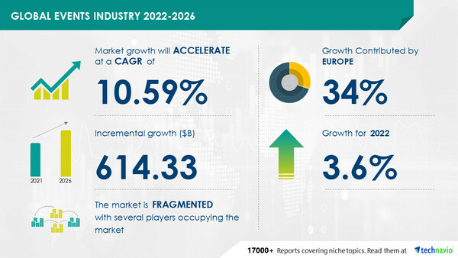
Figure 3: Revenues of Global Event Industry
Source: (Technavio, 2023)
The guests will experience multiple happenings throughout the summit. The process has been planned with technical advancements. There have been provisions made for interactive kiosks and digital signage which can be helpful for engaging the participants. A refined check-in process will be used by implementing technology in the event (ŞAHİN, 2020). Better backup options will be kept so that there is not a threat of power supply and connectivity. After ensuring the comfort of the attendees, the main events will take place.
Itinerary:
11.00 A.M- Check in process will be closed for all the attendees.
12.00 P.M- InnovTech Solutions will highlight the futuristic gadgets and software.
1.00 P.M- Elite Group of Hotels will provide insights about the tech integration in hotel management.
2.00 P.M - Lunch break where beverage brands like BeanBrew Coffee will provide delicious foods for the attendees.
2.30 P.M- Popular software-based companies like ReservEase will show the reservation management systems.
3.00 P.M- All the demo events will be concluded.

Aim and Objectives of the Meeting
The event has a deep vision which was created for discussing the important and newest technological improvements within the hospitality sector. The event was aimed at promoting partnerships and collaborations within the industry leaders. It has tried to mitigate the challenges which are faced by the hospitality sector through creative solutions. It has also tried to set a visionary path for better hospitality trends.
The event has been planned by implementing Smart Goals which is presented below in a tabular format-
Goal | Specific | Measured | Achievable | Relevant | Time
Technological advancements | Improving the technological advancements in the Hospitality sector.  Crystal will create innovative technologies for enhancing the event. | Within the first 2 months, multiple event employees will be trained regarding technological advancements.  In the next month, Crystal will create a deadline for setting up the minor changes in the smart automated controls previously used by Crystal in the past events. | With the ample resources available within Crystal events, the goal is certainly achievable. | In the present situation most of the event-based organisations are trying to implement technological advancements. | Within 3 months
Collaboration | Crystal will promote community engagement by collaborating with the stakeholders for improving economic growth and sustainability (Della Corte et al., 2021). | Stakeholders need to be arranged within two months for improving the collaborative nature of the events. | The goal of implementing better collaboration is certainly achievable as stakeholders can establish trust and improve the approach. | Collaboration is important in the hospitality area as it can improve the brand image of certain organisations. | 2 months
Hospitality trends | Crystal will try to implement the latest trends in the Hospitality sector to enhance the business revenue of multiple organisations. | Crystal will utilize new trends such as Artificial intelligence and apply it for creating events. | As the organisation has multiple resources it can easily apply the new hospitality trends for events. | Hospitality trends are incredibly important in the sector as new innovations can give other organisations a competitive advantage. | 3 months
Table: SMART Goals for Crystal

Event Operations
Multiple skills are needed for organising an event. Crystal has recruited staff who have a clear expertise in hospitality tech gadgets for managing multiple discussions and helping in the work of exhibits. Crystal has carried out multiple training sessions as every employee who is associated with the event needs to be aware about the technological advancements in the sector. The workers need to be proficient at time management skills for maximizing efficiency and minimizing the disruptions. The workers need to have a prominent level of emotional intelligence to provide comfort within the attendees. The workers need to highlight their empathy skills which can help the attendees to have better trust with the organisers of the event. The workers need to be adept at handling the complaints easily. Workers need to have better social skills so that they can build and maintain relationships and collaborate with others. Better social skills can help to resolve conflicts and create a positive work environment. Along with the mentioned soft skills, events need to prioritize the hard skills such as budgeting. Budgeting skills can be beneficiary for the events as it can assure that the estimated costs are within the available resources (Menifield, 2020). It can be also helpful for identifying the important expenses and allocating resources accordingly. Budgeting can be helpful for avoiding overspending and ensuring that the event is profitable. Budgeting can be important for promoting accountability within the event delivery team. Hard skills like Project management skills are important for events as it can ensure that the event is well executed, and attendees have a better experience (Stoyanova-Bozhkova, 2022).

Event Budget
The event hosted by Crystal has a venue rental for approximately £10,000. This incorporates the tech setup and further amenities. Tech setup and other amenities such as interactive equipment had cost £20,000. The event had a staffing cost which included training and operational teams which had cost £4,000. The marketing and promotional activities had cost £15,000. Overall, the organisation had faced miscellaneous expenses of £7,500 for boosting the event reach. This contributed to the total cost reaching £56,500. The event had ticket sales with tiered pricing for different access levels which had approximately contributed to £65,000. Based on the different sponsorship programs, the organisation had gained a revenue of £50,000. This had attracted multiple businesses. The exhibitor fees for industry partners had shown a £ 50,000 revenue. Overall, the organisation had gained £1,65,000 in their revenue streams. This highlighted that the projected profit will be around £108,000 for the event.

Category | Details | Amount (€)
Income
Ticket Sales | Estimated 200 tickets at €100 each | 20,000
Sponsorships | Contributions from tech firms and industry leaders | 60,000
Exhibition Booth Rentals | 10 booths at €3,000 each | 30,000
Workshop Fees | Fees for specialised workshops | 10,000
Food and Beverage Sales | Sales from event catering | 15,000
Merchandise Sales | Sales of branded merchandise | 5,000
Total Income |  | 140,000
Expenditure
Venue Booking | Rental fee for The Savoy Hotel | 50,000
Event Management Team | Staffing and operations costs | 25,000
Marketing and Promotion | Digital marketing, PPC ads, social media campaigns | 20,000
AV Equipment and Technology | High-quality audio-visual setup and interactive kiosks | 15,000
Catering Services | Food and beverage for attendees | 20,000
Printing and Stationery | Event materials, programs, and signage | 5,000
Speaker Fees and Accommodation | Fees and lodging for keynote speakers | 15,000
Security and Insurance | Event security and insurance coverage | 10,000
Miscellaneous | Contingency fund for unforeseen expenses | 10,000
Total Expenditure |  | 170,000

The organisation had potential sponsors who were InnovTech solutions which had planned to showcase future gadgets and software. Better hospitality leaders like Elite Hotel group had provided multiple insights within the tech integration in the hotel management. Collaborative initiatives such as tech in Hospitality were sponsored by TechVenture Capital. The organisation had incorporated exhibitor fees from startups and set up companies to demonstrate new products. The venue management team Crystal had provided a state-of-the-art event space and helped with onsite logistical support. It has also ensured that the venue meets the technological and comfort needs of the summit. The event was sponsored by InnovTech Solutions and Elite Hotel group which had provided financial support and provision of industry expertise. InnovTech Solutions provided innovative tech exhibits and Elite Hotel had shared the best practices for tech integration in hotels (Huang et al., 2022). TechCity Hub were the local tech community who were associated with the event. The organisation had facilitated multiple opportunities and community engagement. It has also attracted local tech startups and entrepreneurs for participating and sharing innovations. Gourmet Event Caterers were the catering partners who were in the event for delivering the better dining experiences for the attendees. It had also customized a tech themed menu and efficient service which had enhanced the event ambiance. The event was professionally held in association with Hospitality technology association which had endorsed the event and encouraged member participation. The event had tried to offer credibility, industry insights and promotions for increasing its professional network.

Industry Trends
This report will follow a SWOT and PESTLE analysis for highlighting the issues and impacts related with the events industry.
SWOT ANALYSIS:
- Strengths: The organisation has a unique focus on technology and innovation within hospitality. It has built strong partnerships with the leading companies of the industries and has improved its professional associations.
- Weaknesses: The event will be held for the first time, so it is estimated that the event has no established track record. It has a high dependency on technology which can create complexities for event execution.
- Opportunities: In recent times, there is a growing interest regarding the technological solutions in the hospitality area (Kuhzady et al., 2021). It has a potential to become a leading annual event in the tech hospitality niche.
- Threats: It can face competition from more established tech and hospitality events. Technological failures or disruptions can impact the event experience.
PESTLE analysis
- Political: The stability of UK and government thinking has been one of the crucial factors regarding the effective operations of the Event industry. The tax system of the United Kingdom is considered as coherent which ignores benefits such as tax credits and withdrawal of benefits (UK Tax, 2023). The biggest problem the UK has been facing is the trade related deficit which has caused financial problems. In 2023, the country had faced a trade deficit of £33 Billion (UK Parliament, 2016). The country has been facing goods related issues as the imports have been facing a deficit from 2019.
- Economy: UK has been experiencing slow growth as since 2010, the economy of UK has been quite slow and the GDP per person has not increased since early 2022. In 2023, the UK economy fell into recession with an overall increase of GDP by only 0.1% (UK Recession, 2024). This has been considered as one of the worst economic conditions of the country since 2009. Multiple banks in the UK have highlighted that the interest rates might increase within the country because of the constant inflation. Households and businesses have faced cost of living problems, which has been significant as 29% of adults cannot afford unexpected expenses of £850 or more.
- Social: The labour market within the country has been facing some problems as the labour market is softening. Employers are quite hesitant in hiring new people and unemployment is expected to increase from 4% in 2023 to 4.2% in 2024 (UK employment, 2024). The labour market is predicted to have an increase of 4.5% in 2025. Many people have been facing social issues of homelessness and mental health. Violent crime and teenage based problems have been occurring within the country.
- Technological: Although there are multiple problems within the UK, cloud computing and sustainable technology are one of the biggest indicators of advancements in the technological sector. There are multiple Artificial intelligence and machine learning improvements within the country (Dahmen, 2023). The country has been improving in renewable energy, crypto and digital monitoring. So, event-based industry can have a better scope within the country.
- Legal: Studies have suggested that the country has been facing problems regarding the welfare, benefits and wills related problems. The consumer-based problems have not been highlighted in the laws (UK Law, 2024). It has been also highlighted that 52% of people face legal issues and need professional help whereas 38% of people do not receive any help.
- Environmental: The biggest environmental threat to the people is the constant greenhouse emissions as 30,000 deaths have occurred under the age of 75 and it has cost the economy of £20 billion. The climate of the UK has been witnessing a change regarding the intensity of storms, floods and heatwaves. The country has been facing biodiversity loss issues and the floods have created problems in the financial condition.

Cultural and Situational Considerations
Cultural considerations are one of the most important aspects beyond the logistics. Effective communication can convey the message easily within the attendees. Translation services need to be kept in the event. Local interpreters are needed in the area of need, so that the local attendees can hear and understand the situations. Otherwise, miscommunication can demote the flow of information and attendees might feel disconnected. A better protocol needs to be maintained in the greetings of a business meeting as it is mostly considered as hierarchical, and this can make a better impression with the local partners and attendees. Variety of cuisine options needs to be provided for ensuring that the attendees feel comfortable.

Reference
Dahmen, P., 2023. Organisational resilience as a key property of enterprise risk management in response to novel and severe crisis events. Risk Management and Insurance Review, 26(2), pp.203-245.
Della Corte, V., Aria, M., Del Gaudio, G., Sepe, F. and Di Taranto, E., 2021. Stakeholder value creation: a case of the hospitality industry. Corporate Ownership and Control, 19(1), pp.314-326.
Hillmann, J. and Guenther, E., 2021. Organisational resilience: a valuable construct for management research? International journal of management reviews, 23(1), pp.7-44.
Huang, A., Chao, Y., de la Mora Velasco, E., Bilgihan, A. and Wei, W., 2022. When artificial intelligence meets the hospitality and tourism industry: an assessment framework to inform theory and management. Journal of Hospitality and Tourism Insights, 5(5), pp.1080-1100.
Kuhzady, S., Olya, H., Farmaki, A. and Ertaş, Ç., 2021. Sharing economy in hospitality and tourism: A review and the future pathways. Journal of Hospitality Marketing & Management, 30(5), pp.549-570.
Li, M., Yin, D., Qiu, H. and Bai, B., 2021. A systematic review of AI technology-based service encounters: Implications for hospitality and tourism operations. International Journal of Hospitality Management, 95, p.102930.
LYYTI, (2021). Introducing the Event Cycle – The core of Event Success Management. [online] www.lyyti.com. Available at: https://www.lyyti.com/en/blog/introducing-the-event-cycle-the-core-of-event-success-management?gclid=undefined. [Accessed on 22nd May 2024]
Markets and Markets, (2023). Mice Model Market - Global Forecast to 2025 | MarketsandMarkets. [online] www.marketsandmarkets.com. Available at: https://www.marketsandmarkets.com/Market-Reports/mice-model-market-1308.html. [Accessed on 22nd May 2024]
Menifield, C.E., 2020. The basics of public budgeting and financial management: A handbook for academics and practitioners. Hamilton Books.
ŞAHİN, E., 2020. An evaluation of digital menu types and their advantages. Journal of Tourism & Gastronomy Studies, 8(4), pp.2374-2386.
Stoyanova-Bozhkova, S., Paskova, T. and Buhalis, D., 2022. Emotional intelligence: a competitive advantage for tourism and hospitality managers. Tourism Recreation Research, 47(4), pp.359-371.
Technavio, (2023). Events Industry Market size to grow by USD 614.33 billion from 2021 to 2026|Rise in the number of corporate events to drive market growth - Technavio. [online] www.prnewswire.com. Available at: https://www.prnewswire.com/news-releases/events-industry-market-size-to-grow-by-usd-614-33-billion-from-2021-to-2026rise-in-the-number-of-corporate-events-to-drive-market-growth---technavio-301869129.html. [Accessed on 22nd May 2024]
UK employment, (2024). Employment in the UK - Office for National Statistics. [online] www.ons.gov.uk. Available at: https://www.ons.gov.uk/employmentandlabourmarket/peopleinwork/employmentandemployeetypes/bulletins/employmentintheuk/april2024#:~:text=The%20UK%20unemployment%20rate%20for. [Accessed on 22nd May 2024]
UK Law, (2024). Two in three people across England and Wales have faced legal problems. [online] www.lawsociety.org.uk. Available at: https://www.lawsociety.org.uk/contact-or-visit-us/press-office/press-releases/two-in-three-people-across-england-and-wales-have-faced-legal-problems. [Accessed on 22nd May 2024]
UK Parliament, (2016). [online] Parliament.uk. Available at: https://researchbriefings.files.parliament.uk/documents/SN02815/SN02815.pdf. [Accessed on 22nd May 2024]
UK Recession, (2024). UK economy went into recession last year, data confirms. [online] www.cnbcafrica.com. Available at: https://www.cnbcafrica.com/2024/uk-economy-went-into-recession-last-year-data-confirms/. [Accessed on 22nd May 2024]
UK Tax, (2023). Unravelling the chaos: Evaluating the UK tax regime. [online] CEPR. Available at: https://cepr.org/voxeu/columns/unravelling-chaos-evaluating-uk-tax-regime. [Accessed on 22nd May 2024]

