
Module Code: ECAD5013
Assignment Title:
Learners, Schools and Communities: where am I teaching?

STUDENT NAME: Kelly-May Hughes (Robst)

STUDENT NUMBER: 2307664
BA Primary Education (QTS)

AI Acknowledgement

I confirm that I have not used any AI tools in the research and creation of this assignment.
I confirm that I have not presented any AI generated materials as my own work.
I confirm that I have copies of my drafts, notes, and other resources I used, which I may be asked to provide in evidence.
Targets from my previous assignment

Target | How I have addressed it in this work
Broaden literacy scope, tapping into cutting-edge research and diverse academic discussions. | I have tried to incorporate this into my literacy research, such as critiques upon the ALN reform.
Use professional standards and relevant literature to guide next steps. | I have tried to reflect on certain aspects and relate these to my professional standards and my own future practice.

ECAD 5015 Journal Assignment
Word Count: 1476
Inclusive practice within education is grounded in the principle that every learner, regardless of background, ability, or circumstance, should have equal opportunities to thrive. This involves recognising diversity, adapting teaching to suit various learning styles and removing barriers to participation. Inclusive education is a continuous process of developing practices which respond to the diverse needs of all pupils (UNESCO IBE, 2009, P.18). According to the Alliance for Inclusive Education (2020), education is truly inclusive when it benefits all learners, promoting an ethos where individual differences are celebrated rather than viewed as challenges.
The rationale of inclusive practice, ensuring fairness, equity and participation, underpins the implementation of universal provision. This refers to high-quality teaching strategies that benefit all learners, whilst specifically addressing those with Additional Learning Needs (ALN). Inclusive practice is the guiding principle, whilst universal provision serves as its application, offering a framework that adapts for all while fulfilling specific needs for some (European Agency, 2015).
The Additional Learning Needs and Education Tribunal (Wales)(ALNET) Act 2018 (Welsh Government, 2018) reflects this inclusive ethos by replacing the former Special Educational Needs (SEND) system with a more integrated ALN framework. It ensures pupils aged 0-25 receive co-ordinated support through an Individual Development Plan (IDP), emphasising early intervention, multi-agency cohesion and flexible, ongoing assessment to promote consistency and fairness across Welsh education.
However, Estyn’s 2024 thematic review (Corbett-Simmons & Williams, 2025) identifies critical implementation challenges. Varying interpretations of the ALN Code and IDPs, along with workforce pressures, Welsh-medium provision and unclear definitions of Additional Learning Provision (ALP), contribute to inconsistencies. These issues risk undermining the reforms intent to ensure equitable, inclusive provision.
This inclusive approach aligns with the Curriculum for Wales (CfW) and its aim to develop ambitious, capable learners, creative contributors, ethical citizens and confident individuals. Universal provision promotes differentiated teaching and supportive environments, aligned with developmentally appropriate Progression Steps (Equal Education Partners, 2023). Cross-cutting themes such as Relationships and Sexuality Education (RSE) and Diversity, enhance inclusivity by ensuring pupils feel represented and valued, an approach supported by both Welsh Government and the Education Review Office (Welsh Government, 2022; Education Review Office, 2020).
A three-tiered support model further structures this commitment. As noted by the Gilbert Ward Academy (2024), the system of universal, targeted and specialist provision ensures support is proportionate to need. High-quality teaching is the foundation, with additional layers applied when necessary.
Creating a genuinely inclusive environment requires educators to reflect upon their attitudes, understand classroom management, assess learning difficulties, monitor progress and possess knowledge of legislation and policy. Barriers such as poverty, disability, ethnicity, gender and religion must be proactively addressed (Kamenopoulou & Dukpa, 2017).
Differentiation is central to inclusive practice, Gravells (2008) describes it as employing various approaches and resources to meet diverse learner needs. Similarly, the Quality Improvement Agency (QIA. 2008) emphasises multiple means of processing and expressing learning. Embedding these into daily teaching makes education more accessible, meaningful and empowering for all pupils.
Retrospectively , the goal of inclusive practice and ALN reform in Wales are rooted in equity, diversity and participation (Welsh Government, 2020), aiming for a flexible, responsive education system that values all pupils and promotes social justice.
An inclusive classroom requires proactive planning and continuous reflection, to ensure equal access to the curriculum. Drawing on PTE2 observations, the following section shall explore strategies to enhance inclusivity, identify barriers and critically reflect on practical experiences.
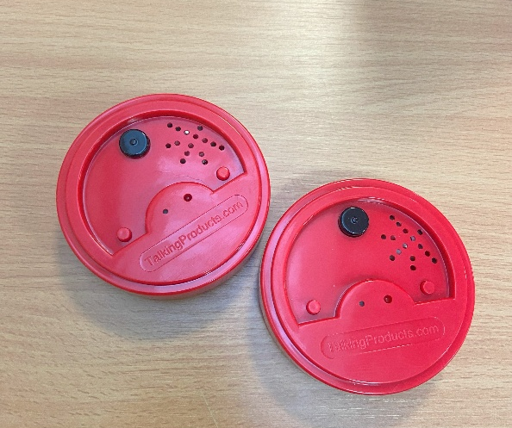
Talking Tins
Own image.
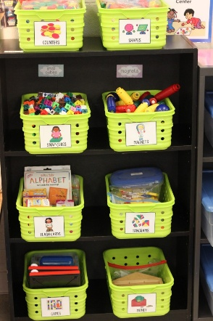
During PTE2, Talking Tins were observed and used to support pupils who required additional assistance with extended writing tasks. Talking Tins provide an auditory scaffold, allowing pupils to record ideas and replay these whilst writing, supporting cognitive processing and language development (Mroz & Hall, 2003). However, the limited availability of these devices (two in the setting) posed a logistical challenge. Pupils would often need to work outside the classroom to minimise disruption and allow for quiet to record their own voices, reducing live access to teacher support. To maximise its effectiveness, Talking Tins could be integrated into classroom zones, ensuring pupils remain within the teaching environment, protecting their right to curriculum participation and content, whilst also allowing for ease of access to assistance is required. Increasing the number of devices available would further enhance accessibility and prevent disruption to learning routines, though notably this would be reliant upon a school's budget.
Hall (2014) image of labelling within a classroom.
Labelling and Braille Integration
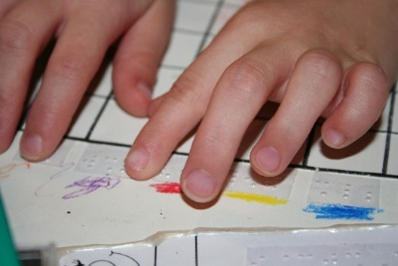
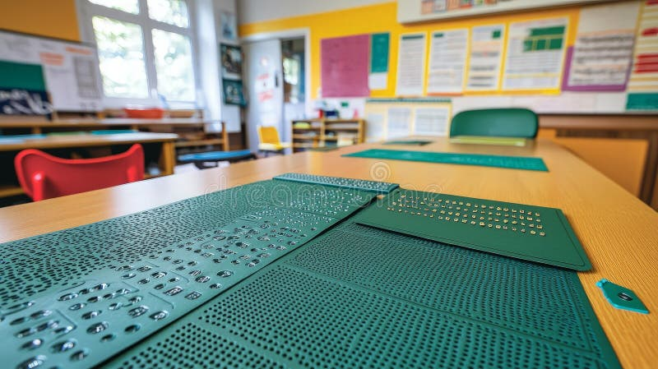
Effective labelling of classroom areas and resources promotes autonomy, supports organisation and benefits all learners. It was observed during PTE2, that whilst this was well implemented within Early Years classrooms, it was inconsistently applied in Key Stage 2. Labelling could also be expanded to incorporate considerations for braille. Government-issued signs, such as fire exits, included braille as a standard, located around the school, there was no wider braille usage within the learning environment. Braille material, such as books and worksheets were not evident, highlighting a gap in truly inclusive universal provision. Barriers to the wider application of braille consist of the cost and logistical difficulty of producing accessible materials (Royal National Institute of Blind People, 2016). However, under the principles of universal provision, having braille signage and basic resources in place, ensure that a barrier is removed before it arises if a visually impaired pupil joins the setting (Florian & Black-Hawkings, 2011). This aligns with preventative, anticipatory inclusion practices, which are encouraged under the ALNET (Wales) 2018.
TWINMOM (2025) image of pupil using braille.
Sobarudin (2025) image of braille in tools in classroom.
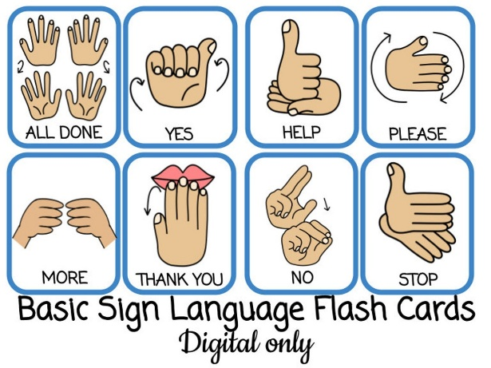
Sign language
Lily (2025) Sign Language Flashcards.
The use of basic sign language, including British Sign Language (BSL) and Makaton, was notable embedded within Early Years Settings observed during PTE1, 2 and Bridging Days, but appeared to diminish in Key Stage 1 and 2 classrooms. Research shows that the use of sign language supports not only pupils with hearing impairments, but also enhances communication development, empathy and inclusivity amongst all learners (Woolfe et al., 2002; Estyn, 2023). Even if not all the pupils require the provision, early exposure to sign language fosters a more inclusive environment and provides pupils with the tools to communicate with deaf peers, or adults in the future, feeding into the concept of a truly inclusive society.
Despite its benefits, barriers to widespread use include the need for staff training, cost, consistency, curriculum time pressures and limited resources which are tailored to different Key Stage levels (Estyn, 2022). Nonetheless, even a modest incorporation of basic signs into daily routines, such as greetings, instructions and story time, could significantly broaden inclusive practice and support the development of the four purposes of the CfW, particularly in nurturing ethically, informed citizens, who are healthy, confident individuals.

Left-Handed Resources
Fantasticdyspraxic (2025) image of loop scissors.
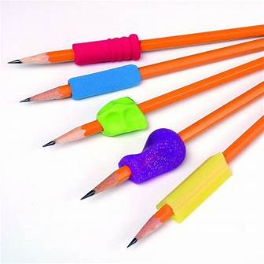
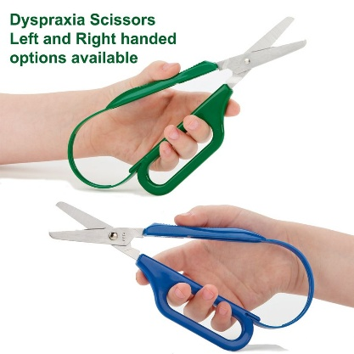
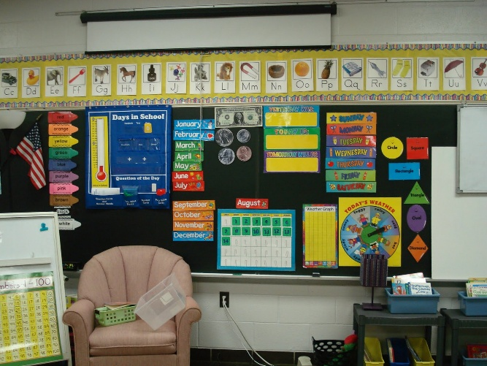
Provision for left-handed pupils was observed during PTE2, though there was a notable limited supply, specifically regarding left-handed scissors, which were often in short supply. Universal provision requires an anticipation of diverse needs withing standard classroom environments (Gravells, 2008). By taking additional measures by providing left-handed grips, appropriately spaced desk arrangements and loop scissors (Ot-Mom Learning Activities, 2024) left-handed pupils would be supported, but this would also include others with fine motor skill challenges and Dyspraxia /DCD. Seating could also be mindfully planned to ensure left-handed pupils have adequate space to write, without clashing with peers, promoting both comfort and engagement. Whilst additional provisions would be subsequent to a schools budget, arguably, whilst 10% of the world's population is left handed (BBC 2024), yet is not considered ALN, but could still potentially pose a barrier to pupils accessing all education equally (Nationwide Disability Representatives, 2025), factoring in that a census shows 52, 152 pupils with ALN or SEN within schools during 2024 (Welsh Government, 2024), such an investment would be highly supportive.
Haley (2025) image of pencil grips.
Visual Aids
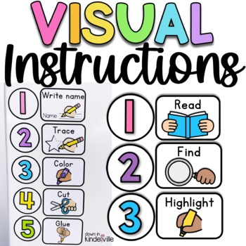
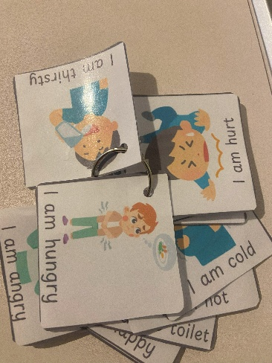
Although visual displays and a timetable were present in the Year 6 classroom during PTE2, the visual timetable was not consistently updated due to time restrictions on teaching staff. Actively maintained visual supports reduce anxiety, aid with executive functioning and support transition management, particularly for pupils with Attention Deficit Hyperactivity Disorder (ADHD) or Autism (Cooper & Jacobs, 2011). In retrospect, whilst the visual timetable was not utilised efficiently, it was observed that during my teaching practice, I would write the times of the lesson, order of instruction and breaks along the side of the whiteboard, in order to provide myself with a professional reminder for time management, pupils were observed engaging and referencing to this during these periods, advocating to its desirable benefits. Expanding visuals into worksheet instructions, such as pictorial lists of required equipment for activities within practical mathematics and science lessons, could support comprehension and independence for a broader range of learners, benefitting all pupils, not just those with identified ALN (National Council for Special Education, 2024.; Naidoo, 2012).
Jessica (2011) image of visuals in a classroom.
Teacherspayteachers (2025) image of visual instructions.
Own image.
Despite promising strategies, as explored above, not all are evident within educational settings, nor utilised to their full potential. Barriers remain such as resource shortages, staff capacity constraints, cost, time allocation, training and systemic challenges, like translation difficulties for multilingual support (Archer, 2010). Moreover, while universal provision aims to anticipate needs, truly effective implementation requires whole-school commitment, strong leadership from Senior Leadership team (SLT) and Continuous Professional Development (CPD), as recommended by Estyn (2022).
With proactive measure, inclusive practices can shift from reactive to embedded, ensuring all pupils have equal opportunity to thrive within a supportive environment aligned with the CfW and ALN Code. I aim to reflect this in my own practice by embedding inclusive strategies where possible, whilst balancing them with practical constraints and workload.
Another consideration, is that whilst visual timetables are widely recognised as effective tools, their impact may be limited in multilingual contexts. Schools pursuing linguistic inclusivity face a greater workload when visual aide with written language must be translated into multiple languages, to be accessible for all pupils and families. Local Authorities (Las) report difficulties sourcing translators for less commonly spoken dialects, such as certain forms of Bengali, Mandarin or Somali. One LA translation team member noted that a school required 12 different translations for a newsletter, highlighting the logistical and resource challenges, in adapting visual timetables for linguistically diverse school populations (Employee X, personal communication, 2025).

Reference List
- Alliance for Inclusive Education, (2020). ‘What is Inclusive Education?’ Available at: https://www.allfie.org.uk/definitions/what-is-inclusive-education/ Accessed on: 27/04/2025
- Archer, L., (2010). ‘Race, Ethnicity and Education’. London: Routledge.
- CBBC. (2024) ‘Newsround- Left-Handers Day: Amazing facts about lefties.’ Available at: https://www.bbc.co.uk/newsround/53739189 Accessed on: 27/04/2025
- Cooper, P. and Jacobs, B., (2011). ‘From Inclusion to Engagement: Helping Students Engage with Schooling through Policy and Practice’. Chichester: Wiley-Blackwell.
- Corbett-Simmons, J. and Williams, K. (2025) ‘Estyn’s Review of ALN Implementation in Wales.’ Available at: https://www.blakemorgan.co.uk/estyns-review-of-aln-implementation-in-wales/ Accessed on: 04/05/2025
- Education Review Office. (2020) ‘Let’s talk about it: Review of Relationships and Sexuality Education.’ Available at: https://www.evidence.ero.govt.nz/documents/let-s-talk-about-it-review-of-relationships-and-sexuality-education Accessed on: 04/05/2025.
- Employee X. Local Authority A. (2025) (name and LA name redacted in order to maintain confidentiality)
- Equal Education Partners. (2023) ‘Curriculum for Wales: The Four Purposes.’ Available at: https://equaleducationpartners.com/blog/curriculum-for-wales-the-four-purposes/ Accessed on: 04/05/2025
- Estyn, (2022). ‘Promoting equality, diversity and inclusion in education and training.’ Available at: https://www.estyn.gov.wales/thematic-report/promoting-equality-diversity-and-inclusion-education-and-training Accessed on: 27/04/2025
- European Agency for Special Needs and Inclusive Education, (2015). ‘Agency Position on Inclusive Education’. Odense, Denmark: European Agency for Special Needs and Inclusive Education.
- Florian, L. and Black-Hawkins, K., (2011). ‘Exploring inclusive pedagogy. British Educational Research Journal’, 37(5), pp.813-828.
- Gilbert Ward Academy, (2024). ‘Three Tiered Approach’. Available at: https://www.gilbertwardacademy.co.uk/202/three-tiered-approach Accessed on: 27/04/2025
- Gravells, A., (2008). ‘Preparing to Teach in the Lifelong Learning Sector’. 2nd ed. Exeter: Learning Matters Ltd.
- Kamenopoulou, L. and Dukpa, D., (2017). ‘Inclusive Education: Perspectives on pedagogy, policy and practice’. London: Bloomsbury Academic.
- Mroz, M. and Hall, E., (2003). ‘Not yet identified: talking tins support for extended writing tasks’. [Unpublished use based on educational practice]
- Naidoo, J. (2012) Teacher reflection: The use of visual tools in mathematics classrooms.’ Available at: https://www.researchgate.net/publication/272644738_Teacher_reflection_The_use_of_visual_tools_in_mathematics_classrooms Accessed on: 04/05/2025.
- Nation Council for Special Needs. (2024) ‘Visual Supports within an Inclusive Learning Environment.’ Available at: https://ncse.ie/wp-content/uploads/2024/10/NCSE-Visual-Supports-Environment-Resource-01.pdf?utm_source=chatgpt.com Accessed on: 04/05/2025.
- Nationwide Disability Representatives. (2025) ‘Is being left-handed a disability?’ Available at: https://www.nationwidedisabilityrepresentatives.com/blog/is-being-left-handed-a-disability/ Accessed on: 27/04/2025
- Ot-Mom Learning Activities, (2024). ‘Helping Left Handed Kids.’ Available at: https://www.ot-mom-learning-activities.com/left-handed-kids.html Accessed on: 27/04/2025
- QIA (Quality Improvement Agency), (2008). ‘Differentiation in Teaching and Learning’. Available at: https://qia.org.uk/aboutus/is.html Accessed on: 27/04/2025
- Royal National Institute of Blind People (RNIB), (2016). ‘Making reading accessible for blind and partially sighted people’. Available at: https://www.rnib.org.uk Accessed on: 27/04/2025
- United Nations Educational, Scientific and Cultural Organization (UNESCO) International Bureau of Education, (2009). ‘Inclusive Education: The Way of the Future’. Geneva: UNESCO IBE.
- Welsh Government, 2018. Additional Learning Needs and Education Tribunal (Wales) Act 2018. Available at: https://www.gov.wales/additional-learning-needs-code-and-regulations-childrens-rights-impact-assessment-html Accessed on: 27/04/2025.
- Welsh Government (2020) ‘The additional learning needs transformation programme: frequently asked questions.’ Available at: https://www.gov.wales/additional-learning-needs-transformation-programme-frequently-asked-questions-html Accessed on: 04/05/2025.
- Welsh Government. (2022) Curriculum for Wales: Cross-cutting themes for designing your curriculum.’ Available at: https://hwb.gov.wales/curriculum-for-wales/designing-your-curriculum/cross-cutting-themes-for-designing-your-curriculum Accessed on: 04/05/2025.
- Welsh Government (2024). ‘Schools’ census results: January 2024,’ Available at: https://www.gov.wales/schools-census-results-january-2024-html#150569 Accessed on: 27/04/2025
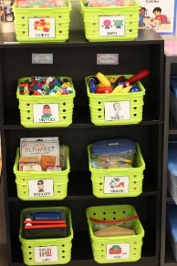
- Woolfe, T., Herman, R., Roy, P. and Woll, B., (2002). ‘Early vocabulary development in deaf native signers: A British Sign Language adaptation of the Communicative Development Inventories’. Journal of Child Psychology and Psychiatry, 43(5), pp. 609–618.
Reference List for Images
- Hall, E (2014) ‘Classroom Reveal!’ Available at: https://kickinitinkindergarten.com/classroom-reveal/ Accessed on: 20/05/2025
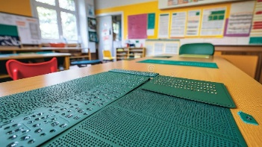
- Sobarudin, A (2025) ‘Braille Learning Tools on a Classroom Table. A close-up view of braille learning tools laid out on a classroom table. The tools provide tactile learning for visually impaired students’ Available at: https://www.dreamstime.com/braille-learning-tools-classroom-table-close-up-view-laid-out-provide-tactile-visually-impaired-students-image334651464 Accessed on: 20/05/2025
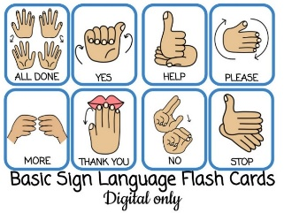
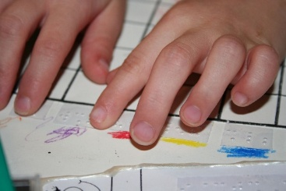
- TWINMOM (2025) ‘Children’s hands reaching for colourful drawing Free Stock Photo.’ Available at: https://www.freeimages.com/photo/braille-reader-1314597 Available at: 20/05/2025
- Lily (2025) ‘Sign Language Flashcards.’ Available at: https://eviebarlow.com/ Accessed on: 20/05/2025
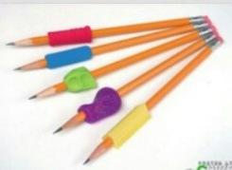
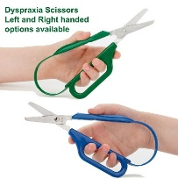
- Fantasticdyspraxic (2025) ‘Dyspraxia Scissors left and Right Handed options available.’ Available at: https://uk.pinterest.com/pin/297870962853479585/ Accessed on: 20/05/2025
- Hayley (2025) ‘Right in the Childhood.’ Available at: https://uk.pinterest.com/pin/459578336944306244/ Accessed on: 20/05/2025
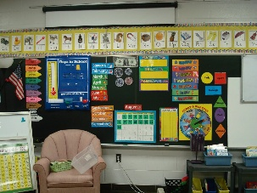
- Jessica (2025) ‘Kindergarten Hill.’ Available at: https://kindergartenhill.blogspot.com/2011/08/classroom-set-up.html Accessed on: 20/05/2025
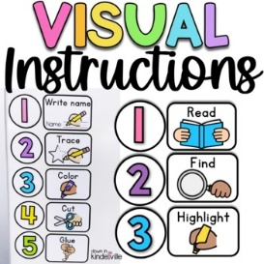
- Teacherspayteachers (2025) ‘Visual Instructions/Editable Visual Directions.’ Available at: https://uk.pinterest.com/pin/visual-instructions--123778689750175019/ Accessed on: 20/05/2025

