Cultural Comparison Between Germany and England

Student Name: Valeriu Bogatu
Student ID: 2231945
Module Title: Foreign Languages & Cultural Awareness
Module Code: BMIH5003
Lecturer: Lisa-Marie Bassler

Table of Contents
Executive Summary 1
Introduction 2
Differences between Germany and England 2
Analysis Based on GLOBE's Project 4
Challenges of Intercultural Leadership 6
Conclusion 7
Recommendations 7
Cultural Awareness Training 7
Advocacy for Inclusivity 8
Team Building Activities 8
References 9

Executive Summary
As the Assistant General Manager at the 5-star Inclusivity Hotel & Spa, I believe intercultural relationships and leadership between our branch in London, England, and the main office in Germany are important for the progress of our organization. The report will guide German employees joining our office in England and help explain the cultural differences while helping them integrate into UK cultures. An analysis of the two countries' cultural differences through the Globe Project's cultural dimensions and Hofstede's Cultural Dimensions will provide a clear understanding of cultural differences and understand the nuanced relationship, leadership, and cultural dimensions to aid in intercultural interactions. In this report, I shall detail the cultural differences between the countries, numerate the leadership and culture of both studies following the Globe Project, highlight the intercultural leadership challenges, and provide recommendations to circumvent these challenges.

Introduction
Vizmonte and Ligot (2024) highlight that Hoftede's six cultural dimensions demonstrate the difference in cultures between different countries. These cultural differences influence the actions, culture, customs, practices, values, and beliefs of employees or leadership behaviour at the workplace. The Globe's project was developed in 1991 to understand the different dimensions of culture and leadership across numerous societies and the different leadership styles and cultural orientations (GLOBE Project, 2024). Unlike Hofstede's dimensions, which assess cultural differences based on six dimensions, Globe's Project assesses cultural differences based on nine dimensions. These individual differences are effective in understanding cultural similarities and differences to help facilitate intercultural interactions between different cultures.

Differences between Germany and England
Per Hofsted-insights (2024), German and English cultures are similar in many aspects and dimensions of culture. Both countries have lower power distance, a high level of individualism, and high motivation toward achieving success as performance is valued. However, Germans and British are distinct in uncertainty avoidance and indulgence. Per Hofsted-insights.com, Germans have a high uncertainty avoidance, thus a high preference for structured work environments. According to the University of Europe (2024), German corporate culture is deeply rooted in its cultural values, which emphasize punctuality, performance, order, and thoroughness. On the other hand, English employees have low uncertainty avoidance, marked by increased flexibility in schedules and freedom and comfort in ambiguous situations. Moreover, the nation's culture is hinged on employees who are not detail-oriented, exhibit higher levels of curiosity and creativity, and desire innovation. Berger et al. (2019) highlight that British employees delight in the 'gig economy' due to the emotional needs placed on self-employment, ideals of freedom, and preferences for autonomy and flexibility. In addition, employees in the UK demonstrated high levels of indulgence compared to the restrained German culture. The British demonstrated an increased desire to explore life, have fun, and prioritize leisure and personal time. (Danik and Lewandowska (2021) highlight that countries with high levels of indulgence have a greater sense of positive emotions and freedom of expression. However, the United Language Group (2017) highlights that Germans have a low indulgence and thus "live for work" and downplay the concepts of leisure time, enjoyment, and instant gratification.
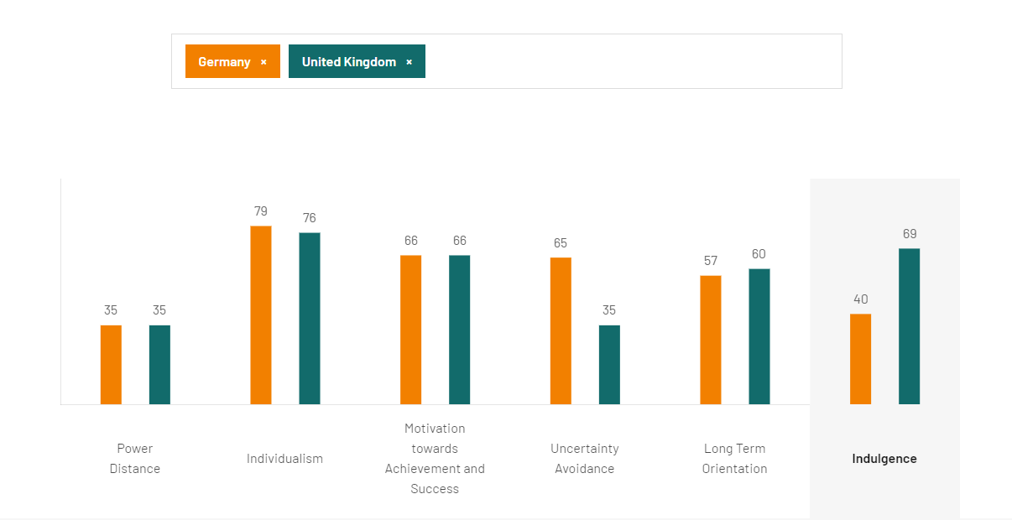
Figure 1 Comparison between Germany and UK. Source: Hofsted Insights, 2024.

Analysis Based on GLOBE's Project
Based on the Globe's leadership scales, German and English leaders almost performed equally across multiple dimensions. England and German leaders were highly performance-oriented (6.38 vs 6.33), stressing the need for high standards, innovation, and decisiveness. Consequently, both leaders had low autocracy (2.55 vs 2.06), implying the leaders focused on a self-centred and individualistic approach to leadership. Germany (east and west) and England had lower scores in the humane and autonomous dimensions. Therefore, German and English leaders don't prioritize compassion and generosity and emphasize the need for support and well-being of others. Also, the leaders focus on having high independence and individualism in the workplace (GLOBE phase 2 Aggregated Societal level date for Leadership scales, 2004).
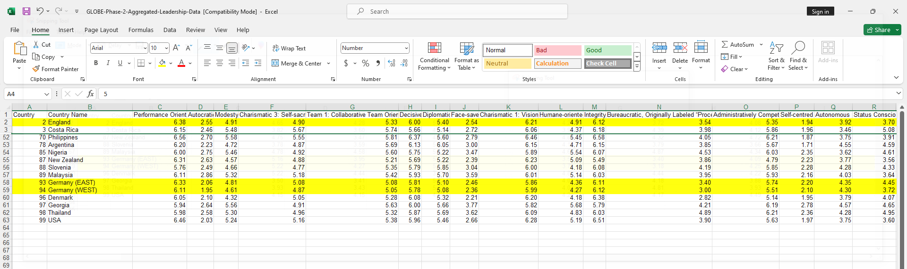
Figure 2 GLOBE Leadership Scale. Source: GLOBE Project, 2004
Also, based on the cultural scores, England scored higher on future orientation society practices, humane orientation society practices, and gender egalitarianism societal practices. On the other hand, German culture scored highly on uncertainty avoidance, collectivist societal practice, performance orientation and assertive societal practices (GLOBE phase 2 Aggregated Societal Level date for Society Culture Scales, 2004).
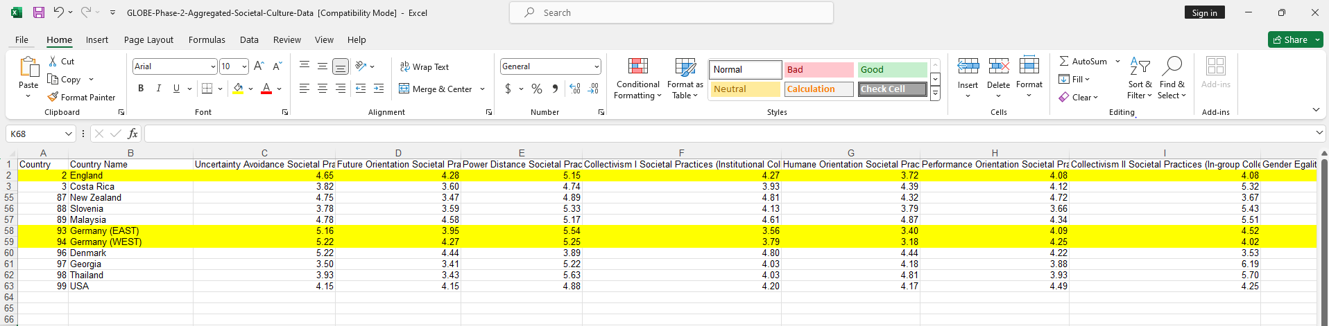
Figure 3 GLOBE Culture Scale. Source: GLOBE Project, 2004

Challenges of Intercultural Leadership
Cross-cultural communication is one of the main challenges that can arise during intercultural leadership. Considering German and UK cultures are distinct and different, it affects the behaviours, beliefs, and attitudes during intercultural interaction. For example, in Germany, where uncertainty avoidance is high, there is a preference for structured and orderly communications, which is different and distinct in English business culture. Shamne and Malushko (2019) highlight that different cultures influence the negotiation goals and outcomes of different nations' cultures during negotiations. The different communication styles between German delegates might be problematic due to their reverence for structure. The straightforward and orderly German leaders might feel offended by the easy and 'careless speaking' British staff, which might be perceived as disrespectful. On the other hand, the English might feel uncomfortable and restrained in interaction with the rigid and 'uncool' German leadership.
Another potential problem that might arise is difficulties in the decision-making process. Based on the Globe's project analysis, German and English leaders have more or less the same cultural orientation, with minute differences. Stolle et al. (2024) highlight that lack of diversity impacts group performance, especially affecting effective decision-making. The problem arises due to a lack of diversity, especially in their reasoning, thus making it difficult to make decisions effectively.

Conclusion
Germany's and England's cultures and leadership approaches are similar and different. Germany and England are distinct in uncertainty avoidance and indulgence. Germans have high uncertainty avoidance and low indulgence, while the English have low uncertainty avoidance and high indulgence. Consequently, based on the leadership approach of the two countries, they both have high-performance orientations and low autonomous and human orientations. These traits in the two countries might result in communication conflicts and ineffective decision-making.

Recommendations

Cultural Awareness Training
Cultural awareness training can be effective in improving cross-cultural interaction and communication. Shepherd (2019) highlights provides a framework for tailored cultural awareness and sensitivity training among German and English leadership. The cultural awareness training will equip employees to acknowledge and understand the differences in leadership approaches and appreciate the cultures.

Advocacy for Inclusivity
Sometimes, diversity could be the solution to the German and English cultures that have so many similarities. Schöttle et al. (2019) highlight that advancing inclusivity is critical in improving team decision-making. It's prudent to ensure that individual teams are saturated with diverse team members who bring diverse perspectives.

Team Building Activities
Henman (2023) highlights that it's critical to establish rapport, mutual trust, and understanding among cross-cultural teams. Team building activities can enhance the development of rapport and the establishment of group norms. It helps diverse teams understand the nuances of practical interactions, such as the significance of body language or greetings.

References
Berger, T., Frey, C.B., Levin, G. and Danda, SR (2019) 'Uber happy? Work and well-being in the 'gig economy", Economic Policy, 34(99), pp.429-477. Available at: https://doi.org/10.1093/epolic/eiz007 (Accessed: 16 February 2024).
Danik, L. and Lewandowska, S. M. (2021) 'Dimensions of Culture and Innovation Linkages. An International Comparison', In Competitiveness Report 2021: Bilateral Economic Cooperation and Competitive Advantages, pp.123-143.
GLOBE Project. (2004) An overview of the 2004 study: Understanding the Relationship Between National Culture, Societal Effectiveness and Desirable Leadership Attributes. Available at: https://globeproject.com/study_2004_2007.html (Accessed: 16 February 2024).
Henman, M. (2023) 'How to build stronger cross-cultural teams,' business.com. Available at: https://www.business.com/articles/from-conflict-to-cooperation-building-stronger-cross-cultural-teams/ (Accessed: 16 February 2024).
Hofstede Insights. (2024). Country comparison tool. Available at: https://www.hofstede-insights.com/country-comparison-tool?countries=germany%2Cunited+kingdom (Accessed: 16 February 2024).
Raimo, N., Zito, M. and Caragnano, A. (2019) 'Does national culture affect integrated reporting quality? A focus on GLOBE dimensions', In 9th International Symposium on Natural Resources Management, May 31st, 2019, Zaječar, Serbia (pp. 383-392). Belgrade: Megatrend University.
Schöttle, A., Christensen, R. and Arroyo, P., (2019) 'Does choosing by advantages promote inclusiveness in group decision-making', In Proceedings of the 27th Annual Conference of the International Group for Lean Construction, pp. 797-808. Available at: https://doi.org/10.24928/2019/0209 (Accessed: 16 February 2024).
Shamne, N.L., Milovanova, M.V. and Malushko, E.Y. (2019) 'Cross-cultural professional communication in the context of globalization', In IOP Conference Series: Materials Science and Engineering, 483(1), p. 012081. IOP Publishing. Available at: https://doi.org/10.1088/1757-899X/483/1/012081 (Accessed: 16 February 2024).
Shepherd, S. M. (2019) 'Cultural awareness workshops: Limitations and practical consequences', BMC Medical Education, 19(1). Available at: https://doi.org/10.1186/s12909-018-1450-5 (Accessed: 16 February 2024).
Stolle, C. M., Gula, B., Yu, R., and Huang, Y. (2024) 'The impact of diversity on group decision-making in the face of the free-rider problem', Judgment and Decision Making, 19, e4. Available at: https://doi.org/10.1017/jdm.2023.47 (Accessed: 16 February 2024).
United Language Group (2017) Localization strategy guide – The cultural dimensions of Germany. Available at: https://www.unitedlanguagegroup.com/blog/localization/localization-cultural-dimensions-germany (Accessed: 16 February 2024).
University of Europe for Applied Sciences. (2023) Need to know about the workplace culture in Germany. Available at: https://www.ue-germany.com/blog/what-you-need-to-know-about-the-workplace-culture-in-germany (Accessed: 16 February 2024).
Vizmonte, E.J. and Ligot, D.V., (2024) 'Analyzing the Relationship Between Cultural Dimensions and Educational Performance using Hofstede model and PISA Data', SSRN. Available at: http://dx.doi.org/10.2139/ssrn.4686789 (Accessed: 16 February 2024).

