University of Wales Trinity Saint David
Swansea College of Art

Vehicle Technology 2
(M5X01364)
Vehicle Structure & Aero

Student: Daniel Modringa
P number: P149386
Course: Automotive Design

Swansea 2018

From the invention of the engine and Henry Ford’s assembly line for the Model T to today’s advanced technologies like monocoque construction, magnetic suspension and autonomous driving system, the enhancement in transportation has been substantial, due to the need of cost reduction, quality improvement, safety, environmental concern and other issues.
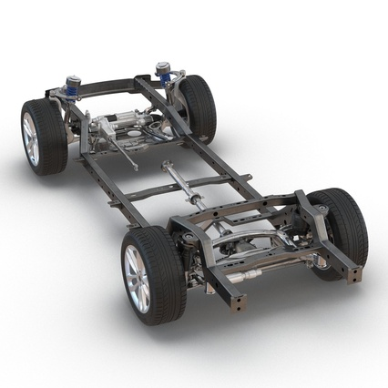
The essential element of any car is the body structure that connects all the components, protects passengers and houses the drivetrain. The oldest structural vehicle design is body on frame concept, which relies on the frame unit and body is bolted to it at various points to provide structural integrity. The frame has to be rigid, since the engine, body and suspension system depends upon the frame to support and keep all units in alignment. This structure is used nowadays only for light trucks and full-size SUV’s.
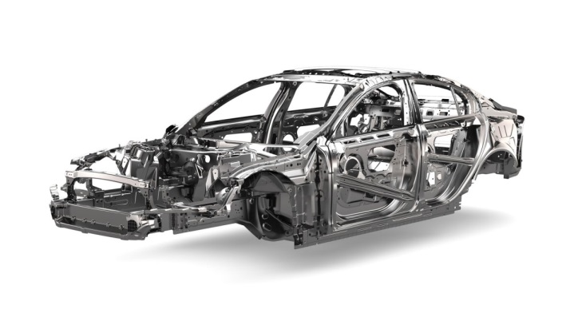
Modern unitized body construction is composed by various frame sections as structural strength parts to support and strengthen the entire unit in order to eliminate heavy chassis frame. Therefore, separate body and chassis is being superseded by the integral or mono-construction system, which allows a significant weight reduction and enables a more compact, yet spacious vehicle configuration. The overall carrying load is lesser. Consequently, a smaller capacity engine could be incorporated to achieve better fuel economy, better handling, ride control and performance compared to a body on frame construction.
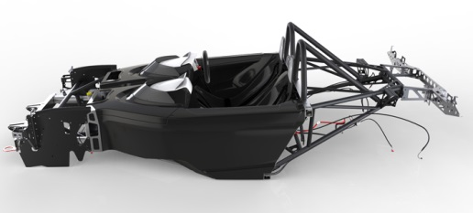
Advanced steel technologies have seen considerable progress over the past decade. Mass reduction through advances in the use of steel is substantial inasmuch as is a dominant material for the vast majority of vehicles and is a low cost material with an extensive experience base to the industry. Steel is the prevalent material used in monocoque body structure due to its particular physical parameters and is mainly used in zones where higher strength is required. Enhancement in fabrication and assembly technique are as relevant as advance in materials. For lightweight steel technology the main process includes stamping, hydroforming, tailored blanks and so forth. Automakers can add strength, enhance crash energy management, and reduce vehicle’s overall weight and cost. However, unitized body is difficult to design, build, modify and repair when compared to the body on frame. Development time is longer due to the complexity it involves and is not well suited for off-road transportation because rigidity and torsional stiffness is not very easy to achieve without making the car top-heavy. Apart from that, monocoque structure is well designed for regular vehicles like hatchbacks, crossovers, saloons, estates etc. It is designed with the help of appropriate crumble zones in order to keep away the impact waves from the passengers as wheel as the driver of the vehicle. Nowadays, car manufacturers are working hard to make the unitized body stronger, affordable and lighter contributing to better fuel economy and outright performance as compared to earlier times.
Bonded aluminum and carbon fiber chassis are suited for sport oriented automobiles like Lotus, Mclaren, Elemental, Jaguar and so forth. For example, Elemental Rp1 has a carbon and aluminum composite tub at its core that weights just 68kg. The car has a very strong and lightweight body construction. This in turns gives the Rp1 better chassis dynamics, while the body construction has been designed to meet FIA side impact standards.
Lotus Elise was very innovative creating epoxy-bonded extruded aluminum chassis tub that formed an immensely stiff and lightweight platform, while keeping weigh and production costs to minimum. Formed on bonded aluminum sheets in a tub shape, the Elise chassis only weights 70 kg. It consists of 63 straight and 2 bends extrusions as well as 5 sheet panels. The body components are joined by adhesive bonding that could eliminate the distortion that could come from welding. Yet, the chassis is not design to absorb impact during a crash and repair could be very expensive and complex process. Still, the car’s body construction, which included a composite energy absorbing front crash structure, was tough enough to meet crash all standards and was modular enough to be used for various models like Tesla Roadster, Opel Speedster and various Lotus road and track cars including Exige, Europa 340R and so forth. The challenge car manufacturers are facing now is translating the aluminum production of limited hand-made sports cars to affordable automobiles that could be mass-produced.
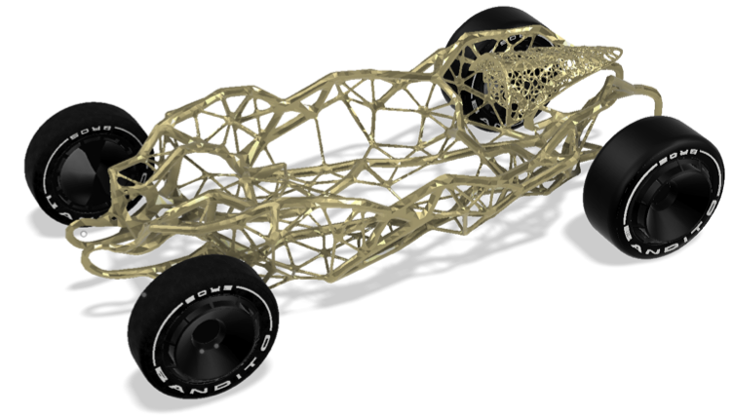
As the technology advances, in the future, car manufacturers could optimize the structural design of automobiles using minimum material possible to create safe and durable structures while taking up as little usable space as possible. Using generative design software as a new method of product development leads to reduction in the time spent for manufacturing objects. The software enables to create a considerable amount of design options and exploring a whole set of new solutions by simply defining the constraints and structural necessities like materials, height, weight and strength. The simulation is a part of the design process, the software can create designs that can be fabricated with the manufacturing method specified like CNC, 3D printing, injection molding etc. The calculations and optimization tasks relating to the geometry and load capacity requirements are solved using intelligent algorithms based on machine learning and advanced simulation generating smart design solutions in a short amount of time. This process leads to major reduction in costs, development time, material consumption and product weight. This method will be the subject of research as a potential new approach to chassis design and generative manufacturing using less material, fuel waste and having less negative impact on the environment. With the development of technology the design possibilities will burst and manufacturing efficiency will further improve.
Aerodynamics plays a significant role in the vehicle construction since it offers a possibility to reduce the emission levels and more favorable driving experience of automobiles. Aerodynamics can contribute as well to the performance, top speed and handling of automobiles, motorcycles, bicycles and motorsport. New legislations and increasing fuel prices are pushing the car manufacturers to develop vehicles with lower fuel consumption and reduced aerodynamic resistance.
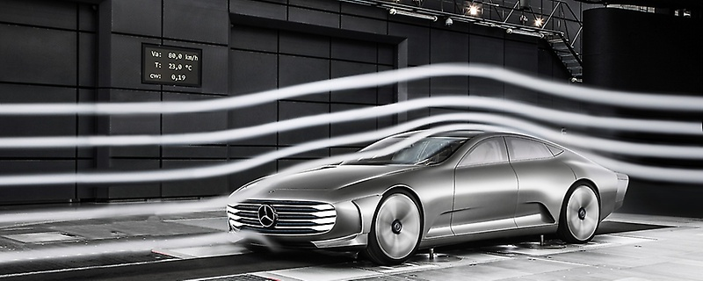
Few decades ago, automobiles were mostly boxy with angular shapes and had humongous amounts of drag. However, a lot has changed since then. The introduction of wind tunnel testing was a huge step forward helping each model to be streamlined, rounded and more slippery than the model before, allowing air to flow easily around it with least possible resistance. In the wind tunnel, the car is fixed as a stream of air is blow towards it to simulate the airflow that the car might encounter in real life conditions. Under the tunnel’s floor, sensitive scales accurately measure the horizontal drag and vertical lift forces and assess the overall aerodynamic performance of the vehicle. Currently, physical wind tunnels are getting replaced by computational fluid flow simulations with virtual wind testing, reducing costs and time and enabling car makers to test their products under a much larger variety of operating conditions. Aerodynamic surfaces can change the drag characteristics and the flow through the frontal area, cooling system and the under-hood area. Drag, in vehicle aerodynamics is the force that opposes the forward movement of a vehicle, in which air goes against the vehicle surfaces and creates disturbances against the body. The drag coefficient (Cd) increases with speed, the more pressure car has produced, the more fuel it will need to use in order to overcome this force. By optimizing the shape of the car, less energy will be required and will be able to transfer more power produced by the engine into movement, resulting with better performance and a higher top speed. Automotive design was the main area of study in order to reduce the drag coefficient. With time, car manufacturers discovered other innovative ways to improve the aerodynamic performance which will fulfill all legislations. The more streamlined form is created the less air resistance is produced.
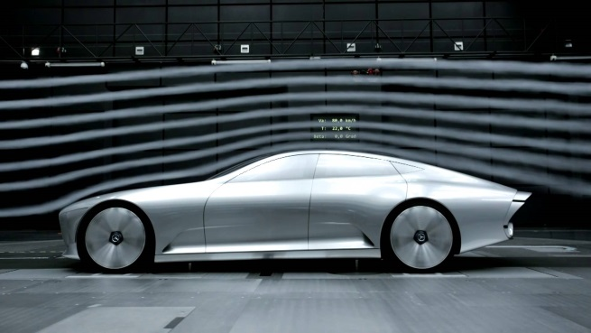
Still, optimizing aerodynamic performance and air resistance remains one of the key challenges designers have to face. Yet, it is no longer exclusive for motorsport, aircraft engineering and the occurrence of virtual prototyping and simulation tools have made to deal with this challenge easier than before. With new technologies and innovations more advanced features are incorporated into the car’s shape like diffusers, trunk spoilers and other elements. Aerodynamics continues to make an increasing contribution to customer demands like noise, handling stability, visibility and ride comfort. Elements like active aerodynamic are getting more popular as a result of cheaper implementation of hardware and software in cars. Thus, opening new possibilities to control the airflow and hence reduce the drag and increase the overall efficiency. For the future, new technologies in powertrain and autonomous automotive designs will place a further prominence on contribution of aerodynamics and automotive manufacturers may require new technologies and facilities to respond to further challenges.

References:
European Aluminum Association (2013) The Aluminum Automotive Manual, (auto@eaa.be) Available at: http://european-aluminium.eu/media/1514/1-introduction_2015.pdf (Accessed: 1 April 2018).

Xufei Wang, Jurong Liu and Yaoji Deng (2016) The effect on aerodynamic performance of electric vehicle caused by battery pack installed in the chassis, Shaanxi University of Technology, Hanzhong, China, 723000 (Accessed: 1 April 2018)

Lennart Lofdahl, Simone Sebben… (2012) Road-Vehicle Aero-Dynamics and Thermal Management (Accessed: 1 April 2018)

Mr. Mithun S. K, Automotive Chassis, Session 2, M S Ramaiah School of Advanced Studies, Available at: http://164.100.133.129:81/econtent/Uploads/Session2%20Automotive%20Chassis.pdf (Accessed: 1 April 2018).

Mickey Howard, (2000) Spaceframes “A study of an emergin body construction Technology”, University of Bath, (Accessed: 2 April 2018)

Tamas Lajos (2002) Basics of vehicle aerodynamics, University of Rome “La Sapienza”, Available at: https://www.ara.bme.hu/oktatas/letolt/Vehicleaerodyn/Vehicleaerodyn.pdf
(Accessed: 2 April 2018)

Corrado Casiraghi (2010) Race Car Aerodynamics, KTH – Royal Institute of Technology, Available at: https://www.mech.kth.se/courses/5C1211/Casiraghi_2010.pdf
(Accessed: 2 April 2018)

