Sophie Grinter - 1050960
Unit birwelco ltd

SECOND SUBMISSION

19th April 2021
Managing Employment Relations

Managing Employment Relations in the context of your Organisation

EXECUTIVE SUMMARY

This report looks at how Covid-19 pandemic has affected organisations in general and the different employment relations factors that have had the most impact on organisations including UnitBirwelco Ltd. The main factors that will be accessed are Employment Relations as a whole, Managing Change, Health & Well-Being & Redundancies.

There will be an assessment of how these factors have effected UnitBirwelco, whether it has a negative or positive impact, this will then allow to draw on the recommendations for the company and how they can improve their employment relations.

ABBREVIATIONS

UB UnitBirwelco Ltd
USE Unit Superheater Engineering Ltd
UEC Unit Engineers & Constructors Ltd
ER Employment Relations
PESTLE Political, Economic, Sociological, Technological, Legal and Environment
SWOT Strengths, Weakness, Opportunities and Threats
HSE Health and Safety Executive
HSA Health and Safety Act 1974
WFH Working From Home

Table of Contents

EXECUTIVE SUMMARY 1
ABBREVIATIONS 2
1.0 INTRODUCTION 4
2.0 LITERATURE REVIEW 6
2.1 Effects from COVID-19 on organisations 6
2.1.1 Employment Relations 6
2.1.2 Managing Change 8
2.1.3 Health & Well Being 8
2.1.4 Redundancies 10
3.0 FINDINGS 13
4.0 RECOMMENDATIONS 15
5.0 CONCLUSION 15
REFERENCES 16
TABLE OF FIGURES 20
APPRENDICES 21
Appendix 1 - PESTLE Analysis 21

INTRODUCTION

UnitBirwelco Ltd is an engineering and manufacturing company that provides design, project management, fabrication and construction for the power, oil and gas and process industries. There are 3 divisions of UB, these are Unit Superheater Engineering Ltd which focus on the design and manufacturing, Birwelco which provides engineering design and Unit Engineers & Constructions which focuses on the construction and maintenance contracts. The sites are placed in specific locations across the UK to enable them to have the best exposure to clients (UnitBirwelco, 2020).
In 1903 Birwelco Ltd were formed and in 1909 USE were formed, both of these entities would have taken the approach in line with the Charters Movement from 1839 which the working class drove on as a mass movement following the 1832 Reform Act which was unsuccessful (Parliament, n.d.).
Moving to 2002 UEC were formed, in 2004 UEC bought USE forming the Unit Group, in 2010 the Unit Group bought Birwelco Ltd forming UB these companies would have adopted the Equal Pay Act 1970 & Industrial Relations Act 1971. Given that UB are in the working sector of engineering, manufacture & fabrication they automatically took the trade union approach within the workforce. “Trade Unions are organizations that represent people at work. ‘Representing’ could mean someone from the union meeting with management on behalf of a member or a group of staff or taking up a problem with the employer for others. Trade unions aim to protect their members.” (Balaji, 2014)
One of the areas that ER focuses on is the process which an organisation takes, these can either be of a high trust, low process or low trust, high process. Organisation should look to aim to be in a high trust, low process sector. As explained by (Mitchell, 2019) people, structure and the environment are the fundamental aspects to ensuring a high trust process is built within any organisation. These organisations will have high productivity, income and profits. As set out by Mitchell, there are five main aspects to creating the high trust process, these are, psychologically safe culture, trust in the employees, ensure strong communication, investment within the employees and a strong organisational structure. When an organisation has low trust, high process in takes an impact on the decisions and communication which could result in bringing costs up and speed of the work force down and lack of communication (Gleeson, 2016).
As demonstrated by (Netflix, n.d.) who have adopted a high trust culture in their employees. Netflix describe their company culture as “we strive to hire the best and we value integrity, excellence, respect, inclusion, and collaboration.” Netflix believe looking after their employees gives the company a more invested workforce, their main philosophy is “people over process”. This alone demonstrates the high trust, low process culture within the company.
From looking at UB I believe it is more of a low trust, high process organisation, the employees seem to have a lack of trust in higher management, this is believed to come from previous management and hopefully will be changed in the coming months / years.
It is reported that in December 2019, the World Health Organisation was informed about cases in Wuhan City, China of an unknown cause regarding a collection of cases of pneumonia. It was then announced in January 2020 that a new coronavirus had been identified from the tests that had been carried out from pneumonia cases, the disease is called COVID-19. (Government, 2020)
Latest cases as of November 27, 2020, globally, as shown in Figure 1. Total Coronavirus Cases: 61,397,419, Deaths: 1,439,585, Recovered: 42,476,031.
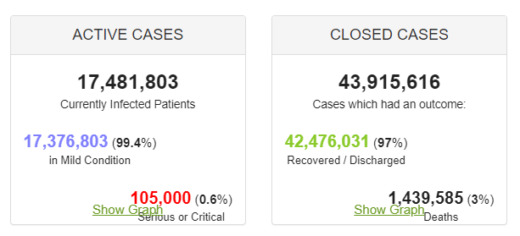
Figure 1 – Global Coronavirus Statistics

Within this report I will be analysing the effects from the current global pandemic and how this has affected organisations, including UnitBirwelco Ltd, how organisations have had to adapt to the changes and how this has financially impacted the organisations.
To conclude a review of recommendations for what UnitBirwelco Ltd could or can put in place going forward.

LITERATURE REVIEW

Effects from COVID-19 on organisations

Employment Relations

Employee relations refers to individual and collective workplace relationships. “It reflects the increasing individualisation of the employment relationship following the rise of individual workplace rights and the decline in trade union.” (CIPD, 2020). As explained in (SAGE, 2016) the way a company focuses on the skills of each employee is the most effective way in reference to individualisation of the workplace, not collective which is also known as unitarist, not pluralist.

Unitarist and pluralist are other ways to look at the employee relations within a workforce, Unitarist is identified where the employer or management of the company sees the workplace from a view that everyone employed within the organisation agrees with its aims and objectives and the objectives that have been set by the management. As defined by (Price, 1980) this approach believes that everyone within the company has the same goals and objectives and all employees should work together. Whereas pluralist notes that different groups / individuals within the workforce exist and that this in turn causes conflict which is natural within any organisation (Heery, 2016).

Employee relations looks at the relationship between an organisation and its employees to ensure that it is managed through up-to-date policies and relevant laws. Organisations are to follow correct procedures therefore they must abide to the Employment Relations Act 1999, the Act consists mainly of the Trade Union and Labour Relations (Consolidation) Act 1992 and the Employment Rights Act 1996 amendments (Government, 1999).

Before the global pandemic organisations were already under pressure operating in the VUCA landscape, this response is becoming popular with managers. VUCA mixes four different types of challenges that require different responses – Volatility, Uncertainty, Complexity and Ambiguity (Lemoine, 2014). Deloitte Global Human Capital Trends survey from 2019 identified the percentages on 21st-century leadership requirements, these were, as shown in figure 2 (Arkenberg, 2019).
Figure 2 - 21st-century leadership requirements

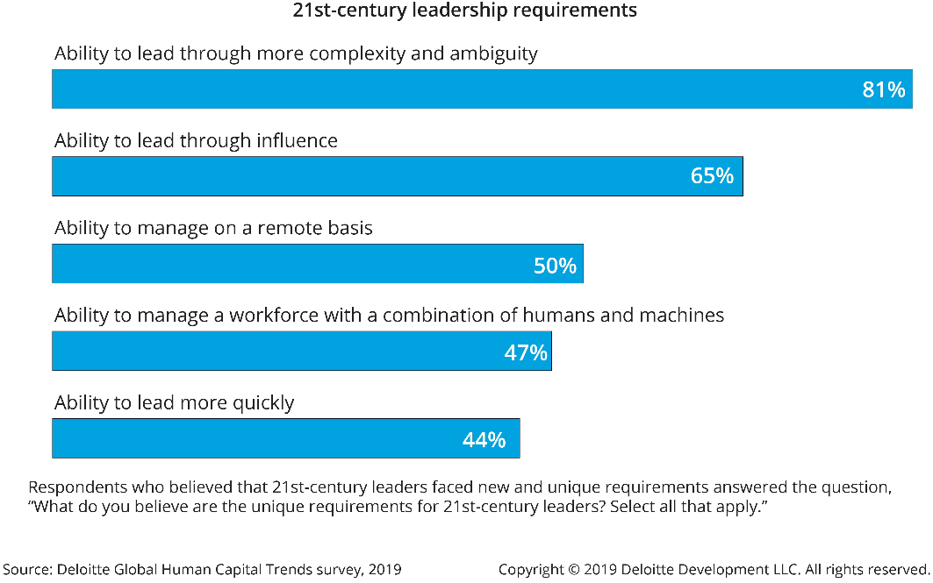

VUCA was created by the US Army War College in the 1990s, this has since been reignited due to the current global pandemic. It provides an awareness of the challenges organisations are facing during this time as the elements of VUCA are amplified in the ever-changing work environment (Koshemani, 2020).

Employee relations in the time of the COVID-19 pandemic would have had to change significantly to what the organisation were used to dealing with, they have had to take extra health & safety precautions, such as, additional risk assessments and consultations to set up and enforce social distancing requiring a change to workstations, office layouts, spilt shifts and any other measures to reduce the number of people within common areas (Organization, 2020). A change in operation as well as the impact on employees, both senior management and employees have had to take on significant changes and trust, both have had to move towards a more digital form of communication, data – driven, more variable structures to ensure smooth running of the businesses, and agile operations and automation this has enforced stronger capabilities in security (Accenture, 2020). Each employee would be treated on an individual basis, depending on their age, health issues etc.

The significant change for organisation was measured using a PESTLE analysis, this is a common analysis method used by a wide variety of organisations. A pestle analysis will look at different external factors that could affect an organisation, the analysis of these factors can then be used by senior management to access the impact of influences they will have on the business. These are then reviewed to ensure the organisation has sufficient practices / procedures / policies in place to ensure the organisation is at minimum risk to any impacts that could come from these external factors.

CIPD have defined a PESTLE analysis as “an audit of six external influences on an organisation.” They believe compiling a PESTLE analysis allows an organisation to “assess any risks specific to their industry and organisation and use that knowledge to inform their decisions.” (CIPD, 2020)

(Business-to-you, 2016)

A PESTLE analysis for UB can be found in Appendix 1. This looks mainly into the effects of COVID-19 and how these factors have been dealt with in regard to the global pandemic and what the organisation could have put in place to ensure minimum risks to the company.

Managing Change

During the COVID-19 pandemic UB has had to adapt to a lot of change, as with a lot of other organisations. We had to ensure we looked at all areas of the company, such as, the way employees work, the financial impacts, technology used. Change can affect an organisation in many different ways, having a big impact of the employees. Some of the aspects involve adapting to a new environment, working practices or personal circumstances (ACAS, 2013). Change can have a detrimental effect on an organisation, depending on the way it affects the employees. These aspects need to be noted and different procedures put in place to ensure all angles are covered. JM Fisher produced a ‘process or transition’ curve which details the journey that employees could go through when change occurs in the organisation. “These emotions are represented in a curve which shows the emotional highs and lows” (ACAS, 2013).

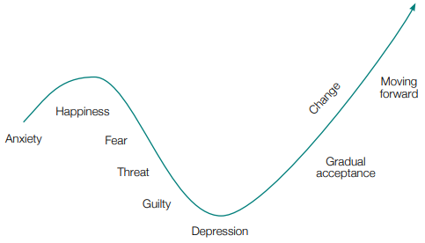
Figure 3 - JM Fisher Process of transition curve

Health & Well Being

From the figure above many emotional factors have been mentioned, a lot of these could have an effect of the employee’s mental health, this would need to be understood and considered when putting in place any changes an organisation is or could implement. An employee’s mental health should be a major concern within the organisation as this could affect the organisation in many ways, especially if the ill mental health of an employee is work-related. This could stem from stress, depression or anxiety and is seen as a damaging “reaction people have to undue pressures and demands placed on them at work”. (Executive, 2020) The latest figures from HSE show that 828,000 of workers suffer from work-related stress, depression or anxiety in and 17.9 million working days are lost due to these reasons. This has risen over the years, assessed from 2001 / 2002 as shown in figure 3, with 2019 / 2020 having the steepest incline per 100,000 workers.

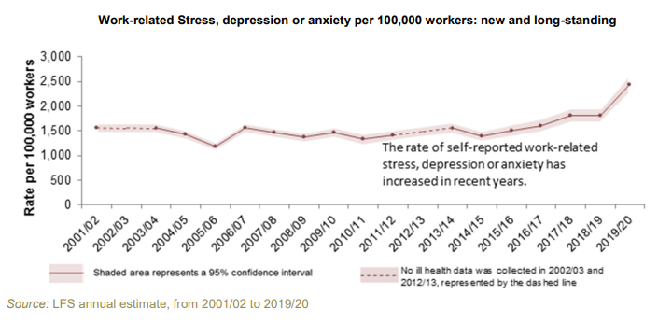
Figure 4 - Work related stress, depression or anxiety per 100,000 workers: new and long standing
Mental Health has now been included within the Health and Safety at Work Act 1974, when in 2003 the HSE issued a stress-related enforcement notice to West Dorset Trust to carry out a risk assessment of working practices following complaints from their staff. TUC’s Mental Health in the Workplace: Educational workbook, is used by unions to provide guidance and details the nature of work-related stress and other mental health problems that can be cause by, or affect, experience of work (Tony Bennett, 2020).

There are 6 essentials factors of the workplace that need to be reviewed to be in line with the HSA 1974, these being;
- Resources and communications – employees need adequate information, training and equipment to do their job.
- Control and autonomy – don’t limit workers’ autonomy to do the job their way.
- Balanced workloads – a balanced workload with a good work-life balance is crucial.
- Job security and change – the impact of change on workers’ needs and any consequent training they need should be assessed.
- Work relationships – employees need to be treated with respect.
- Job conditions – employers should provide the best working conditions, including pay and benefits, that they can. (Tony Bennett, 2020)
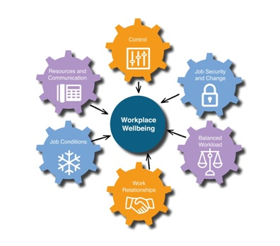
Figure 5 - Six Essentials of Workplace well-being

The COVID-19 pandemic had a big affect on people mental health, organisations had to consider the impacts the pandemic have had on their employees and business. There were a lot of factor to access, effects of lockdown, social distancing, anxiety relating to job security, health issues, work-life balance. The Mind charity reported than 60% of adults and 68% of your people said their mental health was affected during lockdown (CIPD, 2020). Another report specifically looks at depression and reports that “almost one in five adults (19.2%) were likely to be experiencing some form of depression during the coronavirus (COVID-19) pandemic in June 2020; this is almost doubled from around 1 in 10 (9.7%) before the pandemic (July 2019 to March 2020).” (Vizard, 2020).

Organisations needed to ensure they implemented a risk assessment which accessed different areas of the business and how the above effected the employees. When COVID-19 started becoming more renowned organisations should have produced a risk assessment to establish the current risks within the workplace and also what new risks may appear. To ensure they safety or all employees were told to work from home where possible, within UB, unfortunately, this was not possible for the majority of staff therefore “before workers can return to their normal workplace employers should undertake a risk assessment to make it “COVID-secure” (union, 2020).

It was reported that a number of organisations failed to abide by the government guidelines by, for example, Boohoo were scrutinised for not following social distancing as well as under paying their staff “An undercover investigation by The Sunday Times in July revealed that workers were being paid as little as £3.50 an hour. The company was also accused of putting workers at risk by working with factories which continued to operate during lockdown without social distancing measures in place.” (Skopeliti, 2020). This effected the company as many of their customers / suppliers stopped dealing with the brand, it is reported that Boohoo will be implementing changes and enhancements to their procedures and will go on to rebuild their relationships with these companies.

JD Weatherspoons was another company that came under scrutiny during the pandemic as it was reported that they neglected their staff during the crisis. Staff were told to seek other employment as the 43,000 staff were told they would not be paid until the Government reimbursed the company for the furlough pay, this was already after employees had their bonuses taken off them. Whereas Costa employees were told they would receive 8 weeks at full pay from the first lockdown. (Davies, 2020)

Redundancies

During COVID-19 the UK economy was put into a technical recession. April to June 2020 saw a record fall of 20.4%, this was a significant fall from January to March 2020 which saw a 2.2% in the economy as shown n figure 6 (Statistics, 2020). This has led to many changes within organisations.
Figure 6 - Monthly gross domestic product (GDP), seasonally adjected, UK, Jan 2018 to June 2020

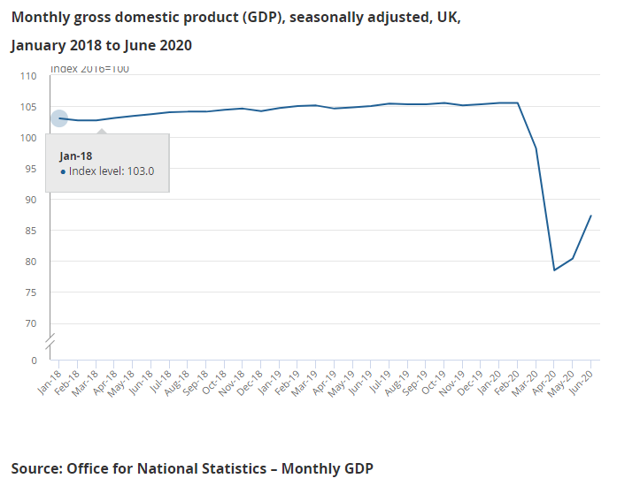

Unfortunately, over the last couple of months many organisations have faced redundancies, this has been seen globally, as shown in figures 7 & 8. Some of the UK retailers that have been affected most by the pandemic and have had to make the most redundancies are, Debenhams who announced there would be 2,500 job losses however it is estimated there would be a total of 10,000 due to rescue deals. Marks and Spencer have announced there are to be 7,000 layoffs, which is the most announced by any company as of February 2021. As well as John Lewis and Laura Ashley (Sophie Smith, 2021). This main reason for this is due to the COVID-19 pandemic and organisations having to close for a period of time, therefore not making any money as mentioned previously and displayed in figure 6. Redundancy should be the last resort for any organisation and all other avenues should be looked at implementing first. Redundancy is classed as “a special form of dismissal which happens when an employer needs to reduce the size of its workforce” (CIPD, 2020). There are five reasons for fair dismissal, organisations will need to ensure they adhere to these as they are set out in law, these were first set out within the Employment Rights Act 1996 (Government, 2020).

The five reasons are:

“Conduct – when the employee has done something that’s inappropriate or not acceptable.

Capability – when the employee is not able to do the job or does not have the right qualifications.

Redundancy – When the job is no longer needed.

A Legal Reason – when the employee cannot do their job legally, for example a lorry driver who’s banned from driving

‘some other substantial reason’ – a term used for a wide variety of other situations.”

(ACAS, 2020)

The UK has been majorly affected by redundancies during the COVID-19 pandemic, the number of redundancies over the last couple of months has risen dramatically, the last noticeably rise in redundancies was in 2007, the below graph shows the rise in redundancies from the same time last year (2019 Jul – Sept) where redundancies were 4.3 per 1,000 employees compared to 2020 where they were 11.3 per 1,000 employees.
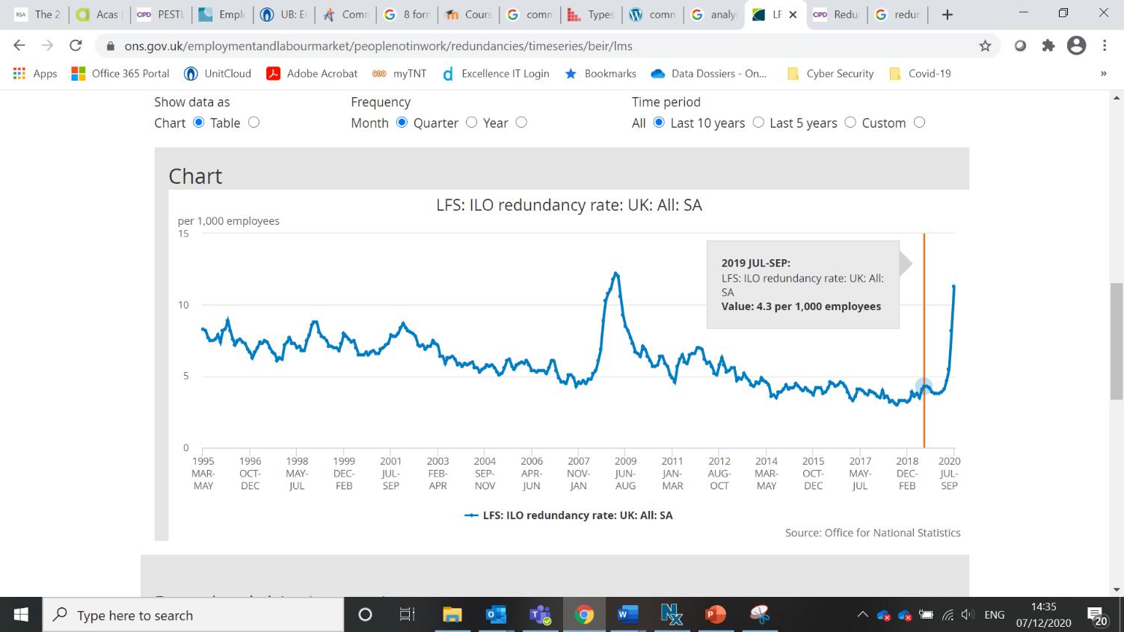
Figure 7 - Redundancy Numbers - 2019

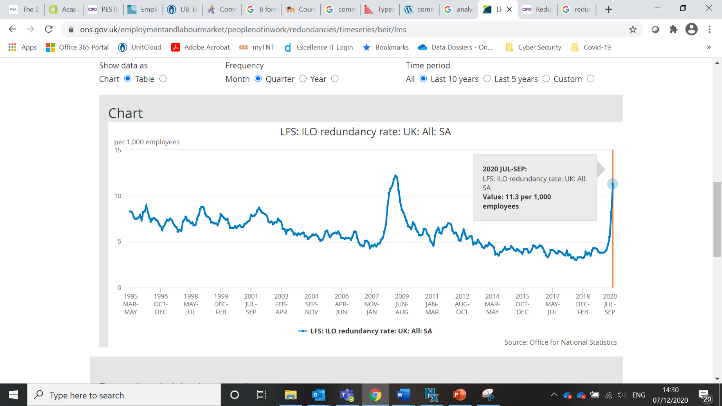
Figure 8 - Redundancy Numbers - 2020

Some of the most well-known organisations have been affected by redundancies and these have had a detrimental effect to the economy. “Businesses in all sectors are struggling with the impact of the coronavirus pandemic but retail and aviation are being hit particularly hard.” (Barker, 2020). The Government tried to support companies at the later end of the lockdown restrictions with introducing the job retention scheme, where the employer claimed up to 80% of the normal employee salary for any hours not worked, up to a maximum of £2,500 per month (Government, 2020).

The pandemic has had a global effect on unemployment with the United States having the biggest impact, the percentage of unemployment has gone from 3.7% in 2019 to 10.4% in 2020, “signalling an end to a decade of expansion for one of the world’s largest economies” (Lora Jones, 2020). With other countries being affected it is looking more likely for a global recession “the IMF says that the global economy will shrink by 3% this year” (Lora Jones, 2020).
The IMF has reported that the COVID-19 pandemic, as most countries put in place strict lockdown measures for the beginning of the year, has affected the global economy dramatically. It states that lockdowns were a significant factor in the recession as well as social distancing. Easing lockdowns could put a partial recovery on the recession however it is likely to remain until health risks decrease (Fund, 2020).

FINDINGS

A PESTLE analysis for UB can be found in Appendix 1. This looks mainly into the effects of COVID-19 and how these factors (mentioned within section 2.1.1 Employment Relations) have been dealt with in regard to the global pandemic and what the organisation could have put in place to ensure minimum risks to the company.

The best method for a SWOT analysis to be completed is by a group of people, this will give more outlooks within the company and enable a better assessment of the environment and how to react accordingly (Kumawat, 2019). Once a SWOT Analysis has been complete the organisation will have a better understand of the different areas that need to be focused on, this will improve focus, strategic alignment and identify unknown aspects (Furgison, 2019).

A SWOT Analysis was carried out to understand the key factors involved in an organisation, we looked at completing a SWOT Analysis in regard to COVID-19 for UB to understand the strategy or process to be applied within the current situation and to allow senior management to act efficiently within the changing circumstances.

STRENGTHS

Implementing health & safety requirement;
- social distancing – Large office space allowing for all employees to keep the required 2 metre distance at all times.
- PPE – company provided all staff with 5 + face masks each, any additional PPE required for shop floor workers and sanitising stations have been put in place around communal areas, as well as providing individual sanitiser for each individual.

Developing home working requirements for those in need;
- Offering alternative arrangements / equipment to ensure communication and all targets are still met – with no effect to the organisation.
- Ensure support was of adequate level to those working from home to ensure they did not feel isolated.
- Office was still open therefore if any found the need to come into the office, they were able to do so.

Split the offices into bubbles to ensure minimum contact between employees, this ensured unnecessary staff were not in different bubbles as well as ensuring if a bubble were to become affected by COVID-19 then the organisation was still able to run and all essential functions were not affected.

UB has worked throughout the pandemic, being an oil and gas manufacture. Despite many businesses losing business, we have been able to gain on this and new companies have become out clients / customers for any urgent work required for their company.

WEAKNESSES

Working from home was not accessed until a later stage, this could have been implemented at an earlier stage to allow more flexibility within the offices – this would have prevented any upset / stress / anxiety in staff if they felt more confident & comfortable from an early stage within the pandemic.

Employees mental health has been affected in a few different ways, this has put a strain on their work and how they have dealt with difficult decisions within the workplace.

Company was unable to allow all staff to work from home, with UB having a workshop and the engineers having to liaise with staff in the workshop to ensure any problems were resolved efficiently we were unable to allow the engineers to work from home on a permanent basis, this caused some friction between the office staff and some grievances were raised.

With some staff having to isolate due to positive COVID-19 tests as well as shielding, UB had a stop on some of our workshop functions. This put a delay on some of the deadlines and UB needed to employ / contract more staff on a temporary basis to ensure job delays were kept to a minimum.

OPPURTUNITIES

Due to UB sites staying open and operating as efficiently throughout the pandemic it gave an advantage to gain new clients & customers for any urgent jobs, as new opportunities rise with these customers UB is now being considered for future opportunities.

Senior level / Manger positions have been given the opportunity to have more virtual meetings as more and more companies are in the same situation; they have become more inclined to accept virtual meetings instead of face-to-face. This has given UB a wider range of new opportunities for the company.

Highlighted the need for some new job opportunities within the group, however, this could be seen as a negative as it has also pointed out the unnecessary need to some job roles (as mention in threats).

THREATS

Outbreak of COVID-19 in the workshop could put a stop to a lot of operations, this would either mean having to close the site and stop all work or having to spend more time & money sourcing more staff to ensure work was maintained.

Long term threats could include enquiries / orders being cancelled / put on hold by the customer due to their requirements changing meaning a lose to business profits for the financial year.

Although no redundancies have affected UB due to COVID-19, some have had to take place with the shift in operations and skills. As UB enforces more positive changes to the company this could have a negative impact on their staff with a potential to face even more redundancies.

RECOMMENDATIONS

For UB to gain more trust from their employees it has been noted that they require to be more informative with company information, regarding communication, problems, new positions etc. This will, hopefully, put less of a strain on employees if they feel they can trust the company at a high level. This in turn will reduce the number of mental health related sickness, improving overall sickness level and a level in production. To support mental health UB should look to implement a Mental Health risk assessment, policy and put in place an effective support line for all employees, this should be in line with their health policy. There are a number of different mental health support organisations within the UK and these should be included within the ‘benefits’ of being with the company. Employees will then feel safer within the company and feel as if they are ‘looked after’.

Secondly, as the health and safety policies and practices have been updated due to the current pandemic it has become apparent this has been an effective change on the organisation. Employees have been more welcoming to these changes than previously expected, having demonstrated this it could mean more policies and practices can be updated to be in line with current employment relations infrastructures such as, ‘21st-century leadership requirements’, as mentioned in section 2.1.1 Employment Relations. Senior level / managers could use this guide to look at a variety of different aspects of the business and how to improve using the VUCA model, specifically ‘Ability to lead through influence’, this would give the employees more of a say within the company and a sense of need. As well as ‘Ability to manage on a remote basis, as this is currently being demonstrated to a low level, currently I believe this can be improved to enable more engagement of site to site and to work more as a group instead of a site basis, this will increase productivity and engagement in employees.

Final recommendation would be for UB to keep rolling out with new technologies and training to encourage employees to keep moving with the 21st century. This would include updating their IT policies, WFH requirements, advancing our digital capability. This has been shown to work well for the company throughout 2020 however there are multiple changes to implement which will benefit the company in the long run. This will also include an update to the IT technology to allow ease of WFH, as currently employees are required to transport their office desktop to and from the office.

CONCLUSION

To conclude as UB currently stands they are in a low trust, high process format, to change this so UB are of high trust they would need to start with the engagement of their employees. To ensure UB progress further with their ER strategies they will need to ensure they put in place a cost budget to ensure they fully utilise the recommendations that have been put forward.

In the next twelve months UB should look to put on different forms of training for all employees across the group. This could be in the form of a learning portal where employees need to carry out training tasks on a monthly basis as a mandatory aspect of the ongoing training, this could include a short video and then a quiz, for example. The training set out in this could focus on Mental Health Illness, Health & Safety training, this will increase the employee’s knowledge is these areas as recommended above.
Action Plan

Action | Description | Cost | Time
Learning / Training Portal | Portal which ensures all employees complete a training course every month of the year. The training course could be set by the employer or when there is no specific course to complete the employee chooses what course they complete for that month. | £11.99 PM / PP  Total Monthly Cost:  £1,870.44  Total Yearly Cost:  £22,445.28 | Complete over 12 months
LinkedIn Learning | Website which holds 16,000 courses, new courses released every week. Option to be personalised. Social learning, Q&A. (LinkedIn, 2021) | £14.99 PM / PP  Total Monthly Cost:  £2,338.44  Total Yearly Cost:  £28,061.28 | Ongoing monthly subscription (increased cost to mentioned) or annual subscription.

I believe if UB follow either of the recommendations within the Action Plan above this will be a start to changing the culture of the organisation to high trust as well as have a unitarist workforce. I do believe the first action plan option of the Learning / Training portal where mandatory training tasks can be set each month which will be more beneficial as any employees that are reluctant to carry out new training will not have an option and long term this could improve the individuals mindset within the company.

REFERENCES

ACAS, (2013). How to manage change. [Online]
Available at: https://archive.acas.org.uk/media/2673/Advisory-booklet---How-to-manage-change/pdf/Acas-How-to-manage-change-advisory-booklet.pdf
[Accessed 2 12 2020].

ACAS, (2020). Dismissals. [Online]
Available at: https://www.acas.org.uk/dismissals
[Accessed 8 January 2021].

ACAS, (n.d). Communications. [Online]
Available at: https://archive.acas.org.uk/index.aspx?articleid=674
[Accessed 7 12 2020].

ACAS, (n.d). Mediation at work. [Online]
Available at: https://www.acas.org.uk/mediation
[Accessed 8 12 2020].

Accenture, (2020). Navigating the human and business impact of coronavirus. [Online]
Available at: https://www.accenture.com/gb-en/about/company/coronavirus-business-economic-impact
[Accessed 6 01 2021].

Arkenberg, C., (2019). Leading in a VUCA world. [Online]
Available at: https://www2.deloitte.com/us/en/pages/technology-media-and-telecommunications/articles/leading-in-a-vuca-world.html
[Accessed 7 January 2021].

Balaji, R., (2014). Role of Trade Unions in Manufactring Concerns. International Journal of Innovative Research in Science, Engineering and Technology, 3(5), p. 1.

Barker, H., (2020). The companies making redundancies in the UK in 2020 so far- including Cineworld, easyJet and Virgin Money. [Online]
Available at: https://www.business-live.co.uk/economic-development/companies-making-redundancies-uk-2020-18526945
[Accessed 7 12 2020].

Business-to-you, (2016). Scanning the Environment: PESTEL Analysis. [Online]
Available at: https://www.business-to-you.com/scanning-the-environment-pestel-analysis/
[Accessed 6 January 2021].

CIPD, (2020). Coronavirus (COVID-19): Mental health support for employees. [Online]
Available at: https://www.cipd.co.uk/knowledge/culture/well-being/supporting-mental-health-workplace-return
[Accessed 8 12 2020].

CIPD, (2020). Employee relations: an introduction. [Online]
Available at: https://www.cipd.co.uk/knowledge/fundamentals/relations/employees/factsheet
[Accessed 7 12 2020].

CIPD, (2020). PESTLE Analysis. [Online]
Available at: https://www.cipd.co.uk/knowledge/strategy/organisational-development/pestle-analysis-factsheet
[Accessed 1 December 2020].

CIPD, (2020). Redundancy: an introduction. [Online]
Available at: https://www.cipd.co.uk/knowledge/fundamentals/emp-law/redundancy/factsheet
[Accessed 7 December 2020].

Davies, R., (2020). JD Wetherspoon denies ‘abandoning’ staff in coronavirus crisis, London: The Guardian.

Executive, H. a. S., (2020). Work-related stress, anxiety or depression statistics in Great Britain, 2020. [Online]
Available at: https://www.hse.gov.uk/statistics/causdis/stress.pdf
[Accessed 2 12 2020].

Fund, I. M., (2020). Work Economic Outlook, October 2020: A Long and Difficult Ascent, #?~: International Monetary Fund.

Furgison, L., (2019). SWOT Analsys Step 5 - Developing Actionable Strategies. [Online]
Available at: https://articles.bplans.com/swot-analysis-challenge-day-5-turning-swot-analysis-actionable-strategies/
[Accessed 2 12 2020].

Gleeson, B., (2016). How to build high-trust organizations that get better results, NEw York City: Forbes.

Government, (1999). Employment Relations Act 1999, s.l.: Government.

Government, (2020). Employment Rights Act 1996, United Kingdom: Government.

Government, (2020). Work and financial support. [Online]
Available at: https://www.gov.uk/coronavirus/worker-support
[Accessed 7 12 2020].

Government, B., (2020). COVID-19: epidemiology, virology and clinical features. [Online]
Available at: https://www.gov.uk/government/publications/wuhan-novel-coronavirus-background-information/wuhan-novel-coronavirus-epidemiology-virology-and-clinical-features
[Accessed 27 November 2020].

Heery, E., (2016). Framing Work: Unitary, Pluralist, and Critical Perspectives in the twenty-first Century. Oxford: Oxford University Press.

Hut, K., (n.d). Communication Methods. [Online]
Available at: https://www.knowledgehut.com/tutorials/project-management/communication-methods
[Accessed 7 12 2020].

Koshemani, O., (2020). What qualities do leaders need for an increadingly VUCA world?. [Online]
Available at: https://www.peoplemanagement.co.uk/voices/comment/what-qualities-do-leaders-need-for-an-increasingly-vuca-world
[Accessed 7 January 2021].

Kukreja, S., (2018). Types of communication within an organization. [Online]
Available at: https://www.managementstudyhq.com/types-of-communication.html
[Accessed 7 12 2020].

Kumawat, D., (2019). 8 Most Popular Business Analysis Techniques used by Business Analyst. [Online]
Available at: https://www.analyticssteps.com/blogs/8-most-popular-business-analysis-techniques-used-business-analyst
[Accessed 2 12 2020].

Lemoine, N. B. a. G., (2014). What VUCA Really Means for You. [Online]
Available at: https://hbr.org/2014/01/what-vuca-really-means-for-you
[Accessed 7 January 2021].

LinkedIn, (2021). LinkedIn Learning. [Online]
Available at: https://learning.linkedin.com/product-overview
[Accessed 17 April 2021].

Lora Jones, D. P. &. D. B., (2020). Coronavirus: A visual guide to the economic impact. [Online]
Available at: https://www.bbc.co.uk/news/business-51706225
[Accessed 7 12 2020].

Mitchell, A., (2019). 5 practical ways leaders can build a high-trust culture in the cyber-physical age. [Online]
Available at: https://www.insidehr.com.au/leaders-build-high-trust-culture/
[Accessed 14 April 2021].

Morland, E., (2018). Workplace mediation: resolving conflict at work. [Online]
Available at: https://www.burnetts.co.uk/blog/workplace-mediation-resolving-conflict-at-work#:~:text=Workplace%20mediation%20is%20a%20voluntary,is%20satisfactory%20to%20everyone%20involved.
[Accessed 8 12 2020].

Netflix, (n.d). Netflix Culture. [Online]
Available at: https://jobs.netflix.com/culture
[Accessed 15 April 2021].

Organization, W. H., (2020). Coronavirus disease (COVID-19): Health and safety in the workplace, Geneva: WHO Team.

Parliament, U., (n.d). The Chartist movement. [Online]
Available at: https://www.parliament.uk/about/living-heritage/transformingsociety/electionsvoting/chartists/overview/chartistmovement/#:~:text=In%201838%20a%20People's%20Charter,the%20vote%20(universal%20manhood%20suffrage)
[Accessed 26 November 2020].

Price, A., (1980). Human Resource Management. 4th ed. Boston: Cengage Learning.

SAGE, (2016). Employee Relations. 1st ed. London: SAGE Publications Ltd.

Skopeliti, C., (2020). Boohoo ignored issues at factories, guilty of 'many failures', review finds. [Online]
Available at: https://www.independent.co.uk/news/business/boohoo-review-working-conditions-leicester-coronavirus-lockdown-b595561.html
[Accessed 1 January 2021].

Sophie Smith, J. W. J. C., (2021). UK job losses: retail redundancies grow as Asos buys Topshop, London: The Telegraph.

Statistics, O. f. N., (2020). Coronavirus and the impact on output in the UK economy: June 2020. [Online]
Available at: https://www.ons.gov.uk/economy/grossdomesticproductgdp/articles/coronavirusandtheimpactonoutputintheukeconomy/june2020
[Accessed 8 January 2021].

Tony Bennett, R. S. a. V. F., (2020). Managing Employment Relations. 7th ed. London: Kogan Page.

Tony Bennett, R. S. a. V. F., (2020). Managing Employment Relations. 7th ed. London: Kogan Page Limited.

union, U. -. t. p. s., (2020). Risk Assessment. [Online]
Available at: https://www.unison.org.uk/get-help/knowledge/health-and-safety/risk-assessment/
[Accessed 2 12 2020].

UnitBirwelco, (2020). Welcome to UnitBirwelco. [Online]
Available at: https://www.unitbirwelco.com/
[Accessed 15 12 2020].

Vizard, T., (2020). Coronavirus and depression in adults, Great Britain: June 2020. [Online]
Available at: https://www.ons.gov.uk/peoplepopulationandcommunity/wellbeing/articles/coronavirusanddepressioninadultsgreatbritain/june2020
[Accessed 06 01 2021].

TABLE OF FIGURES

Figure 1 – Global Coronavirus Statistics 5

Figure 2 - 21st-century leadership requirements 6

Figure 3 - JM Fisher Process of transition curve 8

Figure 4 - Work related stress, depression or anxiety per 100,000 workers: new and long standing 9

Figure 5 - Six Essentials of Workplace well-being 9

Figure 6 - Monthly gross domestic product (GDP), seasonally adjected, UK, Jan 2018 to June 2020 10

Figure 7 - Redundancy Numbers - 2019 11

Figure 8 - Redundancy Numbers - 2020 12

APPRENDICES

Appendix 1 - PESTLE Analysis

 | External Factors  (General) | Effects for UnitBirwelco Ltd  (COVID-19)
POLITICAL | Tax policy; Environmental regulations; trade restrictions and reform; tariffs; political stability | With different restrictions in place across the country and through out the nations it has had a negative impact on the company as we have sites across Wales & England.  This has also affected our suppliers in different ways – bring an affect to UB.
ECONOMIC | Economic growth / decline; interest, exchange, inflation and wage rates; minimum wage; working hours; unemployment (local and national); credit availability; cost of living | Working hours – a spilt in shift (allowing less staff to be working at one time) meaning staff were put on night shifts, effecting the company finances as these shift rates are more than day shift rates.  Furlough of staff during first lockdown due to lack of work from customers due to uncertainty and unknown effects on business.
SOCIOLOGICAL | Cultural norms and expectations; health consciousness; population growth rates; age distribution; career attitudes; health and safety | Health & Safety was the main area UB had to ensure they improved and put in place to ensure the safety of their staff and minimise the effect of COVID-19.
TECHNOLOGICAL | New technologies; security | New form of technology and requirement of new and more devices required to enable ease of staff working from home.
LEGAL | Regulation and legal changes; government change | New laws in place by government effecting ways in which the company operates, including, social distancing, national lockdown restrictions.
ENVIRONMENTAL | Environmental concerns | Purchasing of masks (bought paper masks to start with – went on to purchase reusable).  WFH reduced carbon footprint and engaging with new technology will put long term action in place for UB to restrict the requirement for unessential travel across the country.

