Conrad Coker 1713908
University of wales trinity saint david london , SW9 6EJ
Bullying as a complex problem in the work place

Table of Contents
1.0 Introduction. 2
2.0 Literature Review 3
2.1 Job Satisfaction and Organisational Performance 3
2.2 effects of Bullying in the workplace 4
2.3 How bullying in the workplace result to poor self-esteem. 5
2.4 How workplace Bullying can affect teamwork in an organisation. 6
2.5 conclusion 6
3.0 Bullying as a complex problem in the workplace, scope and its impact. 7
3.1 Impact of Bullying 7
3.1.1 Staff Absenteeism 8
3.1.2 Staff Turnover 8
4.0 Bullying at Coker Hotels Ltd. And personal experience. 9
5.0 Implementation of Decision-Making Techniques, Tools and Analysis 11
5.1 SWOT Analysis 11
3.2 Strength 11
3.3 weaknesses 12
3.4 opportunities 12
3.5 Threat 12
6.0 Applying cause and effect analysis (fishbone) to the problem 13
6.1 Applying root cause analysis using five whys to determine root cause of the problem 13
7.0 Findings from analysis and solution 14
8.0 Evaluation of two solutions and implementation plan 14
8.1 Dismissal 14
8.2 leadership training 14
9.0 Conclusions 15
Bibliography 16

1.0 Introduction.

Bullying seems to be much talked about these days, as bullying can occur in different places and at different times be it at school or workplace, while there is no one single way of describing workplace bullying, (Rayner, et al., 2002) defines workplace bullying as “a situation where one or several individuals persistently over a period of time perceive themselves to be on the receiving end of negative actions from one or several persons, in a situation where the target of bullying has difficulty in defending him or herself against these actions.” (Rayner, et al., 2002) Society understands that bullying exists at the workplace, as the definition above describes it, bullying at the workplace can include inappropriate conduct or comment at a targeted individual or groups or workers. These inappropriate comments or conduct may have been done by a person that knew or may have reasonably ought to have known. The action of such bullying may have resulted in the worker being targeted to be intimidated or humiliated (Tehrani, 2012). This report will seek to explain Bullying as a complex problem in the workplace, scope and its impact. Look at a company case study, the use of decision-making analysis tools and techniques, discuss findings from analysis and evaluate solutions with implementation plans.

2.0 Literature Review

Companies and employers in general always endeavour to provide a safe and conducive environment for work, a safe and comfortable environment will enable workers to thrive in in their careers. But any form of disturbance to this enabling climate in the workplace can have a negative impact on the employees which in turn may affect their work performance thereby impacting the company’s profitability (Yamasaki, et al., 2017).

2.1 Job Satisfaction and Organisational Performance
The notion of people wanting to have or already having a dream job is true, and when individuals are employed and work in an organisation or company that provide them with the type of surrounding, they desire, their work performance is improved.
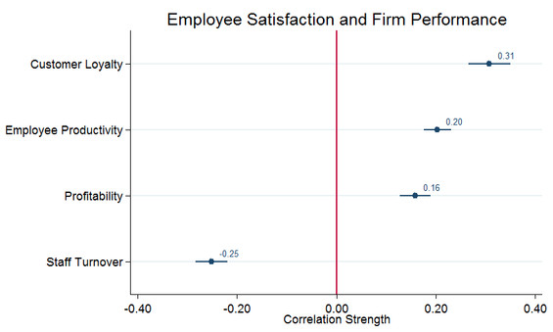
Figure 1: showing correlation between job satisfaction and firm performance (APSC, 2019)
The figure above is a meta-analysis of independent study conducted by Gallup reveals that there is a 95 percent confident interval “correlation between employee satisfaction, productivity and firm performance” (APSC, 2019). Many companies have now placed a high priority on the wellbeing of their workers as they mostly feel that when their workers are happy, that will eventually lead to improved work productivity. Aside from the job satisfaction more people are in today’s world place more value on their self-esteem and self-worth nowadays, than in the past. Secondly, many human rights organisations have recognised and placed more emphasis on things like equal pays, equal treatments, and general equality for all employees (Charlotte., 1999).
Then there is the issue of working conditions which is constantly in the pop-up in the media and always discussed in terms of how, the sort of conditions that employers should provide for prospective or new employees to work in. in the past especially during the industrial revolution which led to exponential growth in the developed world, pressure groups such as workers union mostly concentrated on hazardous working conditions of employees (Rogers, 2017).
Several cases related to work injuries as a result of poor equipment’s etc. these problems would sometimes lead to poor employee work or performance output. But these days’ unions and human rights organisations have created more awareness (Muscatello & Heshizer, 2002). Therefore, many people understand and recognise poor working conditions when they see it in working places today.

2.2 effects of Bullying in the workplace

Workplace bullying affects people’s lives in many different ways, it can affect people’s social and professional lives negatively. Individuals whom have experience workplace bullying can begin to show symptoms of different types of illnesses associated with physical and mental health (Meng & Koh, 2016). Again research suggest that “workplace bullying currently more dangerous than physical violence” (Meng & Koh, 2016). This is due to the recent emphases that is being placed on the issues and the awareness of the effects of its health and safety on employees.
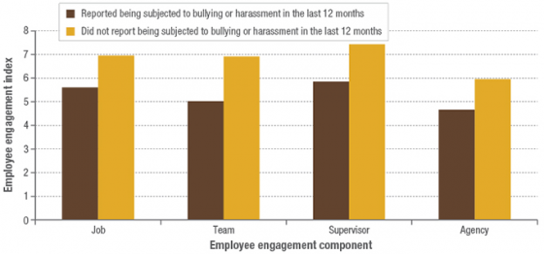
Figure 2: showing the effect of perceived bullying on employee engagement (APSC, 2019)
The figure is a census conducted by the Australian government which shows the effect of perceived bullying on employee engagement. The census revealed that employees have experienced some form of bullying especially in the form of abusive words or “inappropriate application of work policies” (APSC, 2019). The study also reveals that most bullying came that employees experienced came from mostly senior manager, See page 9 for more detailed discussion on the impact of bullying by senior managers on employees.

2.3 How bullying in the workplace result to poor self-esteem.

Many forms of violence exist in the workplace including harassment, physical assault and bullying (Sun & Hye, 2017). As stated earlier, bullying a targeted aggressive behaviour aimed at causing harm or some form of oppression to its victim. The impact of which can be that employees struggle with different forms of health related issues which reduces their work performance and productivity. Some studies suggest that bullying “in the workplace are at higher levels of burnout and turnover intention and at lower levels of organizational commitment” (Sun & Hye, 2017). Therefore bullying in the work place result to poor self-esteem.

2.4 How workplace Bullying can affect teamwork in an organisation.

There are some impediments to organisation functioning and development which result to sometime legal outcome as a result of bullying (Creasy & Carnes, 2017). Project initiations, management and completion in organisations require committed team members. Organisation usually undertake projects to improve their products or services. Therefore it is essential all team members are in a healthy state of mind when carrying out organisational task or project.

2.5 conclusion

With less bullying in the workplace people are able to perform better and job satisfaction is higher. Individuals who are less bullied have better self-esteem than their bullied counterpart. Rights groups and unions have made the issue of workplace bullying and other forms of discrimination a fore front campaign issue which has led to more awareness.

3.0 Bullying as a complex problem in the workplace, scope and its impact.

Workplace bullying appears well placed in organisations therefore, the problem has become increasingly well known in academic settings for research purposes. It is also featured a lot in the media today. The effects are not only detrimental to individuals but also costly to organisations that have the problem among its employees. (Georgakopoulos, et al., 2011). Hence it is of importance as an issue for individuals, employers and the government.

3.1 Impact of Bullying

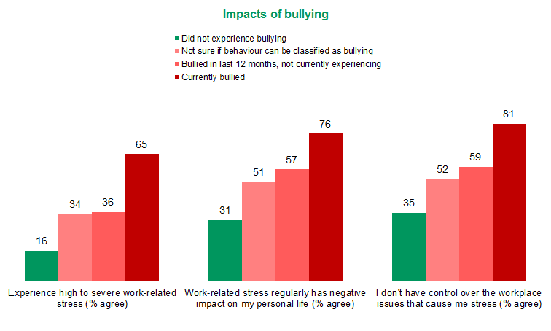
Figure 3: Showing the impact of bullying in the workplace in organisations (VPSC, 2016)
According to some studies, as can be seen from the figure above, the impact of bullying can have severe work-related issues and employee’s wellbeing. From the study about 65 percent of employee who encountered some form of bullying experience high to severe stress, while only 16 percent of employees experience high to severe stress who did not face any form of bullying (VPSC, 2016).

3.1.1 Staff Absenteeism

Workplace bullying can lead to staff absenteeism, when an individual is constantly absent for work without any clear explanation, then it’s a sign that the individual is struggling with a personal situation that could arise from different factors such as work over load, low morale or work-related stress from bullying (Daly, et al., 2004). When an individual or staff absenteeism persist, it will lead to increase pressure on the remaining staff at work, which can also put a lot of stress on them equally. The resultant effect is a clear correlation between turnover and workplace absenteeism, which can have severe economic consequences for the employing organisation (Daly, et al., 2004).

3.1.2 Staff Turnover

Staff turnover can be defined as the “total number of leavers expressed as a percentage of the total number of the employees in a department, unit and/ or organization” (Boella, 2000).
One of the biggest problems that arise from poor work life as a result of workplace problems, bullying included is staff turnover. As (Daly, et al., 2004) Puts it “one of the obvious manifestations of a poor work life is an increase in staff turnover”. There are a lot of studies that point to many different factors as reasons for staff turnover in an organisation for example leadership style, pay packages, and other company polices. But workplace bullying has a direct effect on the turnover intention of employee (Rosario & Millan, 2018)

4.0 Bullying at Coker Hotels Ltd. And personal experience.

I own and operate a medium size hotel in Nigeria, my hotel had a total workforce of about 30 employees. Like most businesses in the hospitality industry my company focused on offering the best customer experience to guest. My workforce consisted of employees with various educational background. As part of the hierarchical structure and arrangement in the organisation, I had a general manager in charge and responsible for managing other staff and activities in the company.
Months later I had a new employee that joined the team the employee was an accountant but prior to his coming on board, the general manager was responsible for all transactions and book keeping of the company. The accountant was to assist the general manager as part of the team, but in the weeks and months that followed, the accountant went through several files and discovered errors in three departments that was causing the company to lose money. The accountant brought the issue to attention of the general manager and he promised to look into it.
But some weeks later the account found he had become the subject of criticism by the general manager at almost every occasion, and by the slightest provocation. For example, his work performance was not satisfactory anymore, his dress code would fell below standard, and he felt intimidated by the general manager but could not say a word about it. This problem went on for quite some time and the accountant was obviously not delivering good results and targets as I observed.
When I had a one on one conversation with him, he mentioned to situation to me, then I advised him that in the next staff meeting, I will raise the issue with staffs and staff members should feel free to speak on any issue that bother them in the company.
During the staff meeting held the following week, about 5 member of staff recounted their experiences which was similar to what the accountant was going through. Some staff members also revealed that they were receiving all kinds of support, including medical treatment as a result of the type of treatment they getting from work by their superior without mentioning any name.
Finally, the resolution passed at the end of the meeting was called ‘workplace bullying and people’s management’ issues. As the owner of the company the Business decision I made was as a result of the following Technique tools and analysis.

5.0 Implementation of Decision-Making Techniques, Tools and Analysis
There are numerous ways of effective business decision making, from Business models to data driven decision making. According to (Gupta & Khanna, 2011) “making decision following guide lines allows us to learn how to make how to make better decision each time”. In other words, decision making is an important managerial responsibility.

5.1 SWOT Analysis
Swot Analysis is used to analyse a company’s internal strength weaknesses opportunities and threat. The process of using swot can help with strategic planning and decision making when used properly. Swot analysis will enable and individual or an organisation to identify factors that can be favourable prior to a decision being made.
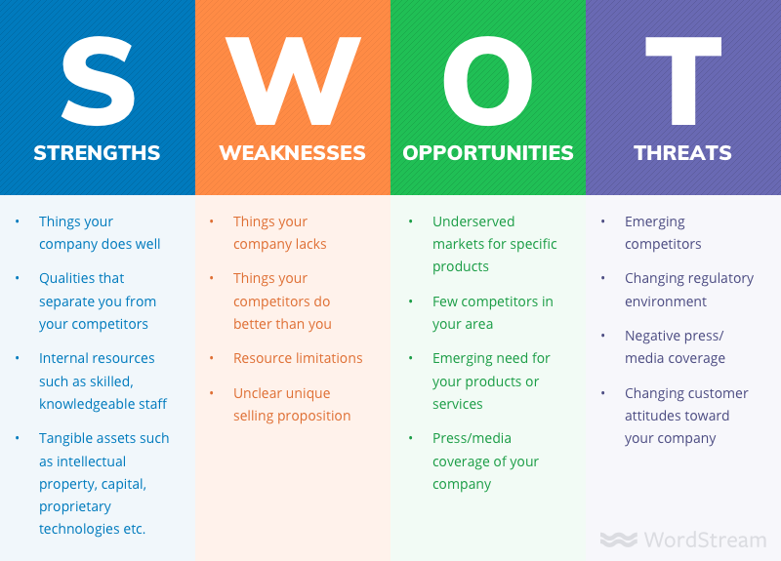
Figure 4: showing swot and its features for internal decision making (Dan Shewan, 2019)

3.2 Strength
As describe above, my company was a small to medium sized business. By that the company had an edge over competitors because the services we provided was faster due to shorter distances that waiters had to cover. Small sized rooms mean that it is easier to clean them and arrange them faster than our competitors. Up to 40 percent of my staff are graduates with various skills to provide for development, improvement and sustainability of the company.

3.3 weaknesses
As a small and medium scale business we most of our revenue was used to service liabilities like staff salaries therefore we lacked availability of liquid cash. We also did not have enough resources to set up an entire ICT department, which could be used for applying technology in business like digital marketing etc, like most of our competitors.

3.4 opportunities
My hotel as a business catered for a small niche market area that most big businesses simply ignored. For example, events for traditional cultural festival organised by neighbourhood family and friends. There are few businesses in the area my company operates because it used to be residential neighbourhood before being approved to operate commercial entities like a medium sized hotel. Another advantage is the fact that only small and medium sized hotel are allowed by the local government to operate in the area, due to it formerly being a densely populated area.

3.5 Threat
Although we enjoyed government policy on regulating property development in the area we operate, there huge demand for floor space by other companies operating in the hospitality industry. Finally drop in customer patronage and changing pattern in consumer behaviour with less demand for our services.

6.0 Applying cause and effect analysis (fishbone) to the problem
Fishbone or cause and effect analysis is used to categorise the causes of a problem in a set of ways in which the root causes can easily be identified. By using fishbone and root cause analysis to make decision it can help to “reduce losses, inefficiencies and waste” (Wilson, 1993). As can be seen from the analysis below.
Poor performance of staff linked to drop in customer patronage
Low quality of service
High price
Management
Poor support
Price of service
Price of product
Response time
Guest relation
Meetings
Salaries
Staff training
After sales service
Service delivery
Communication

6.1 Applying root cause analysis using five whys to determine root cause of the problem
Why is there low customer patronage? Because of poor staff performance.
Why is staff performance poor? Because of lack of communication amongst staff.
Why is there lack of communication among staff? Because of staff, absenteeism and staff turnover.

7.0 Findings from analysis and solution
From the analysis conducted, it found that workplace bullying was responsible for poor performance of staff. The poor performance of staff led to the drop in which was being experienced in the business. From my root, cause analysis of using five whys staff communication was required to resolve the issues bedevilling the company. However, workplace bullying by the general manager was responsible for members of staffs failing to deliver excellent customer service to many of the hotel guests. The solution was to layoff or put the general manager on leadership training

8.0 Evaluation of two solutions and implementation plan
The two main solution to the problem as Identified comes down to either to layoff the general manager, or to place him on leadership training;

8.1 Dismissal
The complete termination of the general manager’s contract with my company was not an option because, that would have increased the workload instantly for my remaining staffs and myself.

8.2 leadership training
Therefore, leadership training was chosen for the general manager. Leadership training matters because most organisational leaders like managers simply have no idea that what they do or do not can affect the success of each team member and also the team as a whole (Horsman, 2018). A company’s success can be measured by the completion of the company’s goals and objective. Therefore having the right person with the right skill. When employees start losing work productivity and performance then it takes a leader with leadership skills. It can also be because a leader has done or failed to do something that is having an impact on the employee.

9.0 Conclusions
In conclusion, bullying is a recognised complex problem in the workplace in today’s world. Bullying can affect employees and organisations in numerous ways, like employees mental and physical health. Workplace bullying affects organisations income output performance. Bullying in the workplace according to studies conducted by the Australian government indicates that workplace bullying is currently more dangerous than physical violence. Employees at the census confirmed they experience bullying in the hands of senior managers in the workplace. Workplace bullying as a complex problem leads to staff absenteeism and turnover. A SWOT analysis conducted for Coker Hotel Ltd. Reveals traces of employee bullying after using a cause and effect analysis brainstorm the problem. Applying a deeper root cause analysis using five whys communication between senior management and staff is flawed as a result of workplace bullying. Evaluating the solution, leadership training has been recommended for the general manager at Coker Hotel Ltd.

Bibliography
APSC, 2019. The Australian Public Service Commission. [Online]
Available at: https://www.apsc.gov.au/how-workplace-affects-employee-health-and-wellbeing
[Accessed 13 August 2019].
Boella, M. J., 2000. Human Resource Management in the Hospitality Industry. 7th Edition ed. Tottenham Court Road, London: by Barrie and Jenkins Publishers Ltd..
Charlotte., R., 1999. Applying strategies for dealing with workplace bullying. International Journal of Manpower, 20(12), pp. 50-56.
Creasy, T. & Carnes, A., 2017. The effects of workplace bullying on team learning, innovation and project success as mediated through virtual and traditional team dynamics. International Journal of Project Management, 35(6), pp. 964-977.
Daly, J., Speedy, S. & Jackson, D., 2004. Nursing Leadership. 1st Edition ed. Smidmore Street MarrickVille: by ELSEVIER AUSTRALIA.
Dan Shewan, 2019. How to Do a SWOT Analysis for Your Small Business (with Examples). [Online]
Available at: https://www.wordstream.com/blog/ws/2017/12/20/swot-analysis
[Accessed 15 August 2019].
Georgakopoulos, A., Wilkin, L. & Kent, B., 2011. Workplace Bullying: A Complex Problem in Contemporary Organizations. International Journal of Business and Social Science, II(Special Issue), p. 3.
Gupta, M. & Khanna, R., 2011. Quantitative Techniques for Decision Making. 4th Edition ed. New Delhi: By PHI Learning Private Limited.
Horsman, J. H., 2018. Servant-Leaders in Training: Foundations of the Philosophy of Servant-Leadership. Spokena WA, USA: by Palgrave Macmillan.
Meng, W. & Koh, S., 2016. Management of work place bullying in hospital: A review of the use of cognitive rehearsal as an alternative management strategy. International Journal of Nursing Sciences, pp. 213-222.
Muscatello, J. & Heshizer, B. P., 2002. Safety teams: Government and business organizations want them and use them, but are they legal?. Journal of Safety Research, 33(I), pp. 21-32.
Rayner, C., Hoel, H. & Cooper, C., 2002. Workplace Bullying: What we know, who is to blame and what can we do?. 1st Edition ed. London: by Taylor and Francis.
Rogers, B., 2017. Workplace Hazards Faced by Nursing Assistants in the United States: A Focused Literature Review. International Journal of Environmental Research and Public Health, 14(5), p. 544.
Rosario, E. & Millan, R., 2018. Effect of the Exposure to Workplace Bullying on Turnover Intention and The Mediating Role of Job Satisfaction, Work Engagement, and Burnout. Revista Interamericana de Psicologia Ocupacional, p. 26.
Sun, Y. & Hye, A., 2017. The Mediating Effect of Self-esteem in the Relationship between Workplace Bullying and Response to Bullying in Hospital Nurses. Journal of Korean Academy, XX(12), pp. 8613-8620.
Tehrani, N., 2012. Workplace Bullying: Symptoms and Solutions. 1st Edition. ed. East Sussex, England: by Routledge.
VPSC, 2016. DATA INSIGHTS: BULLYING IN THE VICTORIAN PUBLIC SECTOR. [Online]
Available at: https://vpsc.vic.gov.au/data-and-research/data-insights/data-insights-bullying-victorian-public-sector/
[Accessed 9 August 2019].
Wilson, P. F., 1993. Root Cause Analysis: A Tool for Total Quality Management. Wisconsin, USA: by American society for quality.
Yamasaki, J., Geist-Martin, P. & Sharf, B. F., 2017. Storied Health and Illness: Communicating Personal, Cultural, and Political Complexities. 1st Editon ed. Long Grove, Illinois: by Waveland Press Inc..

