Qualification: CIPD Diploma in Applied Human Resources

Module Name: Understanding the Business Context of HR

Word Count: 2192 - Activity 1
568 - Activity 2

Student Name: Nicola Westcott
Student Number: 1909408
CIPD Membership Number: 55478551

By signing below, I confirm that the work/evidence presented is my own, unaided work. I understand the regulations pertaining to candidate malpractice and the action that may be taken as a result.

Signed: N Westcott
Date: 15/03/2020

Understanding the Business Context of HR
Activity 1
Organisations fall into one of three distinct sectors:

Example of HRM in a Public Sector Organisation
Mid and West Wales Fire and Rescue Service (MAWWFRS) is a public sector organisation providing emergency response cover for two thirds of the geographical area of Wales. The main business aim of the organisation is to provide a service to members of the public. The Service is government owned and funded by taxpayers. Overall responsibility lies with the Fire Authority, made up of 25 elected members representing across the six Local Authorities the Service covers. The Service has 1350 employees in a typical hierarchy structure (bureaucracy), consisting of three directorates establishing a clear form of operations, so employees understand their responsibility/tasks in alignment with accomplishing Service objectives:

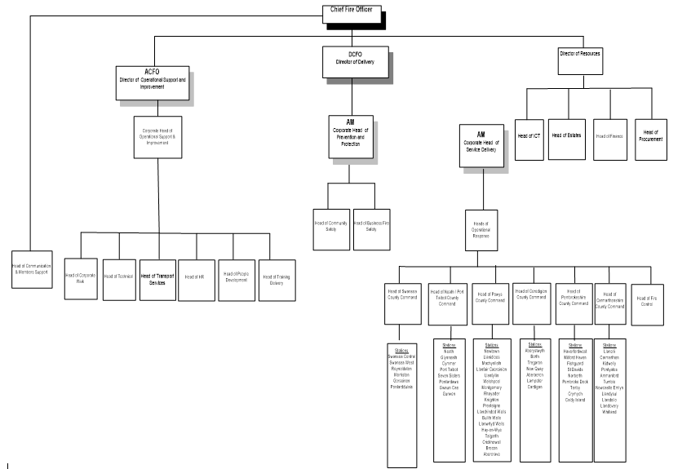
The HR function is a centralised department based in headquarters in Carmarthen, made up of 19 employees, both specialist/generalists working alongside each other on various tasks.

As with most public sector organisations, the HR function has often been criticised for being overly bureaucratic and out of touch with employees which limits its potential to add value, therefore recently as with private organisations, the focus of HR is moving towards becoming more business-focussed by taking a strategic approach to activities.

The HR function is currently undergoing transformation into the business partnering model, following the typical Ulrich model (CIPD 2019c):

This model will increase the visibility of HR out in the wider Service area, procedural guidance is being simplified/rolled out, and various technologies are being implemented/developed.
As with all public sector organisations the Service is under public scrutiny to ensure funds are accounted for and is audited annually by the Welsh Audit Office and internally by Carmarthenshire County Council. The annual Statement of Accounts is published on the Service’s website. According to Bach (2010, p563) employment decisions are ‘subject to levels of public accountability and transparency that arise from the government’s role as custodian of public funds’. This has led to the Service having detailed procedures that are observed and followed by all, leading to employees being treated fairly and with respect. However, this limits managers in the ability to develop new approaches to leading their teams.
Recent recessions/reductions in public funding have placed huge pressure on HR managers who have had to deal with reorganisations/recruitment freezes/redundancies. The HR function has become a target for savings, leading to a slimmer HR function/changes to processes.
Centralised pay bargaining exists, National pay scales and terms/conditions with annual increments/pay awards applying to all employees. No bonuses or social activities are paid. With jobs being paid on what the role is graded rather than performance, managers find it difficult to motivate staff. All employees are also aware of what colleagues are paid.
Generous occupational schemes apply for absence (sickness/maternity/paternity). Flexible working hours and rights to apply for flexible working arrangements apply. Various occupational pension scheme’s in place for uniformed and support staff, which the Service also contributes to.
The Service has formal procedures in place covering all aspects of employment which must be adhered to on all occasions. These require the relevant paperwork to be completed before anything can be processed.
The Head of HR has a place on the strategic leadership team (SLT), along with all other Heads of Departments/Commands. This place on the board allows them to insist on good HR practice and legal compliance. New procedures must be presented to the SLT, before being passed onto and signed off by the executive leadership team, therefore this can often delay/prevent new procedures/ways of working being implemented.
The Service, as with most public sector organisations has a large trade union presence, particularly among the uniformed sector. This can occasionally lead to a negative atmosphere. Union representatives can be present on all employment issues as well as the introduction of new procedure, working arrangements/job evaluation which again can occasionally hamper any decisions and lead to a low-trust employment relations atmosphere.
HR managers in the public sector are more cautious in their approach than their counterparts in the private sector (Taylor and Wilkinson 2016). Public sector HR managers are not in the position to settle with lump sums if taken to an employment tribunal, therefore are keen to avoid any claims, leading to a tendency to take a bureaucratic approach. On the other hand, the union can also assist with the communication of key messages to employees.

Example of HRM in a Private Sector Organisation
Compton group in Swansea is a small family run company, dealing mainly with property development/ground rent investments. The main business aim of the organisation is to generate revenue. Since it was established in 1955, the company has evolved to keep up with the changing market, by acquiring control of new organisations, commercial sites. Following global economic influences in 2008, the company diverted its expertise to solar power energy projects and outsourced some of its activities to India to reduce labour costs.
There are 42 employees based in the company with a typical mini hierarchy structure.

As is typical in smaller private companies, Compton group does not have a dedicated HR function, the office manager (HR Specialist) is delegated to deal with most HR administrative work/issues (contracts/absence) reporting to the Director. Payroll is undertaken in house by one person. Although the company has a legal team, this is for land-based transactions that are undertaken, therefore if any employment law advice is required, it is sourced from outside the company at an additional cost.
The company has de-centralised pay bargaining. All employees are salaried and receive an annual pay award. Pay/contracts are established as per the demands/timing of the role, there are no national payscales/increments applied as with public sector. However, Christmas bonuses are given to all employees as well as paying for the social activities/teambuilding events. Employees are unaware of each other’s salary unless disclosed by themselves.
Only Statutory payments for absence apply, there are no occupational schemes in place. As per Government regulations, pension schemes have been introduced in recent years although these are nowhere near as generous as public sector schemes. Appraisals are undertaken on an ad-hoc basis, training costs are met and limited time off for study. Annual accounts are provided to Companies House which are open for public inspection and annual AGM’s are held to report to shareholders.
The company has a more relaxed atmosphere, there are no formal HR procedures in place, employees are encouraged to speak to the manager to discuss any issues. Employees work normal office hours, no flexible working, although if the need arises employees can discuss with the manager. Smaller organisations prefer informality in the way management deal with staff (Edwards and Ram 2010).
HR procedures that are standard in larger companies, pay increments/pension schemes, discipline procedures/appraisals are often absent. Positive aspects in smaller companies are a less formal atmosphere, leading to higher levels of job satisfaction. Negative aspects of not having clear policies in place are perceptions of favouritism, unfairness as one rule does not apply to all which could lead to lower job satisfaction.
There are no union members in the Compton group, which allows for a less formal approach to be taken. A strategic business approach is taken, supporting business objectives and focusing on long term goals. As there are less obstacles to overcome due to the hierarchical structure it enables any changes to be implemented quicker. The business can develop with the market, rather than having to go through lengthy negotiations/change implementation techniques.
Private companies have revolutionised and developed their own HR strategies by:

This attempt by management to include and aspire people has led to a willingness to go above and beyond role expectations and a willingness to share ideas (Taylor and Woodhams 2016).

Organisational Design (OD)
‘The process and the outcome of shaping organisational structure, to align it with the business and the context of the organisation’ (CIPD 2019e). This is normally a standalone activity and must consider systems, processes, cultures in order to identify the right model for the organisation. OD occurs due to organisational growth, changes in political or economic pressures or in response to customer/stakeholder demands.
Various OD models exist (Kew and Stredwick, 2016):

Organisational Development (ODV)
‘A planned and systematic approach to enabling sustained organisation performance through the involvement of its people’ (CIPD 2020). Longer term and focuses on people to develop/enhance skills and knowledge and understand how teams can assist each other. ODV occurs in response to failure to reach performance measure, a requirement to cut costs/increase productivity. An issue is identified, facts collected/analysed, information fed back, interventions planned, plan implemented and finally evaluated.
Both OD and ODV are strategic areas of HR and are seen in private or public sector regardless of size and form 20% of the HR Profession Map (CIPD 2018).
Internal Factors that influence HR
The main objectives of the HR function are the same in private and public sector:

However, the ways the organisation operates can influence HR structure, agenda and practices is dependent on:
Social – understanding the processes of networking, group behaviour, leadership,
Power/control - identify the power structure/decision makers, rules/systems. Deal with conflict to retain control.
Communication – employee engagement - ensure all staff are communicated to, including regional workers.
Financial – government funding, private investments/share prices could lead to reduction in budgets/redundancies/outsourcing.
Technology – introduction of new technology may result in increased training needs or redundancies due to automation of processes.
Culture – embedded cultures can influence organisational behaviour/performances. Effective cultures should be supported, and attempts made to change ineffective cultures. Is there top down, bottom up or collaborative approach taken in strategy formulation.
Layout – understanding the hierarchy of the organisation as well as the geographical layout of the site.

Organisational culture has a huge impact on organisational behaviour. ‘Organisational culture is the shared characteristics, behaviours, routines, traditions, values and beliefs of individuals within the same organisation’ (CIPD 2019d).
Schein, (1997) identified three levels:
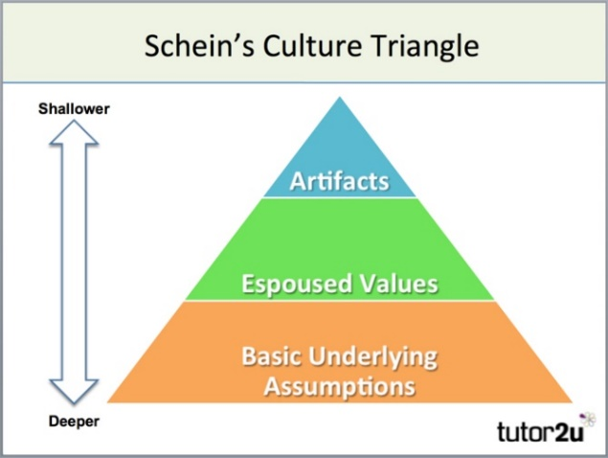
Source: Tutor2u
Artefacts – architecture/dress code, - MAWWFRS uniformed personnel have a strict dress code, support staff wear appropriate business attire. Compton group the dress code is very relaxed, only those meeting clients must adhere to business attire.
Values – beliefs/values – MAWWFRS vision is to be a world class organisation by adopting management procedures that all cover of the organisation’s activities. Compton group’s vision is to continue to act as an entrepreneurial family company by investing in existing business alongside new opportunities.
Assumptions – underpinning organisations values – MAWWFRS has a more traditional/transactional based culture. Compton group has a more caring/compassionate family-based culture.

HR and business strategies
Tyson (1995) defines HR strategy as, ‘a set of ideas, policies and practices which management adopt to achieve the people management objective’. HR strategy is seen as an incremental process promoting key HR practices to improve organisational performance.
HR objectives linking directly with organisational strategy can have a positive effect on an organisations’ overall effectiveness. Having good HR practices and promoting employee behaviour is key to facilitating improved business performance. Organisations approach to strategy formation vary depending on the type of organisation they operate in, the culture, management style. Key objectives in the private sector is linked to revenue generation, whereas in the public sector it is linked to enhancing the service provision to the public.
An effective HR strategy needs an ‘external fit’ and be vertically aligned with business strategies. Vertical integration refers to the links between both strategies and external contexts. Additionally, there is a requirement for an ‘internal fit’ between HR strategies. This horizontal integration means HR policies and practices need to be consistent and compatible. Greater vertical-horizontal integration leads to more effective HR strategy.
Three approaches to formulating strategy can be identified:

Henry Mintzburg (1994), an influential thinker formulated a contingency model showing circumstances that each type of strategy-formation is appropriate.
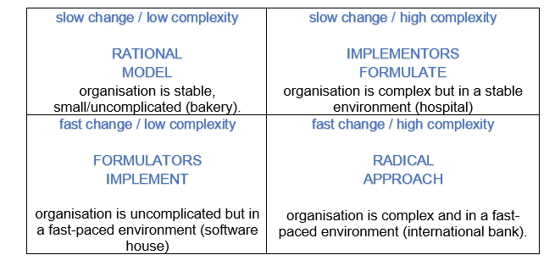
Contingency view
Meaningful HR strategy that aligns with the organisational strategy increases the likelihood of success. Contingency thinking ‘best-fit approach’ and models have helped align these strategies.
Michael Porter’s (1985) model identified three core strategies, that organisations follow:
Other models such as Boston Consulting Model and (Purcell 1989) suggest HR practice should vary depending on market growth or decline and Miles and Snow (1978) identify different types of HR practices for competitive strategy.
Resource-based view
By looking at existing resources and key strengths of employees/managers and developing procedures around them, making the best if what you have. Based on inside-out thinking rather than outside in and aims to find ways of protecting and enhancing these strengths, thus adding value which leads to increased organisational competitiveness.
Critics have argued that from a HR perspective whatever strategy is adopted the same basic practices need to be followed to ensure success.

How HR contribute to organisation strategy
‘Strategic planning is the formal process that takes place, usually in larger organisations, defining how things will be done. Strategy, in contrast, exists in all organisations (may not be written down/articulated) and defines the organisation’s behaviour and how it copes with the environment’. (CIPD 2020c).
HR can contribute in many ways by using their influence to effectively improve organisational performance.
- Participation at different levels – adviser/facilitator or board member to ensure issues are taken seriously – provide employment law advice.
- Analysing and interpreting data – be contextual savvy, organisational savvy, business savvy.
- Provide insights and information – providing different views/ensuring changes are fair and in the best interest of the organisation.
- Prepare position/policy papers – ensure correct procedures are put in place, be regarded as experts.
- Communication with all staff – identify the power structure, liaise with business managers/employees, use influence to improve understanding of management systems/ensure employees support the changes.
- Conflict handling – effectively deal with conflicts that arise.

Alexander (1985) identified the five main features of how to implement a successful strategy as:
Constraints to consider: (Johnson et al, 2011, cited in Kew and Stredwick, 2016 p.431)

Activity 2
MAWWFRS is a public sector organisation, with a main business aim of providing a service to members of the public.
‘As the world of work grows more complex, traditional models of working are giving way to more flexible forms of organisations and employment. Technology, globalisation, changing workforce demographics and skill shortages add to the challenges facing organisations’ (CIPD 2015a).

Using two analysis tools, PESTLE and SWOT (CIPD 2020a and CIPD 2020b), the external factors that affect MAWWFRS have been analysed. The Service needs to react/adapt quickly in response to external changes in order to continue to operate effectively.
HR professionals work closely with business partners/senior management to address issues arising from external change. Internal structures/behaviours have evolved in response. Increased uncertainty/unpredictability mean the Service cannot put strategic plans in place by more than a few years. The HR function has re-organised itself and introduced innovative approaches, such as business partnering to demonstrate it adds value.
The Service has adapted/embraced new approaches, becoming more agile through regular downsizing/upsizing. HRM have been actively involve with change management. Successes/failures depend on how active HRM is in the planning/communication of the forthcoming changes (CIPD 2019a). Change inevitably leads to conflict, which needs to be managed effectively by acquiring political skills to assist with the implementation. A less bureaucratic HR function, having good policies/practices in place allows, the Service to respond to changes and have a culture that expects and embraces change.
The growth in goods/services being traded internationally (globalisation) means organisations have had to reduce costs/outsource work overseas or merge/align themselves with others (Taylor and Wilkinson, 2016). MAWWFRS has undertaken opportunities of collaborative working with partner agencies/schools/third sector organisations.
An ageing workforce has led to fitness capabilities issues whereas an aging society has the potential for more vulnerable people being at risk, thus increasing the skill set required by MAWWFRS personnel.
Other influences are the progression in retirement of the baby boom generation. With less people in the Generation Y era, there are fewer potential employees coming into the labour market to replace them (Taylor and Wilkinson, 2016). With fewer people looking for jobs in the future, for HRM in MAWWFRS, this means smart recruitment and retention are back at the top of the HR agenda. Contractual flexibility of allowing short term contracts, agency workers/apprenticeships has become key in order to ‘achieve more with less’.
The impact on HRM following the Equality Act 2010, is that they must manage teams from culturally different backgrounds. According to Richard Sennett (2012), ‘effective co-operation with people who are different from ourselves is a skill to be learned’. MAWWFRS has an Equality and Diversity Officer to ensure compliance with all legislation and to encourage cultural awareness, thus ensuring diversity becomes a strength not a weakness.
The sheer volume of employment law that the Service must comply with has had a huge impact. Risks need assessing and HR/line managers need to vigilant on all activities, in order to avoid potentially costly/lengthy tribunals. Therefore, a good knowledge of employment legislation is essential (CIPD, 2007).
The introduction of a combined HR/payroll system, self-service technologies, modern approaches to management performance has enabled resources in the function to be released.
MAWWFRS has adapted policies/practices, changing the way business is conducted to minimise waste/conserve energy having a positive impact on the environment. The Service has increased its sustainability efforts by using technology to reduce the carbon footprint.
MAWWFRS HR function must continually evolve in order to deal with these external factors that arise. Recent events such as Brexit means uncertainties lie ahead. Environmental events such as Storm Dennis/Coronavirus outbreak have placed huge pressure on the Service and the way in which it conducts its business.

PESTLE Analysis – Mid and West Wales Fire and Rescue Service
  External factors to consider
  Factors affected within my industry
  Importance to organisation
 |  | New legislation - ensure compliance  Brexit uncertainties  National Framework for Fire Service - increase in sector led development, assurances and improvement policies | High  Medium  Medium
  Political
  Government policy
  Political stability
  Tax
  Global trade agreements/ restrictions
Economical | Globalisation  Economic growth/  Decline  Inflation  Interest rates  Cost of living  Labour costs | National Minimum Wage  Introduction of apprenticeship schemes – retention of employees  Pay re-structing  Budget reductions | Medium  High  Medium  High
Sociological | Population demographics  Ageing society  Lifestyle factors  Career attitudes  Work-life balance | Age related illness – dementia/oxygen users remaining in their homes for longer – increase in specific training/skills required. Collaborative working with third sector – Age UK  Ageing workforce – unable to complete fitness tests  Increase in Health & Wellbeing Schemes | High  High  High
Technological | Automation  Innovation  Social networking  Artificial Intelligence  Security | Integrated HR systems – change in processes/releasing of resources/increased training  Use of drones – increase in training requirements. Ability to share data with other organisations  Social media – connect with wider audiences. Increase in reputation management. Increase in GDPR requirements | High  High  High
Legal | Employment law  Regulatory bodies  Health and safety  regulations | Pension scheme changes (taper protection legal challenge) – increase employer costs, increase in retirements,  Grenfell Inquiry outcome – increase in Health & Safety legislation – changes to business / community fire safety, increased training | High  High
Environmental | Environmental  restrictions  Sustainable  resources  CSR (Corporate  social responsibility)  Transportation  Procurement  Increase in housing developments  Severe weather – floods / grass fires  Terrorism risk  Coronavirus | Introduction of electric pool vehicles to reduce carbon emissions  Teleconferencing – use of skype, meeting owls – help reduce travel costs, carbon footprint  Increased population  Increase pressure on service availability  Specialist training exercise, partnership working  Increase in absence due to self-isolation/remote working/ assisting other emergency services | High  High  Medium  High  High  High

SWOT Analysis – Mid and West Wales Fire and Rescue Service
Strengths  - Employee benefits – Salary Plan, Cycle to Work, Lets Connect  - Pension  - Flexible Working / Annual Leave  - Development Opportunities | Weaknesses  - Hierarchy structure – takes time to get decisions agreed  - Budget constraints – Government funded organisation  - Resistance to change
Opportunities  - Increase in Government funding  - Apprenticeship schemes – Government funded  - Collaborative working with partner agencies  - New technologies | Threats  - Decrease in Government funding – cuts/redundancies  - Ageing demographic  - Brexit  - Coronavirus  - Terrorism  - Adverse weather

Mid and West Wales Fire and Rescue Service
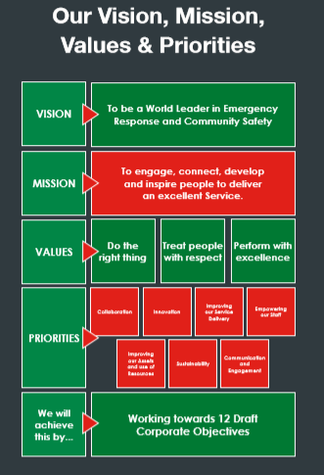
_{Source: MAWWFRS website}

Rough notes used for summary:
Political
Government / political instability – uncertainties of Brexit – could lead to issues with workforce, EU citizens working for MAWWFRS.
Economical
Globalisation - impacted all sectors. Organisations have had to cut costs align with other. MAWWFRS - collaborative working with partner agencies/schools/third sector organisations. The increase in road transportation can potentially increase Road Safety issues for the Service.
The Fire Service roles need to change to adapt/embrace new approaches and become more agile through regular downsizing/upsizing, outsourcing. HRM need to be involved actively with change management.
Contractual flexibility - short term contracts, agency workers, apprenticeships in order to ‘achieve more with less’.
Progression in retirement of the baby boom generation. The generation Y era means there are fewer people looking for jobs in the future, for HR professionals in the Fire Service this means smart recruitment and retention are back at the top of the HR agenda.
Sociological
An ageing workforce can lead to an increase in age-related absence – failed fitness tests, increased absence, operational cover reduced.
Ageing society - Dementia – oxygen users - more vulnerable people at risk which increases the training/skills required by Fire Service personnel.
Equality and Diversity Officer - ensure all legislation is adhered to encourage cultural awareness in order to deal with people’s expectations and ensure diversity becomes a strength not a weakness.
Technology
Introduced conference calling, skype, meeting owls in order to undertake meetings from different locations, helping to reduce the carbon footprint by reducing travel cost.
The use of drones to aid service provision.
Introduction of a combined HR/payroll system and the use of self service.
Legal
80 employment related claims that can be heard in a tribunal.
Recent decisions on pension schemes.
Grenfell Inquiry outcome – increased business/community training.
Risks need assessing and HR/line managers need to vigilant on all activities, in order to avoid potentially costly and lengthy tribunals. Therefore, a good knowledge of employment legislation is essential.

Environmental
MAWWFRS is committed to minimising adverse environmental impacts. By adapting policies/practices that will change the way business is conducted, in order to minimise waste and conserve energy to have a positive impact on the environment. Introduction of electric pool cars.
Recent events such as Storm Dennis and the Coronavirus outbreak have placed huge pressure on the Service and the way in which it conducts its business.
Strengths
Employee benefits – due to low pay award awards introduction of salary sacrifice to assist with cost of living - Salary Plan, Cycle to Work, Lets Connect
Pension – good schemes help with retention
Flexible Working / Annual Leave – assists with family commitments
Development Opportunities – assists with role
Weaknesses
Hierarchy structure – takes time to get decisions agreed
Budget constraints – Government funded organisation
Resistance to change
Opportunties
Increase in Government funding – training opportunities
Apprenticeship schemes – Government funded – opportunities to employ and develop employee
Collaborative working with partner agencies – data sharing, reduction in costs
New technologies – releases resources
Threats
Decrease in Government funding – cuts/redundancies
Ageing demographic – increase to vulnerable people in the community / staff issues with absence
Brexit – uncertainties
Coronavirus – increase in absence, operational cover, assisting other services
Terrorism – increase in training costs
Adverse weather – increase in calls, costs

References
Alexander, L., D. (1985) Successfully Implementing Strategic Decisions, Long Range Planning, Volume 18, No.3,1985, pp.91-97.
Bach, S. (2010) HRM in the public sector. In Wilkinson, A., Bacon, N. and Snell, S. (eds). The Sage handbook of human resource management. London: Sage.pp561-77.
CIPD (2007) The changing HR function. [Survey report]. London: Chartered Institute of Personnel Development.

CIPD (2015) Changing HR Operating Models [Factsheet] 17 Feb 2015. Available at: https://www.cipd.co.uk/knowledge/strategy/hr/operating-models (Accessed 01 Mar 2020).

CIPD (2018) New Profession Map [Factsheet] Available at: https://peopleprofession.cipd.org/profession-map (Accessed 05 Mar 2020).

CIPD (2019a) Change management [Factsheet] 25 Nov 2019. Available at: https://www.cipd.co.uk/knowledge/strategy/change (Accessed 10 Feb 2020).

CIPD (2019b) Ethical practice and the role of HR. Explore the role HR professionals play in applying ethical values to organisational practice [PDF] Nov 2019. Available at: https://www.cipd.co.uk/knowledge/culture/ethics/role-hr-factsheet(Accessed 05 Feb 2020).

CIPD (2019c) HR Business Partnering [Factsheet] 06 Aug 2019. Available at: https://www.cipd.co.uk/knowledge/fundamentals/people/hr/business-partnering-factsheet (Accessed 05 Mar 2020).

CIPD (2019d) Organisational culture and cultural change [Factsheet] 14 Oct 2019. Available at: https://www.cipd.co.uk/knowledge/culture/working-environment/organisation-culture-change (Accessed 14 Mar 2020).

CIPD (2019e) Organisation design [Factsheet] 12 Aug 2019. Available at: https://www.cipd.co.uk/knowledge/strategy/organisational-development/design (Accessed 05 Mar 2020).

CIPD (2019f) The HR Function [Factsheet]. Available at: https://www.cipd.co.uk/knowledge/fundamentals/people/hr(Accessed 08 Feb 2020).

CIPD (2020) Organisation development. Factsheet 02 Mar 2020. Available at:
https://www.cipd.co.uk/knowledge/strategy/organisational-development (Accessed 10 Mar 2020).

CIPD (2020a) Pestle Analysis [Factsheet] 26 Feb 2020. Available at: https://www.cipd.co.uk/knowledge/strategy/organisational-development/pestle-analysis (Accessed 14 Mar 2020).

CIPD (2020b) Swot Analysis [Factsheet] 26 Feb 2020. Available at: https://www.cipd.co.uk/knowledge/strategy/organisational-development/swot-analysis-factsheet (Accessed 14 Mar 2020).

CIPD (2020c) Strategic Human Resource Management [Factsheet] 20 Feb 2020. Available at: https://www.cipd.co.uk/knowledge/strategy/hr/strategic-hrm-factsheet (Accessed 11 Mar 2020).

Strategic Review (2014) Developing a human capital strategy in today's changing environment: eight forces shaping HC strategy Phillips, J., Phillips, P Strategic HR Review; 2014; 13, 3; ProQuest Central pg. 130

Edwards, P. and Ram, M. (2010) HRM in small firms: respecting and regulating informality. In Wilkinson, A., Bacon, N. and Snell, S. (eds). The Sage handbook of human resource management. London: Sage. pp524-40.
Goos, M. and Manning, A. (2003) Mcjobs and Macjobs: the polarisation if jobs in the UK, In: Dickens, R., Gregg, P. and Wadsworth, J. (eds). The labour market under New Labour. Basingstoke: Palgrove. pp70-85.
Kew, J. and Stredwick, J. (2016). Human Resource Management in a Business Context. London: CIPD.

Miles, R.E. and Snow, C.C. (1978) Organisation strategy, structure and process. New York: McGraw-Hill.
Mintzburg, H. (1994) The rise and fall of strategic planning. New York: Prentice Hall.
Nolan, P. (2001) Shaping things to come. People Management. 27 December.
Porter, M.E. (1985) Competitive advantage. New York: Free Press.
Purcell, J. (1989) The impact of corporate strategy in human resource management. In: Stoey, J, (ed.) New perspectives on human resource management. London: Routledge. pp67-91.
Roberts, C. (2016) ‘Organisational Design and Organisational Development’, in Taylor, S. and Woodhams, C. (ed) Human Resource Management: People and Organisations. 2nd ed. London: Chartered Institute of Personnel and Development.

Schein, E. H. (1997). Organizational culture and leadership (2nd ed.). San Francisco: Jossey-Bass.

Sennett, R. (2012) Together: the rituals, pleasures and politics of co-operation. London: Allen Lane.
Taylor, S. and Wilkinson, K. (2016) ‘Business Issues and the Context of Human Resources’, in Taylor, S. and Woodhams, C. (ed) Studying Human Resource Management. 2nd ed. London: Chartered Institute of Personnel and Development.

Tyson, S. (1995) Human Resource Strategy: Towards a General Theory of Human Resource Management. Michigan: Pitman.

