

Synthesize a solution to a potential real life scenario,
Hyper-fort.

Internet Technology and Security
ACCA4018

Author: Geraint Hill
Student Number: 9900497

Table of Contents

1. Introduction 1
2. Related Work 2
2.1 UEM Solutions to Endpoint Devices 2
2.1.1 Comodo 3
3. Problem Formulation 4
4. Implementations 4
4.1 Limitations 4
4.2 Referencing model 4
4.3.1 Physical Layer (Layer 1) 5
4.3.2 Data Link Layer (Layer 2) 6
4.3.3 Network Layer (Layer 3) 9
4.3.4 Transport Layer (Layer 4) 10
4.3.5 Application Layer (Layer 7) 10
5. Conclusion 11
Bibliography 12

Introduction

This report has been produced to provide a solution for Hyper-fort through implementing a secure network for Bring Your Own Technology (BYOT) devices to help mitigate any security threat that could impact future operations. In this document, we explore a Unified Endpoint Management (UEM) Platform that forms part of a requirement that user devices need to have enforced prior to having access to the corporate network.
The author discusses in depth, the security features that will be enforced by the Information Technology (IT) administrators on the network infrastructure. This is also demonstrated via Packet Tracer Software, which has replicated the network, to demonstrate the principles in a real-time scenario.
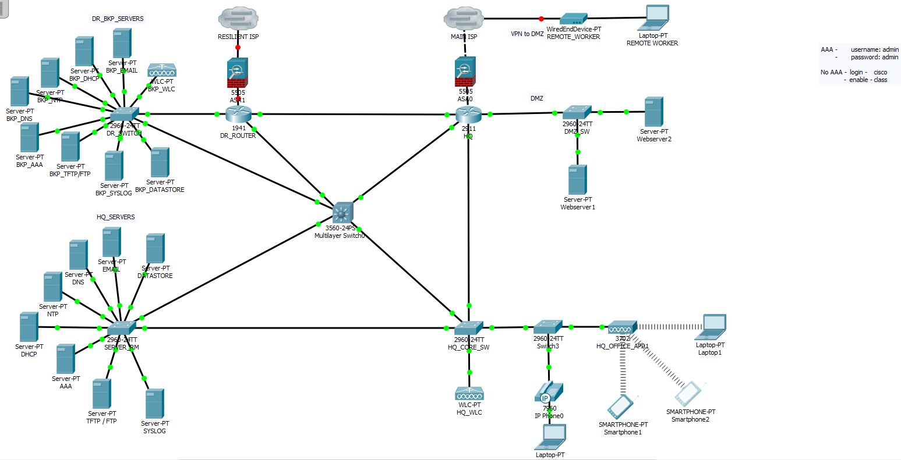
Figure 1: A screenshot of the Hyper-fort Network created via the Packet Tracer Software created by the author.
Figure 1 gives an overview of the Hyper-fort network recently designed by the Author. There are two separate buildings, edged by a group of resilient routers and two firewalls. The main section of the network resides behind the Head Quarters (HQ) router. The separate buildings are connected via high speed fibre links. The Disaster Recovery (DR) site provides resilience for HQ. Replication from HQ to DR happens hourly between the sites so that a reasonable level of service could resume if a catastrophic event happened within the HQ network. Similarly, if a service such as Dynamic Host Control Protocol (DHCP), Domain Name Service (DNS), Authentication, Authorisation, Accounting (AAA), or a storage server ceased to work in HQ, users will seamlessly fail over to the DR site’s replicated resources, and a gateway to the outside, maintaining Confidentiality, Integrity and Accessibility of Data (CIA), the fibre of the Security Triad[1]. As figure 1 demonstrates, there is a full redundancy design in place.

Related Work

With Hyper-forts extensive presence around the globe and 95% of its company wirelessly based, Hyper-forts Bring Your Own Technology (BYOT) policy will require a centralised platform to protect the corporate data from security breaches. The amount of devices that Hyper-fort would expect to see connecting to the corporate network suggests that there will be different flavours of devices requiring access, from Windows, Apple macOS to name a few. In his article Paganini[2] states that securing the corporate networks infrastructure, including its end devices, is the most time consuming and complicated aspect of any roll out. He further goes on to compare UEM as a containment method, protecting data, reducing data leakage and ensuring the posture of the devices that connect to the network are appropriately patched and updated.

2.1 UEM Solutions to Endpoint Devices

Hyper-forts Bring Your Own Technology (BYOT) policy will require a centralised platform to protect the corporate data. Three solutions were researched:
1.Comodo[3]
2. Air Watch[4]
3. Meraki[5]
The scalability of each of the deployments researched were not restricted by deployment options or limitations, however they were restricted by the financial commitment from the purchaser. Comodo and AirWatch only charge a licence per user, which means multiple devices under the user are covered under the one fee per user. Meraki charge a license per device, making their solution more expensive. The features offered by all vendors are ones that could be utilised by Hyper-fort and could be implemented to meet the Security requirements. The Meraki solution is a centralised Cloud based system, where Comodo and AirWatch can be deployed within the corporate network environment on a physical server. Meraki’s other restriction is that the full set of features would only become available if using Meraki equipment, i.e. Routers, Switches and Security Appliances which again need to be licenced. Unfortunately the limitation and financial impact ruled Meraki out of the specification for Hyper-forts deployment as it was too costly and required too many licenses. AirWatch has an armoury of resources to support a BYOT modelled business. One of the main attractions to using AirWatch was the support of the Chrome Operating System(OS) devices. However, between Comono and AirWatch, Comodo offered more facilities that could be used by Hyper-fort, which gives the company plenty of features that could be used to protect End Devices and the network.

Comodo

Below are the solutions offered by the Comodo UEM platform listed on their site[3]:
- Unified Security – All devices will be managed centralised.
- Mobile AntiVirus – AntiVirus will operate on all devices at all times.
- Enforce Mobile Policies – Policies can be created per device / group / user.
- Remote Data Wipe – If a device is lost or stolen the data can be erased.
- Mobile Anti-Theft – Location of the device can be traced, and all the data encrypted.
- Data Isolation – Stops unauthorised user accessing data.
- Mobile Certificates – Devices will receive digital certificates permitting them network access.
- Total Endpoint Protection – All endpoints will be protected from threats.
- Automatic Threat Containment – Threats will be contained and administrators will be notified.
- Application Containerization – Applications will run in their own container so they do not become vulnerable to outside threats.
- Resource Friendly, 10MegaByte (MB) Client software installed on devices, which is a relatively small file size.
- Flexible Deployment – Able to be deployed across many vendors platform.
Further to the above, administrators can also run a service desk system from the centralised management system making it easier for administrators to aide in troubleshooting any issues. The Comodo UEM solutions will support Hyper-forts deployment, and allows room for further scalability. The platform provides additional security to the corporate network along with the security implementations that will be made on the network devices discussed later in Section 4.

Problem Formulation

Hyper-forts main objective is to accommodate BYOT devices whilst protecting its corporate data. 95% of Hyper-forts user connections are wireless therefore the UEM solution mentioned in the previous section will be used to manage these. This means that users accessing the physical resources will be doing this via AP’s (Access Points). Onsite there will be physical devices, Firewalls, Routers, Switches, Wireless Local Area Network Controllers. These will also need to be secured to protect the Corporate network and will be discussed, in depth, later in Section 4.

Implementations

4.1 Limitations

Due to the limitations of the Packet Tracer software, some of the security concepts will be explained in this report.

4.2 Referencing model

The Open Systems Interconnection Model (OSI Model), is a seven layer model set out by the ISO (International Organisation for Standardisation), that provides IT professionals with a standardised structure of how Information Technology (IT) should be structured. Each of the Layers are assigned a dedicated function[6]. The author will explore security measures for Hyper-fort Consultancy relating to the:
Physical Layer (Layer 1),
Data Link Layer (Layer 2),
Network Layer (Layer 3),
Transport Layer (Layer 4),
Application Layer (Layer7).
Layer 5 (Session) and 6(Presentation) are excluded from this policy as they do not fall into the scope of this review.

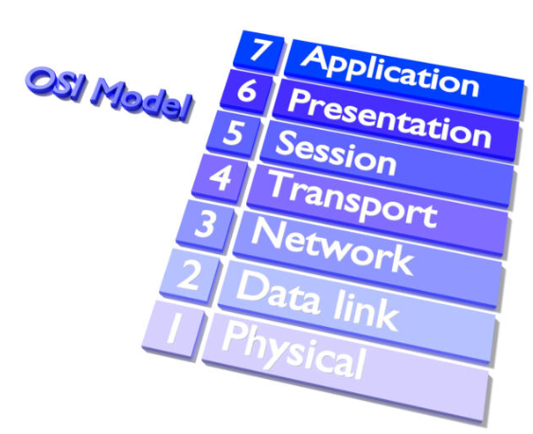
Figure 2[7]: An illustration displaying the format of the OSI reference model.

4.3.1 Physical Layer (Layer 1)

In this section we will discuss the Physical Layer, this layer focuses on all the physical equipment, from the network cabling, Closed Circuit Television (CCTV) cameras, temperature sensors, key fobs, locked doors etc.
Access to Hyper-fort’s Core Network equipment located in the server rooms will be secured by an access control system. Access Control will be regulated by a fob and key system which will be signed for from the onsite IT department, an escort will be provided by an authorised person if the necessary security checks have not been satisfied. Access out of hours can be arranged with the IT Manager, or in case of an emergency with the On Call Engineer.
CCTV equipment will be used throughout the offices for prevention and detection purposes. Clear signage will be placed as a deterrent and a reminder. Recordings can be reviewed and copied for any legal issues if a breach occurred.
Heat levels will be regulated by an environmental system that will send alerts to the building maintenance team if concerning temperature levels are reached, a fire prevention system that dispenses suppression gas will be installed.
All structural cabling will be contained to prevent the leakage of EMF (Electromagnetic Fields), this mitigates the risk of company sensitive data being breached in transit. Alger[8] advises in his publication that where possible, the cables will run overhead (in suspended ceiling) or underground to avoid damage / accessibility from attackers). Overhead and underfloor structural cabling also provides environmental and financial benefits.
There will be redundant links running between each switch, if damage was caused to one cable, traffic will still be able to transit to the destination over the resilient cable.
A Universal Power Supply (UPS) back up will be installed to protect the equipment from any surges or other power issues. Each switch will have a redundant power supply, one that connects to the mains power and one that connects to the UPS.

4.3.2 Data Link Layer (Layer 2)

This section explores the various security measures that will be placed on the Switches, Wireless Lan Controllers (WLC) and the protocols involved when applying the security. We will explore the bonding of switch ports for redundancy, port states on switches when not in use and protocols used to segment the layer 2 network, creating many broadcast domains.
Data Link (Layer 2) Ether Channels will be created between the switches in-case of a link failure. Four ports will be bundled to act as a channel-group in-case an interface between the switches went down, load balancing will also occur over these interfaces so that resources on the interfaces is kept to a minimum allowing free flow of traffic without queuing at all times[9]. As the majority of the businesses devices operate wirelessly, there will be ample ports available for this on the switches to accommodate the Ether Channel setup.
If switch ports are unused, they will remain in the shutdown state to prevent any unauthorised access. Users who require access to the Head Quarters (HQ) Network will be required to have completed an induction package provided by the company. Access to the HQ Network will require a signature accepting the usage policy set out by the IT department.
Switch ports with known devices connected (printers, scanners, fax, franking machines) will be placed on the normal data VLAN (Virtual Local Area Network), the connected switch port will have a sticky Media Access Control (MAC) address command, also known as persistent MAC, which prevents any other device gaining access if the device is disconnected. If an unauthorised device is connected, the port will automatically go into the “shutdown” state[10].
Access switch ports will have trunking disabled, using the command “switchport mode access”, this negates the Dynamic Trunking Protocol (DTP) service, default of Cisco switches to form trunks when another switch is connected to the an interface allowing attacks such as VLAN hopping to occur[11].
VLAN Trunking Protocol (VTP) domain will be used to manage the VLANs from the core across the network, however this will be protected with a shared password so that if a compromise did take place, the VLAN database would not be advertised on the rogue device or re-write the existing database[12].
VLAN’s will not span through the network and will remain local to their area. For instance, if a new floor or office is added, they will have their own VLAN. This contains the VLAN to an area which makes troubleshooting and administration far easier for the engineers. For instance, if a VLAN interface is being monitored and the interface goes down, engineers will know exactly what department is being affected[13].
A voice VLAN has been created for the phones. Quality of Service (QoS) will be applied to prioritise voice traffic. To preserve capacity on the access switches, the “switchport voice vlan” command will run along the “switchport access vlan” command on a selected interface to allow both devices to co-exist. This method allows accessibility for more employers devices at one time, utilising both voice and data services. On regular access switch ports where HQ_DATA and HQ_VOICE vlans co-exist, a total of two MAC addresses will be allowed at any one time, unlike the sticky MAC discussed earlier in the section, any device will be able to connect. This measure secures the port so that if an unauthorised AP (Access Point) is accidentally or deliberately connected, multi users associated will not be able to access the network[14].
802.1x would be implemented so that access devices will be authenticated and authorized by a Remote Authentication Dial in User Service (RADIUS) server to be on the network. This will be implemented to give authentication via an installed certificate and authorisation via username and password, if an attempt to authenticate failed then the user will have no access , if an attempt to authorise is failed, then the users switch port will be put in the Port Disabled condition rendering the connection closed.[15].
Below, figure 3 shows the journey of corporate authenticated devices and the guest devices.
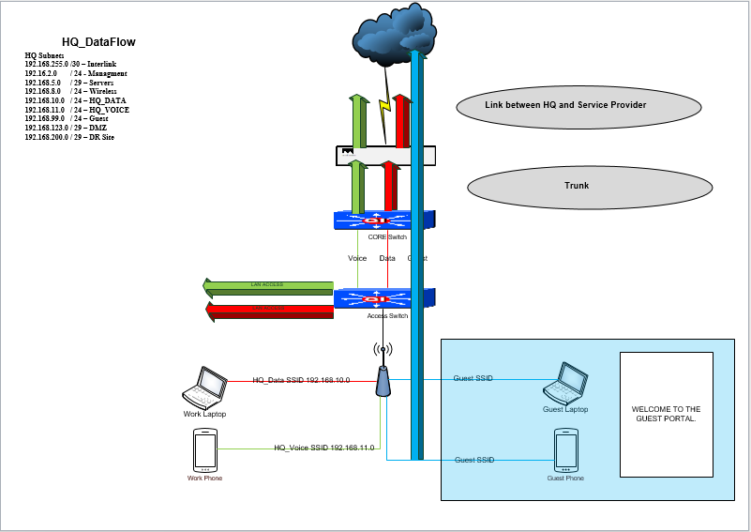
Figure 3: Screenshot of the Bring your own Device (BYOD) and work devices data flow created by the author using Visio 2013.

Users corporate and personal mobile devices will be able to connect to the HQ_DATA and HQ_VOICE Service Set Identifier (SSID). Devices will only be able to connect with the correct certificate installed on their devices and a valid RADIUS Server username and password[16]. Users personal devices will need a security profile discussed in the Mobile Management Section.
A guest VLAN will be created for visitors and employee’s personal devices to access non corporate resources including the internet. Users who connect to the guest VLAN will be isolated from the HQ network. Devices will have to connect to a “Guest” SSID, where they will be prompted to create an account using a valid email address. A valid email address will be required to send an activation link for the user to follow and the user will be prompted for their username and password. After Authentication and Authorisation an Accessible Usage Policy(AUP) will need to be accepted before the Guest network being made available. Guest traffic will be completely isolated from the staff network and will only be able to access the internet via a proxy server with web filtering enabled[17].
Wireless communication will use the Advanced Encryption Standard (AES) as opposed to the Temporal Key Integrity Protocol (TKIP) for encryption. WiFi Protected Access 2 (WPA2) enterprise will be used for employers as this uses AAA RADIUS, and as previously mentioned, username and password for the guest network which incorporates AES. Although AES is susceptible to a Brute Force Attack, with a complex password, it could take millions of years to crack and is the preferred method. TKIP uses a very weak algorithm which can easily be read to an attacker[18].
AP’s will connect to a centralised controller which will only accept join requests from authorised AP’s. Only authorised clients will be able to join SSID HQ_DATA and HQ_VOICE. This will be regulated via a Mac-Address whitelist. Any devices that are not on the whitelist will be rejected. Cisco outline the benefits of a Centralized controller, emphasising Control and Provisioning of Wireless Access Points protocol (CAPWAP), which encrypts all traffic through the tunnel, Cisco also outline the scalability benefits and mobility of devices benefits[19]. Other security measures will be required to be met and will be discussed in the Mobile Device Management (MDM) section.
Spanning Tree Protocol (STP) will be used in order to prevent loops in a network, STP is enabled by default on all Cisco Switches. On all access ports Bridge Protocol Data Unit (BPDU) guard will be configured to shut down the port immediately if a non authorised switch is connected to that port. Portfast will also be configured on all access ports, this improves network convergence times for end user devices as they skip the listening and learning states of STP and Forward immediately[20].

4.3.3 Network Layer (Layer 3)

This section will discuss how the traffic will route through the network, the routing protocol used to autonomously manage the network, how the traffic will be segregated and areas of the network which will be available from the outside network.
The link between HQ main office and Disaster Recovery (DR) site consists of a high speed link that utilises the Open Shortest Path First (OSPF) protocol in one single area ( area 0). This enables the routers to update their routing tables autonomously. OSPF packets will be encrypted in order to protect the confidentiality and integrity of the routing information sent between them. OSPF also allows third party Layer 3 devices such as Routers, Multi-Layer, Switches, Firewalls (non Cisco), to be incorporated into the network if this was ever a requirement. Although Enhanced Interior Gateway Routing Protocol (EIGRP) has faster convergence times when a topology change happens, it is a Cisco proprietary protocol, OSPF is open standard[21].
Access Control Lists (ACL’s) will be created on the Firewall as a control measure. The Firewall is the device that will control CIA for the network and is an integral part. ACL’s will secure the network and meet the overall CIA Triad requirements. ACL’s will also be placed on the network equipment to restrict management to the management VLAN[22]. ACLs will be created to :
- Separate management traffic from regular users;
- Block regular user access to Core IT equipment;
- Allow all traffic types out of the network;
- Restrict traffic into the network;
- PAT (Port Address Translation)[23], masking many private addresses to one public address;
- Allow traffic to the De-Militarized Zone (DMZ), which has been created to avoid any external users to access resources in the internal network;
- Any rules that are not created on the ACL will be sent to the implicit deny rule and subsequently dropped.
Redundant routers will be in place to ensure that a gateway will be available to route traffic outside of the network at all times, giving high availability. The routers will use Hot Standby Routing Protocol (HSRP) to share a virtual address. When the elected secondary router ceases to receive hello packets from the primary, the secondary will take control. A pre-empt command will be in place on the standby configuration to ensure that the roles are reverted back once the original primary comes alive with seamless convergence times[24].
All public facing web-servers in the DMZ will be protected by Network Address Translation (NAT) where the private Internet Protocol (IP) addresses will be accessed externally via a public IP address that sits on the Firewall with a One to One translation rule, as far as the end user is concerned, they will not see the translation from the public IP they entered to the private IP on the local network[25].

4.3.4 Transport Layer (Layer 4)

In this section the author will discuss the secure tunnels used between the corporate networks.
A redundant connection between the HQ and DR site will be encrypted via an Internet Protocol Security (IPSEC) Virtual Private Network (VPN) tunnel, this is an encrypted tunnel between permanent sites that protects traffic traversing between them. The IPSEC tunnel will be configured on each side of the firewall with an outside interface (untrusted) and an inside interface (trusted). The level of the encryption will effect processing power of the devices and speed in which it is delivered. [26].

4.3.5 Application Layer (Layer 7)

This section explores the various protocols used in terms of encrypted management traffic, user traffic from outside the network, management protocols that aide with keeping the network in sync.
The list of Application Layer protocols is very extensive. Hyper-fort will use Secure Shell (SSH) for management traffic. SSH works alongside terminal applications like Putty, or TeraTerm. A crypto key is generated on the Network Device using the Rivest-Shamir-Adleman (RSA) algorithm that encrypts data. If a traffic sniffer was embedded somewhere in the network and managed to capture the management traffic, the hacker would not be able to read the content in plain text, unlike Telnet, which is plain text[27]. SSH on the Hyper-fort network is protected by a login prompt requiring a AAA server challenge. If a connection to the AAA is not present, the admin will login with the local database username and password until AAA is restored.
On the login prompt, to the corporate infrastructure devices (Routers, Switches, WLC), a Message of the Day (MoTD) will be presented warning any unauthorised users of litigation proceedings if they attempt any unauthorised access.
Secure Sockets Layer (SSL) VPN will be used to encrypt sessions between remote users from home and the office. Remote users will be able to dial in remotely from anywhere in the world and access the network using a client such as Cisco AnyConnect or Open VPN. The client software will be pre-configured, once the user opens the Client on their Personal Computer (PC) at home, they will be required to provide their RADIUS username and password for authentication. Depending on their RADIUS group, they will have access to the resources they are authorised to access[28].
Network Timing Protocol (NTP)[29] will be used to set the time across all devices on the Network. NTP will ensure that all System Logs (SYSLOGs) are correct. NTP is a secure means of keeping accurate records of events on the network and keeping all equipment in synchronisation. If an event happened, a timestamp provides the Network Administrator with a precise time to check Closed-Circuit Television (CCTV), inspect logs, make reports and build a pattern of any unusual activity. Of the AAA model, the correct time is important for the accounting aspect of AAA.

Conclusion

The Security of Hyper-forts network was the main focus of this document. The author has set out the basic fabric requirements to provide Hyper-fort with the minimum protection it will need to implement a secure network for the Corporation to utilise on a day by day basis. The author explored a UEM solution that will protect end devices, identifying a robust platform to prevent vulnerabilities being exploited.
A Layered approach, using the OSI 7 Layer model was used to assist in referencing how basic physical security measures, switching and routing protocols, remote access to the network, management protocols, will be used to harden the network.
Cyber Security is a topic that changes daily. Although a basic solution has been created for Hyper-fort, the author advises that a Defence in Depth (DiD)[30] approach should be considered in the near future. Also referred to as the Castle approach as it compares the network to a Castle – a moat, ramparts, draw-bridge, towers etc. Each vulnerability will need to break the defence of the network presented at the ingress and egress point, in order to gain access. Not all vulnerabilities will be identified, but it’s imperative that Hyper-fort continue to invest in the Cyber Security aspect of their business in an ever evolving Cyber Threat industry. Cisco Next Generation Firewalls (NGFW)[31] is a one stop shop, providing administrators with:
- Breach Prevention and Advanced Security,
- Comprehensive Network Visibility,
- Flexible Management and Deployment Options,
- Fast Detection,
- A network member – sharing information with the rest of the community.
Hyper-forts next phase will be to implement a NGFW onto the network. The implementation will be made when a suitable vendor is identified that meets all of Hyper-forts requirements.

Bibliography
[1] “CIA Triad.” [Online]. Available: https://resources.infosecinstitute.com/cia-triad/#gref. [Accessed: 06-Dec-2018].
[2] Paganini Pierluigi, “Unified Endpoint Management: Why a UEM Solution Is a Compulsory Choice for a Modern Organization,” Security Intelligence, 2018. [Online]. Available: https://securityintelligence.com/unified-endpoint-management-why-a-uem-solution-is-a-compulsory-choice-for-a-modern-organization/. [Accessed: 28-Dec-2018].
[3] “Mobile Device Management (MDM) | Free Device Manager from Comodo.” [Online]. Available: https://dm.comodo.com/. [Accessed: 28-Dec-2018].
[4] “Mobile Device Management | MDM | VMware AirWatch.” [Online]. Available: https://www.air-watch.com/capabilities/mobile-device-management. [Accessed: 28-Dec-2018].
[5] “Cisco Meraki | Mobile device management.” [Online]. Available: https://meraki.cisco.com/solutions/mobile-device-management. [Accessed: 28-Dec-2018].
[6] T. Lammle and J. Swartz, “Read: CCNA Data Center - Introducing Cisco Data Center Networking Study Guide,” 2013. [Online]. Available: https://www-dawsonera-com.ezproxy.uwtsd.ac.uk/readonline/9781118745595. [Accessed: 15-Nov-2018].
[7] K. Shaw, “The OSI model explained: How to understand (and remember) the 7 layer network model | Network World,” 2018. [Online]. Available: https://www.networkworld.com/article/3239677/lan-wan/the-osi-model-explained-how-to-understand-and-remember-the-7-layer-network-model.html. [Accessed: 15-Nov-2018].
[8] D. Alger, “Chapter 5: Overhead or Under-Floor Installation? | Network World,” CiscoPress, 2007. [Online]. Available: https://www.networkworld.com/article/2291652/lan-wan/chapter-5--overhead-or-under-floor-installation-.html. [Accessed: 16-Nov-2018].
[9] “Understanding EtherChannel Load Balancing and Redundancy on Catalyst Switches - Cisco,” 2007. [Online]. Available: https://www.cisco.com/c/en/us/support/docs/lan-switching/etherchannel/12023-4.html. [Accessed: 21-Nov-2018].
[10] “Understanding Persistent MAC Learning (Sticky MAC) - TechLibrary - Juniper Networks.” [Online]. Available: https://www.juniper.net/documentation/en_US/junos/topics/concept/port-security-persistent-mac-learning.html. [Accessed: 06-Dec-2018].
[11] “Dynamic Trunking Protocol (3.2.3) &gt; Cisco Networking Academy’s Introduction to VLANs.” [Online]. Available: http://www.ciscopress.com/articles/article.asp?p=2181837&seqNum=8. [Accessed: 15-Nov-2018].
[12] “Understanding VLAN Trunk Protocol (VTP) - Cisco,” 2014. [Online]. Available: https://www.cisco.com/c/en/us/support/docs/lan-switching/vtp/10558-21.html. [Accessed: 15-Nov-2018].
[13] “How to Design a VLAN Based Network Architecture | Convergence | Industrial IP Advantage.” [Online]. Available: http://www.industrial-ip.org/en/industrial-ip/convergence/how-to-design-a-vlan-based-network-architecture. [Accessed: 06-Dec-2018].
[14] “Catalyst 4500 Series Switch Cisco IOS Software Configuration Guide, 12.2(20)EWA - Configuring Port Security [Cisco Catalyst 4500 Series Switches] - Cisco,” 2018. [Online]. Available: https://www.cisco.com/c/en/us/td/docs/switches/lan/catalyst4500/12-2/20ewa/configuration/guide/conf/port_sec.html. [Accessed: 16-Nov-2018].
[15] G. Zorn, B. Aboba, J. Roese, A. Smith, and P. Congdon, “IEEE 802.1X Remote Authentication Dial In User Service (RADIUS) Usage Guidelines.”
[16] B. O’Hara and A. Petrick, IEEE 802.11 handbook : a designer’s companion. IEEE, 2005.
[17] C. Public, “Five Crucial Steps to Deploying a Secure Guest Network Cisco Mobility TV,” 2008.
[18] T. Hardjono, “Security in Wireless LANs and MANs,” Computer Security Series, 2005. [Online]. Available: https://web-b-ebscohost-com.ezproxy.uwtsd.ac.uk/ehost/ebookviewer/ebook/bmxlYmtfXzE0MjgyNV9fQU41?sid=472d721a-e2de-4b74-8945-987bc12e1408@sessionmgr104&vid=0&format=EB&rid=1. [Accessed: 16-Nov-2018].
[19] “Wireless LAN Controller (WLC) Design and Features FAQ - Cisco,” Cisco, 2015. [Online]. Available: https://www.cisco.com/c/en/us/support/docs/wireless/wireless-lan-controller-software/118833-wlc-design-ftrs-faq.html. [Accessed: 16-Nov-2018].
[20] “Configuring Spanning Tree PortFast, BPDU Guard, BPDU Filter, UplinkFast, BackboneFast, and Loop Guard - Cisco,” 2007. [Online]. Available: https://www.cisco.com/c/en/us/td/docs/switches/lan/catalyst4000/8-2glx/configuration/guide/stp_enha.html#wp1046787. [Accessed: 06-Dec-2018].
[21] S. Bhat, “Cisco OSPF vs EIGRP | Difference between OSPF &amp; EIGRP Routing Protocols,” I-MEDITA, 2017. [Online]. Available: https://www.imedita.com/blog/ospf-vs-eigrp-differences-and-comparison/. [Accessed: 16-Nov-2018].
[22] P. Gargano, 31 Days Before your CCNA Security Exam. Cisco Press, 2016.
[23] “Port Address Translation.” [Online]. Available: https://www.cisco.com/assets/sol/sb/RV320_Emulators/RV320_Emulator_v1-1-0-09/help/Setup13.html. [Accessed: 02-Jan-2019].
[24] “Catalyst 3560 Switch Software Configuration Guide OL-8553-07.”
[25] “What is DMZ (networking)? - Definition from WhatIs.com.”
[26] P. Gargano, 31 Days Before your CCNA Security Exam. Cisco Press.
[27] B. Joan, “Difference Between Telnet and SSH | Difference Between,” 2018. [Online]. Available: http://www.differencebetween.net/technology/internet/difference-between-telnet-and-ssh/. [Accessed: 19-Nov-2018].
[28] “SSL VPN Security - Cisco.” [Online]. Available: https://www.cisco.com/c/en/us/about/security-center/ssl-vpn-security.html. [Accessed: 31-Dec-2018].
[29] “What is NTP?” [Online]. Available: http://www.ntp.org/ntpfaq/NTP-s-def.htm. [Accessed: 31-Dec-2018].
[30] “What is Defense in Depth? Defined, Explained, Explored | Forcepoint,” ForcePoint. [Online]. Available: https://www.forcepoint.com/cyber-edu/defense-depth. [Accessed: 31-Dec-2018].
[31] “Next-Generation Firewalls (NGFW) - Cisco.” [Online]. Available: https://www.cisco.com/c/en_uk/products/security/firewalls/index.html. [Accessed: 31-Dec-2018].

