University of Wales Trinity Saint David

Title: Business management
Module: Data Handling&Business Intelligence (LCBB5000)
Lecture’s name: Joy Botu
Student name: Svetla Karadzhova
ID number: 2006939

Contents
Introduction 2
Significance of Business Intelligence 3
The Need to Achieve Business Sustainability 4
Major Business Intelligence Providers 6
Business Intelligence Market Trends 7
Strategic Impacts of Business Intelligence 8
Reference 10

BUSINESS INTELLIGENCE

Introduction
Business intelligence entails unified management information systems that help keep data in business and information insights to enable people to make informed decisions. Over the past few decades, the business environment has witnessed significant transformations as data flow has increased and many organizations use cloud computing to store data. Technology has also simplified the management system, enabling businesses to conduct analytics efficiently. Since 2020, the global COVID-19 pandemic has disrupted industries making many companies consider the advancement of business intelligence (Sun, 2020 p.152). Business intelligence (BI) analytics platforms and tools have evolved alongside BI trends like cloud computing, artificial intelligence (AI), and mobility. The business environment has also become highly dynamic and fiercely competitive, compelling firms to analyze vital data used in decision-making. Business intelligence assists organizations to integrate information technology and management practices to make credible and strategic decisions for improving performance.

Significance of Business Intelligence
Business intelligence helps firms make well-informed choices by illustrating historical and present data from the business perspective. Analysts can use this technique to provide competitor and business performance benchmarks to ensure efficient and effective management. According to Lim and Teoh (2020), BI is a technology-driven process that enables companies to examine data and present helpful information to guide managerial decision-making (par. 2). The introduction of big data has made BI a vital concept in business management. Organizations integrate BI into their routine work practices to help speed up big data extraction for effective decision-making. BI dimensions involve analytical capabilities, data integration, decision-making culture, and better business processes (Lim and Teoh, 2020 par.2). Analysts can also use BI to identify market trends to determine the best ways to boost revenue or sales volume. Therefore, effective use of this data-driven strategy can help businesses handle almost anything from employee recruitment to compliance.
As large corporations adopt business intelligence, the full benefits of this technology-driven approach are still unclear. Lim and Teoh (2020) argue that the mere adoption of BI without full utilization in decision-making and fundamental business processes may not translate to business value (par.3). organizations can observe the strategic impact of BI through proper use across all operations. Firms' data volumes have rapidly grown, meaning that organizations will no longer rely on manual data gathering techniques. Azeroual and Theel (2019) assert that business intelligence has become crucial in collecting comprehensive data and managing the massive volumes of available data (p.30). BI provide proper technologies to help businesses gather, integrate, store, edit, and examine data.
Although only large firms were interested in business intelligence some years back, the topic has also become relevant to small and middle enterprises (SMEs) today (Maleki and Sabet, 2022 p.6). As a result, the BI market has considerably expanded today. The current business environment also requires organizations to embrace business sustainability, growing the BI market (Sun, 2020 p.152). Startups primarily use BI for controlling (89%), business management (70%), and product sales (57%), as illustrated in figure 1.
Figure 1: Uses of Business Intelligence among SMEs (Azeroual and Theel, 2019 p.35)
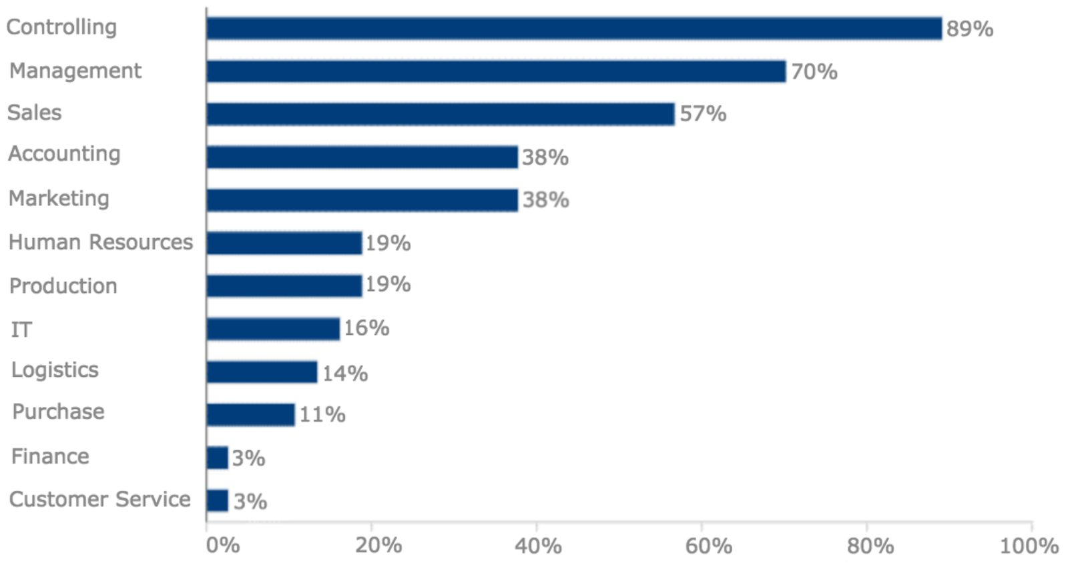

The Need to Achieve Business Sustainability
Business sustainability relates to the impact of businesses on the environment and the entire society. A sustainable business approach focuses on lowering environmental degradation by positively impacting the community and the surrounding. This strategy helps address climate change and other pressing global concerns. According to Ahmad et al. (2020), today's intelligent production environment makes the global textile and apparel (T&A) industry encounter several challenges that affect business survival (p.2). these problems include sustainability, business efficiency, regulatory and quality compliance, and prompt response to consumers' changing tastes and preferences. The global industrial environment, consumer-driven economy, and sustainable business trends also pressure industries to adopt more innovative, sustainable, and agile business models (Ahmad et al. (2020 p.2). Younger consumers have also become increasingly eco-conscious and willing to purchase environmentally-friendly items regardless of the price.
Lim and Teoh (2020) also maintain that business sustainability is now a significant issue among organizations, as depicted in various business news and industry reports today (par.4). Publicly listed corporations get massive pressure from stakeholders to observe business sustainability. These entities also have to combat intensified competition and address uncertainties in the global markets caused by social, political, and economic dynamics (Lim and Teoh, 2020 par.4). As a result, these firms' business sustainability and survival may be at risk. When these organizations analyze business sustainability, they must focus on people, the planet, and profit to balance the dimensions. Business intelligence has become crucial in handling business sustainability issues by availing proper tools for conducting business analysis, performance management, and enterprise reporting. These business management aspects are the three key pillars of business intelligence (Lim and Teoh, 2020 par.4). BI enhances business optimization by effective handling of market uncertainties and risks. Therefore, BI enables organizations to strive toward business sustainability and meet stakeholder interests and demands.

Major Business Intelligence Providers
Today, the top business intelligence providers include Microsoft, Tableau, Qliksense, SAS, IBM, Looker, MicroStrategy, Sisense, Oracle, and SAP (figure 2). These tools assist businesses to organize their data to enable easy access and analysis of information. It is necessary to identify the functions of some of these business intelligent utilities. SAS Institute initially created and released the SAS software in 1972 as a statistical tool (Hu and Yin, 2022 p.499). It is used in business intelligence, advanced analytics, data management, predictive analytics, multivariate analysis, and criminal investigation. Microsoft's Power BI is another data management software that enables interactive data visualization with a fundamental emphasis on business intelligence (Hu and Yin, 2022 p.501). Oracle Corporation's Oracle Business Intelligence Enterprise Edition Plus is an integrated business intelligence system for small, medium, and big enterprises.
In addition, IBM's Cognos Business Intelligence is an online comprehensive business intelligence software that offers practical tools for data analytics, reporting, events monitoring, data metrics, and scorecards. The integrated software has multiple features designed to address an organization's various data requirements (Hu and Yin, 2022 p.501). Also, SAP is a data analysis software developed by a German multinational tech firm that supports customer relations and business operations. Most businesses use SAP for resource planning.

Figure 2: Market Share of Top BI Providers (Source: https://www.trustradius.com/)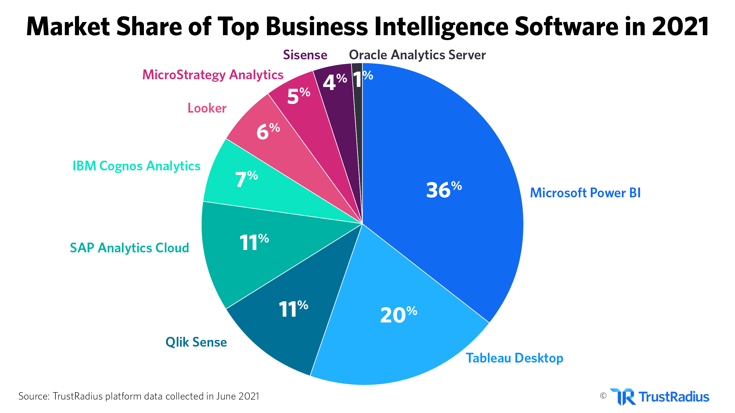

Business Intelligence Market Trends
Jugovic (2022) states that the United States and China are the two largest BI markets (par. 7). In 2020, the U.S. mobile BI market was approximately $2.6 billion (figure 3). China’s economic growth also reflects its BI sector, which has an expected growth at a CAGR of 18.7% to reach about $5.2 billion by 2027 (Jugovic, 2022 p.7). In 2020, the global BI market was about $22.26 billion, with a projected growth with a CAGR of 8.7% between 2021 and 2028. One principal factor driving this market growth is the increasing demand for real-time business insights (Islam, 2018 p.47). in the same year, the BI adoption rate in global businesses was at 26%, meaning that almost 26 individuals in a department of 100 employees regularly use BI software.
Moreover, Bhat (2020) argues that the bigger the organization, the higher the business intelligence implementation rate (19). The BI adoption rate above 80% is primarily evident among organizations with more than 5,000 workers. Bhat (2020) explains that these large firms need specialized business intelligence tools to manage their data. The BI segment with the highest growth rate (23%) is cloud analytics, with a global market value of $19.04 billion in 2020. The segment’s market value is expected to reach $65.4 billion in 2025 (Jugovic, 2022 par.7). The cloud analytics market is rapidly growing because of its scalability, user-friendly features, and flexibility. Businesses also have no data gathering limits when using cloud analytics tools.
Figure 3: U.S. BI Market Growth (Source: https://www.grandviewresearch.com/)
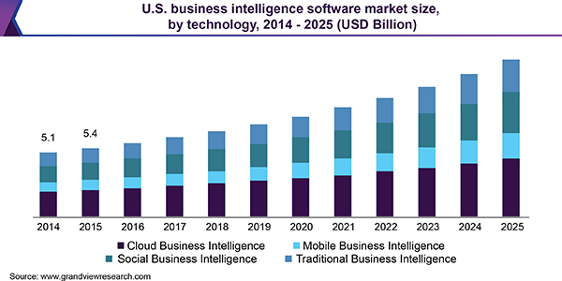

Strategic Impacts of Business Intelligence
According to Tripathi, Bagga, and Aggarwal (2020) BI users nowadays want better visualization, more control, efficient development cycles, and higher analyzing capability levels (p.37). Companies also keenly observe technology trends to determine their next move in the information used to gain a competitive advantage. Thus, many businesses have adopted BI to enhance their business performance (Popovič, Puklavec, and Oliveira, 2018 p.31). These tools enable organizations to monitor customer needs, analyze sales trends, understand market demand and consumer behaviour, and achieve strategic goals. Lim and Teoh (2020) also maintain that BI tools help firms strengthen their environmental sustainability measures and reinforce their social performance (par. 9). BI allows organizations to plan strategically and gain a competitive advantage. The easier and faster access to vital information helps firms acknowledge possible market opportunities and threats, reinforcing social performance.
In conclusion, properly managing business processes has become exceedingly difficult in the current business ecosystem full of massive data volumes, competition, and rapid changes. Organizations can ensure the effective control of operations by adopting business intelligence. The use of modern and professional BI tools helps firms address multiple challenges and make sound and profitable decisions. Significant IT involvement in business operations is the next wave in global business management. BI utilization enhances environmental, social, and economic performance. Therefore, it facilitates the move towards business sustainability in the current complex business environment.

Reference
Ahmad, S., Miskon, S., Alabdan, R. and Tlili, I., 2020. Towards sustainable textile and apparel industry: Exploring the role of business intelligence systems in the era of industry 4.0. Sustainability, 12(7), p.2632.
Azeroual, O. and Theel, H., 2019. The effects of using business intelligence systems on an excellence management and decision-making process by start-up companies: A case study. arXiv preprint arXiv:1901.10555.
Bhat, H.J., 2020. Investigate the Implication of “Self-service Business Intelligence (SSBI)”—A Big Data Trend in Today’s Business World. Curr. Trends Inf. Technol, 10, pp.17-22.
Hu, H. and Yin, M., 2022. Evolution of Business Intelligence: An Analysis from the Perspective of Social Network. Tehnički vjesnik, 29(2), pp.497-503.
Islam, N., 2018. Business Intelligence and Analytics for Operational Efficiency. Available at SSRN 3163429.
Jugovic Spajic, D., 2022. 25 Key Business Intelligence Statistics: Market, Usage, & More. [online] Dataprot. Available at: <https://dataprot.net/statistics/business-intelligence-statistics/> [Accessed 18 April 2022].
Lim, Y. and Teoh, A. 2020. Realizing the strategic impact of business intelligence utilization [Online] Available at: https://www.emeraldgrouppublishing.com/licensing/reprints.htm [Accessed 02 October 2020
Maleki, R. and Sabet, E., 2022. Business Intelligence Analysis in Small and Medium Enterprises. International journal of Innovation in Marketing Elements, 2(1), pp.1-11.
Popovič, A., Puklavec, B. and Oliveira, T., 2018. Justifying business intelligence systems adoption in SMEs: Impact of systems use on firm performance. Industrial Management & Data Systems.
Sun, Z., 2020. Business Analytics Intelligence: An Emerging Frontier for Innovation and Productivity. Retrieved February, 3, p.2021.
Tripathi, A., Bagga, T. and Aggarwal, R.K., 2020. Strategic impact of business intelligence: A review of literature. Prabandhan: Indian Journal of Management, 13(3), pp.35-48.

