Joyce Kumi – 2515780

HOW TO SHARE A FILE
VIA ONEDRIVE


STEP 2: Upload your file

Click “Upload” Choose Files or Folder. Wait for the upload to finish.
STEP 1: Sign in

Open OneDrive and sign in with your Microsoft Work or school account
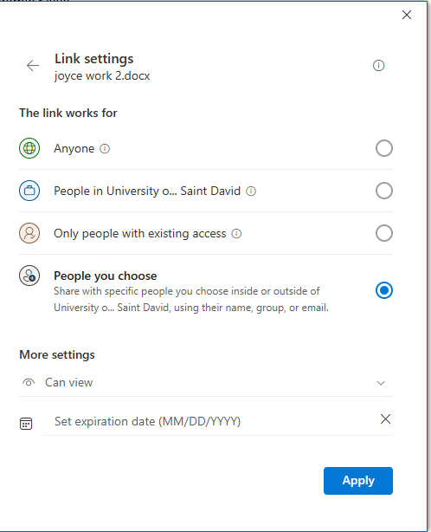
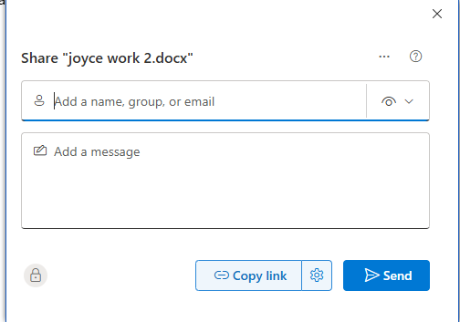

TIPS:
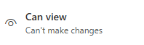

Use view only for files you don’t want other people to be able to access.
STEP 5: Send the link

Click “copy link” to share it manually or enter an email address and click SEND and the Recipients should receive it instantly.
Select “Anyone with link” if you want everyone to receive or choose specific people.
STEP 4: Choose sharing options
This Photo by Unknown Author is licensed under CC BY-NC
STEP 3: Select the file share

Find your file in OneDrive Right click the file or click the three dots (…) choose “share”

