Data Security and Compliance
(ACCA5034)
Year 2 Semester 1
Ryan Morris

Introduction
In 2023 companies rely more than ever on technology, from communicating, to finance and storage. This has greatly enhanced companies and individuals work flows and continues to enhance the way we all work year on year. As companies now store near all of their documents digitally, data security is now fundamental to prevent mass data leaks, hacks and financial loss. Companies need to have robust information security systems in place to protect, detect, react and safeguard company assets, systems and infrastructure in case of system failure or cyber attack.
In Task 1, I am going to research multiple methods in which companies can use to protect their assets, in Task 2, I am going to utilise my research to aid me in creating a digit security strategy for a new company on behalf of StresSolutions.

Task 1

I have read Task 2 of the assignment and have selected the below points to research as I believe they give me a good, broad overview of the subject which will allow me to create a robust security strategy

- Security Framework NIST
- Physical Security
- Intrusion Detection and Prevention systems, and other security tools

NIST

The National Institute of Standards and Technology (NIST) framework is a free Cyber Security Framework (CSF) which was first introduced on February 12th 2014 (Framework 1.0). Framework 1.1 was released to the public in April 2018. It was created to protect against the growing and evolving cybersecurity threat landscape which threatens the livelihood of small and large organisations alike. NIST is a comprehensive set of voluntary guidance and methods of best practice for organisations to assist in prioritising, managing and preventing cyber threats as well as protecting against any threats which cannot be eliminated entirely.
NIST framework is broken down 3 primary framework components, see fig;


- Core – The core component of the CSF is made up of 5 functions
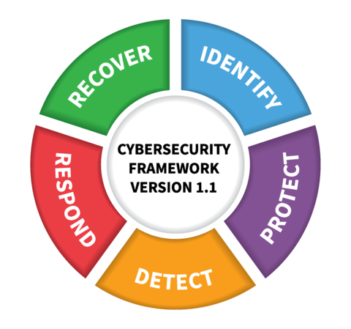
Each of the 5 functions as shown in the figure are then broken down into categories, which are then broken down into subcategories giving an abundance of guidance on cybersecurity. The following is a broad breakdown of what’s included in each function.

Identify

Recover
The recover function begins with recovery planning before any potential attacks take place. Recovery planning involves looking inward at the organisation and documenting important details such as;
- Personnel whose role it is to both design and implement the recovery strategy
- Key personnel, processes and possessions which allow the organisation to operate in its usual capacity and to plan on how the organisation were to run if a cyberattack/cyber-event were to force the organisation to run in a diminished capacity
- At what point does the recovery strategy begin to be implemented in the aftermath of a cyberattack/cyber-event
- Communicating to relevant stakeholders the status of the data/systems recovery at pre-defined intervals, defined in the recovery strategy

Continuous improvement is essential regarding recovery, it is important to document relevant metrics which are important to the organisation such as cost, time taken to recover, productivity lost, customer reaction among many other matrics in order to adjust your cyber recovery plan for future cyber-events.

References
NIST image : https://www.nist.gov/news-events/news/2018/04/nist-releases-version-11-its-popular-cybersecurity-framework

