M6X01206
Powertrain & Sustainability
COMBUSTION CHEMISTRY CALCULATIONS
Juan Sebastian Vacas
P138703

Contents
Chapter 1 – Introduction 3
1.1 – Introduction 3
Chapter 2 – Mass Percentages 3
2.1 – Mass Percentages 3
Chapter 3 – Air:Fuel Mass Ratio 5
3.1 – Air:Fuel Mass Ratio (Stochiometric Combustion In Air) 5
Chapter 4 – Lower Heating Value Calculations 6
4.1 – Lower Heating Value 6
Chapter 5 – Enthalpy Of Formation 7
5.1 – Enthalpy Of Formation (Explanation) 7
Chapter 6 – Higher & Lower Heating Values 7
6.1 – Higher & Lower Heating Values 7
Chapter 7 – CO2 Mass 7
7.1 – Calculation of CO2 Mass 7
Chapter 8 – Ideal Fuel 7
8.1 – Ideal Fuel Description 7
Chapter 9 – Conclusion 8
9.1 - Conclusion 8
Chapter 10 – Appendices & Bibliography 8
10.1 – Appendices & Bibliography 8

Chapter 1 – Introduction

– Introduction

This assignment is titled “COMBUSTION CHEMISTRY CALCULATIONS” with several questions requiring a concise structured response, comprising of both a numerical and logic based narrative.
As a pretext to the chaptered questions the following statement is cited from the assignment brief;
“You are required to carry out a study of a blended bio-ethanol – which has a molar composition as follows:
ETHANOL 50%
ISOOCTANE 50%”
McDonald, Malcolm – UWTSD 2017

Chapter 2 – Mass Percentages

2.1 – Mass Percentages

“Calculate the mass percentages of ethanol and isooctane in this blend.”
McDonald, Malcolm – UWTSD 2017
$$C_{2}H_{5}OH$$
This is the chemical formula for 1 molecule of ethanol, containing: 2 carbon, 5 hydrogen & 1 hydroxide atom(s).
$$C_{8}H_{18}$$
This is the chemical formula for 1 molecule of isooctane (trimethylpentane), containing: 8 carbon and 18 hydrogen atoms.
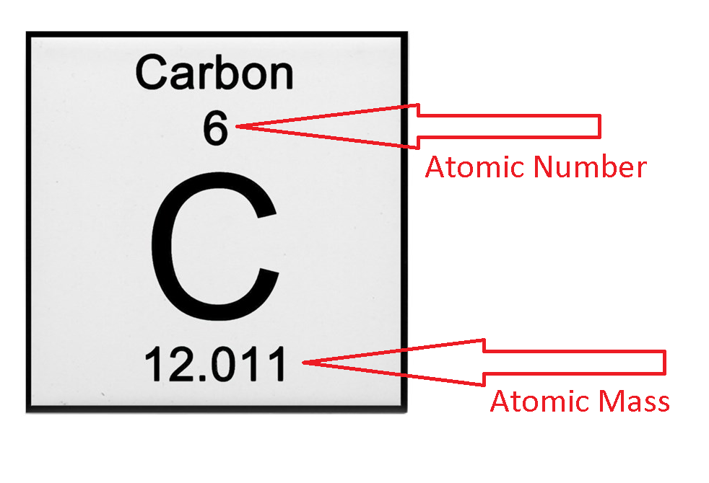
Figure 1: Vacas, Juan 2017 / Cafepress.com (06/11/17)

Figure 1 shows an example of 1 carbon atom as would be pictured in a periodic table, as annotated the atomic number signifies the number of electrons and protons (6&6) and the atomic mass is the summation of average atomic weights.

Table 1: Atomic Weight & Mass
Atom | Atomic Weight | Atomic Mass
Carbon | 6 | 12.011
Hydrogen | 1 | 1.008
Oxygen | 8 | 15.999

Note: “$OH$” (Hydroxide) comprises of 1 oxygen and 1 hydrogen atom in a covalent bond (shared electron bonds).

Table 2: Ethanol
Atom | Atomic Mass | Number of Atoms | Total
Carbon | 12.011 | 2 | 24.022
Hydrogen | 1.008 | 5+1 | 5.04
Oxygen | 15.999 | 1 | 15.999

The molar mass of ethanol is: 2*(12.011) + 6*(1.008) + 1*(15.99) = 46.069 g/mol.

Table 3: Isooctane
Atom | Atomic Mass | Number of Atoms | Total
Carbon | 12.011 | 8 | 96.088
Hydrogen | 1.008 | 18 | 18.144

The molar mass of Isooctane is: 8*(12.011) + 18*(1.008) = 114.232 g/mol.

Total molar mass of a 50:50 blend = 160.301

Therefore, the mass percentages are as follows:

Ethanol = $\frac{46.069}{(\frac{160.301}{100})}$ = 28.74%
Isooctane = $\frac{114.232}{(\frac{160.301}{100})}$ = 71.26%

Chapter 3 – Air:Fuel Mass Ratio

3.1 – Air:Fuel Mass Ratio (Stochiometric Combustion In Air)

Stochiometric combustion is when you have the correct ratio of air to fuel for a complete combustion producing only carbon dioxide and water, hence the initial layout before balancing.

$C_{8}H_{18}$+$C_{2}H_{5}OH+?*\left(O_{2}+3.76N_{2}\right)≫ {?CO}_{2}+ ? H_{2}O+ ? N_{2}$

The left side of the equation is the reactants and the right side the products, the equation has not yet been balanced hence the “?$'s"$.

$$C_{8}H_{18}C_{2}H_{5}OH+?*\left(O_{2}+3.76N_{2}\right)≫ {10CO}_{2}+ 12H_{2}O+ ? N_{2}$$

Firstly the carbon and hydrogen atoms are balanced on the right and consequently the oxygen atoms can be balanced on the left.
$$C_{8}H_{18}C_{2}H_{5}OH+15.5\left(O_{2}+3.76N_{2}\right)≫ {10CO}_{2}+ 12H_{2}O+ ? N_{2}$$

Finally, the nitrogen atoms are balanced on the right.
$$C_{8}H_{18}C_{2}H_{5}OH+15.5\left(O_{2}+3.76N_{2}\right)≫ {10CO}_{2}+ 12H_{2}O+ 58.28N_{2}$$

Summation of molecules and atomic weights.
$$\frac{15.5*15.999*2+15.5*3.76*2*14.007}{10*12.011+24*1.008+1*15.999}$$

$$\frac{2128.62492}{160.292}$$

$AFR Mass Ratio=13.28$:1
Stochiometric AFR for isooctane is 15.7 (taking air to be a 79:21 split of nitrogen to oxygen) and 9:1 (ethanol), so the answer of 13.28:1 seems conceivable considering these parameters and the mass percentage split. This AFR means the 50:50 fuel blend takes up more room in the cylinder and there is less room for air.

Chapter 4 – Lower Heating Value Calculations

4.1 – Lower Heating Value

$$C_{8}H_{18}C_{2}H_{5}OH+15.5\left(O_{2}+3.76N_{2}\right)≫ {10CO}_{2}+ 12H_{2}O+ 58.28N_{2}$$
$$Enthalpy of formation required to get to zero level≫Enthalpy released below zero level$$

Formations of enthalpy (taken from table D2, gas state), MJ/Kmol:

$$224.1+234.6+0+0≫10*393.5+12*241.8+0$$

$$458.7MJ≫635.3MJ$$

$$Net enthalpy released=6836.6-458.7=6377.9MJ$$

$$1 Kmol C_{8}H_{18}+C_{2}H_{5}OH Releases ≫6377.9MJ$$

$$10*\left(12\right)+24*\left(1.008\right)+1*\left(15.999\right) KG C_{8}H_{18}+C_{2}H_{5}OH = 6377.9MJ$$

$$160.182KG C_{8}H_{18}+C_{2}H_{5}OH = 6377.9MJ$$

$$1KG C_{8}H_{18}+C_{2}H_{5}OH = \frac{6377.9}{160.182}$$

Therefore:

$$1KG C_{8}H_{18}+C_{2}H_{5}OH = 39.82MJ/KG LHV (Lower Heating Value)$$

Chapter 5 – Enthalpy Of Formation

5.1 – Enthalpy Of Formation (Explanation)

Enthalpy of formation of a compound is the enthalpy (heat energy at constant pressure) required to make 1Kmol of the compound from its precursory building blocks at a constant pressure of 1 Bar and constant temperature of 298.1K.

Chapter 6 – Higher & Lower Heating Values

6.1 – Higher & Lower Heating Values

The lower heating value is the net heat release per KG of fuel when the product (water) is in the form of a gas (i.e. vaporised in combustion).

Chapter 7 – CO2 Mass

7.1 – Calculation of CO2 Mass

$$1 Kmol C_{8}H_{18}+C_{2}H_{5}OH ≫ 1 Kmol {10CO}_{2}$$

The above is the molar / atomic quantity relative to 1Kmol * the individual atomic weight.

$$10*\left(12.011\right)+24*\left(1.008\right)+1*(15.999)≫10*(44)$$

$$160.301KG C_{8}H_{18}+C_{2}H_{5}OH= 440 KG CO_{2}$$

$$1KG C_{8}H_{18}+C_{2}H_{5}OH=\frac{ 440 KG CO_{2}}{160.301}$$

Therefore, the CO2 mass produced per KG of fuel = 2.74KG

Chapter 8 – Ideal Fuel

8.1 – Ideal Fuel Description

What you term as “ideal” for a fuel could vary greatly according to application, but fundamentally a number of advantageous attributes could be highlighted;
- High flame speed / combustion – this means the unburnt zone has time as a stagnant area, hence reducing the chance of knock occurring. The quicker the combustion, the less time there is for heat loss.
- High calorific value – quite simply you want the fuel to contain the largest amount of potential energy.
- High octane rating – the higher the octane rating the less chance of knock, thus ignition can be advanced closer to MBT.
- Component reactivity – it is important to make sure the fuel does not damage components, for example ethanol can harden and make perish certain hose types (relative to material composition)
- Temperature dependant properties – it is important to make sure the fuel used is always of a suitable composition relative environment temperature (for example the use of recycled oils in diesel cars)
- Cleaning properties – depending on composition and makeup, the ability to clean soot deposits is a potential attribute for a fuel.
- Exhaust tailpipe emissions should be as low as possible
- Low level of volatility to allow ease of storage and transport – gasoline can easily be stored and transported, whereas hydrogen requires robust (weight penalty) storage tanks to try and contain leakage through micro porosity
- There should be ease and efficiency of manufacture (worthwhile NET energy)

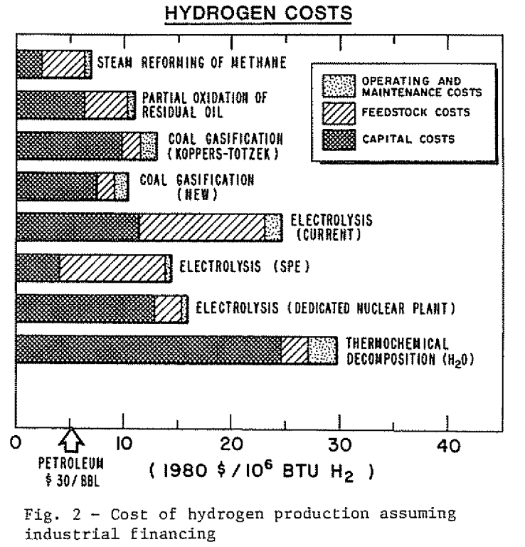
Figure 2 - Hydrogen as an Alternative Automotive Fuel – Carl A. Kukkonen (SAE Technical Paper 810349)

Chapter 9 – Conclusion

9.1 – Conclusion

I feel that the 1000 word limit imposed became increasingly difficult to keep to but at the same time being forced to be concise inherently lead to a greater focus on the subject at hand
If further work was sought, I would start looking at application specific perspectives as whilst there are a many different fuels but the real challenge comes when pairing the right fuel to the right application. This is echoed in the description of an ideal fuel, with there being some elementary points but still the scope to go into a great amount of detail if the potential attributes were reviewed according to application. For example, hydrogen may be suitable if it could be used at source of manufacture and not have to be transported – or bioethanol maybe be a more viable fuel if it is possible to produce it in a more efficient way that negates its consumption of arable farm land.

Chapter 10 – Appendices & Bibliography

10.1 – Appendices & Bibliography

Encyclopedia of Automotive Engineering by David Crolla ISBN: 9780470974025
Internal Combustion Engine Fundamentals – John B Heywood (1989) ISBN: 978-0071004992
McDonald, Malcolm – UWTSD 2017
Figure 1: Vacas, Juan 2017 / Cafepress.com (06/11/17)
Figure 2 - Hydrogen as an Alternative Automotive Fuel – Carl A. Kukkonen (SAE Technical Paper 810349)
The Effect of Diesel Fuel Properties on Engine-out Emissions and Fuel Efficiency at Mid-Load Conditions - Shankar Kumar, Donald W. Stanton, Howard Fang, Rick J. Gustafson and Tim R. Frazier Cummins Inc. – SAE Technical Paper 2009-01-2697

