Harry Woollands
2214706
Designing an automatic traffic light controller for a t-junction road
Electronics 1
2590 Words

Contents
Table of Figures 1
Introduction 2
Research 3
My Circuit 5
Flowchart 7
Code 9
Testing/Results 13
Conclusion 16
Bibliography 17
Appendices 18

Table of Figures
Figure 1 [3] 3
Figure 2 [5] 4
Figure 3 6
Figure 4 7
Figure 5 9
Figure 6 9
Figure 7 9
Figure 8 10
Figure 9 10
Figure 10 11
Figure 11 11
Figure 12 12
Figure 13 12
Figure 14 13
Figure 15 14
Figure 16 14
Figure 17 15

Introduction

I was tasked to design and simulate a traffic light control system for a T-Junction. To achieve this, I used Proteus as a simulation software, creating the system using a PIC16F877A microcontroller, combined with Mikro C Pro for PIC as a C compiler to code my circuit. This report will focus on three main sections; background research, the circuit I made, and the code I wrote for the simulation to function.
The traffic light system must allow for comprehensive traffic management, running within a 40 second loop. The traffic signals must change every 10 seconds, and once within the 40 second loop must account for 10 seconds of pedestrian crossing.
To complete this assignment, I used two pieces of software. These are:
- Proteus 8 Professional
- Mikro C Pro for PIC

At the end of this report, there will be an ‘appendices’ section, where you will find links to my Proteus circuit file, as well as my Mikro C code file.

Research

Traffic lights were first introduced in the UK back in 1868 [1] outside the Houses of Parliament, using green and red coloured gas. However, they proved too dangerous, with the gas igniting, and killing the operator [1]. Traffic lights were not seen again until the 1910’s with the first electrical traffic lights being used in America. These traffic lights also used the amber light for the first time, not previously seen in the UK’s version. The UK then brought back manually operated traffic lights in 1926, with automatic lights being introduced in the following year. These proved to be a success, and as a result, by 1930, traffic lights began to become standard across the UK [1].
To begin, I looked at the Government issued ‘Traffic Signs Manual [2]’, in order to understand the regulations around T-Junctions. This document outlined details such as the required visibility, corner radii, lane width, turning lanes and signage. I also looked into the sequence in which the traffic lights operate in. Figure 1 below shows the sequence in which the lights change in.
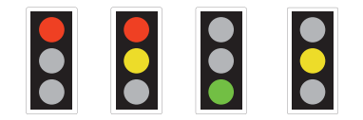
Figure 1 [3]
Firstly, the lights start on a solid red light, informing drivers that they must stop. Next in the sequence is a red and amber light simultaneously. This indicates to drivers that the traffic lights are about to show green, and that they can move off. The green light is then shown alone, until an amber light is shown alone, which indicates that the lights are going to turn red imminently, and that drivers should stop. The lights revert to their first state of a single red light, and the cycle repeats itself infinitely.
Before beginning the task, I wanted to gain a greater understanding of the PIC16F877A microcontroller, in particular, the different Ports and what they are used for. The PIC16F877A has 5 different Ports, Ports A-E [4]. Port A has 6 pins, from pin 2 to pin 7 on the Microcontroller. Ports B, C and D are similar in that they all have 8 pins. However, Port C and D are slightly different to Port B, in that their pins are not located together. Port C have 4 pins on each side of the microcontroller, and Port D has 4 pins on one side, and 4 on the bottom of the microcontroller. Finally, the 5th Port is Port E, which has the smallest number of pins on the microcontroller, with 3 pins. As well as the Ports, the PIC16F877A has two sets of power pins, two oscillator pins, and finally a reset pin. The layout of these pins can see below in Figure 2. I will explain which Ports I use as inputs and which ones I use as output later in the ‘Code’ section of this report.

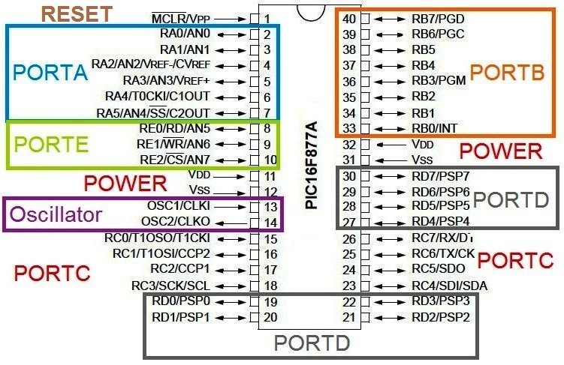
Figure 2 [5]

My Circuit

My circuit is run off of a PIC16F877A Microcontroller. A microcontroller is a compact, integrated circuit that has been designed to complete a specific operation within an embedded system [6]. Alongside the microcontroller, there are other components used to create my traffic light circuit. These include:
- The PIC16F877A Microcontroller
- 6x LED 7-Segment display’s
- 3x Traffic Light components
- 2x Red LED’s
- 2x Green LED’s

The 7-segments displays are digital displays, containing 7 LED’s to display numerical characters [7]. In my circuit, they are used to count up from 0 to 40 seconds. In a realistic scenario, these displays would allow drivers to know when the traffic lights on their side of the road would change.
The traffic light components act just as real traffic lights would do, displaying either ‘green’ or ‘red’ to oncoming traffic. In my circuit, the two traffic lights on the ‘main’ road work simultaneously with one another to allow traffic to flow seamlessly, and the traffic light on the ‘side’ road works independently of the other two.
The two red and green LED’s are used on the pedestrian crossing. For the majority of the circuits loop they will be set so the red LED’s are set to high, and the green LED’s are set to low. For the final 10 seconds of the loop, these will invert, so that they green LED’s are on, allowing for pedestrians to cross the road.
I have designed my circuit so that the traffic lights change colour every 10 seconds. For the first 10 seconds, the ‘main’ road traffic lights will be set to green, and the ‘side’ road will be set to red. For the following 10 seconds, this will be inversed, with both sides of the ‘main’ road set to red, and the ‘side’ road set to green. For the next 10 seconds, the lights will revert to their first colour, with the ‘main’ road being green, and the ‘side’ road being red. For the final 10 seconds of the loop, all traffic lights will be turned off, and the pedestrian LED’s will be set to green, allowing for them to cross. During my 40 seconds loop, the ‘main’ road’s lights get set to green twice, and the ‘side’ road’s lights set to green only once. This is because in a realistic scenario, the ‘main’ road is likely to have a greater amount of traffic using it compared to the ‘side’ road, and therefore this system seems better for efficient traffic management. My circuit design is shown below in Figure 3.
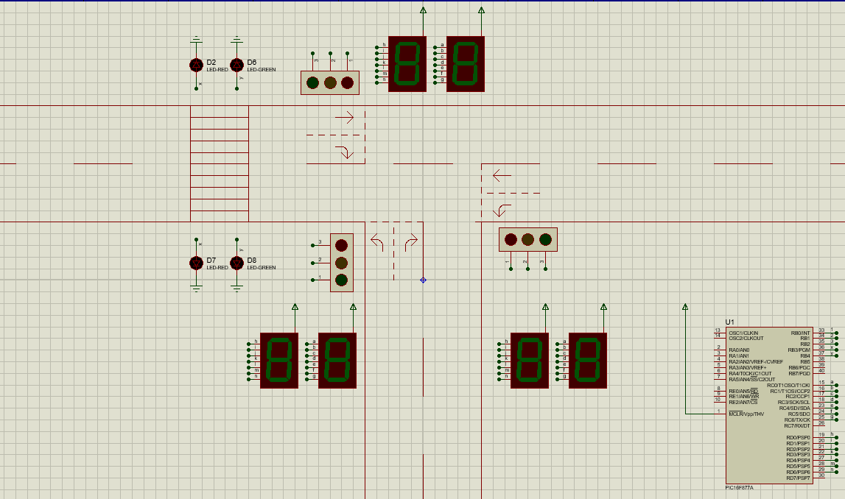
Figure 3

Flowchart
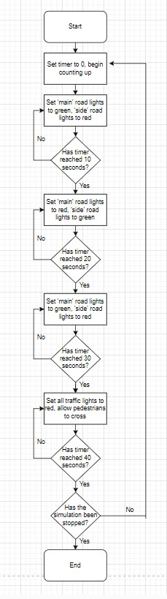
Figure 4
Figure 4 above shows my flowchart for my traffic light system. Flowcharts are a good way of breaking down and visualising a problem before starting to write the code. My flowchart demonstrates my thought process behind my simulation, outlining the key aspects that I will need to include.
As seen in the flowchart, the most important aspect of the traffic light system is changing the lights every 10 seconds, to maintain smooth traffic flow. The other important thing shown in the flowchart is that the system runs in a 40 second loop, and these 40 seconds will continue looping until the simulation is manually stopped.

Code

In this section, I will show the different sections of code that make up my simulation. The first thing I did was to declare ‘i’ as an integer. This will be needed for later in the code to count through to 40 seconds. The next stage was to declare an array which I called ‘display’, containing hexadecimal values so that numbers can be displayed on the 7-segment displays. The ‘10’ in the square brackets determine the number of elements inside of the array. The values inside of the array are the hexadecimal values for integers 0 through to 9. Figure 5 below shows this section of my code.
Figure 5
The next stage of the code involved declaring which pin on the PIC16F887A relates to which colour on the traffic lights. To do this, I had to use the ‘sbit’ function. ‘sbit’ is a function that allows you to define a variable as a bit, so you don’t have to type out the bit name each time you need to access it, only the variable [8]. This also helps with the readability of the code, as it is easier to follow along what is happening. This is shown by my variable names; ‘LED_Red’, LED_Yellow’, LED_Green’, ‘LED_Red1’, and ‘LED_Green1’. The first three variables are the colours on the traffic lights, and the final two are the pedestrian crossing lights. As seen below in Figure 6 and 7, the RB0, RB1 and RB2 pins are connected to the red, amber and green lights on the traffic lights, the RB3 bit is connected to the red pedestrian LED, and RB4 bit is connected to the green pedestrian LED.
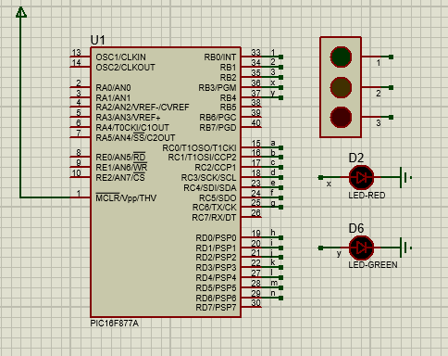
Figure 6
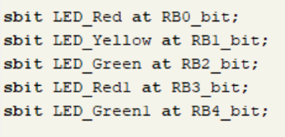
Figure 7
The next element of the code was to declare which Ports I would be using on the PIC16F877A as outputs for the 7-segment displays, the traffic lights and the LED’s. This was done inside of the ‘void main’ function. Void main is a function that represents the start of any code that will be executed [9]. To declare pins as output pins, I used the ‘tris’ function. ‘Tris’ is the abbreviation for ‘Tri-state’ and is followed by which Port you want to declare, and whether it is an input or an output. Setting the Port to 1 sets all pins of that Port as an input, and setting it to 0 sets all pins as outputs. I set Port B, C and D as outputs. The ‘Port’ function after the ‘tris’ function is used to control whether the Port is used to read or write data. Figure 8 below shows this section of my code
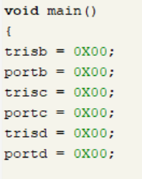
Figure 8
I decided to use Port B for my pins for the traffic lights, as well as for the pedestrian LED’s. I used Port C to output onto the 7-segment display that outputted the ‘units’ value, and I used Port D to output onto the second 7-segment display that outputted the ‘tens’ value.
The next part of my code is used for controlling the traffic lights. The remaining parts of my code are all within a ‘do-while’ loop. A ‘do-while’ loop is a loop that executes the code within it as long as its condition is true [10]. Inside this do-while loop, I have a ‘for’ loop. The for loop specifies how long this section of code runs for. The integer ‘i’ that was declared in the first line of my code starts at value ‘0’, and will loop 10 times, meaning that this section of code will run from 0 seconds to 9 seconds. The next step was to set the ‘tens’ 7-segment display to display the value ‘0’ throughout, as it will not need to display anything else during the first 9 seconds. I did this by setting Port D to hexadecimal value ‘0’. Next, I set the second 7-segment display to count through my ‘display’ array. Next, I had to set the lights on the traffic lights to on or off. For the first instance, I set my ‘LED_Green’ variable to on, and red and amber as off. This meant that the lights on the ‘main’ road displayed as green, and the light on the ‘side’ road displayed as red. I achieved this by inverting the pin numbers of the ‘main’ road traffic lights and the ‘side’ road traffic light. This can be seen below in Figure 9.
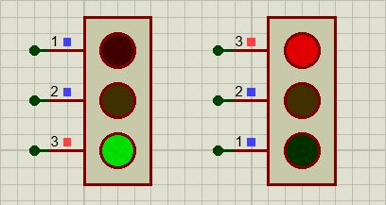
Figure 9
Next, I set ‘LED_Red1’ as on, which meant that the pedestrian LED displayed red. Finally, I added a delay of 1000ms, which converts to 1 second. This meant that the for loop looped every 1 second, and therefore the 7-segment displays counted up in 1 second increments. The code for this section can be seen below in Figure 10.
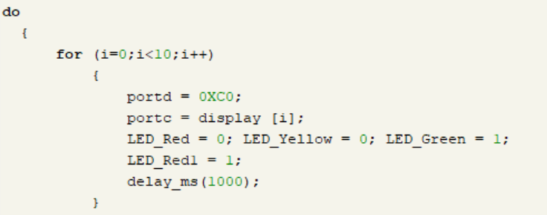
Figure 10
The next two sections of code are very similar to the previous section. In the first for loop, the first change is the value displayed on the ‘tens’ 7-segment display, changing it to ‘1’ with its hexadecimal value for seconds 10 through to 19. The second change is to turn ‘LED_Red’ to high, and ‘LED_Green’ to low. This caused the traffic lights on the ‘main’ road to red, and the traffic light on the ‘side’ road to green. In the second for loop, the value displayed on the ‘tens’ 7-segment display is changed to ‘2’ with its hexadecimal value for seconds 20 through to 29. The traffic lights colour have reverted to what they were in the first for loop, with the ‘main’ road displaying green and the ‘side’ road displaying red. These sections of code can be seen below in Figure 11.
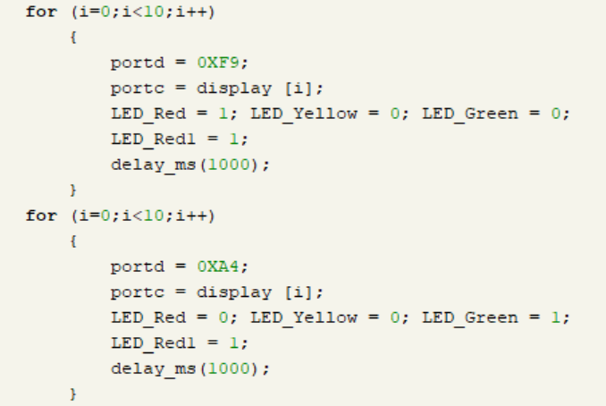
Figure 11

The next section of code is slightly different to the previous sections, as it is the code used for the 10 seconds of pedestrian crossing. Firstly, I once again changed the value displayed on the ‘tens’ 7-segment display to ‘3’ with its hexadecimal value for seconds 30 through to 39. The next change was to turn all lights on the traffic lights to off. I did this by setting LED_Red, LED_yellow and LED_Green to low. The final change was replacing LED_Red1 with LED_Green1, which meant that the pedestrian LED’s would change to green. This section of code can be seen below in Figure 12.
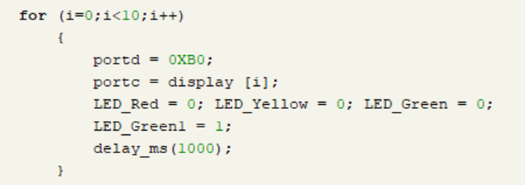
Figure 12
The final section of code also used for pedestrian crossing. However, the for loop conditions have been changed as the loop needs to 40 seconds long, and 39 seconds have already been used. Therefore, ‘i’ has been set to only run once. Finally, I once again changed the value displayed on the ‘tens’ 7-segment display to ‘4’ with its hexadecimal value for the 40th second. Outside of the for loop is the while condition, set to ‘1’ so that the simulation loops until manually stopped. The final section of code can be seen below in Figure 13.
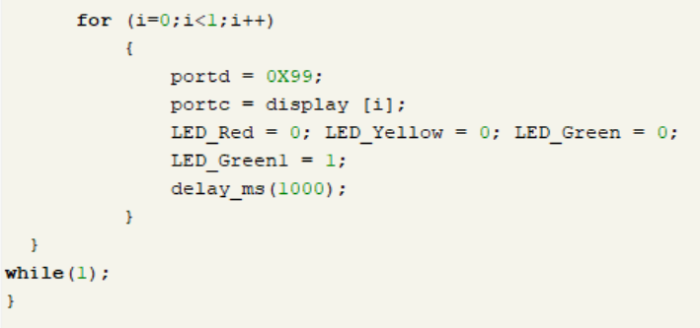
Figure 13

Testing/Results

This section of the report will showcase screenshots of my simulation running.
Figure 14 below shows how my simulation looks between 0 and 9 seconds. The two traffic lights on the ‘main’ road are green, and the traffic light on the ‘side’ road is red. The pedestrian LED is also red.
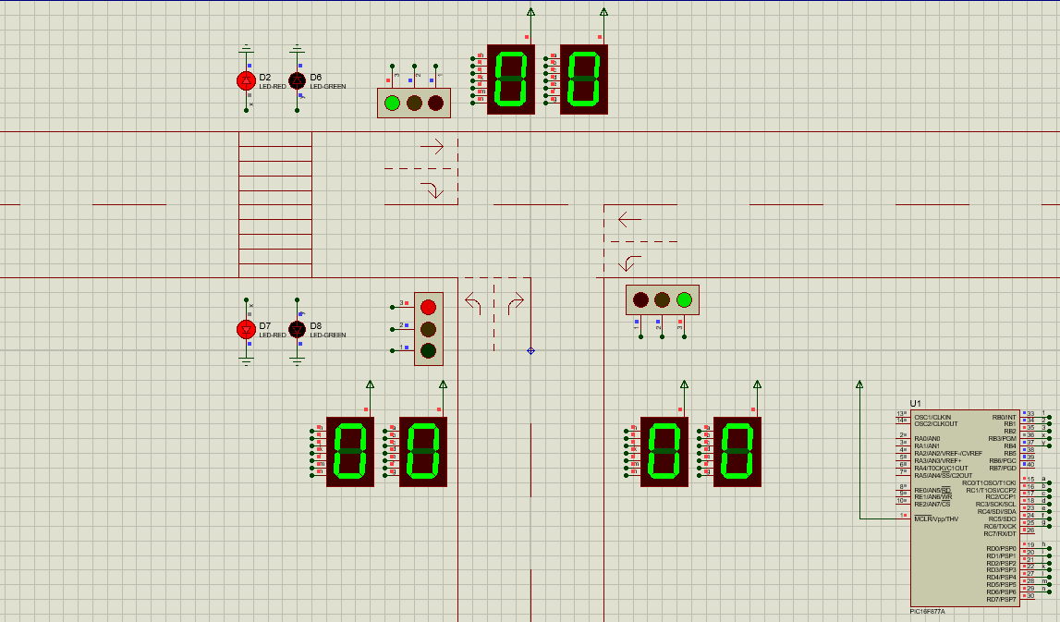
Figure 14
Figure 15 below shows how my simulation looks between 10 and 19 seconds. The two traffic lights on the ‘main’ road have changed to red, and the traffic light on the ‘side’ road has changed to green. The pedestrian LED remains red.
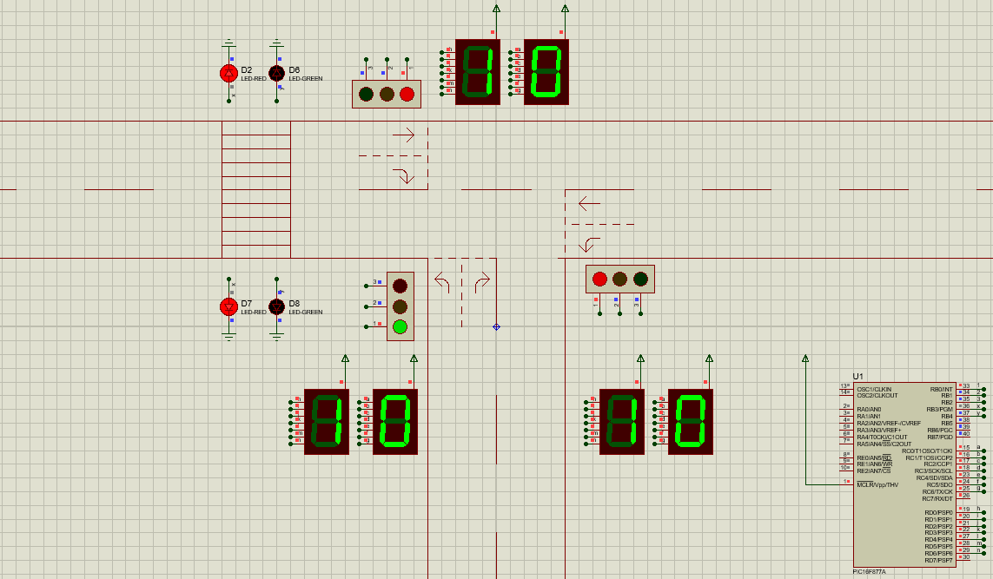
Figure 15
Figure 16 below shows how my simulation looks between 20 and 29 seconds. The two traffic lights on the ‘main’ road have reverted to green, and the traffic light on the ‘side’ road has reverted to red. The pedestrian LED remains red. This 10 seconds matches the first 10 seconds.
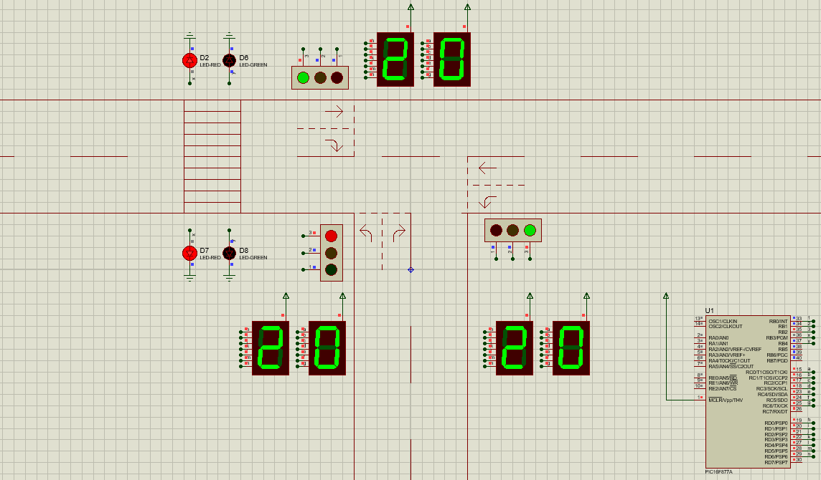
Figure 16
Figure 17 below shows how my simulation looks between 30 and 40 seconds. All traffic lights have turned off, and the pedestrian LED has changed to green, allowing pedestrians to cross safely.

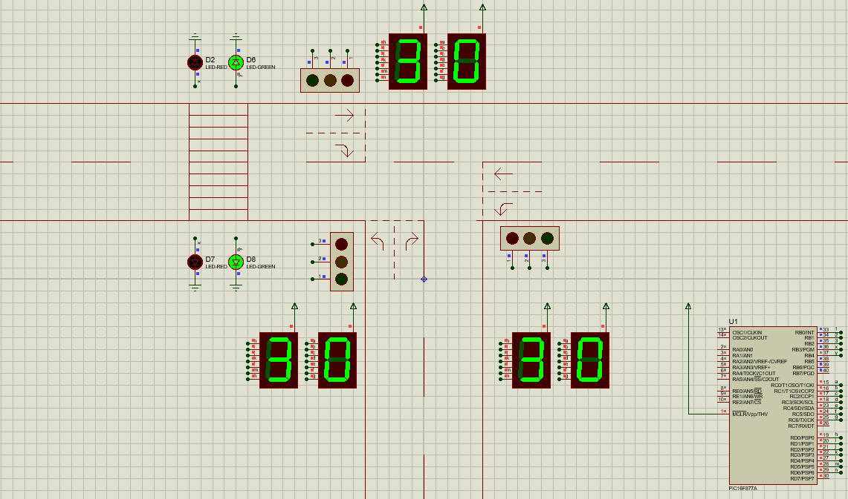
Figure 17

Conclusion

To conclude, this report shows that I can successfully create a functional traffic light system as per the specification. I have demonstrated that using an Embedded C compiler is an efficient way of coding a traffic light simulation, compared to other coding languages that could have been used.
If I were to do this task again, I would try to improve my simulation in a three areas. Firstly, I would incorporate changing all traffic lights to amber 1 second before they change to either green or red to increase realism. I would also like to make all of the traffic lights turn red when the pedestrians cross. To achieve this, I would probably have to use a PIC that has more pins to add additional variables. Finally, I would like to add some push switches to use at the pedestrian crossing, with the traffic lights turning red and allowing pedestrians to cross in the following 10 second cycle.

Bibliography

[1] Stoneacre Motor Group, “The History of Traffic Lights,” Stoneacre Motor Group, Mar. 20, 2020. https://www.stoneacre.co.uk/blog/the-history-of-traffic-lights

[2] Gov.uk, “Traffic Signs Manual,” 2019. Accessed: Dec. 12, 2023. [Online]. Available: https://assets.publishing.service.gov.uk/media/5df0e29fed915d15f42c4820/dft-traffic-signs-manual-chapter-6.pdf

[3] Gov.uk, “Light Signals Controlling Traffic,” 2019. Available: https://assets.publishing.service.gov.uk/media/560aa3f9e5274a036900001c/the-highway-code-light-signals-controlling-traffic.pdf

[4] TheEngineeringProjects, “Introduction to PIC16F877a - The Engineering Projects,” The Engineering Projects, Jun. 20, 2017. https://www.theengineeringprojects.com/2017/06/pic16f877a.html

[5] L. George, “Getting Started with PIC Microcontroller - CCS C Compiler,” electroSome, Sep. 02, 2014. https://electrosome.com/getting-started-pic-ccs-c/

[6] B. Lutkevich, “What is a Microcontroller and How Does it Work?,” IoT Agenda, Nov. 2019. https://www.techtarget.com/iotagenda/definition/microcontroller

[7] ROHM Semiconductor, “Seven-segment LED| Electronics Basics | ROHM,” www.rohm.com, 2019. https://www.rohm.com/electronics-basics/leds/seven-segment-led#:~:text=A%20seven%2Dsegment%20LED%20is

[8] G. L. Team, “Embedded C,” Great Learning Blog: Free Resources what Matters to shape your Career!, Oct. 28, 2021. https://www.mygreatlearning.com/blog/embedded-c/#:~:text=Embedded%20C%20Program%3A%20sbit&text=sbit%20variable%20name%20%3D%20SFR%20bit

[9] R. Kumar, “What is void main () into main and what it does? - UrbanPro,” UrbanPro.com, Oct. 05, 2020. https://www.urbanpro.com/c-language/what-is-void-main-into-main-and-what-it-does#:~:text=Void%20main%20()%20is%20

[10] SimpleLearn, “An Introduction to Do While Loop in C++,” Simplilearn.com, Jun. 10, 2021. https://www.simplilearn.com/tutorials/cpp-tutorial/do-while-loop-in-cpp#:~:text=Like%20other%20loops%2C%20the%20do

Appendices

Here you will find links to my Proteus file and Mikro C file as aforementioned in this report:
Proteus file: trafficlightassignment.pdsprj
Mikro C file: trafficlightassignment.mcpigroup

