UNIVERSITY OF WALES TRINITY SAINT DAVID
LONDON CAMPUS
Assessment 1

Module Name: Introduction in Web & Database Concepts
Module Code: ACCA 4023

Student Name: Jay L Boodhun
Student ID: 2531572
Group: 3

Lecturer’s Name: Dr Anum Paracha

Table of Contents
Introduction 2
GLOSSARY OF TERMS 3
Task 1: Scenario Analysis: Identification of Entities 4
Table 1a Driver ID 4
Table 1b Parking Site (FK) 4
Table 1c Parking Time (FK) 5
Table 1d Vehicle Type (FK) 5
Task 2: Using Cardinality Create an Entity Relationship Diagram. 6
Illustration 1: Conceptual data model 6
Illustration 2: Logical data model 7
Task 3: Constraints on data integrity 8
Task 4: Create a Normalization compliancy 9
Task 5: Sample Data Population 10
Table 2a Driver database 10
Table 2b- Vehicle database 10
Table 2c- Booking database 11

Task 6: Create a Query Development Design 12
Task 7: Evaluating model against its requirements 18
CONCLUSION 19

Introduction

The client AutoPark Management system want a robust database system to handle their multiple parking sites throughout the city.

As the developer this can be addressed by breaking this assignment into various tasks.

Task 1 addresses the identification of entities which are classified as objects such as drivers, and includes names with personal details, attributes which are descriptive. These are essential data to hold on a database.

Task 2 goes a step further by conceptualising both entities and their attributes relate using an Entity-Relationship Diagram (ERD) together using cardinalities.

Task 3 is about utilising MS Access by classifying the data, there it is easy to see visually how tabulating data relate to one another.

Task 4 is the importance of normalisation; a function eliminates duplication of data by simplification. Using the Third Normal Form (3NF) explains this process.

Task 5, shows data that can be put into practice acting like a test system for AutoPark Management to be implemented,

Task 6 is an advancement of task 5 by using Structured Query Language (SQL). This is the final implementation of a database by using this language to ask and seek data

Task 7, and evaluation against functional requirements

Smart parking systems have emerged to address the above challenges by providing real-time information on parking availability, optimizing space utilization, and offering convenient payment and reservation options [1]

GLOSSARY OF TERMS

Auto Park Management Systems | Auto_ParkMS
Entity-Relationship Diagram | ERD
Structured Query Language | SQL
Primary Key | PK
Foreign Key | FK
Internet of Things | IoT
Wireless Sensor Network | WSN
1st Normalised Form | 1NF
2nd Normalised Form | 2NF
3rd Normalised Form | 3NF

Task 1: Scenario Analysis: Identification of Entities
Table below shows the Entities (Name and Last Name) with its personal attributes (Email and Phone Number) together with the remaining three FK entities. All entities are all dependent on the Driver ID, which is the PK.

Table 1a Driver ID
Driver ID | Name | Last Name | Email | Phone Number (PN) | Parking Site (FK) | Parking Time _Duration (FK) | Vehicle Type (FK)
1 | Frederick | Nixon | email1 | 7000001 | 1 | 46 | Van
2 | Sharon | Guthrie | email2 | 7000002 | 3 | 96 | Car
3 | Sally | Trewick | email3 | 7000003 | 2 | 198 | Car
4 | Martin | O Neill | email4 | 7000004 | 1 | 45 | Van
5 | Kenneth | Dalglish | email5 | 7000005 | 2 | 452 | Car

Table 1b Parking Site (FK)
Parking Site | Slot Availability (Y/N) | Opening Time | Closing Time
1 | y | 8:00 | 19:00
3 | y | 8:30 | 20:00
2 | y | 7:30 | 19:00
1 | y | 8:00 | 19:00
2 | y | 7:30 | 19:00

Parking Site (corresponds to the Driver ID- shown in Table 1a) but acts like the PK. for its own composite database. Auto_ParkMS can monitor the following;
Firstly, how many sites are being used (column 1) in this case there is up to three.
Secondly, slot spaces are available (column 2) for parking, and the corresponding times for each Parking site with their own opening/ closing times (columns 3 & 4).
The reason for this could be longer opening hours for drivers accessing out of hours supermarkets (commercial usage), or shorter hours for companies who house their own staff members (business practice). This shows two different sites for two & uses. The third site may be for another priority,

Table 1c Parking Time (FK)
Parking Time_Duration | Entry Time | Exit Time | 60 mins | 120 mins | 240 mins | All Day | Payment | Booking Ref:
46 | 8:35 | 9:21 | Y | n | n | n | 2 | 1001
96 | 9:21 | 10:57 | n | Y | n | n | 2 | 1002
198 | 10:11 | 13:29 | n | n | Y | n | 5 | 1003
45 | 8:57 | 9:42 | Y | n | n | n | 2 | 1004
452 | 9:03 | 16:37 | n | n | n | Y | 10 | 1005

Where Table 1b shows the regional parking site, Table 1c records the drivers individual parking times (columns 1-3) within their chosen parking site. Columns 4-7 gives individual parking checklist and its related payment in Column 8 with the Booking reference in Column 9.

Table 1d Vehicle Type (FK)
Vehicle Type | Vehicle Length cms | Fuel Type
Van | 3000 | Diesel
Car | 2750 | Leaded
Car | 2500 | Unleaded
Van | 3000 | Unleaded
car | 4500 | Electric

Table 1d shows the composite data for vehicles showing its length (Column 2). Auto_ParkMS can decide as to whether longer parking bays are required for future development. Finally Fuel Type (Column 3), whereby Auto_ParkMS may decide to have Electric Vehicle chargers (e.g. row 5).
Based on a 2022 study on IoT parking systems, where using devices can manage/ monitor and in real-time optimise parking spaces. The system incorporates key attributes mentioned in all the tables. This IoT system is an ideal solution for the Auto_ParkMS which incorporated a graphic based study but is relevant to entities [2].

Task 2: Using Cardinality Create an Entity Relationship Diagram.

Illustration 1: Conceptual data model
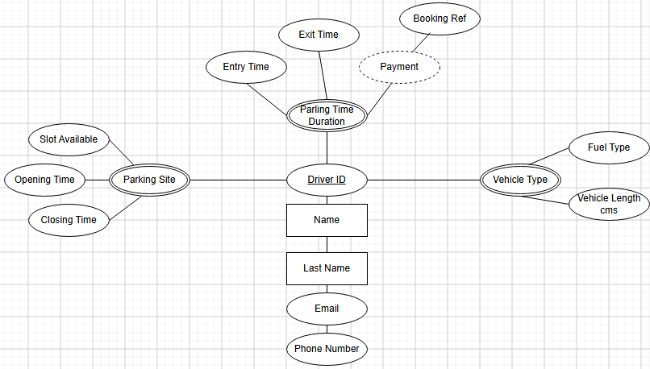

Illustration 2: Logical data model
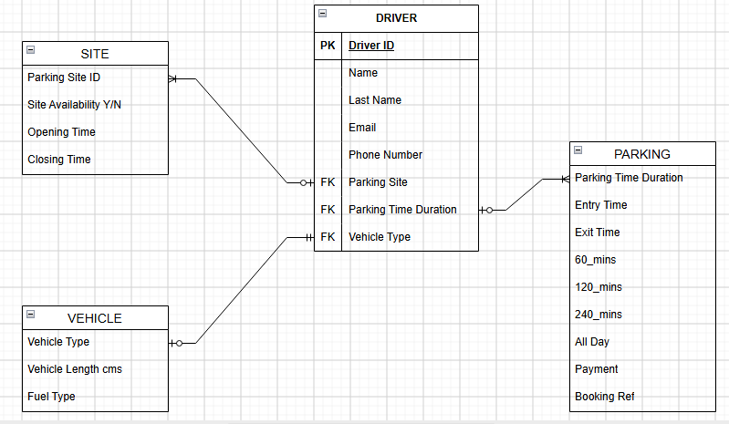
In the above example, tables “SITE” and “PARKING,” both have the 1:M (1 to Many) cardinality. This is because the Driver may use different parking sites, as they may have more than one destination, and so choose a nearer site. For the “VEHICLE,” the Driver will have one vehicle per travel (1:1)
Referencing “ creating the Conceptual Logical model etc..,” the principals of Entity Relationship and their Cardinalities (seen in illustrations 1 & 2) are essential for database design. This is fundamental for Auto_ParkMS database. [3]

Task 3: Constraints on data integrity
The levels of constraint are as follows, firstly the Driver ID is assigned as the PK for the main table. In doing do, it prevents any NULL values showing “UNIQUENESS.” This will be explained in Task 4.
Secondly, the FK ensure the relationship link to the “Driver ID.” Through the tables: Site, Parking & Vehicle tables.
Thirdly, it ensures “DOMAIN Integrity,” which is defined by the relationship by its accuracy, validity and consistency of data stored in a database. This is demonstrated by its link to Driver ID, Name, Last Name, Email, Phone Number, Parking Site, Parling Time Duration, and Vehicle Time. There is NO REDUNDANT data as all fields are used.
Here data integrity constraints are paramount, in ensuring accurate and reliable data in any relational database. This is a fundament rule when converting conceptual ERD into a logical relationship model [3]. This is a primary object for Auto_ParkMS when implementing a database management system.

Task 4: Create a Normalization compliancy

Using the 3NF, it must first eradicate redundant data/ attributes. but most importantly non key attributes must be dependent on the PK.
Before we can clarify 3NF, we must define 1NF and 2NF at the first instance. The rule for 1NF, is that every cell must be Atomic, meaning that all rows MUST be unique (having a single value and so no split values). Once 1NF has been achieved we can proceed to 2NF. 2NF states that for every non key attribute must be dependent on the PK and can be used as an FK and is linked to its composite table. Once this has been fulfilled it is then ready for 3NF.
The 3NF states that there is no transitive dependency, in other words ALL FIELDS must be dependent on the PK and not on any other keys.
Using Driver ID as the PK, we must define the following attributes FK for the Entities Entry Time/ Exit Times, Duration and finally Payment. Here Diver ID has a composite database calculating the time in minutes, The last attribute “Fee” is the parking Tariff charge e.g. Up to 2hrs (charge is £2), 2hrs to 4hrs (charge is £5), and after 4hrs (£10).
According to 2024 paper on Boyce-Codd normal form etc..,. It eliminates redundant online queries. This is due to previous poor database usage not highlighting un simplified forms. [3]

Task 5: Sample Data Population

Table 2a Driver database
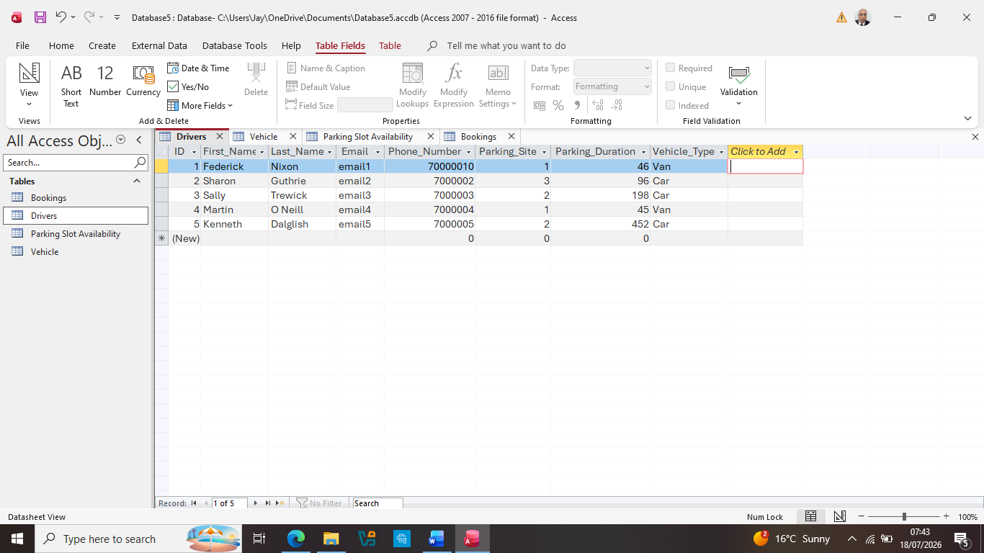

Table 2b- Vehicle database
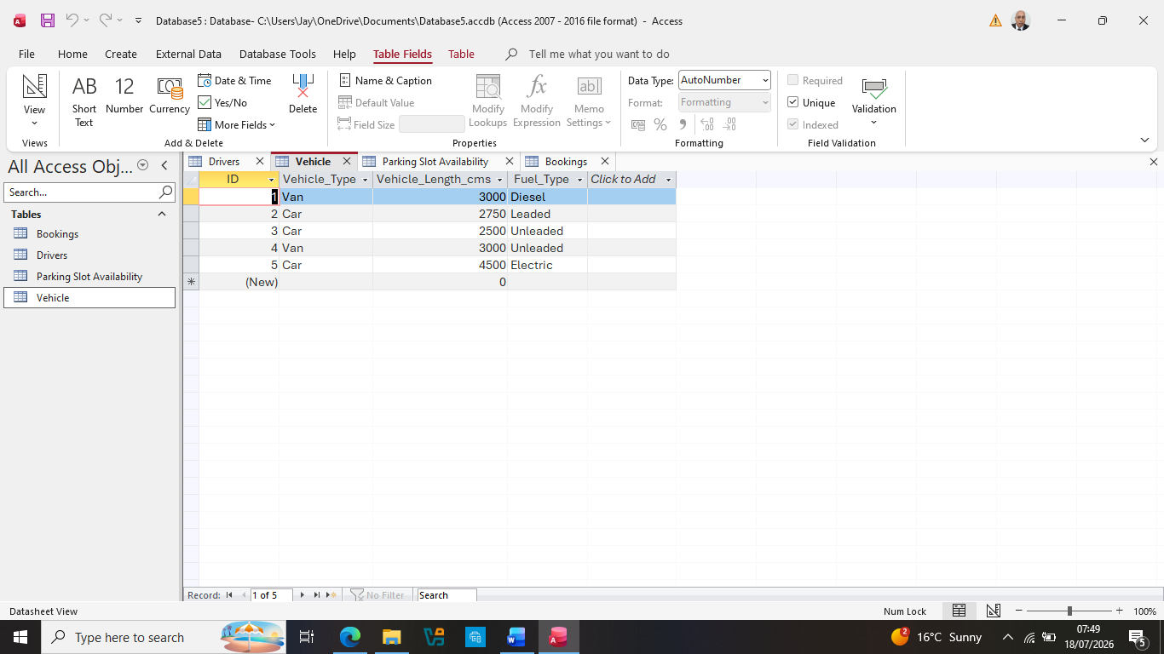

Table 2c- Booking database
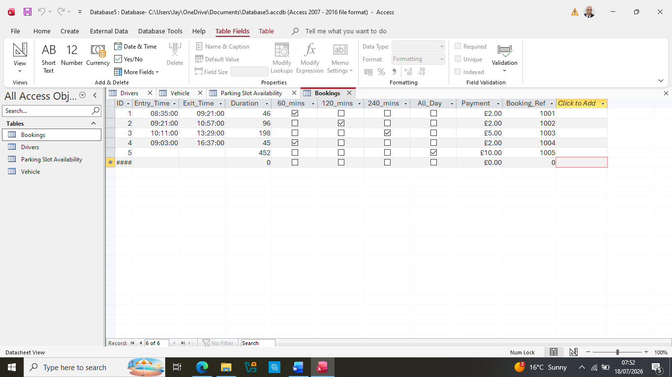

Table 2d-Parking Site: Slot Availability

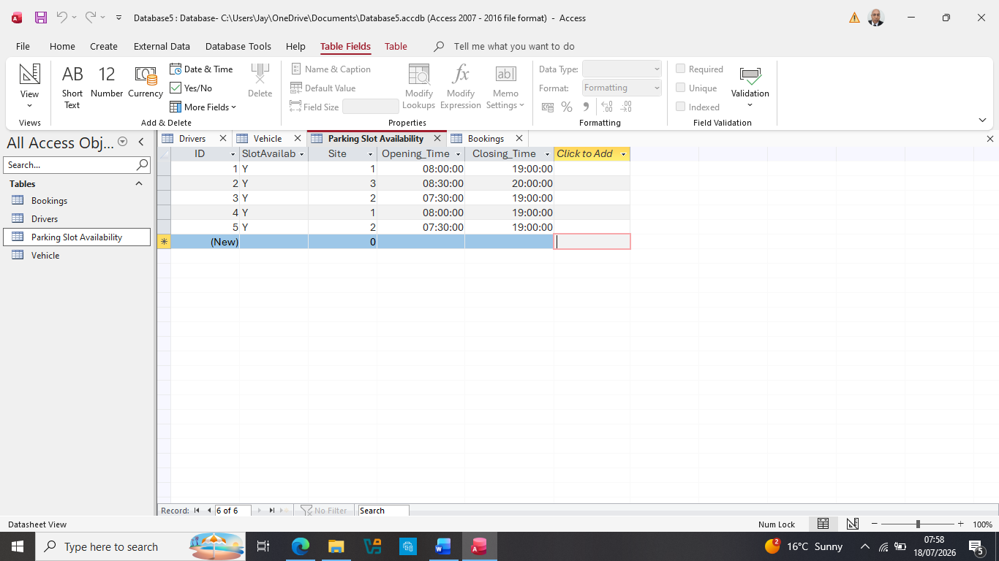
All data from Tasks 1 & 2 have been entered into MS Access. The database itself has it own formatted cells Table 2c (unique as it is the only table that incorporate the Y/N formatted cells. So this is essential for reporting drivers duration within the parking site.

Task 6: Create a Query Development Design
Question 1: Which driver(s) use Parking site 2?
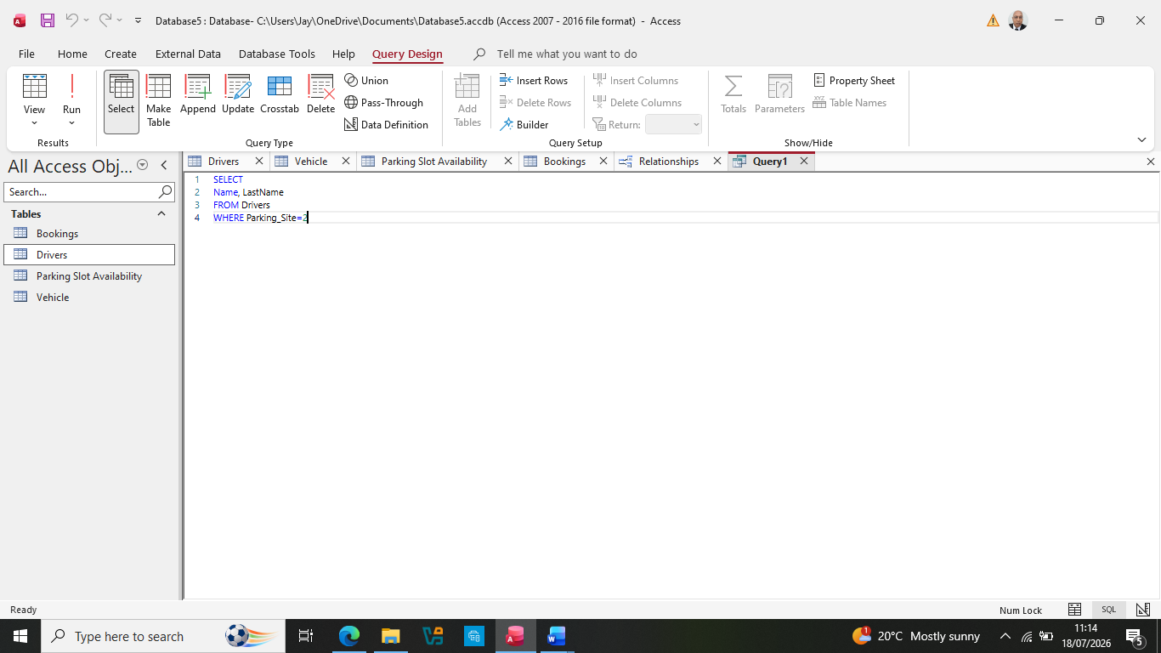
Answer:
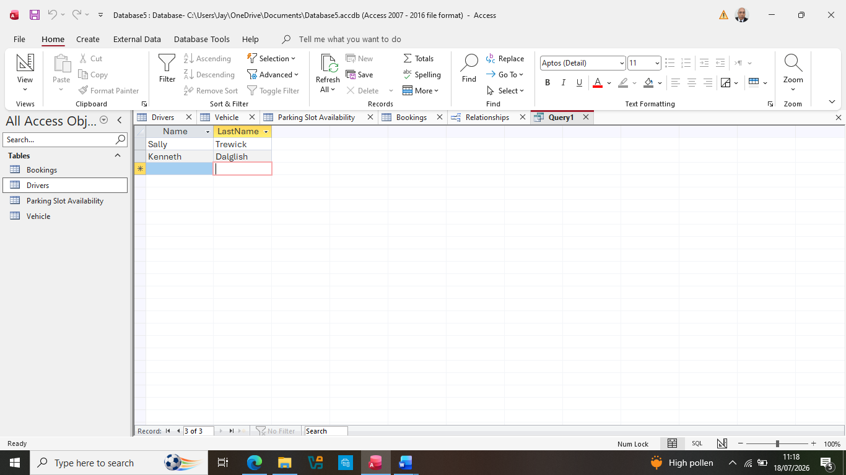
Question 2: What is the Booking Reference for the driver who paid £10.00
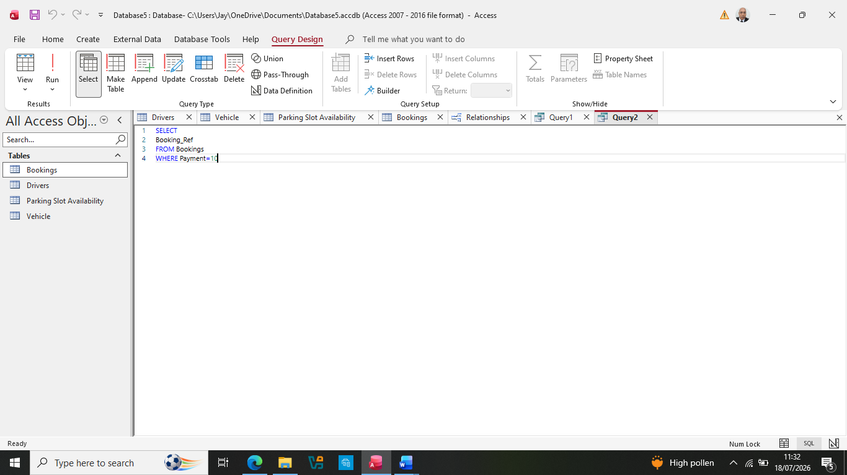
Answer
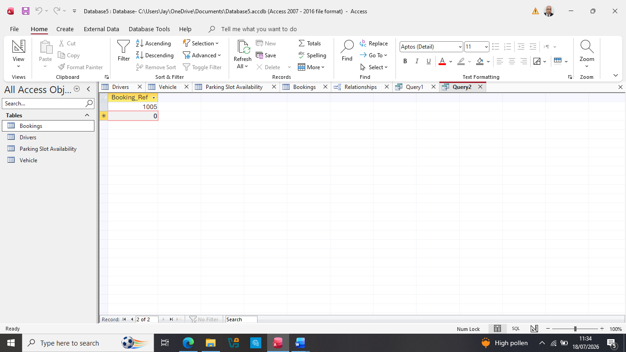
Question 3: What is the Opening/ Closing time for Site 2?
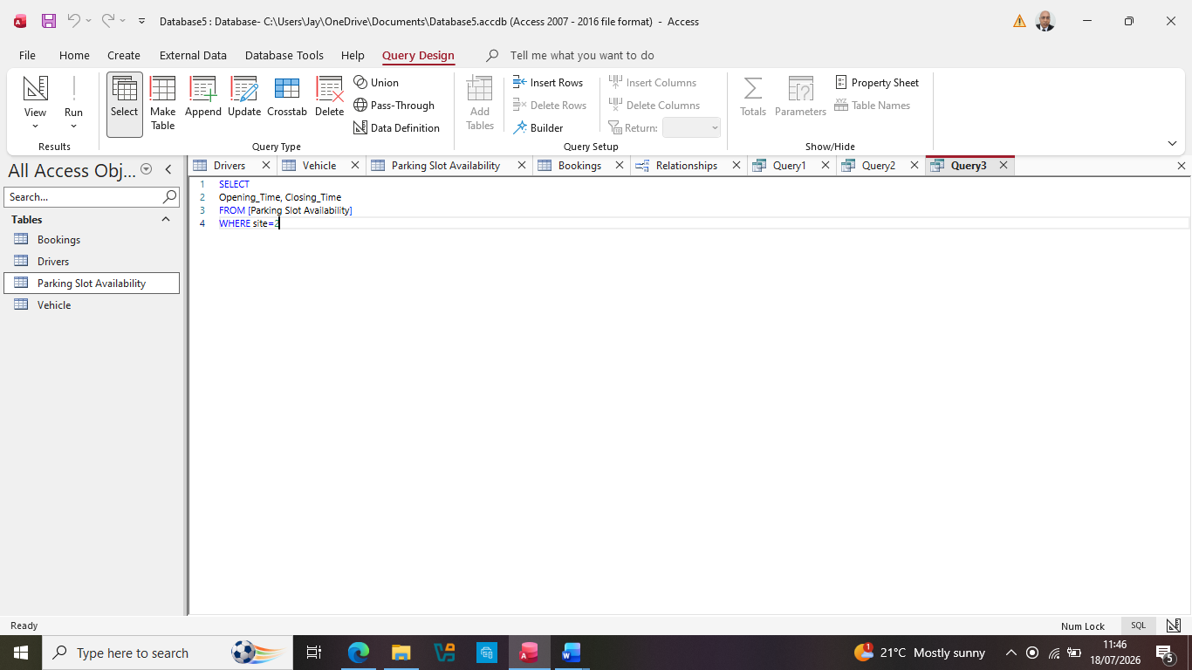
Answer
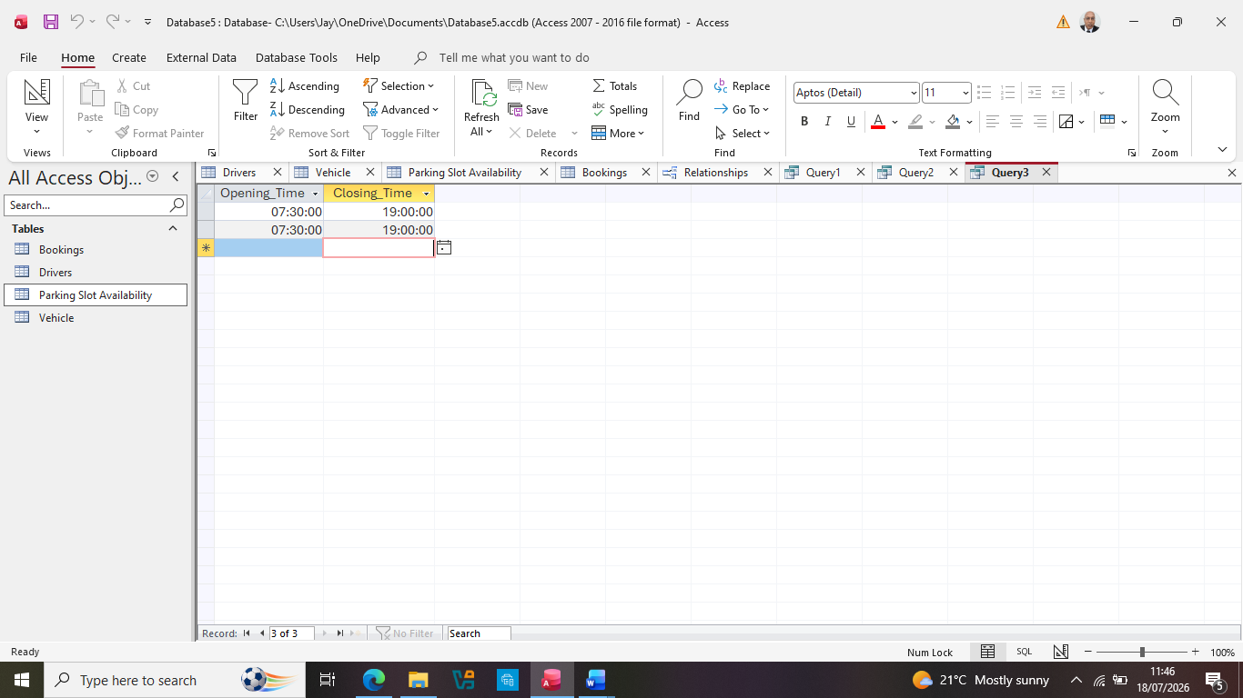
Question 4: How many Vehicles use Diesel?
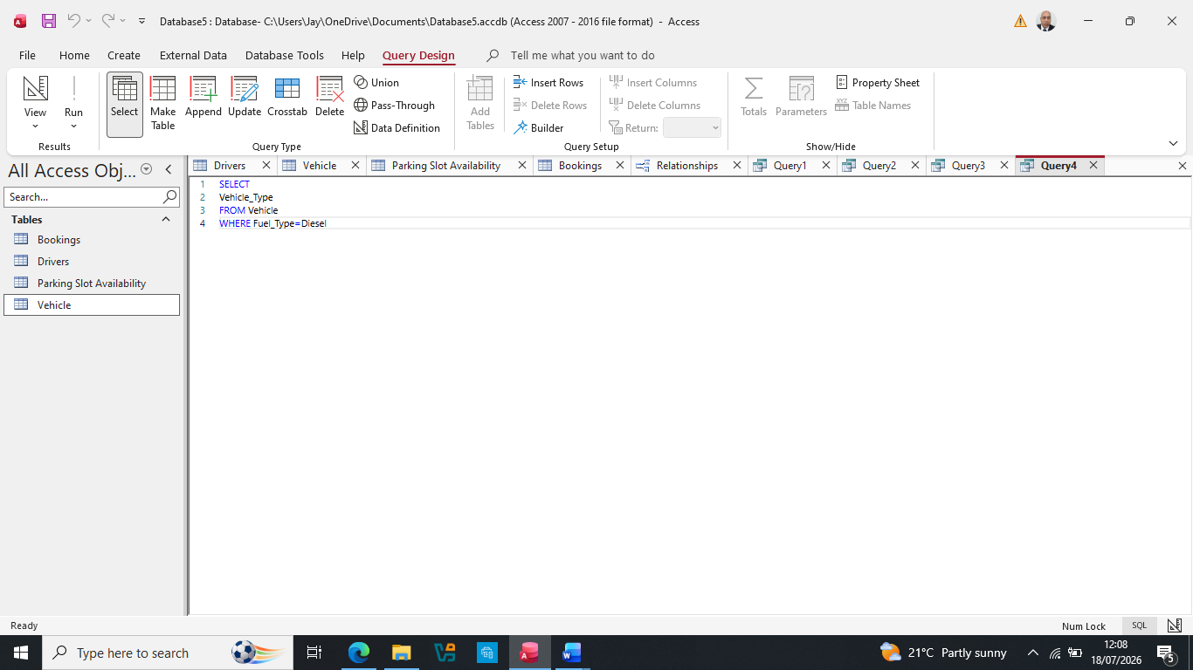
Answer
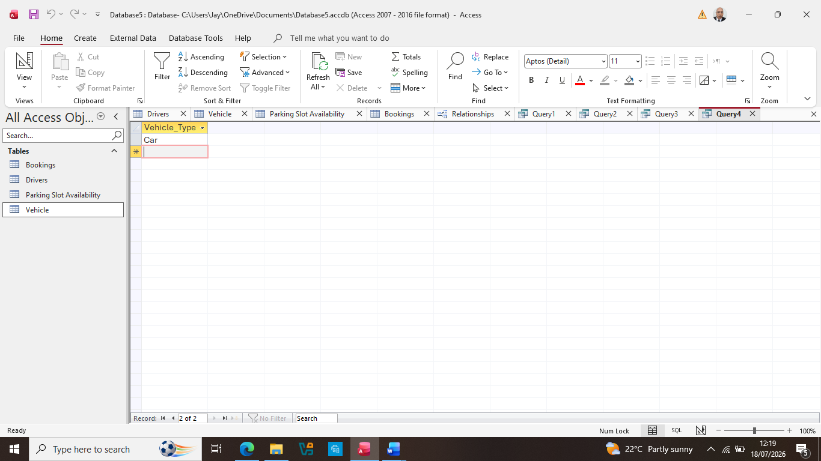
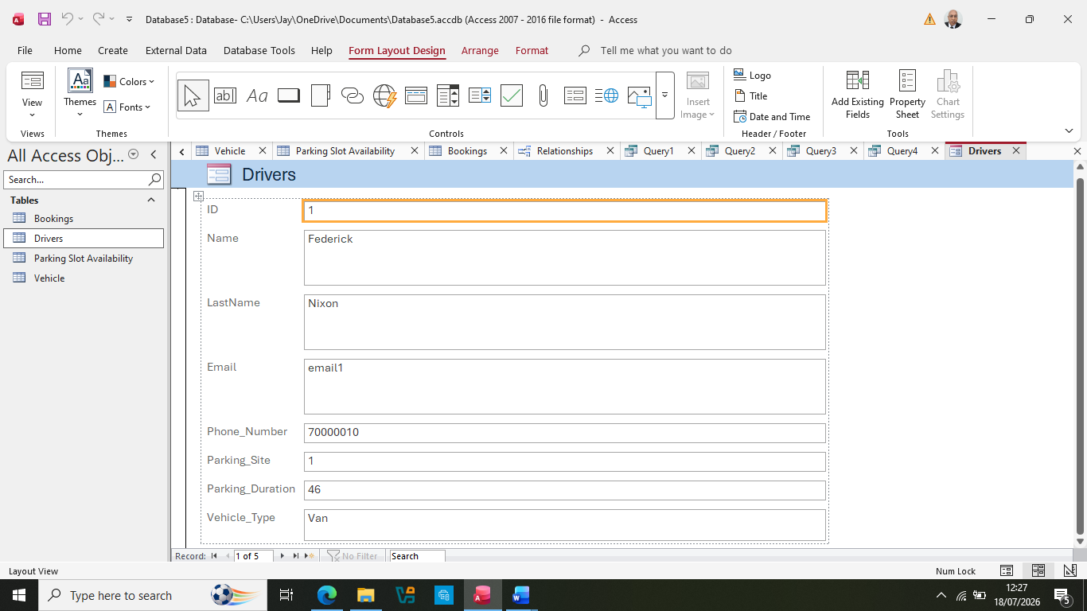
The above report being generated from Microsoft Access loaded the first Driver Frederick Nixon displaying the all the attributes mentioned in Table 2a Driver Database.
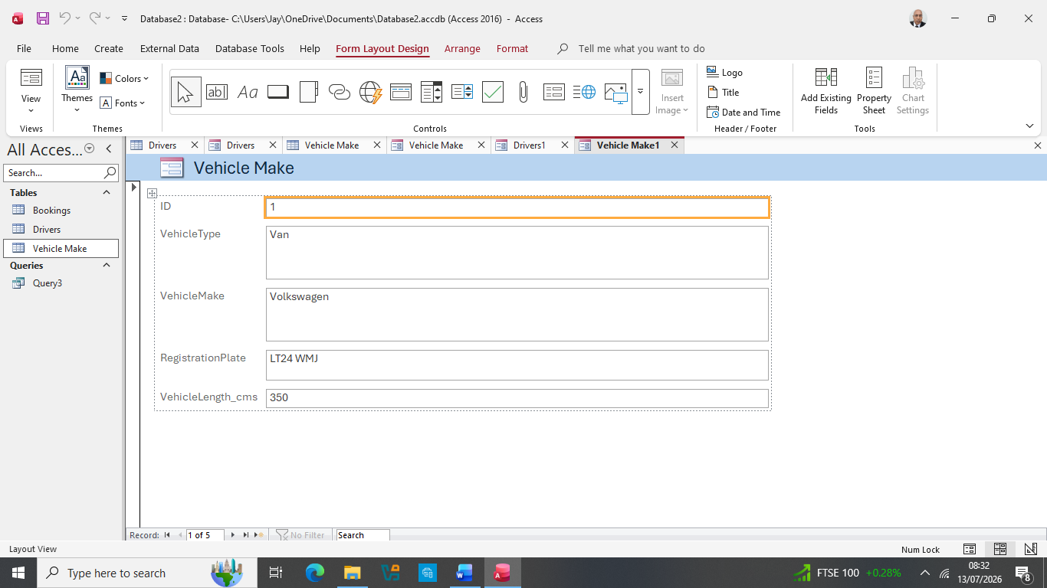
The above report generated the exact attributes from Table 2b- Vehicle Database

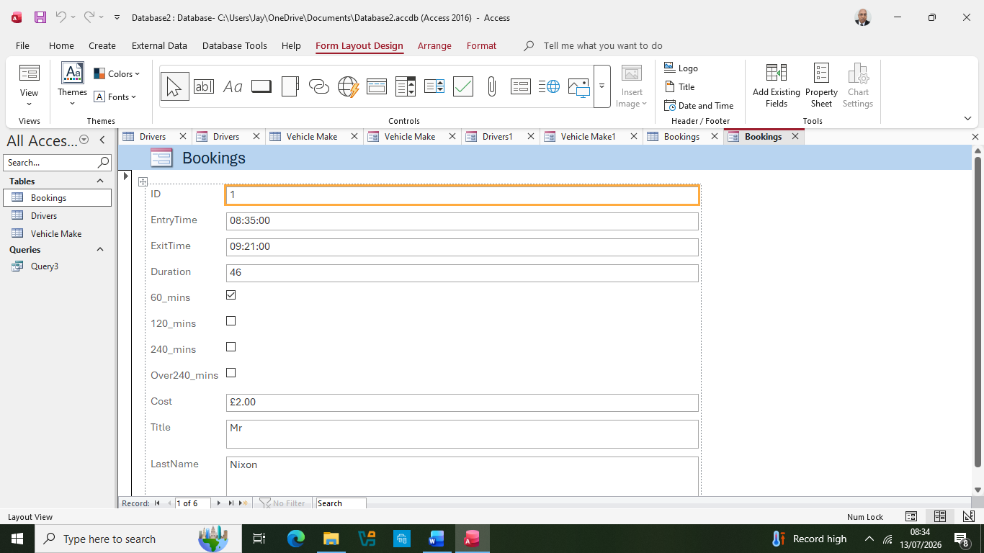
In terms of using SQL we can see that retrieval of data and the generation of reports within MS Access works. To make the most of database usage simply by using “Online Transaction Processing.” Auto_ParkMS is easy to use as a Booking system [4]

Task 7: Evaluating model against its requirements
Following task 6, although the SQL commands do perform and successfully achieve an outcome. It needs refining particularly questions 3 and 4.
Question 3 brings up 2 records (individual drivers of the site) for exit/exit times, but both records are identical. It would be better to have the appropriate SQL command to name the individual drivers who used site 2.
Question 4 asks the question of asking for the vehicle(s) that used “Diesel.” The SQL came up with the “Vehicle Type” of Car which is generic. It would be better to include various types of vehicles like Lorry, Scooters, Motorcycles or perhaps widen the attributes such as colour etc. Widening the attribute range would give a comprehensive database [4], and then with improved SQL range of commands would give a better database because of the data that is being provided. Having comprehensive database would mean that the printed forms would be more detailed and so useful as a record for Auto_ParkMS.

CONCLUSION

For the proposed database to work it requires the interaction of two parties. Firstly, the Driver and secondly the Parking Management company viz. Auto_ParkMS.
The driver can access parking sites in various ways either by visiting the site to check availability on the day, or save time by booking their parking slot online whether computer or an APP. As previously mentioned in task 1, the APP an IoT (internet of things) system technology using devices is advanced method by using sensors to control a parking barrier when entering in the site after making a booking. Although it is essential to pay for the slot beforehand the driver can have an option to for their duration time they think they will be using it for. Upon exiting the site, if they have overstayed their expected duration time then a notification can be sent via mobile phone to pay the difference or they can be re-imbursing the difference if the stay was shorter than expected. Finally, an email confirmation is sent as proof of payment listing the date, time and duration of visit.
The second party is Auto_ParkMS. To make the Booking system succeed, it must have a robust database. Conceptualising the parking model via an ERD tis essential to view the necessary requirements needed to conceive any areas that need to be fulfilled to make it achievable. The Logical model with its cardinalities brings the database into reality as we can see if there are more than one need for the driver. This is before it is loaded onto MS Access.
What MS Access provides is a structure for a booking and billing system [5] whereby the driver is the customer (user of the asset e.g. parking space) and Auto_ParkMS is the administrator of the service, generating reports on the customer’s parking usage.

References:-
[1] | Channamallu,S.S., Kermanshachi,S., Rosenberger,J.M, Pamidimukkala,A, “A Review of Smart Parking Systems,” in The Science and Development of Transport – Znanost i razvitak prometa – ZIRP 2023, Croatia, 2023.
[2] | Floris,A., Porcu,S., Atzori,L., & Girau,R, “A Social IoT-based platform for the deployment of a smart parking solution,” Elsevier, vol. 205, 2022.
[3] | G. Hampel, “Creating the conceptual and logical model of a journal database,” Analecta Technica Szegedinensia, vol. 16, no. 1, pp. 110-121, 2022.
[4] | Khan,W: Zang,C: Luo,B, “SQL and NoSQL Software Architecture Performance Analysis and Assessment,” Big Data and Cognitive Computing, vol. 7, no. 97, 2023.
[5] | Patel, A.S., Tiwara,V., Oijha,M., & Vyas,O.P, “Ontology-based detection and identification of complex event of illegal parking using SPARQL.,” Elsevier-Chaos, Solitons & Fractals, vol. 174, 2023.

