MILLIE GEORGE

An Investigation into the Socio-cultural Impacts of Small-scale, Independent Trade Events



Award BA (Hons) Degree

Dissertation – Events Management
UWTSD Swansea
(2020)

Module: BMTH6000
Tutor: Caroline Jawad
Supervisor: James Prosser

DECLARATION 1
This work has not previously been accepted in substance for any degree and is not being concurrently submitted in candidature for any degree.
Signed................................................... Date......................................................
DECLARATION 2
The researcher is currently employed within the industry and as such an extra effort will be made to keep this dissertation free from subjective validation and bias.
Signed................................................... Date......................................................
STATEMENT 1
This dissertation is being submitted in partial fulfilment of the requirements for the degree of BA Events Management.
Signed.................................................... Date......................................................
STATEMENT 2
This dissertation is the result of my own independent work/investigation, except where otherwise stated. Other sources are acknowledged by footnotes giving explicit references. A bibliography is appended.
Signed................................................... Date......................................................
STATEMENT 3
I hereby give consent for my dissertation, if accepted, to be available for photocopying and for interlibrary loan, and for the title and summary to be made available to outside organisations.
Signed...................................................... Date.........................................................
STATEMENT 4
I hereby give consent for my dissertation, if accepted, to be available on the university’s IT system to those who have consent to use the system.
Signed...................................................... Date.........................................................

Acknowledgments

Table of Contents
Abstract 6
1.0 Chapter 1 – Introduction 7
1.1.1 – Background 7
1.1.2 – Rationale 8
1.1.3 – Aims and Objectives 9
1.1.4 – Conclusion 9
2.0 Chapter 2 – Literature Review 9
2.1 – Socio-cultural Impacts of Small-scale Events 10
2.1.1 – Historical & Cultural Impacts of Small Events 11
2.1.2 – Measuring Socio-cultural Impacts 12
2.1.3 – Impacts of Increased Visitation 13
2.1.4 – Volunteering 14
2.1.5 – Social Networking 14
2.1.6 – Civic Pride and Community Well-being 16
2.1.7 – Sustainability at Small-scale Festivals 17
2.1.8 – Conclusion 18
3.0 Chapter 3 – Research Methods & Methodology 18
3.1 – Methodology Overview 18
3.1.1 - Research Onion 19
Figure 1 – Research Onion (Saunders et al, 2007) 19
3.1.2 - Paradigm & Philosophy 20
3.1.3 – Choice 21
3.1.4 - Research Approach & Purpose 21
Figure 2 – The Process of Deduction, (Bryman and Bell, 2015) 22
3.2 – Strategies 22
3.2.2 - Data Collection Methods & Analysis 22
3.2.3 – Questionnaire Design 22
3.2.4 – Pilot Study 23
3.2.5 – Analysis 23
3.2.6 - Sampling Framework 23
Figure 3 – Sampling Framework (Saunders et al, 2016, pg.276) 24
3.2.7 – Interview Design 24
3.2.8 – Time Horizon 24
3.2.9 – Sampling 25
3.3 - Limitations & Ethical Risks 25
3.3.1 - Resource Limitations 25
3.3.2 - Ethical Considerations 25
3.3.3 – Reliability & Validity 26
3.3.4 – Conclusion 26
4 Chapter 4 – Analysis 26
4.3.1 – Introduction 26
4.3.2 – Interview Analysis 26
4.3.3 – Questionnaire Analysis 26
5 Chapter 5 – Conclusion 26
5.3.1 Reflection on Analysis 26
5.3.2 – Recommendations 26
6 – Reference List 26
7 – Appendices 33
7.3.1 – Appendix 1 – Questionnaire Design 33
7.3.2 – Appendix 2 – Questionnaire Matrix Table 44
7.3.3 – Appendix 3 – Questionnaire Results 46
7.3.4 – Appendix 4 – Interview Design 46
7.3.5 – Appendix 5 - Interview Results 47
7.3.6 – Appendix 6 – Ethics Form 47
Outline any anticipated risks that may adversely affect any of the participants, the researchers and/or the University, and the steps that will be taken to address them. 56
Full risk assessment completed and appended? 56
7.3.7 – Appendix 7 – Interview Consent Form 66
7.3.8 – Appendix 8 – Gantt Chart 67
Figure 3 – Gantt Chart. 68

Abstract
COVID19
After the UK implemented a 24-hour curfew in March 2020, UWTSD took steps to support the research student and research during the curfew and University building closures.
Formal supervision meetings continued as much as possible and arranged via suitable meeting software and documents shared electronically.
Some research was at greater risk to delays, for example projects requiring physical presence to undertake interviews, fieldwork or data collection. Supervisors and research students urgently reviewed their research plans. UWTSD understands that some students’ projects and dissertations were planned to require in-person research and data collection that is not possible in this period of remote learning. Digital research activities that advance the studies, were prioritised. If it was no longer possible to continue with the existing plan then consideration to changes to the project plan should be considered to offset, wherever possible, undue future delays to the project/dissertation submission. All fieldwork conducted by students occurred remotely using electronic means wherever possible.

Chapter 1 – Introduction
This study aims to analyse the socio-cultural impacts of small-scale, independent events in Swansea. Previous studies conducted to investigate the socio-cultural impacts that events have on the community, suggest that one of the biggest research areas in events is the atmosphere and how a consumer felt during and after their ‘experience’, (Getz, 2007). Berridge (2008) states that ‘experiences result from engaging people in a personal way’, meaning that if an event has the power to provide an individual with a unique and meaningful experience, it will be more memorable to the individual, creating a long-lasting effect.
Socio-cultural impacts are formed through the emotional connection an event has with its attendees, this has therefore increased participation levels for events, as there is a need for experience and being a part of the atmosphere. The demand for new technology and entertainment has also increased as a result, (Getz, 2007). The cultural aspects of events refer to participants gaining a new knowledge into community tradition; this emotionally engages them with the event and allows them to make new connections outside their local area, (Getz, 2007). Furthermore, social experiences are generated from planned events, resulting in leisure. Therefore, it could be said that events are the catalyst to shaping the authenticity of events in our minds to explain experiences, resulting in a socio-cultural impact, (Getz, 2007).

– Background
The Uplands Market in Swansea was created in 2013 by a creative regeneration agency called Urban Foundry, whom are a social enterprise, not for profit business. This development was accompanied by the influences of Swansea Council, Swansea residents and the local Assembly Member, following the success of this, the Marina Market was produced.
The development of the markets has produced many job opportunities in the local community, increased secondary spending in the area and enhanced the popularity of local businesses. Many traders at the market have used the development as a catalyst for developing their business, encouraging a range of businesses to set up in the local community, due to increased popularity.
The Uplands Market was ‘ranked in the top 10 street markets in the UK by the Daily Telegraph’, nominated as a runner up in the Observer Food Monthly twice in the best food markets category, and has been nominated in the BBC’s Food and Farming Awards, (Uplands Market, 2020).
The markets also have many aims, such as, to ‘bring quality Welsh produce to the community’, therefore, enhancing the local culture, ‘increase footfall’, resulting in an increased capital in Swansea, ‘provide opportunities’, and to ‘demonstrate the value of and new qualities of public space’, which would in turn increase satisfaction of locals and civic pride in the destination, (Uplands Market, 2020).

– Rationale
Community events portray an area’s identity and image, (Derett, 2000). These small-scale events, such as local food and craft markets, have the power to motivate participation and bring a community together, resulting in a community feel-good factor and a further need for the community to celebrate their identity, (Douglas et al., 2000). Getz further defines these small-scale events as not only having a direct socio-cultural effect on the community in which it is held, but also to a wider host community, (Getz, 1997). Furthermore, ‘Cultural tourism is the movement of people towards cultural attractions, somewhere other than their habitual place of residence, in order to obtain information and knowledge to fulfil their own cultural demands’, (Jovicic, 2016). This statement is also conveyed by Small, Edwards & Sheridan (2005) who states that the exclusive interaction between the visitors of an event and its locals is the founding for socio-cultural impacts, (Small, Edwards & Sheridan, 2005). These interactions continue to encourage the positives of tourism to the resident; however, they can also demonstrate negatives, due to disruption and overcrowding, (Small, 2005).
There is a growing need to measure social and cultural impacts, both by event theorists and planners. If a community event generates frustration, it can be detrimental to future success, therefore, no legacy of the event is left behind and it is deemed unsustainable, (Bowdin et al., 2006).
Getz (2007) defines cultural experiences as understanding and wanting to learn something new to share with friends and family in a community, that creates a sense of belonging and involvement, (Getz, 2007). Bowdin supports Getz’s definition through his theory that communities that share their culture gain an increased sense of passion and pride for where they live, therefore, increasing the sense of identity, (Bowdin et al, 2011). However, Getz also states that there is a lack of research to support how events socially impact a community and more must be done, (Getz, 2007).

– Aims and Objectives
The aim of this study is to critically analyse the socio-cultural factors of small scale, independent events, with particular interest to pop up markets in Swansea, to determine whether the events can contribute to the well-being of a community.
Extensive research has been carried out to complete this investigation in order to meet the below objectives:
- To investigate whether small-scale event can contribute to the well-being of a community.
- To examine whether the event is capable of building community networks and providing new skills for the participants.
- To analyse and provide recommendations as to how a community event can leave a legacy behind, and ensure the event is sustainable.

– Conclusion
This section has assessed the socio-cultural impacts that community events have the power to generate. Investigating the perceptions of locals at a small-scale community event, focussing on personnel involved and shoppers at the markets, to establish whether the markets contribute to the well-being of the community. The main goal of this research was to meet the aims and objectives set.

Chapter 2 – Literature Review
This literature review is intended to assess the socio-cultural benefits generated from a community event, and the secondary research collected previously in the area.
As people are the most socially advanced species, we acquire social interactions which encourage events to take place, (Bladen et al, 2012). Maslow expands this theory through his development of six social needs which are relatively satisfied through social relationships with friends and family, these needs are, Self-actualisation, Esteem, Love, Belonging, Safety and Physiological, (Maslow, 1943). Bladen refers back to these factors as key to the motivations that are triggered as a result of events, (Bladen et al, 2012). These feelings influence human behaviour, for example, community events can enhance an individual’s personal development, a feeling of success and a need or aspiration.
Community events have become increasingly popular over recent years, due to both positive and negative impacts on the locals. This has encouraged theorists to investigate the impacts events deliver and more specifically, the socio-cultural impacts they provide to a host community has seen an increase in interest to research by theorists, (Small, 2005). However, there is still a need for a further increase in literature on social impacts as many theorists mainly focus on the economic impacts that events generate, (Grosbois, 2009). The need for social impact studies is important as events provide long lasting effects on the well-being and social inclusion of a community, which acts as a catalyst for further events to be developed in the local area.
The image of a host area can also be enhanced by events, through infrastructure developments and a long-lasting legacy if the projects are utilised well post-event, which in turn contributed to the tourist’s economy, (Derrett, 2004).
Furthermore, the increased theories on social impacts have resulted in researchers offering frameworks and assessment techniques for evaluating the societal impacts an event provides, (Grosbois, 2009). Some researchers which have done this are Getz, 2007; Ritchie 1984 and Dwyer et al, 2000, whom all examine whether events create positive experiences and involvement for both residents and tourists in the host area, (Groisbois, 2009).

– Socio-cultural Impacts of Small-scale Events
Ritchie (1984) developed a theoretical framework in order to assess an event’s impacts, both positive and negative. This assessment was concerned with means of tourism, economic factors, socio-cultural, physical factors, psychology and politics. Ritchie (1984) found that the socio-cultural impacts from events positively included participation levels and interests in community events, improved social relationships due to enhanced volunteer levels, an increase in traditions and values in an area and a growth in attention and contribution levels around the subject the event provided, (Ritchie, 1984). However, the study also found that there was a tendency for offensive behaviour towards foreign participants, resulting in host/visitor hostility, (Grosbois, 2009). Another negative impact generated from events was that when the events were being adapted and infrastructure was being developed in order to accommodate visitors for the event, a negative perception in the local community was created, due to a disturbed community life, (Grosbois, 2009).
Dwyer (2000) further introduced a version of the positive and negative effects an event has on a community. The benefits included in the study were education, civic pride, increased reputation of the host area and community participation. However, Dwyer also argued that a large disruption to community life comes along with events, for example, noise pollution, crowding, congested roads, crime and damage to property, (Dwyer et al, 2000).
Both studies discussed state varying frameworks to assess the socio-cultural impacts of a community event, therefore, it is difficult to compare events studies or to analyse whether events to positively develop the host area, meaning that there is a need for continued research in this field.

– Historical & Cultural Impacts of Small Events
Events have the capability to encompass traditions to pass on to the local community through procreating historical and cultural festivals, (Arcodia & Robb, 2000). These community events have the ability to encourage visitors to attend to experience a new culture and endure a new activity to provide them with skills and knowledge about the host destination and if utilised well, it may encourage tourists to visit the host area again and put the community on the map with a high reputation. However, Abraham and Waldren (1997) suggest that communities do not have a particular identity or culture and therefore, the engagement with cultured events brings them together as a ‘community’, (Abraham & Waldren, 1997). However, Taylor & Francis (2006) state that community identity is ‘strengthened’ through hosting events, (Taylor & Francis, 2006).
Getz (2012) states that small, community festivals, can sometimes lack resources, knowledge and expertise to carry out a successful event, (Getz, 2012). Additionally, communities are compelled to be self-supporting by authorities in managing and planning the event, (Reid, 2011).
Events also encounter a number of negative socio-cultural impacts. Timothy (2011) suggests that these are ‘conflicting use of social space; cultural change; cultural commodification or disharmonious resident-tourist or destination-tourism relations’, (Timothy, 2011). Conversely, Getz (2008, 2012) suggests that the subject of ‘touristification’ of community events has very little research surrounding it and events pose on the destinations that possess them. There are many opposing arguments as to whether tourism adds to the negative impacts of cultural festivals, or the reasons the impacts develop, (Noronha, 1977). Furthermore, it could be said that that negative impacts can be caused from management techniques, suggesting that managers need to utilise effective planning strategies in an attempt to minimise any harmful outcomes. Barrio et al (2012) goes on to suggest that ‘from the analytical point, interest now lies in highlighting that all these new cultural expressions have become part of citizens demands and particularly as a means whereby they engage tourism’, (Barrio et al, 2012).
Event managers have the opportunities to encourage tourists to visit the local area through expressing a community’s culture and heritage. Research on both tourism and anthropology literature have investigated residential outlooks on tourism and have found that there are positive perceptions surrounding economic development, but negative thoughts on how the event is negatively affecting the destinations landscape and environment, Pavlic et al, (2015).

– Measuring Socio-cultural Impacts
Although there will always be both negative and positive impacts as a result of an event, managers will always have an aim to achieve which is both desired and predicted, (Getz, 2007). In order for this to be done successfully event planners follow strategies and tests designed by researchers to both predict outcomes in an attempt to minimise any negativity, but also post-event tests in order to revise strategies to improve for future events.
it could be said that that negative impacts can be caused from management techniques, suggesting that managers need to utilise effective planning strategies in an attempt to minimise any harmful outcomes. Therefore, Fredline, Jago & Deery (2003), invented the Generic Scale which measures all impacts generated as a result of running a community event. Fredline (2003) encompassed six factors in his scale such as, social and economic impacts, inconvenience and justice issues, issues affecting public facilities, behaviour and environment, community impacts in the long-term, and impacts on goods and services, (Fredline, Jago & Deery, 2003). The aim of this scale is to assess the resident’s quality of life, expand local businesses and advance social networks. Additionally, in 2007, Small formulated the Social Impact Perception Scale to identify the reliability and validity of social perceptions, the scale also provided six aspects. These are personal frustration, inconvenience, community identity and cohesion, opportunities for socialization, entertainment and community development, (Small, 2007), (Woosnam & Aleshinloye, 2018). These scales can determine positive social opportunities for participation and new connections and skills that can become of a small-scale event. However, costs in the area, crime and congestion rates may be inflated as a result of hosting a community event, which in turn would create disruption to community lifestyle.
The impacts discussed mainly arise from increased visitation in the area and if strategies are not put in place to minimise the negative effects, both civic pride and the regional reputation of the area can be damaged, (De Bres & Davis, 2001). On the other hand, both Getz (2010) and Felsenstein (2003) agree that local residents view events as a means of economic development, resulting in residents accepting tourism, (Getz, 2010), (Felsenstein, 2003), resulting in an overall increase in civic pride and a content lifestyle for locals, in turn providing the event with a long-lasting legacy, (Woosnam & Aleshinlove, 2018).

– Impacts of Increased Visitation
Small (2005) conveys that social interactions occur as a result of increased tourism in an area. This is due to small communities advertising their destination on the global events map encouraging socio-cultural impacts to arise as a result of the new increase in visitation, (Small, 2005). Delemere, Wankel and Hinch (2001) devised a scale assessing socio-cultural impacts at festivals as a result of tourism, (Delemere et al, 2001). The study used a Nominal Group Technique which enabled initial socio-cultural impacts at community festivals to develop, (Small, 2005). However, the study also found negative aspects such as over-crowding, which resulted in a disruption to locals lives, if this issue is not managed effectively by planners, residents may lose their sense of civic pride for their community and end up being pushed out.
Pavlic et al (2015) states that acknowledging residents’ perceptions of tourism is crucial to ensure they have a content community life and therefore, support further projects, (Pavlic et al, 2015). However, a study by Griffiths and Sharpley (2012), which assessed locals and visitors as separate subjects at a festival, ‘as members of the “in” and “out” group’, proved that connections were not present between the community and tourists, and that locals understood the positive social aspects events generate, but also, recognised the negative environmental issues that damaged their community, (Griffiths & Sharpley, 2012). These results may be damaging to future tourism development due to dissatisfaction of residents.
Stylidis (2014) reviewed place image in communities and how increased visitation impacts their support for forthcoming tourism plans in their area, (Stylidis, 2014). The study showed that when environmental, economic and socio-cultural impacts are all compared together, locals have an increased approval for future projects, due to community participation, quality of life and individual benefits. In order to create further social groups generated through events, research will need to be expanded in order to encourage residents and visitors to connect with one another.

– Volunteering
Volunteers are a vital component in event planning, ‘which can comprise a range of different types of employees including paid staff, external suppliers and contractors’, (Page, S. & Connell, J, 2012, pp. 316). Clary and Snyder (1999) go on to convey that it is essential to inspire volunteers to ensure that they are motivated to devote their time and effort to the event, without anticipating any financial gain, (Clary & Snyder, 1999). Bladen (2012) more recently suggests that the success of many events is driven by the determination of the volunteers, (Bladen et al, 2012). Nevertheless, Tyson (2000) states that motivation is ‘an inner force that impels individuals to behave in a variety of ways’, (Tyson, 2000).
Getz (2007) suggests that volunteers whom have an enjoyable experience while working at an event will be more motivated to put in effort than others, (Getz, 2007). However, a study by Clary and Snyder (1999) found that the main motivational factors for volunteers were career progression, the importance of helping other people, community participation and other social factors such as networking with peers whom have similar interests, (Clary & Snyder, 1999).
Furthermore, Thoits and Hewitt (2001) insinuate that the socio-cultural benefits that volunteers encounter while working at an event are higher self-esteem levels and improved mental health, (Thoits & Hewitt, 2001). However, Wilson (2000) devised these motivations into two factors, being symbolic and psychological reasons. Wilson suggests that social influences such as networking and interactions, would enthuse people to work at an event for free, giving up their resources and time. Whereas, psychological influences would relate to serotonin levels and self-esteem being raised as a result of volunteering, (Wilson, 2000).
Many of the studies conducted have focussed mainly on small, repeated events and human resource motivation theories, which may suggest there is a need to provide practical and concrete explanations for the motivation of a volunteer, (Bladen et al, 2012).

– Social Networking
Many studies have been constructed to assess the impacts of ‘social capital’, ‘community self-worth’, ‘civic pride’, ‘social belonging’, ‘quality of life’ and ‘place identity’ of small-scale community events, (Fredline & Faulkner, 2000). However, theorists tend to have varied definitions of these concepts, making it unclear as to definite concept of socio-cultural impacts, (Groisbois, 2009). Narayan defines social capital as ‘the norms and social relations embedded in the social structures of societies that enable people to achieve desired goals’, (Narayan, 1999).
According to Kelly and Kelly (2000) social networking in events in mainly concerned with socio-cultural cohesion, local identity, local company developments, the regeneration of local facilities and knowledge on the culture and heritage of the host destination, (Kelly & Kelly, 2000). A further study by Mackeller (2007) investigated the networks that are generated from small-scale events, the community interactions it provides and the motivation this gives to other communities to develop, (Mackeller, 2007). The event experience is largely created from social interactions and connections and this gives the opportunity for a community to understand the strength of their local relationships and attempt to improve them. Also, infrastructure can be maintained through local support and both social and community networking has the power to link sub-groups to participate, this would also ensure an event legacy is left behind.
An opposing framework devised by Wood (2006) assessed locals’ perceptions before and after an event to identify the overall social capital and civic pride in the area. Wood (2006) found that social networking is made through ‘trust, networks and participation’, whereby, civic pride is more effective as ‘it relates to feeling and attitude and does not act as a precursor to behavioural change’, (Wood, 2006). Furthermore, a theory by Schulenkorf (2009) examined groups of attendees and their social capital, and found that sporting events have the power to decrease ‘intergroup conflict’, improve community identity, and improve the ‘quality of life’ for residents through social capital being established, (Schulenkorf, 2009). Despite there being many theories on social networking, the use of different frameworks and theories has led to disjointed research on the topic.
Festivals are often recognised as being reliant on social networks, (Derrett, 2003). Derrett (2003) interviewed a variety of festival attendees and found that the majority of the data was based on relationship connections, and that festivals were a catalyst for old connections to be re-created and new ones to be formed, but the majority believed that existing relationships were the main driver, (Black, 2016). These interactions have the power to reunify a community and form new relationships with visitors to create long lasting connections, therefore, encouraging a positive reputation of the host area.
Festivals provide the time for participants to share an experience with loved ones and bonded networks with a number of communities without a restricted place, (Black, 2016). This allows them to make social connections to a wider demographic beyond their usual residence, (Black, 2016). Bowen (2013) further labels festivals as a ‘unique’ display of artwork, (Bowen, 2013), suggesting a cultural experience. In order for an event to be perceived as open to foreign communities, a balance of both internal and external networks must be made to avoid becoming ‘exclusive or inward looking’, (Macnab et al, 2010). Many connections were specified by attendees concerning more formal connections prompted through the participation of local groups and businesses and informal individual connections through personal involvement. Also, the participants recognised that the festival planners did not do enough to ensure connections through the community were made and perceived a low level of native content and opportunities, (Black, 2016). Furthermore, cultural impacts were assessed to connect tourists with the host community, and through interviewing festival participants it was found that there was a decreased impact in heritage and inauthenticity of the community culture was shown, (Black, 2016). Event managers must ensure that heritage is connected to the event in order to provide the area with connections between locals and visitors.

– Civic Pride and Community Well-being
The well-being of the community is a necessity for gaining local support of any events being planned, it is a main focus point of most policy deliberations and projects. Another reason community well-being is vital in event assessment is that it gives an insight into how locals reflect on their area and their civic pride of the destination, (Chen. Lehto & Cai, 2013). There are many elements that effect a residents’ perception of their community and well-being, however, theorists suggest that events that provide people with opportunities to increase social networks and linking with attendees with similar interests, (Chang, Wray & Lin, 2014).
An individual’s well-being can be defined as ‘a person’s cognitive and affective evaluations of his or her life’, (Diener & Suh, 1997). Diener & Suh evaluated how an individual’s emotions and feelings generated from an event can influence their ‘life satisfaction’ and fulfilment, (Diener & Suh, 1997).
Ryan and Frederick (1997) believe that ‘competence, independence and relatedness’ are essential needs to impact an individual’s ‘experience’ and ‘well-being’, (Ryan and Frederick, 1997), and that without these needs a person cannot thrive from an event, (Ryan and Deci, 2000). Events have the power to provide their attendees with fundamental opportunities and goals, such as, socialising, spending time with loved ones, self-actualisation, learning new skills and community participation and pride, resulting in basic human needs being satisfied, (Yolal et al, 2015).
A host community can gain a positive ‘identity between residents’ while also creating connections between locals and tourists through providing cultural exchange, (Arcodia & Whitford, 2006). Theorists also state that recreational prospects and amusement is also provided to residents, resulting in an increased civic pride, (Arcodia & Whitford, 2006). However, Leenders, Go and Bhansing (2015) convey that community festivals bring negative socio-cultural affects to residents, resulting in a decrease in identity and pride and losing a sense of community culture, (Leenders et al, 2015). Nevertheless, there is many theorists whom have found that the positive social influences overshadow the negative, leaving an overall ‘feel-good’ factor in the host community.

– Sustainability at Small-scale Festivals
UNESCO (2003) defines community festivals as ‘the living expressions and traditions inherited by communities and transmitted to their descendants’, (UNESCO, 2003). Additionally, Black (2016) believe that events are able to be sustainable through prolonging traditional values and cultures as this provides a ‘consistent opportunities for cultural display, participation and engagement’, (Black, 2016). However, Highmore (2016) believes that culture refers to social interaction and economic values, and that in terms of social sustainability, ‘social cohesion’ is vital to a ‘fragmented and disenfranchised social scene’, (Highmore, 2016).
A study by Putman (2000) portrays that a community that claims to be ‘socially sustainable’ still need to ensure connections are made through ‘exchanging knowledge’ through these possibilities as it positively impacts the end result, (Putman, 2000). Conversely, Coalter (2017) conveys Putman as being basic, and over-simplifying the negative issues that occur, while exaggerating the benefits, (Stevenson, 2016). Furthermore, Derrett (2005) produced a model recognising the link between events and social stability in a community, (Derrett, 2005). Derrett (2005) goes on to say that festivals, through their range of heritage and culture, have the ability to handover and share authority to local stakeholders, (Derrett, 2005), (Black, 2016). Black’s (2016) theory showed that even though there are opportunities to connect with stakeholders and foreign communities, strategies and concepts must be both pioneering and culturally appropriate, (Black, 2016).
Sustainability in communities contrasts due to the varying governing bodies in a range of diverse destinations, meaning that the position of verdict-making authority varies, (Stevenson, 2016). Due to this, it is difficult to be known as a sustainable community and development can be strained due to authority issues, (Yang, Ryan & Zhang, 2014). Additionally, issues such as, poverty and low employment rates in an area can affect residents’ ability to participate, this will often result in disputes over gaining a fair balance, (Scheyvens, 2011).

– Conclusion
It is evident that a considerable number of studies have been conducted by theorists, in the notion of concluding the state of socio-cultural benefits and weaknesses generated through a community event. This chapter has given reasoning for the need for innovative strategies and additional research to be carried on in this subject as it is an ever-growing interest of study. However, the chapter has also shown that there is extensive literature available on the topic of socio-cultural impacts, and the frameworks that have been devised to improve event managers planning process of small-scale events, and the ways to mitigate the negative social issues that occur.

Chapter 3 – Research Methods & Methodology

– Methodology Overview
Research is often defined as an essential form of collecting data while also gaining a new knowledge of the topic (O’Gorman and Macintosh, 2015). Also, Hussey (1997) describes research as a ‘process of enquiry and investigation’ which can ‘increase knowledge’ (Hussey, 1997, pp.1). Correspondingly, Jankowicz (1997) believes that by conducting primary research, the researcher is able to ascertain data in a systematic way, while increasing their knowledge (Jankowicz, 1997). – SENTENCE STRUCTURE
Bryman and Bell state that all research is constrained by time and resources, (Bryman & Bell, 2007). In order to fully understand and achieve the aims and objectives set for the study, various resources were used and for this to be successful, planning necessary resources and methods of data collection was key.
The use of primary and secondary data assisted in developing the understanding of the socio-cultural impacts of events and the researcher included these aspects in the literature review. Secondary data was accessed through books in the university library, the online resources, academic journals and articles and reliable websites. Key words such as civic pride, local participation, tourism and local identity were explored and appropriate resources were selected on the basis of their relevance to local independent trade events. Additionally, a cut off year for research was set at 1970 in order to incorporate modern theories. Primary data was gathered through the university computers and the online questionnaire, which was distributed to Facebook groups who follow the markets around Swansea. Furthermore, the researcher obtained primary data through attending the independent trade events around Swansea and conducting surveys and interviews on stallholders and shoppers.
A mixed methods approach will be utilised in this study, through the use of interviews for qualitative data and questionnaires for quantitative data, therefore incorporating both a positivistic and interpretivist approach. Furthermore, a case study of the Uplands and Marina Markets in Swansea has been referred to throughout, using both a qualitative and quantitative design. Bryman (2016) believes that both approaches are often used in case studies, which is called a mixed methods approach. This enhances the findings of the study as the decision of the researcher to use either a qualitative or quantitative approach may not provide a sufficient understanding into the research question being reviewed, (Bryman, 2016).

3.1.1 - Research Onion
Saunders defines research as ‘something that people undertake in order to find out things systematically (Saunders et al, 2009, pg.5), by objectively using facts and data in an orderly manner can provide evidence to resolve the researcher’s original enquiry (Ariola, 2006). The researcher of this study will refer to the Research Onion to create a research design in order to ensure no strategies are absent, (Saunders et al, (2007).
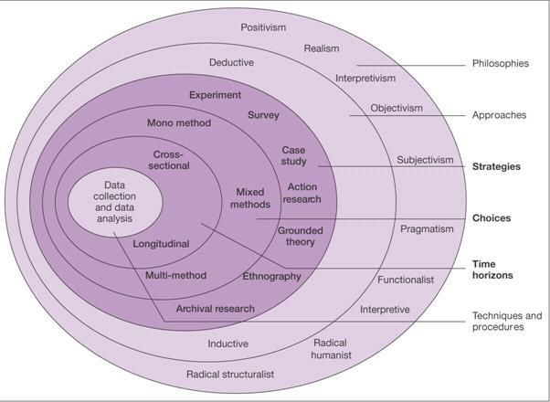

Figure 1 – Research Onion (Saunders et al, 2007)

Figure 1 shows the Research Onion, created by Saunders. This theory contains layers relating to different stages of research, suggesting that if the researcher follows the layers of the onion, an effective research strategy will be created, (Saunders et al, 2007).

- Paradigm & Philosophy
- SECTION DISJOINTED – DOESN’T FLOW
Positivism philosophy is researched by Johnson and Clark (2006), who convey the importance of philosophy and the way it is chosen for the research strategy, it is of significant importance to the understanding and application of what is being investigated, (Johnson and Clark, 2006). This is mainly concerned with methods that are highly structured with large quantitative samples, which then makes the study open to duplication, (Saunders and Philip, 2012). This paradigm has been used in this study, as the researcher has carried out a large number of questionnaires to generate numerical results on participation levels at the events. Additionally, the study has also adopted an interpretivist approach, resulting in mixed methods being utilised. An interpretivist approach requires methods of qualitative data from interviews (Saunders et al, 2016). This study has also incorporated qualitative data in order to analyse overall satisfaction at the markets, resulting in an interpretivist approach being the most appropriate paradigm. Furthermore, a case study of the Uplands and Marina Markets in Swansea has been referred to throughout, using both a qualitative and quantitative design. Bryman (2016) believes that both approaches are often used in case studies, which is called a mixed methods approach. This enhances the findings of the study as the decision of the researcher to use either a qualitative or quantitative approach may not provide a sufficient understanding into the research question being reviewed, (Bryman, 2016).

– Choice
Due to analysing procedures sequentially in this study, a mixed methods approach has been used, both qualitative and quantitative data collections have positives and negatives. Also, varied procedures will have different effects, and this study utilised diverse methods in an attempt to cancel out the ‘method effect’. This approach will allow triangulation to form (Saunders et al, 2007).

- Research Approach & Purpose
The deductive research approach focusses on logical theory to produce a research hypothesis, whereas, an inductive approach would detect similarities and differences to previous theories through patterns and relations, (Ritchie et al, 2013). Loseke supports this theory by stating that a deductive approach involves ‘using what is already known to determine what data to collect’, (Loseke, 2017).
This dissertation has utilised a deductive approach, as a wealth of knowledge already exists on socio-cultural theories and event analysis. The researcher also followed the process of deduction created by Bryman and Bell, as shown below in figure 2, (Bryman and Bell, 2015). The purpose of this study is exploratory as the outcome has not provided concluding categorical explanations to the issue in question, however, the intention of this investigation was to explore the research question and deliver a foundation to future study on the topic, (Dudovskiy, 2018).
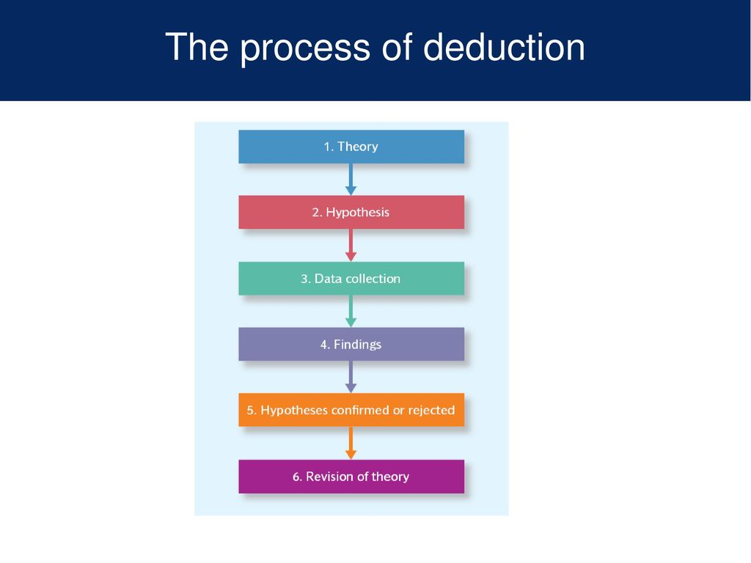

Figure 2 – The Process of Deduction, (Bryman and Bell, 2015)

– Strategies

- Data Collection Methods & Analysis
The researcher has used mixed methods triangulation, as questionnaires and interviews have been carried out to generate both quantitative and qualitative data, to determine the socio-cultural standard for small-scale events in Swansea. Triangulation allows previous socio-cultural event studies to be examined and compared with the information collected. This has been done through multiple techniques in order to detect similarities and differences between studies, resulting in an insightful analysis, (Olsen, 2004). This study best lends itself to a combination of interviews and surveys to make a detailed case study. This study has focussed on a mixed methods approach, collecting both qualitative data through interviews, aimed at stall traders and surrounding businesses at the Uplands and Marina Markets and quantitative data through questionnaires, aimed at shoppers at the markets.

– Questionnaire Design
The questionnaire used for this research was aimed at the shoppers of the case study and consisted of 23 questions, which considered the socio-cultural benefits that can be generated from a small-scale community event, and more specifically the Uplands and Marina Markets in Swansea. The questionnaire included closed ended multiple choice questions, in order to make it easier to compare responses and demonstrate relationships between answers (Bryman and Bell, 2003). However, this method generates limited detail and can hold back opinions from participants and make them feel ‘constrained’ (Jensen & Laurie, 2016, pp. 142). Therefore, open ended questions were also included to gain a more in-depth insight into the thoughts of the events visitors, this will also decrease researcher bias. However, a disadvantage of this method is that it is more time consuming for respondents and requires more effort (Jensen & Laurie, 2016). Furthermore, in order to ensure all questions were relevant to the study, a matrix table was constructed to link all questions to the literature being reviewed in this research (See Appendix 2 for Matrix Table).

– Pilot Study
A pilot study was conducted before the questionnaire was released online, through peers and various people who have attended the Uplands and/or Marina Markets, in order to identify any design issues and make final alterations (Jensen & Laurie, 2016). This test is crucial when attempting to gain quantitative data as respondents do not have the opportunity to clarify questions when the questionnaire has been distributed, this will also confirm the feasibility of the study (Jensen & Laurie, 2016). To ensure that quality information is being collected, the pilot study was conducted on five participants.

– Analysis
When analysing primary data, statistical analysis techniques was used in order to detect themes, which was then summarised through pie charts and graphs displaying an overview of trends found from the collection of data (Wilson, 2009). Quantitative data from questionnaires was analysed through SPSS software in order to group together trends in statistics and demographics and qualitative data from interviews was analysed through NVivo, which resulted in word clouds from popular answers.

- Sampling Framework
Figure 3 shows the varied methods of sampling frameworks. Saunders states that an in-depth study must prove an ‘information rich case study’, (Saunders et al, 2008, pgs.276-297), therefore, non-probability sampling was used in this investigation as it focusses on both interviews and secondary data.
A volunteer sampling method was tested, as the researcher asked stallholders at the market events to participate in interviews to generate qualitative data and post in the markets’ Facebook groups, asking spectators of the events to participate in an online questionnaire, to produce both quantitative and qualitative. Additionally, purposive sampling was used when researching in order to select specific cases that related directly to the topic to assist in meeting the objectives and answering the research question set. This method is often used when a small sample is being assessed and has allowed the generation of informative data (Saunders et al, 2007).
Furthermore, an inclusion and exclusion criteria has been followed when analysing questionnaire results. As the survey was posted on Facebook, a number of unreliable responses were collected, meaning that a selection process was needed in order to gain a reliable sample of results.

Figure 3 – Sampling Framework (Saunders et al, 2016, pg.276)

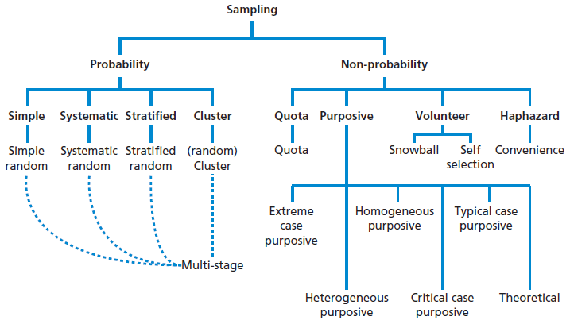

– Interview Design
Three semi-structured interviews have been conducted for this study, which each consisted of 14 questions. This approach allows participants to ‘answer freely based on personal reflection, knowledge and experience’ (Jensen & Laurie, 2016, pp. 173). This was the most appropriate method as the aim of the research is to ‘understand individuals’ perspectives on a specific topic in depth’ (Jensen & Laurie, 2016, pp. 173), interviews also enable the individual to express their opinions in an authentic manner. A known disadvantage of interviews is that they are time consuming when needing to transcribe for analysis, however, this study conducted interviews online meaning that this wasn’t an issue. The researcher chose the participants for interviews from stallholders at both the Uplands & Marina Markets and local businesses surrounding the event in order to gain an internal and external perspective.

– Time Horizon
The time horizon of a study is concerned with the length of time conducting research takes. Longitudinal time horizon refers to research which is conducted over a long-time period, whereas, cross-sectional time horizon signifies the phenomenon of a study at a certain time (Saunders et al, 2007). Due to the short time limits and focus of this study, cross-sectional research will be utilised, as it can be applied to both qualitative and quantitative research.

- Limitations & Ethical Risks

- Resource Limitations
Due to the limited time-frame for this study, resources and primary data was at risk of facing a limitation. Additionally, the sample used for questionnaires, surveys and interviews may not be a true reflection of the wider population, but it is the most appropriate sample for the research in this time-frame. However, the researcher attempted to overcome these limitations by creating a Gantt Chart, (See Appendix 8), in order to stick to a structured time frame and avoid as many restrictions as possible.

- Ethical Considerations
Generally, the study was low risk and unlikely to cause any offence to participants or the public, or pose any risk to the university or researcher. However, ethical considerations have become of significant importance to achieving a meaningful and successful study and the protection of participant must be considered, clear communication and consent was provided prior to anyone taking part in the study, (Sage Publications, 2007). This is backed up by Saunders who states that everyone has the ‘right to privacy’ and should not feel ‘coerced into participating’, (Saunders et al, 2016, pg.249). All research conducted in this investigation strictly followed the ethical guidelines, supported by the ethics document, (See Appendix 6).
Prior to the research, all participants were given full information of the details, their role, the aims and objectives and the purpose for carrying out the study. All participant information was kept confidential and kept within the strict anonymity regulations as stated in the ethics form.

– Reliability & Validity
Reliability and validity are concerned with the credibility of research and how successful the researcher has been in reaching the objectives set, (Kirk & Miller, 1986). Reliability is how repeatable the results of the tests are, whereby validity refers to the findings accuracy. For this research, it was of particular importance to understand the threats that reliability and validity may face. This was overcome through ensuring that the correct methodology and research design was used to meet the objectives, but also, testing the findings for bias.

– Conclusion
All research conducting during this study has been undertaken and completed in a systematic way for the purpose of this study. A mixed-methods approach was selected, as it best fit the objectives of the study. Additionally, both quantitative and qualitative data will be collected, which will both update the research discussed in this study and potentially provide new knowledge on the subject being discussed, which would in turn generate new initiatives to contribute to the well-being of an area.

Chapter 4 – Analysis

– Introduction

– Interview Analysis

– Questionnaire Analysis

Chapter 5 – Conclusion

Reflection on Analysis

– Recommendations

– Reference List
Abraham, S. and Waldren, J. (1997), ‘Introduction: Tourists and tourism – identifying with people and places’, Tourists and tourism: Identifying with people and places, Oxford: Berghan Books, pp. 1-11.
Arcodia, C. & Robb, A. (2000), ‘A future for event management: A taxonomy of event management’, Journal of Convention and Event Tourism, Vol. 8, No. 2, pp. 1-18.
Ariola, M. (2006), Principals and Methods of Research, Manila: Rex Book Store.
Barrio, M. Devesa, M. & Herrero, L. (2012), ‘Evaluating intangible cultural heritage: The case of cultural festivals’, Journal City, Culture and Society, Vol. 3, No. 4, pp. 235-244.
Bladen, C. Kennel, J. Abson, E and Wilde, N. (2012), ‘Managing the event human resource’, Events Management; An Introduction, Abington: Routledge.
Bladen, C. Kennel, J. Abson, E. & Wilde, N. (2012), ‘Managing the event human resource’, Events Management an Introduction, Abington: Routledge, pp. 128-129.
Bowdin, G. Allen, J. O’Toole, W. Harris, R. and McDonnell, I. (2006), Events Management, (Third Edition), Great Britain: John Wiley & Sons.
Bryman, A and Bell, E. (2015), Business Research Methods, (Fourth Edition), Oxford: Oxford University Press.
Bryman, A. and Bell, E. (2007), Business Research Methods, (Second Edition), Oxford: Oxford University Press.
De Bres, K. and Davis, J. (2001), ‘Celebrating group and place identity: A case study of a new regional festival’, Journal Sociologia, Vol. 44, No. 6, pp. 704-728.
Derrett, R. (2004), Festivals, events and the destination, Oxford: Butterworth.
Dudovskiy, J. (2018), ‘Exploratory Research’, [Online], Research Methodology, Available: https://research-methodology.net/research-methodology/research-design/exploratory-research/, Accessed Date: 20th November 2019.
Dwyer, L. Mellor, R, M, N. Mistillis and Mules, T. (2000), ‘A framework for assessing ‘tangible’ and ‘intangible’ impacts of events and conventions’, Events Management, Vol. 6, No. 3.
Felsenstein, D. (2003), ‘Local Festivals and Tourism Promotion: The Role of Public Assistance and Visitor Expenditure’, Journal of Travel Research, Vol. 41, No. 4, pp. 385-392.
Fredline, L. Jago, L & Deery, M. (2003), ‘The development of a generic scale to measure the social impacts of events’, International Journal of Event Management, Vol. 8, No. 1, pp. 23-37.
Getz, D. (2007), Event Studies: Theory, research and policy for planned events, Oxford: Elsevier.
Getz, D. (2008), ‘Event tourism: Definition, evolution, and research’, International Journal of Tourism Management, Vol. 29, No. 3, pp. 403-428.
Getz, D. (2010), ‘Event tourism: Definition, evolution and research’, International Journal of Tourism Management, Vol, 29, No. 3, pp. 403-428.
Getz, D. (2012), ‘Event Studies; discourses and future directions’, Journal of Event Management, Vol. 16, No. 2, pp. 171-187.
Grosbois, D, D. (2009), ‘Assessing the Socio-Cultural Impact of Special Events: Frameworks, Methods, And Challenges’, Journal of Tourism Challenges and Trends, Vol. 11, No. 2.
Grosbois, D. D. (2009), ‘Assessing the Socio-Cultural Impact of Special Events: Frameworks, Methods, and Challenges’, Journal of Tourism Challenges and Trends, Vol. 11, No. 2, pp. 39-52.
Johnson, P. and Clark, M. (2006), Business and Management Research, London: Sage.
Jovicic, D. (2016), ‘Cultural tourism in the context of relations between mass and alternative tourism’, Current Issues in Tourism, Vol. 19, No.6, pgs. 605-612.
Kirk, J and Miller, M, L. (1986), Reliability and Validity in Qualitative Research, London: Sage.
Loseke, D, R. (2017), ‘Methodological Thinking basic principles of social research design’, (Second Edition), London: Sage.
Maslow, A, H. (1943), ‘A Theory of Human Motivation, Psychological Review’, Journal Psychological Review, Vol. 50, No. 4.
Maslow, A. H. (1943), ‘A Theory of Human Motivation, Psychological Review’, Journal Psychological Review, Vol. 50, No. 4, pp. 370-396.
Noronha, R. (1977), ‘Paradise reviewed: tourism in Bali’, Paradise Reviewed, Oxford: Oxford University Press, pp. 177-204.
Olsen, W. (2004), ‘Developments in Sociology’, Triangulation in Social Research: Qualitative and Quantitative Methods Can Really Be Mixed, [Online], Available: https://www.federica.eu/users/9/docs/amaturo-39571-01-Triangulation.pdf, Accessed Date – 20th November 2019.
Pavlic, I. Portolan & Puh, B. (2015), ‘The Social Impacts of Tourism of Local Communities’ Quality of Life’, Journal of Tourism in Southern and Eastern Europe, Vol. 3, pp. 259-272.
Reid, S. (2011), ‘Event stakeholder management: developing sustainable rural event practices’, International Journal of Event and Festival Management, Vol. 2, No. 1, pp.20-36.
Ritchie, J. (1984), ‘Assessing the impact of hallmark events: Conceptual and research issues’, Journal of Travel Research, Vol. 22, No. 1.
Ritchie, J. Lewis, J. Nicholls, C. M. and Ormston, R. (2013), A GUIDE FOR SOCIAL SCIENCE STUDENTS AND RESEARCHERS, London: Sage.
Sage Publications, (2007), ETHICAL ISSUES IN CONDUCTING RESEARCH, London: Sage.
Saunders, M and Philip, L. (2012), Doing Research in Business & Management, Harlow: Pearson Education Limited.
Saunders, M., Lewis, P and Thornhill, A. (2016), Research Methods for Business Students, (Seventh Edition), Harlow: Pearson Education Limited.
Saunders, M., Lewis, P. and Thornhill, A. (2009) Research Methods for Business Students. Pearson, New York.
Saunders, M., Lewis, P., and Thornhill, A. (2007). Research Methods for Business Students, (Sixth Edition), London: Pearson.
Saunders, M., Lewis, P., and Thornhill, A. (2008). Research Methods for Business Students, (Fifth Edition), Italy: Rotolito Lombarda.
Small, K. Edwards, D. & Sheridan, L. (2005), ‘A Flexible Framework for Evaluating the Socio-Cultural Impacts of a (Small) Festival’, International Journal of Event Management Research, Vol. 1, No. 1, pp. 66-77.
Timothy, D. (2011), Cultural heritage and tourism: An Introduction, Vol. 4, Bristol: Channel View.
Woosnam, K. and Aleshinloye, K. (2018), ‘Residents’ Emotional Solidarity with Tourists: Explaining Perceived Impacts of a Cultural Heritage Festival’, Journal of Hospitality & Tourism Research, Vol. 51, No. 3, pp. 315-327.
Delamere, T. A. Wankel, L. and Hinch. T. (2001), ‘Development of a scale to measure resident attitudes toward the social impacts of community festivals, Part 1: Item generation and purification of the measure’, Journal Event Management, Vol. 7, No. 1, pp. 11-24.
Pavlic, I. Portolan. And Puh, B. (2015), ‘The Social Impacts of Tourism on Local Community’s Quality of Life’, Journal of Tourism in Southern and Eastern Europe, Vol. 3, pp. 259-272.
Griffiths, I. and Sharpley, R. (2012), ‘Influences of nationalism on tourist-host relationships’, Journal Annals of Tourism Research, Vol. 39, No. 4, pp. 2051-2072.
Stylidis, D. (2014), ‘“Residents” Support for Tourism Development: The Role of Residents’ Place Image and Perceived Tourism Impacts’, Journal of Tourism Management, Vol. 5, pp. 260-274.
Page, J. & Connell, J. (2012), ‘The Routledge Handbook of Events’, Oxon: Routledge.
Clary, E. and Snyder, M. (1999), ‘The motivations to volunteer theoretical and practical considerations’, Journal of Current Directions in Psychological Science, Vol. 8, No. 5, pp. 156-159.
Tyson, S. and Y. A. (2000), Essentials of Human Resource Management, (Fourth Edition), Oxford: Butterworth-Heinemann.
Thoits, P. and Hewitt, L. (2001), ‘Volunteer Work and Well-being’, Journal of Health and Social Behaviour, Vol. 42, No. 2, pp. 115-131.
Wilson, J. (2000), ‘Volunteering’, Journal Annual Review of Sociology, Vol. 26, No. 1, pp. 215-240.
Fredline, E. and Fraunkler, B. (2000), ‘Host community reactions: A cluster analysis’, Annals of Tourism Research, Vol. 27, No. 3, pp. 763-784.
Narayan, D. (1999), Bonds and bridges: Social capital and poverty, Poverty Group, PREM, The World Bank, [Online], Available: http://documents.worldbank.org/curated/en/989601468766526606/pdf/multi-page.pdf, [Accessed Date – February 10th 2020].
Kelly, A. and Kelly, K. (2000), Impacts and values, assessing the arts and creative industries in the South West, Bristol: Bristol Development Consortium.
Mackellar, J. (2007), ‘Conventions, festivals and tourism: Exploring the network that binds’, Journal of Convention and Events Tourism, Vol. 8, No. 2, pp. 45-56.
Wood, E. (2006). ‘Measuring the social impacts of local authority events: a pilot study for a civic pride scale’, International Journal of Nonprofit Voluntary Sector Marketing, Vol. 11, No. 3, pp. 165-179.
Schulenkorf, N. (2009), ‘An ex ante framework for the strategic study of social utility of sports events’, Journal of Tourism and Hospitality Research, Vol. 9, No. 2, pp. 12-131.
Derrett, R. (2003), ‘Festivals and regional destinations: How festivals demonstrate a sense of community and place’, Journal Rural Society, Vol. 13, No. 1, pp. 35-53.
Black, N. (2016), Festival connections: How consistent and innovative connections enable small-scale rural festivals to contribute to socially sustainable communities’, International Journal of Event and Festival Management, Vol. 7, No. 3, pp. 172-187.
Bowen, M. (2013). “A Festival Frenzy” ArtsProfessional, [Online], Available: https://www.artsprofessional.co.uk/magazine/268/article/festival-frenzy?utm_source, [Accessed Date – February 10th 2020].
Macnab, N. Thomas, G. and Grosvenor, I. (2010). “The changing nature of connectivity within and between communities”, [Online], Available: https://ahrc.ukri.org/funding/research/researchfundingguide/, [Accessed Date – February 10th 2020].
Chen, Y. Leto, X. and Cai, L. (2013), ‘Vacation and well-being: A study of Chinese tourists’, Journal Annals of Tourism Research, Vol. 42, pp. 284-310.
Chang, P. L. Wray, L. and Lin, Y. (2014), ‘Social relationships, leisure activity and health in older adults’, Journal Health Psychology, Vol. 33, No. 6, pp. 284-310.
Diener, E. and Suh, E. (1997), ‘Measuring quality of life: Econonomic, social and subjective indicators’, Journal Social Indicators Research, Vol. 40, No. 1/2, pp. 1-31.
Ryan, R. and Frederick, C. (1997), ‘On energy, personality, and health: Subjective vitality as a dynamic reflection of well-being’, Journal of Personality, Vol. 65, No, 3, pp. 529-565.
Ryan, R. and Deci, E. (2000), ‘Self-determination theory and the facilitation of intrinsic motivation, social development, and well-being’, Journal American Psychologist, Vol. 55, No. 1, pp. 68-78.
Yolal, M. Rus, R. Cosma, S. and Gursoy, D. (2015), ‘A pilot study on spectators motivations and their socio-economic perceptions of a film festival’, Journal of Convention & Event Tourism, Vol. 16, No. 3, pp. 253-271.
Arcodia, C. and Whitford, M. (2006), ‘Festival attendance and the development of social capital’, Journal of Convention and Event Tourism, Vol. 8, No. 2, pp. 1-18.
Leeanders, M. A. Go, F. and Pawan. Bhansing. (2015), ‘The importance of the location in hosting a festival: A mapping approach’, Journal of Hospitality Marketing & Management, Vol. 24, No. 7, pp. 754-769.
UNESCO. (2003), ‘Text of the convention for the safeguarding of intangible cultural heritage’, [Online], Available: https://www.unesco.org/culture/ich.index , [Accessed Date - February 11th 2020].
Black, N. (2016), ‘Festival connections: How consistent and innovative connections enable small-scale rural festivals to contribute to socially sustainable communities’, International Journal of Event and Festival Management, Vol. 7, No. 3, pp. 172-187.
Highmore, B. (2016), ‘Social Science > Popular Culture’, (Fifth Edition), Oxford: Routledge, pp. 1-165.
Putman, R. (2000), ‘Bowling alone: The collapse and revival of the American Community’, New York: Simon and Schuster.
Stevenson, N. (2016), ‘Local festivals, social capital and sustainable destination development: experiences in East London’, Journal of Sustainable Tourism, Vol. 24, No. 7, pp. 990-1006.
Derrett, R. (2005), ‘Why do regional community cultural festivals survive? The impacts of Events: Triple bottom line evaluation and event legacies’, Sydney: Third International Event Management Conference.
Scheyvens, R. (2011), ‘The challenge of sustainable tourism development in the Maldives: Understanding the social and political dimensions of sustainability’, Asia Pacific Viewpoint, Vol. 22, No. 1, pp. 28-51.
Yang, J. Ryan, C. and Zhang, L. (2014), ‘Sustaining culture and seeking a just destination: Governments, power and tension-a-life-cycle approach to analysing tourism development in an ethnic-inhabited scenic area in Xinjiang, China’, Journal of Sustainable Tourism, Vol. 22, No. 8, pp. 1151-1174.
Bryman, A. (2016), Social Research Methods, (5th Edition), Oxford: Oxford University Press.
Taylor & Francis. (2006), ‘Community identity discourse and the heritage academy: colorblind educational policy and white supremacy’, International Journal of Qualitative Studies in Education, Vol. 19, No. 4, pp. 455-476.
Uplands Market. (2020), ‘About Us’, [Online], Available: https://www.uplandsmarket.com/about-us.html, [Accessed Date – 6th March 2020].
Saunders, M. Lewis, P. and Thornhill, A. (2007), Research Methods for Business Students, (Fourth Edition), Essex: Pearson Education Limited.
Jensen, E. A. Laurie, C. (2016), Doing Real Research, London: SAGE Publications Ltd.
Bryman, A. Bell, E. (2003), Business Research Methods, New York: Oxford University Press.
Wilson, J. (2009), Essentials of business research, (Third Edition), London: California.

– Appendices

– Appendix 1 – Questionnaire Design

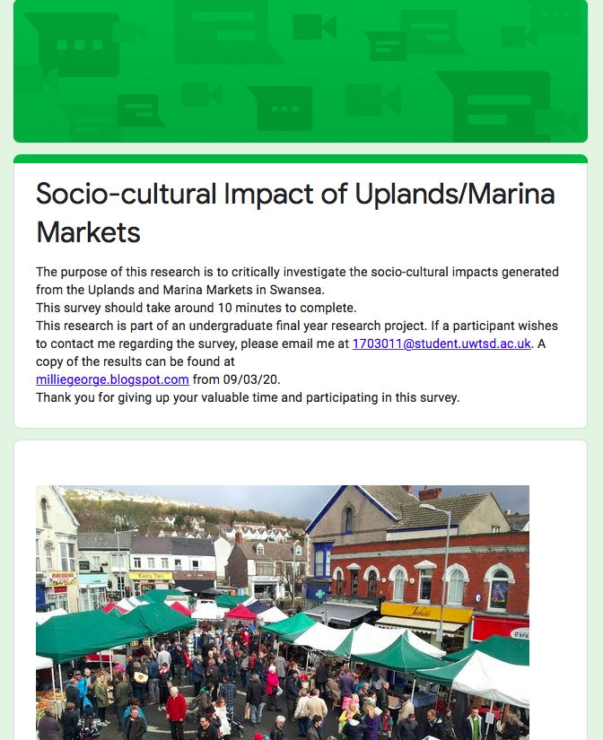

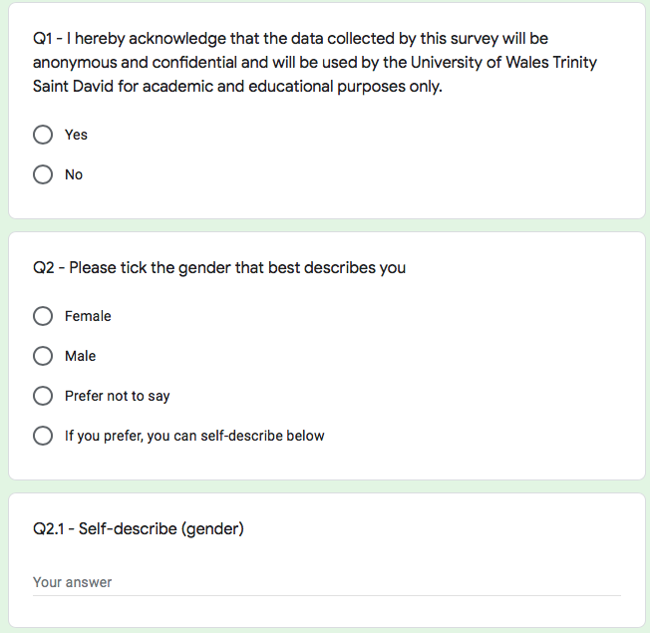
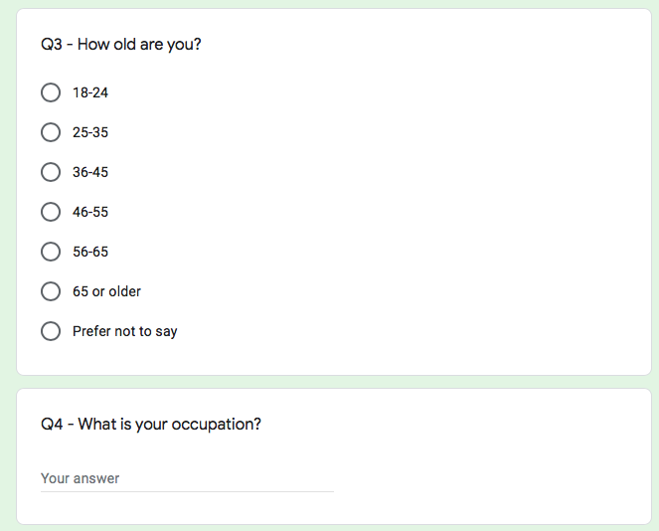
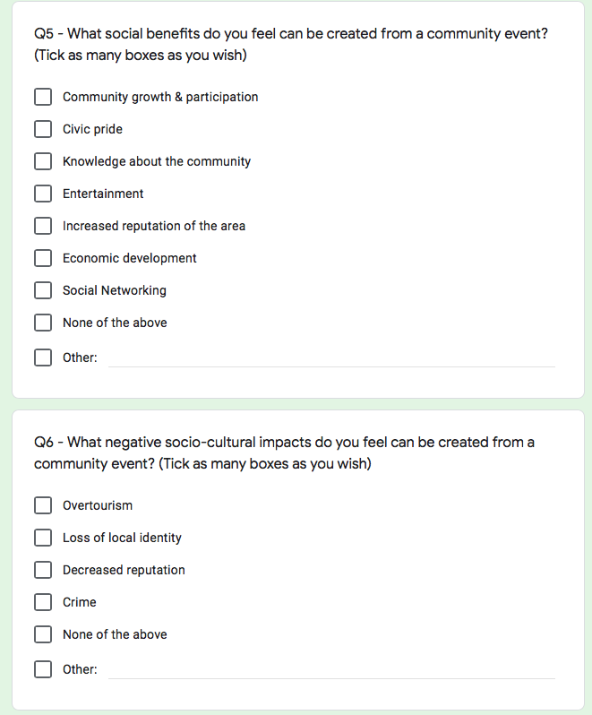
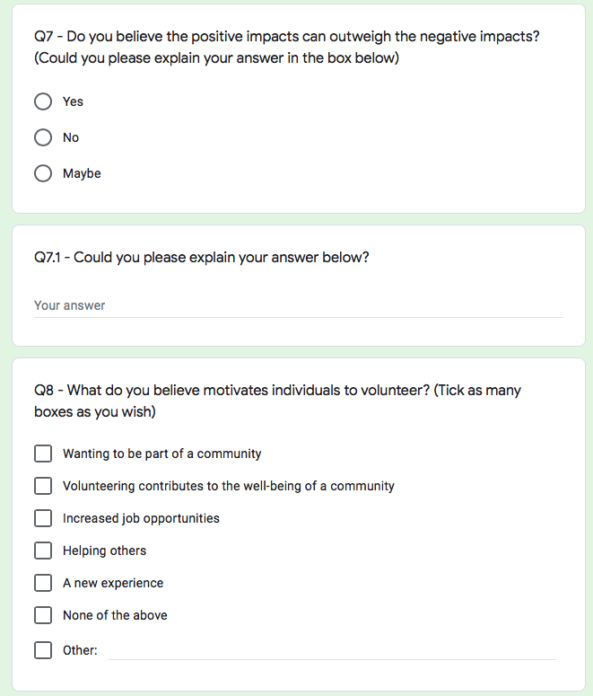
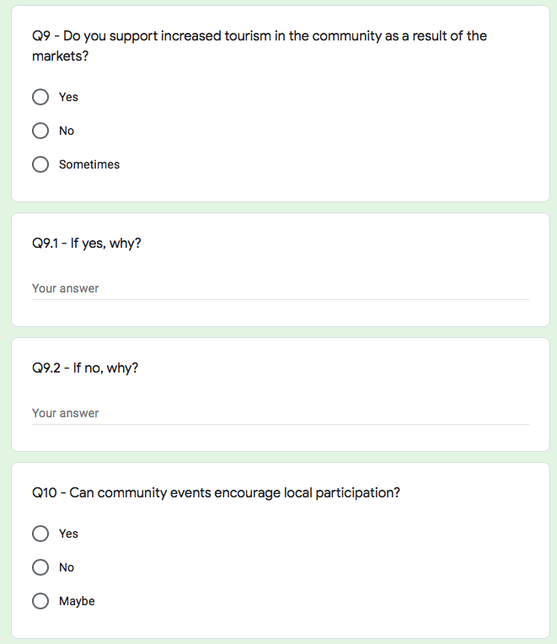
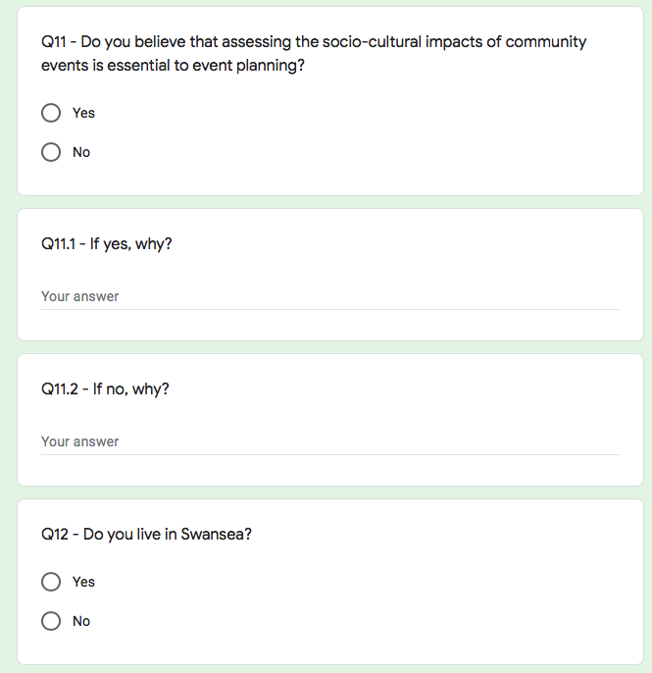
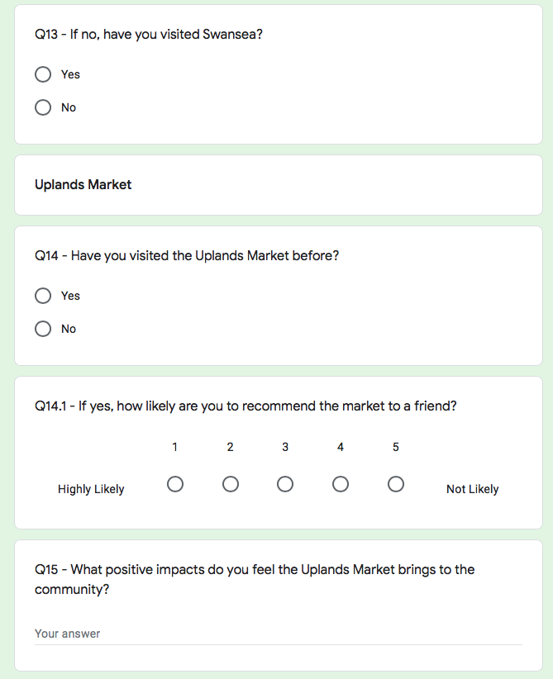
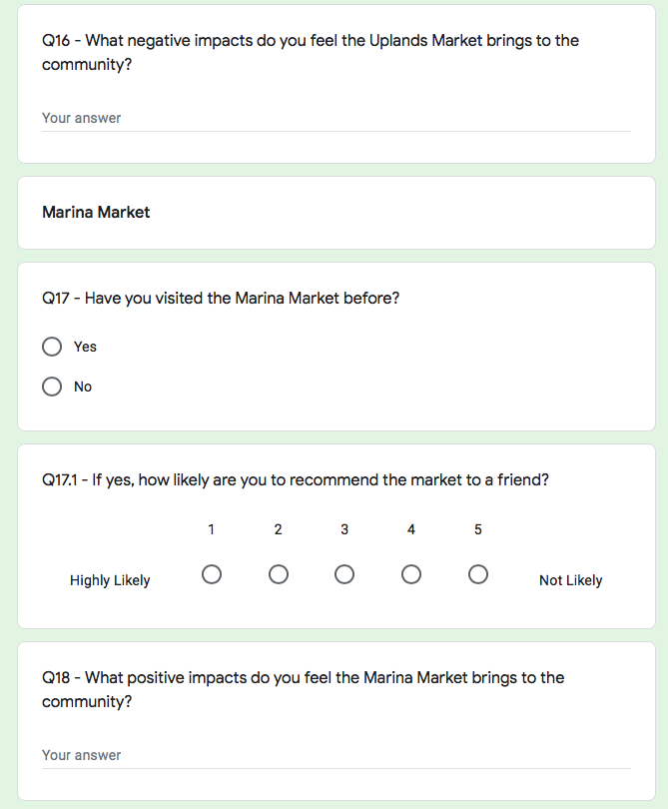
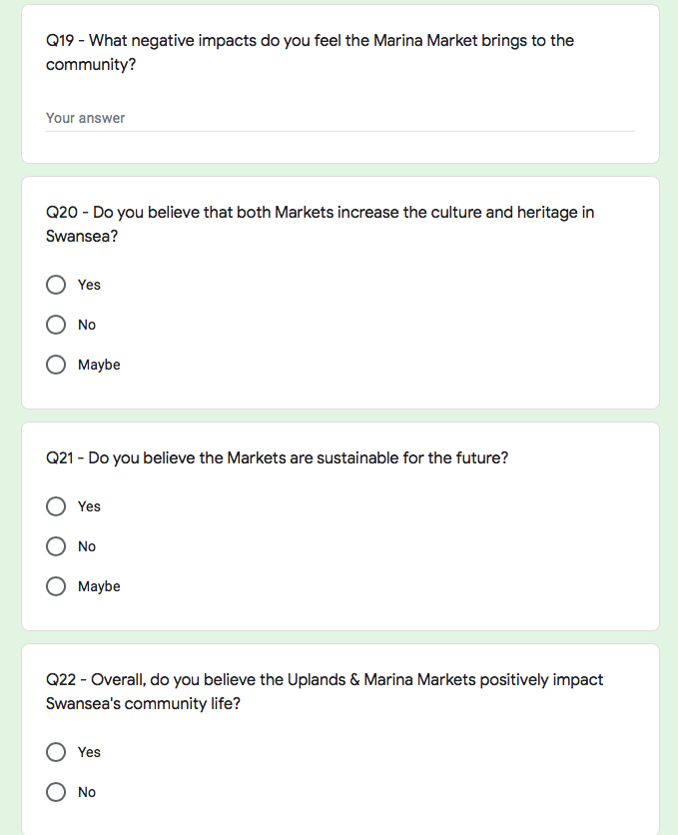
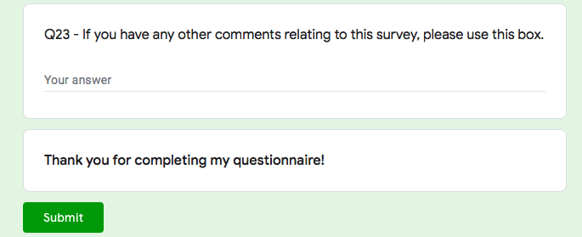

– Appendix 2 – Questionnaire Matrix Table

Questions in survey | Relation to chapter 2
Q2 – Please tick the gender that best describes you  Q3 – How old are you?  Q4 – What is your occupation?  Q12 – Do you live in Swansea?  Q13 – If no, have you visited Swansea? | Questions 2, 3 & 4 are all demographic based which will contribute to relevant research on participants, which will then be tested using SPSS.
Q5 – What social benefits do you feel can be created from a community event? (Tick as many boxes as you wish).  Q6 – What negative socio-cultural impacts do you feel can be created from a community event? (Tick as many boxes as you wish).  Q7 – Do you believe the positive impacts can outweigh the negative impacts? (Could you please explain your answer in the box below).  Q10 – Can community events encourage local participation?  Q15 – What positive impacts do you feel the Uplands Market brings to the community?  Q16 – What negative impacts do you feel the Uplands Market brings to the community?  Q18 – What positive impacts do you feel the Marina Market brings to the community?  Q19 – What negative impacts do you feel the Marina Market brings to the community?  Q22 – Overall, do you believe the Uplands & Marina Markets positively impact Swansea’s community life? | Bladen et al, (2012).  Maslow, (1943).  Small, (2005).  Grosbois, (2009).  Derrett, (2004).  Ritchie, (1984).  Dwyer et al, (2000).  Chen, Lehto & Cai, (2013).  Chang, Wray & Lin, (2014).  Diener & Suh, (1997).  Ryan & Frederick, (1997).  Ryan and Deci, (2000).  Yolal et al, (2015).  Arcodia & Whitford, (2006).  Leenders, Go, Bhansing, (2015).  Fredline & Faulkner, (2000).  Narayan, (1999).  Kelly & Kelly, (2000).  Mackeller, (2007).  Wood, (2006).  Schulenkorf, (2009).  Derrett, (2003).  Black, (2016).  Bowen, (2013).  Macnab et al, (2010).
Q8 – What do you believe motivates individuals to volunteer? (Tick as many boxes as you wish). | Page & Connell, (2012), pp. 316.  Clary & Snyder, (1999).  Bladen, (2012).  Tyson, (2000).  Getz, (2007).  Thoits and Hewitt, (2001).  Wilson, (2000).
Q9 – Do you support increased tourism in the community as a result of the markets? Q9.1 – If yes, why? Q9.2 – If no, why? | Small, (2005).  Delemere, Wankel & Hinch, (2001).  Pavlic et al, (2015).  Griffiths & Sharpley, (2012).  Stylidis, (2014).
Q11 – Do you believe that assessing the socio-cultural impacts of community events is essential to event planning? Q11.1 – If yes, why? Q11.2 – If no, why? | Getz, (2007).  Fredline et al, (2003).  Small, (2007).  Woosnam & Aleshinloye, (2018).  De Bres & Davis, (2001).  Getz, (2010).  Felsenstein, (2003).
Q20 – Do you believe that both Markets increase the culture and heritage in Swansea? | Arcodia & Robb, (2000).  Abraham & Waldren, (1997).  Getz, (2012).  Reid, (2011).  Timothy, (2011).  Getz, (2008, 2012).  Noronha, (1977).  Barrio et al, (2012).  Pavlic et al, (2015).
Q21 – Do you believe the Markets are sustainable for the future? | UNESCO, (2003).  Black, (2016).  Highmore, (2016).  Putman, (2000).  Coalter, (2017).  Stevenson, (2016).  Derrett, (2005).  Yang, Ryan & Zhang, (2014).  Scheyvens, (2011).

– Appendix 3 – Questionnaire Results

– Appendix 4 – Interview Design

- Are you a seller at the Uplands & Marina Markets? (If no, what is your role at the markets?).

- What do you think motivates shoppers to attend the markets?

- What are your thoughts on why individuals volunteer at community events?

- Do you feel that the markets contribute to the well-being of a community?

- What are your thoughts on small-scale, community events in general?

- Do you believe the markets increase social networking in Swansea, and how?

- Do you think that the markets contribute to developing the community, and how?

- In which ways do you believe Swansea locals view the markets?

- Do you feel this event can attract tourism to the area, and how?

- How do you feel about increased tourism in Swansea, and why?

- In which ways if any, do you feel the market generates any negative social impacts to the community?

- In which ways do you believe the markets contribute to developing local businesses in Swansea?

- In which ways do you believe the markets are sustainable for the future?

- Overall, in which ways do you believe the Uplands & Marina Markets positively impact Swansea’s community life?

Thank you very much for taking the time to answer my questions, if you have any questions or queries please to not hesitate to ask.

– Appendix 5 - Interview Results

– Appendix 6 – Ethics Form

APPLICATION FOR ETHICAL APPROVAL

In order for research to result in benefit and minimise risk of harm, it must be conducted ethically. A researcher may not be covered by the University’s insurance if ethical approval has not been obtained prior to commencement.

The University follows the OECD Frascati manual definition of research activity: “creative work undertaken on a systematic basis in order to increase the stock of knowledge, including knowledge of man, culture and society, and the use of this stock of knowledge to devise new applications”. As such this covers activities undertaken by members of staff, postgraduate research students, and both taught postgraduate and undergraduate students working on dissertations/projects.

The individual undertaking the research activity is known as the “principal researcher”.

Ethical approval is not required for routine audits, performance reviews, quality assurance studies, testing within normal educational requirements, and literary or artistic criticism.

Please read the notes for guidance before completing ALL sections of the form.

This form must be completed and approved prior to undertaking any research activity. Please see Checklist for details of process for different categories of application.

SECTION A: About You (Principal Researcher)

Full Name: |  |  | Millie George
Tick all boxes which apply:
Member of staff: | ☐ | Student: |  | ☒ | Honorary research fellow: | ☐

Faculty/School/Centre: | Business School
Campus: | Swansea
E-mail address: | 1703011@student.uwtsd.ac.uk
Contact Telephone Number: | 07896886328
For students:
Student Number: | 1703011 | Undergraduate | ☒
Programme of Study: | Events Management | Taught Postgraduate | ☐
Director of Studies/Supervisor: | James Prosser | Research | ☐

SECTION B: Approval for Research Activity

Has the research activity received approval in principle?  (please check the Guidance Notes as to the appropriate approval process for different levels of research by different categories of individual) |  | YES | ☒ | NO | ☐
 |  |  |  | Date
If Yes, please indicate source of approval (and date where known): | Research Degrees Committee |  | ☐
 | Faculty Research Committee |  | ☐
 | Other (write in) |  | ☒ | Supervisor
Approval in principle must be obtained from the relevant source prior to seeking ethical approval.

SECTION C: External Ethical Guidance Materials

Please list the core ethical guidance documents that have been referred to during the completion of this form (including any discipline-specific codes of research ethics, and also any specific ethical guidance relating to the proposed methodology). Please tick to confirm that your research proposal adheres to these codes and guidelines.
Dissertation Handbook | ☒
Advice from supervisor | ☒
 | ☐

SECTION D: External Collaborative Research Activity

Does the research activity involve collaborators outside of the University? |  | YES | ☐ | NO | ☒
If Yes, please provide the name of the external organisation and name and contact details for the main contact person:
Institution
Contact person name
Contact person e-mail address

Where research activity is carried out in collaboration with an external organisation
Does this organisation have its own ethics approval system? | YES | ☐ | NO | ☐
If Yes, please attach a copy of any final approval (or interim approval) from the organisation

SECTION E: Details of Research Activity

Indicative title: | An Investigation into The Socio-cultural Impacts of Small-scale, Independent Trade Events.
Proposed start date: | 1st Febuary 2019 | Proposed end date: | 1st May 2019
Purpose of research activity (including aims and objectives)
Outline the purpose, aims and objectives of the research activity, including key research questions. Show briefly how existing research has informed the proposed activity and explain what the research activity will add and how it addresses an area of importance. (Maximum 300 words)
Aim

The aim of this study is to critically analyse the socio-cultural factors of small scale, independent events, with particular interest to pop up markets in Swansea, to determine whether the events can contribute to the well-being of a community.

Objectives

- To investigate whether small-scale event can contribute to the well-being of a community.
- To examine whether the event is capable of building community networks and providing new skills for the participants.
- To analyse and provide recommendations as to how a community event can leave a legacy behind, and ensure the event is sustainable.

(this box should expand as you type)
Proposed methods
Provide a brief summary of all the methods that may be used in the research activity, making it clear what specific techniques may be used. If methods other than those listed in this section are deemed appropriate later, additional ethical approval for those methods will be needed. (Maximum 600 words)
Online questionnaire & surveys.
Interviews.

(this box should expand as you type)

Location of research activity
Identify all locations where research activity will take place.
Uplands Market
Marina Market
Mumbles Market
Facebook groups

(this box should expand as you type)
Research activity outside of the UK
If research activity will take place overseas, you are responsible for ensuring that local ethical considerations are complied with and that the relevant permissions are sought. Specify any local guidelines (e.g. from local professional associations/learned societies/universities) that exist and whether these involve any ethical stipulations beyond those usual in the UK (provide details of any licenses or permissions required). Also specify whether there are any specific ethical issues raised by the local context in which the research activity is taking place, for example, particular cultural sensitivities or vulnerabilities of participants.
(this box should expand as you type)

SECTION F: Scope of Research Activity
Will the research activity include: | YES | NO
Use of a questionnaire or similar research instrument? | ☒ | ☐
Use of interviews? | ☒ | ☐
Use of diaries? | ☐ | ☒
Participant observation with their knowledge? | ☒ | ☐
Participant observation without their knowledge? | ☐ | ☒
Use of video or audio recording? | ☒ | ☐
Access to personal or confidential information without the participants’ specific consent? | ☐ | ☒
Administration of any questions, test stimuli, presentation that may be experienced as physically, mentally or emotionally harmful / offensive? | ☐ | ☒
Performance of any acts which may cause embarrassment or affect self-esteem? | ☐ | ☒
Investigation of participants involved in illegal activities? | ☐ | ☒
Use of procedures that involve deception? | ☐ | ☒
Administration of any substance, agent or placebo? | ☐ | ☒
Working with live vertebrate animals? | ☐ | ☒
Other primary data collection methods, please explain in this box | ☐ | ☒

If NO to every question, then the research activity is (ethically) low risk and may be exempt from some of the following sections (please refer to Guidance Notes).

If YES to any question, then no research activity should be undertaken until full ethical approval has been obtained.

SECTION G: Intended Participants

Who are the intended participants: | YES | NO
Students or staff at the University? | ☐ | ☒
Adults (over the age of 18 and competent to give consent)? | ☒ | ☐
Vulnerable adults? | ☐ | ☒
Children under 18? | ☐ | ☒
Prisoners? | ☐ | ☒
Young offenders? | ☐ | ☒
Those who could be considered to have a particularly dependent relationship with the investigator or a gatekeeper? | ☐ | ☒
People engaged in illegal activities? | ☐ | ☒
Others (please identify): | ☐ | ☒

Participant numbers and source
Provide an estimate of the expected number of participants. How will you identify participants and how will they be recruited?
Expected a valid sample: minimum 100 people – online questionnaires.

this box should expand as you type)

Information for participants: | YES | NO | N/A
Will you describe the main research procedures to participants in advance, so that they are informed about what to expect? | ☒ | ☐ | ☐
Will you tell participants that their participation is voluntary? | ☒ | ☐ | ☐
Will you obtain written consent for participation? | ☒ | ☐ | ☐
Will you explain to participants that refusal to participate in the research will not affect their treatment or education (if relevant)? | ☒ | ☐ | ☐
If the research is observational, will you ask participants for their consent to being observed? | ☒ | ☐ | ☐
Will you tell participants that they may withdraw from the research at any time and for any reason? | ☒ | ☐ | ☐
With questionnaires, will you give participants the option of omitting questions they do not want to answer? | ☒ | ☐ | ☐
Will you tell participants that their data will be treated with full confidentiality and that, if published, it will not be identifiable as theirs? | ☒ | ☐ | ☐
Will you debrief participants at the end of their participation, in a way appropriate to the type of research undertaken? | ☒ | ☐ | ☐
If NO to any of above questions, please give an explanation
(this box should expand as you type)

Information for participants: | YES | NO | N/A
Will participants be paid? | ☐ | ☒ | ☐
Is specialist electrical or other equipment to be used with participants? | ☐ | ☒ | ☐
Are there any financial or other interests to the investigator or University arising from this study? | ☐ | ☒ | ☐
Will the research activity involve deliberately misleading participants in any way, or the partial or full concealment of the specific study aims? | ☐ | ☒ | ☐
If YES to any question, please provide full details
(this box should expand as you type)

SECTION H: Anticipated Risks

Outline any anticipated risks that may adversely affect any of the participants, the researchers and/or the University, and the steps that will be taken to address them.

If you have completed a full risk assessment (for example as required by a laboratory, or external research collaborator) you may append that to this form.

Full risk assessment completed and appended?

Yes ☐
No ☒

Risks to participants
For example: emotional distress, financial disclosure, physical harm, transfer of personal data, sensitive organisational information
Sensitive organisational information.

(this box should expand as you type)
If research activity may include sensitive, embarrassing or upsetting topics (e.g. sexual activity, drug use) or issues likely to disclose information requiring further action (e.g. criminal activity), give details of the procedures to deal with these issues, including any support/advice (e.g. helpline numbers) to be offered to participants. Note that where applicable, consent procedures should make it clear that if something potentially or actually illegal is discovered in the course of a project, it may need to be disclosed to the proper authorities
Non-disclosure agreement.
(this box should expand as you type)
Risks to investigator
For example: personal safety, physical harm, emotional distress, risk of accusation of harm/impropriety, conflict of interest
Both participants and the researcher will be treated with respect and consideration.
Option to not participate in research.

(this box should expand as you type)
University/institutional risks
For example: adverse publicity, financial loss, data protection
Good standing of UWTSD will be considered at all times.

(this box should expand as you type)
Adverse outcomes
List measures put in place to limit any adverse effects or outcomes of research activity where appropriate. Include any emergency protocols.
All information will be confidential and stored securely.

(this box should expand as you type)

Disclosure and Barring Service
If the research activity involves children or vulnerable adults, a Disclosure and Barring Service (DBS) certificate must be obtained before any contact with such participants. | YES | NO | N/A
Has a DBS certificate been obtained? | ☐ | ☐ | ☒

SECTION I: Feedback, Consent and Confidentiality

Feedback
What feedback will be provided to participants, how will this be done and when?
The dissertation will be available to all participants by email request.

(this box should expand as you type)
Informed consent
Describe the arrangements to inform potential participants, before providing consent, of what is involved in participating. Describe the arrangements for participants to provide full consent before data collection begins. If gaining consent in this way is inappropriate, explain how consent will be obtained and recorded.
Participants will sign a form with their agreement to participate.

(this box should expand as you type)
Confidentiality / Anonymity
Set out how anonymity of participants and confidentiality will be ensured in any outputs. If anonymity is not being offered, explain why this is the case.
All participants will remain anonymous, confidentiality will be guaranteed and no participant will be identifiable.

(this box should expand as you type)

SECTION J: Data Protection and Storage

In completing this section refer to the University’s Research Data Management Policy and the extensive resources on the University’s Research Data Management web pages (http://uwtsd.ac.uk/library/research-data-management/).
 | YES | NO
Does the research activity involve personal data (as defined by the Data Protection Act)?  “personal data” means data which relate to a living individual who can be identified—  (a) from those data, or  (b) from those data and other information which is in the possession of, or is likely to come into the possession of, the data controller, and includes any expression of opinion about the individual and any indication of the intentions of the data controller or any other person in respect of the individual. | ☐ | ☒
If YES, provide a description of the data and explain why this data needs to be collected:
(this box should expand as you type)
Does it involve sensitive personal data (as defined by the Data Protection Act)?  “Sensitive personal data” means personal data consisting of information as to –  (a) the racial or ethnic origin of the data subject,  (b) his political opinions,  (c ) his religious beliefs or other beliefs of a similar nature,  (d) whether he is a member of a trade union (within the meaning of the Trade Union and Labour Relations (Consolidation) Act 1992),  (e) his physical or mental health or condition,  (f) his sexual life,  (g) the commission or alleged commission by him of any offence, or  (h) any proceedings for any offence committed or alleged to have been committed by him, the disposal of such proceedings or the sentence of any court in such proceedings. | ☐ | ☒
If YES, provide a description of the data and explain why this data needs to be collected:
(this box should expand as you type)

Will the research activity involve storing personal data on one of the following: | YES | NO
Manual files (i.e. in paper form)? | ☐ | ☒
University computers? | ☐ | ☒
Private company computers? | ☐ | ☒
Home or other personal computers? | ☒ | ☐
Laptop computers/ CDs/ Portable disk-drives/ memory sticks? | ☒ | ☐
“Cloud” storage or websites? | ☐ | ☒
Other – specify: | ☐ | ☒
For all stored data, explain the measures in place to ensure data confidentiality, including details of password protection, encryption and anonymisation:
All data collected is anonymous. A number of passwords will be needed to access all data. Small devices such as memory stick will be stored in a locked drawer. Computers fully encrypted.

(this box should expand as you type)

Will the research activity involve any of the following activities: | YES | NO
Electronic transfer of data in any form? | ☒ | ☐
Sharing of data with others at the University? | ☐ | ☒
Sharing of data with other organisations? | ☐ | ☒
Export of data outside the European Union or importing of data from outside the UK? | ☐ | ☒
Use of personal addresses, postcodes, faxes, emails or telephone numbers? | ☐ | ☒
Publication of data that might allow identification of individuals? | ☐ | ☒
Use of data management system? | ☐ | ☒
Data archiving? | ☐ | ☒
If YES to any question, please provide full details, explaining how this will be conducted in accordance with the Data Protection Act (and/or any international equivalent):
Electronic transfer of data – from Facebook groups, to personal laptop, run through SPSS for data analysis and written about in dissertation. This will be fully confidential and only the researcher will have access to initial research – analysis of data written in the dissertation will be available to participants on email request.

(this box should expand as you type)

List all who will have access to the data generated by the research activity:
Researcher.

(this box should expand as you type)
List who will have control of, and act as custodian(s) for, data generated by the research activity:
Researcher.

(this box should expand as you type)
Give details of data storage arrangements, including where data will be stored, how long for, and in what form. Will data be archived – if so how and if not why not.
All data will be stored on the researcher’s personal laptop and not shared with anyone. Irrelevant data will be deleted and inaccessible to anyone – all data being used in the dissertation will be available upon email request.

(this box should expand as you type)

SECTION K: Declaration

The information which I have provided is correct and complete to the best of my knowledge. I have attempted to identify any risks and issues related to the research activity and acknowledge my obligations and the rights of the participants.

In submitting this application I hereby confirm that I undertake to ensure that the above named research activity will meet the University’s Research Ethics and Integrity Code of Practice
Signature of applicant: |  | Date: | 24/11/19

For students:
Director of Studies/Supervisor: | James Prosser
Signature:
Date:

For staff:
Head of School/Assistant Dean:
Signature:
Date:

Checklist: Please complete the checklist below to ensure that you have completed the form according to the guidelines and attached any required documentation:
☒ | I have read the guidance notes supplied before completing the form.
☒ | I have completed ALL RELEVANT sections of the form in full.
☒ | I confirm that the research activity has received approval in principle
☐ | I have attached a copy of final/interim approval from external organisation (where appropriate)
☐ | I have attached a full risk assessment (and have NOT completed Section H of this form) (where appropriate)
☒ | I understand that it is my responsibility to ensure that the above named research activity will meet the University’s Research Ethics and Integrity Code of Practice.
☒ | I understand that before commencing data collection all documents aimed at respondents (including information sheets, consent forms, questionnaires, interview schedules etc.) must be confirmed by the DoS/Supervisor, module tutor or Head of School.

RESEARCH STUDENTS AND STAFF ONLY
All communications relating to this application during its processing must be in writing and emailed to pgresearch@uwtsd.ac.uk , with the title ‘Ethical Approval’ followed by your name.
You will be informed of the outcome of your claim by email; therefore it is important that you check your University and personal email accounts regularly.

STUDENTS ON UNDERGRADUATE OR TAUGHT MASTERS PROGRAMMES should submit this form (and receive the outcome) via systems explained to you by the supervisor/module leader.

This form is available electronically from the Academic Office web pages: http://www.uwtsd.ac.uk/academic-office/

Application Process

All staff research projects and all research students must submit the Ethical Approval Form to the University Ethics Committee via the Academic Office (pgresearch@uwtsd.ac.uk). Staff research directly in relation to personal study for taught undergraduate or Masters programmes should be submitted via the Faculty procedures explained below.

Taught masters and taught undergraduate research Ethical Approval Forms are considered within Faculties. Faculties will provide details of the specific processes for this. Where the Ethical issues within any single ethical application are of particular concern the Faculty will refer these to the University Ethics Committee. Any student activity that involves the collection of primary data needs to undergo Ethical approval, this includes assignment work as well as dissertations.

Notes for guidance in completion of this form

Section A: About You
Please complete all relevant sections

Section B: Approval for research activity
Research proposals must be approved in principle before applying for Ethical Approval. The proposal approval only becomes final when the ethical approval is received.

The process for proposal approval varies according the individual and programme of study:
- Research students, by application on form PG1 to the Research Degrees Committee
- Taught students by review of research proposal within Faculties (Faculties provide specific details of these processes)
- Staff, by agreement by the Head of School/Assistant Dean

Section C: External Ethical Guidance materials
Many discipline areas are required to operate with the discipline specific codes of research ethics (for example health, psychology, education etc.), any such codes must be listed and you must tick to confirm that you have consulted with these.

Section D: External Collaborative Research Activity
Provide details of the external collaborative partners, where appropriate you might want to submit a copy of the external collaboration agreement with the Ethical Approval Form. If the partner requires the research to be subject to its own internal Ethical approval process then please provide details of that process and a copy of any final (or interim) approvals received from the organisation.

Section E: Details of Research Activity
Remember that the individuals reviewing this Ethical Approval Form may not have seen your research proposal, and also may not be experts in the specific area of your research. The information provided should therefore be jargon free and clearly stated.
Indicative Title: please use the same title as used on the research proposal.
Purpose: the Ethical approval process will want to ensure that the methods you propose are adequate and appropriate to address the research aims and objectives. Excessive additional data collection can be seen as unethical.
Proposed Methods: the Ethical approval process seeks to ensure that you understand the methods that are intended, and that the implementation of those methods will be appropriate and without unnecessary impact on respondents. Please be specific.
Location: this needs to mention geographical location and also local situation (for example, within Local Authority Offices in Cardiff, using a private room but close to other individuals). If you are collecting data within an organisational setting then you need to explain the permissions that you have obtained to do this.
Research Activity outside of the UK: please complete this section in detail, and note any guidance you have received. Also describe your own familiarity (or not) with the location that you will be utilising.

Section F: Scope of Research Activity
Please tick ALL of the research activities that might be undertaken. If any additional types of activity are intended then please add an extra box and describe these.
If you have answered no to all questions in F then sections G and J do not need to be completed. Section H should be considered, and may be completed. Signatures are still required in section K.

Section G: Intended Participants
Please tick all categories that might apply.
Numbers & Source: if you are using a series of different methods or research activities please list numbers for each stage/phase. Be clear about how you will find respondents. Will you use intermediaries, and if so how? How will you ensure compliance with your sampling strategy?
Information for participants: all participants should be appropriately informed about the research, what is expected of them and what will happen to the information that they provide. The Ethical review process does not ask to see this documentation, but requires this to be reviewed and approved by the Director of Studies in the case of research students, the supervisor/module tutor in relation to students on taught programmes and the Head of School/Assistant Dean in relation to staff research.

Section H: Anticipate Risks
All research carries some level of risk. The answers you provide to questions in this section will be reviewed to ensure that you have an appropriate understanding of the type of risks involved and how you can mitigate against these risks. If you have completed a full risk assessment, as required for example for laboratory work, field work, clinical tests, diving operations, or by a collaborative partner, you may append that to this form. In that case, please tick the box indicating this has been provided. You will not then be required to complete Section H.
Risk to participants Think very carefully about how your actions/questions/discussions might affect the people you are involving as participants. You might identify the risk as small but it would still be a risk. Many types of question have the potential to make respondents less content with their life / job; you need to recognise and try to ameliorate any such effects
If these are business owners, time with you may reduce profit.
In some locations physical risk is very real to both participants and yourself, please consider this.
Risk to you, the researcher Think about where you will meet people, if there are any dangers involved in the location. If you are meeting people as individuals think about using a public place. In general do not visit people in their own homes or remote locations. If you are talking to individuals about certain issues think about how their responses might affect you emotionally. What about the risk of collecting insufficient data?
Risk to the University When undertaking your research, you are acting as a member of the University (student or staff). Professionalism is important, so it is important to be well organised and well prepared. Punctuality, clarity etc. are all part of this. What will you do to ensure this? You must ensure you do not harm the good name of the University in any way and do nothing to undermine the reputation of the research it conducts and sponsors. Upholding high standards of conduct and integrity are vital in this regard. You must also conduct the research in such a way to minimise the potential for claims of negligence made against the University, its researchers and any collaborating individual or organisation. In this respect you should always comply with ethical, legal and professional frameworks, obligations and standards as required by statutory and regulatory authorities, as well as the university’s Research Integrity and Ethics Code of Practice. Research misconduct in this respect can take many forms, including:
- fabrication: making up results or other outputs (eg, artefacts) and presenting them as if they were real
- falsification: manipulating research processes or changing or omitting data without good cause
- plagiarism: using other people’s material without giving proper credit
- failure to meet ethical, legal and professional obligations: for example failure to declare competing interests; misrepresentation of involvement or authorship; misrepresentation of interests; breach of confidentiality; lack of informed consent; misuse of personal data; and abuse of research subjects or material
- improper dealing with allegations of misconduct: failing to address possible infringements such as attempts to cover up misconduct and reprisals against whistle-blowers

Adverse Outcomes. Think carefully about the possibilities, and cover here

Section I: Feedback, Consent and Confidentiality
Feedback to participants: outline your approach. Will interview transcripts be shared with respondents to check accuracy? Will summaries of questionnaire analysis be made available to respondents in some way? Will an overview report be provided? How and when?
Informed consent: Draft letter / e-mail / or heading (or footer) section of questionnaire must be approved by DoS/supervisor (if research student), supervisor/module tutor if taught student, or Head of School / Assistant Dean if a member of staff.
Confidentiality/Anonymity. Explain clearly how you will ensure confidentiality and anonymity.

Section J: Data Protection and Storage
Before completing this section it is necessary to read the University’s Research Data Management information. The questions that follow are designed to ensure compliance with the Data Protection Act as well as established research protocols.

Many research activities will involve electronic transfer of data and use of data management systems in the summarisation and analysis of data. You will need to explain these in relation to compliance with the Data Protection Act.
Think carefully about who will have access to your data, this will include supervisors and examiners. Also that a thesis will be made available via the University library and the British Library system. If you are seeking an access bar for a period of time after completion then mention it here. If you will provide a copy of your findings, or intend to give a presentation, to a facilitating/ supporting/accessing organisation then explain that in this section. But also think about the general principle of data sharing, as explained in the Research Data Management information.
In terms of storage of data please ensure security, and also mitigate against loss of data.

Section K: Declaration
Ensure the appropriate countersignatures have been provided
Look carefully at the checklist and ensure that you comply with and tick all that are relevant to your research.

– Appendix 7 – Interview Consent Form

Theme: Socio-cultural impacts of the Uplands & Marina Markets in Swansea.

Interviewer: Read out the following:

I am an undergraduate student, studying Event Management in UWTSD, Swansea. I am currently carrying out research to evaluate the socio-cultural impacts of the Uplands & Marina Markets in Swansea.
Would you mind answering a few questions on your perceptions? (If they decline, discontinue the interview and thank them). Your answers will be anonymous and be treated with complete confidentiality. You are free to interrupt at any time if you wish to ask any questions, or have any concerns with the questions being asked.
Would you mind if I recorded the interview?

…………………………………………………………………………………………………..
Consent Form

Interview Reference Number ………………………………………………………

I hereby acknowledge that the data collected by this survey will be anonymous and confidential and will be used by the University of Wales Trinity Saint David for academic and educational purposes only.

I hereby agree to the recording of this interview. Yes / No (Please circle).

Signed ………………………………………… Date ……………………………….

– Appendix 8 – Gantt Chart

A planning technique that will be used throughout this study is a Gantt Chart in order to meet deadlines and keep all work up to date. The Gantt Chart shown below is a timescale against the activity that needs to be completed, (see Figure 3 below).

Figure 3 – Gantt Chart.


