Science coursework part 2

2. (a) (i) mgcosθ+mgcosθ = W
2. (a) (ii)
m/kg | y/m | ($\frac{x}{y})$² | $$\frac{1}{\sqrt{4-(\frac{x}{y})^{2}}}$$
0.375 | 0.322 | 2.411 | 0.793
0.400 | 0.308 | 2.635 | 0.856

x = 0.500 m

$(\frac{0.500}{0.322})^{2}$= 2.411 = 2.41
$(\frac{0.500}{0.308})^{2}$= 2.635 = 2.64

$\frac{1}{\sqrt{4-(\frac{0.500}{0.322})^{2}}}$ = 0.793 = 0.79
$\frac{1}{\sqrt{4-(\frac{0.500}{0.308})^{2}}}$ = 0.856 = 0.86

2 (a) (iii)
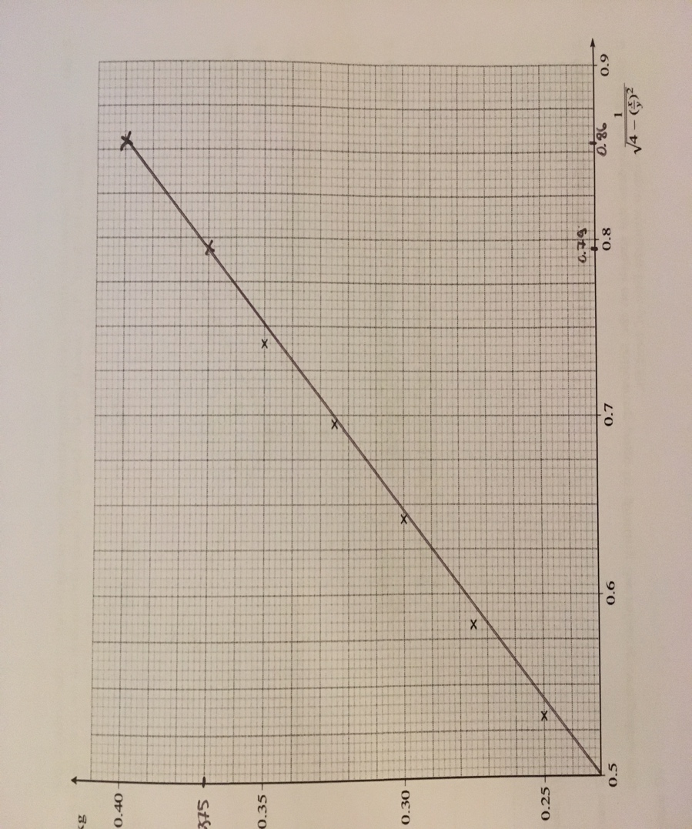

2. (d) (i)
Systematic errors in experimental observations usually come from the measuring instruments. Can be something wrong with the instrument or its data handling system, or because the instrument is wrongly used by the experimenter.

